Ohio Department of Transportation

Scope of Services

C-R-S: HAM LMST Spring Hill

General Information

District/Central Office: District Eight

PID#: 114496

 | No. | Scope of Services Meeting Date | Approved Final Scope of Services
Prime Agreement | 0 | TBD

US-50
 |  |  | Unit | Measure
Functional Classification | Minor Arterial | From: | 31.47 | Mm
Design Functional Classification | Minor Arterial | To: | 31.95 | Mm
Posted Speed (MPH) | 40 | Project Length | 0.48 | Mm
Design Speed (MPH) | 40 | Work Length | 0.5 | Mm
 |  | Lateral Limits | 150+/- | ft

PDP Phase Included in this Agreement: Preliminary Engineering (PE) through Construction (CO)
Agreement between Consultant and Ohio Department of Transportation

This scope is the initial scope for development of the agreement.

This Agreement will be implemented in Parts appropriate to the PDP Phases. The initial price proposal and authorization will include:

Phase PE

The specific scope of work and cost proposal for succeeding PDP Phase(s) will be developed as the current Phase(s) is completed.

Price Proposal Due Date: 7/15/2021

Project Location:

Begin: HAM-50 at the intersection of Spring Hill

End: Existing western terminus of the Little Miami Scenic Trail (LMST)

Project Description:

Purpose & Need:
In August of 2019, ODOT worked with the Eastern Corridor Partners, local stakeholders, and the Stantec-led consultant team to complete the Implementation Plan for Segment II/III of the Eastern Corridor. The plan recommended nearly 70 different transportation improvements to address primary and secondary needs throughout the study area. Along this portion of the US-50 within the study area, the following needs were identified:

- Primary Needs
  - Address eastbound PM peak-hour delays
- Secondary Needs
  - Address pedestrian connectivity to businesses on south side of US 50
  - Address bicycle connectivity from Mariemont to Little Miami Trail

The purpose of this first task for this project is to complete a Feasibility Study (FS) in order to work with local stakeholders to provide a recommended preferred alternative for this location. Once the FS is complete, it is anticipated that ODOT and Great Parks of Hamilton County will work together to identify a funding strategy for the proposed improvement before moving forward with additional project development.

Context:
Upcoming work planned within or adjacent to the study limits includes:
- SFY 2022: PID 101029 will replace signs in this area
- SFY 2022: PID 112171 will implement wayfinding signage at this location as recommended in the 2019 Implementation Plan.
- SFY TBD: PID 114497 will construct the LMST from the Village of Mariemont to the western terminus of this project

MPO Long Range Plan recommendations within or adjacent to the study limits (if not listed in work planned above):
- OKI 2050 Plan Project Wasson Way Little Miami Connector: this project from the OKI plan is alignment with the subject project as well as PID 114497 (https://2050.oki.org/recommended-projects/#map)

For more information on planned projects in the area, please visit TIMS or District 8’s MYWP site at https://gis3.dot.state.oh.us/d08/MultiYearWorkPlan/.

Stakeholders:
Stakeholders identified at the time of project initiation are as follows:

- ODOT District Eight and Central Office
- SORTA/Metro
- City of Cincinnati
- Great Parks of Hamilton County
- Columbia Township
- Hamilton County Engineer’s Office
- Utilities within the project limits, especially Duke Energy
- Emergency responders
- Environmental resource agencies (USACE, EPA, SHPO, USFW)
- Sierra Club
- Tristate Trails

Feasibility Study (FS):
The Feasibility Study will evaluate two alternatives:
- Alternative 1: further evaluate Concept F7, as developed in the 2019 study and available online at https://easterncorridor.org/wp-content/uploads/2018/10/Board31.jpg.

- Alternative 2: evaluate an alternative that follows along US-50 from Spring Hill to just east of the Walton Creek before proceeding on a new alignment to the existing western terminus of the LMST.

The purpose of this study is to complete a Feasibility Study (FS) to recommend one alternative for the project.

Discipline specific scope items have been identified below.

Roadway:
As noted in the FS discussion, a significant amount of conceptual design has been completed. The following discussion describes tasks needed for the FS.
- Prepare layout of the proposed alternative, similar to format shown Concept F7.
- Identify potential design exceptions.
- Using field survey data, establish worst case construction limits to confirm that the proposed project can be constructed within existing right of way.
- Update construction estimate.
- Assume one meeting to discuss landscaping options for the project, along US-50 and at the Spring Hill intersection.

Traffic Control:
- Provide preliminary pavement marking plan for all alternatives for public presentation.
- Provide preliminary warning and regulatory sign plan for public presentation.

Traffic Analysis:
No traffic analysis is anticipated for this study.

Survey:
- Complete field survey for worst case construction limits.
- ODOT will provide aerial mapping for this location in August of 2021.
- Coordinate with Environmental Group and D8 Survey to locate the ordinary high-water mark

Maintenance of Traffic:
No additional MOT analysis is needed for the FS.

Geotechnical:
- Identify potential retaining wall locations.
  - Perform preliminary subsurface exploration for new wall locations. Coordinate drilling with District prior to commencement.
- Obtain additional geotechnical information as needed to support AER decision making process (i.e. utilize existing geotechnical information when available but obtain boring information at structures if no existing geotechnical information is available).

Drainage:
- Identify areas for potential BMPs to confirm that project can be constructed within existing right of way.
- The alignment is proposed in the AE Zone of the floodplain for the Little Miami River. Work with Great Parks to obtain any floodplain coordination that was completed previously, including with the recently completed construction project extending the LMST to the east terminus of this proposed project.
- Obtain linework of floodway from FEMA. This should be on their website
- Floodplain Coordination is required per L&D Volume 2, Section 1005.
  - Determine if there be will a need for fill in the floodway –-NOTE-- I recommend avoiding fill in the floodway
    - If fill in the floodway is unavoidable, then you will need to determine the impacts of the fill. The following steps are needed:
      - Obtain FIS and model from FEMA
      - Calibrate the model in HECRAS
      - Make revisions (add proposed fill) to the model in HECRAS
      - Run the calculations
      - Complete the no-rise certificate or do a CLOMAR/LOMAR
- Assume one meeting to coordinate with the Little Miami Conservancy District

Railroads:
No railroad coordination is anticipated with this project.

Structures:
- Coordinate with Great Parks to obtain any analysis from IBI and any photos that may be available from work to salvage existing substructure units at the Walton Creek crossing.
- Complete a structures type study of the proposed crossing of the Walton Creek
  - The structure type will need to accommodate high water levels/high frequency of flooding as the structure will be inundated regularly.
  - Ensure that the structure will be designed to carry service vehicles for maintenance and inspection purposes.
  - Provide truss style bridge similar to the nearby trail bridges over the Little Miami River and Dry Run Creek along Newtown Road.
    - Note: Those bridges were completed under HAM-LTMIAM PID 24033. Please see the attached plans for reference.
Pavements:
- Work with Great Parks of Hamilton County and ODOT D8 to determine pavement build-up.

Environmental:
The consultant will complete the following tasks for the FS:
- RMR
  - Complete an RMR for the project. It is likely that a Phase I ESA will be needed for the recommended preferred alternative.
- Cultural Resources
  - Complete a 106 SRF
- Ecological Resources
  - Complete a Level 1 ESR
  - Identify information needed for potential waterway permit determination request for impacts associated with the proposed bridge over Walton Creek as well as work along the Little Miami River
  - Identify potential impacts to potential bat habitat along Spring Hill area
- 4(f)
  - Complete 4(f)/6(f) DRF
- Underserved Populations
  - No analysis needed at this time.
- Noise Analysis
  - No noise analysis will be required.
- Determine if a 408 Permit will be required in future phases of development
- Determine if any leaks have occurred from the Kroger Fuel Station
- NEPA document will be addressed in a future modification.

Public Involvement:
The consultant will be tasked with preparation of materials for public outreach. The following activities will be required:
- Prepare a one pager and exhibit for property owner notification letters. Mailings are anticipated for survey operations, environmental field work, and to announce the public involvement meeting.
- Assume 2 implementation group meetings and 1 advisory committee meetings. Consultant will prepare exhibits and take minutes for each meeting.
- Prepare public meeting materials (exhibits, comment sheet, project handout) and Public Input website.
  - Assume one public and one virtual meeting on a weekday evening.
  - Prepare a concise set of boards that could be provided to local governments for display in their lobbies during public outreach.
- Provide a Google Earth KML of the alternatives.
- Compile and draft responses to all public comments.

Real Estate:
- According to CAGIS, it appears that Parcel #052001000017 is owned by Great Parks of Hamilton. Confirm this ownership.
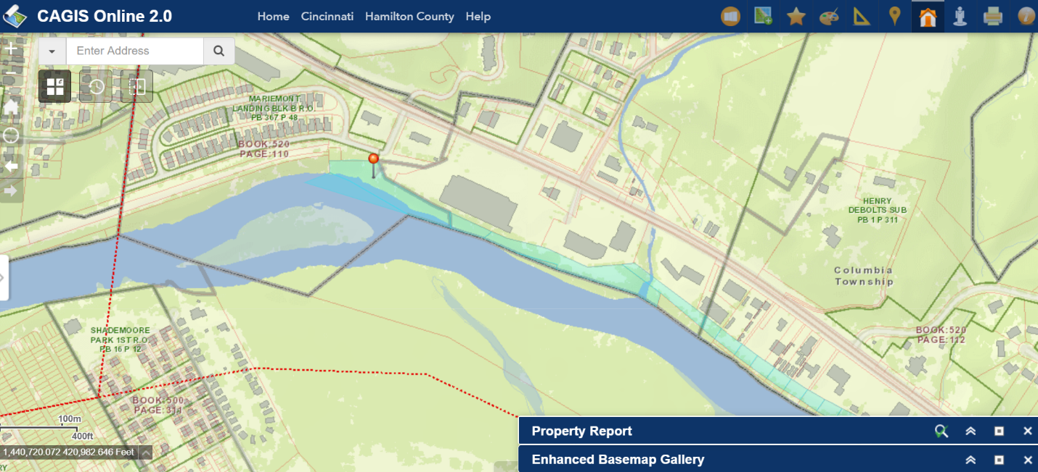

- 2-3 partial and temporary takes are anticipated for this project. Provide areas of proposed takes 45 days prior to submitting the FS. The District will then use this information to complete a cost estimate for right of way services, acquisition of right of way, and relocation benefits. The consultant will then include this cost estimate in the FS.

Utilities:
- Provide cost estimates for reimbursable utilities.
- Complete utility coordination as noted below:

Consultant to try to avoid utility conflicts throughout design while holding to the scope of work. If utility conflicts cannot be avoided, they should be minimized. Consultant to provide a copy of the OUPS ticket information to ODOT PM (if applicable). Up to date utility contacts shall be identified for the FS. Utility contact information can be requested by consultant from ODOT PM. If OUPS and OGPUPS ticket are more than two (2) years old, a design non-marking ticket shall be requested to obtain most up to date Utility Members List. The ticket does not need to be submitted to obtain the Utility Members List.

Consultant to provide a utility set of plans with the utility lines shown in color using the most recent version of ODOTcadd_UTPen.tbl with the FS. This file is found in the standard ODOTcadd executable file that can be downloaded from the CADD services webpage. Additionally, Consultant to prepare a summary of potential utility conflicts with the FS. Summary to be provided to Utility Companies with the FS as well. Summary to include, but not limited to station and offset of conflict, type of conflict (direct, decreased cover, proximity, etc.), utility owner (if known) and utility type. Consultant to use District 8's 'standardized' letter for sending FS and plans to Utility Companies for review and comment. Consultant to provide the ODOT PM a copy of all Utility Correspondence. Consultant to compile Utility Company responses and forward to the ODOT PM. Final compilation of utility correspondence is due 35 days after FS submission to utilities

A “no response” from a utility on a plan submission review cannot be considered as “no comment”, “no conflicts” and/or “a confirmation of the consultant’s findings” from the utility. A written response (email is sufficient) must be received from the utility verifying that they have no comments, no conflicts and/or they agree with the conflicts identified by the consultant.

Consultant to review the Utility Company responses and evaluate. The evaluation of the responses shall include validating that a conflict does exist or that a utility may remain in place. If a conflict does exist, consultant should provide an evaluation of the feasibility of potential resolutions. A disposition of utility status will be completed in future design submittals under a separate consultant contract.

Project Management:
As noted earlier, the purpose of this first task for this project is to complete a Feasibility Study (FS) in order to work with local stakeholders to provide a recommended preferred alternative for this location. Once the FS is complete, it is anticipated that ODOT and Great Parks of Hamliton County will work together to identify a funding strategy for the proposed improvement before moving forward with additional project development.

Funding:
This project will utilize a combination of federal and state funds through the TRAC program. Plan splits will not be required at this time items.

Schedule:
The preliminary schedule for this work is as follows:

