To: | Stephanie Otten  ODOT | From: | Nick Mueller  Khizer Zaman  Stantec, Blue Ash, OH
Project/File: | 173620147 Spring Hill Hydraulics | Date: | August 30, 2024

Reference: Spring Hill No-Rise Analysis

The purpose of this technical memorandum is to document the hydraulic analysis completed to support design of the Little Miami Scenic Trail (LMST) Connector located along the Little Miami River in Hamilton County, Ohio. The proposed project is located partially within the Effective Special Flood Hazard, Zone AE with Floodway as published on digital Flood Insurance Rate Map (DFIRM) Panel no. 39061C0263F. Because of the projects location within the effective Floodway limits, a no-rise analysis was performed to determine the pre- and post- project water surface elevations during the 1%-annual-chance discharge event, also called the Base Flood Elevations (BFE). The proposed project extents are shown in Figure 1.
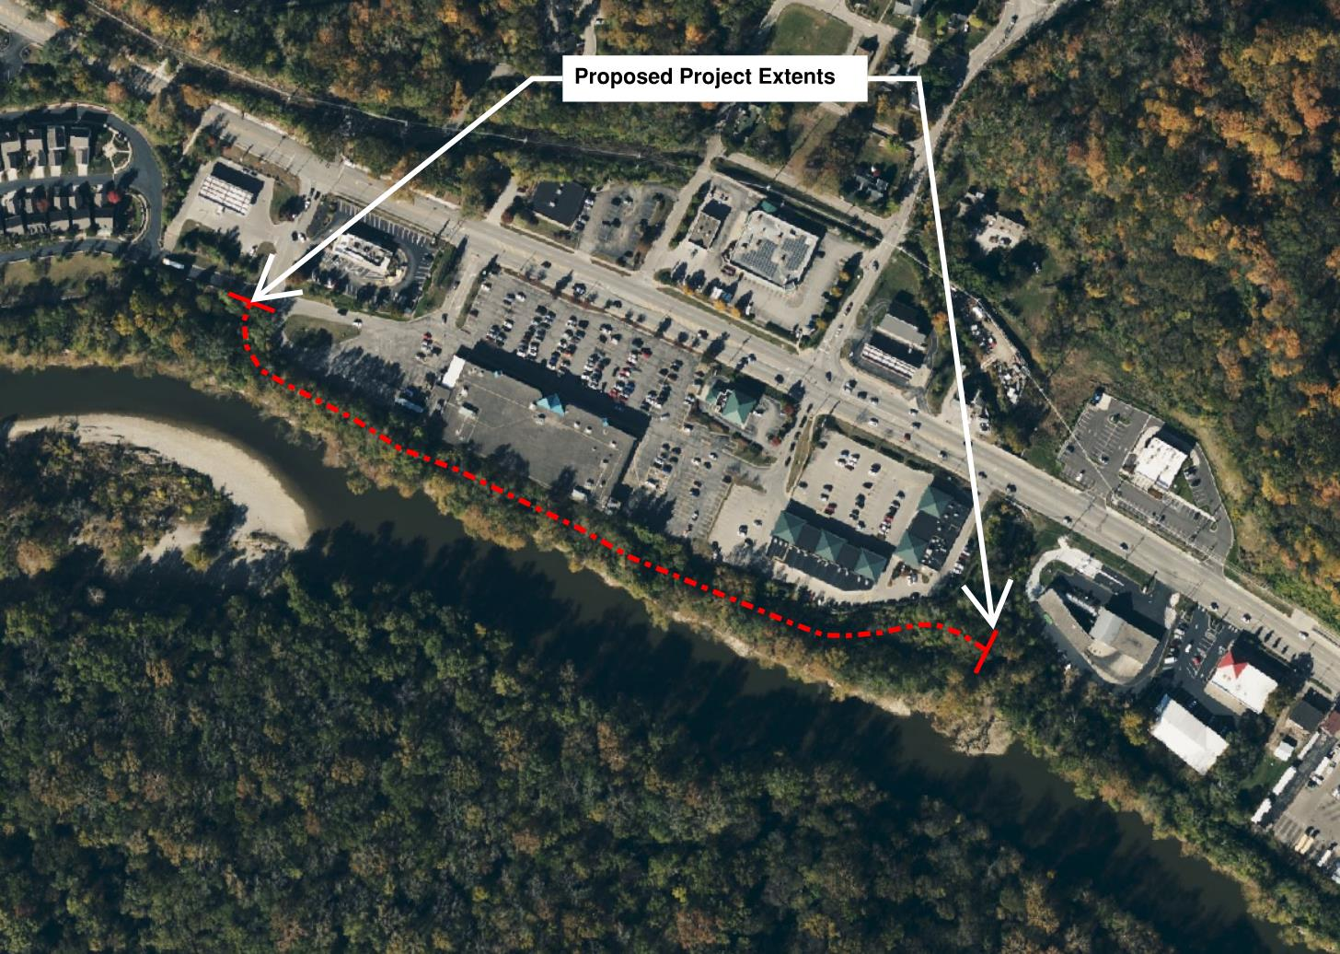
Figure 1. Project Extents

Hydrologic Analysis
The hydrology used in this analysis utilizes the peak discharges and hydrographs from the Effective Flood Insurance Study (FIS). New hydrologic analysis was not performed for this study. The flow rates and other hydrologic parameters from the effective FEMA model were utilized without modification. Peak discharges for various recurrence intervals as reported in the FIS are shown in Table 1.
Table 1. Effective FIS Peak Discharges
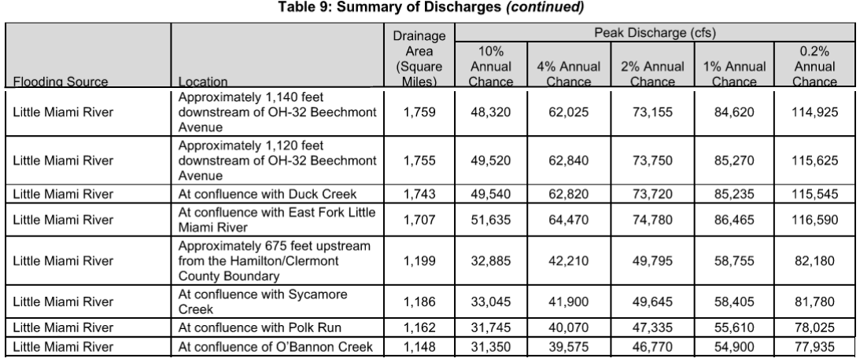

Hydraulic Analysis

Effective FEMA Model
Stantec obtained the effective FEMA hydraulic model of the Little Miami River in Hamilton County. The 1-dimensional, unsteady state hydraulic model was developed in the Hydraulic Engineering Center – River Analysis System (HEC-RAS) version 5.0.3. The proposed site is located between hydraulic model river stations 39180 and 41238.

Duplicate Effective Model
A duplicate effective model was developed by running the effective model with the latest version of HEC-RAS used in this study, Version 6.5. No changes were made to the model geometry, the duplicate effective model is used to confirm that the effective model can be replicated with the latest version of the software. The duplicate effective model results are typically similar to the effective model results with most cross sections within 0.1 to 0.2 feet difference. The greatest difference between the two models was 0.56 feet occurring around model station 136,694 which is approximately two miles upstream from the project site.
A comparison of duplicate effective model and effective model 1% water surface elevations is shown in
Table 2. Water Surface Elevation Comparison, 1% Effective Vs. Duplicate Effective

Corrected Effective / Pre-Project Model
A corrected effective model was produced to reflect physical modifications that have occurred within the floodplain since the effective model, prior to the project. For this analysis, the corrected effective model and the pre-project model are the same.
A pre-project conditions geometry was developed to update the duplicate effective model geometry and reflect current topographic conditions of the project area based on recent field survey. New model cross sections were added within the project area between the effective cross sections 39180 and 41238. The locations of these new cross sections are illustrated in Figure 2. The new cross sections allow for a comparison with the post-project conditions model results.
Below-water river channel geometry for the new cross sections was interpolated using the geometry editor tools in HEC-RAS based on the bounding effective model cross section geometry. Overbank geometry was updated using an existing surface digital elevation model (DEM) of the project area.
Within the project area, overbank Manning’s ‘n’ values were horizontally varied based on land use observed in aerial imagery of the site taken in 2021. Manning's ‘n’ values of the interpolated cross sections, including the original cross-sections 41238 and 39180, were manually adjusted. This adjustment was performed to more accurately represent the land cover and channel characteristics at each interpolated location, rather than relying on the interpolated values. A summary of Manning’s ‘n’ values and corresponding land use values is shown in Table 1 below.
Table 2. Manning's 'n' values used
Manning’s N vs Land Cover
Trees / Forest | 0.12
Developed, Open Space | 0.04
Developed, Medium Intensity | 0.12
Developed, High Intensity | 0.16
Asphalt / Concrete Pavement | 0.016
A comparison of corrected effective / pre-project model and effective model is included in
Table 3. WSE Comparison, Corrected Effective vs. Effective 1% Profile

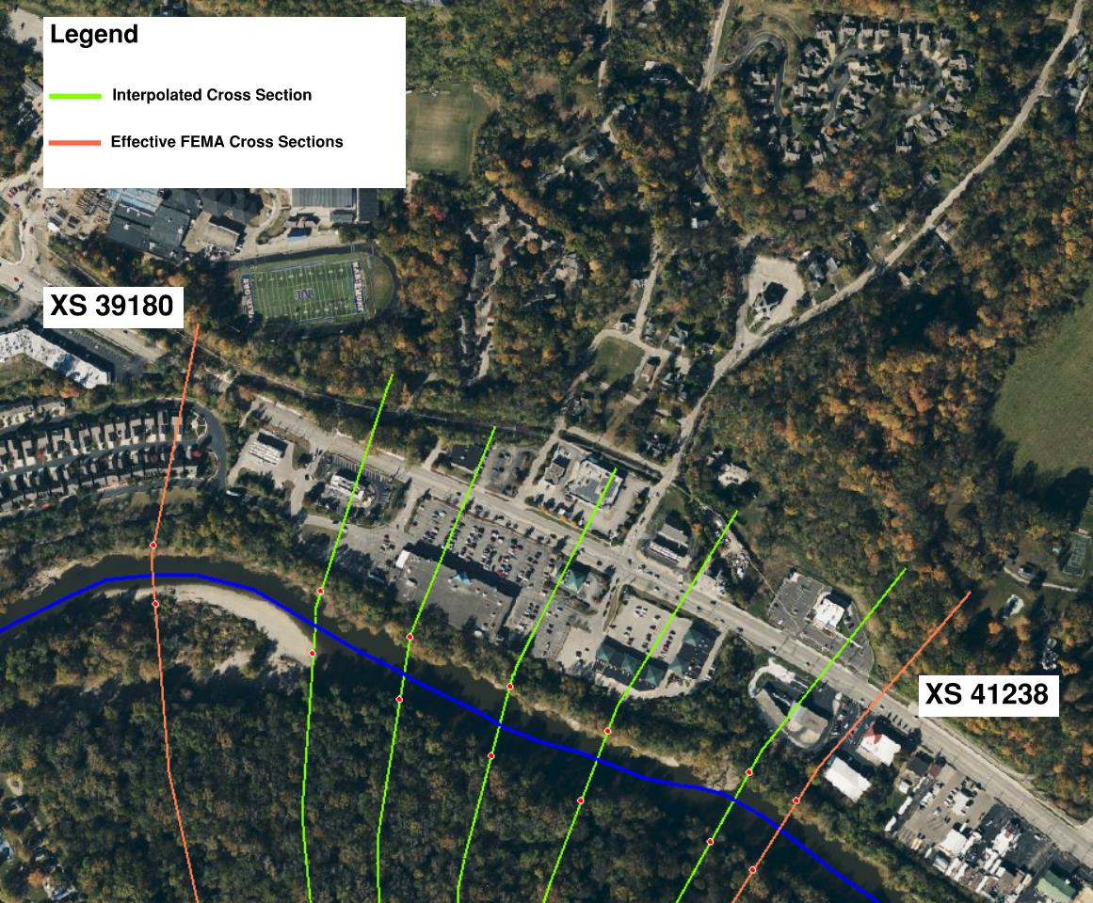
Figure 2. Hydraulic Model Cross Sections
Post Project Model
Post-project conditions geometry was developed in HEC-RAS to reflect the LMST project. Channel geometry in the post-project geometry is identical to the pre-project model, except for the following changes. Overbank geometry in the project area was updated to reflect proposed grading of the LMST paved trail. Manning’s ‘n’ values were updated to reflect the changes to the land-use in proposed conditions. The paved portion of the trail was set to a consistent ‘n’ value = 0.016 to reflect the proposed asphalt bike path surface. An n value of 0.04 was assigned to either side of the paved surface to reflect the grass strip on either side of the trail which will be maintained. Interpolated model cross sections were revised to reflect the addition of the LMST and are shown in Figure 3 below. An example comparison of pre- and post-project HEC-RAS model cross section geometry is shown in Figure 4.
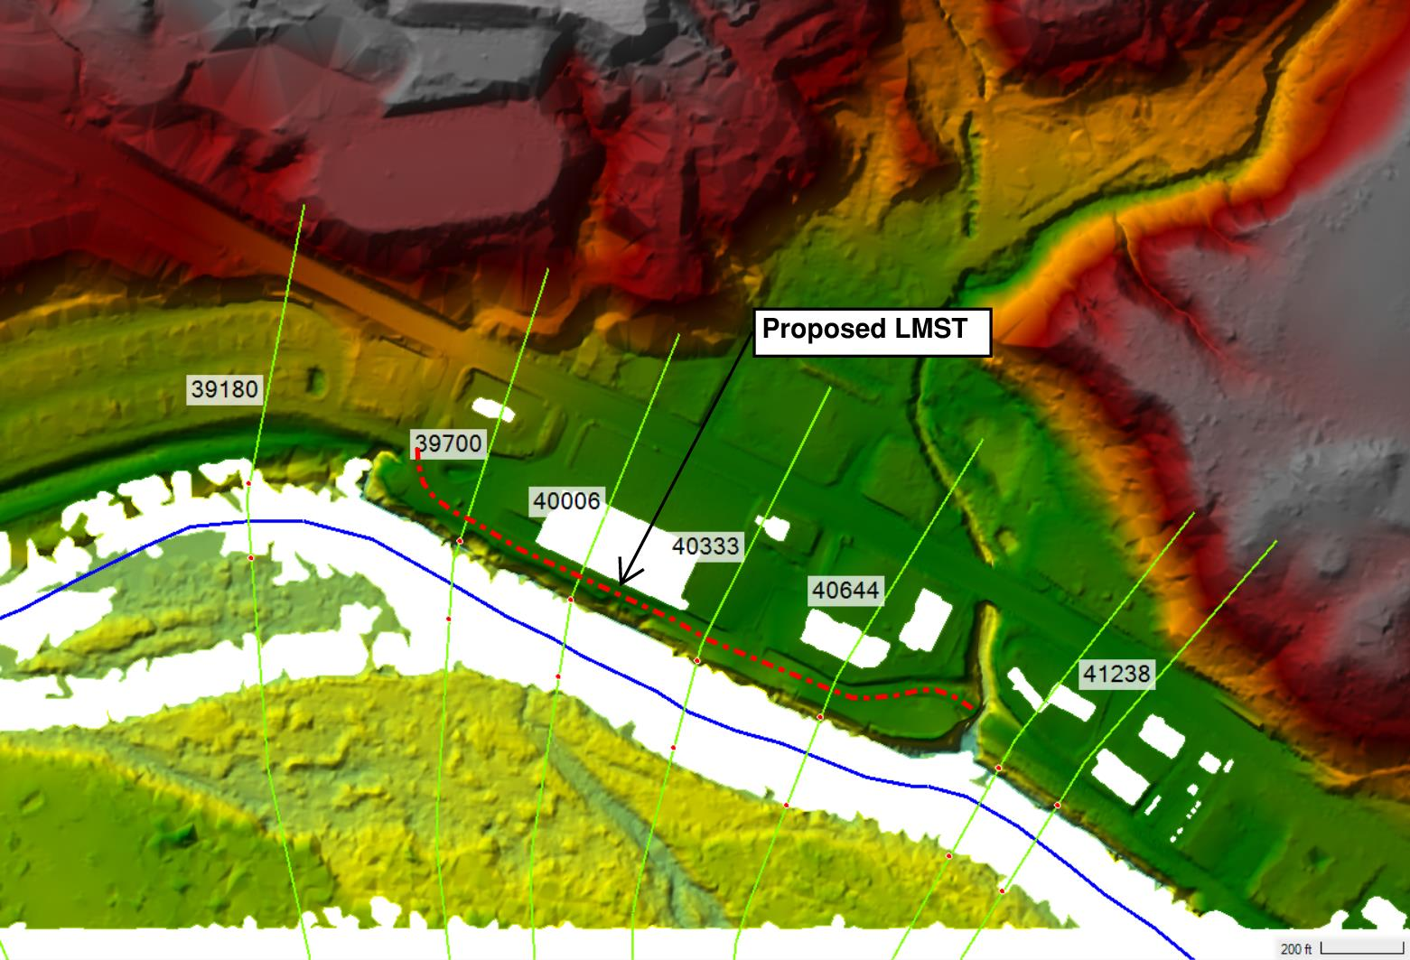
Figure 3. Proposed Location of LMST

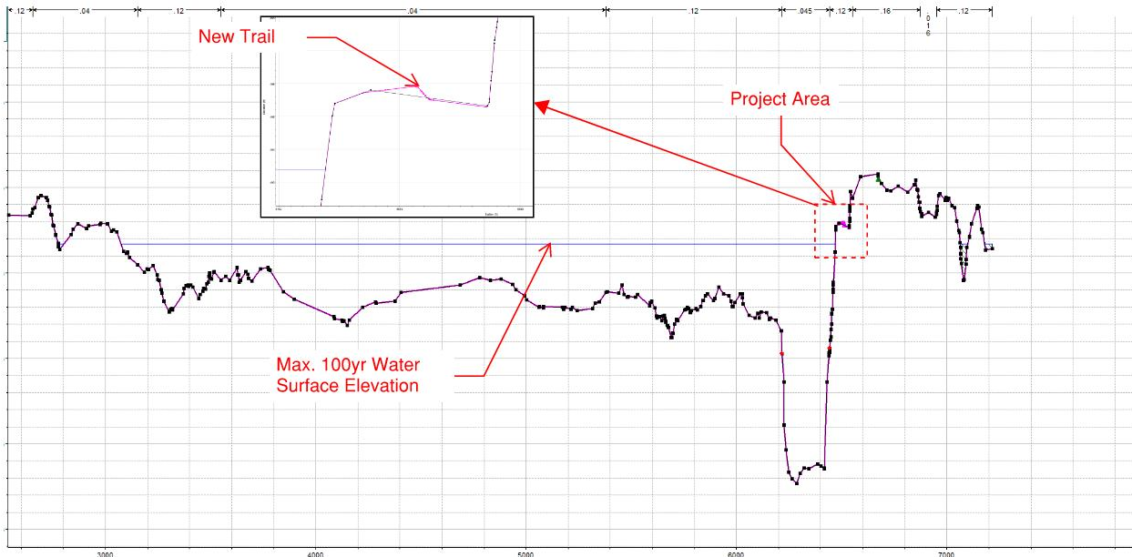
Figure 4. River Station 40644 Pre-and Post HEC-RAS Cross Section Geometry Comparison Example

Model Results
A comparison of pre-project and post-project hydraulic model results within the project area is presented in Table 2 below. Model results indicate no-rise (0.00 ft) in post-project water surface elevations within the project area or immediately upstream and downstream of the project site.

Table 3. Pre-and Post Project Base Flood Elevation Comparison
Hydraulic Model Results
River Station | Corrected Effective / Pre-Project  100-yr WSE  (Maximum, Feet NAVD88) | Post-Project  100-yr WSE  (Maximum, Feet NAVD88) | Change in Base Flood Elev. (Feet) | Notes
42968 |  |  |  | Newtown Pedestrian bridge
42929 | 494.65 | 494.65 | 0.00 | Upstream of Project Site
42449 | 494.43 | 494.43 | 0.00 | Upstream of Project Site
41238 | 493.73 | 493.73 | 0.00 | Upstream Limit of Project
41077 | 493.65 | 493.65 | 0.00 | Project Area
40644 | 493.39 | 493.39 | 0.00 | Project Area
40333 | 493.20 | 493.20 | 0.00 | Project Area
40006 | 492.98 | 492.98 | 0.00 | Project Area
39700 | 492.78 | 492.78 | 0.00 | Project Area
39180 | 492.50 | 492.50 | 0.00 | Downstream Limit of project
38268 | 492.07 | 492.07 | 0.00 | Downstream of Project Site
37178 | 491.79 | 491.79 | 0.00 | Downstream of Project Site
36422 | 491.58 | 491.58 | 0.00 | Downstream of Project Site
36197 | 491.49 | 491.49 | 0.00 | Downstream of Project Site
36153 |  |  |  | Mariemont Railroad

Conclusion
Based on the hydraulic model results, the proposed Little Miami Scenic Trail Connector project will not increase the Base Flood Elevation (BFE) within the project area or in the areas immediately upstream and downstream of the project site. The analysis demonstrates that there is no rise in water surface elevations for the 1%-annual-chance flood event (100-year flood) when comparing pre-project and post-project conditions. Therefore, the proposed project meets the no-rise criteria for development within the regulatory floodway.

Regards,
Stantec Consulting Services Inc.
Nick Mueller, PE
Senior Project Engineer
Phone: (513) 842-8239

Nick.Mueller@stantec.com

