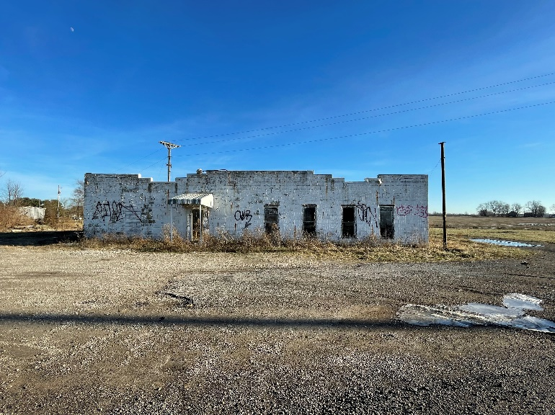
FRONT (Facing South-East from Intersection)

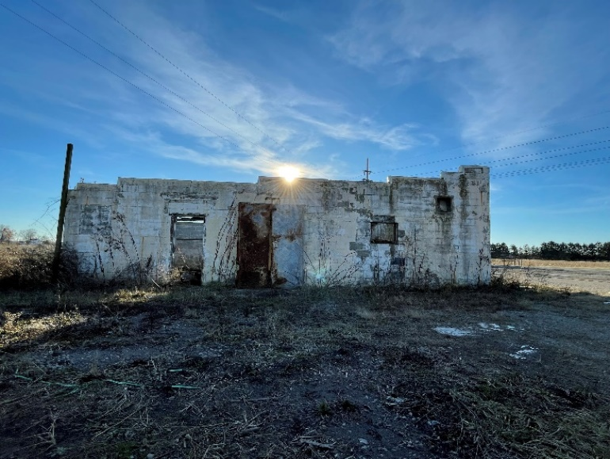
SIDE (Facing South-West from SR-256)

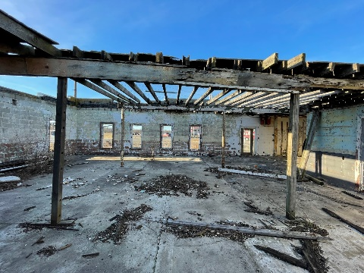
INSIDE (Facing North-West at Front)

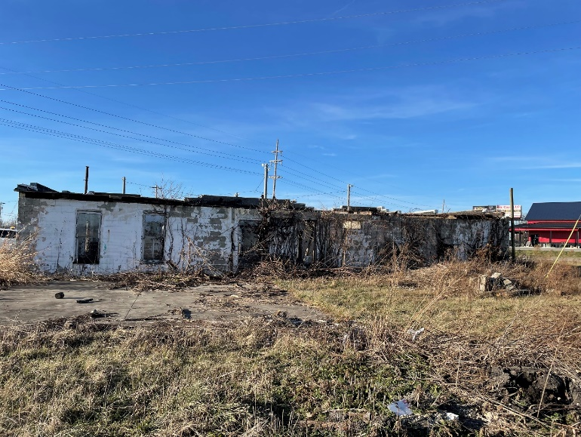
REAR (Facing North-West from Field)

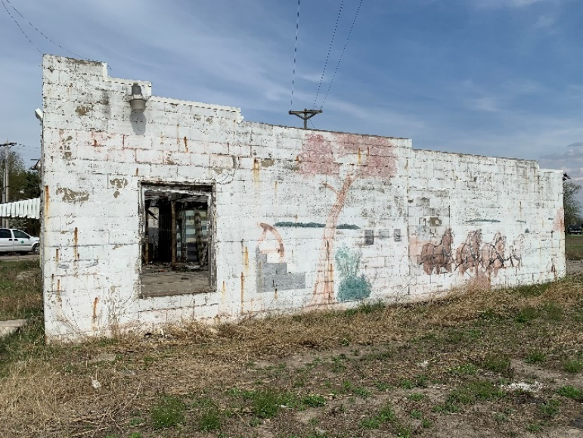
SIDE (Facing North-East from SR-37)

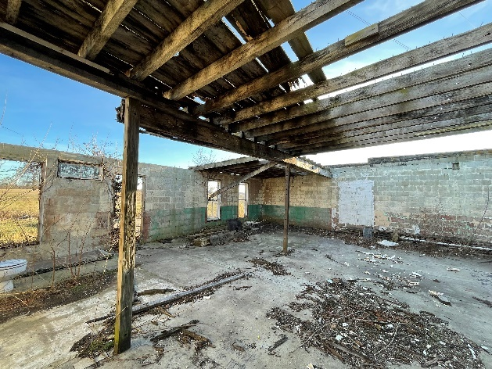
INSIDE (Facing South at Rear and Side)

