FRONT (Facing South-East from Intersection)

SIDE (Facing South-West from SR-256)

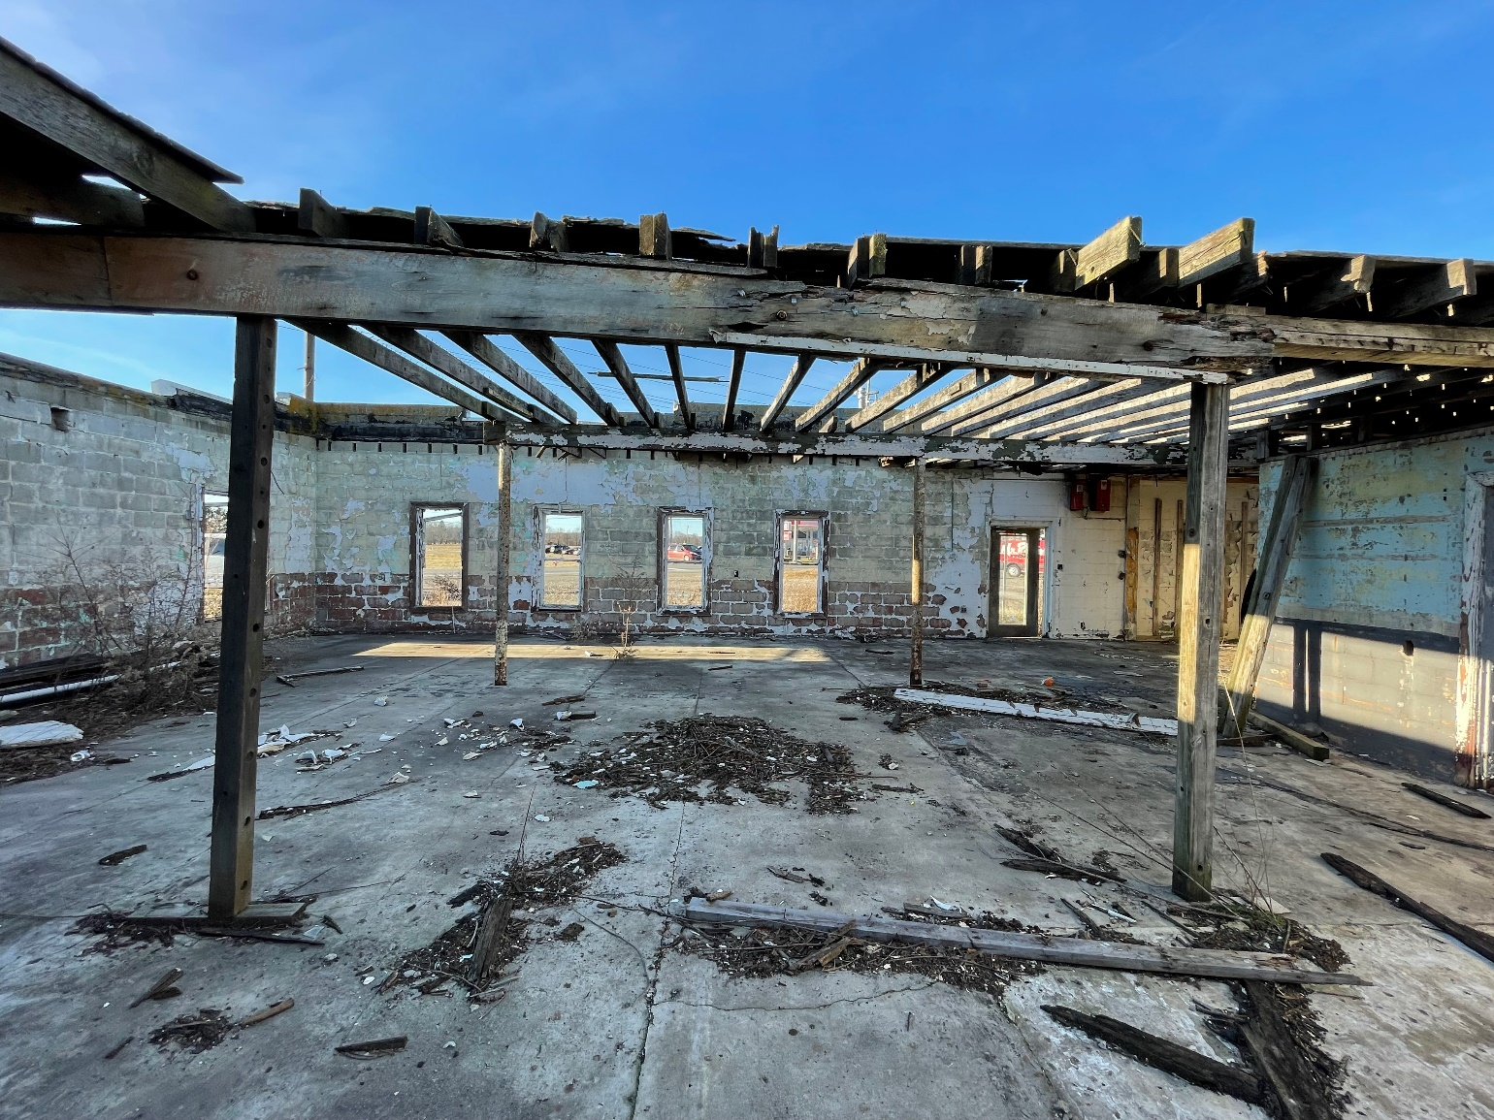

INSIDE (Facing North-West at Front)

REAR (Facing North-West from Field)

SIDE (Facing North-East from SR-37)

INSIDE (Facing South at Rear and Side)