STRUCTURE APPRAISAL
Common Pleas Court, |  |  | FAIRFIELD |  |  |  |  |  | County, Ohio
In the matter of the appropriation of
Standard Highway Easement
type of take
For highway purpose over the lands of
EICHHORN LIMITED PARTNERSHIP
property owner
and necessary in the construction and improvement of
110412 |  | 037/256 |  | 06.10 |  | 001 |  | FAIRFIELD
PID |  | Route No. |  | Section |  | Parcel No. |  | County
County, Ohio
 | Case No. |  |  |  | 21 CV 457

After filing, all copies are to be signed by each appraiser and the distribution is to be as follows:
- Original to the Clerk of Courts
- Copy to the property owner’s attorney
- Copy to each appraiser (Appraiser for the property owner, appraiser for the county and appraiser for the ODOT)
- Copy to the assigned Assistant Attorney General
- Copy to the ODOT District Office
- Copy to the Records Section, Office of Real Estate, ODOT
SKETCH PAGE(S)
Sketch of each structure that is taken. Each sketch to have exterior dimensions.

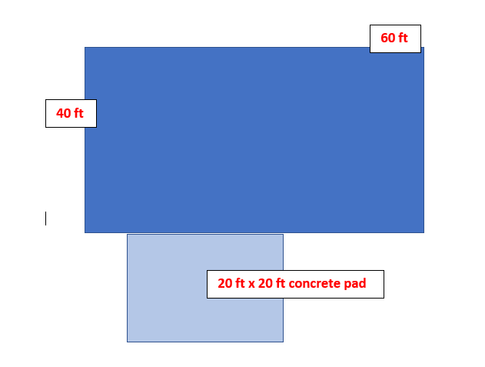
PHOTOGRAPHS OF IMPROVEMENTS TAKEN
Photographs are taken to preserve evidence. Exterior photographs are to show each side of the structure(s) to be taken. Each structure to be taken shall also have interior photographs to illustrate condition, built-in items, areas of functional concern and to preserve those items/elements/features which influence value. Each picture shall be no smaller than 5 inches by 7 inches

JULY 15, 2020

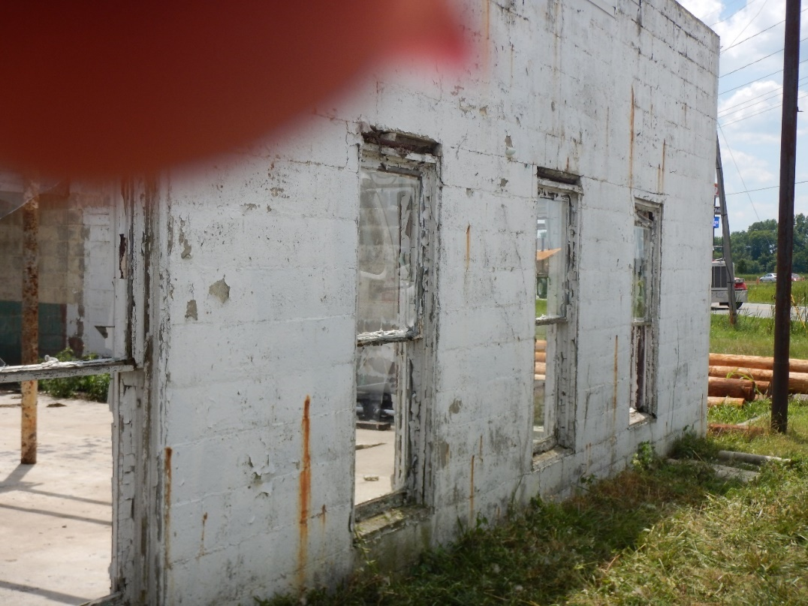

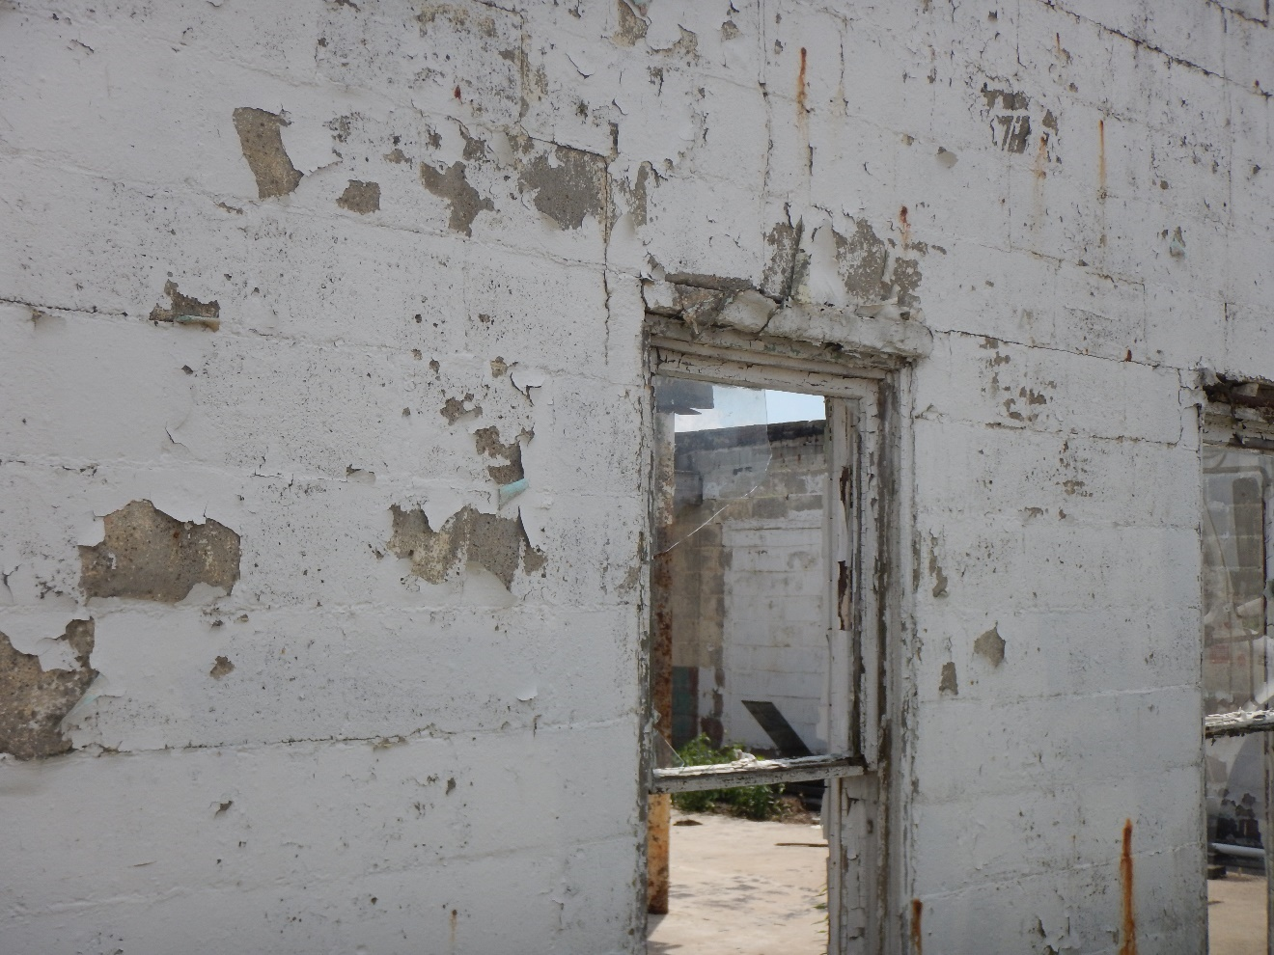
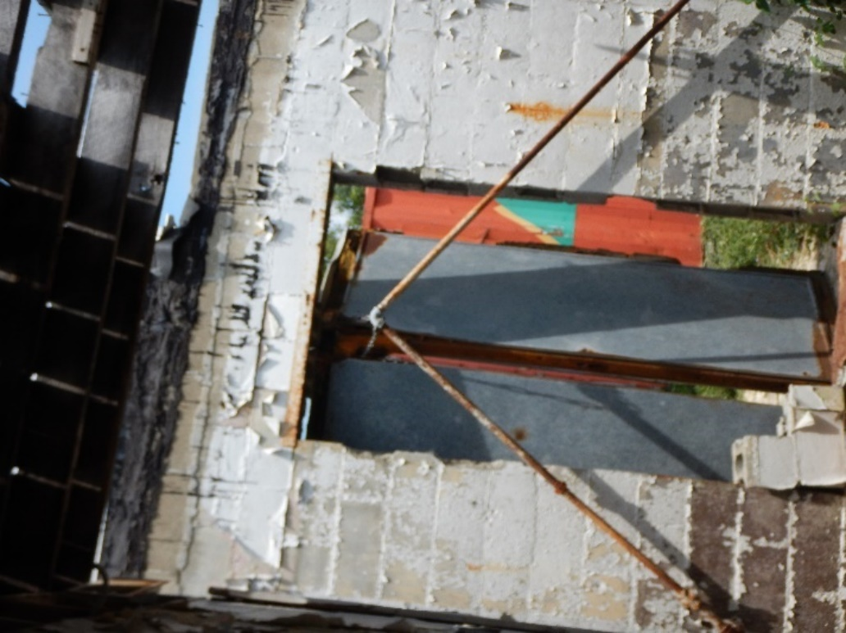

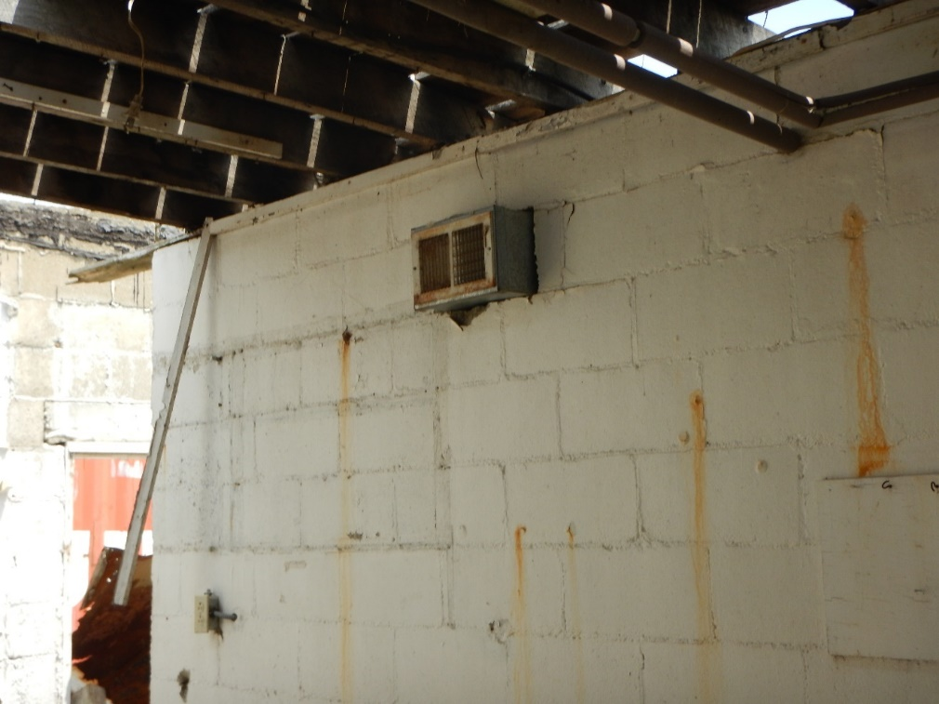
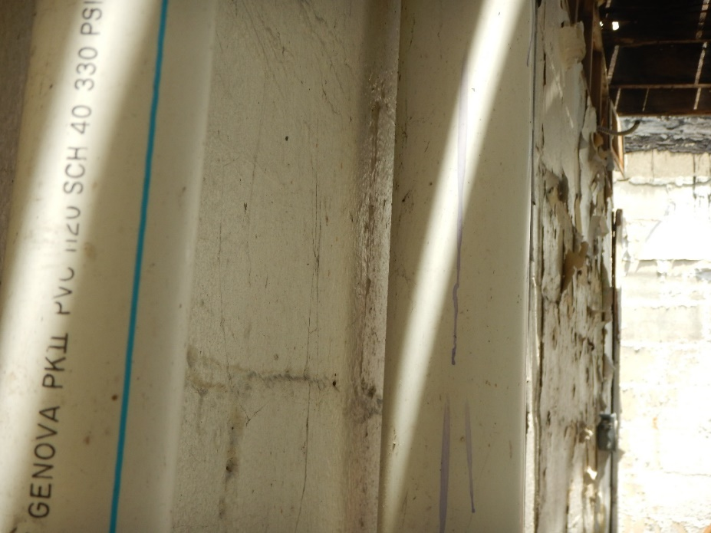

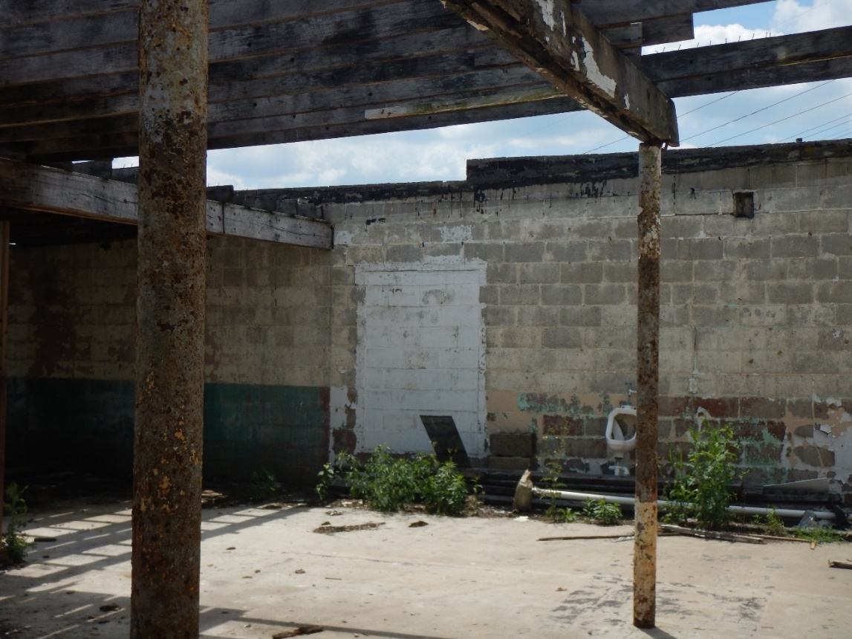
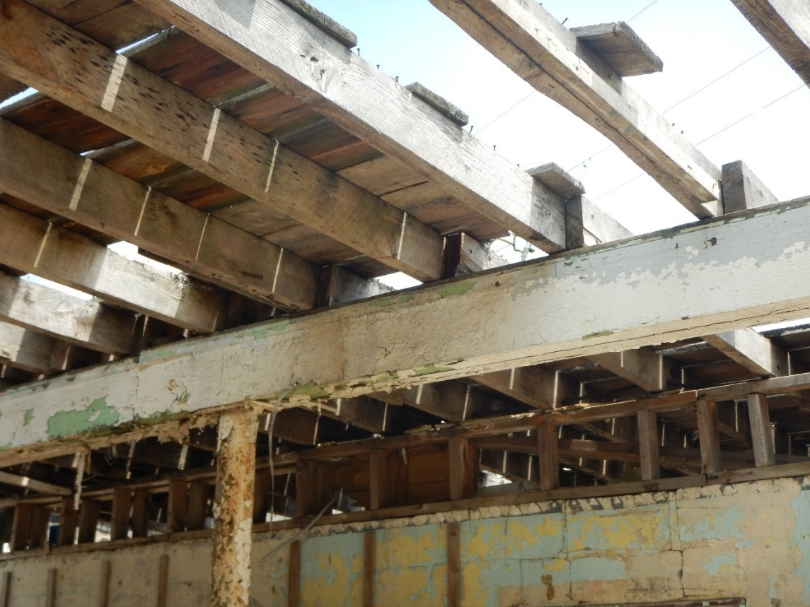
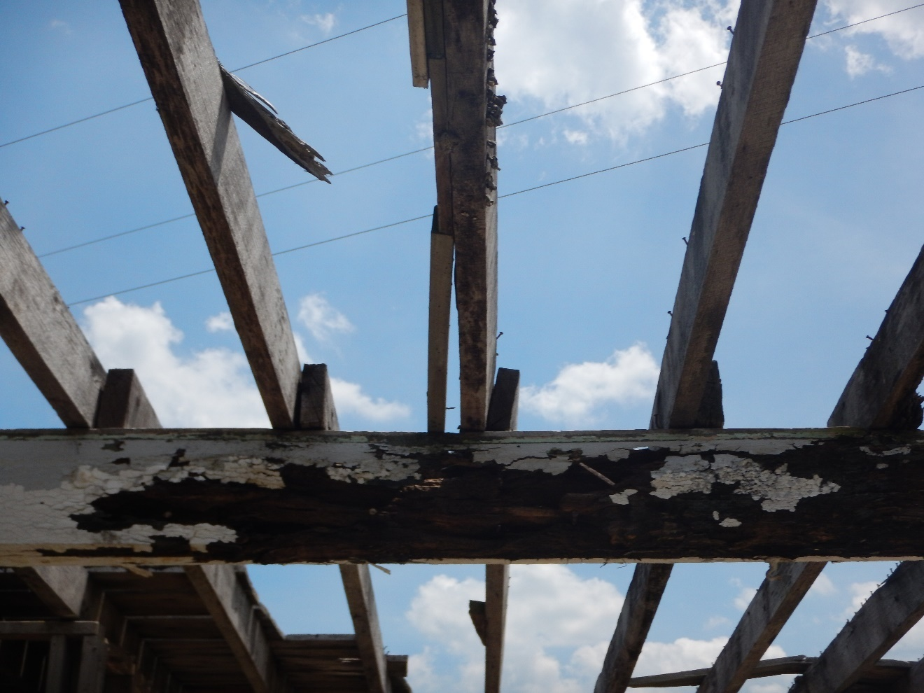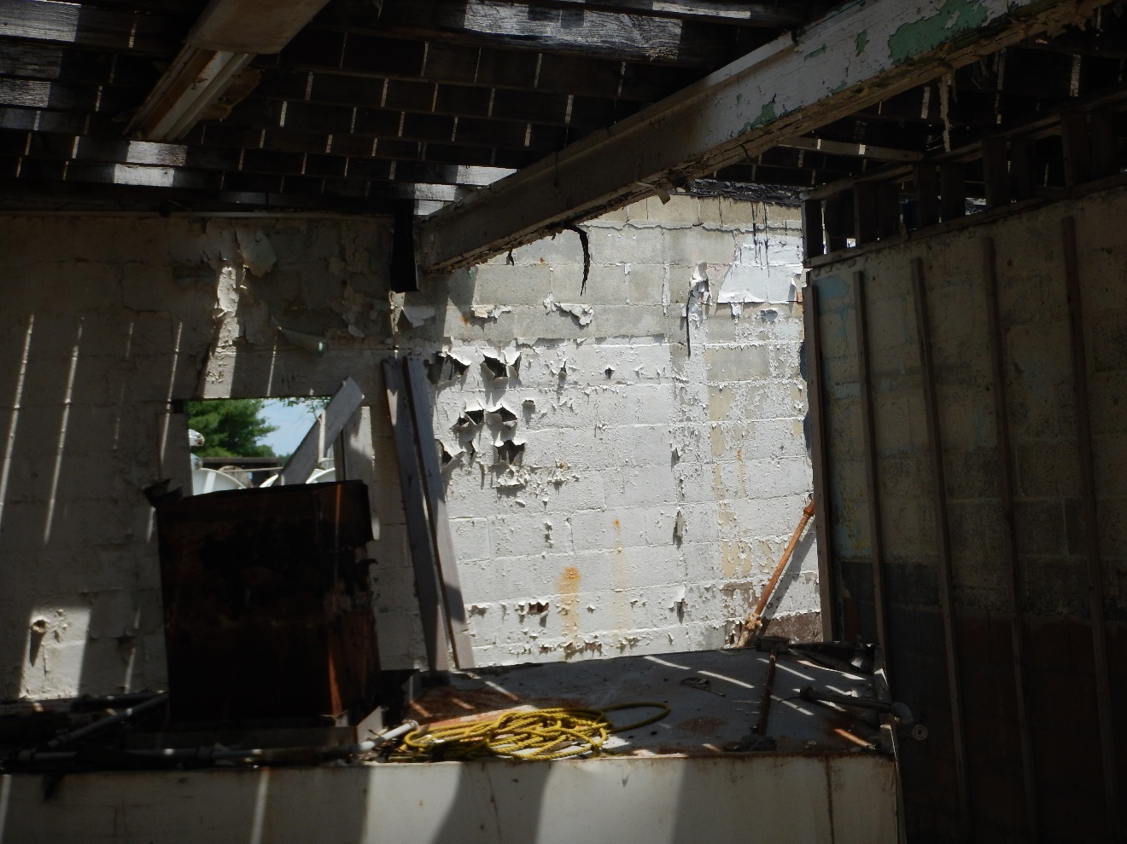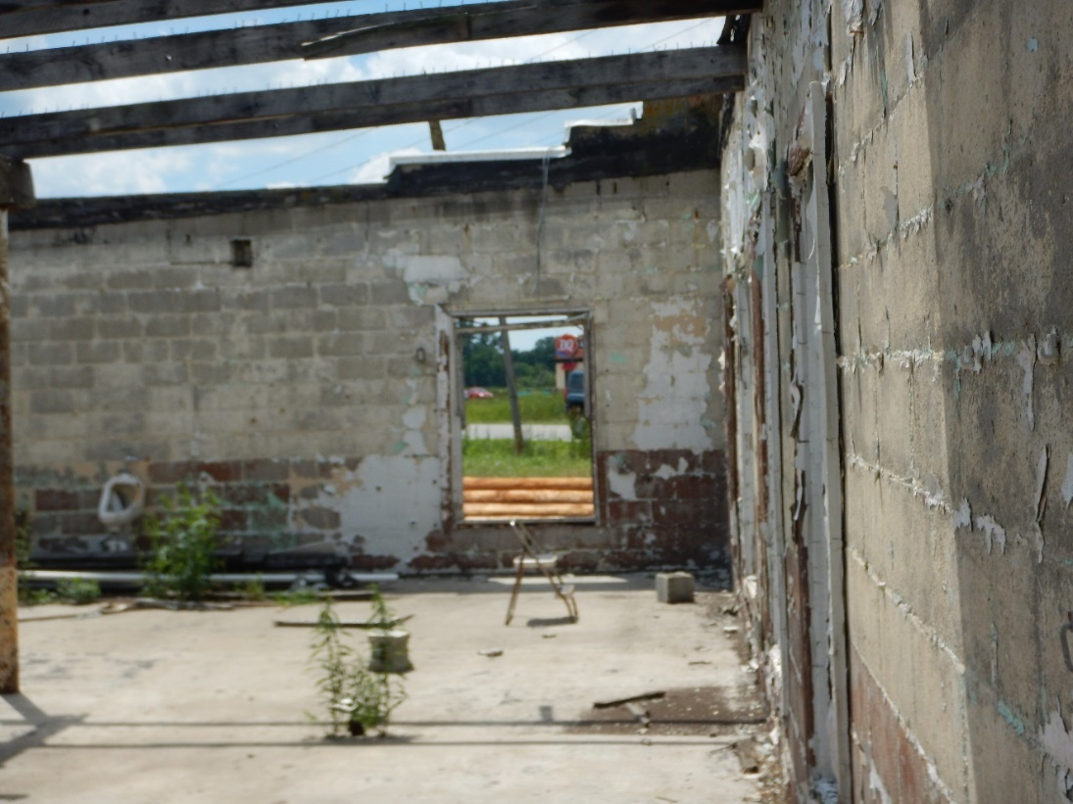

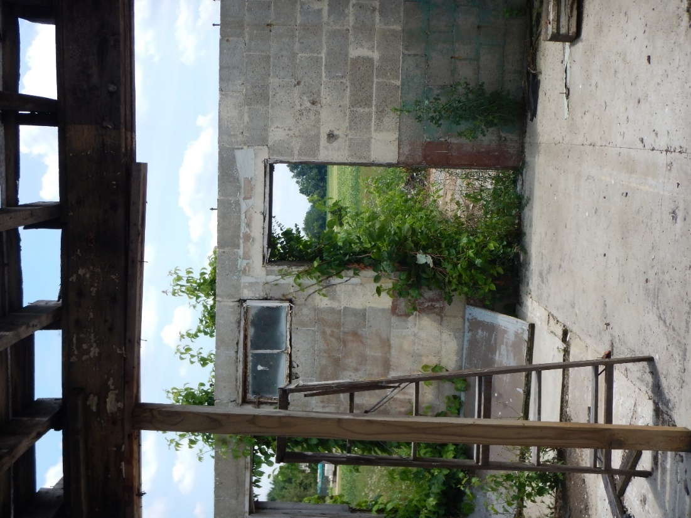

April 7 2021

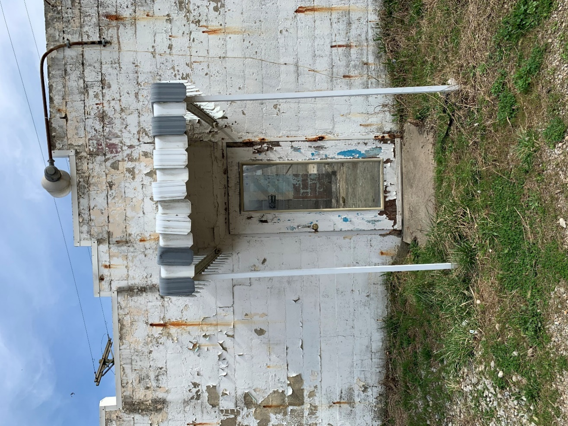

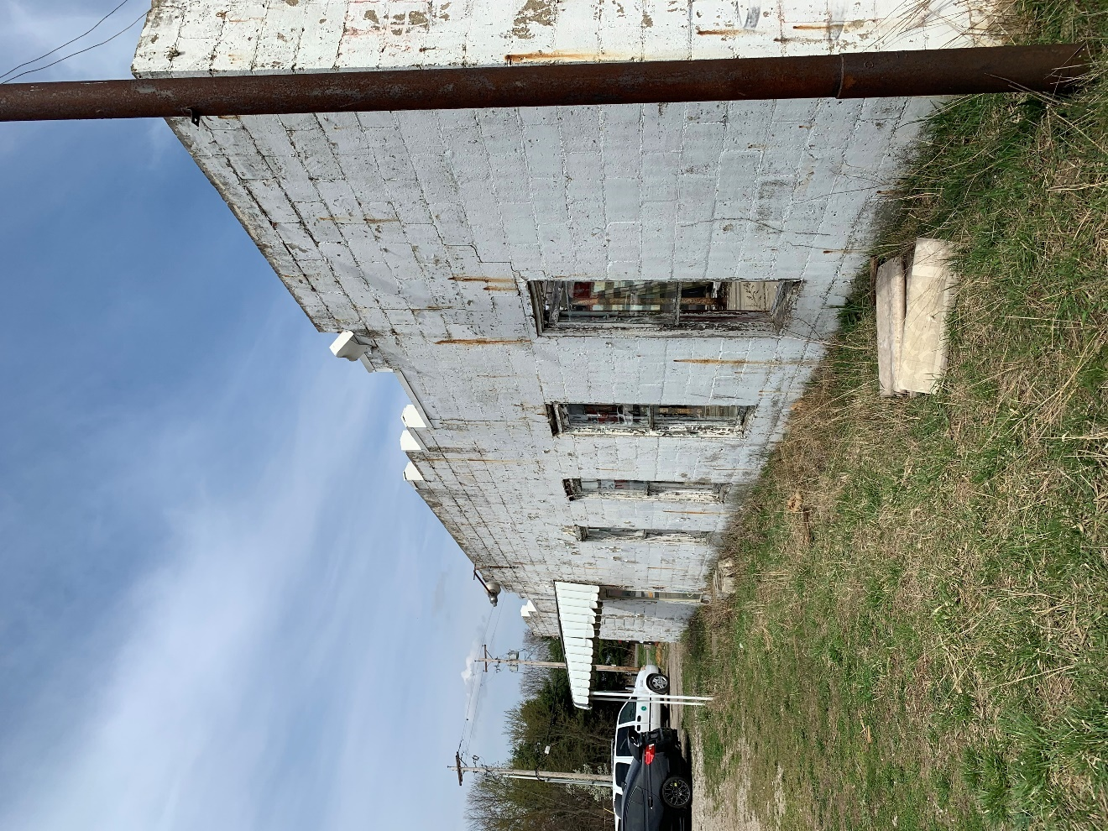
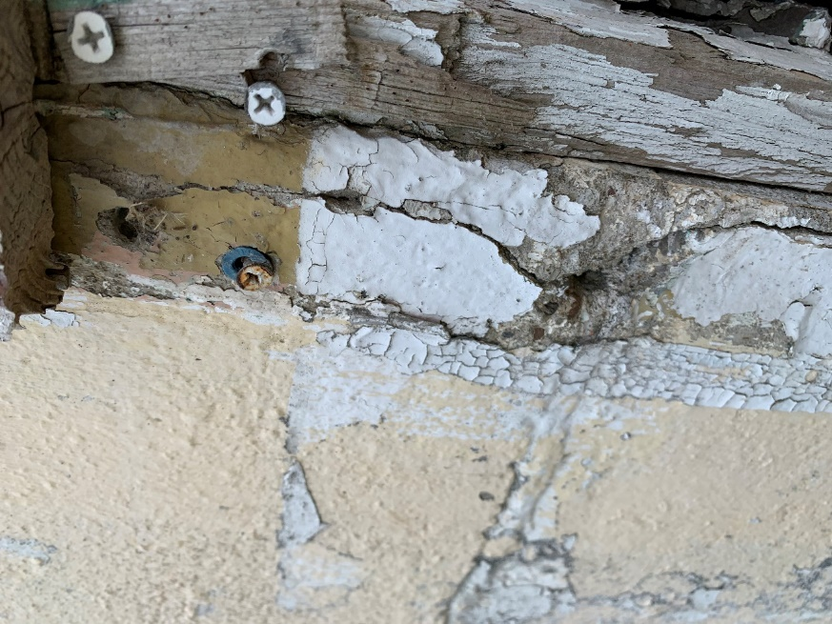

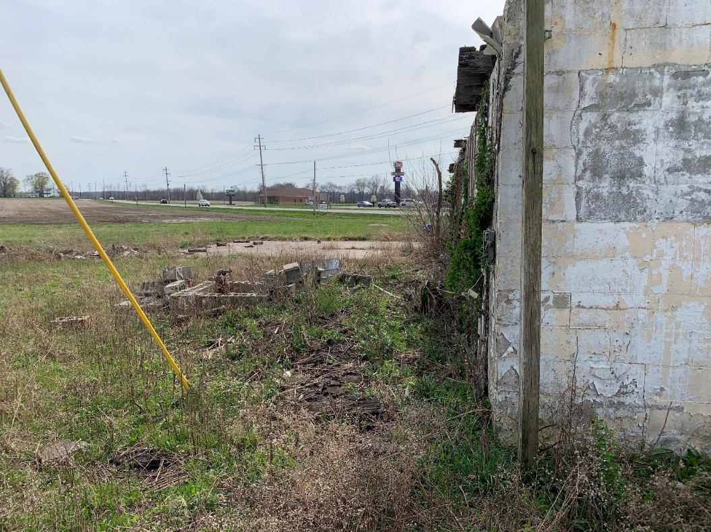
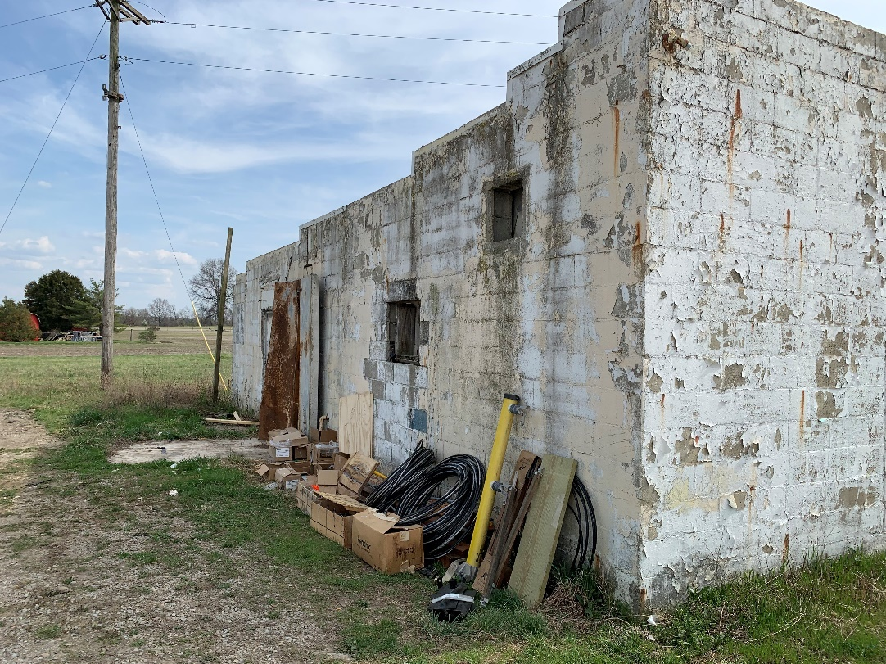

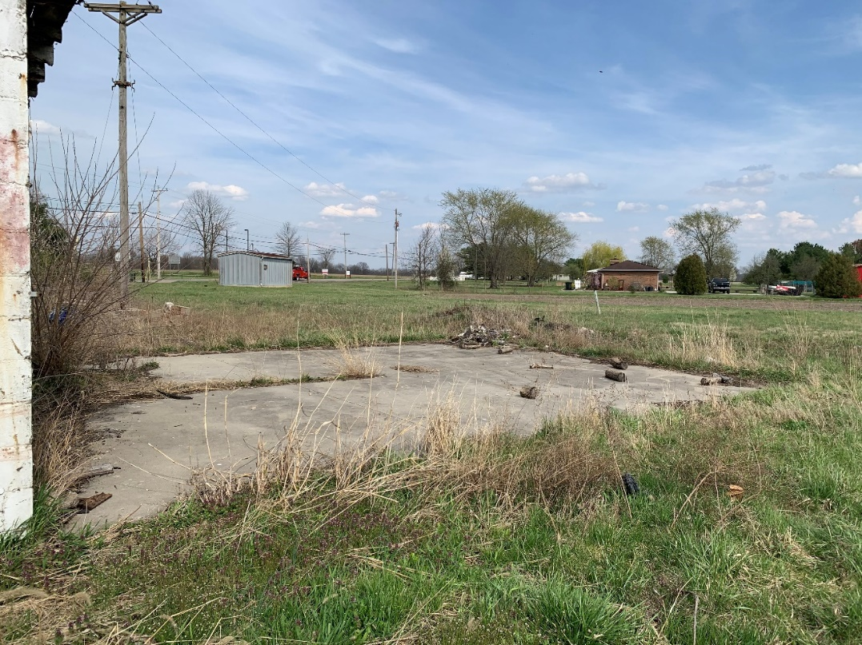
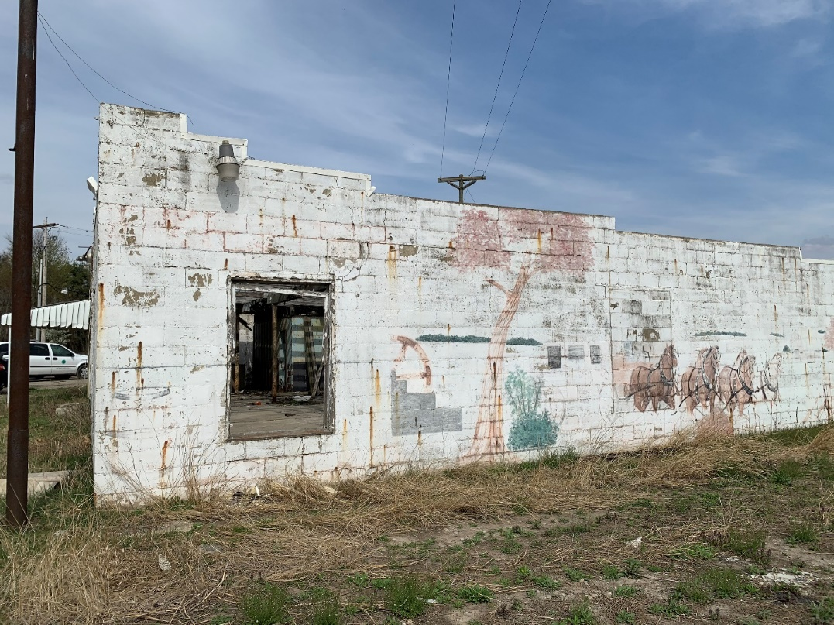

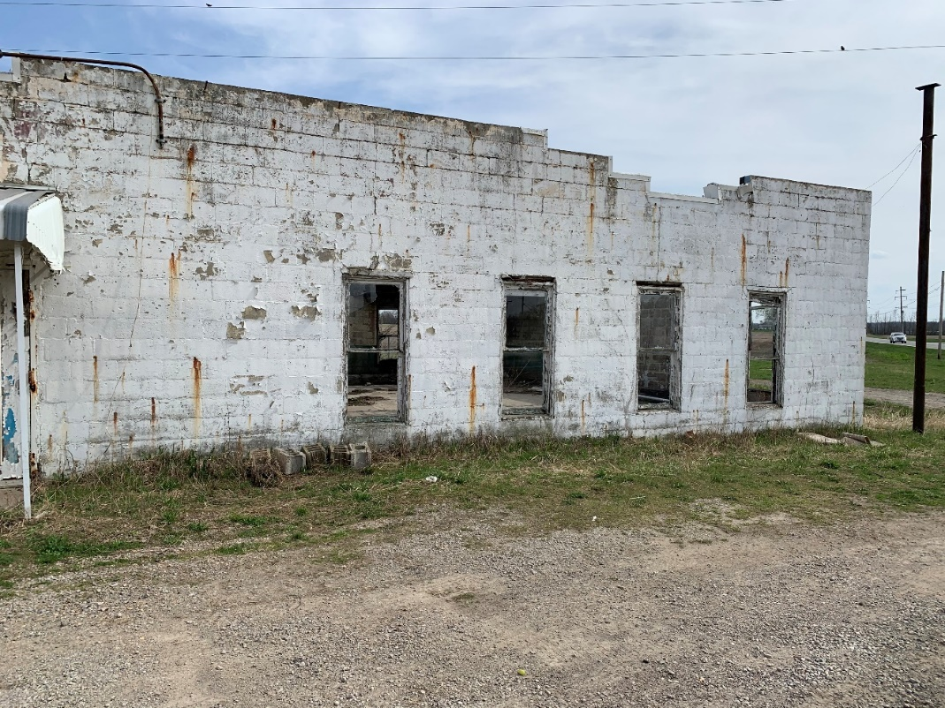

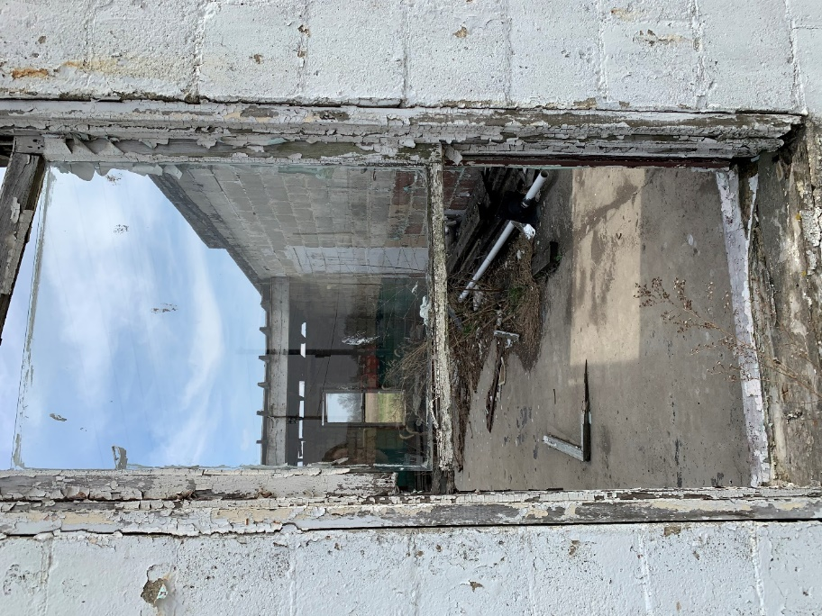

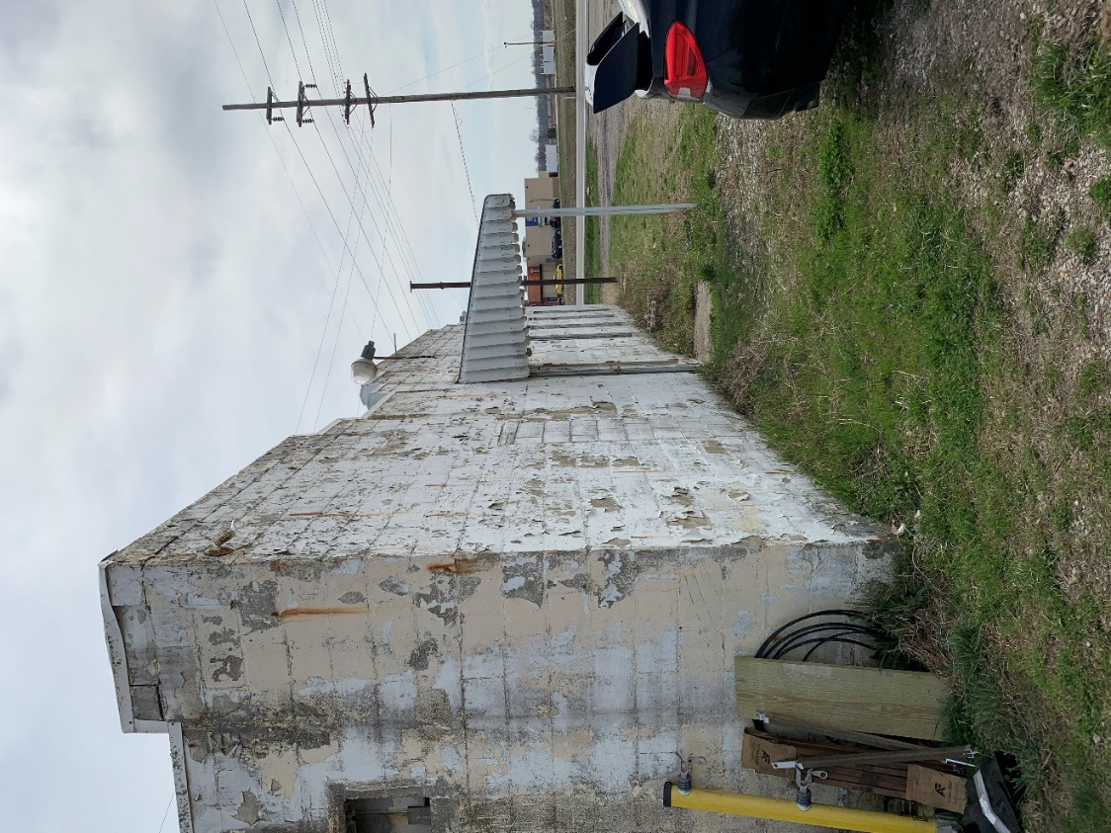

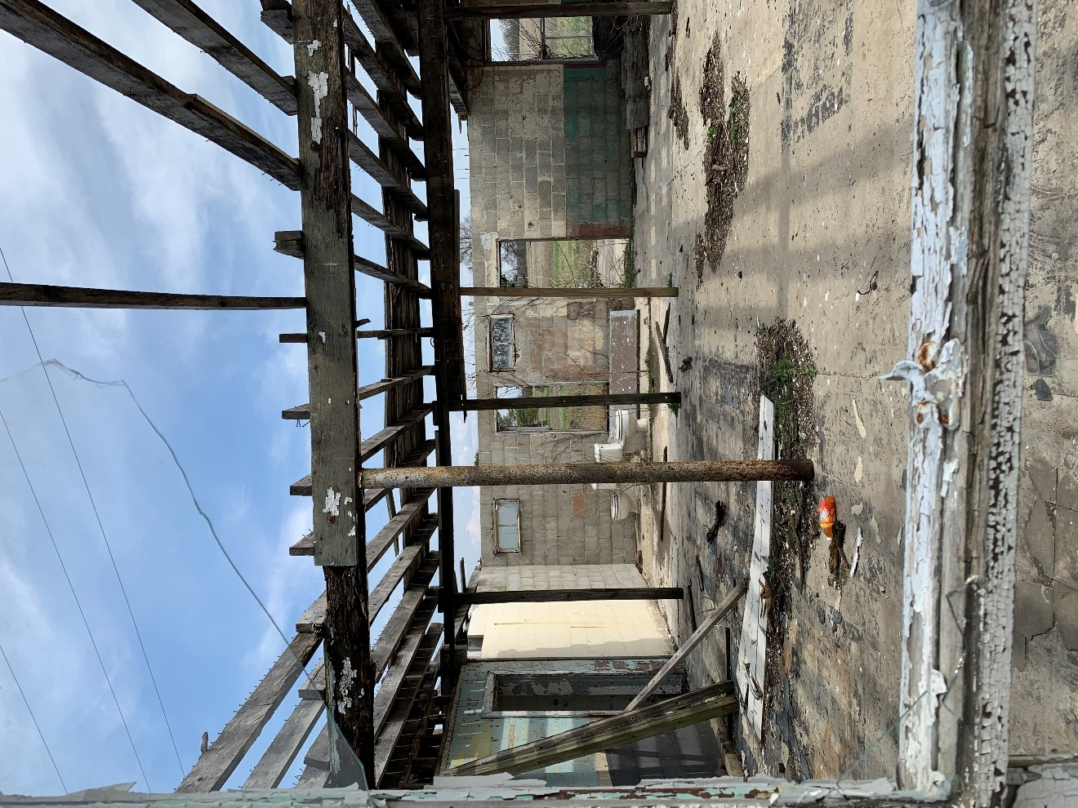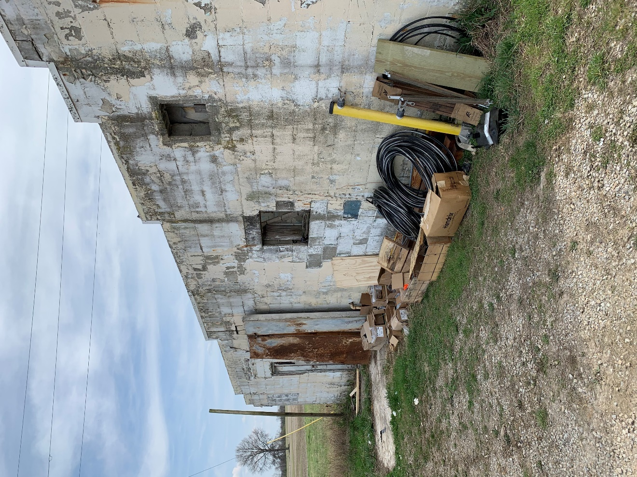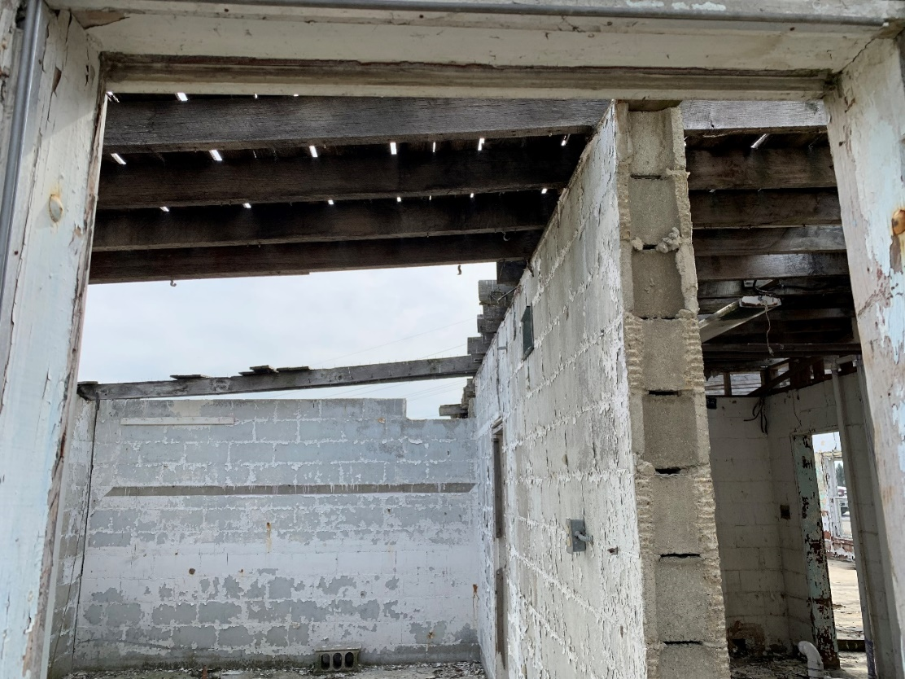

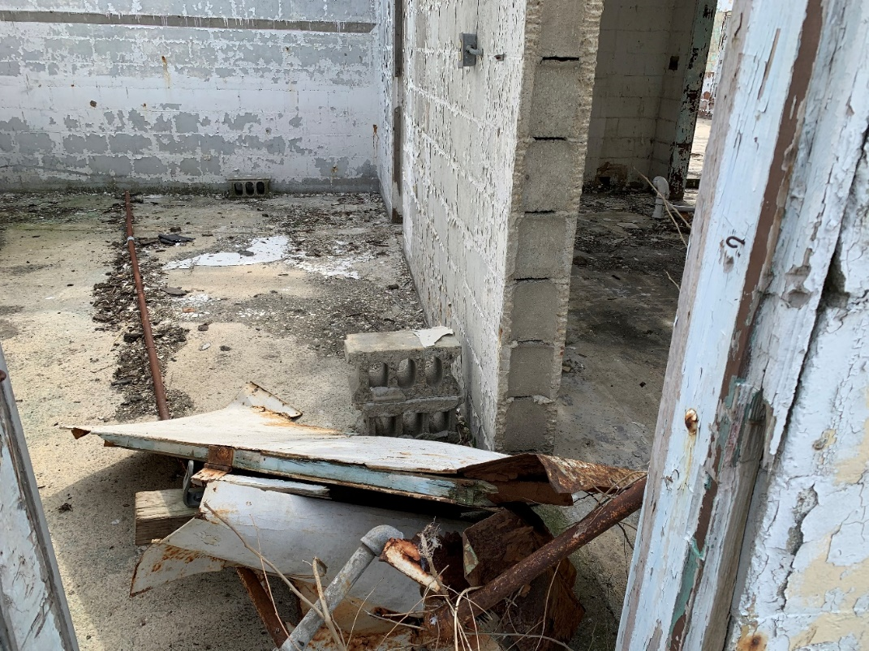
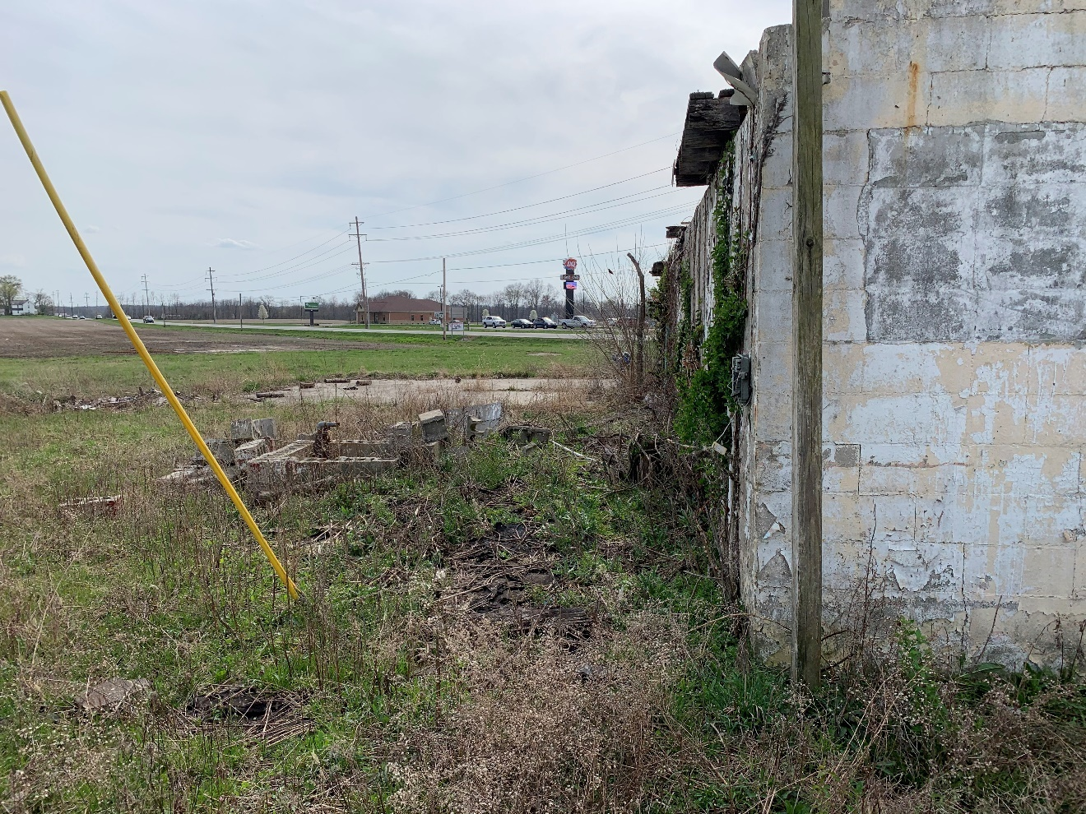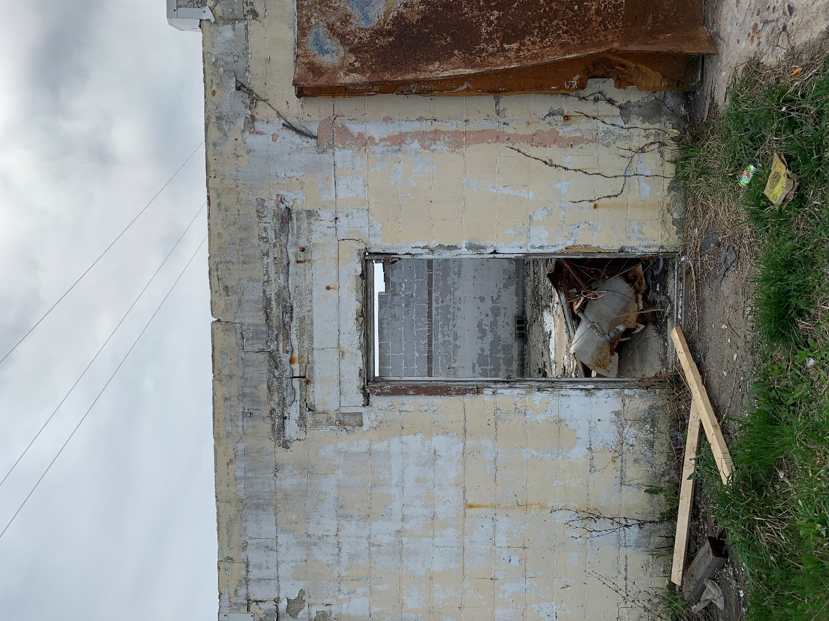
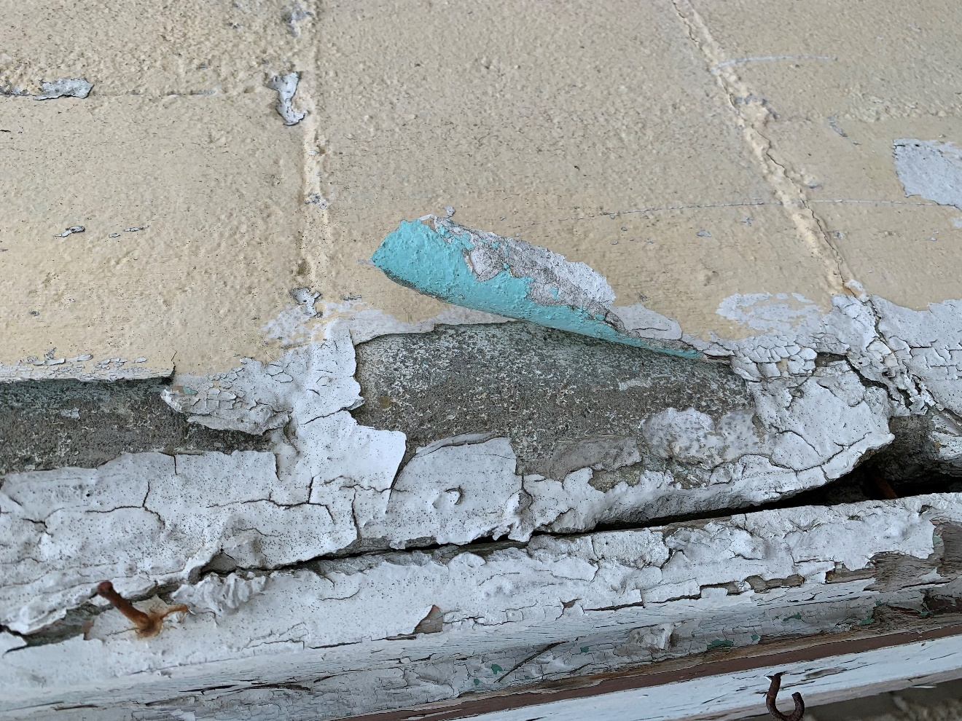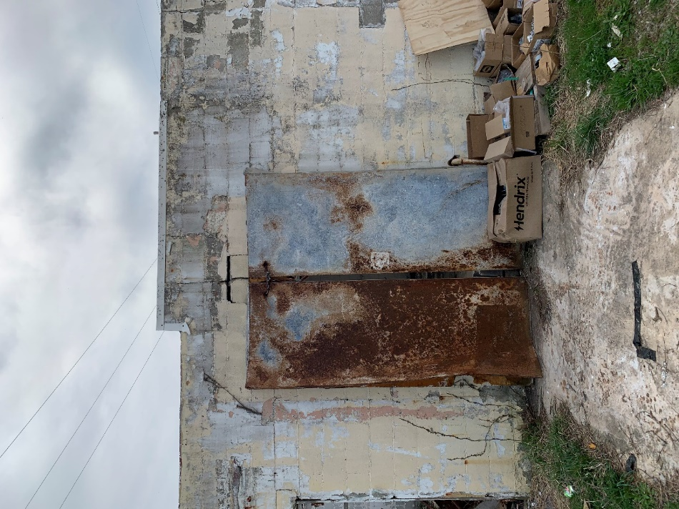

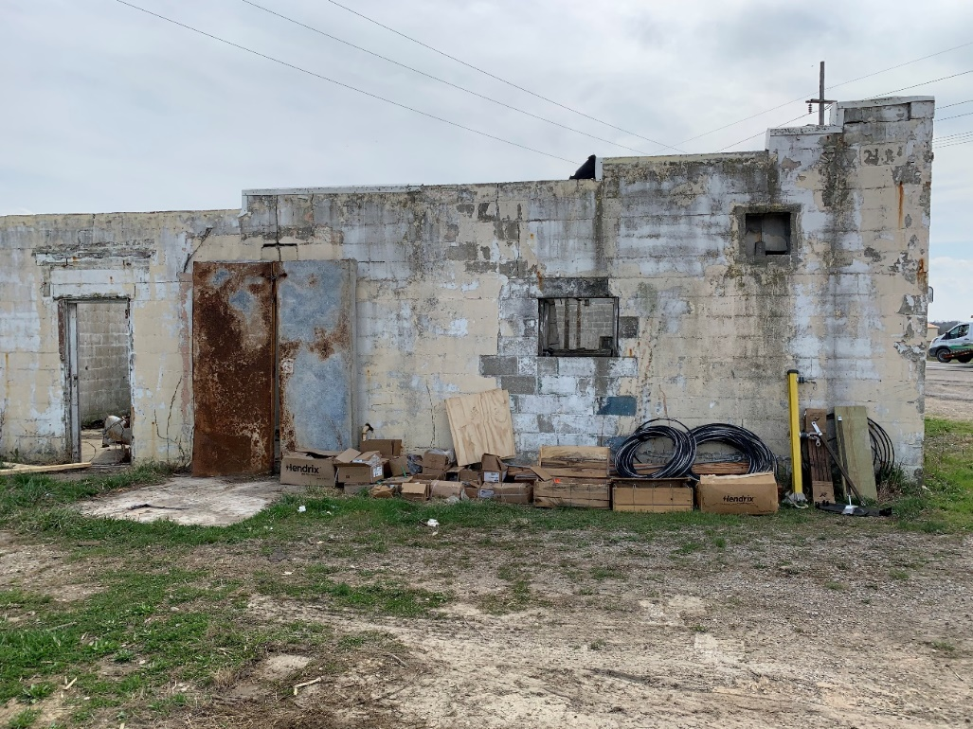

End of 04/07/2021 Interior and Exterior Photos

October 20, 2021

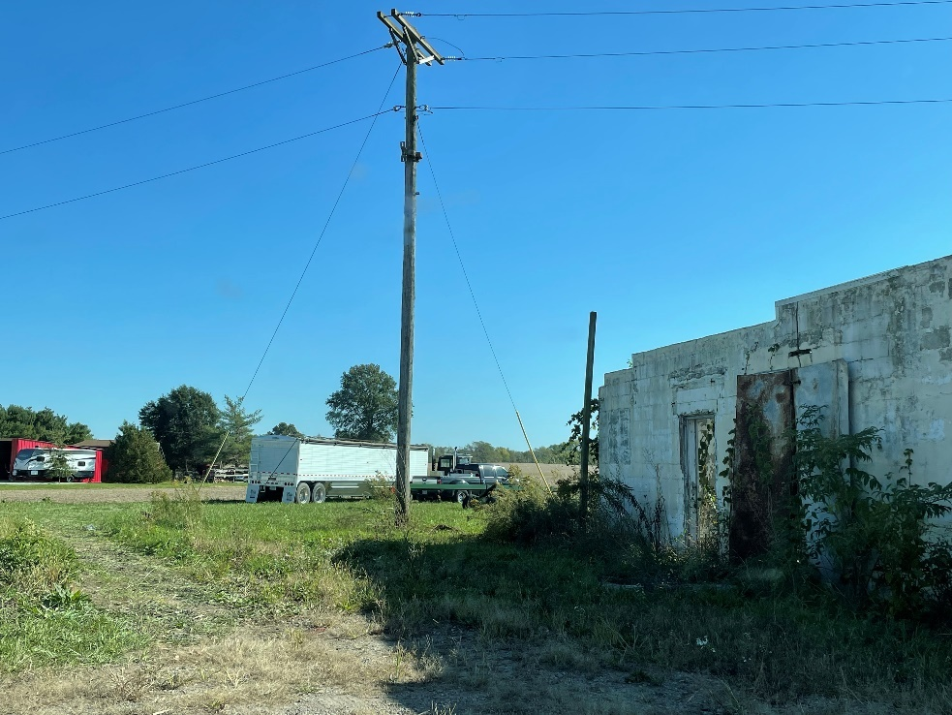

January 11, 2022

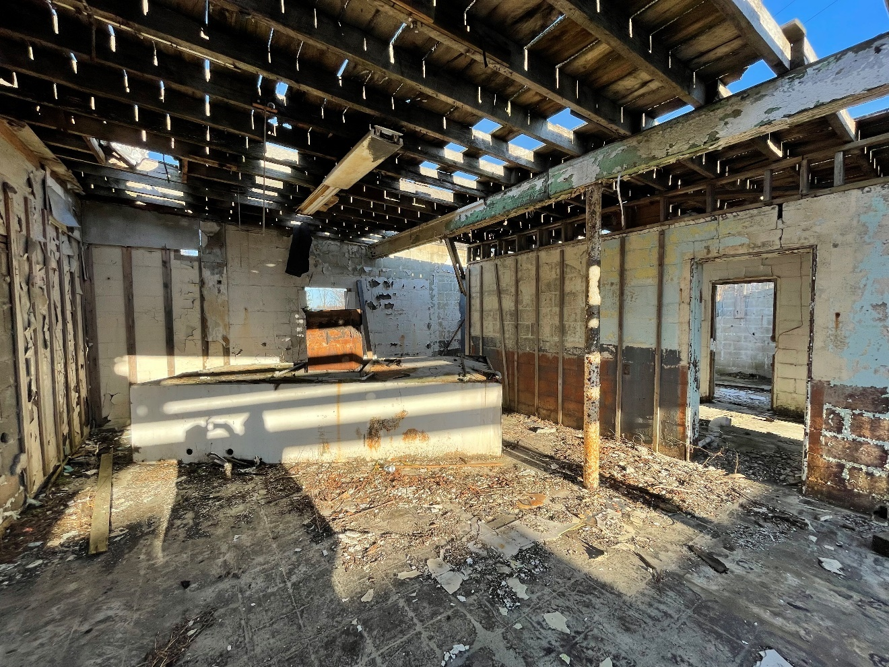
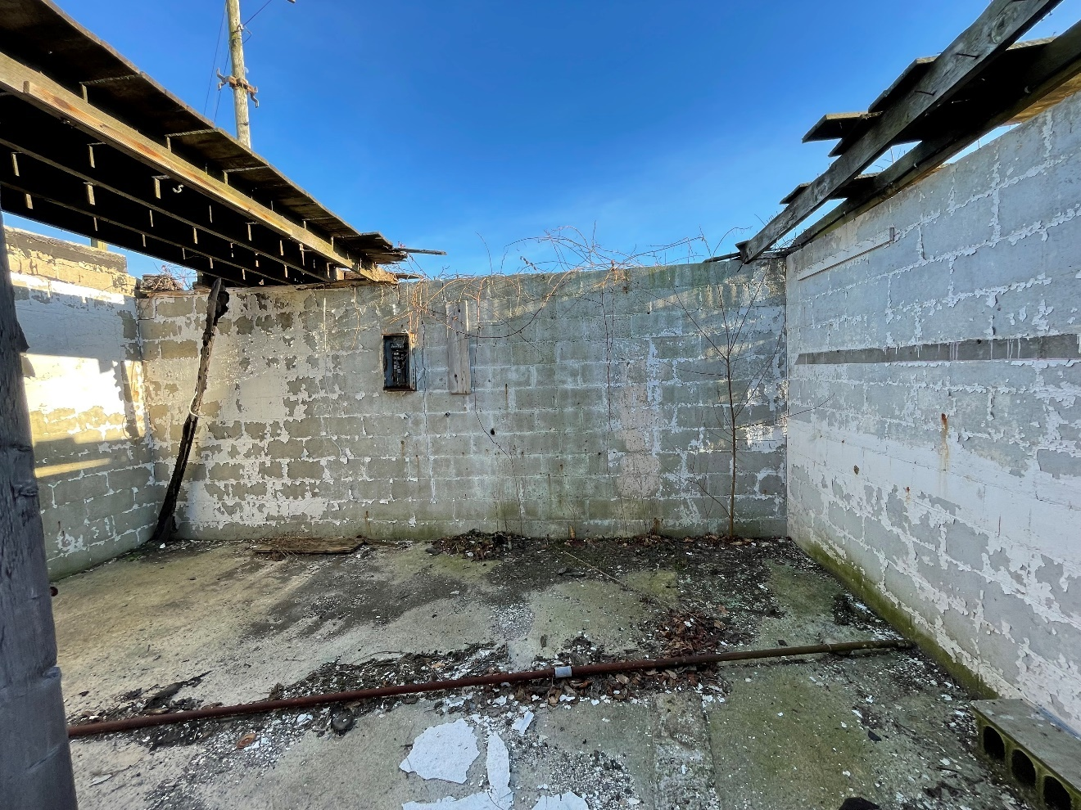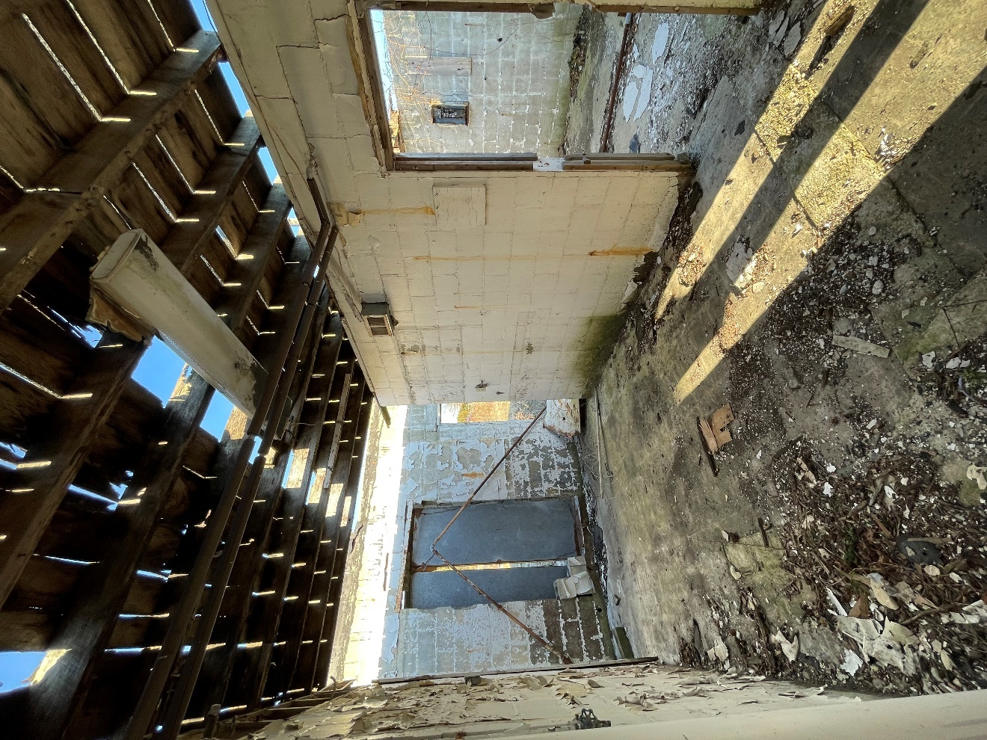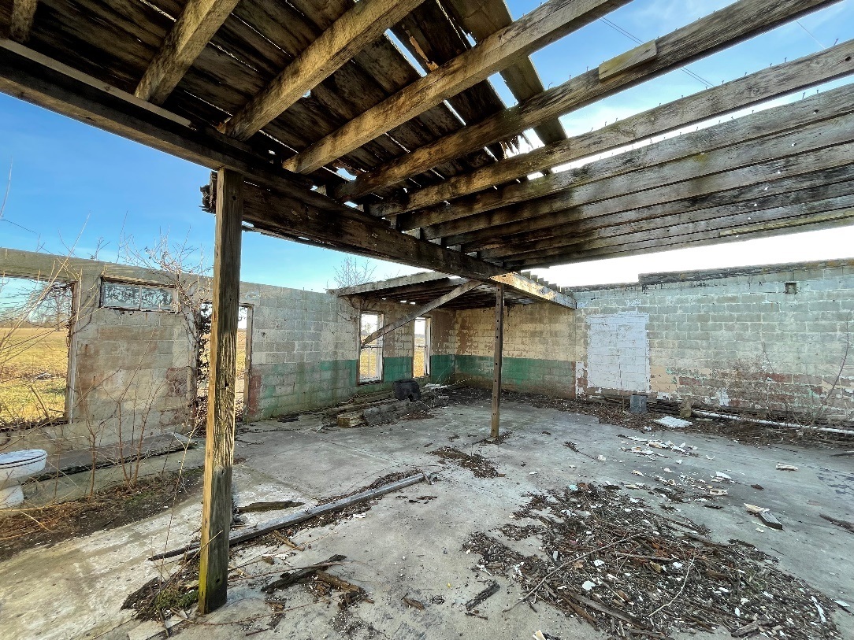

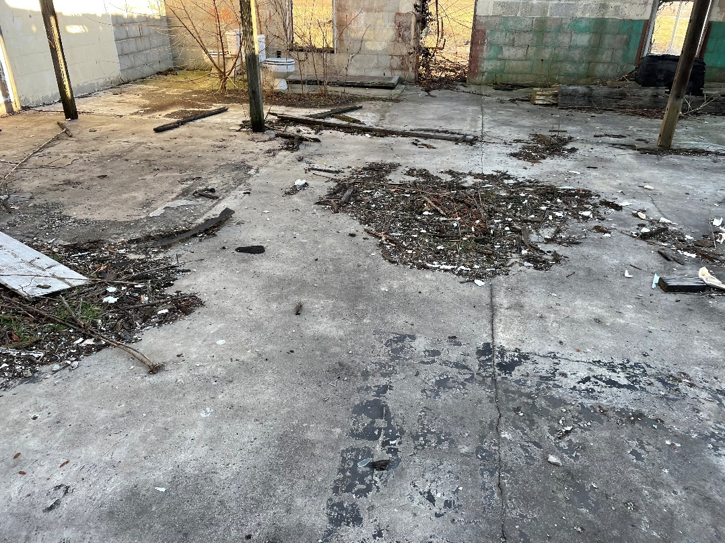
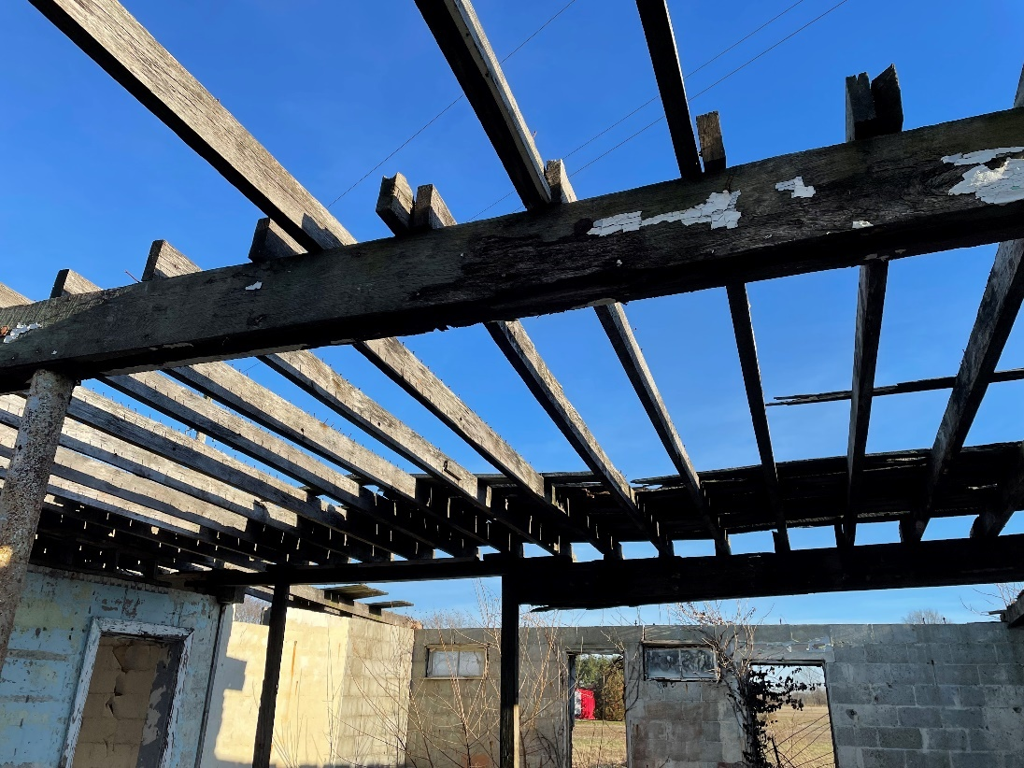

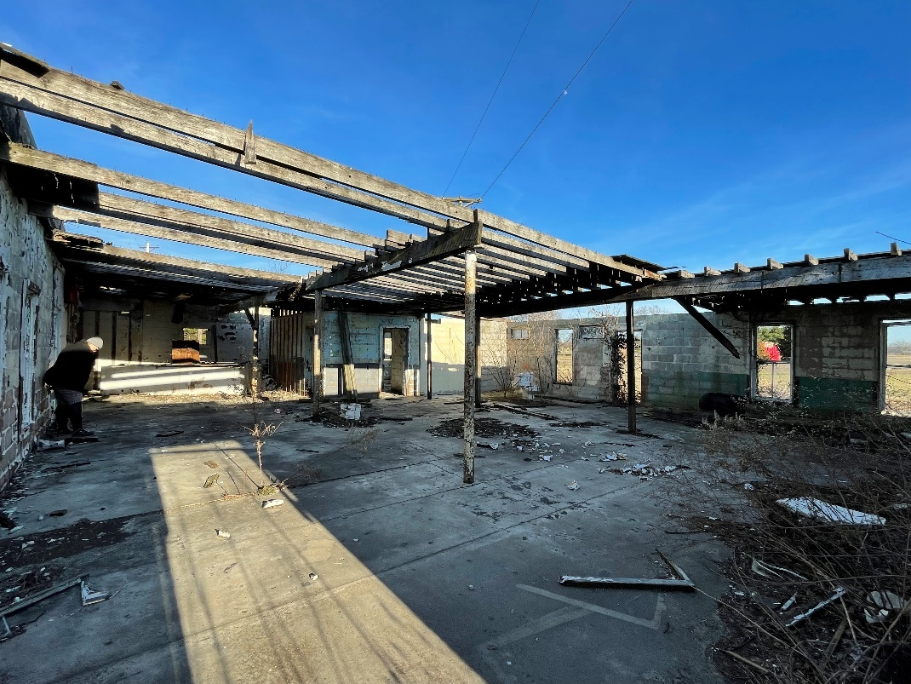
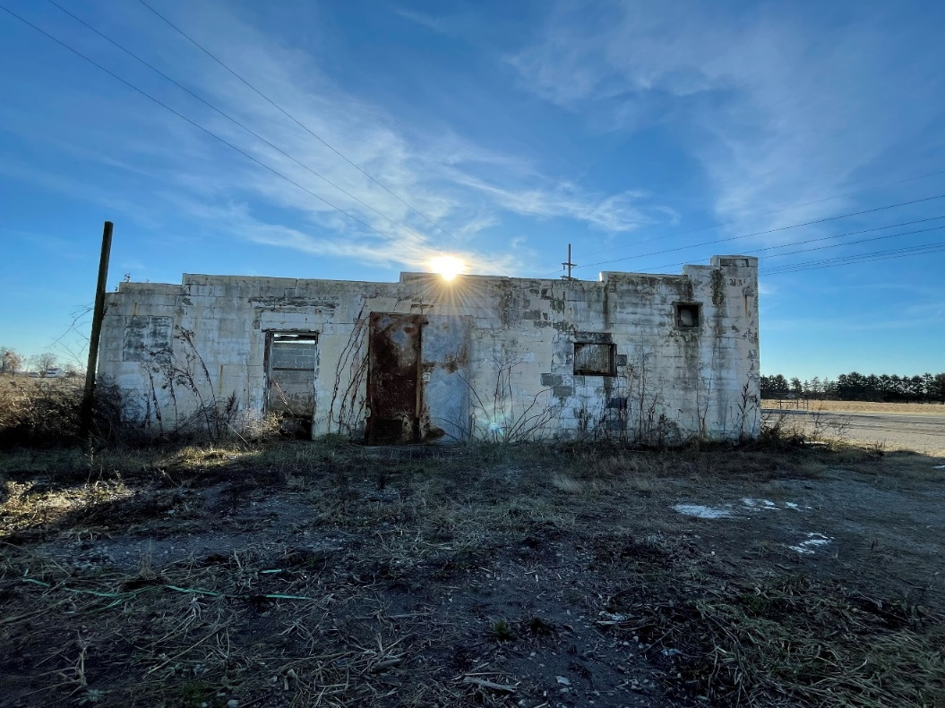
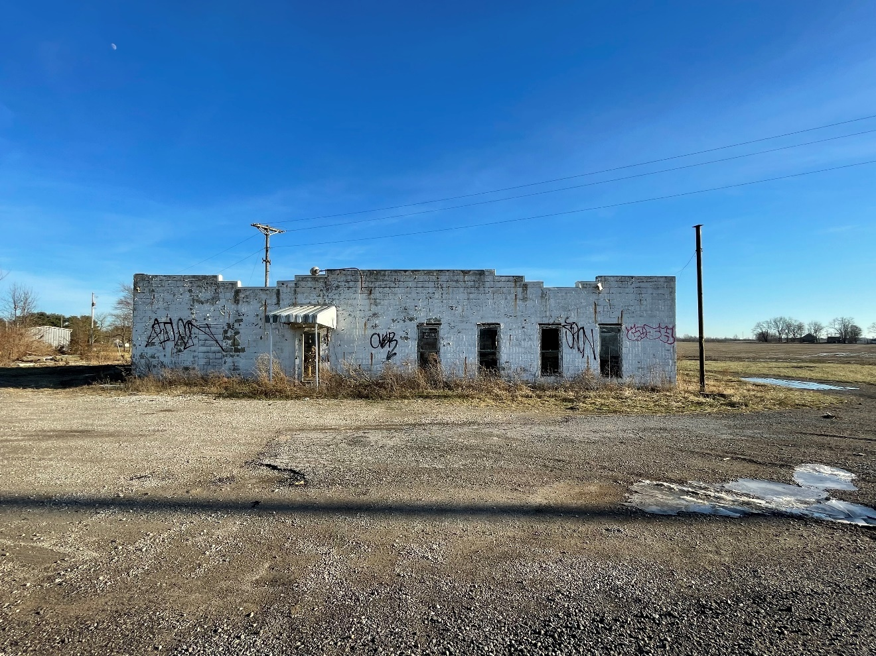
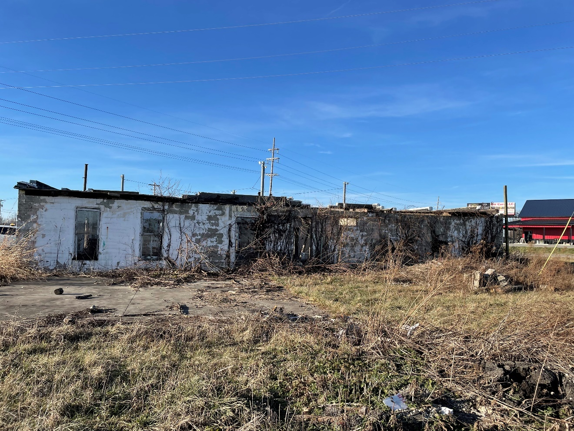
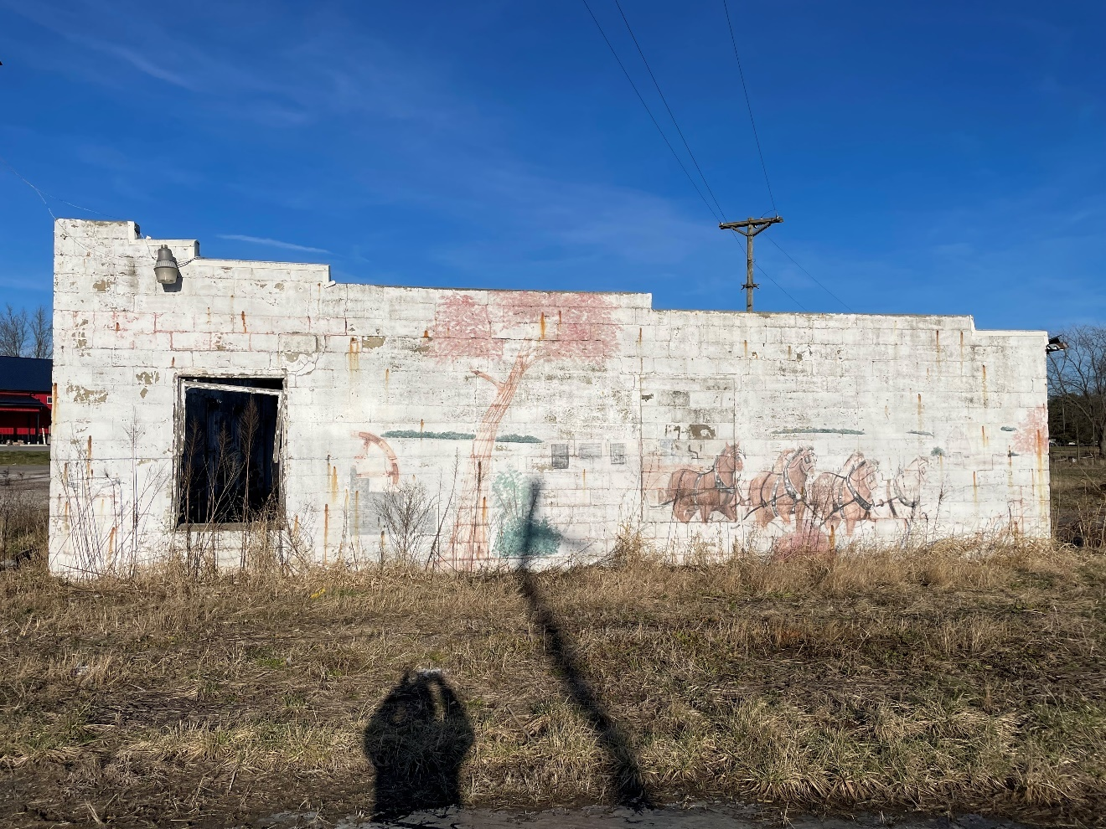
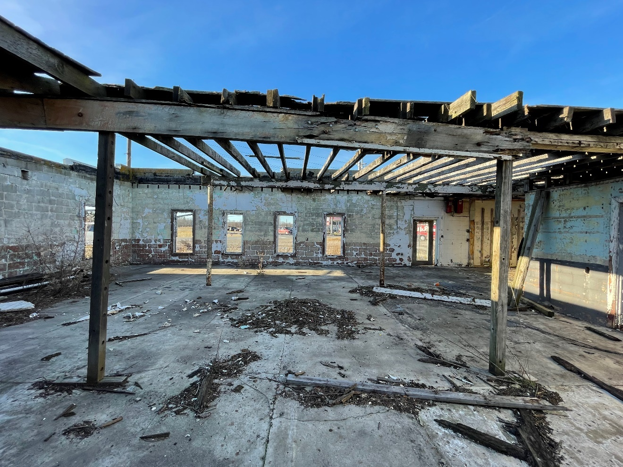

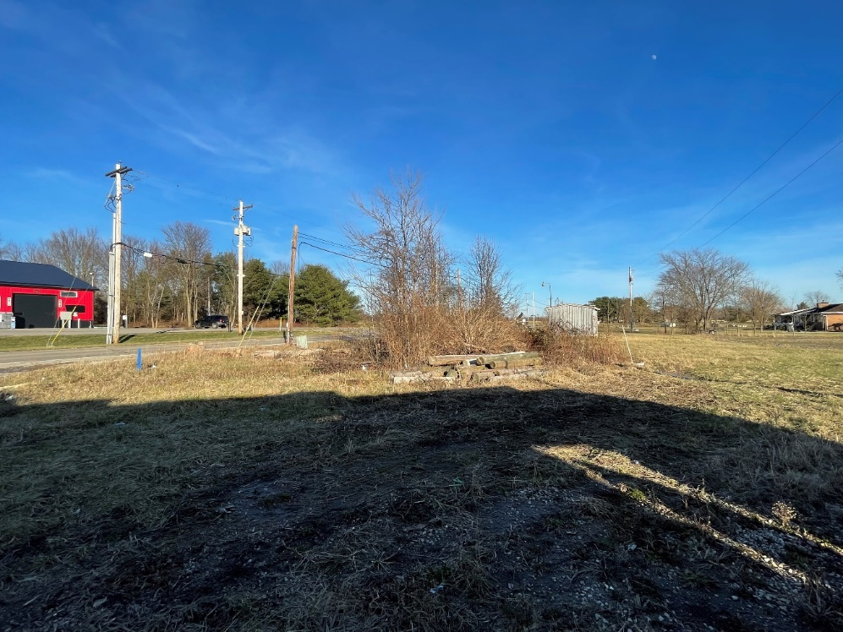

April 20, 2022
Day of Demolition

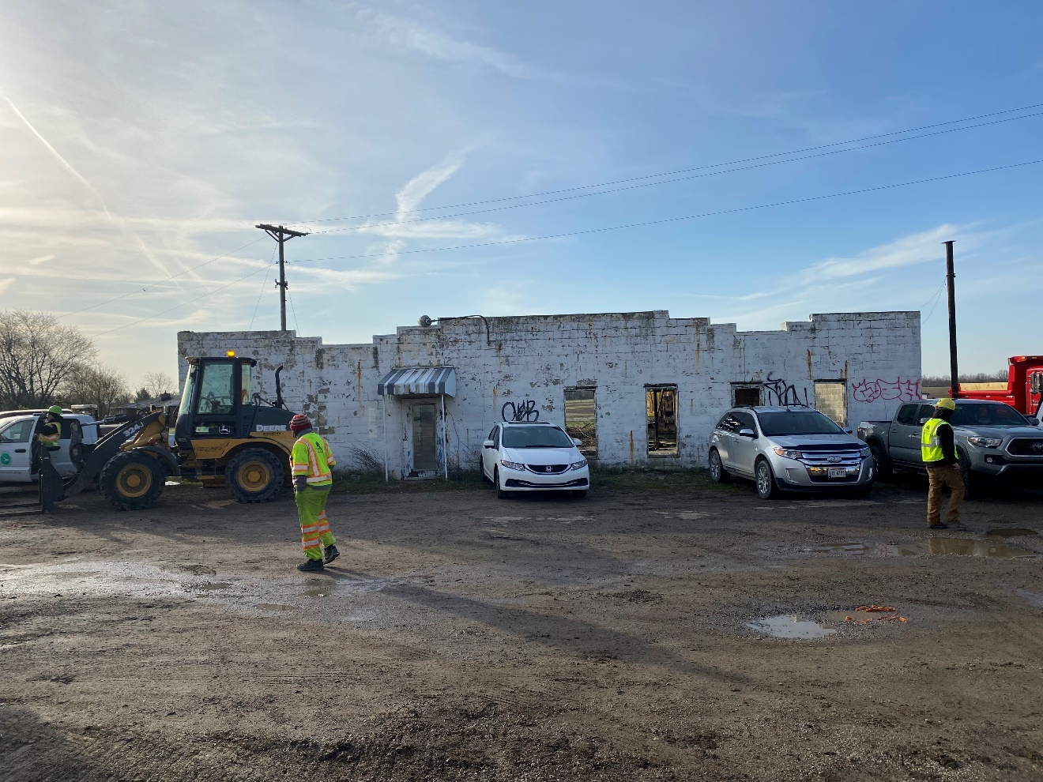
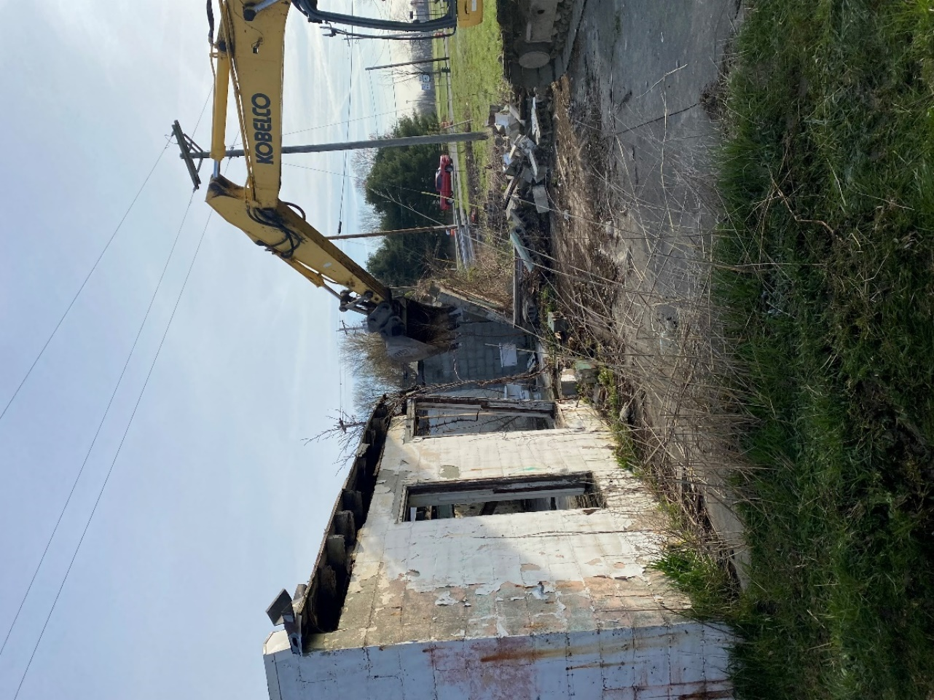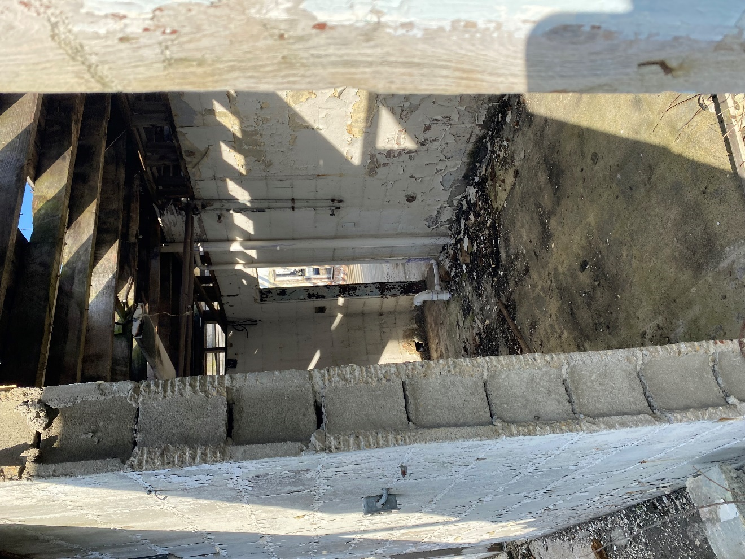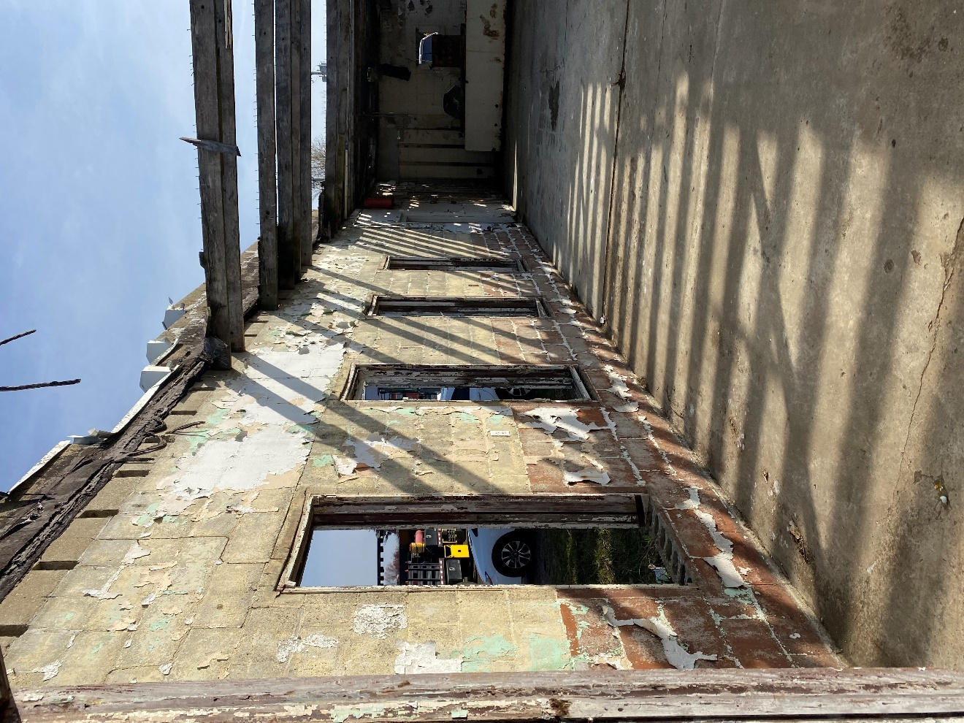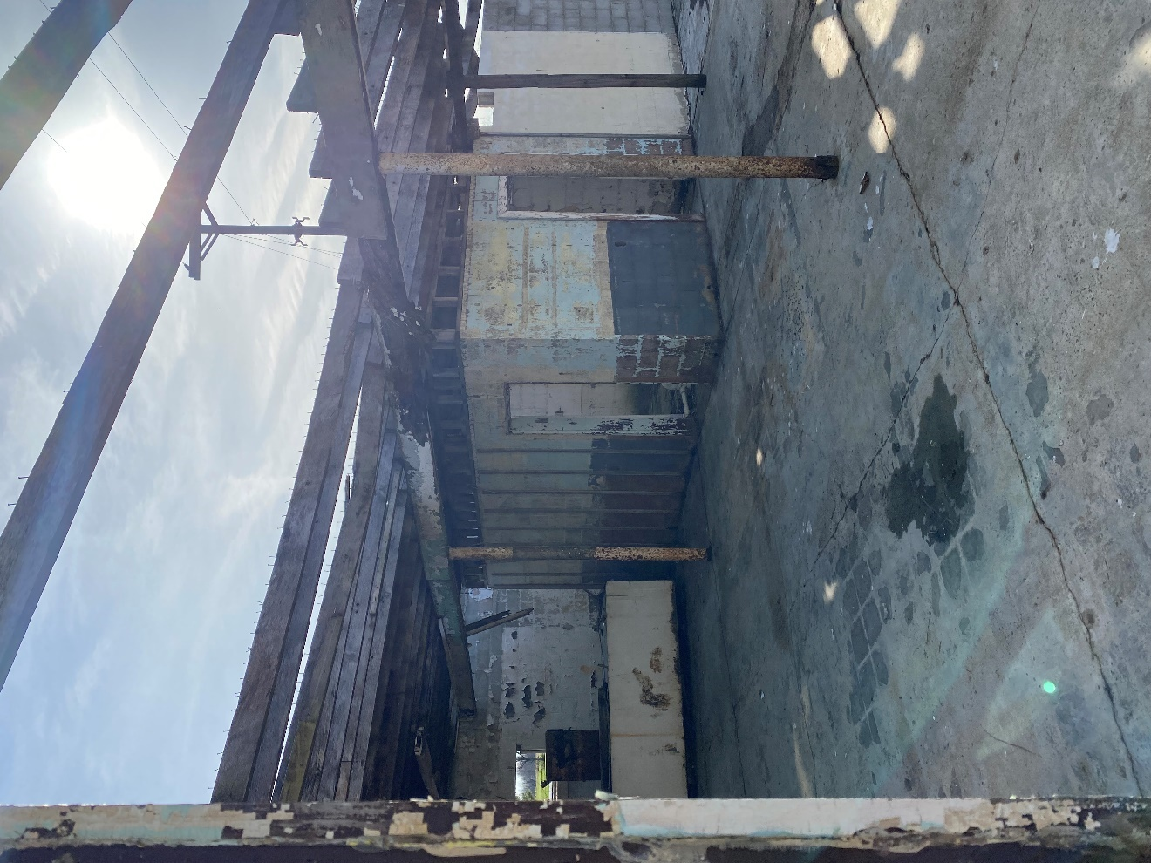

DESCRIPTION OF IMPROVEMENT(S) TAKEN
GENERAL DESCRIPTION |  |  |  |  |  |  |  |  |  |  |  | EXTERIOR DESCRIPTION
No. of Stories |  |  |  |  | 1 |  |  |  |  |  |  | Foundation |  |  |  |  |  |  |  | Concrete Pad
Type(Det./Att.) |  |  |  |  |  |  |  |  |  |  |  | Exterior Walls |  |  |  |  |  |  |  | Concrete Block
Design(Style) |  |  |  |  | Block Building |  |  |  |  |  |  | Roof Surface |  |  |  |  |  |  |  | No roof in tact
Age(Years) |  |  |  |  | 75+ |  |  |  |  |  |  | Gutter/Downspouts |  |  |  |  |  |  |  | None
Effective Age(Yrs.) |  |  |  |  | 1925 per Auditor |  |  |  |  |  |  | Window/Type |  |  |  |  |  |  |  | Sash, but missing
 |  |  |  |  |  |  |  |  |  |  |  | Storm/Screens |  |  |  |  |  |  |  | None
 |  |  |  |  |  |  |  |  |  |  |  | Manufactured Home |  |  |  |  |  |  |  | No
DESCRIPTION IF NON-RESIDENTIAL
Block building with no attached doors except front door, no windows, no bathroom facilites, no utilities connected. Concrete pad behind the South wall of building.

FOUNDATION |  |  |  |  |  |  |  |  | BASEMENT |  |  |  |  |  |  | INSULATION
Slab |  |  |  |  |  |  |  |  | Area Sq. Ft. |  |  |  |  |  |  | Roof
Crawl Space |  |  |  |  |  |  |  |  | %Finished |  |  |  |  |  |  | Ceiling
Basement |  |  |  |  |  |  |  |  | Ceiling |  |  |  |  |  |  | Walls
Sump Pump |  |  |  |  |  |  |  |  | Walls |  |  |  |  |  |  | Floor
Dampness |  |  |  |  |  |  |  |  | Floor |  |  |  |  |  |  | None
Infestation |  |  |  |  |  |  |  |  | Outside Entry |  |  |  |  |  |  | Unknown
ROOMS DESCRIPTION
Rooms | Foyer |  |  | Dining |  |  |  | Kitchen |  | Den | Family Rm |  |  |  | Rec. Rm |  |  | Bedrooms |  |  |  | #Baths |  | Laundry
Basement
Level1
Level2
Finished area above grade contains:
No. of Rooms
No. of Bedrooms
No. of Baths
Sq. Ft. of Living Area
INTERIOR(Materials/Condition)
Floor |  |  |  |  |  |  |  |  |  |  |  |  | Bath Floor
Walls |  |  |  |  |  |  |  |  |  |  |  |  | Bath Wainscot
Trim/Finish |  |  |  |  |  |  |  |  |  |  |  |  | Doors
HEATING |  |  |  |  |  |  |  |  |  |  |  |  | COOLING
Type |  |  |  |  |  |  |  |  |  |  |  |  | Central
Fuel |  |  |  |  |  |  |  |  |  |  |  |  | Other
Condition |  |  |  |  |  |  |  |  |  |  |  |  | Condition
KITCHEN EQUIPMENT
Refrigerator |  |  |  |  |  |  |  |  |  |  |  |  | Fan/Hood
Range/Oven |  |  |  |  |  |  |  |  |  |  |  |  | Microwave
Disposal |  |  |  |  |  |  |  |  |  |  |  |  | Washer/Dryer
Dishwasher
ATTIC
None |  |  |  |  |  |  |  |  |  |  |  |  | Floor
Stairs |  |  |  |  |  |  |  |  |  |  |  |  | Heated
Drop Stair |  |  |  |  |  |  |  |  |  |  |  |  | Finished
Scuttle
AMENITIES
Fireplace(s) |  |  |  |  |  |  |  |  |  |  |  |  | Fence
Patio |  |  |  |  |  |  |  |  |  |  |  |  | Pool
Deck |  |  |  |  |  |  |  |  |  |  |  |  | Other
Porch
CAR STORAGE
None | Garage |  |  |  |  |  |  |  |  | # of Cars |  |  |  |  | Carport |  |  |  |  |  | Driveway
 | Attached
 | Detached
 | Built-In

Additional features (special energy items, etc.):

Condition of improvements, depreciation (physical, functional, and external), repairs needed, quality of construction, remodeling/additions, etc.:

Adverse environmental conditions (such as, but not limited to, hazardous wastes, toxic substances, etc.) present in the improvements:

Description of site improvements within the take area:

The only improvement except the block building.

CERTIFICATION PAGE
PREPARERS CERTIFICATION
 | I certify that I have:
1. | Prepared this Red Book to preserve evidence in compliance with Section 163.06 of the Ohio Revised Code.
2. | Personally inspected the property, inside and out, which is the subject of this Red Book and that the sketches and pictures do reflect the condition and improvements which are to be taken. If I have not personally inspected the inside of the property, the reason is as follows:
3. | No personal interest, present of prospective, in the owner, the land or the structures that are to be taken.
4. | Verified with
 | That the improvement/structures is to be removed on
 | Signature of Preparer |  |  |  |  | Date Signed
 | Kimber L. Heim
 | Name Typed
APPRAISER’S CERTIFICATION
 | I/We hereby certify that:
1. | I have viewed the property described in the book, inside and outside;
2. | It is the same property that is identified by description and photographs contained herein;
3. | I have no interest, present or prospective, in the owner, the land or the building;
4. | To the best of my knowledge, I determine the value of the structures only to be
 |  | $ |  |  |  |  |  | .
 | Signature of Appraiser for the Ohio Department of Transportation |  |  |  |  | Date Signed
 | Name Typed or Legibly Printed

APPRAISER’S CERTIFICATION
 | I/We hereby certify that:
1. | I have viewed the property described in the book, inside and outside;
2. | It is the same property that is identified by description and photographs contained herein;
3. | I have no interest, present or prospective, in the owner, the land or the building;
4. | To the best of my knowledge, I determine the value of the structures only to be
 |  | $ |  |  |  | .
 | Signature of Appraiser for (Landowner/County Auditor) |  |  |  | Date Signed
 | Name Typed or Legibly Printed

