**CONFIDENTIAL**

**ATTORNEY WORK PRODUCT**

**MEMORANDUM**

**TO:** John Wooldridge, Real Estate Administrator, ODOT District 5

**THROUGH:** Rachel O. Huston, Chief, Executive Agencies Section

Corinna V. Efkeman, Unit Coordinator, Transportation Unit

**FROM:** Avery T. Young, Assistant Attorney General

**DATE:** April 6, 2023

**RE: TRIAL SUMMARY REVIEW**

*Marchbanks, Director of ODOT v. Eichhorn Limited Partnership, et al.,* Fairfield County Case No. 21CV457, Judge David A. Trimmer

Date Case Filed: October 6, 2021 FAI 37-6.10

Amount of Deposit: $19,440.00 PID 110412

Amount of ODOT’s Full Appraisal: $14,870 Parcel No. 1-SH1, 1-SH2, 1-T

Landowner’s Demand Before Trial: $124,930

Landowner’s Demand at Trial: $131,432.50 Matrix # 605503

**Jury Verdict: $112,472.50**

Landowner’s Counsel: Aaron Kenter

**Additional monies needed: $93,032.50**

**Accordingly, please do the following:**

* **Process a warrant for an additional $93,032.50**
* **Do NOT mail or deliver the warrant until you get a file-stamped copy of the judgment entry**
* **After you get a file-stamped copy of the judgment entry:**
* **Mail or deliver the warrant to the Fairfield County Clerk of Courts—NOT the Attorney General’s Office, and**
* **Email the assigned AAG that you have mailed or delivered the warrant**

**ODOT’s Project:** This project includes the widening of 1.2 miles of roadway at the State Route 37 and State Route 256 intersection by providing a left-turn lane of each approach and reconstruction of the existing traffic signals in Fairfield County, Ohio.

**Subject Property and Takings:** The subject consists of tax parcel(s) 0490261230, confirmed by R/W plans and the title report. According to the county auditor and the title report, the owner of record is Eichhorn Limited Partnership, who acquired the property on October 10, 2007 from Watson Farm Ltd. for $945,000. The transaction is recorded in OR 1477 Page 2270. The subject consists of a 111.132 net acre site, improved with a single-family residence and a dilapidated structure.

There are two standard highway easements and a temporary easement needed from the subject property.

Parcel 1-SH1 is a permanent standard highway easement, containing 2.436 acres which includes 1.271 acres of PRO leaving a net take of 1.165 acres. This acquisition begins at a point on the parcel’s western property boundary and abuts the current SH Lancaster-Newark Rd (SR 37) easement. The proposed acquisition is irregular in shape but follows the current SH easement. The easement is shaded in blue on the right of way plans.

Parcel 1-SH2 is a permanent standard highway easement, containing 0.080 acres which includes 0.041 acres of PRO leaving a net take of 0.039 acres. This proposed acquisition has a width of approximately 25 feet. The proposed acquisition is irregular in shape.

Parcel 1-T is a temporary easement containing a net area of 0.205 acres. The easement will begin on the first day construction begins on the parcel and continue for 18 months maximum. The easement is irregular in shape.

**ODOT’s Appraisal:** Jeffrey Helbig prepared the appraisal on behalf of ODOT. Using the sales comparison approach Helbig determined a reconciled land value of $12,000 per acre.

Helbig’s figure for the land taken for Parcel 1 is **$14,498**.

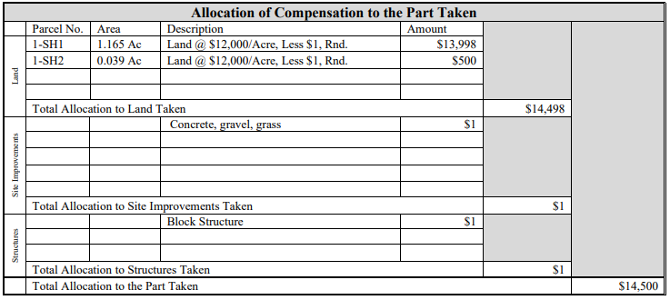

Helbig allocated **$1** to concrete, grass and gravel and **$1** to the block structure on the property.

Total FMVE = **$14,500**

**Landowners’ Appraisal:** Richard Vannatta prepared the Appraisal on behalf of the property owner. Using the sales comparison approach Vannatta determined a reconciled land value of $70,000 per acre.

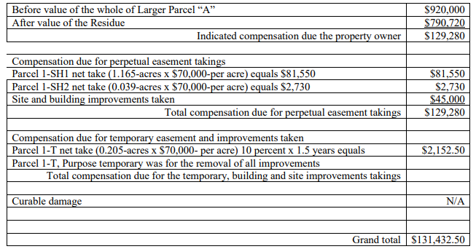

Vannatta’s figure for the land taken is **$86,432.50**. Vannatta’s figure for the improvements taken is **$45,000**. Total compensation due to landowner = **$131,432.50**

**Procedural History:** This case was filed with the court on October 6, 2021. The parties participated in mediation on December 12, 2022, which was unsuccessful. At mediation, the landowner came down to an amount of $124,930 and ODOT’s highest number for settlement was $88,000. Due to the landowner’s small movement in numbers during mediation, it was very evident that we were not going to get this case resolved outside of a jury trial.

**First Day of Trial – February 14, 2023:**

Trial began on February 14, 2023, as scheduled, and began with jury selection. 8 jurors and two alternates were selected. Opposing counsel, Aaron Kenter, inquired of the jury first followed by questions from AAG Justine Allen. Both parties challenged 1 juror each for cause, each of these challenges was upheld by the Judge. The parties then exercised their preemptory challenges. After the jury was impaneled both parties gave opening statements. There was no jury view in this case.

Following opening statements, Defendant began presenting their case. Mr. Kenter called the property owner, Mr. Eichhorn, as his first witness. Mr. Eichhorn testified about why he purchased the property, different opportunities he had to have various commercial businesses on the land, that he ultimately wanted to use the property for commercial purposes, and his opinion of value of his property.

Following the questioning from Mr. Kenter, AAG Avery Young questioned Mr. Eichhorn. Mr. Eichhorn was asked multiple questions to establish that the property was purchased for agricultural purposes, was currently being used for agricultural purposes, and was zoned as agricultural land by the Fairfield County Auditor. Mr. Eichhorn was also questioned about the dilapidated structure that was on the property, but has been removed by ODOT. Mr. Eichhorn testified that he never had the building inspected, nor did he ever meet with a contractor to renovate the building or have any site plans made.

Following Mr. Eichhorn’s testimony, Mr. Kenter called their appraiser, Richard Vannatta, to testify. Mr. Vannatta testified that in his opinion, the acquisition was valued at $131,432.50. Mr. Vannatta testified in depth about his process for coming to his opinion of value. He testified that one of the main factors he used was the “larger parcel test” where he essentially split the parcel into two different parcels and assigned the parcel including the take as commercial land. Mr. Vannatta testified that he did not do an analysis of the larger parcel that did not contain the take because he did not believe that was necessary. Mr. Vannatta did not assign any damages in his analysis, but found the highest and best use of the land to be commercial and valued it as such at $70,000 per acre. Mr. Vannatta placed a value of $45,000 on the structure that was on the subject property.

Following this testimony, Avery Young cross-examined Mr. Vannatta about his report and the processes that he used to come up with his valuation. After the cross-examination, Mr. Kenter followed we redirect. The Court recessed for the day following Mr. Kenter’s redirect.

**Second Day of Trial – February 15, 2023:**

The second day of trial began with the Defendant resting their case. Avery Young began presenting the Plaintiff’s case by calling ODOT Engineer, Doug Morgan, to testify. Mr. Morgan walked us through ODOT’s process for these types of projects and he walked us through the Right of Way Plans for this specific project. Mr. Morgan also testified about the purpose of the project and that it had been competed for safety purposes. Mr. Kenter cross-examined Mr. Morgan and we followed on redirect.

Next, we called our appraiser Jeffrey Helbig to testify. Mr. Helbig walked us through his process of completing his appraisal on the subject property. He explained the concept of highest and best use as well as the sales comparison approach that he used in his valuation. He further walked us through all 4 of the comparable sales that he used to value the property. Mr. Helbig explained why he did not use the larger parcel test in his analysis and also why he found the highest and best use of the property to be “future mixed use.” Mr. Helbig also did not assign any damages and valued the subject property at $12,000 per acre for a total value of compensation of $14,870. Mr. Helbig assigned a value of $1 for the structure that was on the property and gave his reasoning for that valuation.

Mr. Kenter cross-examined Mr. Helbig regarding his report. He had Mr. Helbig explain his process for valuing the property and why he did not use the “larger parcel test” as Mr. Vannatta had. Mr. Kenter asked Mr. Helbig if he had completed any other appraisals on properties in the area. At this time, Avery Young objected on the grounds of relevance. The Judge called Mr. Young and Mr. Kenter to the bench to discuss the objection. Mr. Young explained that this line of questioning was not relevant because it was outside the scope for the fair market value for this specific subject property. Mr. Kenter argued that he was asking Mr. Helbig this line of questions to ask him about an appraisal that he had completed on the property across the street where he valued the land as commercial land. He further argued that according to the Ohio Rules of Evidence this line of questioning was permissible for impeaching a witness. The Judge agreed that the questions were permissible for impeachment purposes, but instructed Mr. Kenter to limit his questions to Mr. Helbig’s previous report and valuation and not what ODOT paid for the other parcel.

Mr. Kenter continued his questioning of Mr. Helbig about his appraisal report of the neighboring parcel and his classification of the land as commercial land and placing a value of $85,000 per acre on the property. Following Mr. Kenter’s questions, Mr. Young questioned Mr. Helbig on redirect to allow Mr. Helbig the opportunity to explain his report on the neighboring parcel and why he did not value the subject parcel as commercial land as he did the neighboring parcel. Mr. Kenter then questioned Mr. Helbig again on cross-examination.

Following Mr. Helbig’s testimony, ODOT rested its case. Both parties then gave closing statements. The Judge read the Jury Instructions to the jury and then the jury began their deliberations. After about two hours of deliberation, the jury returned with a verdict. The jury awarded $112,472.50 as compensation for the property taken.

**Jury Verdict:**

Compensation for Land Taken: $112,472.50

**Appeal:**

There are no grounds for appeal on this case. On February 22, 2023, there was a meeting with ODOT District 5 to discuss whether they wished to appeal the case and what potential grounds there were for an appeal. Avery Young, Justine Allen, Corinna Efkeman, John Wooldridge, and Kimber Heim all attended this meeting to discuss potential appeal options. On February 16, 2023, John Wooldridge emailed our office with his proposed appellate issues to be discussed during our meeting. During the meeting on February 22, 2023, we all discussed his proposed appellate issues and our office advised him of why these reasons were not appropriate for appeal. John noted the issue of the Judge overruling Avery Young’s objection during trial and allowing Mr. Helbig’s testimony regarding the appraisal he completed of the neighboring parcel. We informed him that the Judge’s ruling was appropriate due to the rules of evidence on impeaching a witness and the testimony’s relevance to this case. However, we told Mr. Wooldridge that we would do additional research on the issue to determine whether or not this issue was grounds for an appeal. After performing additional research on the issue and consulting with the attorneys in the Unit, we have determined that this is not grounds for an appeal and that the Judge’s ruling during trial was proper in allowing the testimony.

**PHOTOGRAPHS OF PARCEL 1**

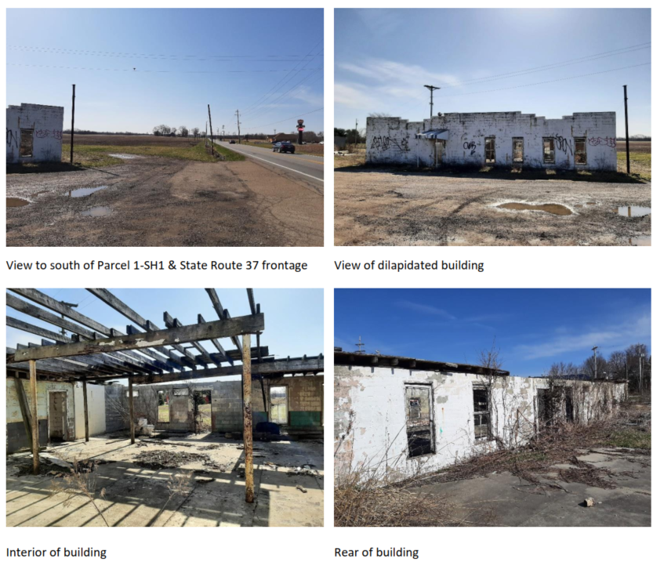

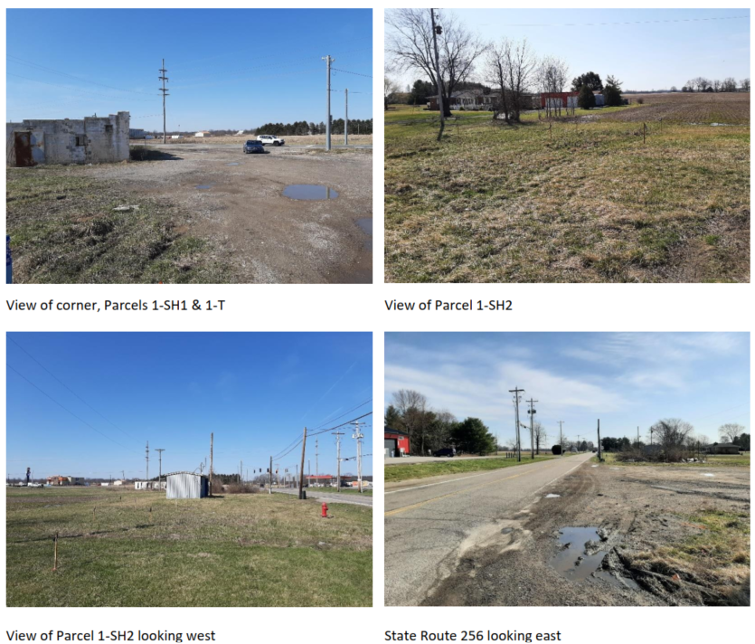

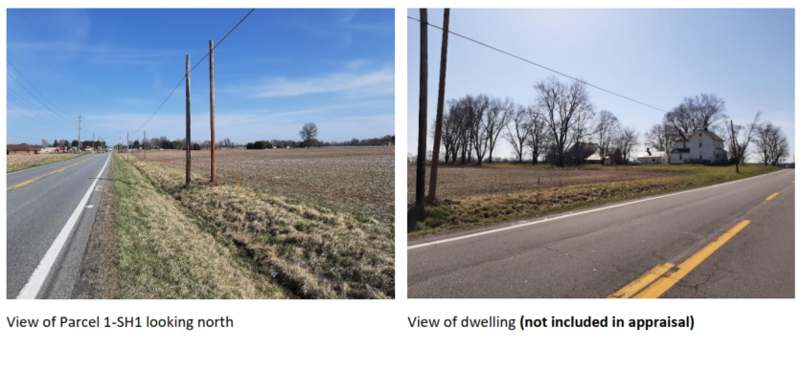

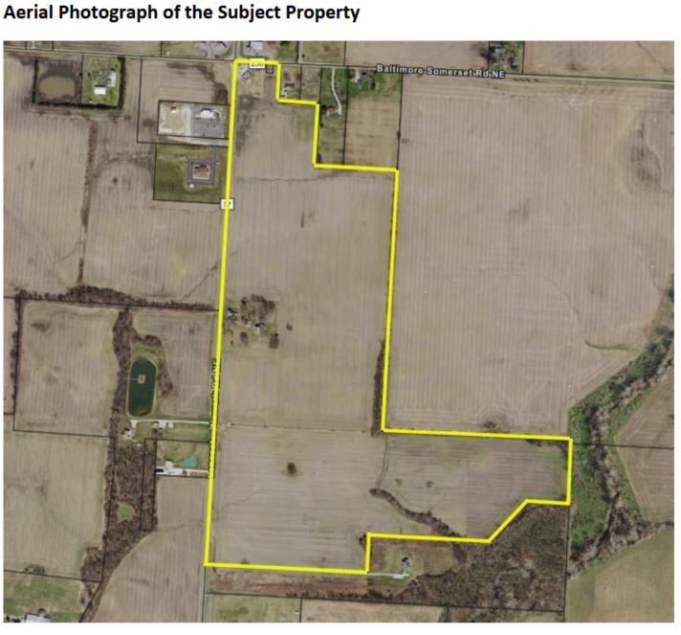

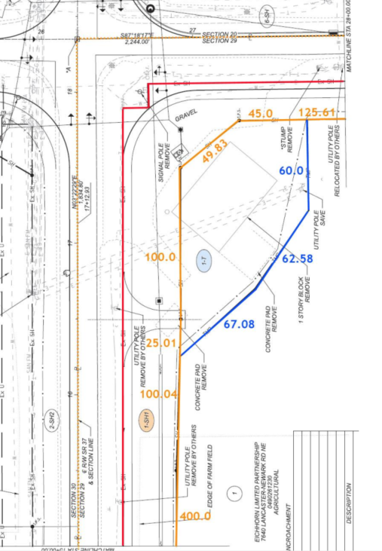**TAKE DIAGRAM**