RE 60 | NEGOTIATION SUMMARY REPORT |  | C/R/S | FAI-037-06.10
 |  |  | PARCEL | 002-SH1, SH2
Rev. 02/2019 |  |  | PID NO | 110412
Federal Job No. | E191296

1. | NAMES OF TITLE HOLDERS (Include marital status) | RESIDENCE ADDRESS (Note any expected changes)
Act Investments LLC |  | 3650 Dolson Court
 |  | Suite P
 |  | Carroll, OH 43112
 | NAMES OF LIEN AND/OR LEASE HOLDER | ADDRESS (Note any variances with title report)
Mortgage Farm Credit Mid-America, FLCA |  | 3939 Reynoldsburg Baltimore Rd NW
12501 Lakefront Place |  | Baltimore, OH 43105
PO Box 34390
Louisville, KY 40232

2. | NOTE ANY TITLE INFORMATION NOT FOUND IN TITLE REPORT (Incompetency, unrecorded documents, etc.)
Unrecorded lease for farming the property, but crops are present.

3. | RECORD OF OWNERS/NEGOTIATOR MEETINGS
DATE |  | NAME | LOCATION | OFFER $ | COUNTER OFFERS

02/05/2021 | Kimber Heim, Robert Landis | Telephone conversation setting up appointment 2/8/2021 at 9:00 am at Weidner’s Corner | $18,218.00
02/08/2021 | Kimber Heim, Robert Landis | Telephone conversation changing the meet date due to weather to 2/11/2021 | $18,218.00
02/11/2021 | Kimber Heim, Robert Landis | Telephone call rescheduling to 2/18/2021 | $18,218.00
02/18/2021 | Kimber Heim, Allison Durant, Robert Landis, and Chris Welch | Weidner’s Corner, Corner of SR256 and SR 37 | $18,218.00
03/03/2021 | Kimber Heim, Chris Welch | Email | $18,218.00 | $70,000.00
03/10/2021 | Kimber Heim, Chris Welch | Email | $18,218.00 | $70,000.00
03/11/2021 | Kimber Heim, Chris Welch | Email | $18,218.00 | $70,000.00
03/30/2021 | Kimber Heim, Chris Welch | Email | $21,178.00 | $70,000.00
03/30/2021 | Kimber Heim, Chris Welch | Phone Call | $21,178.00 | $70,000.00
4/26/2021 | Kimber Heim, Atty Kenter | Email notification of representation | $21,178.00 | $70,000.00
4/29/2021 | Kimber Heim, Atty Kenter | Email documents to Atty as requested | $21,178.00 | $70,000.00
5/28/2021 | Kimber Heim, Atty Kenter | Email check in with Atty Kenter | $21,178.00 | $70,000.00
6/08/2021 | Kimber Heim, Atty Kenter | Email | $21,178.00 | $70,000.00
9/21/2021 | Kimber Heim to AGO | Appropriations Package forwarded | $21,178.00 | $70,000.00

RE60 | C/R/S | FAI-037-06.10
Rev. 01/2010 | PARCEL | 001-SH1,SH2,T

4. ARRANGEMENTS PERTAINING TO POSSESSION OR VACATE DATE- At closing

5. DATE PROPERTY MANAGEMENT SECTION WAS NOTIFIED OF PURCHASE DETAILS. 3/4/2021
DATE STATE’S ACQUISITION BROCHURE GIVEN TO OWNER 3/4/2021

Remarks – (Briefly discuss taxes, relocation assistance, points of discussion, promises of action, etc.)
(Use 3rd page for full narration)
Property owner told us he would be turning over to his attorney for review. I was contacted by Atty Kenter from Goldman Braunstein Stahler Kenter, LLP via email with an unsupported counter offer of $175,000.00 due to correct HBU, damages and value of the structure. A rejection of this counter offer was returned to Atty Kenter with the State providing a counter offer of $25,000.00. Attorney Kenter rejected this offer and provided a second unsupported counter offer of $167,500.00. I requested an appraisal or supportable documentation for the counter offer. Atty Kenter replied without the State paying for an appraisal, Appropriation will have to be filed as there is no mechanism for property owner to recoup the cost of getting supporting appraisal for their counter offer. Pictures of the structure have been taken to chronicle the building and concrete pad condition as recommended. There is a current lease for farming, recorded, and a lease with a utility subcontractor as satellite location, unrecorded. Entire property is on the CAUV program for Fairfield County. Current zoning is Rural Residential. Property owner requested salvage of the razed building’s concrete blocks. This was agreeable at the expense of the property owner once the building has been demolished.

I, the undersign, do hereby state the following:

1. The written agreement secured embodies all of the considerations agreed upon between the property owner and myself.
2. The agreement was reached without coercion, promises other than those shown in agreement, or threats of any kind whatsoever.
3. I understand that this parcel is or may become part of a Federal aid highway.
4. I do not have a direct or indirect, present or contemplated personal interest in the parcels or in any benefit from the acquisition of such property.
5. I submit herewith the instruments on the above parcel, together with complete notes on the negotiation, including details of any unusual agreement or arrangements with the owner
DATE | 4/19/2021 |  | SIGNED |  | 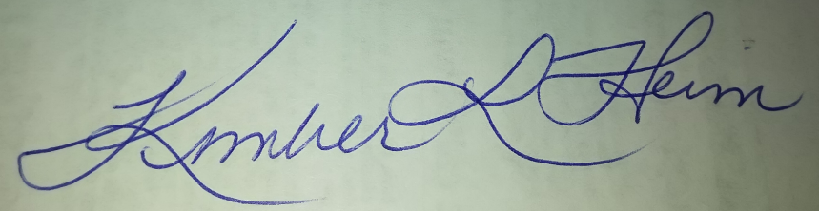 | REALTY SPECIALIST
 |  |  |  |  | Kimber L Heim | NAME TYPED OR PRINTED

