Rev.07/2011 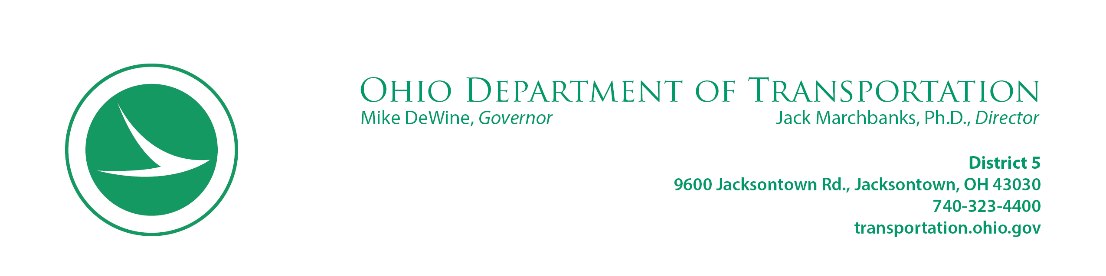

**APPROPRIATION LETTER**

May 7, 2021

Act Investments, LLC

Robert Landis

3560 Dolson Court

Suite P

Carroll, Ohio 43112

RE: Project 110412 FAI-037-06.10

Parcel 2 – SH1 & SH2

0 Baltimore-Somerset Road NE, Baltimore, Ohio 43105

Dear Mr. Landis of Act Investments, LLC:

It is the sincere desire of the Department of Transportation to arrive at a mutually satisfactory settlement with every property owner when rights of way need to be acquired. At times this goal is difficult to attain and we must turn to the courts for a jury determination of just compensation due the property owner. This action assures that the owner’s rights will be fully protected and it will also permit the construction of the highway to proceed for the benefit of all.

Our offer to you in the amount of $ 18,218.00 represents the Department’s best estimate of the value of the property needed for the highway improvement and includes damages, if any, to your remaining property. This amount is based upon a valuation made of your property in accordance with standard procedures established, by the State of Ohio and the Federal government.

This letter notifies you that if the offer of compensation is not acceptable to you, that it will be necessary for the Department to initiate appropriation proceedings. As soon as the required papers can be prepared, a case will be filed in the courts. Upon the filing of an appropriation case, the law provides that the Director of Transportation shall deposit with the court the amount he deems to be the value of the property in question, and thereupon the Department gains the right to enter upon the land. Meanwhile, should you decide to accept the State’s offer, our negotiating agent will be happy to meet with you at your request.

If there are buildings on the land being acquired, the State will allow the owner (60) days to vacate and turn over possession after service of the notice to appropriate, as provided in the law. The owner may agree to accept the deposited money as full payment and the case will be closed.

If the owner is not satisfied with the amount of the deposit he must file an answer or appeal with the court in the manner and within the time specified on the summons which is served upon him by the court, requesting the amount due him to be determined according to law. He may also apply to the court to withdraw the deposited money, and the court shall permit such withdrawal subject to the rights of other parties of interest. Such withdrawal shall in no way interfere with the owner’s right to have a jury determine the amount paid. Interest does not accrue on any money deposited under this procedure. If the money withdrawn from the court should exceed the final award, the owner will be required to return the excess payment.

It is desired to emphasize that this is not an arbitrary action, but one designed to protect your legal right as a property owner to have the value of the property independently determined by a jury, should you so desire.

If you have questions, please contact Kimber Heim at 740-323-5422.

Respectfully,

John R. Wooldridge

District 5 Real Estate Administrator

District 05

9600 Jacksontown Rd., Jacksontown, Ohio 43030

740-323-5427