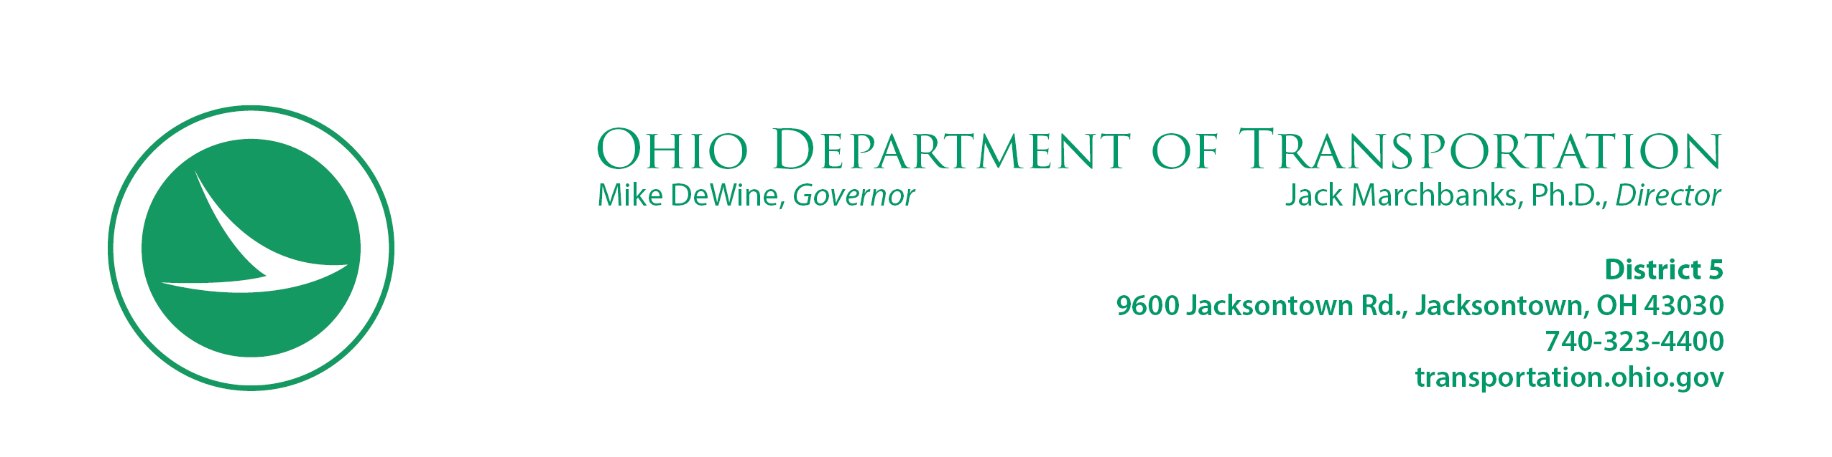

Rev. 03/2020

INTRODUCTION LETTER

Top 150 Safety Projects

October 9, 2020

CHAOS, LLC

6644 Woolard Road

Pleasantville, OH 43148

Project: FAI-SR37-6.10

Parcel: 6-SH, T1, T2

Dear Jeffrey P and Jacqueline M Watson:

Improving safety has always been a vital part of the Ohio Department of Transportation’s mission; however, deaths on Ohio roadways have been on the rise since 2013. Data collected in 2019, shows that Ohio experienced an average of 3 deaths per day on our roadways. This is unacceptable; therefore, The Ohio Department of Transportation is making every effort to decrease that number to zero deaths.

One way that the Ohio Department of Transportation is working to reduce that number is by investing in safety improvements at the Top 150 priority, high crash intersections in the state. This project on FAI-SR37-6.10 is one of the critical intersections that the Ohio Department of Transportation is working to expedite as quickly as possible. As we move forward with this safety project, we will need to work closely with you to improve the safety of the motoring public as quickly as possible.

We want to share with you that a future safety improvement project on FAI-SR37-6.10 may involve a portion of your real property. The purpose of this safety improvement project is to improve the safety in this area for the travelling public by widening of 1.2 miles of roadway at the SR 37 and SR 256 intersection by providing a left-turn lane on each approach and reconstruction of the existing traffic signals.

Soon, a Realty Specialist from of our office will be contacting you to clarify the proposed area to be acquired and the amount of compensation offered for the acquisition of that area. In the meantime, included in this letter is a brochure entitled “When ODOT Needs Your Property.” This booklet outlines our right of way acquisition procedures and provides answers to some of the most frequently asked questions.

We sincerely appreciate your time in this important matter, and we look forward to speaking with you soon to arrange an appointment to discuss this matter in detail. If you have any questions, please do not hesitate to contact our office.

Respectfully,

John R. Wooldridge,

District 5 Real Estate Administrator

Enclosure

cc: File

Jonathon C. Clark, Attorney

Clark & Clark and Associates

130 E. Chestnut Street

Lancaster, OH 43130