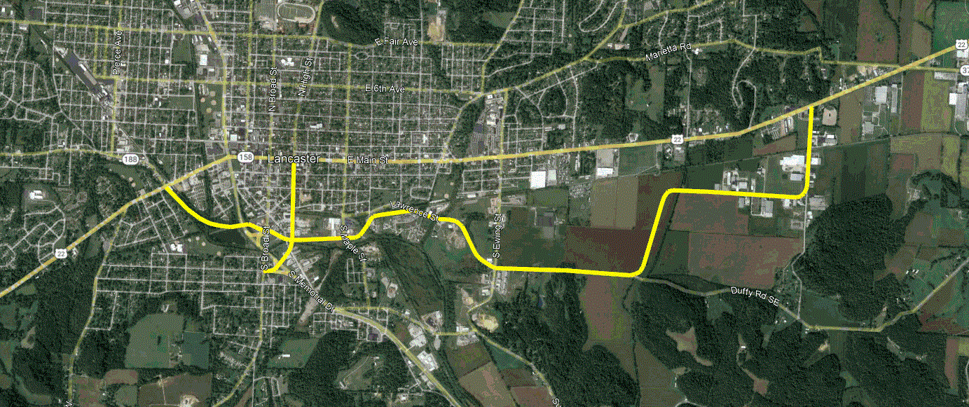
Since the 1950’s the City of Lancaster has recognized the bottleneck in the state highway network that occurs in the heart of the City. Numerous studies have been done and shelved. The congestion grows and the options disappear as the City develops.
A recent planning study, performed by American Structurepoint and funded by the USEDA and the Lancaster Port Authority, identified a corridor that would reduce commercial traffic on Main Street and improve access to the industrial land on the east side.
An analysis of comprehensive data from Streetlight Data, provided by MORPC, about half of the traffic on Main Street is passing through, and most of that is using 37N, 33S, 22W, 33S and 22/37E.
The 6-mile corridor includes the upgrade of 3 miles of existing streets (Canal, Lawrence, Duffy, Commerce and Quarry) and 3 miles of proposed streets that connect to all five federal and state routes in the city, improving connectivity to the Fairfield Medical Center, the Historic Downtown District, and neighborhoods south of US22.
The Eastside Industrial Connector is consistent and supportive of the City’s planning initiatives such as the Southern and Western Gateways.
This 50-million-dollar project is an ambitious transportation initiative promoted by the city. It will benefit the entire region and require the cooperation and support of all levels of government.

