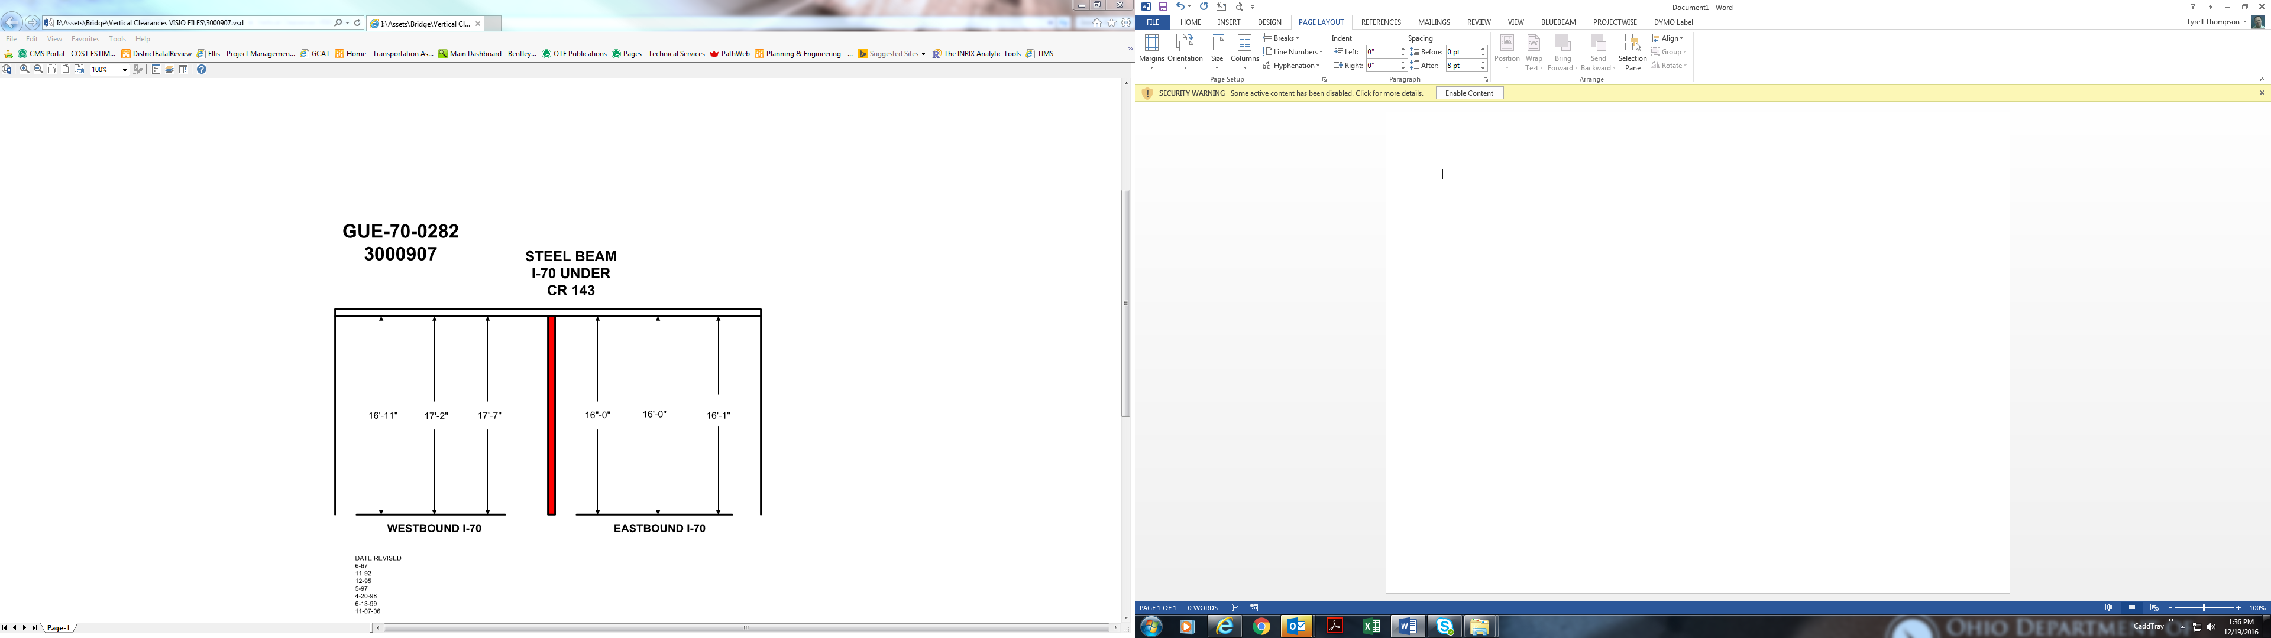

Date Revised: 6-67

11-92

12-95

5-97

4-20-98

6-13-99

11-07-06

16’-0” 16’-0” 16’-1”

16’-11” 17’-2” 17’-7”