**FRA 674-2.48-Hydraulic Report**

**Gender Road Bridge Replacement**

**Preliminary Report for 2D Model Review**

Kyle Brandon, P.E., ODOT Office of Hydraulic Engineering

Overview

The Ohio Department of Transportation, District 6, is proposing a bridge replacement over Little Walnut Creek in Franklin County. The project is located on SR 674-2.48 (Gender Rd.) in the City of Canal Winchester, Ohio. The crossing is located in a FEMA AE Zone with a floodway. The creek has a wide floodplain which is primarily occupied by a golf course and is subject to frequent flooding. While the downstream channel is relatively straight, there are several bends in the creek upstream of the structure. A very sharp bend just before the bridge exhibits behavior of significant channel migration. In addition to these features, a tributary enters the main channel approximately 1000’ upstream of the bridge crossing. The complex hydraulics made this crossing an ideal candidate for a 2D hydraulic analysis pilot project. A 2D model was developed in SMS SRH-2D along with a 1D HEC-RAS model for regulatory and comparison purposes. At the time of this analysis, the proposed structure design has not been completed. The HEC-RAS model was completed for the duplicate effective and existing conditions and the SRH-2D model was completed for the existing conditions only. The completed portions of both the 1D and 2D models are currently under review. Comparisons between the models will be made following completion of the review process and the proposed conditions model.

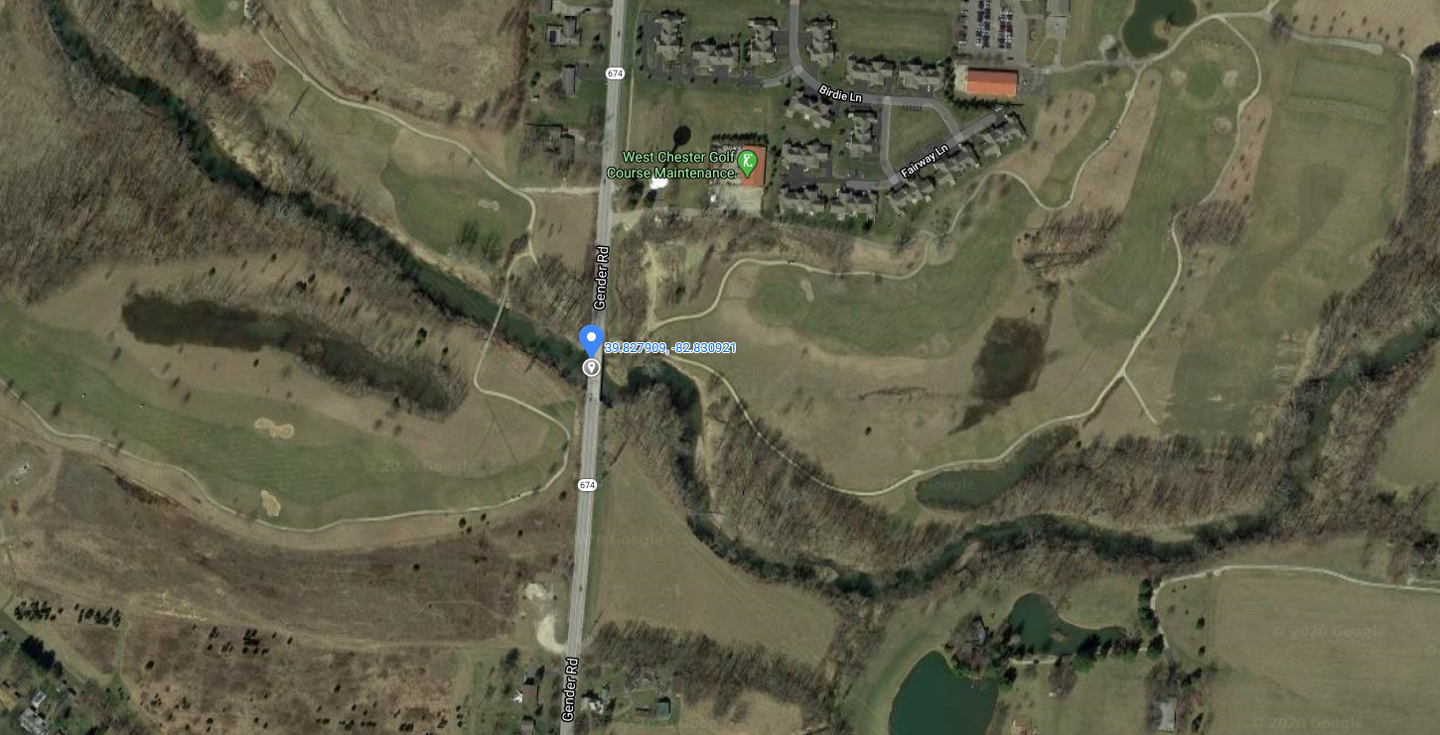

Site Location Map

Analysis Methodology and Results

The survey was collected with airborne LiDAR and supplemented with field collected channel cross sections. The hydrology was determined using USGS StreamStats for the design year (25yr) and flood (100 yr.) discharge. The drainage area delineated at the bridge crossing is 153 Sq. Mi. The StreamStats results determined a Q25=10400 CFS and Q100=14300 CFS. The Q100 from the FEMA FIS report is 24000 CFS. The difference in the flow values for the 100 yr. FIS and the flow determined by StreamStats is substantial. The drainage area used in the FIS was determined downstream from the project site at the confluence of Little Walnut Creek with George’s creek. The drainage area at this downstream location was also delineated with StreamStats. Both StreamStats and the FIS indicate a drainage area of 161 Sq. Mi., however, the FIS study computed much higher flow values. While the full reasons for the discrepancies in the hydrology is unknow, StreamStats is widely accepted in Ohio for larger drainage areas. It is suspected that the flow rates were overestimated in the 1978 FIS study based on both previous experience and comparison of the model results with field observations and first-person accounts. While a formal calibration has not yet been performed, an interview with a long-term employee at the surrounding golf course regarding past flood events and the high-water elevation or 747 +/- feet shown on the record plan set provide us with insight. These accounts indicate that the water surface elevation (WSEL) determined using the stream stats flow appears to be more characteristic of what appears in the natural channel. While the flow rates for the personal account and the record plan elevation are unknown, neither indicate the water surface coming in contact with the low chord of the bridge. The Q FIS Flow indicates an elevation close to or slightly exceeding the low chord elevation, while the StreamStats Q100 indicates an elevation approximately 1-2 feet below the low chord elevation. The StreamStats elevation is within the range indicated by firsthand accounts and the recorded high-water elevation. While the FIS flows are required for regulatory purposes, it is expected that StreamStats will be utilized for design purposes. Pending model review, additional comparisons will be performed between the 1D and 2D results as well as the elevations provided on the FEMA FIRM.