**C-R-S: HAM IR 275 5.25**

**PID 116663**

**DRAFT Scope Narrative**

# PDP Phase Included in this Agreement:

# Agreement is for Detail Design*.*

# Agreement between Consultant and Ohio Department of Transportation.

# This is an agreement to prepare plans through final design.

# Study Location:

The embankment slope on the west side of IR 275 is sliding and in need of repair. The coordinates are 39.202795, -84.765826. Follow link, [Google Maps](https://www.google.com/maps/@39.2029209,-84.7660025,93m/data=!3m1!1e3?entry=ttu&g_ep=EgoyMDI0MDgyOC4wIKXMDSoASAFQAw%3D%3D). A 36-inch drainage pipe was installed to replace an existing 36-inch pipe in 2011. In 2012 a Geohazard exploration was completed by Terracon. Repair recommendations were provided and can be found in the reference documents.

# General Information:

District/Central Office: **District Eight**

PID#: 116663

|  | **No.** | **Scope of Services Meeting Date** | **Approved Final Scope of Services** |
| --- | --- | --- | --- |
| Prime Agreement | TBD | To Be Determined – Will be a field site meeting with D8 staff |  |

|  | | | | |
| --- | --- | --- | --- | --- |
|  |  |  | Unit | Measure |
| Functional Classification | Interstate | From: | 5.25 | MM |
| Design Functional Classification | Interstate | To: | TBD based on MOT Need | Mm |
| Posted Speed (MPH) | 65 | Project Length | TBD | mile |
| Design Speed (MPH) | 70 | Work Length | TBD | mile |
|  |  | Lateral Limits | TBD | ft |

Note: Adjust project limits based on MOT needs.

**Map of existing Slope:**

The existing Slope is highlighted in red on the map below.

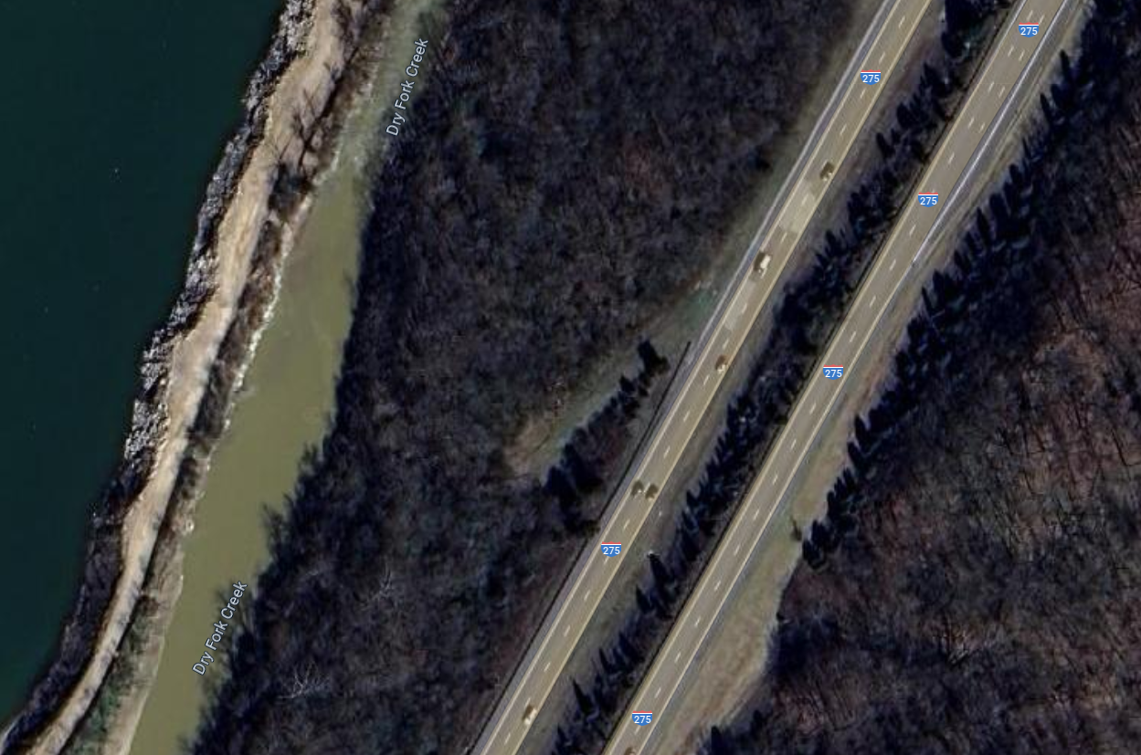

**Purpose & Need:**

The primary issues include:

1. The slope continues to slide leaving a head scarp on the shoulder of IR 275. This continued movement is deforming and lowering the guardrail in the area while deteriorating the asphalt in the shoulder.
2. The 36-inch conduit that was installed in 2011 was inspected by ODOT personnel. Pipe appears to be in good condition. No repairs required, Avoid pipe by at least 3 ft during installation of pier wall.

Secondary issues that require consideration are as follows:

1. Possible curb (Type 6) if grade requires it (two lanes or more draining to the shoulder) confirm with survey. Curb face to be flush or up to 6” in front of the guardrail face. Provided catch basins as required.

**Project Scope:** Discipline specific scope items have been identified below.

**Structures:**

1. N/A

**Roadway:**

1. Remove the existing pavement at head scarp. Pavement replacement to extend 1’ into the existing pavement beyond the scarp line. The repair area shall be full thickness asphalt.
2. Remove and re-install the guardrail in areas that are impacted by proposed wall construction. Replace from the existing end anchor to the limits of the proposed wall with MGS guardrail. Tie-in to the existing guardrail at the other end per MGS-4.3.
3. If any curb is installed, the pavement is to be widened such that the face of guardrail shall be either flush or up to 6” behind the face of curb. Curb to be Type 6 and any location where curb is installed shall also have the guardrail upgraded to MGS. Existing guardrail alignment to be maintained.
4. No curb to be installed along the limits of the guardrail end anchor.

**Pavement:**

1. ODOT to provide pavement design to match existing conditions.

**Traffic Control:**

Use Item 644 Thermoplastic for long line pavement marking replacement, if required by the work.

**Surveying:**

To be completed be the consultant including basemaps and all necessary surveying to complete a final design.

**Geotechnical:**

1. Design a drilled plug/pier wall as recommended in the geotechnical hazard report completed by Terracon in 2012. Repair to follow current GDM section 900. The anticipated length of repair area is 150-175 linear feet, which is to be confirmed with the survey. Ideally, a wall is placed 5ft behind the guardrail for ease of construction. A picture containing chart

   Description automatically generated
2. Global stability to be a minimum factor of safety 1.3.

**Drainage:**

1. ODOT has performed a camera inspection of the 36-inch steel pipe that crosses the interstate. The pipe is in good condition; an inspection file is being provided for information. The pipe is not to be damaged with repair.
2. If curbs are required, Inlet spacing calculations, storm sewer calculations are to be provided.
3. CIPP Line 36" Existing under I-275 NB (see image below for more information)
4. Replace CB4 in median (see image below for more information)
5. Locate upstream end of existing 36" CMP that was abandoned. Leave the material in place, but Plug and Fill remaining voids under I-275 SB (see image below for more information)
6. Properly Plug and Fill Manhole (see image below for more information)
7. Properly Plug and Fill 36" abandoned conduit (see image below for more information)

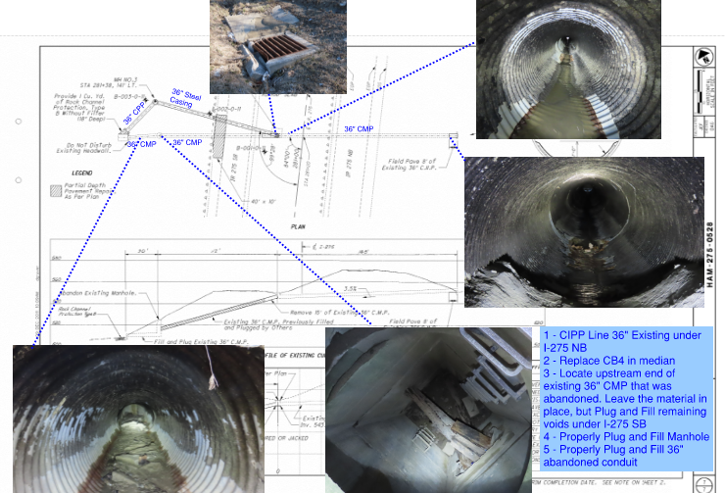

**Maintenance:**

N/A

**Maintenance of Traffic:**

1. Provide a single lane closure on IR 275 to allow the project to be completed. The plans are to include a window contract table.
2. Traffic control in accordance with C&MS 614 and other applicable portions of the specifications, as well as the Ohio Manual of Uniform Traffic Control Devices.
3. Lane closures shall be in accordance with the 2023/2024 PLCS.

**Environmental:**

Environmental work will be completed by ODOT District 8. Consultant to provide plans and include notes in the plans as needed.

**Right-of-Way:**

Right-of-way is not anticipated.

**Utility Coordination Requirements:**

Consultant to try to avoid utility conflicts throughout design while holding to the scope of work. If utility conflicts cannot be avoided, they should be minimized. Consultant to provide a copy of the OUPS ticket information to ODOT PM (if applicable). Up to date utility contacts shall be used at each plan submission. Utility contact information can be requested by consultant from ODOT PM. If Ohio 811 (OUPS) are more than two (2) years old, a design non-marking ticket shall be requested to obtain most up to date Utility Members List. The ticket does not need to be submitted to obtain the Utility Members List.

Consultant to provide a utility set of plans with the utility lines shown in color using the most recent version of ODOTcadd_UTPen.tbl at each plan submission. This file is found in the standard ODOTcadd executable file that can be downloaded from the [CADD services webpage](http://www.dot.state.oh.us/Divisions/Engineering/CaddMapping/CADD_Services/Standards/Pages/Files.aspx). Additionally, Consultant to prepare a summary of potential utility conflicts at each plan submission. Summary to be provided to Utility Companies at each plan submission. Summary to include, but not limited to station and offset of conflict, type of conflict (direct, decreased cover, proximity, etc.), utility owner (if known) and utility type. Consultant to use District 8's 'standardized' letter for sending submissions and plans to Utility Companies for review and comment. Consultant to provide the ODOT PM a copy of all Utility Correspondence. Consultant to compile Utility Company responses and forward to the ODOT PM. Final compilation of utility correspondence is due 35 days after plan submission to utilities.

A “no response” from a utility on a plan submission review cannot be considered as “no comment”, “no conflicts” and/or “a confirmation of the consultant’s findings” from the utility. A written response(email is sufficient) must be received from the utility verifying that they have no comments, no conflicts and/or they agree with the conflicts identified by the consultant.

Consultant to review the Utility Company responses and evaluate. The evaluation of the responses shall include validating that a conflict does exist or that a utility may remain in place. If a conflict does exist, consultant should provide an evaluation of the feasibility of potential resolutions. A disposition of utility status (i.e. utility to stay in place, utility facility relocation plan in writing or plan format) is required at the Stage 3 submission. This disposition shall be included to the utilities with the Stage 3 plan submission. This disposition shall be formulated based on utility responses from previous plan submissions.

A draft utility note shall be submitted after evaluation of the Stage 3 utility coordination in word format. The note should include discussion about the existing utilities for each utility, if they are staying in place and in service or if they are being relocated. If a utility is relocating, information about the location of their relocation should be included. Additionally, the relocation time frames should be included in the utility note as discussed with the utility companies. Example utility notes can be provided by the District utility coordinator upon request.

**Funding:**

1. Funding for the project is 100% District Preservation. 01/IMS/44 is to be incorporated into in the General Summary for this work.

**Existing Plans:** See ProjectWise for existing plans. Folder 999-Scratch

|  |  |  |  |  |  |
| --- | --- | --- | --- | --- | --- |
|  | **Arch No** | **Name** | **Year** | **PID** | **Description** |
| 1 | N/A | HAM/IR-275-5.28 | 2011 | 92075 | Conduit Replacement |
| 2 | N/A | Report of Geohazard Exploration | 2012 | 92075 | Geohazard Exploration |
| 3 | N/A | 36-inch bored pipe inspection | 2024 |  | Pictures |
| 4 |  |  |  |  |  |
|  |  |  |  |  |  |

**Reference Photos:**

**Area of concern:**

**Schedule:**

The schedule shown below is the tentative schedule at the time of scoping. The Official schedule will be maintained in Ellis.

Consultant to provide a schedule following authorization to proceed with the project. The consultant will coordination with the Project Manager to ensure ELLIS schedule is met and a reasonable schedule is developed.

