**C-R-S: HAM SR 4 6.41**

**PID 116567**

**Scope Narrative**

# PDP Phase Included in this Agreement:

# Agreement is for the Preliminary Engineering (PE) and Detail Design*.*

# Agreement between Consultant and Ohio Department of Transportation.

# This is a Two-Part agreement to prepare a feasibility study, then prepare plans through final design.

# Study Location:

Bridge HAM-4-6.41 (SFN 3100669) which carries SR 4 over West Fork Mill Creek, immediately north of Grove Rd.

**Map of existing bridge:**

The existing bridge is highlighted in red on the map below.

~~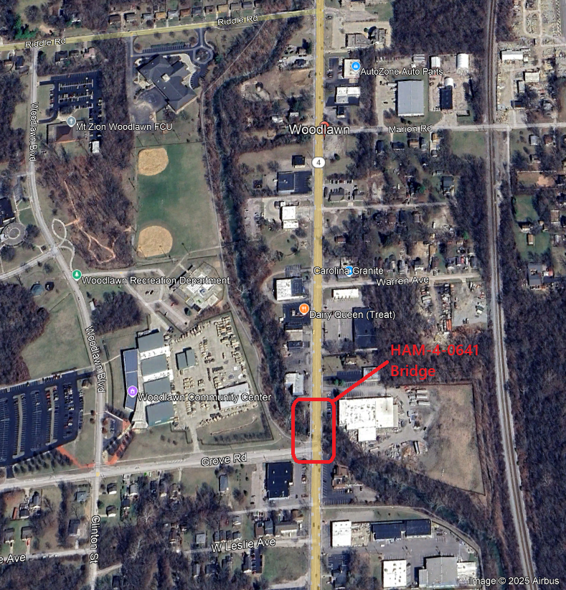~~

Study Description:

**Purpose & Need:**

The primary issues include:

1. Bridge HAM-4-0641 (SFN 3100669) which carries SR 4 over the West Fork of Mill Creek has a deteriorating box beam superstructure.
2. The HAM-4-0641 bridge has substructure which was constructed in 1916 is also deteriorating, is founded on timber piling, and is unreinforced.

Secondary issues that require consideration are as follows:

1. The structure carries multiple utilities.
2. There is a long wingwall/headwall and box culvert under the shared use path at the southwest corner that is deficient.

**Project Scope:** Discipline specific scope items have been identified below.

**Structures:**

1. Replace the existing bridge. Preference is given to a single span Prestressed I-beam bridge or composite box beam bridge. Widen existing bridge to accommodate four 10’ wide lanes, 2 foot shoulders, and 7’ wide sidewalks on either side, and 1’ wide barrier per BR-2-15. The south abutment is expected to be a wall type abutment. The north abutment could be wall type or spill through depending on the outcome of the hydraulic study. The proposed substructures shall be designed to avoid or straddle the existing piles. Approach slabs shall be full width including sidewalks, but may be modified at the southeast corner to avoid joints at/near/through the ADA ramps.
2. Due to the urban nature of this location, number of utilities, and the densely spaced existing piling, it is possible some utilities may be permitted to be carried by the proposed structure. Consultant shall coordinate utilities, accommodate the weight of utilities and attachments, accommodate utility penetrations, etc for each existing utility. Utility plans including temporary or permanent utility supports independent of the bridge superstructure may need to be provided by the utility and included in our plans.
3. Perform a hydrologic and hydraulic analysis per L&D Volume 2, Section 1107
   * 1. Complete FEMA coordination per L&D Volume 2, Section 1005. All attempts should be made to ensure a “No-Rise” for this project.
     2. Conduct a scour analysis per L&D Volume 2, Section 1008.10.
     3. Complete a Waterway Permit Hydraulic Analysis per L&D Volume 2, Section 1010.
4. Replace the existing headwall/wingwall at the southeast corner with a new wall of similar length and location. The height may be reduced, but not below the 100 year flood elevation for West Fork of Mill Creek.
5. Seal the exposed concrete surfaces with an Epoxy Urethane sealer per the typical limits shown in the bridge design manual. Color shall be Federal Color 17778 (light neutral).
6. Replace the existing approach guardrail as needed to meet MGS standards.
7. Load Rate the structure per section 900 of the BDM.

Materials for structures:

1. Concrete: Include macro-fibers and corrosion inhibitor in concrete mix. District to provide notes during design development.
2. Reinforcing steel: Use galvanized reinforcing steel for all new reinforcing steel.

**Roadway:**

1. Mill and fill existing pavement as needed to eliminate MOT and utility relocation scars.

For any MOT scar clean-up beyond full depth pavement use:

1.5” Item 254 Pavement Planing, Asphalt Concrete

1.5”   Item 441 Asphalt Concrete Surface Course, Type 1, (448), PG64-22

The existing pavement is approximately:

|  |  |
| --- | --- |
| 3” min | asphalt |
| 6”-9” | concrete |
| 4” | brick |

1930 plans:   Arch No 08c2857

The full depth composition will be flexible.

The full depth pavement composition is:

|  |  |
| --- | --- |
| 1.25” | Item 441 Asphalt Concrete Surface Course, Type 1, (448), PG64-22 |
|  | Item 407 – Non-Tracking Tack Coat |
| 1.75” | Item 441 – Asphalt Concrete Intermediate Course, Type 2 (448) |
|  | Item 407 – Non-Tracking Tack Coat |
| 7” | Item 301 – Asphalt Concrete Base, PG 64-22 (449) |
| 6” | Item 304 – Aggregate Base |
| TBD | Subgrade Treatment – Undercut (assumed) |

**Traffic:**

* + - 1. The existing signal at the intersection of SR 4 and Grove Rd will not be used during MOT phasing when Grove Rd is closed. Temporary modifications and/or relocation will be needed for excavation and MOT.
      2. Existing aesthetic lights shall be removed and stored during the affected phase of construction and re-erected on new foundations with the project.

**Geotechnical:**

Geotechnical borings and recommendations are to be provided by the consultant with the feasibility study.

1. **Bridge Abutments:** The proposed foundations are anticipated to be supported by piling. One boring is anticipated behind each of the existing abutments (2 borings type E1 per SGE including bedrock cores). Borings through the bridge superstructure are not allowed. Care shall be taken to avoid existing utilities. The geotechnical study will determine the depth of rock, recommended pile type, and soil properties for scour analysis and retaining walls at a minimum.

A proposed boring plan with existing utility locations shall be provided to the District Geotechnical Engineer prior to drilling.

**Drainage:**

1. Replace existing storm drains in the vicinity of the existing bridge to the nearest catch-basin or manhole. Out-letting through the existing abutment is acceptable if necessary.

2. Replace the box culvert back to the round conduit that is located under Grove Rd. Size the new structure for existing and future conditions assuming the upstream conduit will be some day be replaced/increased to current standards.

**Maintenance:**

None required.

**Maintenance of Traffic:**

SR 4:  Maintain one lane of vehicular traffic in each direction using part-width construction. Temporary MOT lanes shall consist of 10’ lanes minimum.  Barrier/curb offsets may vary by phase.

* Phase 1:  Remove a portion of the existing sidewalk to maintain traffic. Portable barrier may be anchored on the existing structure, the anchor shall be located within the box web.
* Phase 2:  Defer the proposed sidewalk until post-phase 2 to maintain traffic.  Portable barrier should not be anchored in the new structure.

Grove Road:  Close Grove Road just west of the SR 4 intersection.  The existing traffic signal will be covered.

Pedestrian traffic across the bridge may be detoured to the shared use path. Pedestrian and shared use path traffic shall be detoured to cross Grove Road using a temporary sidewalk east of the box culvert crossing and west of SR 4, pedestrian/shared use path traffic will then travel along the closed portion of Grove Road, to the southwest corner curb ramp.  The pedestrian detour will continue south on the western sidewalk along SR 4 to the existing crosswalk at McLean Street.

The existing bus stop located near the northwest corner of the structure will need to be closed/relocated.  Coordinate the closure/relocation of the bus stop with Go-Metro.  Include a Metro Coordination note in the plans (District to provide template); the note will need to be modified to describe project specific requirements.

**Maintaining Transit Operations**

Transit facilities are located within the project limits and are affected by the proposed work and/or the maintenance of traffic. Transit operations shall be maintained at all times. Invite the below listed transit agency contact(s) to the preconstruction meeting and provide them with the project schedule including updates relative to transit impacts.

SORTA/Metro

* Brian Messer: [Bmesser@go-metro.com](mailto:Bmesser@go-metro.com)
* Kim Wyatt: [Kwyatt@go-metro.com](mailto:Kwyatt@go-metro.com)
* Paul Johnson: [pjohnson@go-metro.com](mailto:pjohnson@go-metro.com)
* [scheduling@go-metro.com](mailto:scheduling@go-metro.com)
* [busstops@go-metro.com](mailto:busstops@go-metro.com)

Coordination with the transit agency is required. Provide notification at least 14 calendar days in advance to allow the transit agency to implement any changes to the transit operations as described below:

* List all items that require coordination per project phase. Identify both internal and project related items. Examples below
* Internal – Bus route XX modified to rt. XX-1
* Project function – Relocate bus stop sign from sta. XX+XX to XX+YY

Designer note:

It is possible to re-route an existing bus route; however, lead time (approximately 8 months) is needed to do so. Coordination during the typical design process should be sufficient to meet this lead time. The above plan note should identify the bus route being relocated and include any agency specific nomenclature for the relocated bus route.

Temporary bus pads shall be 8’ long by 5’ wide, shall be shown on the plans and installed by the contractor. Items performed by the contractor will not be itemized in the plan note above.

Notification during construction should include the pre-construction meeting and 14 calendar days before any relocation, re-route, or other action needed by the transit agency. Verify any work, internal or project related, that the transit agency performs can be performed within 14 calendar days’ notice.

**Environmental:**

The fieldwork for the Level 1 ESR shall be performed prior to the feasibility study. Identify stream/wetland and threatened & endangered species/habitat information within the study limits to be incorporated into the feasibility study. This information may play a role in identifying the preferred alternative design and will help scope future environmental tasks. The Level 1 ESR will be submitted through EnviroNet when Stage 1 Plans (or equivalent) are available to determine impacts to ecological resources.

The consultant shall coordinate the environmental work with District 8’s Environmental PM. See the task list in SAFe for anticipated coordination.

**Survey:**

ODOT will provide the centerline of survey and existing right of way along with primary control. The consultant shall perform all field necessary survey and R/W plans using the Ohio County Coordinate System for Hamilton County.

**Right-of-Way:**

Right-of-way will be required. Feasibility Study to determine project limits, number of parcels, and acreage of each parcel. ODOT to provide R/W estimate. Consultant to prepare R/W plans during final design.

**Utility Coordination Requirements:**

Consultant to try to avoid utility conflicts throughout design while holding to the scope of work. If utility conflicts cannot be avoided, they should be minimized. Consultant to provide a copy of the OUPS ticket information to ODOT PM (if applicable). Up to date utility contacts shall be used at each plan submission. Utility contact information can be requested by consultant from ODOT PM. If Ohio 811 (OUPS) are more than two (2) years old, a design non-marking ticket shall be requested to obtain most up to date Utility Members List. The ticket does not need to be submitted to obtain the Utility Members List.

Consultant to provide a utility set of plans with the utility lines shown in color using the most recent version of ODOTcadd_UTPen.tbl at each plan submission. This file is found in the standard ODOTcadd executable file that can be downloaded from the [CADD services webpage](http://www.dot.state.oh.us/Divisions/Engineering/CaddMapping/CADD_Services/Standards/Pages/Files.aspx). Additionally, Consultant to prepare a summary of potential utility conflicts at each plan submission. Summary to be provided to Utility Companies at each plan submission. Summary to include, but not limited to station and offset of conflict, type of conflict (direct, decreased cover, proximity, etc.), utility owner (if known) and utility type. Consultant to use District 8's 'standardized' letter for sending submissions and plans to Utility Companies for review and comment. Consultant to provide the ODOT PM a copy of all Utility Correspondence. Consultant to compile Utility Company responses and forward to the ODOT PM. Final compilation of utility correspondence is due 35 days after plan submission to utilities.

A “no response” from a utility on a plan submission review cannot be considered as “no comment”, “no conflicts” and/or “a confirmation of the consultant’s findings” from the utility. A written response (email is sufficient) must be received from the utility verifying that they have no comments, no conflicts and/or they agree with the conflicts identified by the consultant.

Consultant to review the Utility Company responses and evaluate. The evaluation of the responses shall include validating that a conflict does exist or that a utility may remain in place. If a conflict does exist, consultant should provide an evaluation of the feasibility of potential resolutions. A disposition of utility status (i.e. utility to stay in place, utility facility relocation plan in writing or plan format) is required at the Stage 3 submission. This disposition shall be included to the utilities with the Stage 3 plan submission. This disposition shall be formulated based on utility responses from previous plan submissions.

A draft utility note shall be submitted after evaluation of the Stage 3 utility coordination in word format. The note should include discussion about the existing utilities for each utility, if they are staying in place and in service or if they are being relocated. If a utility is relocating, information about the location of their relocation should be included. Additionally, the relocation time frames should be included in the utility note as discussed with the utility companies. Example utility notes can be provided by the District utility coordinator upon request.

**Feasibility Study:**

Prepare a feasibility study including the following:

* Structure type study including span length, abutment height, wingwall, bridge type, and foundation type.
* Geotechnical borings, study and recommendations.
* Hydrology and Hydraulics study including scour.
* Determine if a TAF will be needed. Design elevations of the TAF if needed will be completed during Part 2
* The consultant shall work with each utility to determine the location of their proposed alignment, temporary support if permitted to say on the structure, permanent support if permitted to stay on the structure, R/W purchase needs, and schedule for relocation relative to the project schedule.
* Construction Work Limits for environmental work including contractor staging area(s).
* Provide the following for Maintenance of Traffic (MOT).
* Contractor work zone for slope work in phase 1 and limits of temporary pavement.
* Cross section of MOT on the structure that includes the following: lane widths, barrier offsets, Portable Barrier (PB) locations, PB locations relative to existing boxbeam dimensions for both generic PB and proprietary PB, and dimension between existing and phase 1. Ensure the dimension between the existing bridge is sufficient working room for deck forming, overhang brackets, closure pours, abutment work, etc.
* Environmental tasks.
* Level 1 ESR
  + Perform field work in summer prior to FS
  + In FS state acres of tree impacts beyond 100’, list any PMRT impacts too
  + In FS state all stream and wetland impacts (anything within the construction limits)
  + Note that the Level 1 ESR will not be submitted until Stage 1 plans are available to accurately document impacts.
* Public Involvement (PI) letters
  + 1st batch of letters notifying the public, and local service providers, of the project and asking for comments to consider while designing the project.  Including relevant comments in the FS.  Inform the public that a follow up letter will be sent once plans are further refined and will include more information such as MOT impacts.
  + 2nd batch of letters will include all require information per OES guidelines for project notification letters and our typical letter to local service providers regarding MOT.
* R/W impacts including parcels, limits, and acreage. ODOT will provide the estimated cost
* Estimated project cost including reimbursable utility costs.

**Project Management:**

Part 1 shall be the feasibility study. Upon acceptance of the feasibility, a contract modification will be requested to provide final plans and R/W.

**Funding:**

This project will be District Bridge Allocations. Provide a separate cost for R/W and utility reimbursements.

**~~D~~esign Designations:**

|  |  |
| --- | --- |
|  | HAM-4 |
| Functional Class | 03 Principal Arterial (Urban) |
| NHS | Yes |
| Opening Year AADT (2031) | 15,500 |
| Design Year AADT (2051) | 15,500 |
| Design Hourly Volume (2051) | 1,700 |
| Directional Distribution | 0.51 |
| TRUCKS (24 Hour B&C) | 2% |
| Trucks (Design Hour) | 3% |
| Posted Speed | 35 MPH |
| Design Speed | 35 MPH |

**Existing Plans:** See the FTP Site for existing plans and photos.

|  |  |  |  |  |  |
| --- | --- | --- | --- | --- | --- |
|  | **Arch No** | **Name** | **Year** | **PID** | **Description** |
| 1 | 08C3153 | Woodlawn Carthage Hamilton Pike | 1916 |  | Original Plans |
| 2 | 08C3151 | Carthage Hamilton Rd | 1920 |  | Roadway Project |
| 3 | 08C2550 | HAM-4-6.41 | 1972 |  | Superstructure Replacement |
| 4 | 08R0381 | HAM-4-6/41 |  |  | R/W Plans |
| 5 | 08r1153 | HAM-4-6.80-8.40 |  |  | R/W Plans |
|  |  |  |  |  |  |

**Bridge Inspection Photos:**  See the FTP site for existing inspection photos.

2024 Insp Photos: \\D08fs100.dot.state.oh.us\archives\structures\bridges\24 photos\HAM\SR4\0641

PIP Photos: \\D08fs100.dot.state.oh.us\archives\structures\bridges\25 photos\HAM\SR4\0641\PIP 071525

FTP site with above info available here:

\\ftp.dot.state.oh.us\pub$\Districts\D08\Programmatics\2025-September\HAM-4-6.41

**Schedule:**

The Official schedule will be maintained in Ellis. The consultant may propose changes to the schedule that don’t alter the final plan package submittal or sale dates.