C-R-S: HAM US 50 19.80
PID 124627
Scope Narrative

PDP Phase Included in this Agreement:

Agreement is for the Preliminary Engineering (PE) and Detail Design.

Agreement between Consultant and Ohio Department of Transportation.

This is a One-Part agreement to prepare a prepare plans through final design.

Study Location:
Rehabilitate Bridges HAM-50-1980 L/R (SFN 3103005 / 3103064) which carries US 50 over Central Railroad of Indiana, CSX Railroad, Flood Wall, and Linn Street.

Map of existing bridge:
The existing bridges are circled in red on the map below.

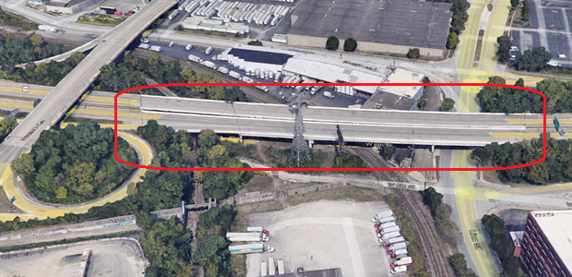

Study Description:

Purpose & Need:

The primary issues include:
- Bridges HAM-50-1980 L/R (SFN 3103005 / 3103064) US 50 over Central Railroad of Indiana, CSX Railroad, Flood Wall, and Linn Street have deteriorating concrete bridge decks and superstructure paint and are both rated a 5 out of 9 (9 being best and 4 being deficient).
Secondary issues that require consideration are as follows:
- The barrier on the westbound structure also has condition issues and is also rated a 5.
- The bridge does not meet current seismic requirements.
- The are repairs needed to the substructure other bridge secondary components such as bearings, expansion joints, drainage, etc.
- There are scheduled closures US 50 in the eastbound direction and possible the westbound direction due to the Brent Spence Bridge project.

Seismic Study:

A detailed feasibility study is not needed for this project, but study to determine the scope necessary to achieve seismic compliance is needed as follows:

Evaluate the structure for seismic compliance per the Bridge Design Manul. In the event the structure does not meet the seismic requirements, at a minimum, following Alternatives shall be explored
  - Evaluate extensions to the beam seat width for seismic beam seat requirements at the abutments and Pier 3.
  - Evaluate restraint systems at beam ends located beneath expansion joints.
  - Evaluate replacing the existing cross frames (configuration and location) over the fixed piers (Pier 2 and Pier 5).
  - Evaluate the use of seismic isolation bearings for the fixed piers.
  - Evaluate adding fixed pier locations.
  - Fiber wrap systems

The study should include the cost, estimated duration of repair, shoring requirement/cost, preliminary design of bearings sufficient to evaluate available beam seat width and/or beam seat modifications, and impacts to railroad including the number of days the work will impact the railroad. ODOT will provide the flagging cost per day for inclusion with the estimate.

Project Scope: Discipline specific scope items have been identified below.

Structures:

- Remove and replace the existing deck with a new composite deck, approach slabs per AS-1-15, and barriers per SBR-1-20.
- Replace the backwalls down to the beam seat. Patch deteriorated portions of the abutments and piers for epoxy injection, patching per 519, and patching with anodes per SS844 for patches larger than 5 square feet. Consultant to sound the existing substructure to determine repair quantities. Evaluate the need for temporary supports at Pier 3 based upon pier condition based upon the results of the sounding.
- Regardless of seismic study, replace the abutment bearings and pier bearings at Pier 3 due to condition. Determine if temporary shoring is needed for bearing replacement or seat modifications.
- Include seismic retrofits as determined by the approved Seismic Study.
- Replace the existing scupper with new scuppers per GSD-1-19. Replace the existing downspouts down to the ground and clean the portions of the conduit below ground to the first manhole or catch basin. Include a note requiring the new conduit to be galvanized steel only. Other material types are not allowed. (homeless encampment fires have occurred under this bridge in the past).
- Remove Existing trees within the R/W.
- Weld the cross frame stiffeners to the top and bottom flanges of the plate girders to prevent out-of-plan bending cracks (similar to current standard GSD-1-19).
- Paint the existing structural steel per 514 OZEU Specifications. Color shall be Federal Color FS 595C-14277 (light green). (unless another color is requested and approved by the City Cincinnati)
- Seal the concrete per the typica limits defined within the BDM with epoxy urethane sealer 512 specifications, Federal Color 17778. Include a quantity for the removal of existing sealers.
- Coordinate existing utilities and lighting. Light poles on the bridge will need to be replaced. Coordinate lighting requirements with the City of Cincinnati.
- Update the Load Rating for both structures per the requirements of the BDM, Section 900.

Materials for structures:
- Concrete: Include macro-fibers and corrosion inhibitor in concrete mix. District to provide notes during design development.
- Reinforcing steel: Use galvanized reinforcing steel for all new reinforcing steel.

Roadway:

No roadway improvements are anticipated.

Traffic:

No traffic sign impacts are anticipated. Pavement markings shall be ______.

Lighting:
Reuse existing poles. Mount poles in locations similar to existing.

Traffic Analysis:

No traffic analysis is required.

Geotechnical:
No geotechnical work is anticipated.

Drainage:

See the structures section for drainage on the bridge. No drainage modifications are anticipated off the bridge.

Maintenance:

None required.

Maintenance of Traffic:

Due to the Brent Spence Project, it is expected that US 50 will be closed as noted below. The ODOT project manager shall coordinate with the Brent Spence project as necessary to ensure closure schedule and to adjust project sale dates as necessary so this project coincides with US 50 closures.

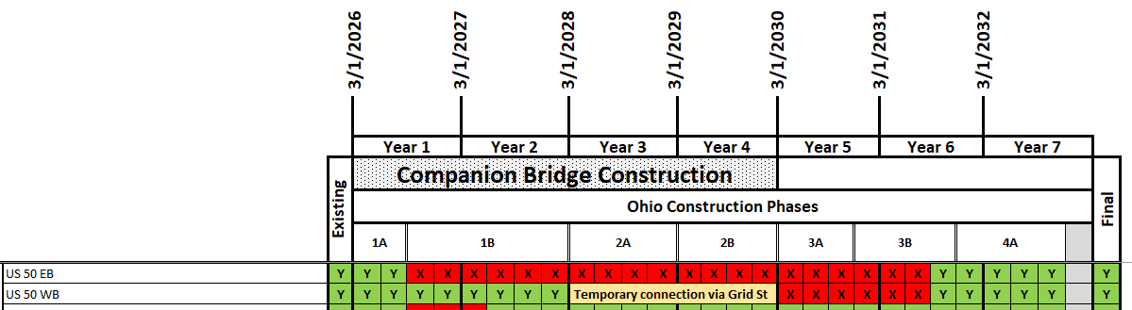

It is possible that one lane of US 50 in the westbound direction will need to be maintained. This is still being determined. A contract modification will be requested if this is requested.

Scott Kraus / Joe Smithson: Please review and update MOT as necessary.

Environmental:

ODOT District 8 will complete all environmental work. (Tony- Please confirm).

Survey:
The consultant shall provide all necessary survey.

Right-of-Way:
The existing aerial easement allows for the construction, operation, maintenance and replacement of the structure. No R/W is anticipated with this project.

Utility Coordination Requirements:
Consultant to try to avoid utility conflicts throughout design while holding to the scope of work. If utility conflicts cannot be avoided, they should be minimized. Consultant to provide a copy of the OUPS ticket information to ODOT PM (if applicable). Up to date utility contacts shall be used at each plan submission. Utility contact information can be requested by consultant from ODOT PM. If Ohio 811 (OUPS) are more than two (2) years old, a design non-marking ticket shall be requested to obtain most up to date Utility Members List. The ticket does not need to be submitted to obtain the Utility Members List.

Consultant to provide a utility set of plans with the utility lines shown in color using the most recent version of ODOTcadd_UTPen.tbl at each plan submission. This file is found in the standard ODOTcadd executable file that can be downloaded from the CADD services webpage. Additionally, Consultant to prepare a summary of potential utility conflicts at each plan submission. Summary to be provided to Utility Companies at each plan submission. Summary to include, but not limited to station and offset of conflict, type of conflict (direct, decreased cover, proximity, etc.), utility owner (if known) and utility type. Consultant to use District 8's 'standardized' letter for sending submissions and plans to Utility Companies for review and comment. Consultant to provide the ODOT PM a copy of all Utility Correspondence. Consultant to compile Utility Company responses and forward to the ODOT PM. Final compilation of utility correspondence is due 35 days after plan submission to utilities.

A “no response” from a utility on a plan submission review cannot be considered as “no comment”, “no conflicts” and/or “a confirmation of the consultant’s findings” from the utility. A written response (email is sufficient) must be received from the utility verifying that they have no comments, no conflicts and/or they agree with the conflicts identified by the consultant.

Consultant to review the Utility Company responses and evaluate. The evaluation of the responses shall include validating that a conflict does exist or that a utility may remain in place. If a conflict does exist, consultant should provide an evaluation of the feasibility of potential resolutions. A disposition of utility status (i.e. utility to stay in place, utility facility relocation plan in writing or plan format) is required at the Stage 3 submission. This disposition shall be included to the utilities with the Stage 3 plan submission. This disposition shall be formulated based on utility responses from previous plan submissions.

A draft utility note shall be submitted after evaluation of the Stage 3 utility coordination in word format. The note should include discussion about the existing utilities for each utility, if they are staying in place and in service or if they are being relocated. If a utility is relocating, information about the location of their relocation should be included. Additionally, the relocation time frames should be included in the utility note as discussed with the utility companies. Example utility notes can be provided by the District utility coordinator upon request.

Project Management:
This project shall be One Part Project to complete plans for the project that will include the Seismic Study. It is understood that a modification will be needed for the detail design of the seismic retrofit items once the Seismic Study is complete.

Funding:
This project will be funded 50%/50% using Major Investments / District Allocation funding that are both State and Federal.

Design Designations:

 | HAM US 50 19.80
Functional Classification | 02 Other Freeway/Expressway (urban)
Design Functional Classification | 02 Other Freeway/Expressway (urban)
National Highway System (NHS) | Yes- Intermodal Connector
Opening Year ADT (2031) | 40,500
Design Year ADT (2051) | 42,500
Design Hourly Volume | 5,500
Direction Distribution | 0.62
Trucks (24 Hour B&C) | 8%

Existing Plans: See the FTP Site for existing plans and photos.

 | Arch No | Name | Year | PID | Description
1 | 08c2204 | HAM-50-19.76 | 1962 | n/a | Original Construction
2 | 08c1739 | HAM-50-1936 | 1992 | n/a | Minor Rehab
3 | 08c3057 | HAM-50-1903 (Part 2) | 2011 | 20082 | Minor Rehab
4
5

Bridge Inspection Photos: See the FTP site for existing inspection photos.

2025 Insp Photos:

J:\structures\bridges\25 photos\HAM\US50\1980 L
J:\structures\bridges\25 photos\HAM\US50\1980R

PIP photos are available here:
J:\structures\bridges\26 photos\HAM\US50\1980R\PIP 02-17-26

FTP site with above info available here:
ftp.dot.state.oh.us - /pub/Districts/D08/Programmatics/2026-September/HAM-50-1980 PID 124627/

Schedule:
The Official schedule will be maintained in Ellis. The consultant may propose changes to the schedule that don’t alter the final plan package submittal or sale dates.

