Case Study 3.1 – Increased Interest Payments

With Answers

Scenario A
Mr. and Mrs. Kouskouris are being displaced due to a highway project. They presently have a mortgage on their property with an interest rate of 5%, an outstanding balance of $32,000 for a term of 100 remaining months, and a monthly payment of $391.94.

The prevailing interest rate in the project area is 5.5 %. Due to a poor credit history, the only loan available to Mr. & Mrs. Kouskouris has an interest rate of 7%. Can the increased mortgage interest payment be used to pay for the higher than prevailing rate mortgage?

Suggested Response:
Some Agencies may hesitate to pay higher than the prevailing rate of 5.5%; however, this would prevent the displaced family from obtaining a comparable replacement dwelling. Under these conditions, we can pay the higher rate through our Increased Interest calculations.

Although the Displacees may have poor credit, they do still have their house and it is the Agency’s action that is causing them to lose the favorable interest rate and their ability to obtain a replacement mortgage.

Scenario B
Mr. and Mrs. Maynard are being required to move due to a highway project. They presently have a mortgage on the displacement dwelling of $27,235 with 60 remaining payments at 7% with a monthly payment of $539.30. The typical mortgage for the project area is 6% with 1 point origination fee. For what payments are Mr. & Mrs. Maynard eligible?

Suggested Response:
New loan has a lower interest rate than old loan, therefore they would not qualify for an Increased Interest payment, but they are eligible for the 1% loan origination fee payable as an incidental expense.

Scenario C
Mrs. Moorman obtained a $35,000 home equity loan at 5.5% to purchase a new car seven months before the initiation of negotiations for her dwelling. ODOT has appraised the subject dwelling and typical home site for $60,000. Mrs. Moorman found a replacement property to purchase for $250,000, but rates have changed in the market area and her new mortgage will be at 6%.

Is she eligible for an Increased Interest Payment?

Suggested Response:
Yes. In the case of a home equity loan, the unpaid balance which existed 90 days prior to the initiation of negotiations or the balance on the date of acquisition, whichever is less, will be used to calculate her Increased Interest payment.

Scenario D
Mr. and Mrs. Maitland are being displaced due to a bridge project. They have a mortgage on the displacement dwelling with a remaining balance of $38,233 with 80 remaining payments at 5.5%. Their current monthly Principal and Interest payment is $571.95.

The typical interest rate for the project area is 6.5% with no points. The Maitlands have found a mortgage for $80,000 at 6.5% for 15 years (180 months) that will have a monthly Principal and Interest payment of $696.89.

You have calculated the Maitland’s Increased Interest payment at $1,181.51 using the online Excel application.

Mr. Maitland informed you that his mortgage broker informed him that if he pays 4 points, his interest rate will be reduced to 5.5% for the new loan. What is your advice to Mr. Maitland?

Suggested Response:
Increased interest is payable, but excessive points generally are not payable. Purchaser’s points and loan origination fees should not exceed rates normal to similar real estate transactions in the area. In this case we know that the going rate is 6.5% with no points.

However, if it results in a lower cost to the Agency you may want to consider an exception to this rule. Let’s look at the math on this problem on the next slide.

(advance slide)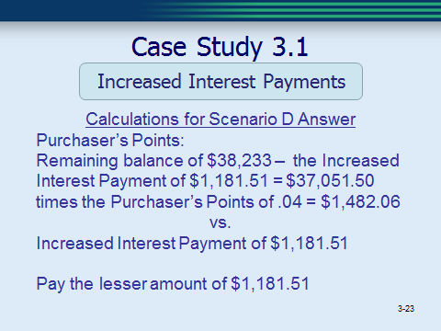

In this case, the Increased Interest Payment is $1,181.51 and the points would be $1,482.06 [remaining balance of 38,233 – 1,181.50 = 37,051.50 x .04 = $1,482.06). So the payment of the 4 points would not result in a lower net payment for the Agency. You would pay Increased Interest and not the points.

