Case Study 3.2 – Incidental Expenses

With Answers

Larry and Carolyn Hamilton are being displaced as a result of the I-270 expansion project in Gahanna, Ohio. The subject home is a six room, three bedroom, two bath brick ranch dwelling located on a half-acre lot, which is considered typical for their residential subdivision. The Hamiltons signed the State’s offer for the Fair Market Value at $150,000. The closing on their property with the State has completed, and the Hamiltons received $100,000 of the proceeds with the remaining $50,000.00 going to pay off the balance of their existing 5% mortgage. Their Relocation Offer advised them that based on a comparable that was for sale for $165,000, they were eligible for a maximum Replacement Housing Payment of $15,000.

Mr. & Mrs. Hamilton never intend to move again. Consequently, they are going to buy their dream home. The Hamiltons sign a contract to purchase Mr. Glenn Stephen’s four bedroom colonial dwelling located on a one acre lakefront lot in Monroe County for $300,000. The Hamiltons intend to use the equity from their acquisition plus the $15,000 price differential payment and some personal savings as a down payment, and finance $150,000 with a 6%, 30 year fixed rate mortgage. To receive the 6% interest rate the Hamiltons must pay a 1% Discount Purchaser’s Points, which you have already paid for in their Increased Interest payment. Their new mortgage company also requires that all homes they finance have a termite inspection and gas line warranty.

The loan has been approved, and the dwelling has passed the decent, safe, and sanitary inspection. Mr. Hamilton retained the services of a real estate law firm, Schoch and Hawe, to advise him through the relocation process and to conduct the settlement.

You attend the closing and are presented with a copy of the attached Consumer Financial Protection Bureau’s Closing Disclosure Form.

Problem 1:
With the use of the Closing Disclosure Form and the attached RE-611-2 Form, determine the incidental expenses you would reimburse to the Hamiltons.

Additional Factual Information
- The owner’s title insurance is calculated at .0020 times the price of the house.
- The lender’s title insurance is calculated at .0025 times the loan amount.
- One point origination fee is typical in this mortgage market, and you will pay this amount as it is not included in the Increased Interest Payment.

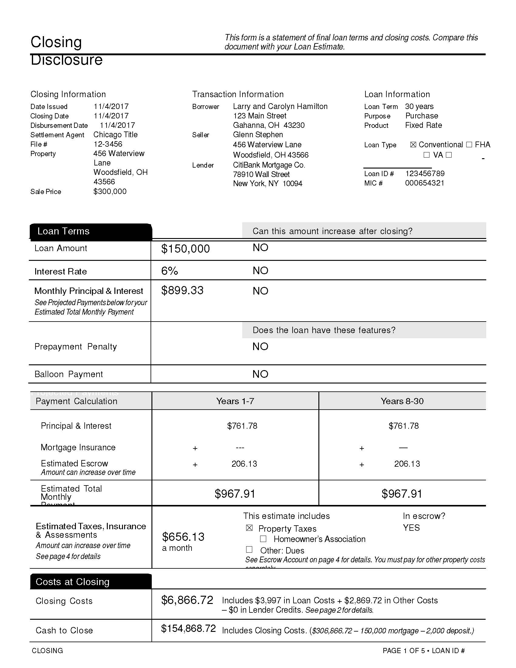

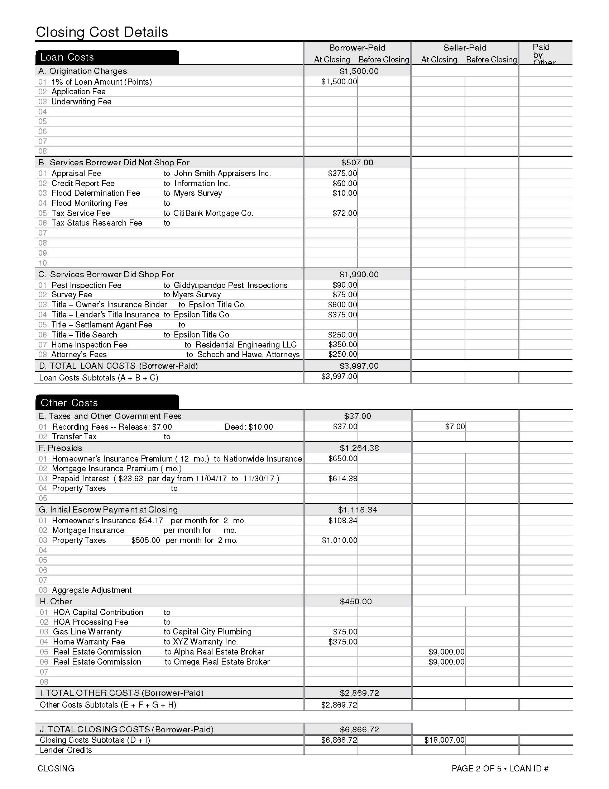

Advance Slide to Show Answers
The following incidental expenses are considered to be eligible expenses:
Attorney’s Fees: |  |  | $ 250.00 |  | Miscellaneous Incidental Expense Not Listed:
Title Search: |  |  | $ 250.00 | Tax Service |  | $ 72.00
Appraisal Fee: |  |  | $ 375.00 | Flood Certification |  | $ 10.00
Credit Report: |  |  | $ 50.00 | Home Inspection |  | $ 350.00
Closing Fee: |  |  | $ - | Recording |  | $ 37.00
Title Insurance: |  |  | $ 455.00 | Gas Line Warranty |  | $ 75.00
Notary Fee: |  |  | $ - | Misc. Item |  | $ -
Application Fee: |  |  | $ - | Misc. Item |  | $ -
Title Policy: |  |  | $ - | Misc. Item |  | $ -
Survey: |  |  | $ 75.00 | Misc. Item |  | $ -
Termite Inspection: |  |  | $ 90.00 | Misc. Item |  | $ -
Escrow Fee: |  |  | $ - | Misc. Item |  | $ -
Purchaser's Points: |  |  | $ - | Misc. Item |  | $ -
EPA Endorsement: |  |  | $ - | Misc. Item |  | $ -
Origination / Assumption Fee: |  |  | $ 500.00 | Misc. Item |  | $ -
TOTAL ELIGIBLE INCIDENTAL EXPENSES: |  |  |  |  | $2,589.00

Suggested Response:
Note: Costs associated with new mortgage are based on existing mortgage on acquired dwelling - $50,000

First of all let’s discuss all of the fees that we will pay 100% since the Hamilton’s had a mortgage in the before situation:
- We will pay for their Attorney’s Fees for representing them in the purchase of their replacement dwelling
- We will pay their $250 Title Search Cost
- We will pay their $375 Appraisal Fee
- We will pay their $50 Credit Report
- We will pay their $75 Survey
- We will pay their $90 Termite Inspection
- We will pay their $72 Tax Service Fee
- We will pay their $10 Flood Certification Fee
- We will pay their $350 Home Inspection Fee
- We will pay their $37 Recording Fee
- We will pay their $75 Gas Line Warranty

(Advance Slide)
Next, let’s discuss their Incidental Expenses that we will pay a portion of:
- On their Title Insurance we will pay a total of $455, how did we arrive at that figure?
  - Their Owner’s Title Insurance is limited to the value of the replacement home or their Prime Comp, whichever is less. In this instance the payment would be limited to the Prime Comp’s asking price of $165,000 vs. the $300,000 they are paying for their replacement home
    - The math works like this: 165,000 x 0.0020 = $330
  - Their Lender’s Title Insurance is limited to the remaining balance on their mortgage ($50,000) as that is all they would have had to finance if they bought the Prime Comp or their Lender’s Coverage ($150,000), whichever is less. In this instance the payment would be limited to the remaining mortgage balance
    - The math works like this: 50,000 x 0.0025 = $125
  - Owner’s Coverage of $330 + Lender’s Coverage of $125 = $455
(Go back one slide)
- On the Hamilton’s Origination Fee we will pay the points, but only to the extent they would be applied against the remaining balance on their mortgage ($50,000) or their replacement mortgage ($150,000), whichever is less
  - In this instance we would pay 1% of $50,000 or $500

The Hamiltons would be reimbursed for a Grand Total of $2,589.00 of their Incidental Closing Costs

The remaining costs are not reimbursable:
- We would not pay for their 1% Purchaser’s Discount Points, as that was already reimbursed under their Increased Interest Payment
- We would not pay for any of their Pre-Paids or Escrow Reserves
- We would not pay for their Home Warranty Policy, as this is a form or insurance, and is usually a Seller’s cost. In addition, it is not required for the purchase of their replacement home.

Problem 2:

- Mr. Hamilton requested reimbursement for a bill from the law firm of Schoch and Hawe in the amount of $1,500 for relocation advisory services, Determine if this is a reimbursable item.

Suggested Response:
You would want to seek more information about the nature of the services provided by the Hamilton’s’ attorney, but it is unlikely that this is reimbursable.

As we will discuss in Module 5 on eligible and ineligible moving expenses, any legal fee or other cost for preparing a claim for a relocation payment, or for representing the claimant before the Agency is ineligible.

However, the $250 as shown on line C-08 of the Closing disclosure Form is reimbursable, as the attorneys assisted the Hamiltons in their purchase of the replacement dwelling by reviewing the closing documents and participating in the closing.

