Participant Workbook

Design-Build Training Course

(This page has been left intentionally blank)

Course Overview
This course was designed to provide participants with an overview of design-build (DB) project delivery.
DB is an alternative project delivery system that combines both project design and construction under one contract. The design build team (DBT) performs design, construction engineering, and construction according to design parameters, performance criteria, and other requirements established by the Department.
DB has been implemented in the highway construction industry in a variety of ways based in part on how state statutes are written, what procurement approach is used (e.g., low bid versus best-value), and how much responsibility is transferred to the DBT for the design and other aspects of project performance. This course has been specifically tailored to address how ODOT implements the DB delivery method.
Course Structure
The course is divided into four parts:
- Part 1 provides a brief overview of the DB delivery method, including its advantages and disadvantages and the characteristics that would make a project a good candidate for DB delivery.
- Part 2 explores how the use of DB impacts the traditional project development process and highlights the importance of developing complete and thorough scoping documents.
- Part 3 addresses procurement processes and contracting issues that are unique to DB.
- Part 4 addresses the post-award administration of the design, construction, and closeout phases of a DB project.
Course Materials
This course is designed to provide a fast-paced yet comprehensive review of DB. This workbook contains copies of the slides used by the instructor, as well as supplemental background and reference information to help clarify and further emphasize the major points of the discussion. The instructor will use the slides and course notes to guide the discussion through each of the major topic areas.

(This page has been left intentionally blank)

Course Overview
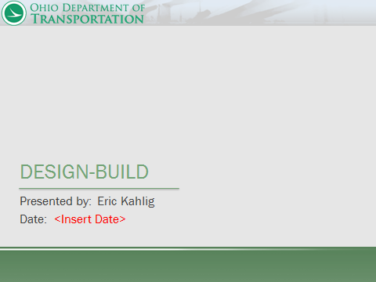

Course Overview and Introductions
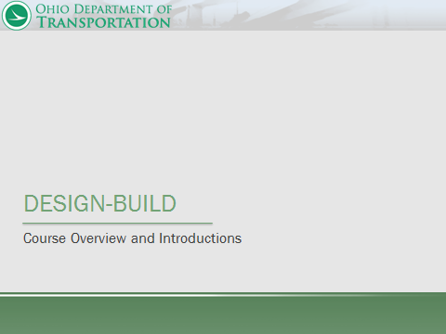

Course Agenda
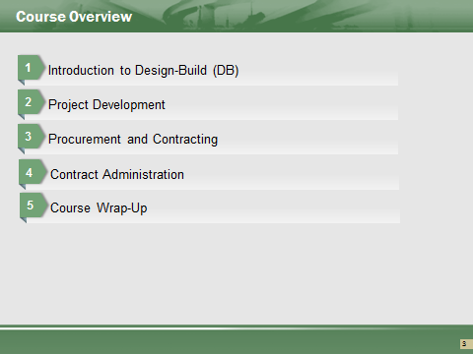

Part 1: Introduction to Design-Build
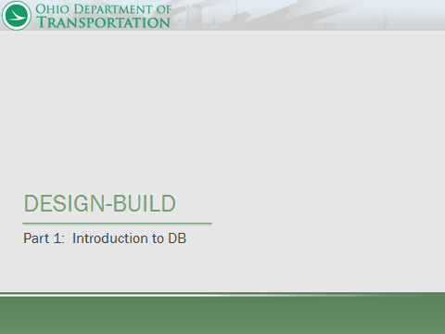

Part 1 Learning Outcomes
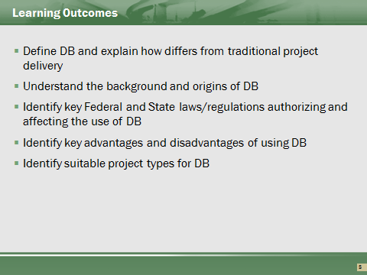

Part 1 Contents
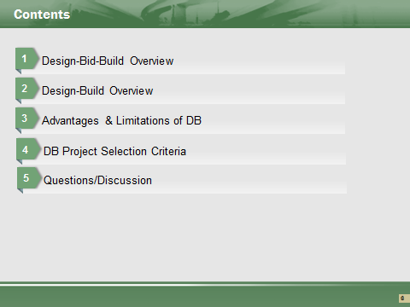

This course is intended to provide participants with an introduction to DB project delivery. For more detailed information regarding DB, participants should consult the following ODOT guidance documents:
- Alternative Contracting Manual
- Design Build Scope Manual
- Project Development Process (PDP) Manual
- Code of Federal Regulations (CFR 363)

Overview of Design-Bid-Build (DBB)


This section of the course provides an overview of the Department’s traditional design-bid-build (DBB) project delivery system. Overview of traditional process for comparison purposes.

DBB: Traditional Contracting Method Defined
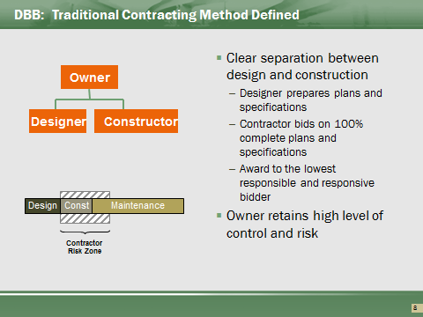

Design-Bid-Build (DBB), or design then bid then build, is the Department’s traditional delivery system, in which fully completed plans and specifications are incorporated into a bid package, which contractors then competitively bid. The Department evaluates the bids received, awards the contract to the lowest responsible and responsive bidder, uses prescriptive or method specifications for construction, and retains significant responsibility for quality, cost, and time performance.
This traditional procurement system has performed reasonably well over the past century, providing taxpayers with an adequate, safe, and efficient transportation facility at the lowest price that responsible, competitive bidders can offer. For the most part, it has resulted in a satisfactory degree of quality, and has effectively prevented favoritism in spending public funds, while stimulating competition in the private sector.
However, in the traditional system, the separation of design and construction services can foster adversarial relationships between the Department, designers, and contractors, can restrict innovation, and result in high cost and time growth. The traditional system may therefore not necessarily provide the best value to the Department for all project types. In recent years, the Department has therefore been increasingly turning to DB to streamline and enhance project delivery and risk allocation by contracting with one entity to provide design, construction, and other pre or post-construction services.

Advantages of DBB
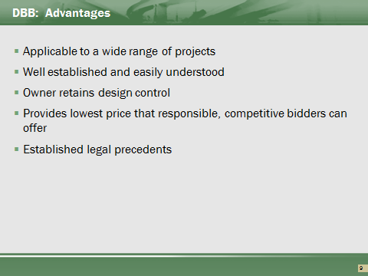

Majority of ODOT projects let Design-Bid-Build. ODOT processes tailored towards delivery using DBB.
ODOT owns all the design control and owns all specification development.
This process is well known, accepted, and promotes competition between all prequalified ODOT contractors.

Risks and Limitations of DBB
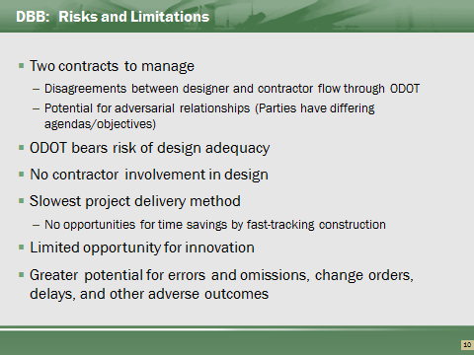

This method has owners in full control of plans, but requires the owner to be the go between the designer and builder.
This process requires the owner to determine the most economical design, but removes the builder from being able to assist in this determination.
The delivery time is the longest as a full design and specification must be complete.
As the owner owns the design, the owner also owns all errors within the design. This results in the potential of cost growth through change orders. These errors can also require additional overhead to be paid as the contractor’s time to manage the project increases.

Design Build: Overview


DB Defined
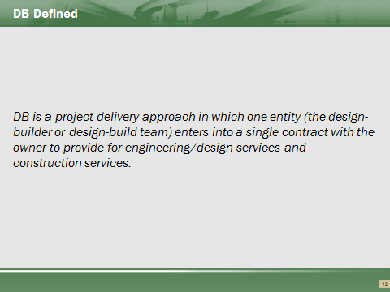

DB is an alternative project delivery system / project delivery methods that combines both project design and construction under one contract. The DBT performs design, construction engineering, and construction according to design parameters, performance criteria, and other requirements established by the Department.

This is an overall project contracting approach, not just a change in the contract.

DB has been implemented in the highway construction industry in a variety of ways based in part on how state statutes are written, the procurement approach used, and how much responsibility is transferred to the DBT for the design and other aspects of project performance.

Key Differences between DBB and DB
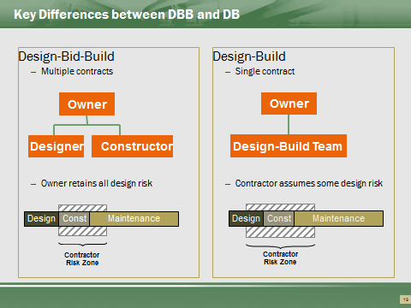

Under traditional DBB delivery, the Department acts as both the owner and the designer. In this role, the Department in effect guarantees the completeness and accuracy of the design and retains most, if not all, of the risk for the success of the design.
In DB, several design-related risks shift to the DBT. Although the Department will continue to retain responsibility for defining the project scope, design criteria, and general site conditions (e.g., initial geotechnical investigation), the DBT, as Designer-of-Record, has ultimate responsibility for the accuracy of the plans, conformance with established standards, and constructability.
Maintenance risk, during the life of the physical construction, primarily remains the same.

Historical Perspective of DB
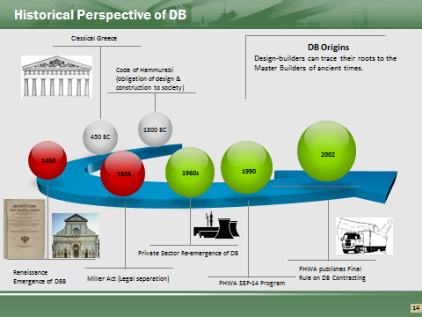

DB is not a new delivery method. From ancient times up through the Renaissance, construction was accomplished by so-called Master Builders who oversaw design and construction.
Master Builders
The Code of Hammurabi – a Babylonian law code of ancient Mesopotamia that dates back to before 1800 BC – contains an early framework for DB contracting. The Code consists of 282 laws, with scaled punishments, that adjust “an eye for an eye, a tooth for a tooth.”
The Code defined an obligation of design and construction to society, leading to the emergence of Master Builders who were responsible for the temples of Classical Greece and the cathedrals of Medieval and early Renaissance Europe. For example, the following provision from the Code defines a builder’s liability for a house that collapses:
A. If a builder build a house for a man and does not make its construction firm and the house which he has built collapse and cause the death of the owner of the house—that builder shall be put to death.
B. If it cause the death of the son of the owner of the house—they shall put to death a son of that builder.
C. If it cause the death of a slave of the owner of the house—he shall give to the owner of the house a slave of equal value.
D. If it destroy property he shall restore whatever it destroyed. And because he did not make the house which he built firm and it collapsed—he shall rebuild the house which collapsed at his own expense.
E. If a builder build a house for a man and does not make its construction meet the requirements and a wall fall in—that builder shall strengthen the wall at his own expense.
From the Code of Hammurabi, King of Babylonia
The Renaissance and the Rise of the Architect
The writings of Leon Battista Alberti contain the first documented separation of arts and crafts. Alberti is known as the first modern day architect in that he developed drawings that were then used by others to construct buildings. The architect no longer needed to be present to direct the construction of a project they had designed. Instructions were conveyed by drawings, and builders built the buildings according to the drawings.
The Industrial Revolution
Further separation of design from construction continued, and by the time of the Industrial Revolution, the design and construction industry had become more specialized and segmented with the rise of Professional Societies and divisions of labor into trades.
In 1897, the US passed the first architectural licensing laws.
Federal Legislation and DBB
In response to the growing segmentation of the construction industry, Congress enacted laws that served to endorse the DBB delivery model.
1893: Legal separation of design and construction responsibilities on Federal projects came about through the passage of a 1893 Congressional Act that authorized the Department of Treasury to “obtain plans, drawings and specifications for the erection of public buildings in the US” through a fee competition.
1926: The Omnibus Public Buildings Act of 1926 required all capital project plans and specifications to be completed and approved before the construction can begin.
1935: With the passage of the Miller Act in 1935, a builder on a federal project of more than $100,000 had to post bonds. The Miller Act essentially took designers out of the construction business as they typically did not have the capital to post a bond. In effect, the Miller Act created a legal separation between design and construction.
1949: Congress enacted the Federal Property and Administrative Services Act, which mandated the separation of design and construction by requiring the selection of builders on public contracts through open competition and lowest responsible price.
1968: Federal Highway Act revised Title 23 USC 112 to award construction contracts “only on the basis of the lowest responsive bid.”
1972: The passage of the Brooks Architect-Engineer’s Act solidified the separation of design and construction and reinforced the DBB project delivery method. The Brooks Act requires government agencies to award architectural and engineering contracts based solely on qualifications, rather than price.
Reemergence of DB
As owners began to experience problems with DBB, DB re-emerged as a possible solution for eliminating the often adversarial relationships between designers and contractors and for obtaining better cost certainty.
Private sector use of DB began to expand in the 1960s with the proliferation of Engineer-Procure-Construct contracts in the oil and gas industry.
In 1990, FHWA implemented Special Experimental Project No.14, Innovative Contracting (SEP-14) as a vehicle for State highway agencies to use Federal-aid funds – with FHWA approval – to experiment with alternative contracting methods for selected projects. In return, the FHWA asked that these agencies report on outcomes, particularly in terms of the ability to save time, reduce costs, or improve performance. DB was one of four alternative contracting practices approved for evaluation in SEP-14, (along with cost-plus-time bidding, lane rental, and warranty clauses).
In 1998, under the Transportation Equity Act for the 21st Century (TEA-21), FHWA took the first steps in developing regulations for the regular use of DB on federally funded transportation projects. Section 1307 of TEA-21 amended federal law, 23 U.S.C. 112, to authorize the use of DB, in states which authorized it under their own legislation, on ITS projects which exceed $5,000,000 and all other projects which exceed $50,000,000.
Based on this change in the law, the FHWA published a final rule for DB contracting in December 2002, which became effective in 2003.

Historical Background on ODOT’s DB Program
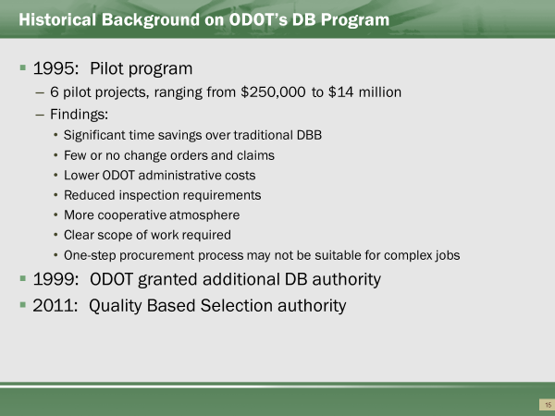

In 1995 the Ohio State Legislature passed legislation authorizing ODOT to develop and implement a DB pilot program for a maximum of six projects.
ODOT selected six pilot projects ranging in value from $250,000 to $14 million to demonstrate the effectiveness of the DB project delivery method.
In 1999, the Ohio legislature gave ODOT additional DB authority in House Bill 163. This bill allows ODOT to contract a maximum of $250 million using DB.
ODOT’s authority expanded in 2011to allow up to $1billion per fiscal year. The revised legislation allowed ODOT to consider Qualifications by combining technical qualifications and competitive bidding elements. ODOT can also pay compensation for preparation of a responsive preliminary design concept to not more than two bidders who, after the successful bidder, submitted the next best bids (stipends).

Historical Background on ODOT’s DB Program

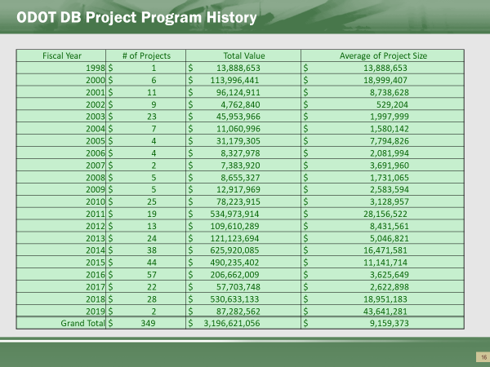

Program size has varied – large increase of overall number of projects beginning in 2011. Large projects / expanded overall program primary driver.

Ohio Bridge Partnership Program and Ramp Clear initiatives increased the overall number of project from 2014 to 2016.

Max per year not reached.

Historical Background on ODOT’s DB Program
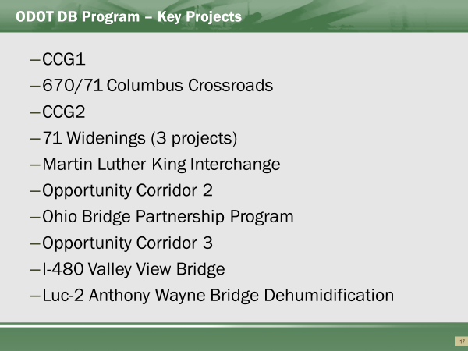

CCG1 – George Voinovich Bridge (Project 1): First Value Based DB award
670 / 71 – First major interchange reconstruction
CCG2 – DB with a Finance component
71 widenings – 3 consecutive DB projects for the widening of 71 between Columbus and Cleveland
MLK – First Two-step Low Bid
OC2 – First project to use minority goals in determination
OBPP – replacement of 200 bridges
OC3 – First project to allow more than 40% award on proposal
I-480 Valley View Bridge – First Pass/Fail evaluation
LUC-2: First DBOM

Authority/Legal Basis for Use of DB
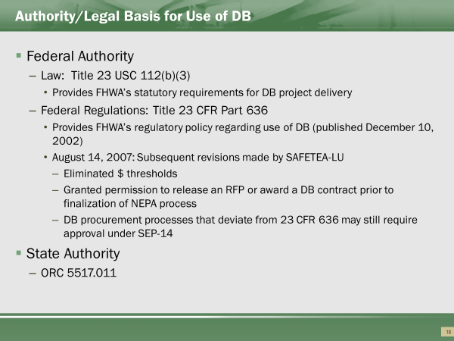

Federal Authority
In 1998, under the Transportation Equity Act for the 21st Century (TEA-21), FHWA took the first steps in developing regulations for the regular use of DB on federally funded transportation projects. Section 1307 of TEA-21 amended Federal law, 23 U.S.C. 112, to authorize the use of DB – in states that authorized its use under their own legislation – on ITS projects that exceeded $5,000,000 and all other projects that exceeded $50,000,000.
Based on this change in the law, the FHWA published a final rule for DB contracting in December 2002, which became effective in 2003 (23 CFR Part 636).
Subsequent modifications required by section 1503 of SAFETEA-LU resulted in revisions published in a final rulemaking on August 14, 2007. Among the revisions made by SAFETEA-LU were the elimination of the dollar thresholds for “qualified” projects; and permission to release an RFP or award a DB contract prior to completion of the NEPA process.
DB procurement processes that deviate from the requirements of 23 CFR 636 may require an SEP-14 work plan and approval.
State Authority
State authority to use DB is derived from ORC 5517.011, which allows a project’s design and construction elements to be combined into a single contract and the work to be bid using a scope of work document.
The provision grants the director the discretion to use a value-based procurement process, which bases contract award on a combination of price and qualitative considerations.
ORC 5517.011 Combining design and construction elements of highway or bridge project into single contract. Notwithstanding section 5517.01 of the Revised Code, the director of transportation may establish a program to expedite the sale and construction of special projects by combining the design and construction elements of a highway or bridge project into a single contract. The director shall prepare and distribute a scope of work document upon which the bidders shall base their bids. Except in regard to those requirements relating to providing plans, the director shall award contracts under this section in accordance with Chapter 5525. of the Revised Code.
Notwithstanding any provision of Chapter 5525. of the Revised Code, the director may use a value-based selection process, combining technical qualifications and competitive bidding elements, including consideration for minority or disadvantaged businesses that may include joint ventures, when letting special projects that contain both design and construction elements of a transportation project into a single contract.
The total dollar value of contracts made under this section shall not exceed one billion dollars per fiscal year. The director may provide compensation for preparation of a responsive preliminary design concept to not more than two bidders who, after the successful bidder, submitted the next best bids. The director may establish policies or procedures necessary to determine the amount of compensation to be provided for each project and the method of evaluating the value of the preliminary design concept submitted, but in no instance may the compensation exceed the value of such concept.

ODOT’s DB Delivery Options
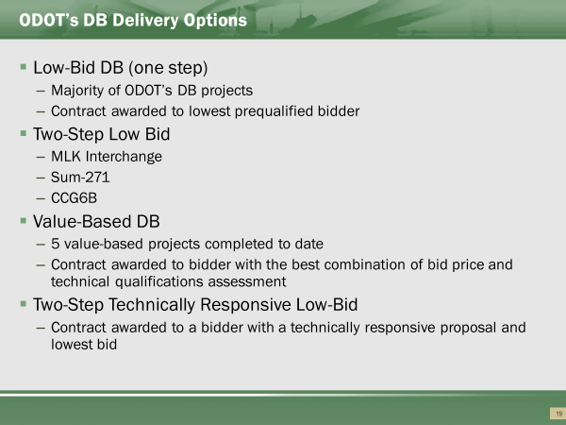

ODOT has been granted fairly broad discretion when it comes to selecting a DB approach appropriate for the specific needs of a given project.
ODOT has implemented DB using three different approaches:
- One-Step Low Bid. Under one-step low bid, pre-qualified Offerors submit bids, which the Department uses to determine the Apparent Low Bidder. Quickest DB method.
- Two-Step Low Bid. A two-step low bid process incorporates a Request for Qualifications (RFQ) step in which Offerors prepare Statements of Qualification (SOQ), which the Department then uses to limit the playing field to the most qualified firms and a limited number of scored criteria. The short-listed Offerors are then invited to prepare Price Proposals, which the Department uses to determine the Apparent Low Bidder.
- Value-Based. Value-based DB contracting also entails an RFQ step, followed by an RFP step in which the short-listed Offerors are invited to submit Technical and Price Proposals, which the Department evaluates and scores to determine the Apparent Best Value Bidder based on a combination of bid price and a technical qualifications assessment. Timely process adding approximately 6months in the delivery timeframe. Used rarely.
- Two-Step Technically Responsive Low-Bid. Two-Step Technically Responsive Low-Bid process incorporates a Request for Qualifications (RFQ) step in which Offerors prepare Statements of Qualification (SOQ), which the Department then uses to limit the playing field to the most qualified firms. The short-listed Offerors are then invited to submit Technical and Price Proposals. The Department evaluates the Technical proposal on a Pass/Fail evaluation. Process usually includes a “pre-submission” / Proprietary Techincal Information meetings to discuss concept before official submittal.

Advantages and Limitations of Design Build
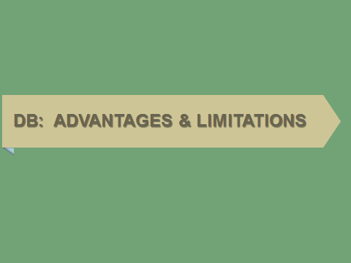

Advantages of DB
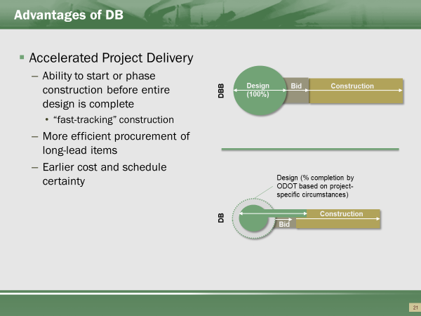

The overall project schedule is typically a driving consideration for selecting the DB delivery approach. The ability offered under DB to overlap (“fast-track”) design and construction activities can be used to accelerate the overall project delivery schedule, even if actual construction time remains similar to that of a traditional project. Time is gained as complete design is not required. Final design is provided as a result of the contract.
Earlier contractor involvement also allows for more efficient procurement of long-lead items, earlier cost and schedule certainty, and enhanced constructability of plans.
In addition, allocating design and construction responsibilities to one entity should improve communication and coordination efforts between the designer and contractor, and thus minimize the potential for project delays associated with requests for information and design-related errors and omissions.

Additional Advantages of DB
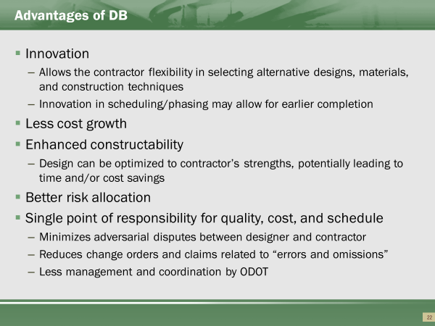

In addition to quicker delivery, other considerations for using DB include the following:
Innovation – To the extent that the Department is willing to relinquish control over some aspects of the work, use of DB has the potential to foster contractor innovation and thereby improve the quality or economy, or both, of the end-product. Innovation can also extend to management techniques and other elements of the project, such as public information and community relations, maintenance and protection of traffic (MPT), and schedule.
Less Cost Growth – Assigning control over design and construction to one entity should minimize cost growth due to errors and omissions in the plans. Furthermore, the lump-sum nature of the DB contract eliminates cost increases due to variation in unit quantities. No 104.02 adjustments for quantities.
Enhanced Constructability – Early contractor involvement and coordination with the designer should allow the design to be optimized to the contractor’s strengths, potentially leading to time and/or cost savings.
Better Risk Allocation – Risk can be allocated to the party best able to manage it. This is identified and determined in the development of the bid package. This is handled in the determination of the level of preliminary design.
Single Point of Responsibility – Having a single point of responsibility for design and construction services promotes a non-adversarial relationship between the designer and contractor and reduces change orders and claims related to errors and omissions in the plans.

Risks and Limitations of DB
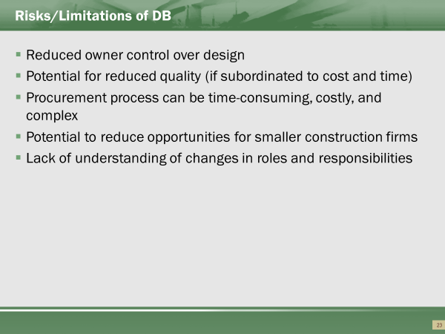

Note that before deciding to use DB, it is important to consider its potential risks, which may include:
Reduced owner control over design – By only providing a Scope of Work document, the Department can exert less control over the final design.
Quality concerns – DB eliminates the traditional checks and balances between the designer and contractor. As part of the DBT, the designer is no longer in the position to act as the Department’s advocate. Quality may be subordinated by cost or schedule considerations.
Reduced competition – Opportunities for smaller, local construction firms may be reduced. Fewer competitors may result in higher initial costs. Primarily a concern in the early stages of a DB program. Less likely to occur in Ohio.
Lengthy procurement process – Particularly if using a two-step value-based process, the scoping and procurement phase can be critical to project success.
Confusion regarding roles and responsibilities – Roles and responsibilities of the contractor and the Department can become blurred if not adequately defined in the specifications or contract documents. “Traditionalists” to be less likely to accept.

Design-Build Project Selection
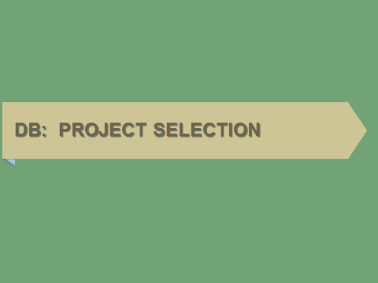

This section of the course discusses DB project selection criteria. For more detailed information, refer to the following ODOT manuals:
- Design Build Scope Manual
- Innovative Contracting Manual

Criteria for Using Design-Build
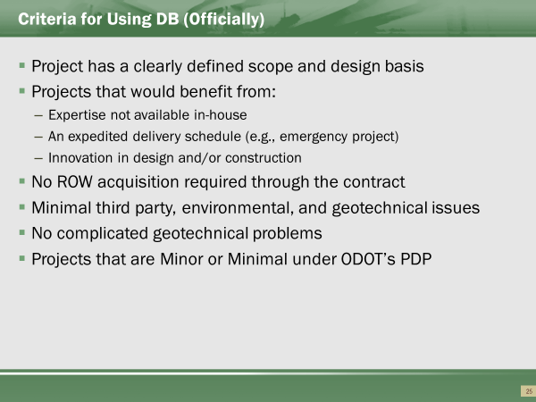

Considerations for Using DB
Although DB can be used to deliver almost any project, best practice suggests that it provides the greatest benefit on projects for which reduced schedule duration, increased constructability, and/or enhanced innovation offset the potential risks and associated costs of transferring design responsibility and other roles traditionally held by the Department to the DBT.
DB has been used successfully on projects for which:
- The project scope can be adequately defined without 100% complete PS&E.
- A compressed schedule is needed.
- Outside expertise is needed.
- Schedule certainty is needed.
- Early cost certainty is required.
- Project quality can be defined through minimum design.
- Opportunity for innovation exists.
- Minimal third party risks exist or can be mitigated.
In addition, ODOT’s PDP identifies the following additional screening characteristics for identifying candidate projects for DB:
- Minimal utility coordination required.
- Manageable public controversy.
- Projects that are environmentally exempt or qualify for a Level 1 Categorical Exclusion.
- Projects that are Minor or Minimal under ODOT’s PDP.
As a final consideration, the Department must have adequate staff to devote to the DB procurement effort, particularly for a two-step value-based selection. Development of the solicitation documents and evaluation of proposals require a far more intensive effort under DB delivery than in a traditional procurement. Best practice also suggests that key personnel remain involved with the project from its inception to completion of construction.
Considerations for NOT Using DB
Reasons for not using DB to deliver a particular project include:
- The project schedule cannot be compressed or there is no benefit from compression.
- The design must be complete to obtain accurate pricing.
- The design must be complete to resolve environmental and/or other third party issues.
- Environmental or other third party issues are better managed by the Department, not the DBT.
- Project is too small to attract competition.

Suitable Project Types for DB Delivery
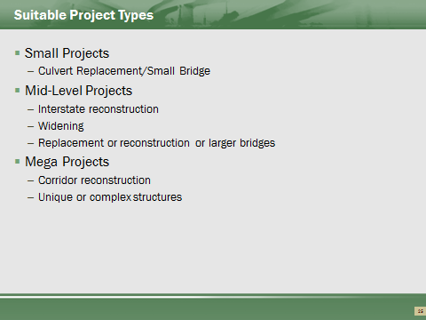

While stated that project with difficulties (ie ROW, railroads, utility conflicts, complex geometrics) are not generally good candidates, ODOT has realized considerable benefits. Complex and difficult projects are usually the best opportunities for innovations.

Central Office should be consulted when considering highly difficult projects for DB candidates.

Recap of Part 1 Learning Outcomes
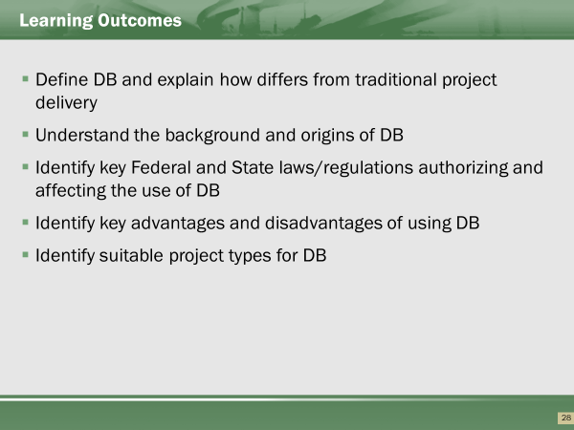

Part 2: Project Development
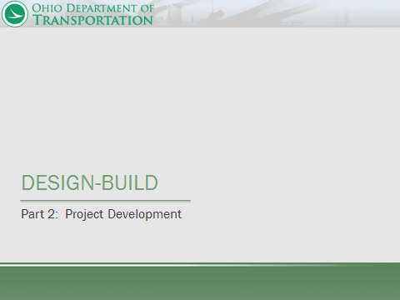

Part 2 Learning Outcomes
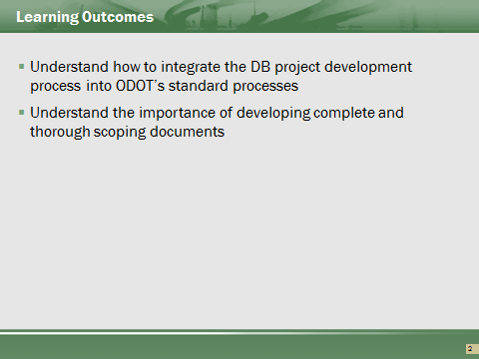

Contents of Part 2
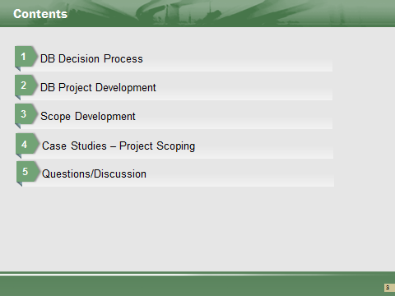

DB Decision Process
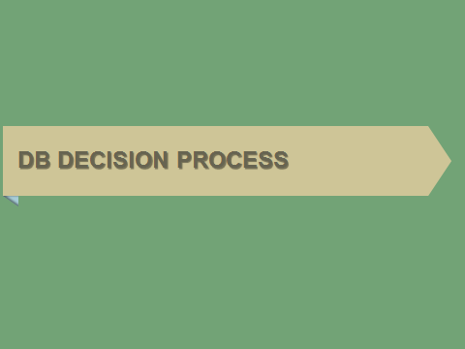

Project Delivery Decision Process
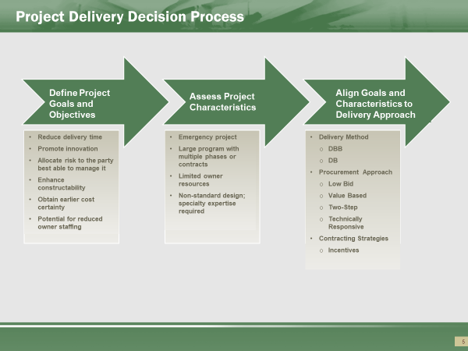

Identification of project goals and risks are critical to the success of any project. However, when the Department is considering use of an alternative delivery method such as DB, articulation of these factors takes on even greater importance as they set the foundation for the entire project development process.
Decisions made with respect to risk allocation, procurement method (low-bid vs. best-value), RFQ/RFP development, and the proposal evaluation and DBT selection process, should all stem from the goals identified at project inception.

DB Project Development
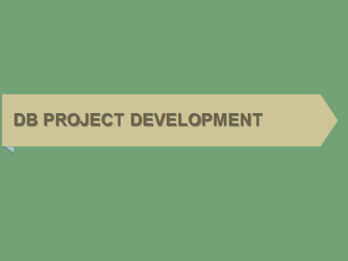

This section of the course discusses how DB can be integrated into ODOT’s standard project development processes. For more information, users should consult the following ODOT manuals:
- Project Development Process Manual
- Location and Design Manual (particularly Section 1401.5 on DB)

DBB vs. DB Project Delivery
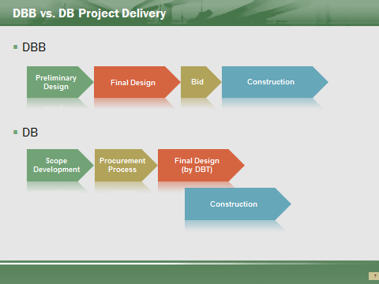

Under its standard DBB delivery approach, the Department prepares complete plans, specifications, and estimates (PS&E) to fully define project requirements. These design documents are then used to procure construction contractors (typically on a low-bid basis) to build the project in strict accordance with the Department’s design.
In contrast, under DB delivery, the DBT, and not the Department or a consultant retained by the Department, is the Designer-of-Record (or Engineer-of-Record) responsible for the final project design, in addition to construction of the project in accordance with this design.
With this change in roles and responsibilities comes a change in the basis of the contract between the Department and the constructor. No longer are 100 percent complete plans and specifications the technical basis of the construction contract. Instead, the Department’s Scope of Work Document forms the technical basis of the DB contract, and the 100 percent complete plans and specifications are a required deliverable under this contract. As such, the Scoping Phase (akin to Preliminary Design under DBB) takes on heightened importance under DB.

DBB Project Development Process (PDP)
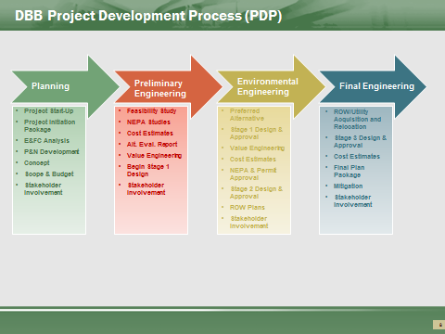

For more information, users should consult the following ODOT manual:
- ODOT Project Development Process Manual

How Does DB Modify the Planning Phase?
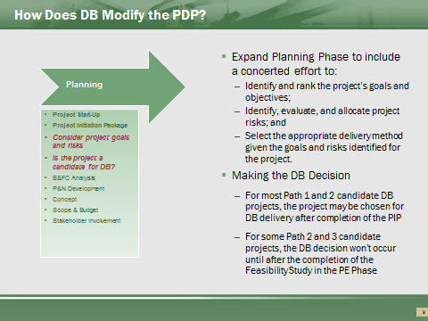

For most projects, the possibility of using DB will not substantially alter the Department’s existing Planning phase. The need for the Department to prepare a Project Initiation Package, obtain input from stakeholders, develop a budget, etc. will still be required under DB delivery.
To facilitate the DB decision process, this phase should be expanded to include a concerted effort to:
- Identify and rank the project’s goals and objectives;
- Identify, evaluate, and allocate project risks; and
- Select the appropriate delivery method given the goals and risks identified for the project.
These additional activities are not necessarily sequential and will likely require some iteration as project data is refined through subsequent investigations and preliminary engineering efforts.

How Does DB Modify the Preliminary Engineering Phase?
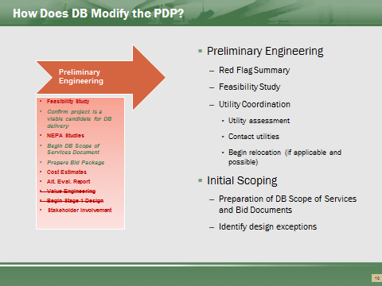

To develop the basic project configuration for the solicitation documents, the Department must still perform preliminary engineering and design, similar to that required for a traditional DBB project. With DB, however, the challenge is not to progress this design to a point that precludes any innovation and flexibility on the part of the DBT, particularly if innovation is a stated goal of the project.
ODOT will normally prepare the Design Red Flag Summary and Feasibility Study, using this information to help determine if the project is a candidate for further development as a DB project. Once this is confirmed, the Department will begin to prepare the DB Scope of Services document and the Bid package.
This scoping effort essentially replaces several of the Department’s traditional tasks during the Preliminary Engineering phase of project development. Instead of initiating an effort to take plans and specifications to 100 percent completion, the project team will begin to define the project scope, which will form the basis of the bid documents.

How Does DB Modify the Environmental & Final Engineering Phases?
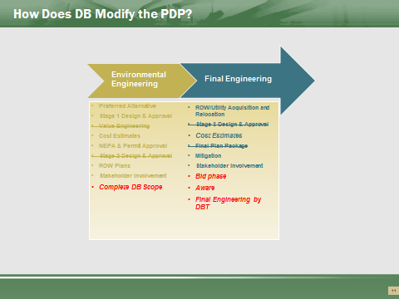

The Department will generally have to perform enough preliminary engineering and design to support the NEPA, ROW acquisition, and Utility relocation efforts.
With regard to the NEPA process, the Department’s role will likely remain unchanged under DB. Note, however, that the FHWA’s Final Design-Build Rule under SAFETEA-LU (amended August 14, 2007) does allow agencies to issue RFPs, execute agreements with the selected DBT, and issue the notice-to-proceed with preliminary design work prior to the completion of the NEPA process. Such early involvement of the design-builder could further accelerate the delivery process by advancing the preliminary design of the preferred alternate in parallel with the NEPA process. To avoid conflicts of interest under such a procurement strategy, the Design-Build Final Rule does preclude the DBT from preparing the NEPA documents and from having any decision-making responsibility with respect to the NEPA process. The DB contract under these conditions would also require appropriate provisions (e.g., through the use of contract hold points) to prevent the design-builder from proceeding with the final design and any physical construction prior to conclusion of NEPA. Similarly, the contract would have to include termination provisions in the event that the no-build alternative is ultimately selected.
Although federal regulations allow the RFP and DBT selection to occur prior to completion of the NEPA process, ODOT will generally only issue a bid package once the NEPA process is complete and the necessary environmental clearances have been received. The preliminary engineering and preparation of the appropriate environmental documents will therefore remain the Department’s responsibility, just as with the DBB process.
Similarly, ROW acquisition and utility relocation will proceed much the same as it does under a traditional DBB project. The Department will retain responsibility for obtaining ROW for most DB projects. However, under certain circumstances, it may not be practical or possible to define the final footprint for the project, and complete the acquisition process, until the DBT completes the design phase. In these cases, the DBT must determine what additional ROW and temporary easements are necessary to accommodate the final design. If additional ROW is deemed necessary, the DBT must submit a written request to the Department justifying the need for additional ROW.
The Department in turn would be responsible for assessing whether the additional ROW remained within the scope of the environmental permits, acquire the additional property, and determine the cost and lead-time impacts to be borne by the DBT. The Department would also handle the acquisition of temporary construction easements identified by the DBT but might transfer responsibility for acquiring additional temporary easements to the DBT if it is practical to do so. In either case, the DBT would be responsible for any schedule or cost impacts associated with the acquisition of additional temporary easements.
The Department has a long-standing relationship with most local agencies, Utilities, and railroads. As such, the Department will likely be in the best position to influence and obtain the required cooperation from these third party entities. In most cases, the Department will obtain the required agreements with these parties prior to its issuance of the bid package to avoid schedule impacts. If these have not been secured by the time of advertisement, the RFP should indicate the status of any outstanding agreements.

DB Project Development
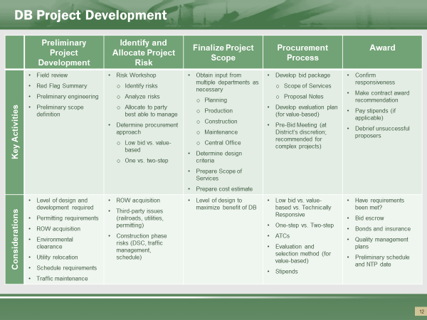

The scoping and bid package development process can be intensive effort, requiring input from multiple functional areas and specialized expertise a dedicated effort to identify goals, risks, and Department preferences, and a significant effort to evaluate proposals (if a value-based procurement process is used).
The decision to use a two-step low bid, two-step technically responsive, or value-based procurement process is a Central Office decision.
Topics covered in DB Manual, PDP process, and the L&D manual.
On large DB projects, consideration to be given to having outside help in developing a large DB project.

Project Scoping


For further information on project scoping, users may consult the following ODOT documents:
- Design-Build Manual and Instructions for Completing the Scope of Services form
- Scope of Services template

Function of Scope of Services Document
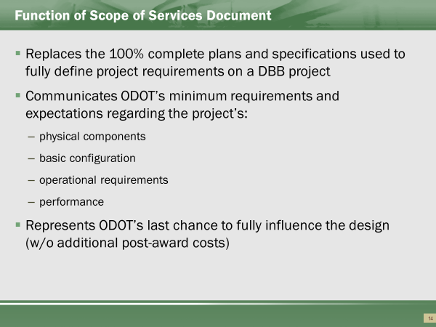

Of the various documents to be prepared and issued during the procurement process, the Scope of Services document, which communicates the Department’s expectations to bidders and serves as the basis for the DB contract, is perhaps the most critical factor to a project’s success. In this respect, the Scope is akin to the plans and specifications prepared under traditional DBB delivery.

Scoping Objectives
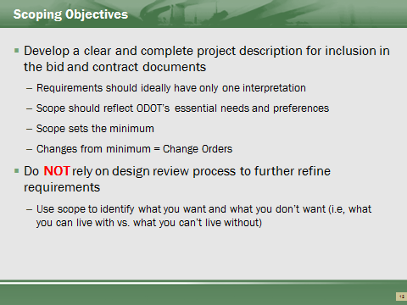

Critical to continue to consider that any preferences need determined prior to advertising the DB project. The Scope of Services and contract documents, which include design manuals, are the minimum requirements for the design.

When using a DB process, we are acknowledging that we are only asking for the minimums.

Defining the outcomes of the project through the review process is not an option.

Scope Development
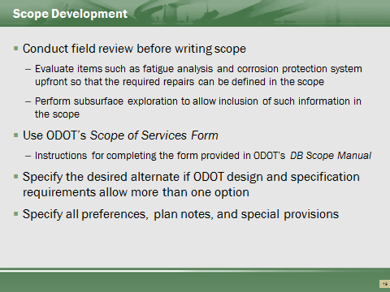

In disputes, the contract is construed against the person writing the contract.
ODOT has the knowledge of the projects and know the intent of the project. Scope and project developers must spend adequate time in the development of the bid documents.
Ensure what is being described can be built. ODOT has the responsibility to understand the project in sufficient detail to know a viable solution is achievable.

Scope Development
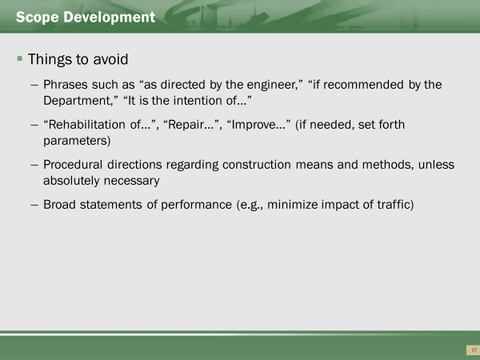

Language within the Scope must be enforceable. Making recommendations without definable outcomes has limited to no value. Stating the intention of the outcome does not add value.
Ambiguities in the requirements will cause conflict during the management of the contract. Broad overall statements will not result in desired outcomes.

Key Scope Areas to Address
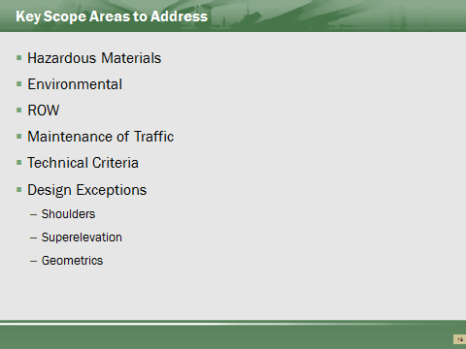

Hazardous Materials
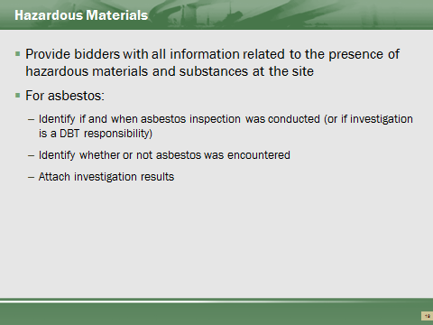

Environmental Site Assessments should define the limits of any hazardous material. It is appropriate to include abatements within the DB scope if clearly definable.
- Limits
- Types
- Quantities
Potential unknowns of quantities could be handled with an established unit bid item. This removes the risk of quantity from the builder, but owner should make appropriate estimates.
Asbestos inspection needs performed prior. Asbestos was used in concrete in the past, so a survey to determine if the concrete on bridges, retaining walls, and other structures needs performed. Asbestos in concrete is a high cost.

Environmental
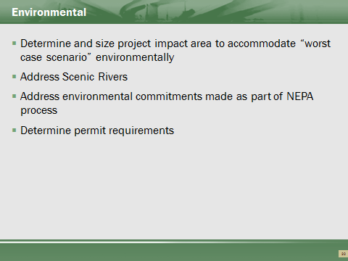

Limits determined from best estimate of work.
Scenic Rivers and review requirements may require the DBT to submit reviewable package of only the interested area.
Clearly include commitment requirements within the Scope, and not just attach the Environmental Document.
Clear as many permits prior as possible (i.e. 401/404 permits). This reduces construction timing risks.

Additional Right of Way
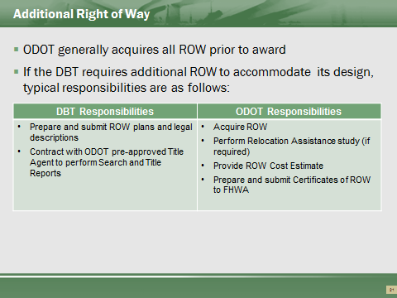

Allowed to sell a project prior to completing ROW, but not recommended.
If ROW acquisitions performed/completed after award, then timeframes need included. Timeframes become contractual obligations on ODOT. If considered, FHWA contact and Central Office needs to be included.

Utilities
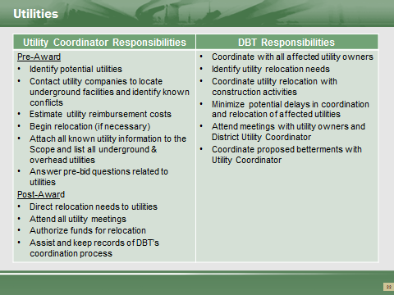

Utility coordination by the Contractor does not infer ODOT has no responsibilities in the Utility work.
Ohio Design-Build Utility Responsibilities Pre sale -Reference Locations & Good Practices
ODOT Responsibilities:
PDP: Requirements of utility coordination same on DB as for all projects through the Feasibility Study and the Alternative Evaluation Report. (PDP Manual-Introduction 11.1. lithe project may be chosen for Design-Build during the Planning Phase of the PDP after the Project Initiation Package (PIP) is completed. For some Path 2 projects and the non-complex Path 3 candidate projects, this decision will occur after the Feasibility Study (FS) is completed in the Preliminary Engineering Phase.")
- Utility Assessment (PDP Manual-Preliminary Engineering: 1. Feasibility Study Development)
- Utility companies are contacted and asked to locate their underground facilities within the project area. (PDP Manual-Preliminary Engineering: 3: Alternative Evaluation Report)
- Utilities which conflict with the proposed project work are identified for relocation. (PDP Manual -Preliminary Engineering: 3: Alternative Evaluation Report)
- Determine estimated utility reimbursement cost. (PDP Manual-Preliminary Engineering: 3: Alternative Evaluation Report)
Determine which utilities are located in the location of the project. Gather and provide all known utility information (PDP Manual-Planning: 8.4) and provide this information to the DBT during the Bidding process and list all underground and overhead utilities, similar to a Utility note (DB Manual-Section 12.1).
Direct the utility owners to relocate or adjust water lines, gas lines, wire lines, service connections, water and gas meter boxes, water and gas valve boxes, light standards, cableways, signals, and all other utility appurtenances within the limits of the proposed construction (unless otherwise noted in the contract). (PN126: 105.07 Cooperation with Utilities)
Coordinate early with the utilities to establish realistic relocation schedules upon final design (Good practice and inferred in 105.07 Cooperation with Utilities -B. "If performance of the Contractor's work is delayed because the utility owners fail to relocate or adjust their facilities as previously agreed, the contract time will be adjusted in accordance with the provisions of108.06.")

Maintenance of Traffic
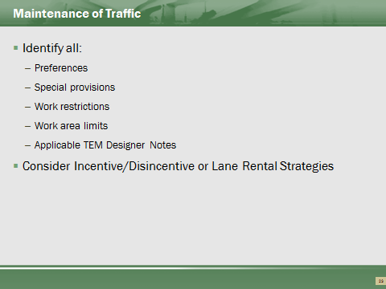

- Specify minimum number of lanes to maintain.
- Review all TEM notes and specifically include if needed.
- Known restriction on time to be clearly noted. Do not specify ambiguous restrictions without noting.
- Innovative Contracting methods allowed.
  - A+B allowed
  - Incentive/Disincentive allowed
  - Window Contract / Flexible Start allowed

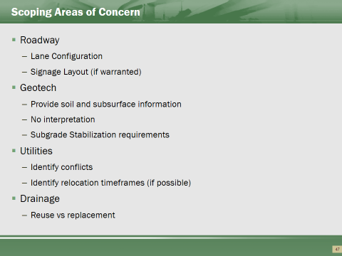

- Coordinate with the Office of Pavements for buildup and types.
  - Rehabilitation types and options to be specified.
- Lane Configuration and Turn lane required lengths – specify graphically or narrative. Ensure clarity. Specify minimum underdrain depths as design guides specify a max depth.
- Signage – Overhead or ground mounted (freeway). Potentially provide preliminary layout.
- Provide soil or structure borings, but do not provide recommendations. DBT to determine capabilities from information provide – interpretation risk on the DBT.
  - Subsurface high risk item.
  - Reuse of existing borings acceptable to provide IF quality of borings appears good and Office of Geotech agrees.
- Perform subgrade analysis and specify subgrade treatment per Geotechnical Bulletin-1 (GB1).
- Major drainage installations need evaluated prior to award.
  - Consideration of reuse only if determined usable prior.
  - Do not leave the determination of quality of drainage structures (pipe and installations) up for DBT to determine if available for reuse.

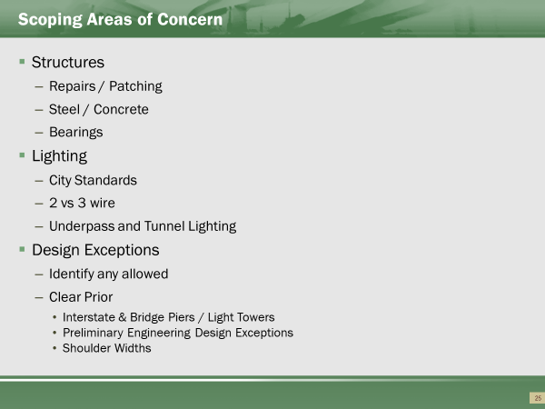

- Specify minimums allowed for structure types. Considerations given for replacements for railroads.
- Identify bearing work needed for rehabilitated structures. New vs refurbished. Shear requirements of existing pier caps need addressed, or potentially ignored. Loading of existing substructures and unknown piling may disallow concrete beams (if substructure not new). Consideration needing to be given for drilled shafts vs
- Repair areas (patching) needed to be clearly scoped, or consideration for establishing unit price pay item. Subjective area of evaluation by DBT will almost always be made towards the minimal option.
- Lighting – consider underpass lighting requirements. Specify tunnel lighting, if required. Consideration given for upgrading of system.
- Identify allowed design exceptions. If shown in preliminary engineering, then difficult to disallow after award. Median towers and median bridge piers often require shoulder exceptions.
- Traffic Signals – Consult with Traffic Engineering for requirements. Coordinate with municipalities to establish and use their criteria (if applicable)

Technical Criteria
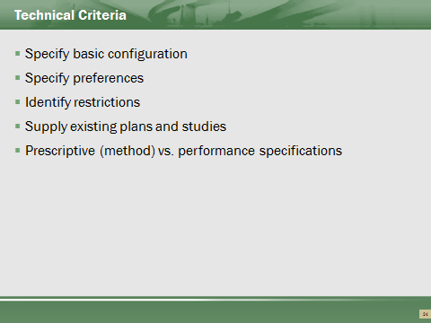

Basic Configuration
A key aspect of scope development entails establishing the basic configuration. The DBT’s proposal and design must be consistent with the basic configuration (though it could be subject to changes approved in accordance with ACT procedures). Typical constraints addressed in the basic project configuration include:
- Project Boundaries:
- ROW plans that depict the limits of ROW or easements obtained or to be obtained by the Department
- Environmental constraints (e.g., wetland protection)
- Project limits
- Horizontal and vertical alignment;
- Vertical clearance requirements;
- Critical project components:
- Number of lanes
- Interchanges
- Ramps
- Location of major structures
Performance versus Method Specifications
To the extent that the Department is willing to relinquish control over some aspects of the work, the use of more performance-oriented specifications has the potential to foster contractor innovation and thereby improve the quality or economy, or both, of the end-product. Use of less prescriptive specifications will also shift more performance risk from the Department to the DBT.
The difference between performance and method specifications and conditions under which each would be appropriate are described below.
- Method specifications (also called prescriptive or recipe specifications) require contractors to use specific materials, equipment, and methods to complete the work. The prescribed requirements are typically based on materials and methods that have historically produced satisfactory results for the Department, thereby eliminating risk associated with newer, less proven methods and risk associated with varying contractor performance. Contractors are provided few, if any, opportunities to deviate from the specified requirements, and, provided that the specifications are met, is not responsible for performance deficiencies of the end product (i.e., the Department retains performance risk).
- Performance specifications contain statements of required results that focus on the desired quality level or performance of the finished work. (For example, “the interchange should perform at LOS B”).
Appropriate Conditions for Using Method vs. Performance Specifications
Method Specifications | Performance Specifications
- End product performance cannot be easily defined.  - End product performance cannot be easily or economically measured and verified.  - Limited methods exist that would satisfy the agency’s minimum requirements.  - The agency must retain performance risk because of permit requirements; maintenance considerations; need to tie into existing or adjacent construction; and similar issues.  - Removing and replacing defective work would be impractical.  - Pre-existing conditions would compromise the transfer of performance risk to the contractor. | - End product performance can be defined in terms of desired outcomes or user needs.  - Key performance parameters can be measured and tested, and the test methods are rapid, reliable, and economical.  - There are multiple approaches to achieve the desired results.  - Industry is willing to assume performance risk.  - Agency is willing to relinquish control over some aspects of the work.

How Far to Take Preliminary Design?
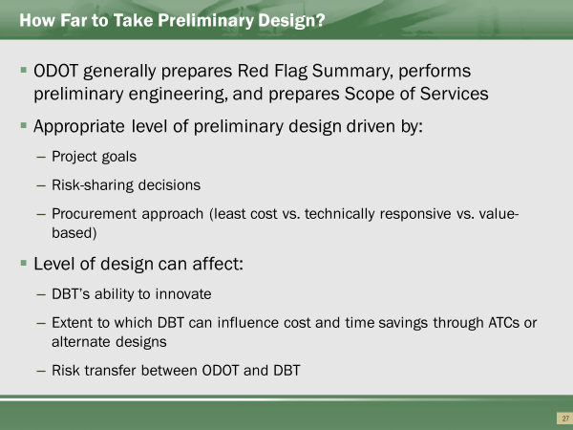

Under traditional DBB delivery, the Department acts as both the owner and the designer. In this role, the Department in effect guarantees the completeness and accuracy of the design and retains most, if not all, of the risk for the success of the design.
In DB, several design-related risks shift to the DBT. Although the Department will continue to retain responsibility for defining the project scope, design criteria, and general site conditions (e.g., initial geotechnical investigation), the DBT (as Designer-of-Record) has ultimate responsibility for the accuracy of the plans, conformance with established standards, and constructability.
Determining the appropriate level of design by the Department therefore requires a careful balancing of the needs, goals, and risks identified for the project. Providing too much design can restrict innovation and increase design liability for the Department, whereas providing too little can create uncertainty, driving bidders to increase the contingency included in their bids.
To a large extent, the information needed to advance the environmental documents and ROW acquisition will drive the level of preliminary design needed. The risks identified during the risk management process will also indicate where the Department needs to focus its scoping efforts. For example, any risks related to utilities, ROW, railroads, and other stakeholder concerns may necessitate additional engineering and design to mitigate the concern or to secure the appropriate agreements with the affected third party.

Level of Design vs. Risk
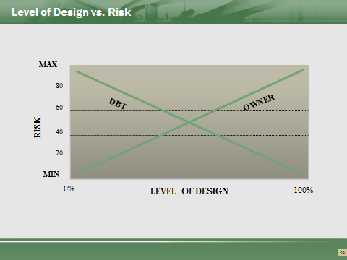

Determining the appropriate level of preliminary design by the Department can be challenging. Providing too much design can restrict innovation and increase design liability for the Department, whereas providing too little may result in the Department not receiving what it wants or placing undue risk upon the DBT (which the DBT will likely pass on to the Department in the form of a higher bid).
Agencies experienced in DB often report higher levels of project satisfaction with lower levels of preliminary design (with 30 percent often cited as a benchmark). However, this is not to say that the same level of preliminary design should be applied to every DB project, or that every element within a single project should be taken to the same level of design. Each project, as well as each component of a single project, must be examined to determine the extent of preliminary or conceptual design needed to clearly convey the Department’s performance expectations. For certain project elements, defining performance requirements could require close to 100 percent design, whereas for others, very little design may suffice.

Design Risk and the Spearin Doctrine
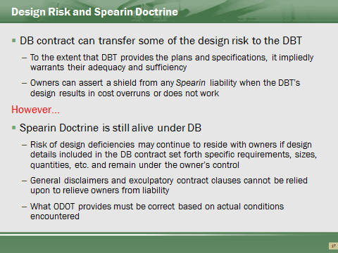

The Spearin Doctrine
A long held principle of construction law is that if a contractor is bound to build according to plans and specifications provided by the owner, the contractor will not be responsible for defects in the plans and specifications (i.e., there is an “implied warranty” that the owner’s plans and specifications are suitable for the purpose intended).
The leading Supreme Court case on the subject, U.S. v. Spearin, 248 U.S. 132 (1918), involved cross-claims by the owner and contractor resulting from a failure of a sewer. Although the contractor built the sewer to specifications, it was determined to be inadequate to handle the actual flows and tides encountered. The sewer failed to function because of an existing dam in an adjoining line that was unknown to both the government and the contractor.
The Supreme Court excused the contractor’s non-completion and allowed them to recover extra costs related to the failure, holding: “[T]he insertion of the [contract] articles presenting the character, dimensions and location of the sewer imparted a warranty that, if the specifications were complied with, the sewer would be adequate.”
In the wake of the Spearin decision, similar case law further affirmed the right of contractors to assume the specifications are free of defects. While some cases have based the implied warranty on the owner’s presumed “superior knowledge” of the work conditions, it is more commonly based on the simple rationale that the party preparing the specification bears the risk of its inaccuracy.
Applying the Spearin Doctrine to DB Projects
In the context of a DB project, the owner will generally provide design criteria and performance standards, but the DBT will prepare the actual construction plans and specifications. The DBT will thus generally bear the risk of non-performance and cost overruns related to its final design.
However, risk of design deficiencies may continue to reside with owners if design details included in the DB contract set forth specific requirements, sizes, quantities, etc. and remain under the owner’s control. Recent case law suggests that the courts may continue to invoke the Spearin Doctrine to protect the contractor if it can trace the ultimate cause of the problem to defective design specifications issued by the owner.
A recent case in which the Spearin Doctrine was applied to protect a contractor on a DB project is described in the box below.
Drennon Construction & Consulting, Inc. v. Dept. of the Interior
In Drennon Construction & Consulting, Inc. v. Dept. of the Interior, CBCA No. 2391 (January 4, 2013), the Civilian Board of Contract Appeals (CBCA) held that even if a DB contract required the contractor to build the project in strict accordance with the specifications provided, the DBT’s failure to perform the work exactly as instructed did not shield the government from Spearin liability.
Factual Background
The Department of the Interior’s Bureau of Land Management (BLM) contracted with Drennon Construction & Consulting, Inc. (Drennon) to widen a road to a campground in central Alaska. The project required the contractor to excavate a hillside and build a gabion wall along it. As Drennon excavated, the hillside slopes collapsed. Both parties agreed that work should cease until a solution to the problem could be devised. Ultimately, the project was scaled back; the wall was not built and the road was not widened.
A dispute arose regarding the cause of the hillside slope collapse:
- Drennon contended that the design of the project was defective and that the geotechnical information provided in the solicitation – on which Drennon relied to price the job – was flawed.
- Drennon claimed that it was entitled to recover costs it incurred during the suspension of work and costs it incurred to buy and assemble gabions that were of no use due to the way in which the project was ultimately completed.
- BLM counter-argued that the problems on the project were caused by Drennon’s inappropriate building approach, which did not comply with the recommendations contained within the geotechnical report.
- BLM noted that the contract required Drennon to design, as well as build, the gabion wall. BLM argued that Drennon’s design was faulty and therefore if not entitled to recover damages.
The Board’s Findings
The board found in favor of Drennon, applying the Spearin Doctrine to explain that although Drennon’s technique for excavating the hillside may not have been ideal, due to the defects in the design of the project and significant differences between the geotechnical information provided and the actual soil composition, the hillside would have collapsed no matter what technique the contractor had used.
The board noted that Spearin liability attaches to design specifications (i.e., method) and not performance specifications and affirmed that general disclaimers are insufficient to shift this implied warranty from the owner to the contractor. In the board’s opinion, the contract provision requiring a contractor site survey “alerted bidders to the possibility that the design might have required a bit of tweaking, but cannot reasonably be read to impose on the contractor an obligation to construct the project in a manner significantly different from that envisioned in the contract.”
The board also stated that the word “approximate” implies a “reasonably accurate interpretation” rather than “a mere estimate for which the Government need accept no responsibility.” The board found that such general disclaimers did not suggest that Drennon should have anticipated the project’s overall design flaws.
The board further explained that whether the contractor’s design for the wall (which was approved by the agency) would have succeeded was irrelevant because the virtue of the design was not tested, since the project was scaled back before the wall was built. Consequently, the board granted Drennon’s appeal, excluding from the award only the contractor’s profit on its suspension of work claim.
Key Takeaways
The board’s decision suggests that even on projects where the contractor is tasked with both design and construction responsibilities, the Spearin doctrine may still be applied to protect the contractor if the ultimate cause of the problem on the construction project can be traced to defective owner-furnished design specifications.
The Drennon decision further emphasized that who had design control over a particular project element is key to resolving liability. In Drennon, the contractor’s design fell within the owner’s overall project design. As the owner’s overall project design was flawed, it followed that Drennon’s wall design would be similarly flawed through no fault of the contractor.
General disclaimers such as those in Drennon alerting bidders to potential design inaccuracies may not be sufficient to relieve owners of Spearin liability. On the other hand, carefully drafted site inspection clauses and contract language specifically disclaiming contested information may help shield an owner from Spearin liability.

Case Studies


Case #1
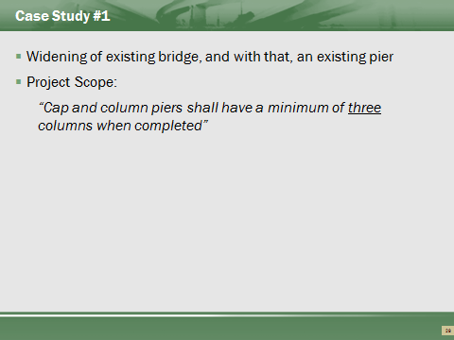
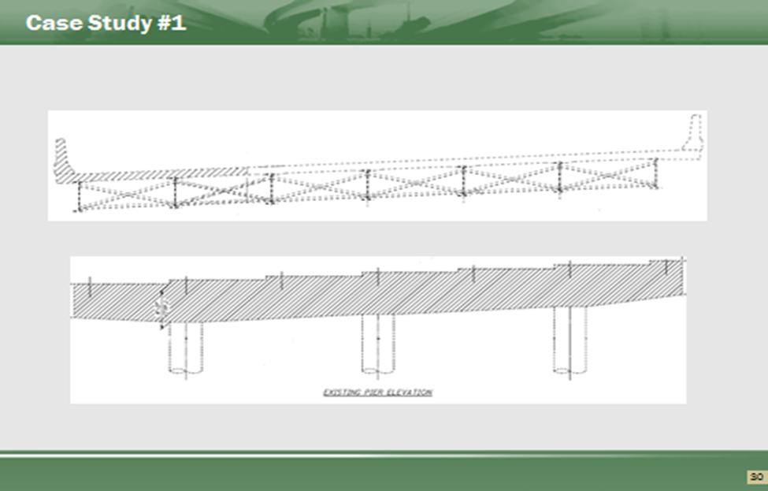
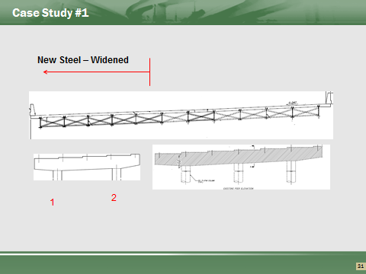
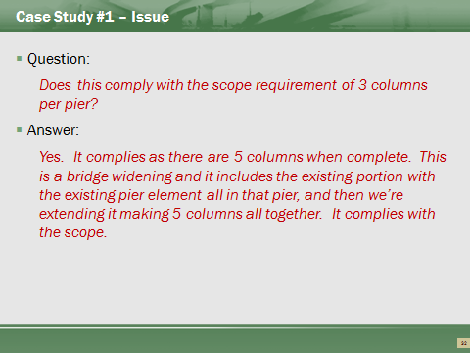
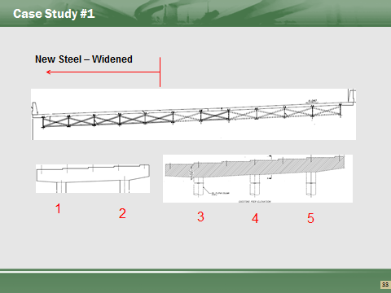
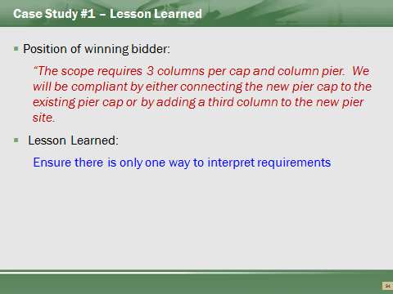

Case Study #2
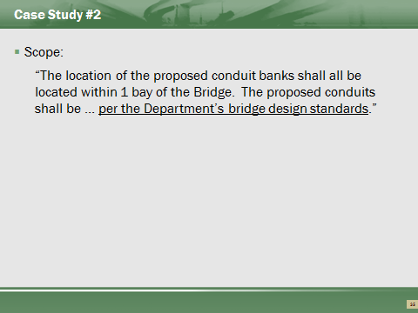
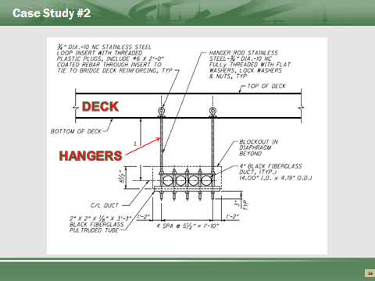
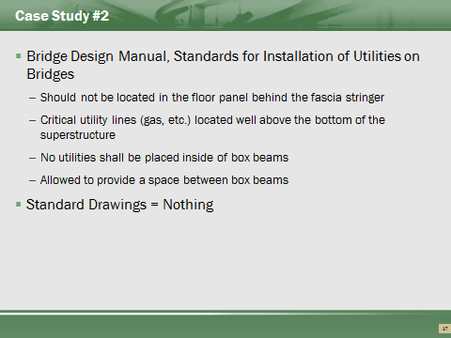
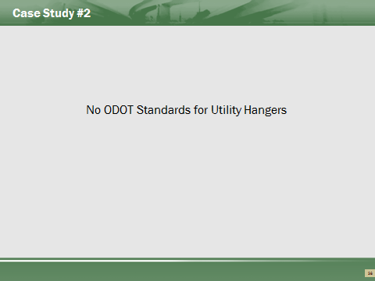
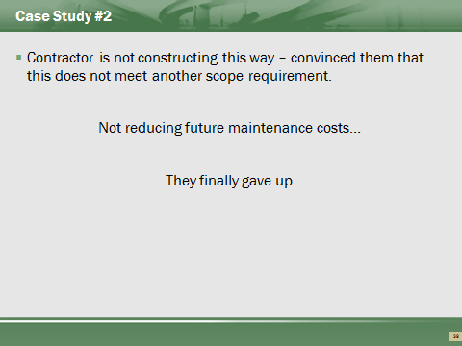
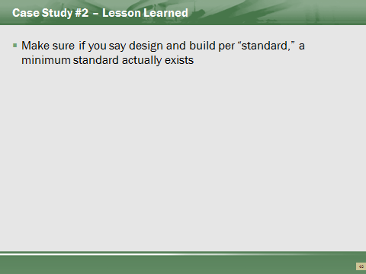

Questions


Recap of Part 2 Learning Outcomes

Part 3: Procurement and Contracting
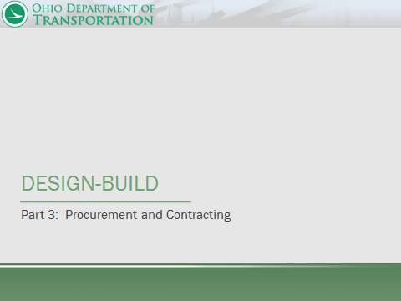

Part 3 Learning Outcomes
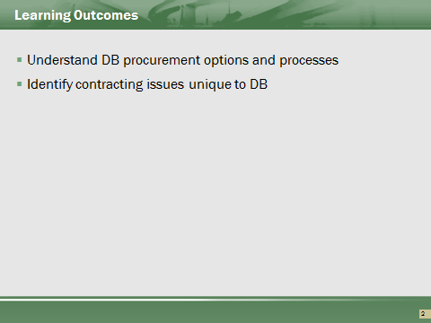

Contents of Part 3
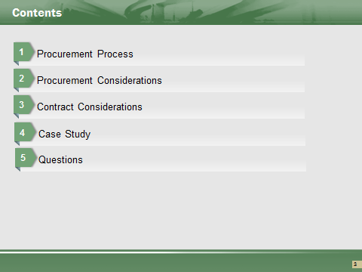

DB Procurement
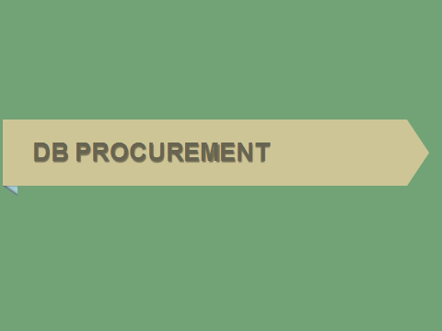

For more information on DB procurement options, refer to the following:
- PN 126
- PN 136
- ODOT DB Value-Based Selection Policy (November 17, 2010)

Procurement Process Overview
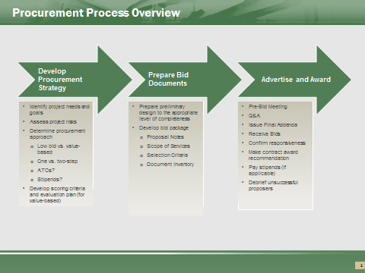

• The first step in the procurement process should begin by planning a procurement strategy that aligns with the needs and goals of the project and the reasons why DB was selected as the project delivery system. These three elements (i.e, project goals, delivery system, and procurement approach) should all be in harmony.
• In conjunction with the development of the Scope of Services document, the complete bid package must be prepared.
• Finally, the project can be advertised and awarded. Note that the bidding phase is generally much longer and more involved under DB than DBB, particularly when a value-based approach is used.

Developing a Procurement Strategy
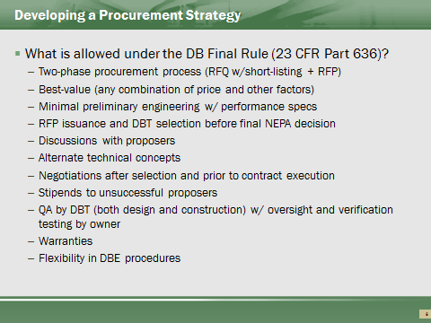

The DB Final Rule explicitly addresses many procurement options, not all of which will necessarily be implemented by ODOT with any regularity, if at all. For example, although the Final Rule allows agencies to issue an RFP and award a DB contract before the final NEPA decision, ODOT will generally only issue a bid package once NEPA is complete and the necessary environmental clearances have been obtained.
Allows price and scope negotiations after contractor selection before award. ODOT does not allow as this could lead to challenges from unsuccessful bidders.
Allows the assignment of Quality Assurance procedures to be assigned to DBT – ODOT has performed on a limited basis. Consult Central Office Alternative Project Deliver for further recommendations if considering.
Allows DBE selection procedures to occur after award – plan provided without naming all DBEs at award.

Developing a Procurement Strategy
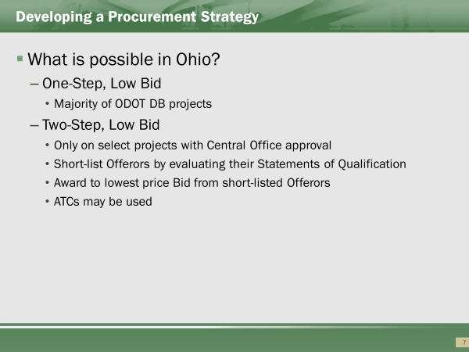

Although the majority of projects are procured using a one-step low-bid process, the Central Office can decide to apply a two-step low bid or value-based process if warranted by project conditions.
Under both the two-step low bid, and the low bid are solely selected on price. On the Two-Step Low-Bid, only the most qualified candidates can bid. The shortlist is created by the Department performing a qualifications evaluation on a submitted proposal.
One-step Low Bid is open to any pre-qualified contractor.

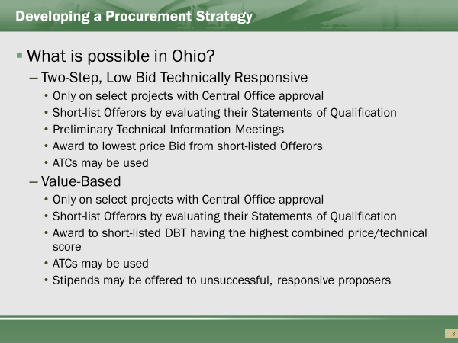

The Two-Step Low Bid Techically Responsive process and the Value-Based process both require the DBT to submit technical proposals. Technically responsive evaluation is solely on a pass fail determination. The Value-Based is performed with a scoring evaluation.
Under the two-step low bid, Two-Step Low Bid Technically Responsive, and value-based options, the Department may allow Offerors to propose Alternate Technical Concepts (ATCs), which will be discussed more a bit later in this presentation. In brief, an ATC is a request by a proposer to modify a contract requirement (for its competitive advantage) that provides a solution that is equal to or better than the base design requirements.

Spectrum of Procurement Methods
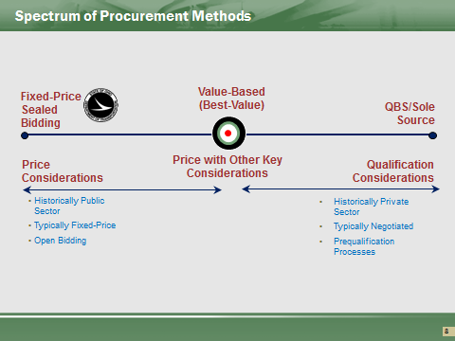

Starting with the left-hand side of the graphic, the traditional procurement decision for construction services is based primarily on price (or qualified low bid). Add that this method is generally the most objective process, requiring only a comparison of bid prices, a responsiveness check, and a price reasonableness analysis.
Moving on to the right side of the graphic, the procurement of so-called “professional” or design services is traditionally based on qualifications, a much more subjective approach.
A value-based process falls in the middle, as it marries together price and other factors. Note that value-based procurement approaches are often used in connection with DB and other non-traditional delivery methods that combine design and construction services.

Procurement Strategy - Project Considerations
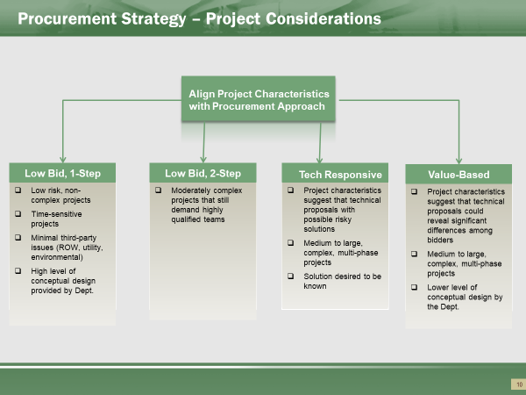

A one-step low-bid DB approach would apply to low-risk, non-complex projects where a compressed construction schedule is beneficial or possible. The Department must still provide a high level of design definition. Other circumstances conducive to a one-step low bid approach would include the following:
- Proposers do not have to perform substantial design work to develop price proposals
- Time constraints do not allow for a separate short-listing step
- Department lacks the resources to develop the required documents and manage a two-phase selection process
- Department wants to open up the bidding process to more firms, including those with minimal or no DB experience

A two-step low bid approach would apply to moderately complex projects that still require highly qualified teams.
A two-step technically responsive low bid approach would apply to moderately to highly complex projects which have many possible solutions, but the Department is only looking for the minimally acceptable solution.
A value-based DB approach is better suited to projects where the Department can convey project requirements based on a low level of design definition, there is opportunity for innovation, and the DBT can assume greater responsibility for quality and third party coordination.

Low-Bid Procurement
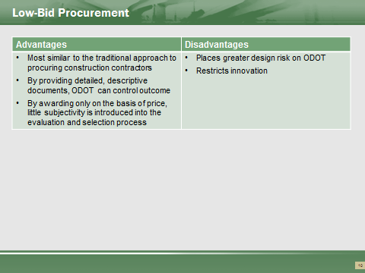

A low-bid procurement process has the advantage of being the most similar to the Department’s traditional low-bid approach to procuring construction contractors. ODOT can provide a high level of design definition and thus control the design solution. Also, awarding only the basis of price and responsiveness introduces relatively little subjectivity into the evaluation and selection process.

One-Step Low Bid Process
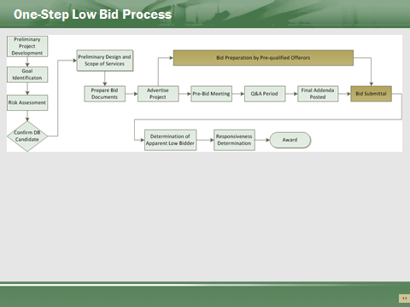

Under a low-bid approach, the Department will award the contract to the bidder that submits the lowest price and has a responsive proposal. Implementing the one-step low-bid procurement approach typically entails the following major steps:
- Identify project goals and risks.
- Based on the goals and risks identified for the project, take the preliminary design to the desired level of completion.
- Prepare and issue the DB solicitation package.
- Hold a pre-bid meeting.
- Issue addenda to address questions submitted during the Q&A period.
- Receive and open bids.
- Determine the Apparent Low Bidder.
- Verify bid responsiveness.
- Award contract.

Two-Step Low Bid Process
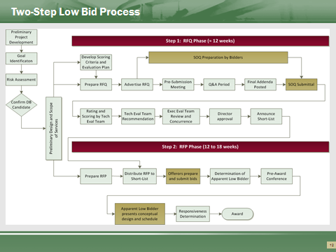

The FHWA’s DB Final Rule (at 23 CFR 636.201) encourages the use of a two-step selection process, in which the Department first short-lists DBTs on the basis of their responses to a Request for Qualifications (RFQ). (The document submitted in response to the RFQ is called a Statement of Qualifications (SOQ).)
The short-listed firms, in response to an RFP solicitation, may then submit proposals, which the Department evaluates for contract award (step 2).
Developing Requests for Qualifications (RFQ) and SOQ Evaluation System Planning (Shortlisting)
When planning to use a two-step selection process, the Department should begin to think about evaluation factors soon after identifying project goals, as such criteria will be needed to prepare and complete the RFQ. Evaluation factors may be set up on a pass/fail basis, in which the proposers have to meet certain minimum prescribed requirements to be responsive, or on a more qualitative, best-value basis, in which evaluators rate the SOQs according to the evaluation criteria included in the RFP.
Development and issuance of the RFQ will likely take place sometime prior to finalization of the project requirements. Given this timing, instead of requesting specific information regarding the Offerors’ approach to the project, the evaluation factors should focus on the general qualifications of the Offerors to perform the work, using indicators such as their experience, past performance, and bonding capacity.
Typical SOQ evaluation factors include the following:
- General pass/fail factors such as:
- Responsiveness of the SOQ in general;
- Provision of draft legal documents identifying the legal relationships and organizational structure of the proposers;
- Designation of authorized representative;
- Evidence that the DBT has the capacity to obtain all required payment and performance bonding, liability insurance, and errors and omissions insurance;
- Acceptable certification regarding debarment status and other legal compliance issues;
- Letter from Surety indicating sufficient bonding capacity; and
- For larger projects, financial data indicating sufficient capacity to undertake and sustain a project of the size and scope contemplated.
- Experience of the proposing entity, including that of the lead design entity, major construction contractors, and any specialty design consultants and/or subcontractors as identified in the RFQ.
- Identification of key staff and experience on similar projects.
- Information that addresses the capability of the firms to perform the work, such as:
- Manpower and equipment resources;
- Experience in completing projects of similar size, scope, and complexity; and
- Experience in obtaining environmental permits, ROW, or assistance or cooperation from Utilities and railroads (as applicable based on risk allocation).
- Project understanding and approach
- General approach to meet requirements
- Description of major tasks
- General CPM schedule
- Potential risks and mitigation
- Opportunities for innovation

Two-Step Technically Responsive Low-Bid
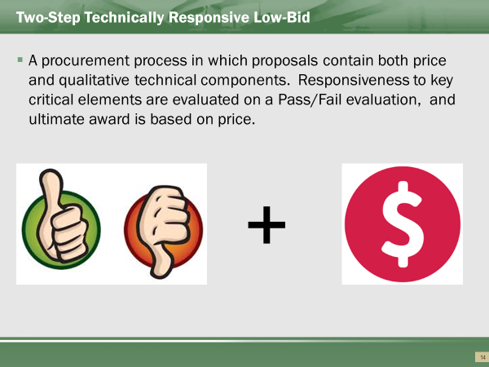

Two-Step Technically Responsive Low-Bid process requires a shortlisting process as well as a technical proposal evaluation. The Short-listed Offerors are to prepare and submit a Technical Proposal and a Price Proposal.
The Short-listed Offeror that submits both the lowest responsive Price Proposal and a responsive Technical Proposal will be considered successful. The Price Proposal will include the cost of all Work proposed to be completed in accordance with the Contract Documents and Technical Proposal.
Risk to the Offeror as their bid may not be opened if the proposal isn’t acceptable. Technical proposal is not submitted until the price is submitted, therefore, the Department usually holds Proprietary Technical Information (PTI) meetings and discussions. These are confidential meetings to discuss the intended offeror’s approach. The Department can “warn” the offeror of potential failures, allowing the bidders to adjust the approach.
Two-Step Technically Responsive Low-Bid approach eliminates surprises for both parties.

Two-Step Technically Responsive Low-Bid
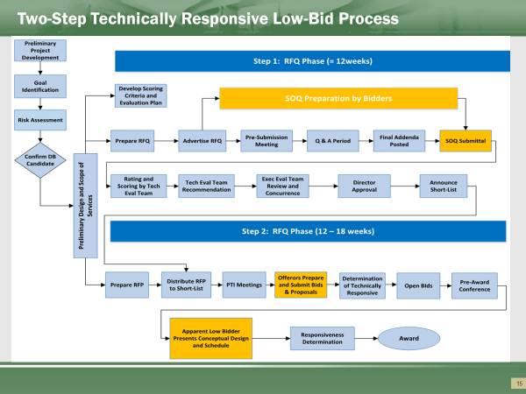

Implementing a Two-Step Technically Responsive Low-Bid procurement process typically entails the following:
- In conjunction with the development of the project requirements and RFQ and RFP documents, determine the critical risk key items.
- Determine the Pass/Fail evaluation items which for submission by the Offeror. These items are technical approaches to the final design and should align with the risk items for the Project.
- Prepare and issue an RFQ (assuming a two-phase selection process is used).
- Receive SOQs.
- Evaluate SOQs against the established standards.
- Announce the short list of Offerors.
- Issue the DB RFP to the short-listed competitors.
- Hold PTI (Proprietary Technical Information) meetings to confidentially discuss Offeror’s approach.
- Receive price and technical proposals submitted by the short-listed Offerors.
- Open technical proposals and determine Pass/Fail responsiveness.
- Eliminate any non-responsive proposals.
- Open the price proposals to determine the apparent lowest responsive Offeror.

Two-Step Technically Responsive Low-Bid
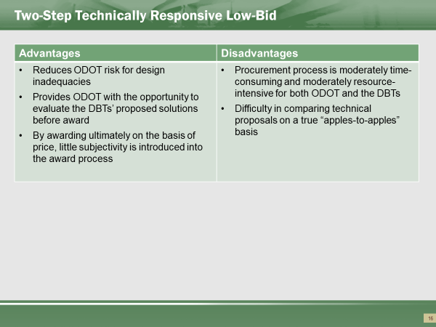

This allows ODOT to perform an evaluation of the caliber of the proposed personnel through the RFQ process.

The ultimate selection is determined using the low-bid after knowing the DBT approach is acceptable. ODOT can provide a lower level of design definition, but still have assurances that the design will meet the desired result. Also, awarding only the basis of price and responsiveness introduces relatively little subjectivity into the evaluation and selection process.

Value-Based Procurement
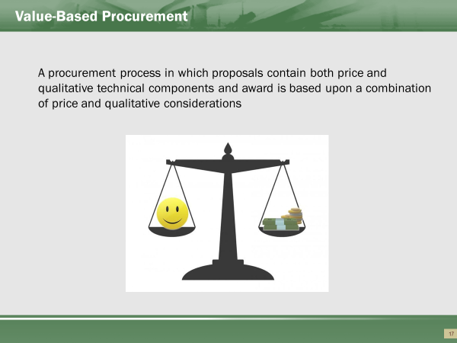

A value-based procurement approach allows for the consideration of price and other key factors (e.g., cost, time, qualifications, quality, and design alternates) in the evaluation and selection process. ODOT has implemented value-based procurement as a two-step selection process:
- Step 1 entails short-listing Offerors based on qualifications submitted in response to an RFQ.
- Step 2 entails evaluating price and technical proposals submitted by short-listed Offerors in response to an RFP.

Value-Based Procurement
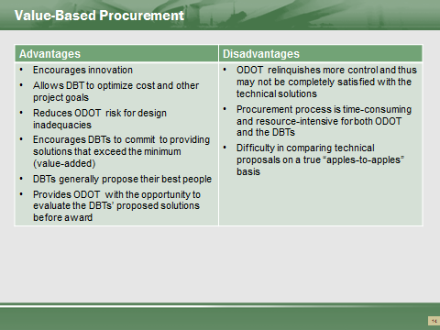

Value-Based Procurements based upon Quality Based Selection and a Technical Proposal evaluation allows ODOT to consider the caliber of the proposed personnel. It allows Teams to propose betterments, as judged by ODOT, which could increase a proposal’s value to the Department, resulting in a higher score. These betterments become contractual. ODOT able to evaluate, and potential, disallow a Team to propose a price if the proposal violates the Scope.
Value Based selection is very time consuming and costly. A VB DB adds approximately 9months to the procurement (3 months shortlisting, 6 months to DBT’s proposal evaluation). VB DB almost always pay Stipends to non-winning bidders.

Value-Based Procurement Process
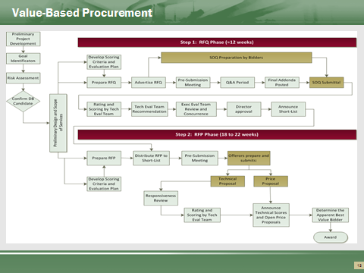

Implementing a value-based procurement process typically entails the following:
- In conjunction with the development of the project requirements and RFQ and RFP documents, determine qualifications, technical, schedule, and cost evaluation criteria. The non-price factors and their maximum point values or weightings should align closely with the goals and the perceived value that the criterion brings to the project.
- Devise a scoring system to evaluate the proposal’s responsiveness to the evaluation criteria established in the RFQ and RFP.
- Prepare and issue an RFQ (assuming a two-phase selection process is used).
- Receive SOQs.
- Evaluate SOQs against the established standards.
- Announce the short list of Offerors.
- Issue the DB RFP to the short-listed competitors.
- Receive price and technical proposals submitted by the short-listed Offerors.
- Open technical proposals and determine responsiveness.
- Score the responsive proposals in each technical area.
- Open the price proposals to determine responsiveness to required pricing requirements.
- Eliminate any non-responsive proposals.
- Roll-up evaluation results, and determine the total point score for each responsive proposal.
- Compute the final scores and determine the Apparent Best Value Bidder.

Value-Based Procurement
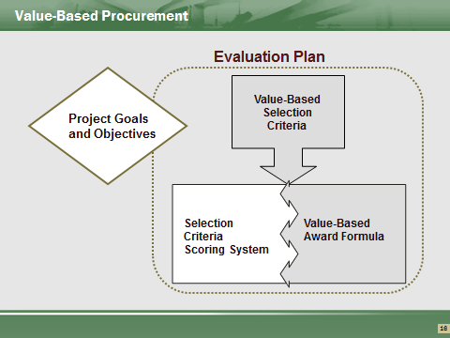

Evaluation System Planning
The DB Final Rule recognizes several options for implementing a value-based selection process (e.g. adjusted bid, weighted criteria, tradeoff analysis, etc.). On past value-based projects, the Department has used a weighted criteria approach, in which technical factors and price are scored and summed to arrive at a total score.
To use such an approach, early in the project development process, the Department should begin to outline a plan for evaluating the proposals submitted by DBTs. Preparing the evaluation plan before the solicitation documents ensures that the RFQ and RFP will contain sufficient information for prospective DBTs to prepare proposals that address the Department’s major concerns.
The Department will ultimately develop the selection criteria into a formal, internal document that details each step in the evaluation and selection process, from the receipt of proposals to the final documentation of the selection decision. The evaluation and selection plan should describe the evaluation factors and their relative importance (weighting), rating guidelines, and other information critical to maintaining the integrity and fairness of the selection process. Adherence to this plan will help the Department defend its selection decision in the event of a bid protest.
With all point scoring methods, maximum point values should be pre-established and stipulated in the RFP. By specifying maximum point values in the RFP, the Department can directly convey its perceptions regarding the relative importance of the various evaluation criteria that will be used to assess proposals. Proposers can then use these relative weights as a guide to determine where best to focus their attention and resources when developing a proposal.
Evaluation of proposals will entail members of the evaluation team assigning a score for each of the criteria in the evaluation plan. Ideally, these scores should correspond to some measurable standard (e.g., schedule savings in work days, lane closures, etc.). However, for criteria that require discretionary judgment on the part of the evaluators (e.g., design solutions, quality management plan, etc.), ensuring uniform application of evaluation standards can prove to be difficult, particularly if reviewers have different perceptions regarding the value of a point.
To promote consistency in how members of the Evaluation Team interpret the selection criteria included in the RFQ/RFP, the Department may conduct training sessions in the following topic areas:
- Key elements of the RFQ/RFP and related evaluation plans;
- Project requirements;
- Project constraints;
- Appropriate documentation of the selection decision;
- Roles and responsibilities of the evaluators; and
- Confidentiality.
Such training would generally precede the receipt of SOQs (if applicable) and proposals, and would be mandatory for all members of the Evaluation Team.
Selection Criteria
A key element of evaluation system planning is identifying the evaluation criteria that will be used to assess the ability of Offerors to meet the needs and goals of the project. For example, although not a complete guarantee of quality and/or innovation, the experience of design consultants and subcontractors in relevant specialty areas can often serve as an indicator of the Offerors’ ability to successfully complete the project or a particular portion of the work. Such information would generally be obtained through the RFQ phase. The technical approach provided in the proposals submitted in response to the RFP could then provide a further indication of the Offerors’ understanding of the work and its ability to meet the project requirements, particularly for those project components for which the Department will allow some flexibility in design and/or construction solutions.
Risk allocation strategies may also drive evaluation criteria. For example, if the Department were to transfer construction quality assurance responsibilities to the DBT, the RFP could require proposers to address their general approach to quality management in their technical proposals. By evaluating and rating these approaches, the Department could continue to exert some control over quality management.
Identification of possible selection criteria should began soon after identifying project goals. Considering that project goals typically fall into the categories of time, budget, and quality, it is not surprising that evaluation factors generally follow suit, falling into the categories of schedule, price, and technical criteria. Evaluation factors may be set up on a pass/fail basis, in which Offerors have to meet certain minimum prescribed requirements to be responsive, or on a more qualitative, best-value basis, in which evaluators rate the proposals according to the evaluation criteria included in the RFP. Either way, to be effective, each criterion should be defined in terms of some measurable standard against which responsiveness can be measured.
Evaluation factors should be designed to solicit information that can support meaningful comparison and discrimination among competing proposals. When identifying these factors, consideration should be given to the time and effort that Offerors will have to invest in preparing responsive proposals, and that of the Department in evaluating this information.

Previously Used Scoring System
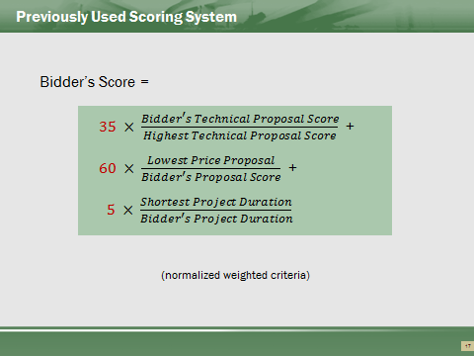

This is the approximate shoring breakdown used. The determination of award is on a point system, in which the DBT’s scores are compared to each other.
The primary component remains to be price.

Value-Based Selection Best Practices
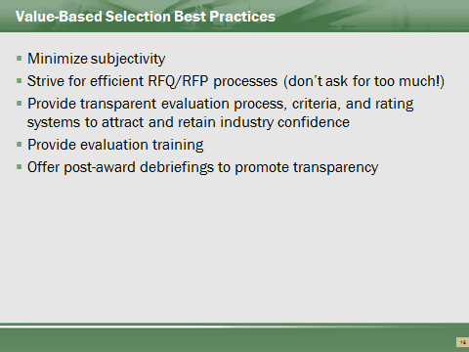

Evaluation criteria needs to be clear and predetermined. Reviewers must be subjective and remove preconceived ideas of proposers.
When determining what to request and evaluated, the desire is to over request. If we are evaluating everything, then nothing is important.
Evaluation results will ultimately be published and discussed with proposers. All comments and evaluation results need to be justified. Challenges result from variations from the process. Reviews must follow the criteria established.
Debriefings to proposers occur. Teams are interested in the results so to improve for future proposals.

Procurement Considerations
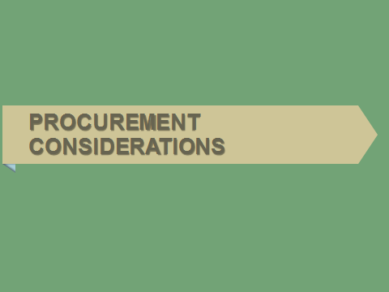

Obstacles/Risks
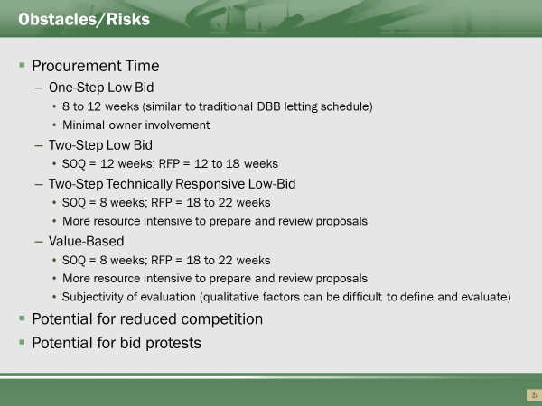

Timeframes do not include initial industry outreach. Projects which are going to be Two-Step Low-Bid or Value-Based need to be identified early. Teaming by Contractors and Designers consider the quality based selection when determining and establishing contractual agreements. From industry feedback, teaming begins much earlier than the advertising timeframe.
Smaller firms (Contractor and Designer) less likely to engage in Shortlisting and Value Based DBs. Very time consuming.
For the majority Ohio contractors, quality based selection isn’t the typical business model. Consulting firms are more open to QBS.
Quality Based Selection can be subjective, therefore, open for challenges. Protests by proposers can occur.

Potential Protest Areas
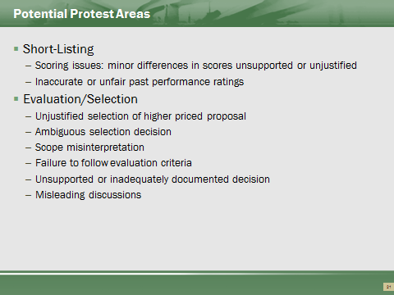

Straying from the predetermined process is the most likely challenge to be won by the protesting firms.
All evaluations must be justified. This information, once the project is awarded, becomes public knowledge.

Level of Design
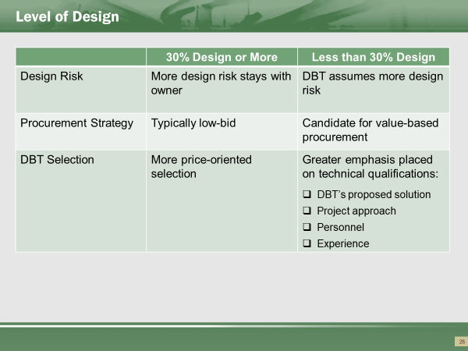

The level of design will also vary with the procurement approach. If the Department provides a high level of design definition (affording industry little flexibility or opportunities for innovation) a low-bid process is suitable.
As less design is provided, a value-based approach may become necessary to evaluate technical qualifications and approach.

Alternative Technical Concepts (ATC)
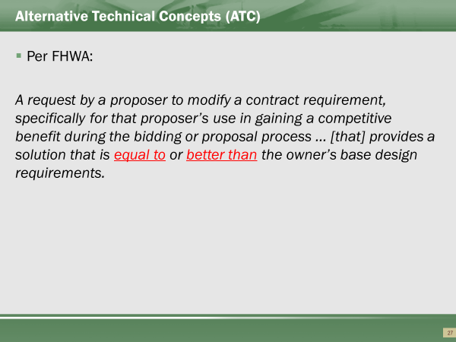

If project conditions do not restrict the range of possible technical approaches, alternative technical concepts (ATC) may be used as a means to promote innovation.
As defined by FHWA, an ATC is a:
A request by a proposer to modify a contract requirement, specifically for that proposer’s use in gaining a competitive benefit during the bidding or proposal process … [that] provides a solution that is equal to or better than the owner’s base design requirements
If the RFP allows ATCs, a proposer can suggest an ATC during the proposal preparation period, and, if accepted, can then decide to concentrate on developing a proposal around the accepted ATC.
The ATCs could address different configurations, different design criteria, materials not previously used on Department projects, and similar issues for which some design flexibility may exist.
Allowing ATCs does not equate to automatic acceptance of the alternate approaches by the Department; however, the Evaluation Team should be prepared to seriously consider ATCs and the benefits they may offer. For example, possible benefits may include schedule or cost reductions or minimized disruption during construction.
To consider ATCs, the Department needs to carefully tailor evaluation factors related to technical criteria to ensure that both baseline and alternate solutions are evaluated and rated with fairness and consistency.
Other potential challenges related to implementing ATCs include the following:
- Additional procurement time/cost to review
- Maintaining confidentiality and fairness among bidders
- Comparing an “equal or better” design to base design
- Possible impacts on NEPA permits, ROW, utilities, etc.
- Protecting intellectual property of DBTs
- Increased protest risk (perceived inequity by unsuccessful bidders)

ATC Submittal and Evaluation Process
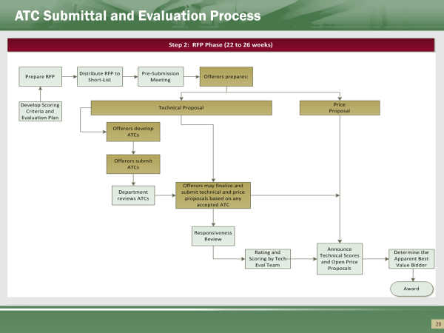

- ATC process is used only with concurrence of Central Office.
- ATC process is confidential. All ATC reviewers must agree to a confidentiality agreement. All ATC are strictly controlled.
- ATC meetings with proposers are to only discuss potential or existing ATCs. Meetings provide feedback, but do not give direction.
- Official evaluation of ATC is performed by a Core Evaluation group, with support of technical specialists.
- ODOT’s process does not consider pricing in the evaluation. The savings, if any, is identified in the price submittal.
  - Until recently, the CFR required the Bidders to price the “Base” project.

Procurement Summary
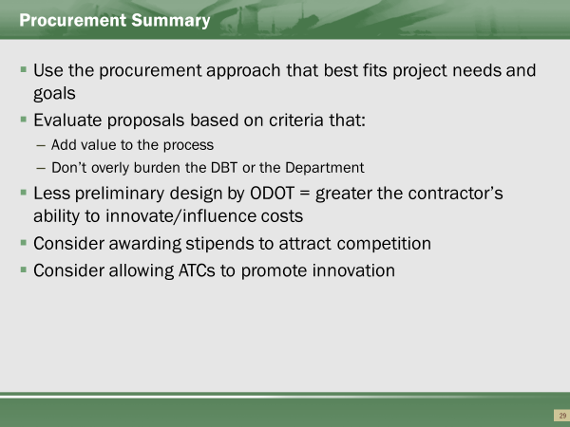

Quality Based Selection and ATC not appropriate for small and simple projects.

DB Contracts


New or Modified Definitions
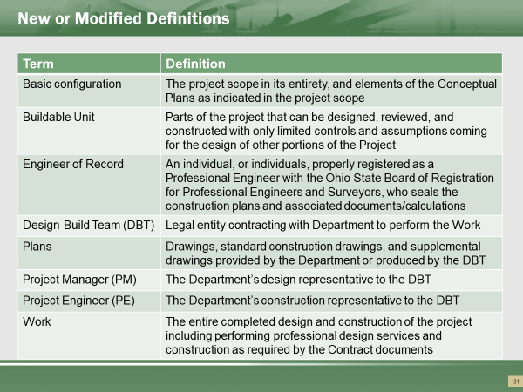

The DBT and Contractor for ODOT are interchangeable terms. ODOT requires the contract to be with a General Contractor.
Plans can be either supplied by ODOT during bid, or those produced by the DBT.
Work includes Design.
Buildable Units are plan portions submitted for review and allows portions of construction.

Bid Documents
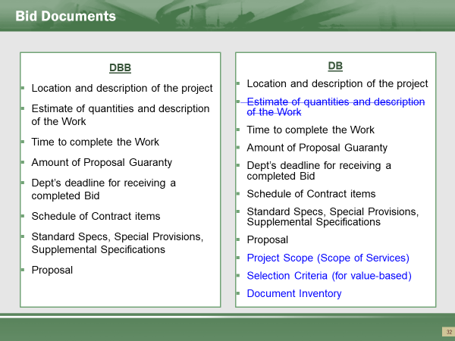

ODOT uses the same bid mechanisms as a traditional. Using EBS continues, unless there is a Value-Based award.
Document inventory is all the supplemental documents needed to design and build the projects. This includes any historical information, soil borings, schematics needed to depict requirements. These documents are referred to as “Bridging Documents”.

DB Contract Provisions
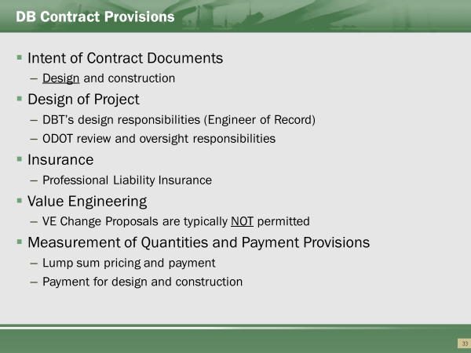

The contract documents needs to address both design and construction.
On a DB project, in addition to general liability and builder’s risk insurance, it is also common to require professional liability, or Errors and Omissions (E&O) insurance, as the DBT, and not the Department or a design consultant, is the Engineer-of-Record. The professional liability insurance policy should be held in the name of the DBT that enters into a contract with the Department. This means that the DBT cannot rely on the insurance policy or policies of its designers to cover professional liability. This protects the Department from dealing with multiple insurance agencies and policies that may or may not cover the risks associated with a particular project.
VE Change Proposals are typically not accepted.
Measurement and payment – primarily lump sum.

Specifications
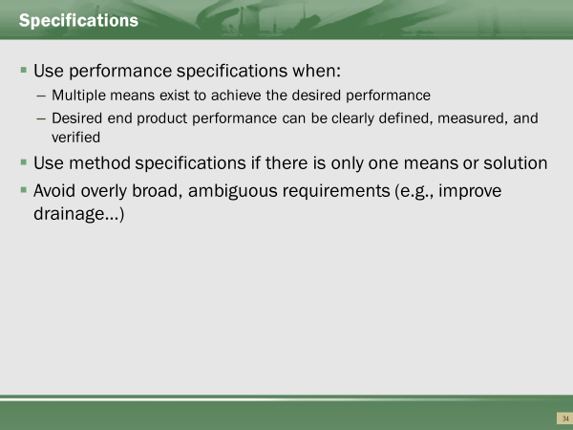

Performance specifications refer end result of the Scope, not just “specifications” as typically understood by ODOT. For example, this could be Level of Service for an interchange.

Case Study


Case Study #3
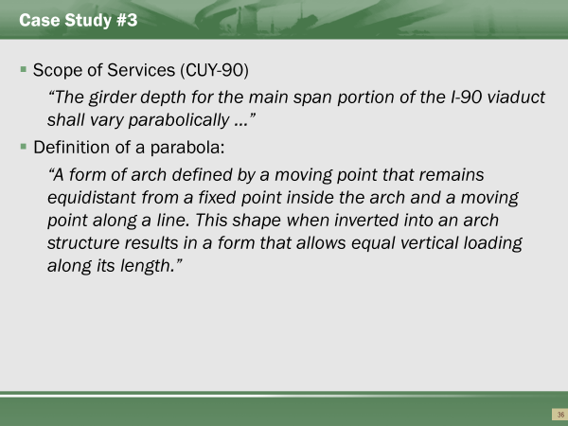

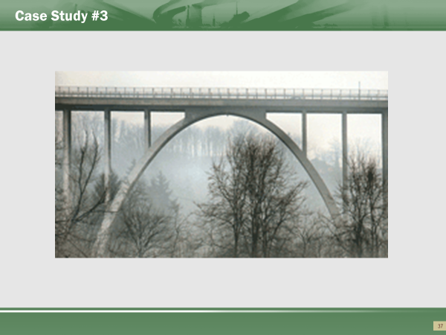
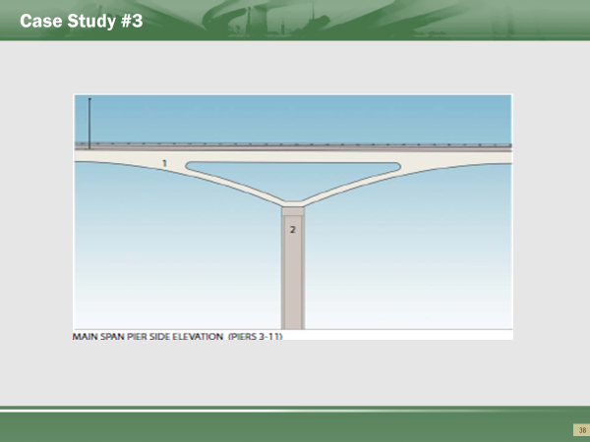
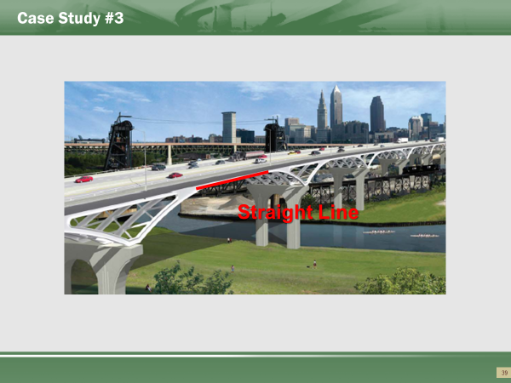
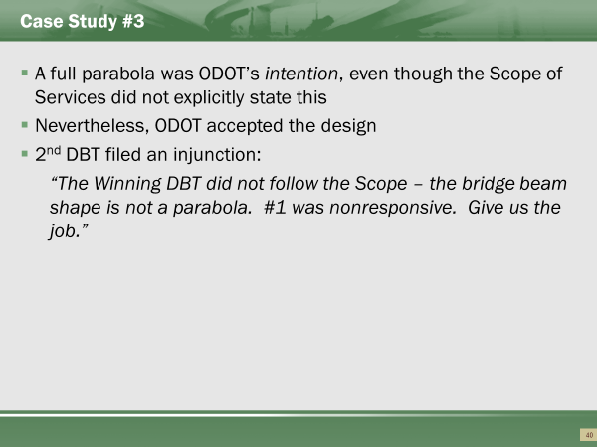

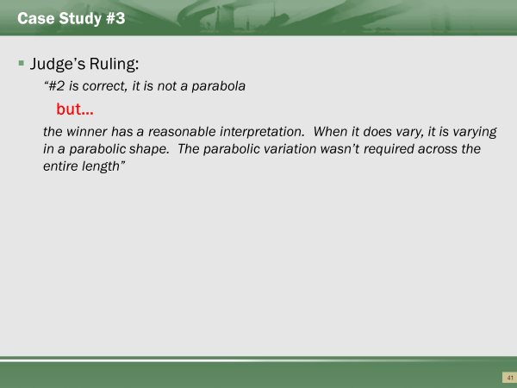
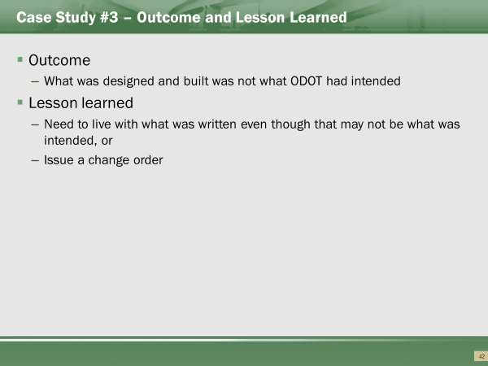

Questions
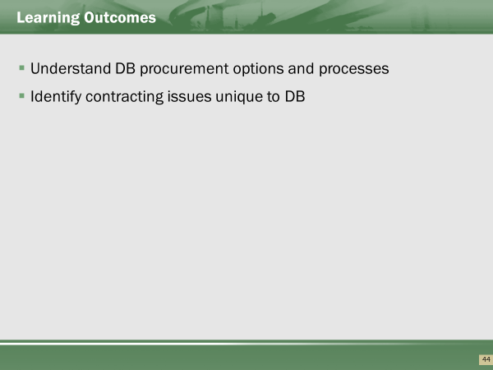

Part 4: DB Contract Administration
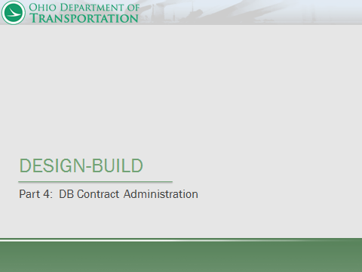

This portion of the course is intended to provide participants with an overview of DB contract administration processes and best practices for design and construction administration.
References
- ODOT Design Manual, Section 1400
- ODOT Construction Administration Manual of Procedures (MOP), 2016
- ODOT Construction and Materials Specifications (CMS), 2016

Part 4 Learning Outcomes
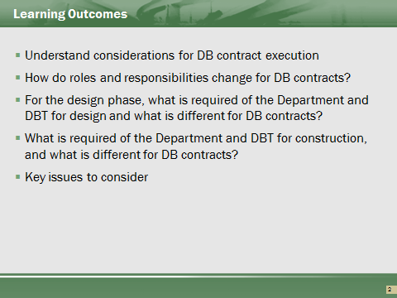

Contents of Part 4
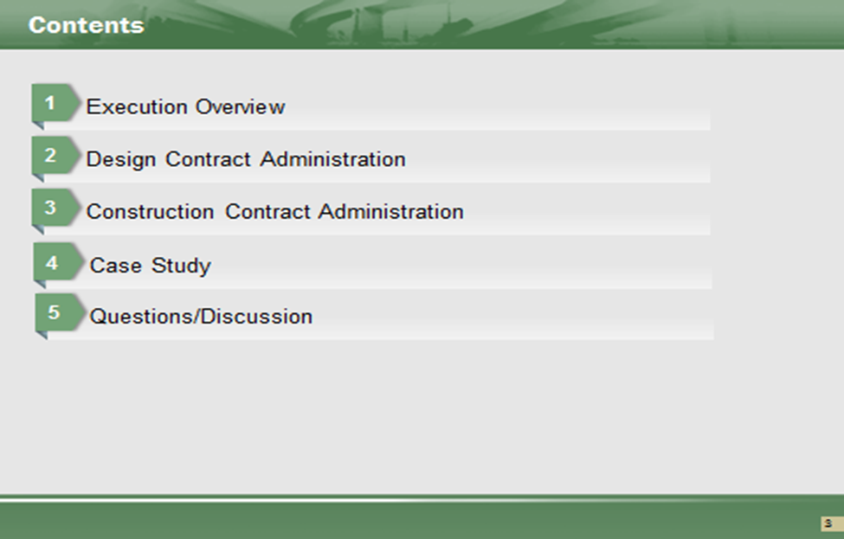

Some Key Considerations for DB Contract Execution
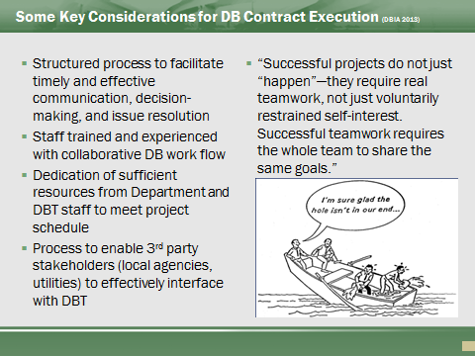

DBIA has a wealth of information on DB processes. See website: http://www.dbia.org
For best practices, refer to Transportation Sector: Design-Build Done Right (DBIA 2016)
https://dbia.org/wp-content/uploads/2018/05/Best-Practices-Transportation.pdf

Traditional contract administration under DBB design and construction are administered under separate contracts. Administrative decision-making and approvals are often less efficient and difficult to coordinate
DB integrates design and construction to meet shared goals – “all on the same team” mentality
The pace of DB demands that ODOT staff dedicate sufficient resources and experienced staff to meet DBT schedule while ensuring that design and construction are in compliance with ODOT requirements.

Collaboration
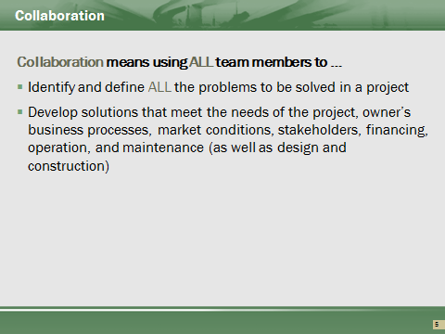

“All members of the Design Build Team must understand that the project’s success is dependent on the ability of the team members to work collaboratively and trust that each member is committed to working in the best interests of the project.” (Design-Build Done Right - Project Execution)
Integrated Project Delivery (or “little IPD”) means adopting a collaborative working relationship in while maintaining the traditional contracting protections/constraints in DB contract.
ODOT personnel need to be willing to participate. While the DBT is responsible for more of the project, ODOT needs to be involved. DB projects require Partnering, and the project management needs to be willing to “jump-in”.

Design-Build Execution Process Overview
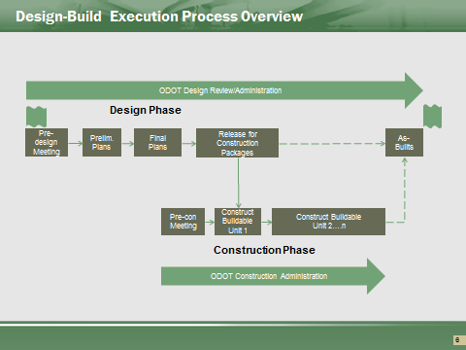

Project execution for DB means integrating design and construction activities. Construction will often proceed in Buildable Units (BU) before the final design is complete. Contract administration must adapt to this integration and work flow.

“Workflow” for the DBT and the ODOT project team needs to be determined.

Quality Assurance for Design-Build
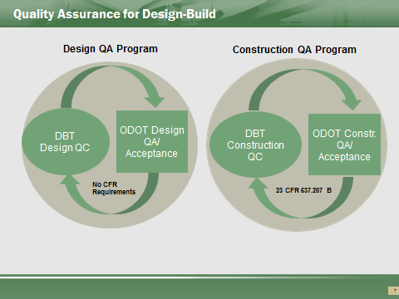

References
- CFR 637 Subpart B, Quality Assurance Procedures for Construction
- FHWA Techbrief, Construction Quality Assurance for Design-Build Highway projects, 2012
- ODOT Design Manual
- ODOT Construction Administration Manual of Procedures, 2013
- ODOT Construction and Materials Specifications, 2010

Design Administration
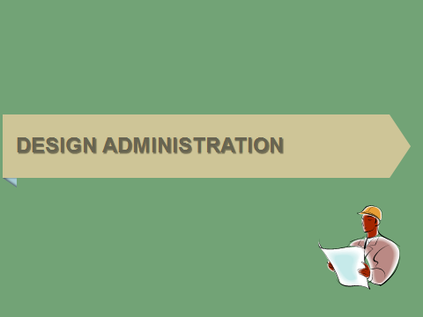

What’s Different?
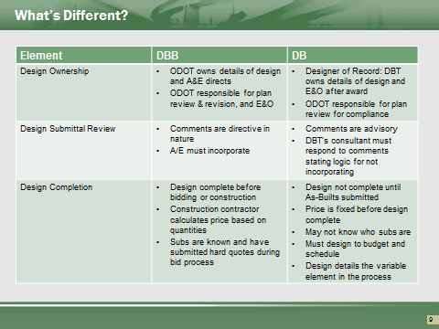

For DBB: “Project is a product of the design,” DB: “Design is a product of DB contract.
Design Ownership
- ODOT no longer serves as the “go between” the design professional and contractor
- Traditionally, ODOT owns the details of design. For DB, the DBT responsible for the design details and E&O.
- ODOT’s role in design review shifts to oversight and plan review for compliance with the scope
- Design is not complete until final as-builts submitted after construction
- Design and construction are not sequential – they overlap and integrate.
- The focus is on design efficiency/constructability to support and enhance the construction process
- ODOT will establish minimum standards “quality of design” and performance goals in scope, but should not dictate details of design to meet those standards

Pre-Design Meeting
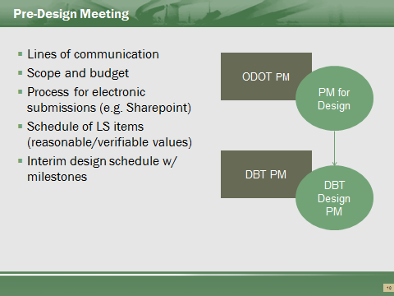

References
- ODOT PN 126
Mandatory pre-design meeting for DB
Establishes how the project team (ODOT & DBT) will work
- Establish Lines of communication, roles and responsibilities,
- Inventory major features of design work & correlate to major features of construction,
- Develop initial progress schedule with design submittal breakdown of deliverables and milestones for payment,
- Identify sub-consultants & other firms involved in design,
- ODOT and 3rd party design review requirements and schedule, and
- If applicable, project management office and facilities.

DBT Design Responsibilities
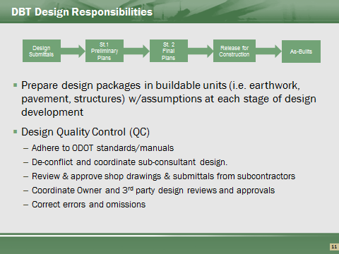

DBT defines Buildable Units (BU) and how far they take design in logical packages that can be reasonably reviewed
DBT is responsible for development of design and construction plans to meet the contract requirements.
PN126 Section 104.011 “Standard of care…will be the care and skill ordinarily exercised…under similar conditions at the same time and locality.”
Builders will argue “build at risk” is allowed. Building without a plan is not allowable. The Design must be reviewed and checked for quality, but the DBT decides the size of the Buildable Unit. For example, a BU can only be the removal of a structure or potentially clearing and grubbing. The Buildable Unit needs to be discrete and verifiable.

Submittals of Buildable Units
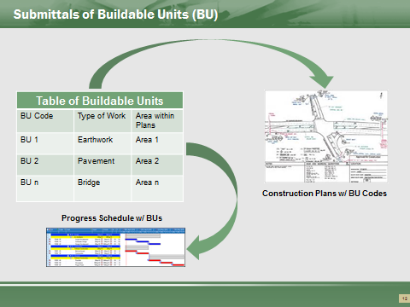

Buildable units (BU) are defined in terms of logical units of work, or areas within the work zone organized in a table of BUs coded to project plans and schedules
BU submittals should define logical discrete items of work
BUs require sufficient information for adjoining components or areas of work to allow for evaluation of BU submittals.
Any assumptions need to be clearly defined (e.g. loading for superstructure during substructure review), and all supplemental information is required for a complete review
MOT submittals should include description of all work to be done in a specific MOT phase

Design Administration - Key Responsibilities
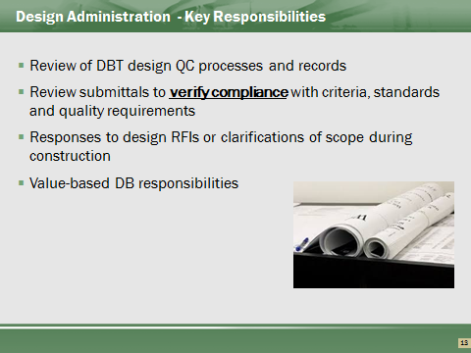

ODOT reviews should not ask for or provide additional design details. Review only for compliance with scope and design standards. Excessive direction or requests for more detail may lead to ODOT assuming “ownership” for design if issues arise during construction related to the design.
ODOT should point out obvious errors or omissions or lack of compliance but not direct the DBT how to fix.
Review comments should clearly define whether a response (or revision) is needed
For value-based DB, ODOT’s role becomes of an oversight function, auditing the DBT’s design QMP processes and procedures, ensure that IQF is performing QA of design, and confirming DBT adherence to design QMP

Submittal Reviews
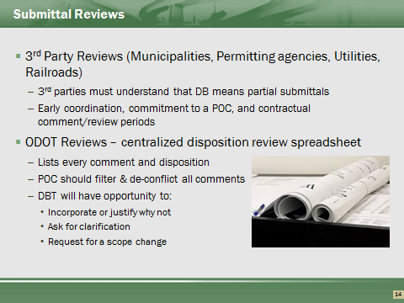

Reviewers of 3rd parties need identified prior to award. They must be made aware that the project is a DB, and a submittal will be “non-traditional”. A Point of Contact for each reviewing party reduces confusion with the 3rd party.
ODOT project management should utilize a single review disposition spreadsheet. A central disposition assists in filtering out of repetitive comments. This avoids the “trickling in” of review comments.
Turnaround times by reviewers are contractual times. Delays in reviews can result in delays in the project resulting in Field and Home Office overhead payments.

Case Study
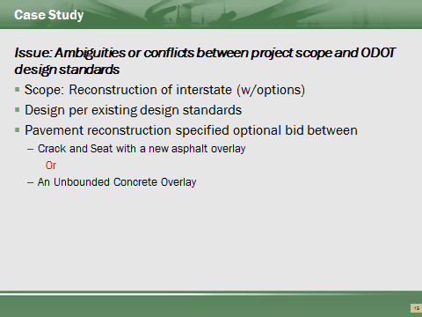

Case Study
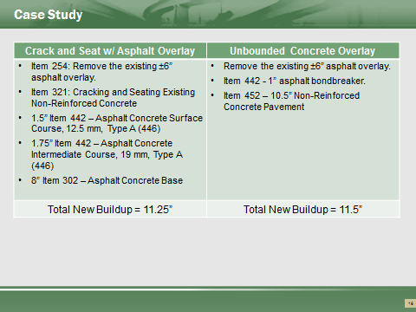

Case Study
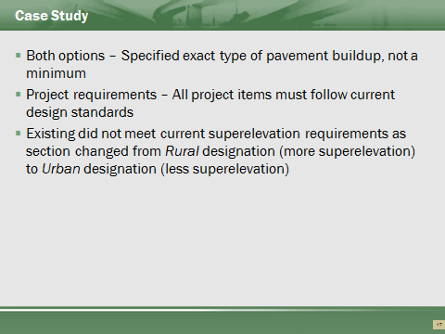

Case Study
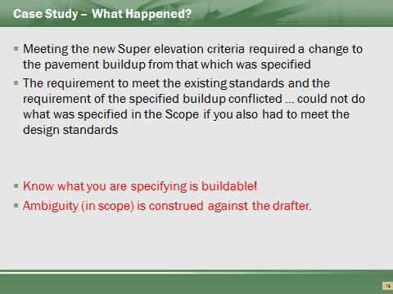

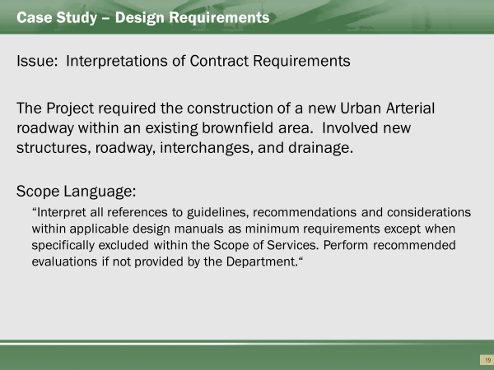
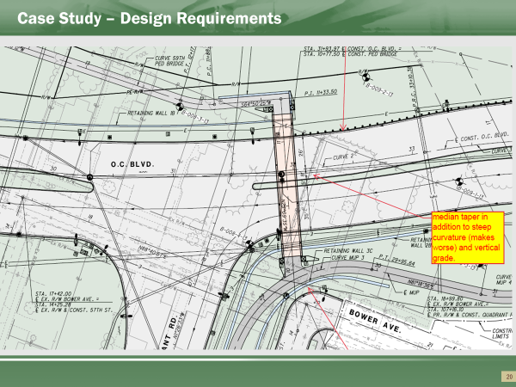
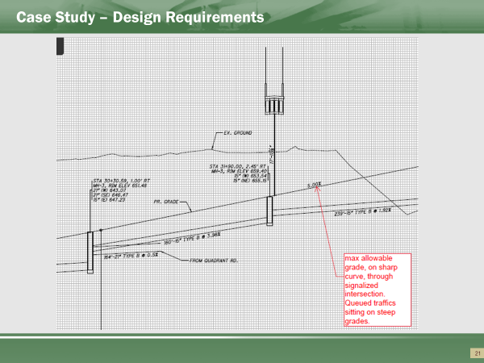
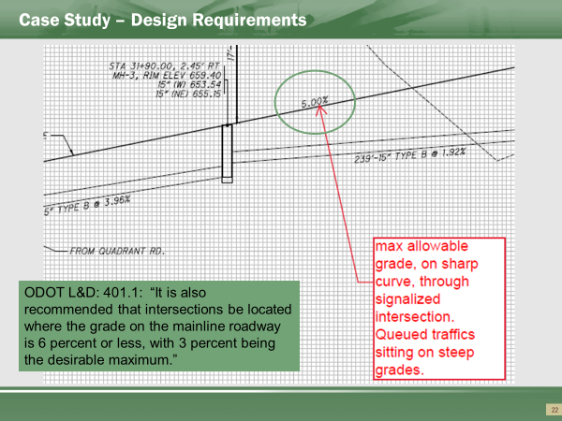

Project Design Administration Summary
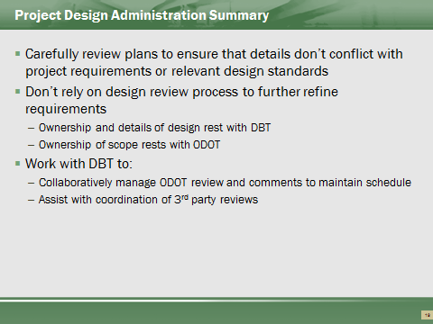
Comments that prescribe a design solution (when more than one solution exists), or request more detail may lead to taking ownership of design and a change in scope or revisions in DBT assumptions related to purchasing or construction.
Careful development and review of scope to meet current design standards.
The review of a DB Plan is not the opportunity to complete the desired results.

Questions


Contract Administration
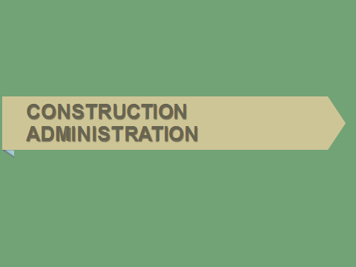

References
- ODOT Construction Administration Manual of Procedures 2013
- ODOT Construction and Materials Specifications, 2010
- FHWA Techbrief, Construction Quality Assurance for Design-Build Highway projects, 2012
- NYS DOT Design-Build Procedures Manual, 2011
- SHA Design-Build Manual, 2013

What’s Different?
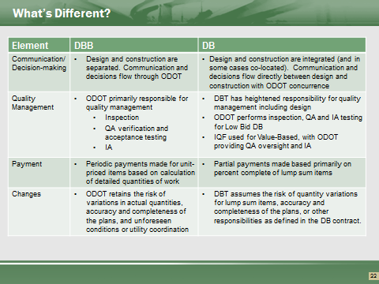

ODOT no longer serves as the go between for communication and decision-making. Decisions must be made collaboratively to support the DB project schedule
Quality management: For DBB, ODOT has primary responsibility for quality. For DB, quality management is heightened (Low Bid) or shifts to the DBT (Value-based)
For DBB, payments are made based on detailed quantity calculations for standard unit priced bid items. For DB, payments are based on percent complete of standard DB lump sum items
Changes: For DBB, ODOT retains the risk of quantity variations, completeness and accuracy of the design, and unforeseen conditions. For DBB, the DBT assumes the risk of quantities for lump sum items, and accuracy and completeness of plans.

Pre-Construction
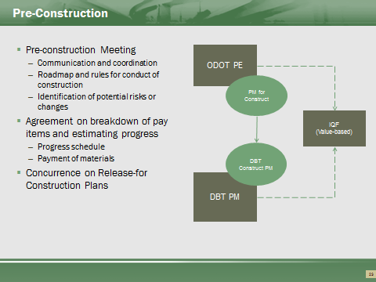

A preconstruction meeting review of the design is not possible as the design is not completed. Scope review and requirements of the project to be discussed.
Payment discussions need discussed.

Release for Construction
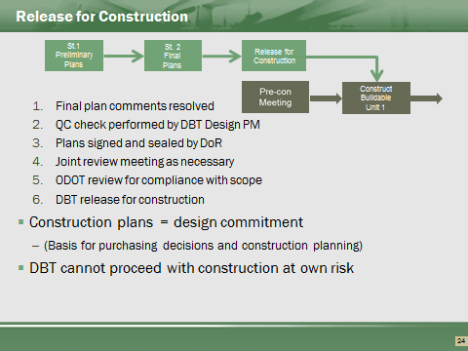

• Design is integrated with construction. Several design steps are typically needed to achieve release–for–construction Bus. If needed, a collaborative review meeting is held where the DBT summarizes design submission and provides supporting documents to ODOT, and ODOT reviews for compliance with the scope.
• The Release-For-Construction plans represent the commitment by DBT and ODOT that project will be constructed in accordance with the final design.

Some Potential Issues to Consider
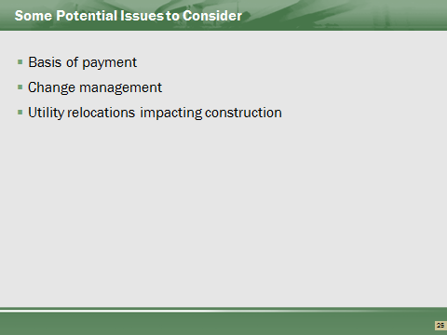

Payment
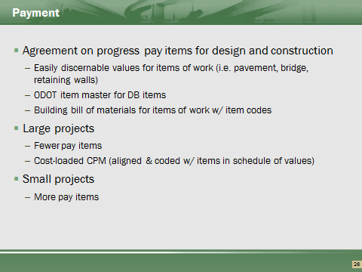

During development, consideration to be given to amount of breakdown. Additional pay items makes it simpler to determine amount complete.
Large projects lend to potential cost loaded schedules. Cost loaded schedules are difficult to manage initially. Central Office concurrence required prior to using Cost loaded schedule.
Pay items need broken down to check payments and materials by the DBT. Provided breakdown needs to be able to justify payments and material reporting.
Agreement on breakdown of LS items. Payment and payment milestones can be flexible, as long as an agreed reasonable method is performed.

Payment (cont’d)
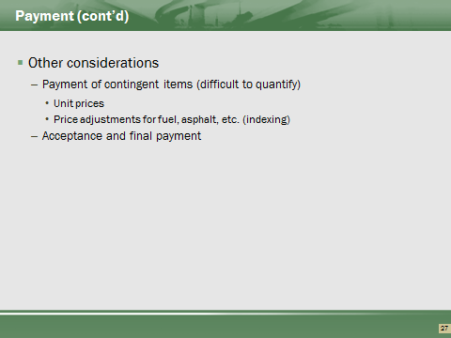

Price adjustments based on unit pricing will use existing state average unit pricing, adjusted for inflation.

Changes
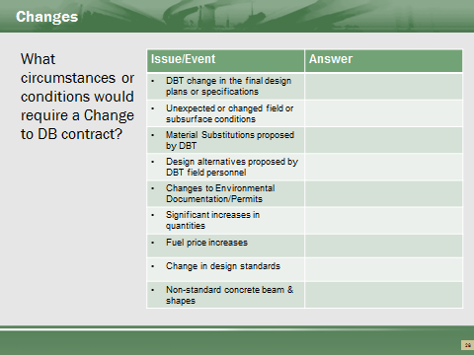

References
- ODOT MOP, 2013
- ODOT PN 126
- ODOT Materials and Construction Specifications, 104 Scope of Work

Managing Design Changes during Construction
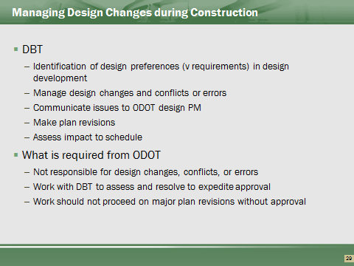

• ODOT not the go between design and construction
• Don’t manage communications between the designer and builder
• Collaborate with DBT to expedite review and approval
• Work should not proceed on major plan revisions without approved plans – not build at risk.

Methodology of document control to ensure the correct version of the plans are available to all. Revisions to RFC plans must be checked as an original. Versioning control of plans to be clear and defined by designer.

Change Order Pricing under DB
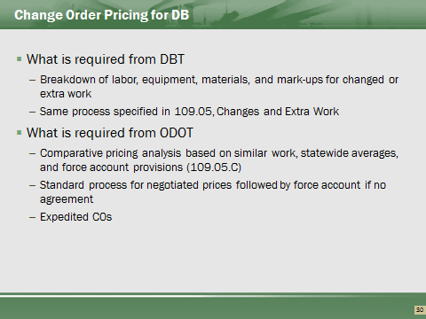

• If lump sum contract, pricing must still be justified
• Should give some consideration to risk in pricing
• Need timely processing
Change orders need the same kind of backup as a typical project, except no existing unit pricing available.

Utility Coordination
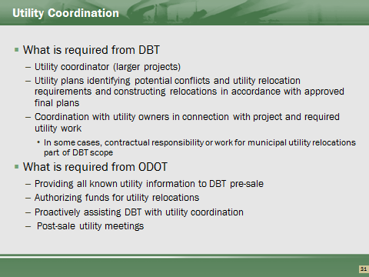

References
- ODOT Materials and Construction Specifications, 105.07 Cooperation with Utilities

DBT must justify that they have tried to design around and mitigate impact.
Only ODOT has responsibility to notify utilities to perform extra work.
ODOT Utility Involvement Post sale - -Reference Locations & Good Practices
Attend all utility meetings post sale. (PN 126: 104.011 Design of the Project and Scope 12.2)
Authorize project funds for utility relocations eligible for reimbursement and issue permits to the utilities relocating facilities that require relocation within the Right of Way. (PN 126: 104.011 Design of the Project)
Determine eligibility of betterments or eligible costs if utility relocations are included in the project (Standard Scope of Service template -Section 12.2)
Keep record of all coordination correspondence between DBT and utilities (PN 126: 104.011 Design of the Project)

Assist in the coordination if utilities are non-responsive to DBT (Good practice as Per PN 126 -105.07 -A. The Engineer shall be satisfied that the Contractor has made every effort to prosecute the design and construction work despite any delays encountered or revisions in the Contractor's scheduling of work. B. If performance of the Contractor's work is delayed because the utility owners fail to relocate or adjust their facilities as previously agreed, the contract time will be adjusted in accordance with the provisions of 108.06.)
DB Team Responsibilities
- Stake the existing ROW in the field and perform clearing and grubbing within that ROW, in order to allow utility relocation and reduce potential delays. (Scope 12.2)
- Be cognizant of the project's impact on utility facilities. In the event utility relocations are required, do not preclude legal occupancy of the highway ROW by the relocated utility facilities. (Scope 12.2)
- Coordinate all existing utilities with construction activities. Ensure that potential delays in coordination and relocation of the affected utilities are minimized. (Scope 12.2)
- Hold a meeting at or near preliminary review between the DBT, the District Utility Coordinator and the utility owners to determine if any significant utility relocations can be eliminated or mitigated. (Scope 12.2)
- Perform SUE required for utility relocations at Department's option. (Scope 12.3)
- Coordinate all design for relocation or accommodation of any utilities within the project (PN126 -104.011 Design of the Project)
- Determine and show on the plans the names of all existing utilities within project limits. (PN126 -104.011 Design of the Project)
- Identify and resolve utility conflicts and reflect the resolutions and decisions accepted on the plans and details. (PN126 -104.011 Design of the Project)
- • Call any utility meetings needed to ensure that the concerns are addressed on the plans involving utilities. (PN126 -104.011 Design of the Project)
- Notify the Project Engineer at least two working days in advance of any utility meeting. (PN126 -104.011 Design of the Project)
- Take responsibility for working with the individual utilities to ensure that all utility concerns are addressed and that any required utility relocation plans, estimates and support material are developed and copies are provided to the district utility office. (PN126 -104.011 Design of the Project)
- Keep the district utility office aware of all utility coordination information. (PN126 -104.011 Design of the Project)
- Design for and perform any relocation of utilities as required in the Scope of Services.

Final Acceptance
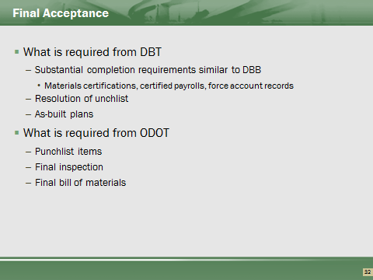

Process similar, except DBT’s consultant required to provide as-built plans.
Final bill of material will need to come from LS breakdown provided from the DBT, as required by Scope of Services. Project Engineers will need to create the Project Bill of Materials for the project.

Questions


Course Recap
