INFORMATION FOR EXCEPTION TO THE MINIMUM DESIGN STANDARDS

PROJECT: ATH-33/50-15.05/11.46

PID: 21904

STATE JOB NO.: 502370

FEDERAL PROJECT NUMBER: E040437
FUNCTIONAL CLASSIFICATION: URBAN FREEWAY/EXPRESSWAY BETWEEN THE RICHLAND AVE. AND EAST STATE STREET INTERCHANGES, URBAN ARTERIAL EVERY WHERE ELSE
2-2-09
************************************************************************

EXISTING FACILITY:

This minor pavement rehabilitation project is located in the City of Athens in Athens County. The project begins at USR 50 SLM 11.46 and ends at SLM 17.50 (6.04 mile long project). Between USR 50 SLM 12.17 and SLM 14.14, USR 33 overlaps with USR 50. The opening year (2010) Average Daily Traffic is estimated at 25,970 vehicles with 9% truck traffic. The legal speed for this facility is 55 mph from USR 50 SLM 11.46 to SLM 14.85 and 60 mph from USR 50 SLM 14.85 to SLM 17.50. Most of the highway was built on the banks of the Hocking River except for the beginning of the project which follows a tributary valley from a hilltop down to the river. The steepest grade in the project area is 4.88%.

When the roadway was originally constructed in the 1970’s, USR 50 was a rural arterial except where it overlaps with USR 33 in which case it was a non-interstate, rural freeway. Design speed was 60 mph.

From settlement and deterioration, the existing pavement has become uneven. The existing pavement is reinforced concrete for the traveling lanes and either asphalt or concrete for the shoulders. There are two 12’ wide through lanes in each direction. In tangent sections all lanes slope towards the median at 1.6% slope. The median shoulders have 4’ wide pavement at 4% slope and 6’ wide grass shoulders at 12:1 for a total graded width of 10’. The median ditches have 4:1 slopes. The outside shoulders have 8’ wide pavement at 4% slope. For sections without guardrail, the graded width is 8’. For sections with guardrail, there are 4’ wide shoulders at 12:1 to support the guardrail which makes the total graded shoulder width 12’ wide. The guardrail offset from the traveling lanes is 10’ for the outside shoulders and 6’ for the inside shoulders.

There are eleven bridge sites in the project area: ATH-50-1168 (EB 50 over ramps), ATH-50-1185 L&R (USR 50 over EB USR 33), ATH-33-1760 L&R (Richland Ave. crossing), ATH-682-0004 (SR 682 over mainline), ATH-33-1713 (Hooper St. over mainline) ATH-33-1631 L&R (CR 25 crossing), ATH-33-1600 L&R (Stimson Ave. crossing), ATH-50-1420 (ramp to Stimson Ave. over USR 50), ATH-33-1580 (WB USR 33 over USR 50) ATH-50-1592 L&R (Hocking River crossing), ATH-50-1673 L&R (East State St. crossing). The bridges that carry the mainline have two 12’ wide lanes, 6’ wide inside shoulders and 10’ wide outside shoulders (8’ for the bridges which also have ramp lanes). Shoulder offset was measured as shown on Standard Drawing BR-1-67 (10-15-71). The parapets are Jersey shaped.

The project contains four interchanges. The first interchange is at the beginning of the project which starts at the end of a five lane wide section of USR 50 that is undivided and contains a center left turn lane. The eastbound and westbound lanes of USR 50 diverge from each other so that an undivided on and off ramp can continue on a tangent and down grade to Richland Ave. where there are additional ramp entrances to USR 33. Eastbound USR 50 flies over this ramp and then joins back with westbound USR 50 to create a 40’ wide median which is the median width for the remainder of the project. Once the two directions rejoin each other, they cross over two lanes of eastbound USR 33. On the other side of the bridge, two lanes of westbound USR 33 join with eastbound USR 50 and two lanes of eastbound USR 33 diverge from westbound USR 50. Between this point and the ramps at the SR 682 interchange, there is a third shared 12’ wide lane in each direction.

The second interchange has four ramps to connect with SR 682. The third interchange has multiple ramps to connect with CR 25, Stimson Ave. and it allows for USR 33 to diverge from USR 50. Between the third and fourth interchanges is an at grade T shaped intersection with CR 24. The fourth interchange is near the end of the project and has four ramps to connect with East State St.

Table 1 – Original Construction Plan Information
C-R-S | Location | Construction  Project No. | Design Year | Design Speed
ATH-50-14.10 | CR 52 to Stimson Ave. | 717(73) | 1973* | 60 mph
ATH-33-16.17 | Stimson to Richland Ave. | 625(76) | 1975 | 60 mph
ATH-33-17.77 | Richland Ave. to TR 32 & 60 | 745(77) | 1975 | 60 mph
*Instead of a design year, the current year was listed.

PROPOSED FACILITY:

This proposed project is a minor pavement rehabilitation that will break and seat the existing concrete pavement and then a 6.5” asphalt overlay will be constructed. The shoulders will be built up to the new elevation with borrow and linear grading and the guardrail will be replaced. There will be limited full depth pavement replacement at tie in points and at bridges. On ramps, the asphalt will be tapered down just beyond the gore and only spot concrete repair will occur on the remainder of the ramps. The design year (2022) Average Daily Traffic is estimated at 27,500 vehicles with 9% truck traffic (T_{D} 231). The design speed for this facility is 60 mph.

The standards used for horizontal alignment, vertical alignment and widths for medians, traveled way and shoulders for minor rehabilitation projects may be the design standards that were in effect at the time of original construction. Designs will generally be made to values as high as commensurate with the conditions. Values detailed below will be maintained as is only where the use of higher values will result in unacceptable social, economic or environmental consequences.

There will not be any changes to the horizontal alignment, lane widths, paved shoulder widths, pavement slope, guardrail offset, or outside graded shoulder width. In areas without guardrail, the median shoulders will have a 6:1 slope from the edge of the paved shoulder to the ditch. In areas with guardrail, the median shoulders will have an additional 5’ wide 12:1 slope to support the guardrail. The median ditch will have a 40’ radius bottom.

ATH-33-1633 L&R and ATH-33-1600 L&R will receive concrete deck overlays and all mainline bridges in the project will get new approach slabs.

ENHANCED SAFETY:

The proposed project will enhance safety by restoring the pavement cross slope and profile grade from the current uneven condition caused by settlement and deterioration.

CONTROLLING CRITERIA:

Lane Width _____ Grades _____

Shoulder Width _____ SSD __X__

Bridge Width _____ Cross Slopes _____

Structural Capacity _____ Superelevation __X__

Horizontal Clearance _____ Horizontal Alignment __X__

Vertical Clearance _____ Vertical Alignment _____

DETAILED ANALYSIS:

- Description of Deviation:

Horizontal Alignment (Maximum Curvature): When there is a divergence point in a roadway, there is a limitation on the curvature of the diverging roadway. At the EB USR 33 divergence, WB USR 50 is on a 5° curve while EB USR 33 splits off on a 3°30’ curve on the outside. At the EB USR 50 divergence, the ramp to Richland Ave. continues on a tangent on the median side while EB USR 50 curves to the outside on a 1°30’ curve.

Table 2 – Summary of Horizontal Alignment Deviation
Horizontal Curve Name | Design Speed | Legal Speed | Curvature
 |  |  | Max. Differential* | Project
USR 33 Curve 1 | 60 mph | 55 mph | 40’ (Class 2) | 1°30’
USR 50 Curve 2 | 60 mph | 55 mph | 1° (Class 3) | 1°30’
*From Diverging Roadways Figure (1964 manual)

Stopping Sight Distance (Sag Vertical Curve): The sag vertical curve with a VPI of 649+00 for USR 50 has a down station grade of -4.00%, an up station grade of 0.40%, and a length of 450’.

Table 3 – Summary of SSD Deviation
Vertical Curve Name | Curve Type | Design Speed | Legal Speed | Vertical SSD
 |  |  |  | Required Min.* | Project
USR 50 at VPI 649+00 | Sag | 60 mph | 55 mph | 462’ (K = 105) | 449’ (K=102, 59 mph)
*Required SSD is from Figure 601-5 (1978 manual)

Maximum Superelevation: USR 33 Curve 1 is located where EB USR 33 diverges from WB USR 50.

Table 4 – Summary of Superelevation Deviation
Horizontal Curve Name | Design Speed | Legal Speed | Degree  of Curv. | Max. Superelevation
 |  |  |  | Required* | Project
USR 33 Curve 1 | 60 mph | 55 mph | 3°30’ | 8.3% | 6.25%
*Required superelevation is from Figure 602-1 (1978 manual)

- Accident Data:

The accident data for the project comes from the roadway sections covering USR 50 SLM 11.46 to SLM 12.17 and SLM 14.14 to SLM 17.99 and USR 33 SLM 15.86 to SLM 17.99. There were 86 accidents reported in this area from 2005 through 2007. 35 accidents (40% of the total) involved animals (deer). 25 accidents (29% of the total) occurred during inclement weather (snow, ice, rain, fog). 16 accidents (19% of the total) had injuries and there were no fatal accidents. 2 accidents (2% of the total) were intersection accidents at CR 24.

The non-intersection accident rate for this roadway section is 0.442 acc/MVM. The non-animal involved accident rate is 0.258 acc/MVM. The animal involved accidents do not relate to the design deviations. Instead, they can be attributed to geography - the highway has wooded hills on one side and the Hocking River on the other so as deer move from their cover habitat to their water source, they cross the roadway.

The accident locations were graphed to find clusters. With the exception of one location, the clusters coincided with interchange ramps where closely spaced ramps and congestion and not the design deviations can be attributed to the accidents.

The one cluster location away from any ramp area is a bridge over the Hocking River near the CR 24 intersection where 15 accidents occurred in half a mile. Two accidents were intersection accidents, 6 were animal accidents, and 4 accidents occurred during inclement weather. The roadway is straight and flat at this location and there is enough distance between the bridge and intersection for unobstructed intersection sight distance. The animals were likely drawn to the location because of the river. The flatness of the roadway may be a reason for the non-intersection and non-animal accidents since there is a crest vertical curve with a down station grade of 0.40% and an up station grade of -0.24%. With settlement of the bridge approach embankment and pavement deterioration, the slope and grade of the pavement may be preventing water from quickly draining away in inclement weather and the rough pavement may be causing drivers to over correct during dry conditions.

- Future Traffic Safety:

By restoring the pavement cross slope and profile grade from the current uneven condition caused by settlement and deterioration, the project will enhance future safety. The replacement of the guardrail will eliminate obsolete items such as Type A anchor assemblies from the clear zone.

- Impact On Adjacent Property:

The proposed work will occur within the existing right of way. The only impact to adjacent properties will be being near the dust and noise of a construction project.

Upgrading the roadway to meet all standards in effect at the time of original construction will not require additional right of way.

- Proposed Mitigation:

The mitigation measures to be used on this project are:
- Improve roadway delineation by installing new thermoplastic pavement markings, raised pavement markers at 80’ maximum spacing, barrier reflectors and delineator posts. The current painted pavement markings don’t adhere well to the existing concrete pavement and deterioration of the pavement has left spots where raised pavement markers can’t be safely installed. Exposure to the environment has degraded the existing barrier reflectors and delineators. Many barrier reflectors are missing and the spacing of delineators is too large for current standards.

- Keep traffic from encroaching on the roadside by installing continuous rumble strips in the shoulders, restoring the pavement grades and cross slopes, and improving the surface of the existing paved asphalt shoulders. Currently, only a portion of the project length has rumble strips and they are intermittent. With settlement and deterioration of the existing pavement, water can no longer drain directly off of the pavement in all locations and the roughness may cause drivers to over steer. The existing asphalt shoulders are severely deteriorated and settled which has created an uneven pavement condition at the edge of the traveling lane.

- Reduce crash severity by updating obsolete guardrail installations such as Type A anchor assemblies in the clear zone and insufficient clearance between guardrail and obstacles (replacing Type 5 guardrail with Type 5A or concrete barrier).

- Improve driver awareness by maintain existing warning signs and installing additional warning signs. USR 50 Curves 1 and 3 have dual W1-2 and W13-1 (45 mph) warning signs on the approach to each curve and W1-8 chevrons along the curves. Also along USR 50 Curve 1 is a W18-13 (Watch for Ice On Bridges) sign with flashing lights in advance of the ATH-50-1155 bridge. USR 33 Curve 2 has W1-2 and W13-1 (45 mph) warning signs on the approach. There is a W11-3 deer sign at USR 33 SLM 17.01 WB and there are W2-2 signs in advance of the CR 24 intersection. Additional warning signs for CR 24 and USR 33 Curve 1 will be installed on the inside shoulder to create dual installations. Four W11-3 deer signs will be installed along the project. The existingW4-1R sign at the merge point between EB USR 50 and WB USR 33 will be replaced with a W4-H1 sign which accurately shows how the inner lanes merge together into one lane.

- Pertinent Information:

The original plans show that the terminal of EB USR 50 where USR 50 Curve 2 is located was designed as a one lane ramp speed change lane. At some point it was changed to a diverging roadway configuration, but there are no archived plans that show this change.

The roadway segments beyond USR 33 Curve 1 and USR 50 Curve 2 are classified as two lane directional roadways with design speeds of 50 mph.

- Support For Deviation:

Meeting the horizontal curvature requirements at both diverging roadway locations will result in 3,600’ of roadway reconstruction. This reconstruction will result in increased cross section work along both roadways as well as lengthen the diverging roadway to accommodate the flatter curvature. The rebuilt roadway may result in a reduction in the available horizontal sight distance along the inside of each curve. Below is a detailed description of the effects at each location.

EB USR 50 curves away from a tangent ramp in the median so that it can swing around and cross over the ramp on a bridge and then rejoin with WB USR 50. Changing the USR 50 Curve 2 curvature from 1°30’ to 1° to conform with the divergence curvature requirement would shift the roadway laterally by 10’ at most, but would require 1,400’ of pavement reconstruction and the lengthening of the 8° curve that follows USR 50 Curve 2. Only the last 225’ of Curve 2 is inside the project limits.

Table 5 – Summary of USR 50 Curve 2 Costs
To Upgrade Curvature to 1°
Construction Features | Quantity | Unit Cost | Cost
 |  |  | In Millions of Dollars
Rebuild WB USR 50* | 1,400’ | $2.45 M/Mile of 4 lane | 0.33
Misc. Items** |  |  | 0.32
TOTAL |  |  | 0.65
*Two lanes
**Miscellaneous items include: Earthwork, Erosion Control, Maintenance of Traffic, Traffic Control, etc.

EB USR 33 separates from WB USR 50 and curves away from USR 50 so it can then drop down and cross underneath USR 50. Changing the USR 33 Curve 1 radius to conform with the divergence curvature requirement would decrease the curve radius from 1,637’ to 1,322’ since it is on the outside of the mainline curve. It would also require the use of barriers and a retaining wall beyond the gore area because of the reduced separation between the roadways (more than 60’ closer). It would also cause the 8° curve that follows USR 33 Curve 1 to be extended under the bridge. 2,200’of pavement would have to be replaced. The reduced separation between roadways and bridge piers would reduce sight distance.

The required superelevation for USR 33 Curve 1 that was compared to the existing roadway came from Table 602-1 in the 1978 manual. In that table, full super was reached at 3°30’ curvature and held at 8.3% up to the maximum curvature of 5°. At some point after 1978 this design method was dropped. Also, the functional classification of the roadway was changed sometime in the past from rural to urban. The current design manual requires 5.8% maximum superelevation for a 60 mph urban roadway instead of the 1978 value of 8.3%.

Table 6 – Summary of USR 33 Curve 1 Costs
To Upgrade Superelevation and Curvature to 4°20’
Construction Features | Quantity | Unit Cost | Cost
 |  |  | In Millions of Dollars
Rebuild EB USR 33* | 2,200’ | $2.45 M/Mile of 4 lane | 0.51
Build Retaining Wall | 4,000 SF | $135/SF | 0.54
Misc. Items** |  |  | 0.32
TOTAL |  |  | 1.37
* Two Lanes
** Miscellaneous items include: Earthwork, Erosion Control, Drainage, Maintenance of Traffic, Traffic Control, etc.

Improving the vertical stopping sight distance of the sag curve with a VPI of 649+00 would require replacement of the ATH-33-1763 L&R bridge deck to change the profile grade. The vertical curve extends 225’ on to the bridge which is almost the entire bridge length. A longer vertical curve would extend all the way across the bridge. The current condition of the bridge is good and the only work currently required is the replacement of the approach slabs and sealing of the concrete parapets.

Table 7 – Summary of Costs To Upgrade
Sag Vertical Curve at VPI 649+00
Construction Features | Quantity | Unit Cost | Cost
 |  |  | In Millions of Dollars
Rebuild Bridge Deck | 28,400 SF | $35/SF | 0.99
Rebuild Pavement* | 400’ | $2.45 M/Mile of 4 lane | 0.28
Misc. Items* |  |  | 0.32
TOTAL |  |  | 1.59
*Six Lanes
**Miscellaneous items include: Erosion Control, Maintenance of Traffic, Traffic Control, etc.

Table 8 – Summary of Costs To Eliminate Deviations
Features To Be Improved | Cost
 | In Millions of Dollars
USR 50 Curve 2 curvature | 0.65
USR 33 Curve 1 curvature & super | 1.37
Sag vertical curve at VPI 649+00 | 1.59
GRAND TOTAL | 3.61

The purpose of the current project is to do a minor rehabilitation to the pavement and not do a major reconstruction for which there is no funding available. Reconstructing the roadway to meet all design standards in effect at the time of original construction would add expense for little gain. Reconstructing the roadway to meet current design standards would cause situations where broader curves would overlap each other unless major horizontal alignment relocations were made as well as reconfiguration of interchanges.

SUMMARY:

The project will enhance safety by improving the pavement to ride better and drain faster. It will improve the delineation of the roadway and eliminate obsolete guardrail items. Reconstruction of the roadway to meet design standards would be costly at little additional benefit.

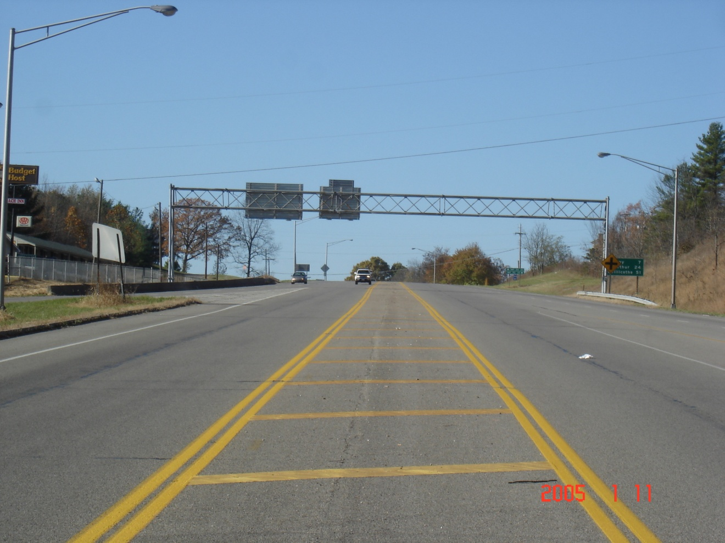

USR 50 near Sta. 600+00 looking WB. West of here USR 50 is a undivided 5 lane road. The center three lanes continue east on a tangent to Richland Ave. and the ramp intersections for USR 33. USR 50 EB splits away on two lanes shown in the left of this picture. To the right is where two lanes of WB USR 50 join. USR 50 Curve 2 is on the left.

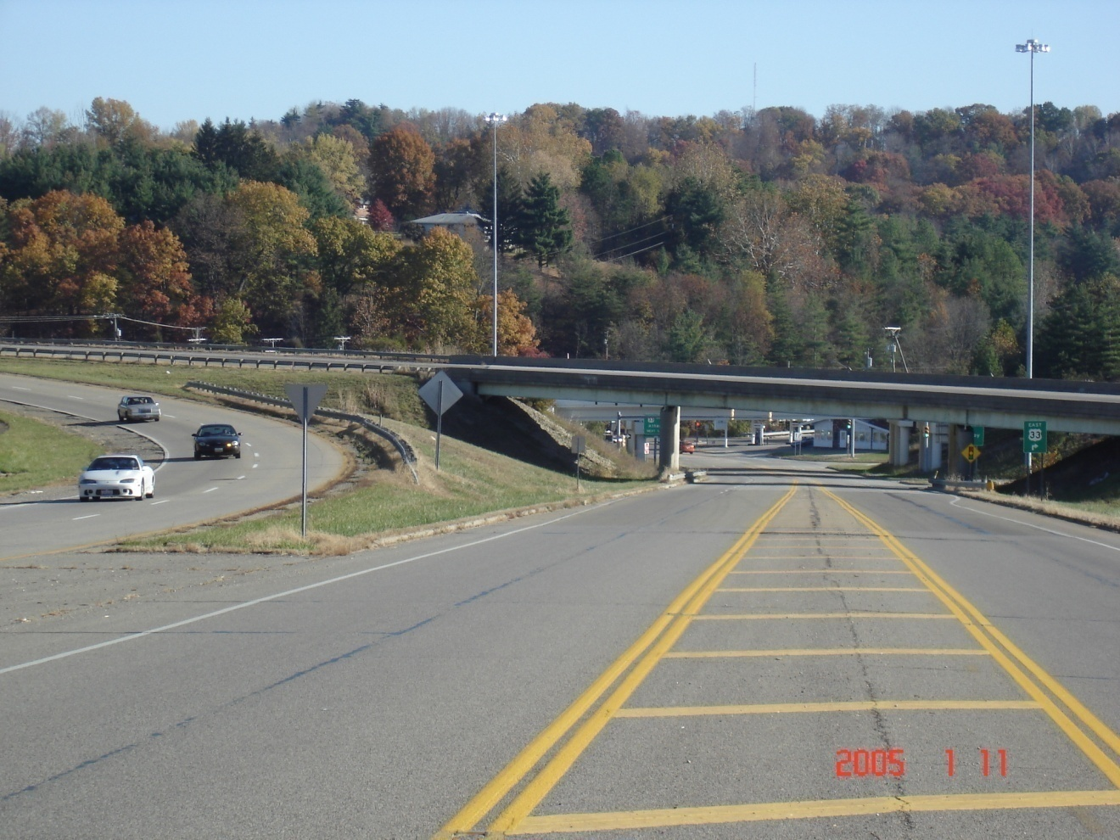

USR 50 near Sta. 603+00 looking towards Richland Ave. EB USR 50 crosses over this undivided ramp on ATH-50-1155. WB USR 50 joins to the left. This is the ramp that USR 50 Curve 2 has diverged from.

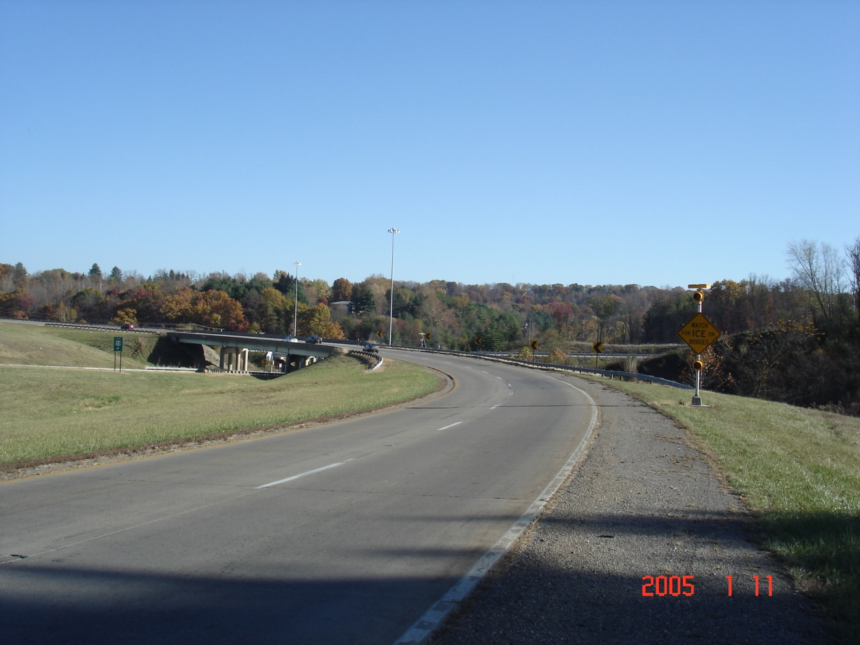

EB USR 50 at USR 50 Curve 3 looking east. The bridge is ATH-50-1155. The photo shows the ice warning sign and the chevrons.

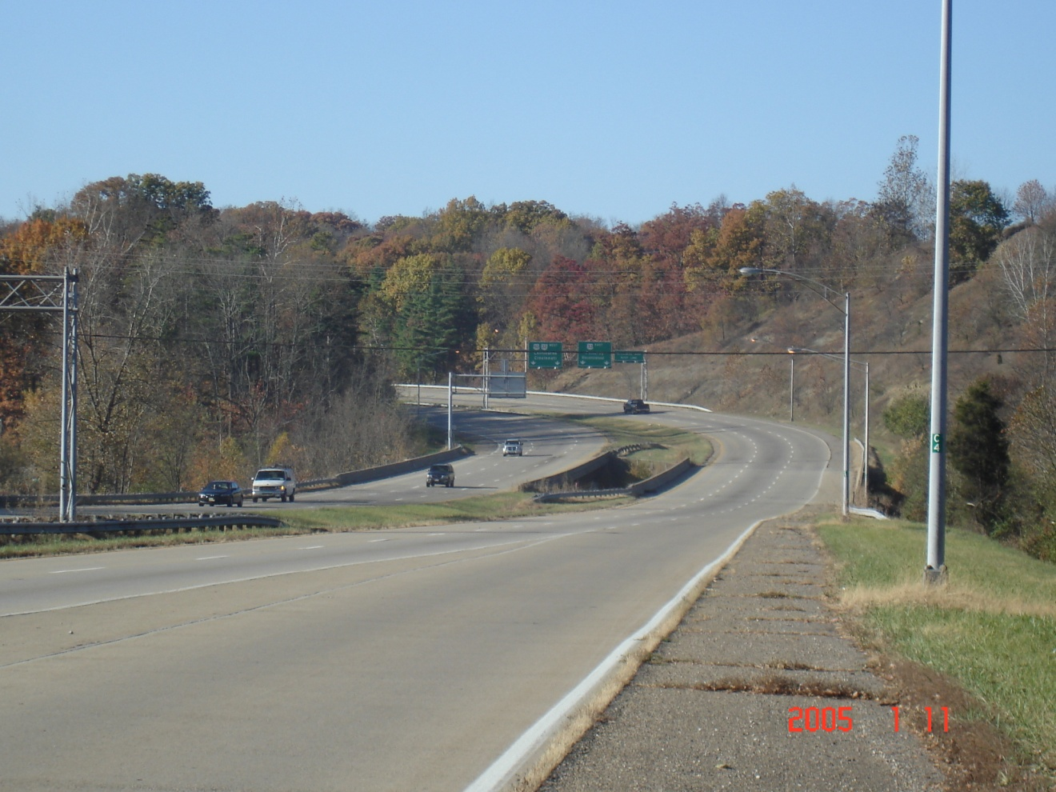

Looking west from the SR 682 interchange towards USR 50 Curve 4. The bridges in the photo are ATH-33-1763 L&R. The sag vertical curve with a VPI of 649+00 is in the center of the photo. The condition of the asphalt shoulder can be seen too. In the background, EB USR 33 splits off from WB USR 50.

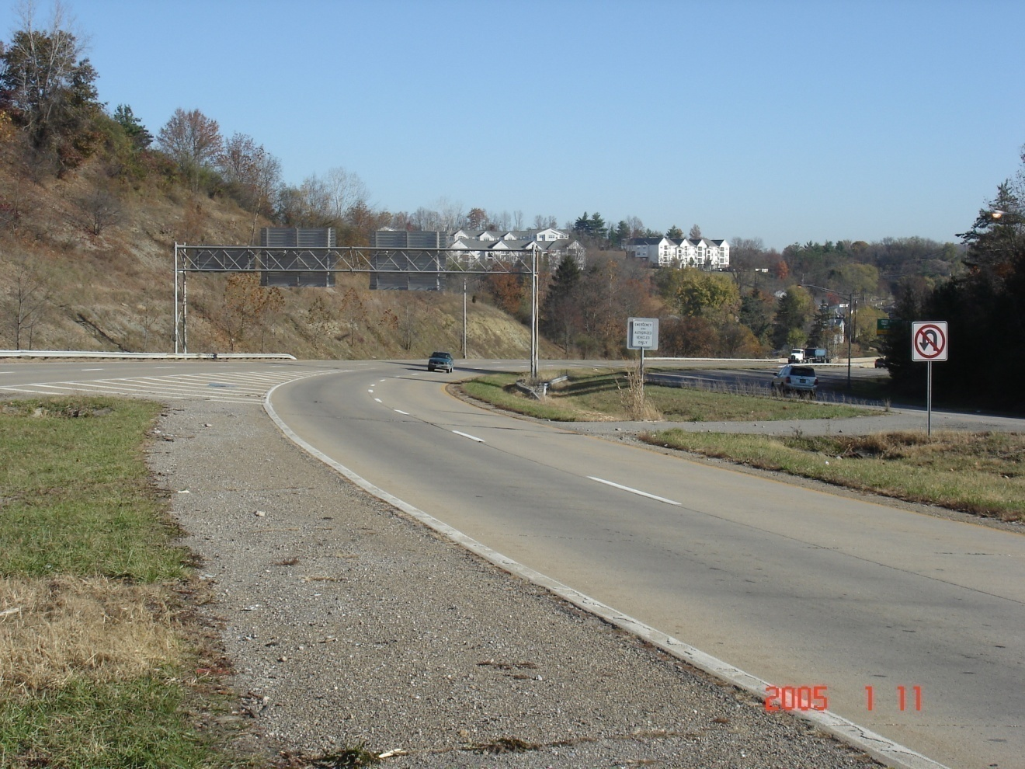

USR 50 Curve 4 looking east towards the SR 682 interchange. The EB USR 33 split from WB USR 50 can be seen in this photo. USR 33 Curve 1 is to the left.
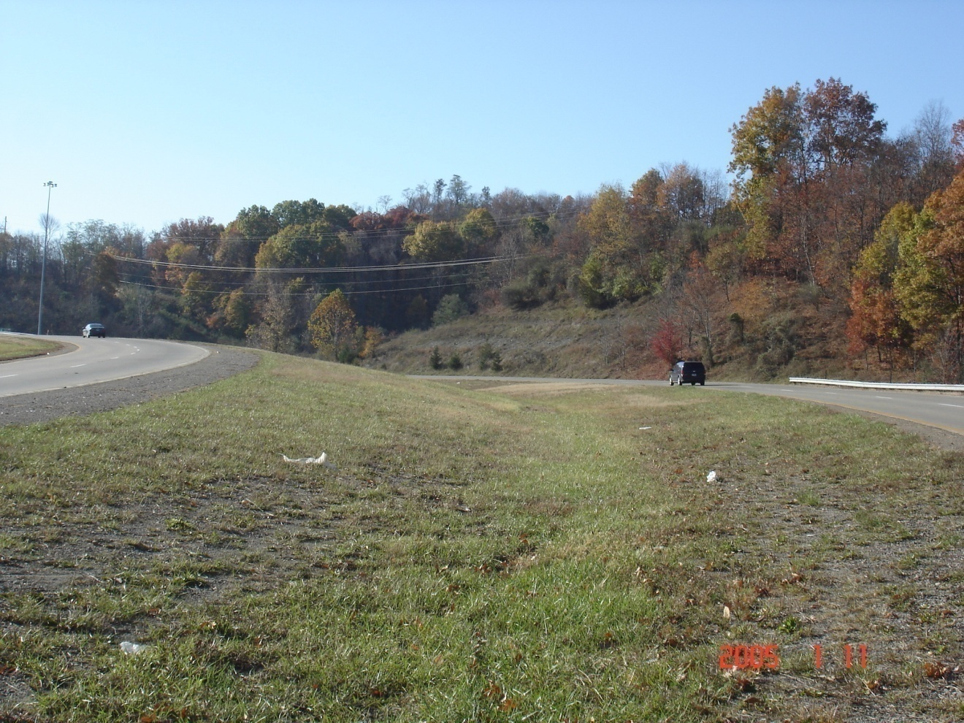

Looking west. USR 50 Curve 4 is on the left side. USR 33 Curves 1 & 2 are on the right side of the photo. EB USR 33 has just split off from WB USR 50 and will cross underneath USR 50 just beyond this photo.

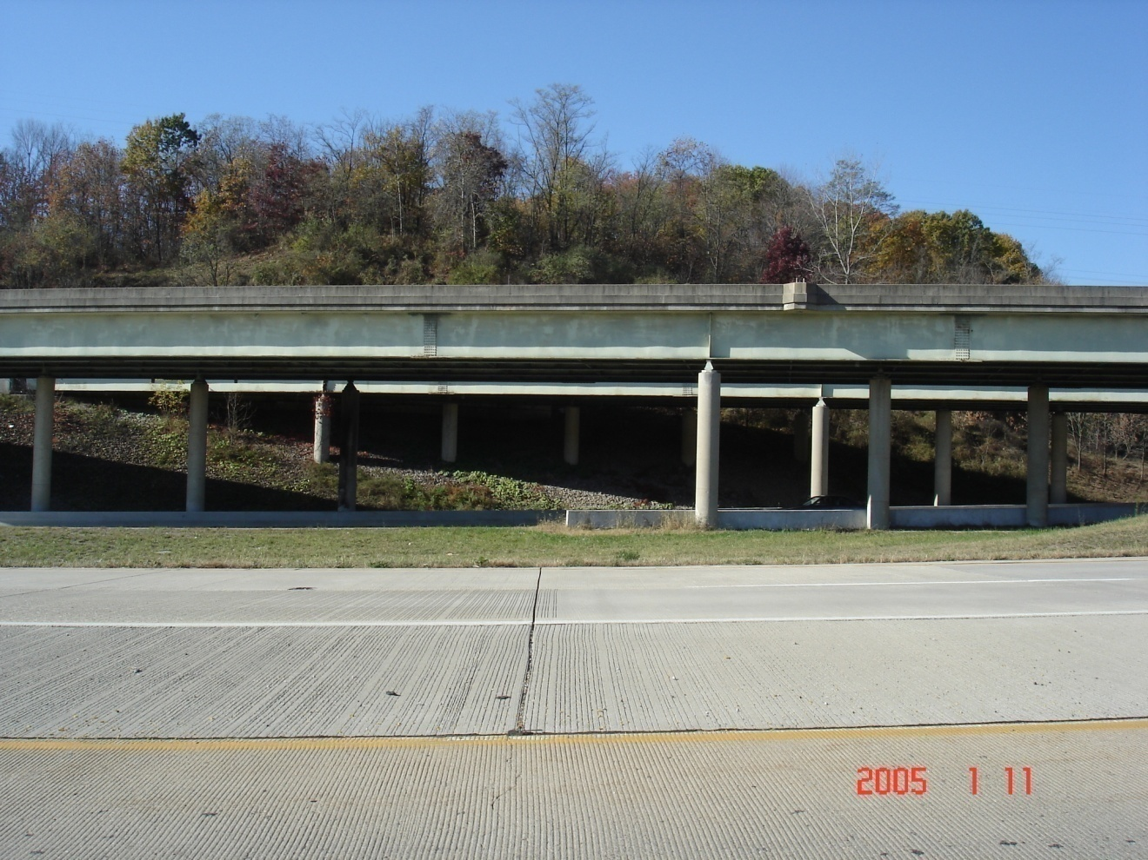

The near pavement is Ramp B joining WB USR 33. The ATH-50-1185 L&R bridges carry USR 50 over EB USR 33.
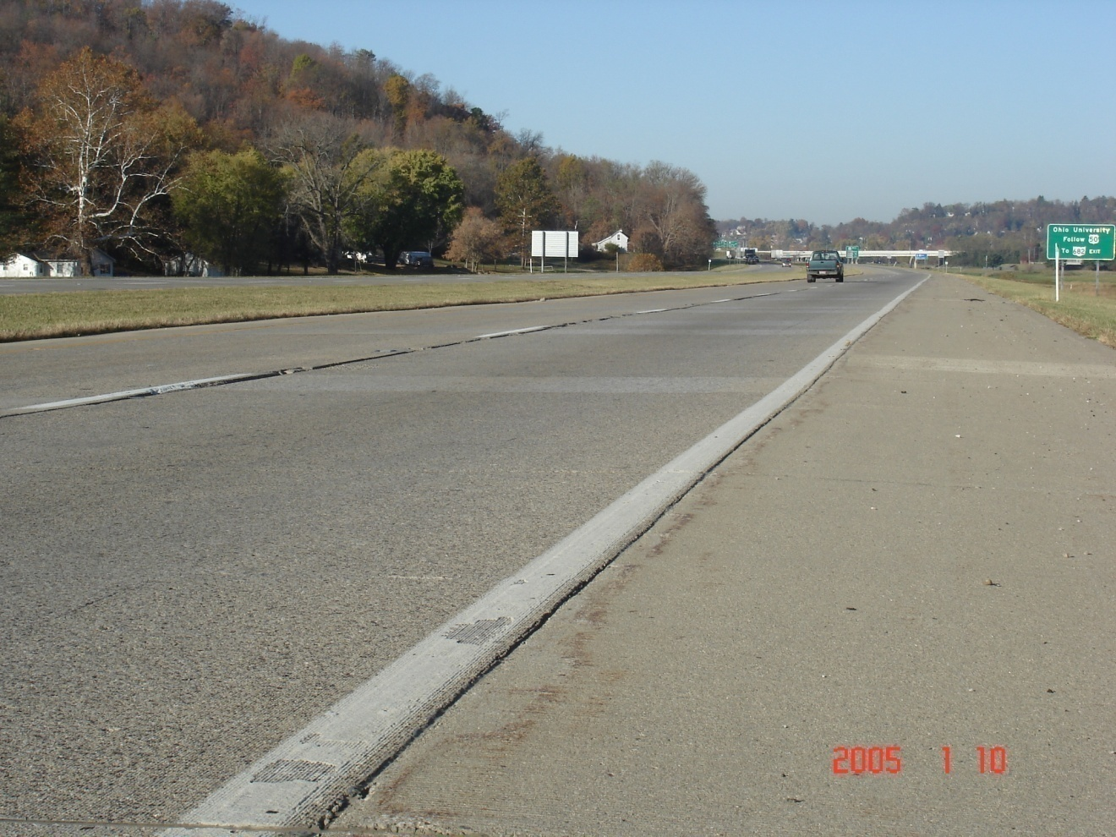

USR 50 looking west. The overhead bridge in the background is ATH-33-1580. The uneven settlement of the pavement can be seen in this picture.

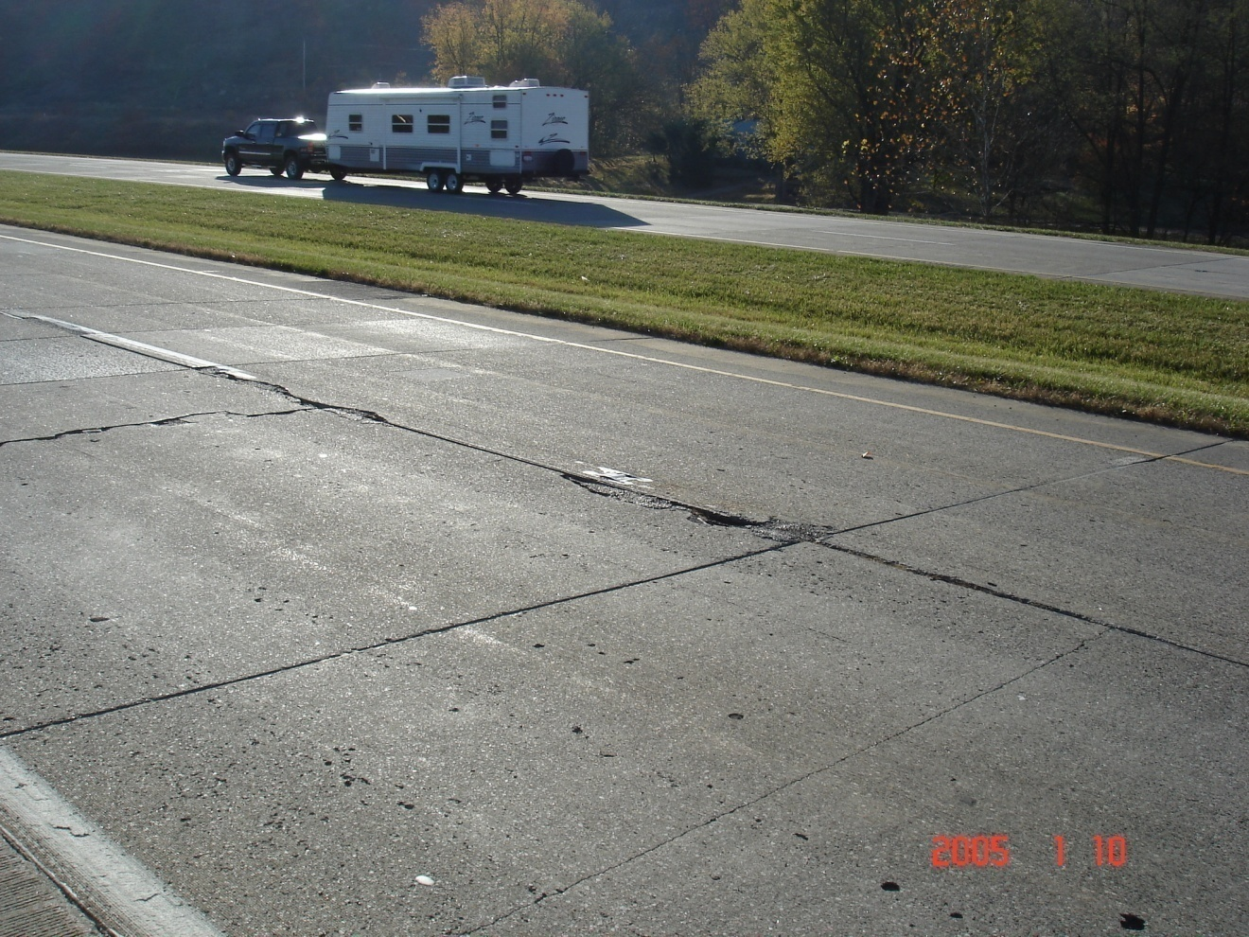

USR 50 near the previous picture. The condition of the pavement can be seen.

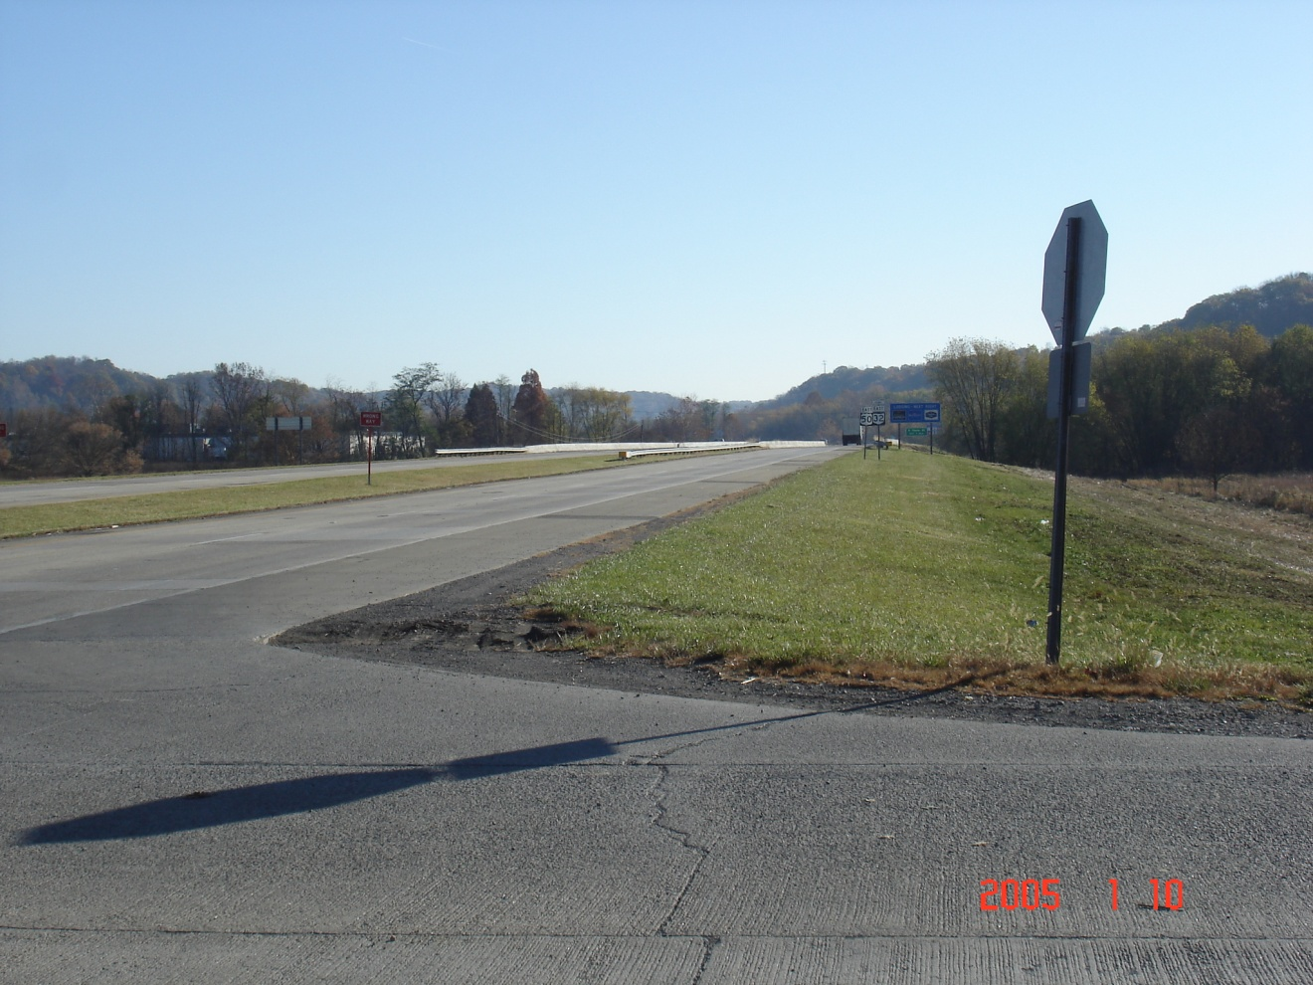

USR 50 at the CR 24 intersection looking east. The bridges are ATH-50-1592 L&R over the Hocking River.

