COMPARISON OF THE ORIGINAL PLANS TO THE DESIGN STANDARDS

PROJECT: ATH-33/50-15.05/11.46

PID: 21904

STATE JOB NO.: 502370

FEDERAL PROJECT NUMBER: E040437
CURRENT FUNCTIONAL CLASSIFICATION: URBAN FREEWAY/EXPRESSWAY BETWEEN THE RICHLAND AVE. AND EAST STATE STREET INTERCHANGES, URBAN ARTERIAL EVERY WHERE ELSE
1-8-09
************************************************************************

PURPOSE:

A design exception request was written for this project comparing the existing roadway to the current roadway classification and current design criteria. Roadway Engineering responded that the project should be compared to the original classification and design criteria. Portions of design manuals from 1964 and 1978 were provided and this document compares the roadway to these manuals. Questions on interpretation are highlighted below and a response from Roadway Engineering is needed to finalize which items will require design exceptions.

ORIGINAL PLANS:

Table 1 – Original Construction Plan Information
C-R-S | Location | Construction  Project No. | Design Year | Design Speed
ATH-50-14.10 | CR 52 to Stimson Ave. | 717(73) | 1973* | 60 mph
ATH-33-16.17 | Stimson to Richland Ave. | 625(76) | 1975 | 60 mph
ATH-33-17.77 | Richland Ave. to TR 32 & 60 | 745(77) | 1975 | 60 mph
*Instead of a design year, the current year was listed.

No functional classifications were listed in any of the plans. No design exceptions were listed in any of the plans.

ANALYSIS:

According to Figure 201-1 in the 1978 manual, USR 50 was a rural arterial except where it overlaps with USR 33 in which case it was a non-interstate, rural freeway.

According to Table 202-2 in the 1978 manual and Dean Focke, the non-interstate, rural freeway matches Code Number RF60 which has the same design data as given in Table 401-1 (1978 manual) for an urban, state freeway (60 mph design speed, 5° max curve, etc.).

The design data for the rural arterial portion of the project is given in Table 401-1 (rolling, divided highway) in the 1978 manual.

Table 2 – Summary of Graded Shoulder Information for Potential Design Exception
Road Type | Effective Outside Shoulder Width* |  | Effective Inside Shoulder Width*
 | Required | Project | Required | Project
Freeway | 10’ | 10’ | 6’ | 6’
Arterial | 10’ | 10’ | 6’ | 6’
*Note F on Figure 401-1 (1978 manual) defines effective shoulder width as the distance from pavement edge to guardrail face. There is no definition given for areas without guardrail. Looking at Figure 703-1 for instances where there isn’t any guardrail, it shows 10’ of shoulder paving for freeways which only matches the interstate condition of Table 401-1 and is inconsistent with the non-interstate freeway condition. If it is assumed everything labeled “freeways” on Figure 703-1 should say “Interstates” instead and “Arterials” should read “Non-Interstate Freeways & Arterials”, it would be consistent with Table 401-1. With this interpretation, shoulder width where guardrail isn’t present would be 8’. Dean Focke agreed there was an inconsistency and that this assumption would be correct.

Therefore, no shoulder width design exception is required.

Table 3 – Summary of Bridge Width Information for Potential Design Exception
Bridge | Lateral Clearance for Outside Shoulder*
 | Required | Project
ATH-33-1600 L | 10’ | 10’
ATH-33-1600 R | 8’** | 8’
ATH-33-1633 L&R | 10’ | 10’
*According to Standard Drawing BR-1-67 (10-15-71), the offset to the face of New Jersey shaped bridge parapet was measured to the point where the upper, steeper slope changed to the flatter, lower slope, not the vertical face closest to traffic. Mainline required offset stated above is from Table 401-1 (1978 manual).
**This location has a ramp deceleration lane on the bridge. The Interchange Ramp Typical Sections figure in the 1964 manual shows an 8’ offset on the Speed Change Lane detail.

Therefore, no bridge width design exception is required.

Table 4 – Summary of Vertical Clearances
Structure | Required Clearance | Current Clearance | Proposed Clearance
ATH-33-1730 (SR 682 ramps over USR 33/50) | 15’-0” | 15’-0” | 15’-0”
ATH-33-1713 (Hooper St. over USR 33/50) | 15’-0” | 15’-1” | 15’-1”
ATH-50-1420 (Stimson Ave. ramp over USR 50) | 15’-0” | 15’-1” | 15’-4”
ATH-33-1580 (WB USR 33 over USR 50) | 15’-0” | 15’-4” | 15’-4”
Required clearance is from Table 401-1 (1978 manual). Current clearances are also acceptable for STRAHNET non-interstate routes.
Therefore, minimum bridge clearances are maintained or exceeded.

Table 5 – Summary of Horizontal Alignment Deviation Information for Potential Design Exception
Horizontal Curve Name | Curvature
 | Required Max. | Project
USR 50 Curve 1* | 5° | 8°
USR 50 Curve 3* | 5° | 8°
USR 33 Curve 2 | 5° | 8°
USR 33 Curve 3 | 5° | 6°
* Curve is located on a roadway labeled “Two Lane Ramp” in the original plans. The current straight line diagram calls the roadway section where Curve 1 is located “Ramp J”. The current straight line diagram calls the roadway section where Curve 3 is located “Ramp M”.

The original plans show that the terminal of EB USR 50 where it is called Ramp M on the SLD was designed as a ramp speed change lane and not as a diverging roadway. At some point it was changed to a diverging roadway configuration, but there are no archived plans that show this change. The amount of work needed to accomplish this change would have been small and it would have been possible for maintenance forces to have done this work.

The original design of the WB USR 50 terminal where it is called Ramp J on the SLD does not match either of the ramp or converging roadway details in the 1964 manual. It is closest to the Multi-lane Converging With Multi-Lane detail except that a 40:1 taper rate was used instead of 50:1 and the gore width at the taper point does not match. At some later point the preferential flow was switched and one of the two lanes coming from Richland Ave. was eliminated. It is now setup as a single lane ramp terminal with the ramp on the median side.

Therefore, if the above curves are not considered to be located on ramps, a horizontal design exception will be needed.

Table 6 – Summary of Vertical SSD Deviation Information for Potential Design Exception
Vertical Curve Name | Curve Type | Design Speed | Legal Speed | Vertical SSD
 |  |  |  | Required Min. | Project
WB USR 50 at VPI 609+00 * | Sag | 60 mph | 55 mph | 651’ (K = 105) | 429’ (K=97, 57 mph)
USR 50 at VPI 649+00 | Sag | 60 mph | 55 mph | 462’ (K = 105) | 449’ (K=102, 59 mph)
Required SSD is from Figure 601-5 (1978 manual)
* Curve is located on a roadway labeled “Two Lane Ramp” in the original plans and the current straight line diagram calls the roadway section where the curve is located “Ramp J”.

Therefore, SSD does not meet the 1978 requirement for 60 mph and a design exception will be needed. If the VPI 609+00 curve was designed for a ramp instead of mainline condition, then it would fall within the high speed design values for ramps. If the legal speed can be used a design exception won’t be needed.

Table 5 – Summary of Superelevation Deviation Information for Potential Design Exception
Horizontal Curve Name | Design Speed | Degree of Curvature | Max. Superelevation
 |  |  | Required | Project
USR 50 Curve 6 | 60 mph | 3° | 7.1% | 5.5%
USR 33 Curve 1 | 60 mph | 3°30’ | 8.3% | 5.8%
Required superelevation is from Table 602-1 (1978 manual). In the table, full super was reached at 3°30’ curvature and held at 8.3% up to the maximum curvature of 5°. At some point after 1978 this method was dropped, but it is unknown whether this method was used in the early 1970’s.

Therefore, superelevation for the mid-range curves does not meet the 1978 requirement. It is unknown what type of super transition design was used in the early 1970’s. If the 1978 criteria is used, a design exception for superelevation will be needed.

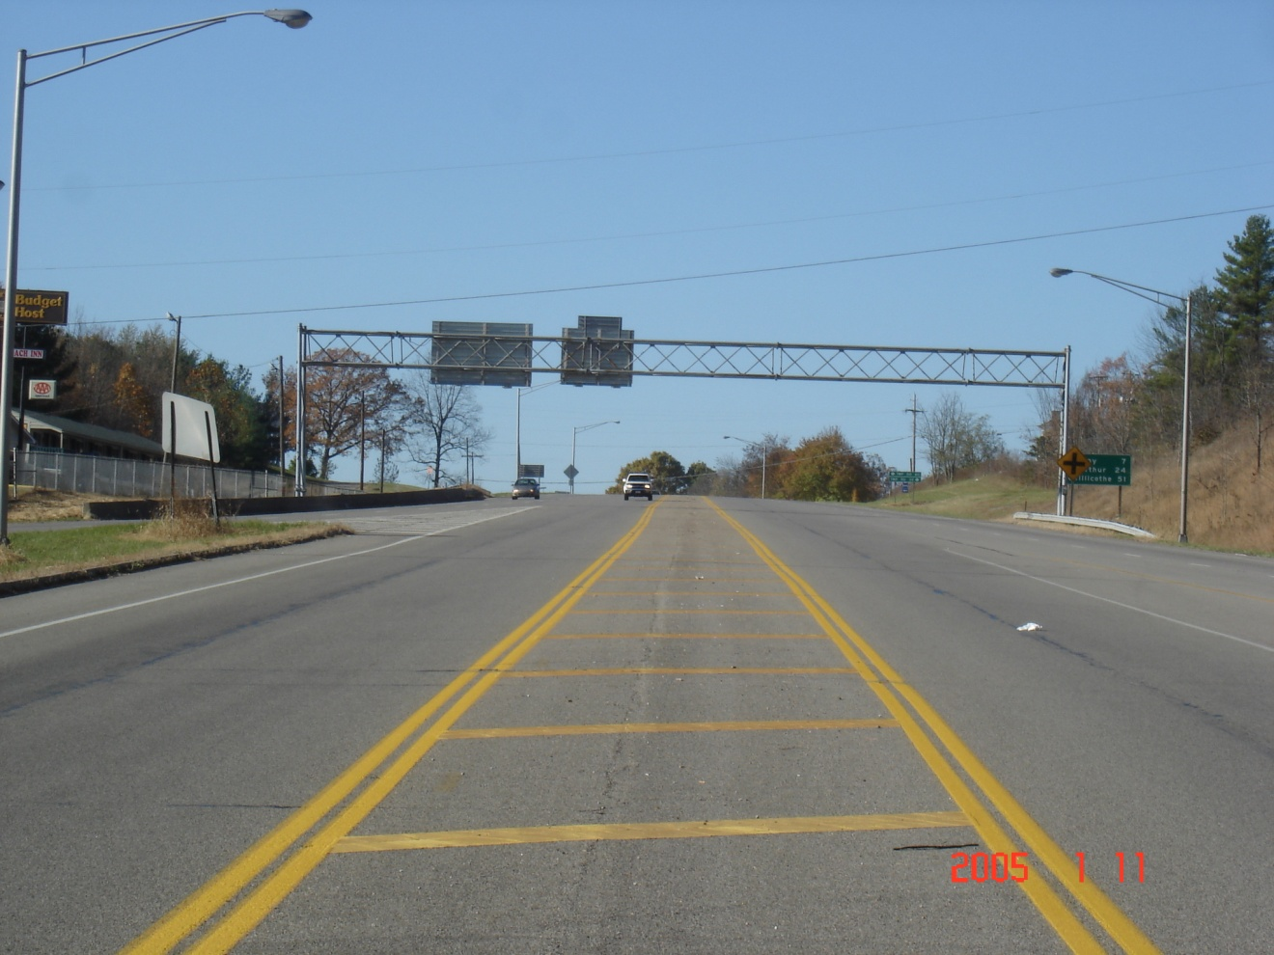

USR 50 near Sta. 600+00 looking WB. West of here USR 50 is an undivided 5 lane road. The center three lanes continue east on a tangent to Richland Ave. and the ramp intersections for USR 33. USR 50 EB splits away on two lanes shown in the left of this picture. To the right is where two lanes of WB USR 50 join.

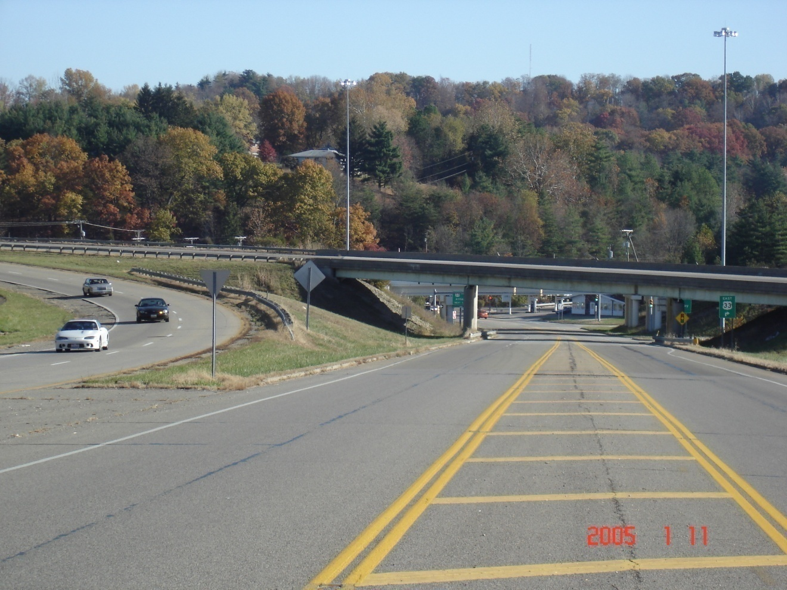

USR 50 near Sta. 603+00 looking towards Richland Ave. EB USR 50 cross over this undivided ramp on ATH-50-1155. WB USR 50 joins to the left. The curve shown on the left of the picture is USR 50 Curve 1. The location of the sag vertical with a VPI of 609+00 is also shown on the left.

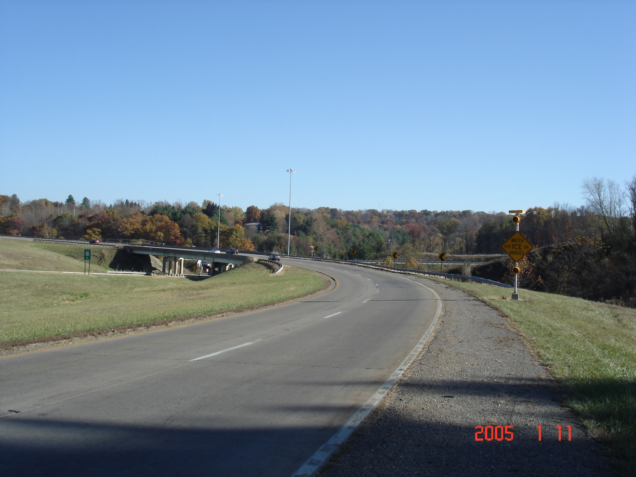

EB USR 50 at USR 50 Curve 3 looking east. The bridge is ATH-50-1155.

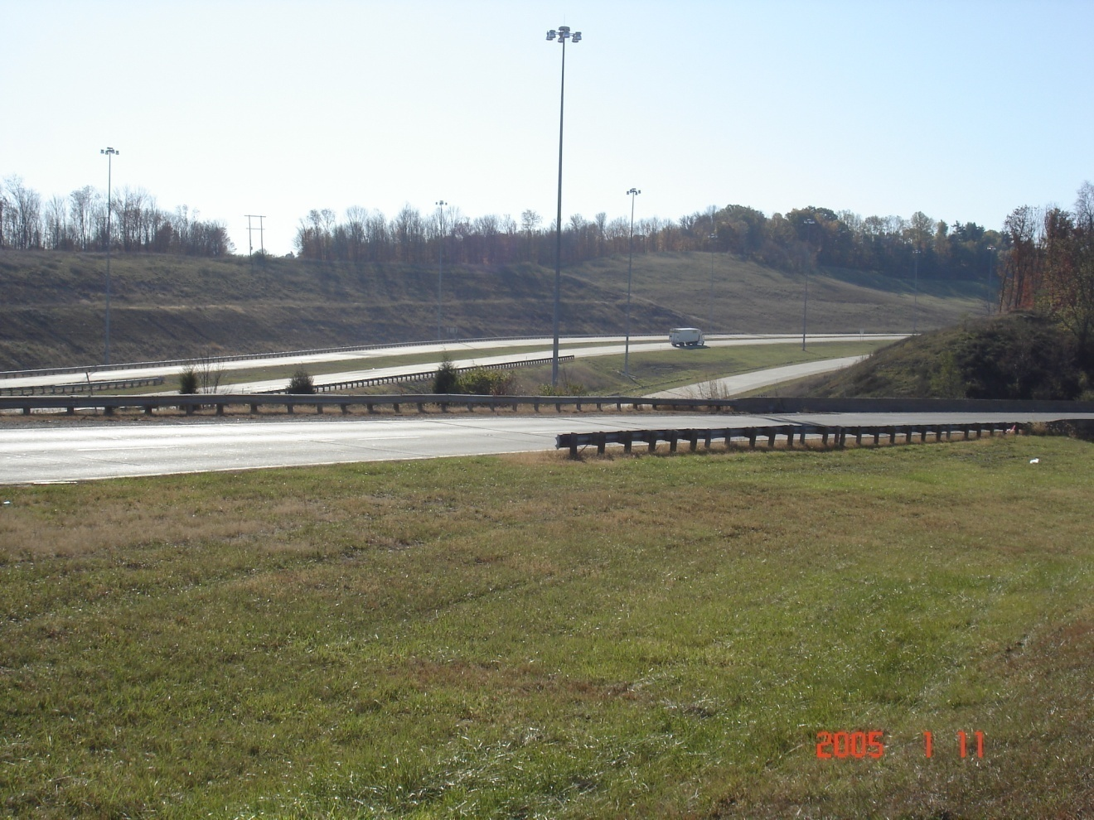

EB USR 50 at USR 50 Curve 3 looking west. The bridge at the far right in the picture is ATH-50-1155. USR 33 which heads towards Pomeroy can be seen in the background.

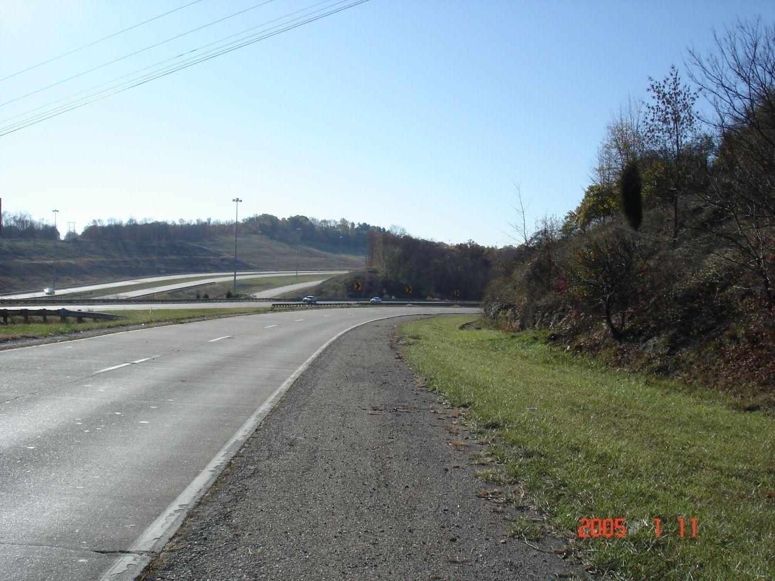

WB USR 50 at USR 50 Curve 1 looking west. EB USR 50 and USR 33 are in the background.

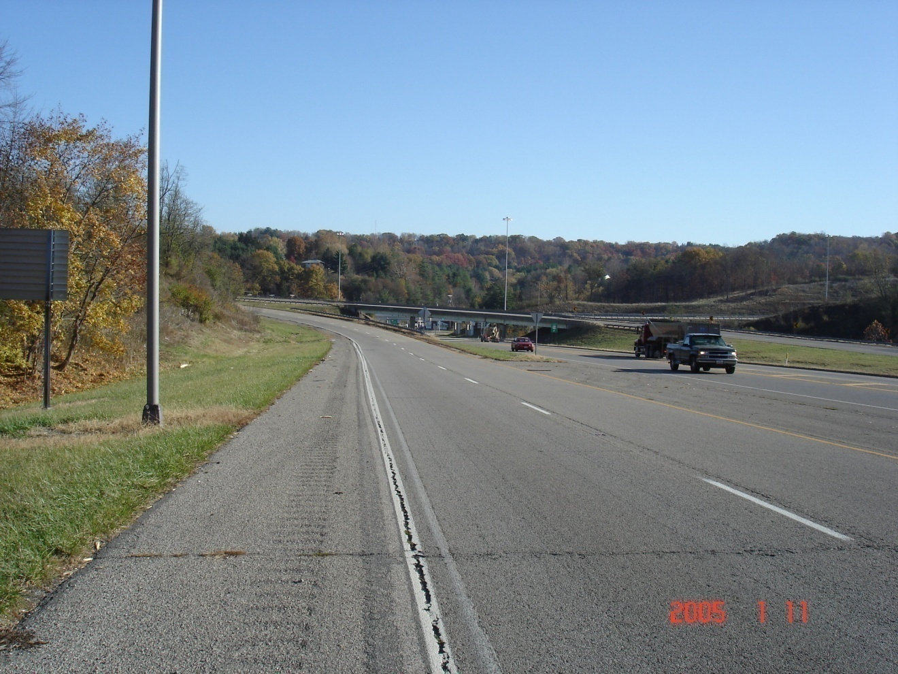

WB USR 50 at USR 50 Curve 1 looking east. The undivided ramp from Richland Ave. joins on the median side. ATH-50-1155 is in the background.

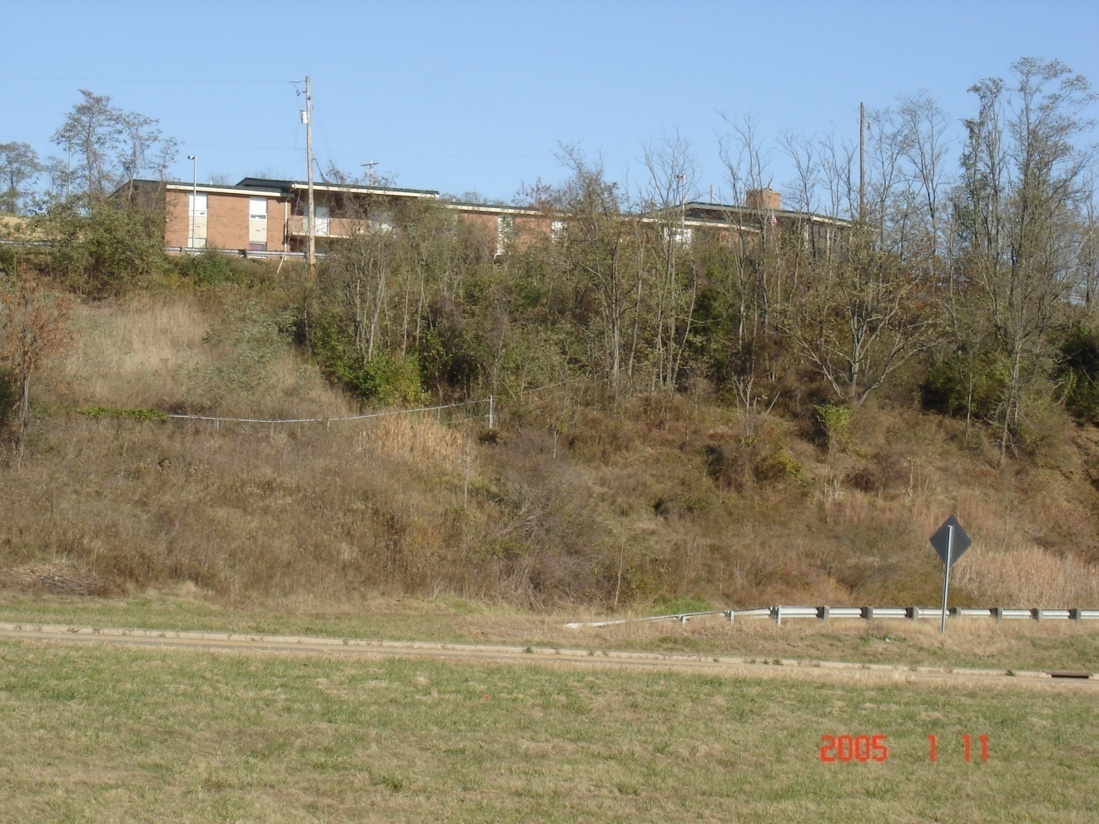

WB USR 50 at USR 50 Curve 1 looking left. The guardrail in the photo is along WB USR 50. The curb is along the undivided ramp from Richland Ave. The building is the Kimes’ rest home which sits at the top of the slope on the inside of the USR 50 Curve 1.

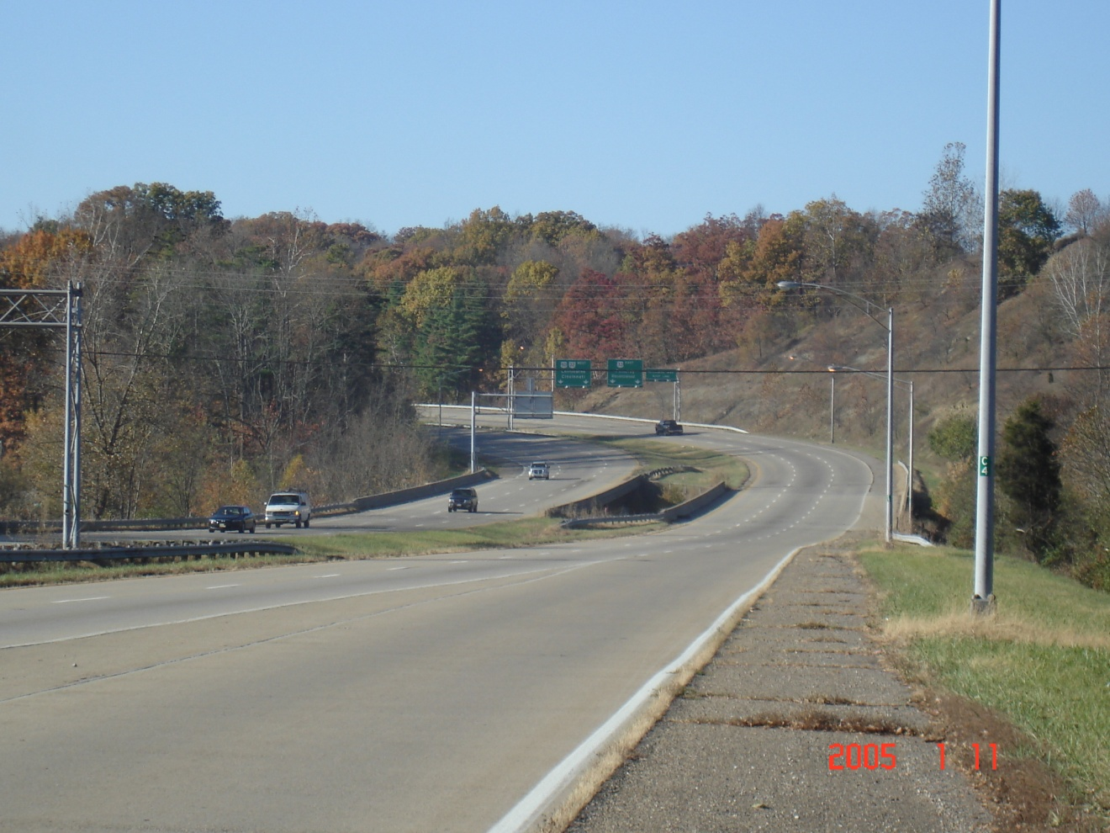

Looking west from the SR 682 interchange towards USR 50 Curve 4. The bridges in the photo are ATH-33-1763 L&R. The sag vertical curve with a VPI of 649+00 is in the center of the photo. The condition of the asphalt shoulder can be seen too. In the background, EB USR 33 splits off from WB USR 50.

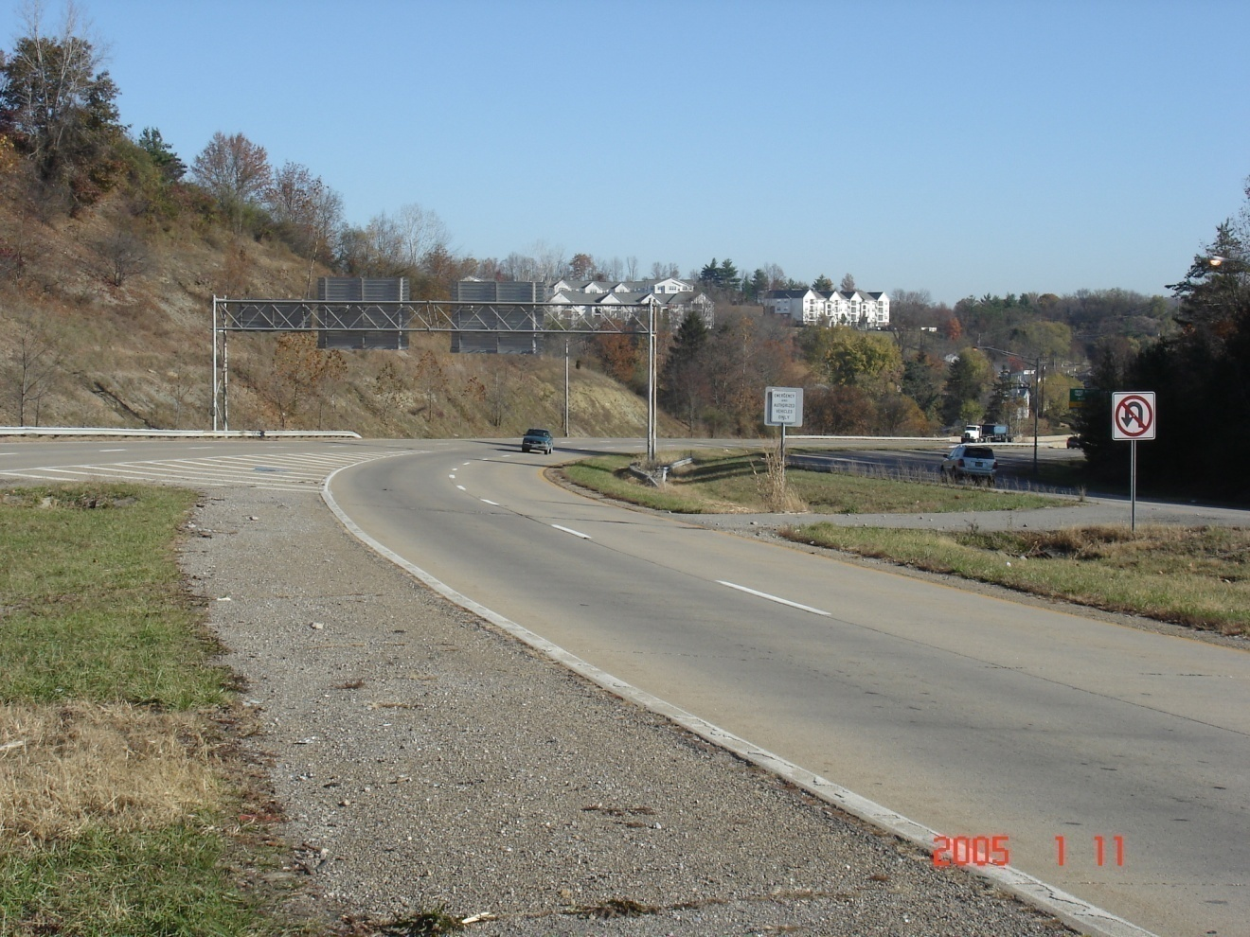

USR 50 Curve 4 looking east towards the SR 682 interchange. The EB USR 33 split from WB USR 50 can be seen in this photo.

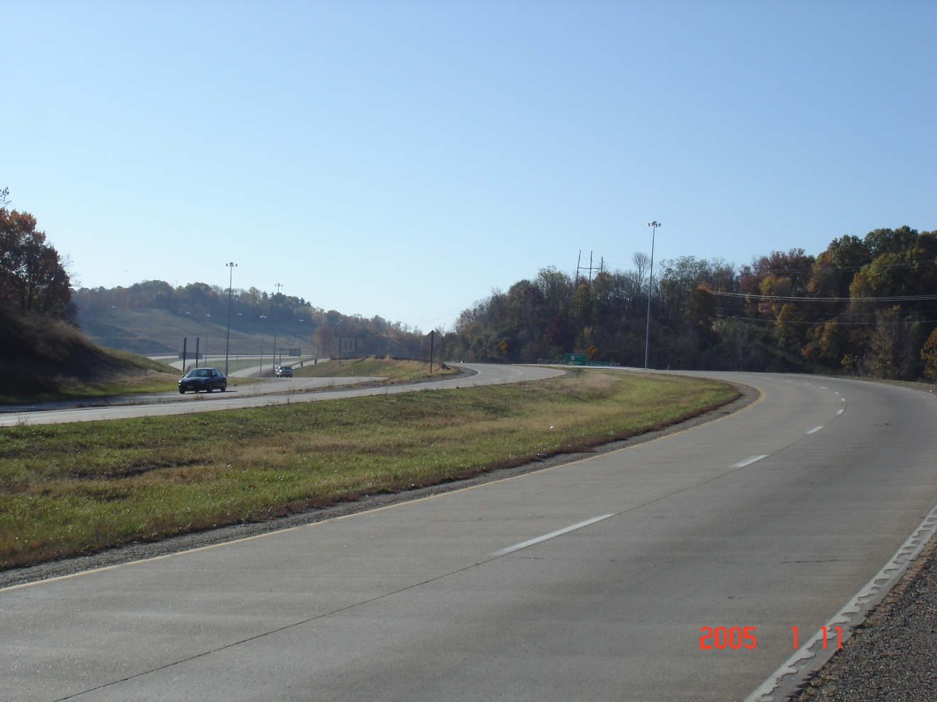

USR 50 Curve 4 looking west. EB USR 33 has already split off from WB USR 50. On the left side of the photo, WB USR 33 can be seen joining with EB USR 50. Warning signs for USR 50 Curve 1 can be seen in the background. In the far background is USR 33 going towards Pomeroy.

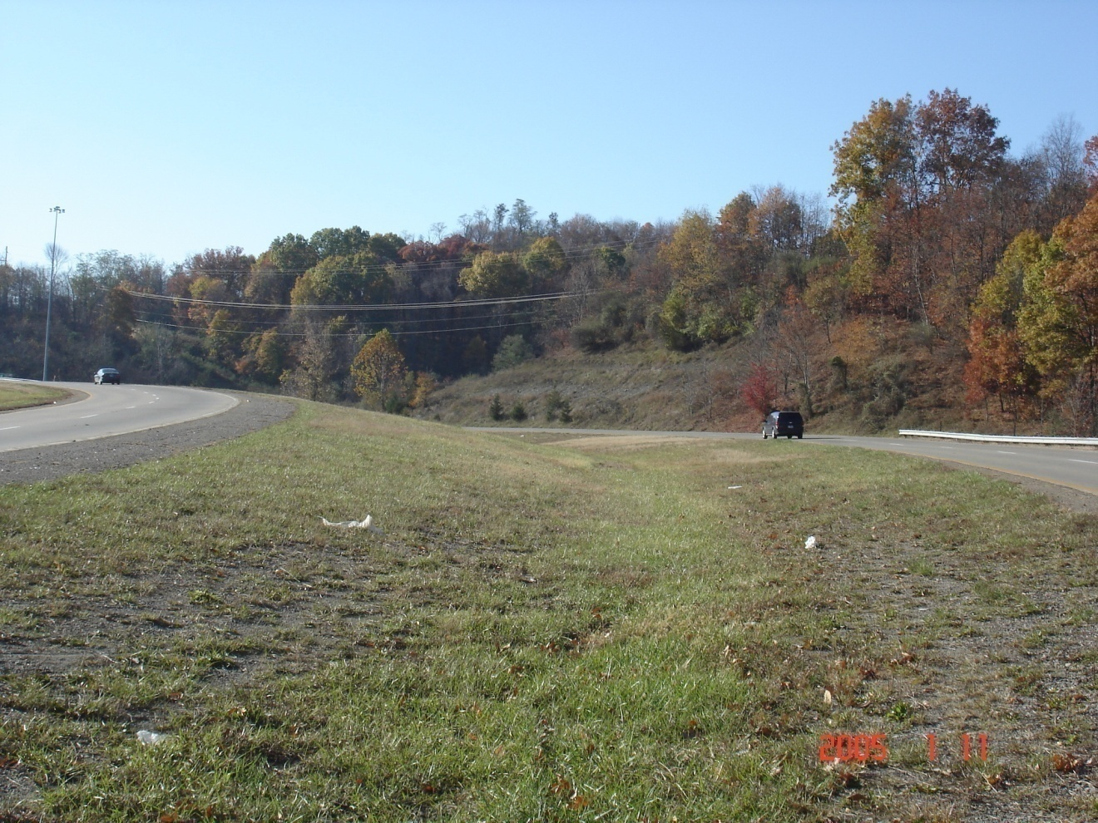

Looking west. USR 50 Curve 4 is on the left side. USR 33 Curves 1 & 2 are on the right side of the photo. EB USR 33 has just split off from WB USR 50 and will cross underneath USR 50 just beyond this photo.

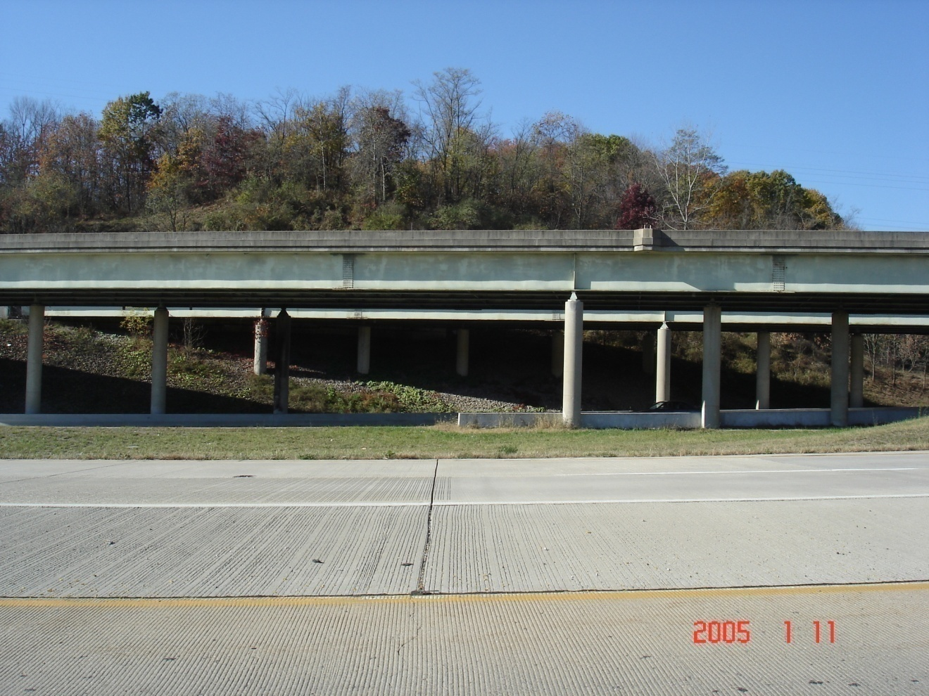

The near pavement is Ramp B joining WB USR 33. The ATH-50-1185 L&R bridges carry USR 50 over EB USR 33.

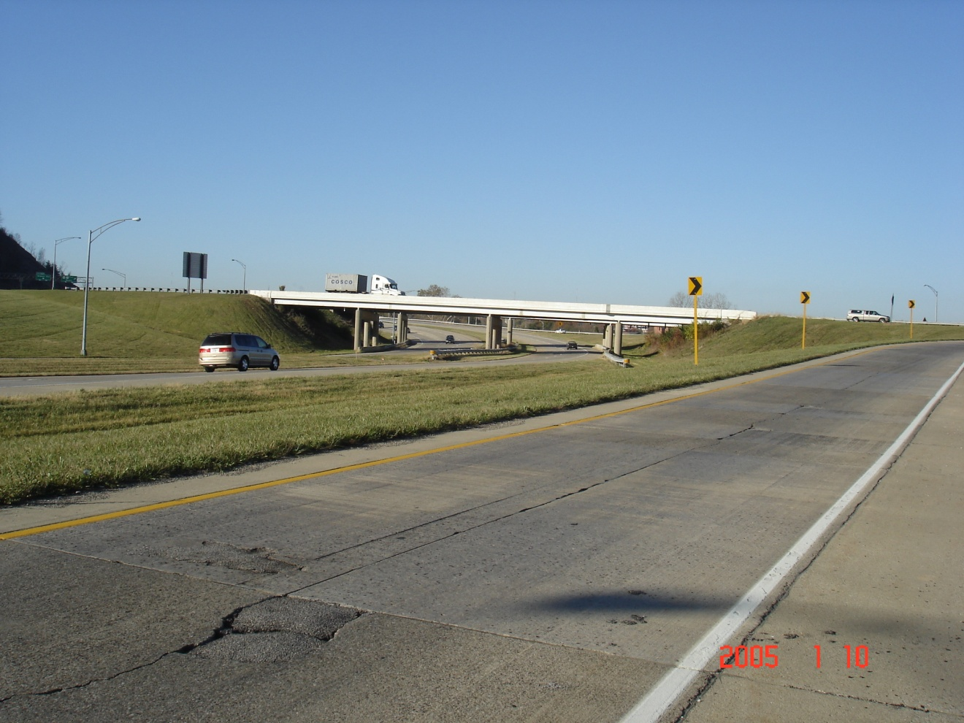

USR 50 Curve 6 looking west from Ramp T. The closest overhead bridge is ATH-33-1580 which carries WB USR 33 towards Columbus.

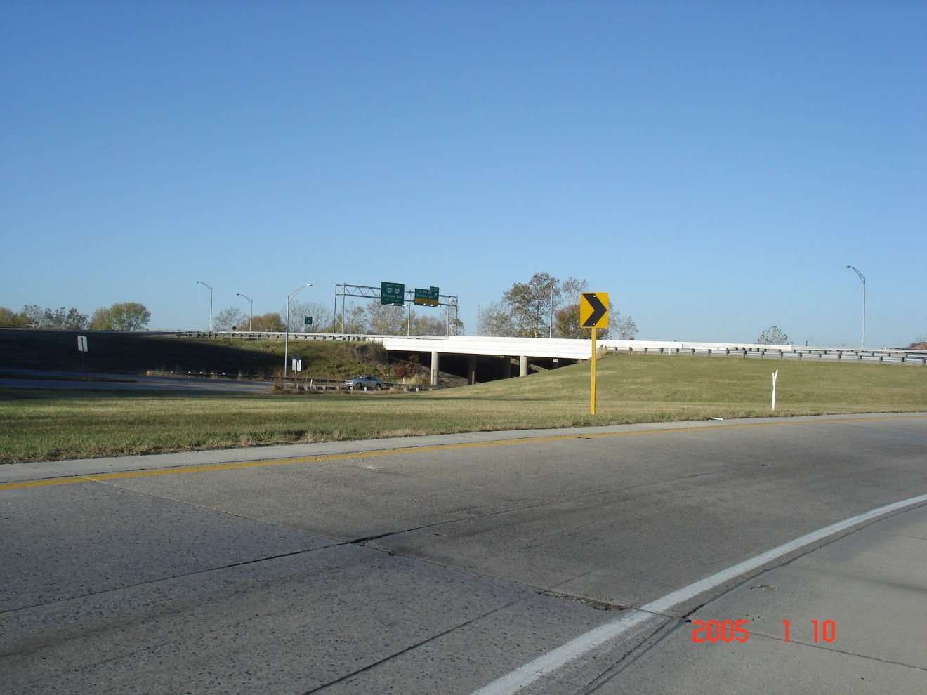

USR 50 curve 6 looking from Ramp U. The bridges are ATH-33-1600 L&R. The Stimson Ave. ramps are below.

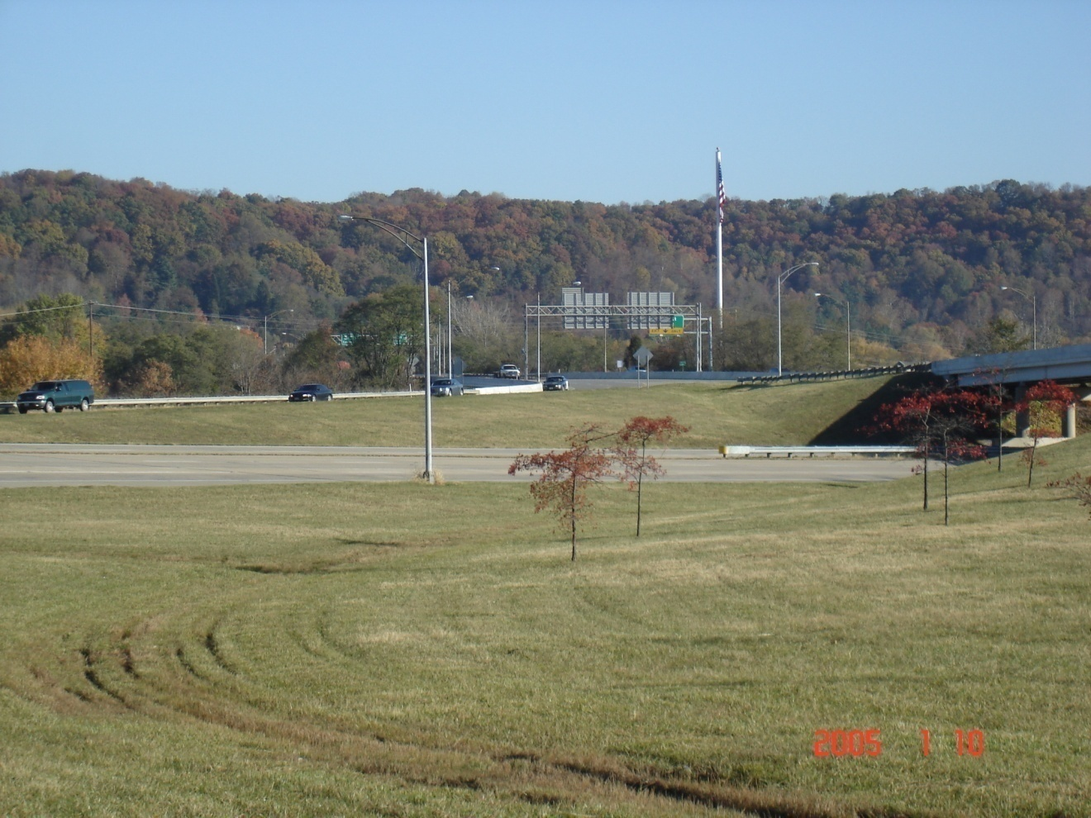

USR 50 Curve 6 looking from Ramp U. The bridge is ATH-50-1420. The ramp in the background is EB USR 33 from Columbus.

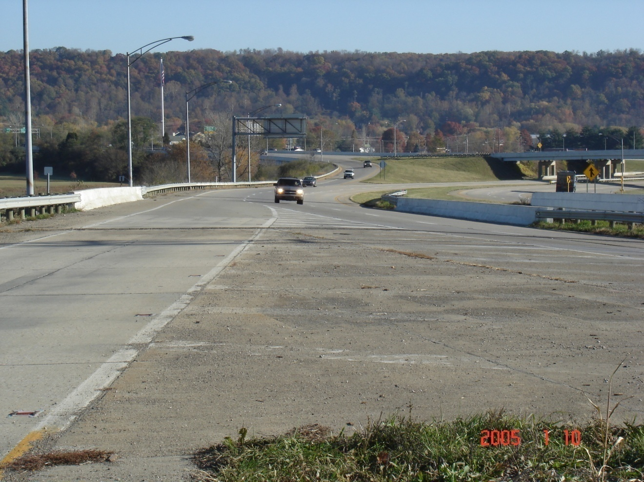

USR 50 Curve 6 looking east from Ramp R. The bridge is ATH-33-1600 R. The ramp in the background is EB USR 33 from Columbus. The overhead bridge in the background is ATH-50-1420.

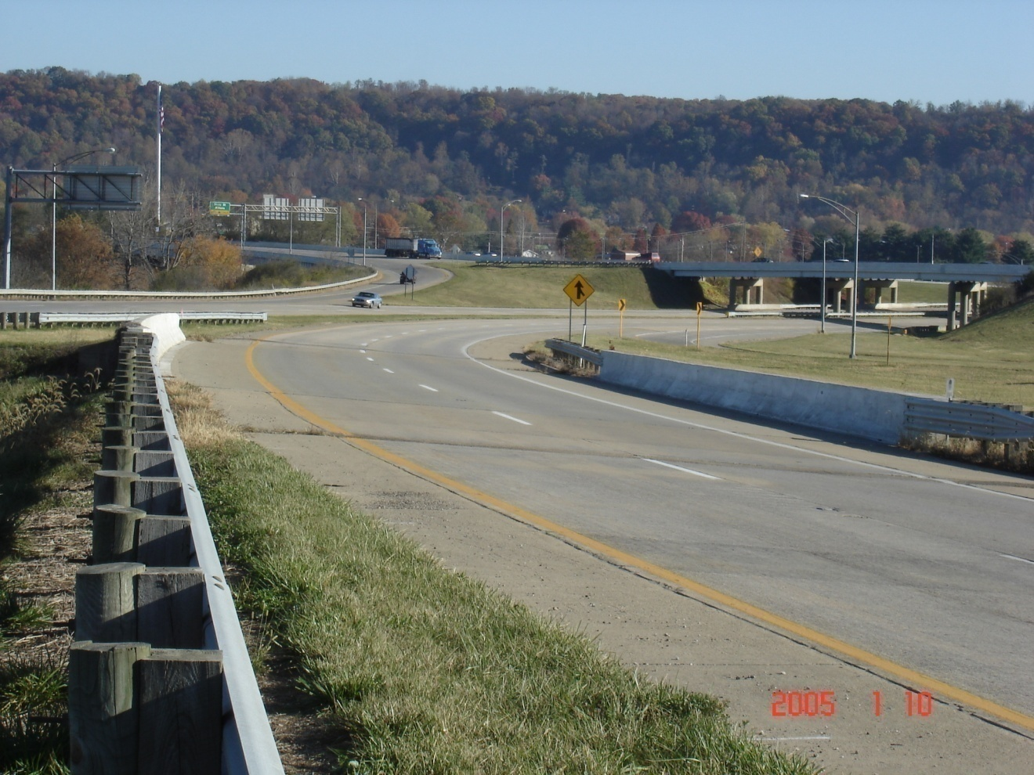

USR 50 Curve 6 looking east. The bridge is ATH-33-1600 L. The ramp in the left background is EB USR 33 from Columbus. The overhead bridge in the background is ATH-50-1420.

