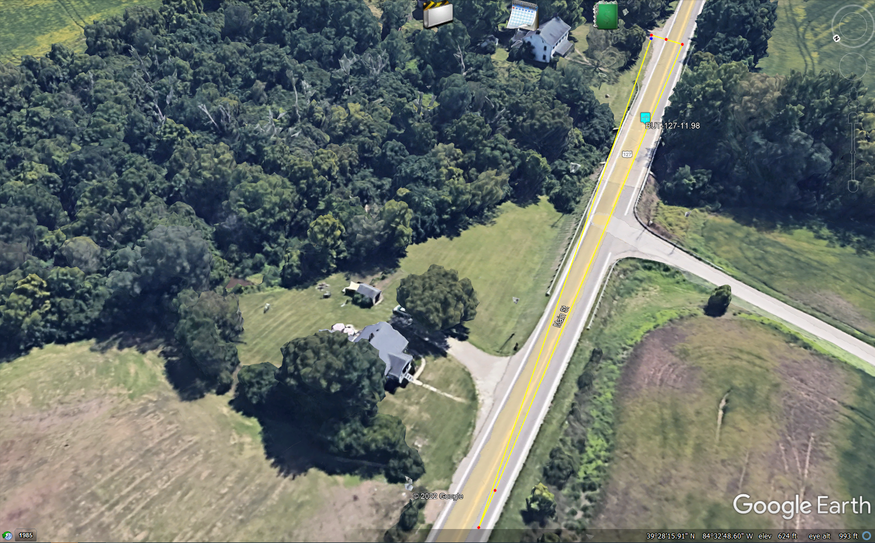

Driveway Intersection Sight Distance – Vehicle 17.8’ back from white edge line. ISD 610 feet for left turn from drive at 55 MPH.
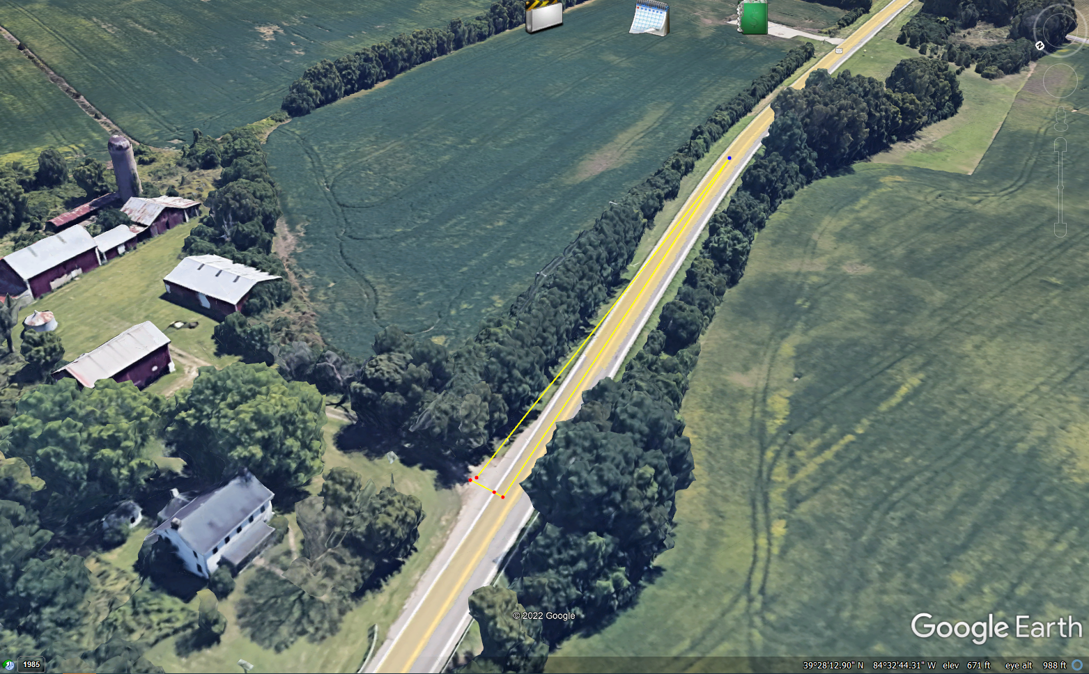
Driveway Intersection Sight Distance – Vehicle 17.8’ back from white edge line. ISD 530 feet for right turn from drive at 55 MPH.
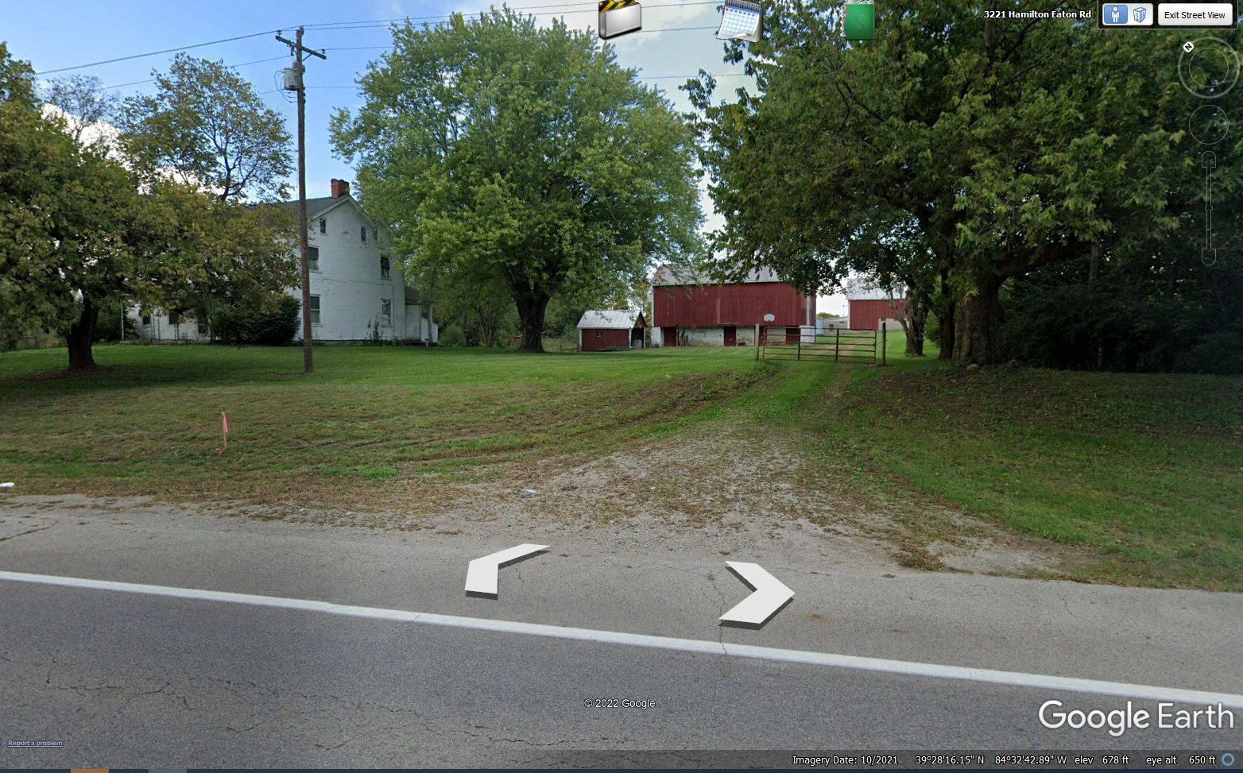
Driveway coming downhill towards US 127
Verdict => Intersection Site Distance is adequate.

