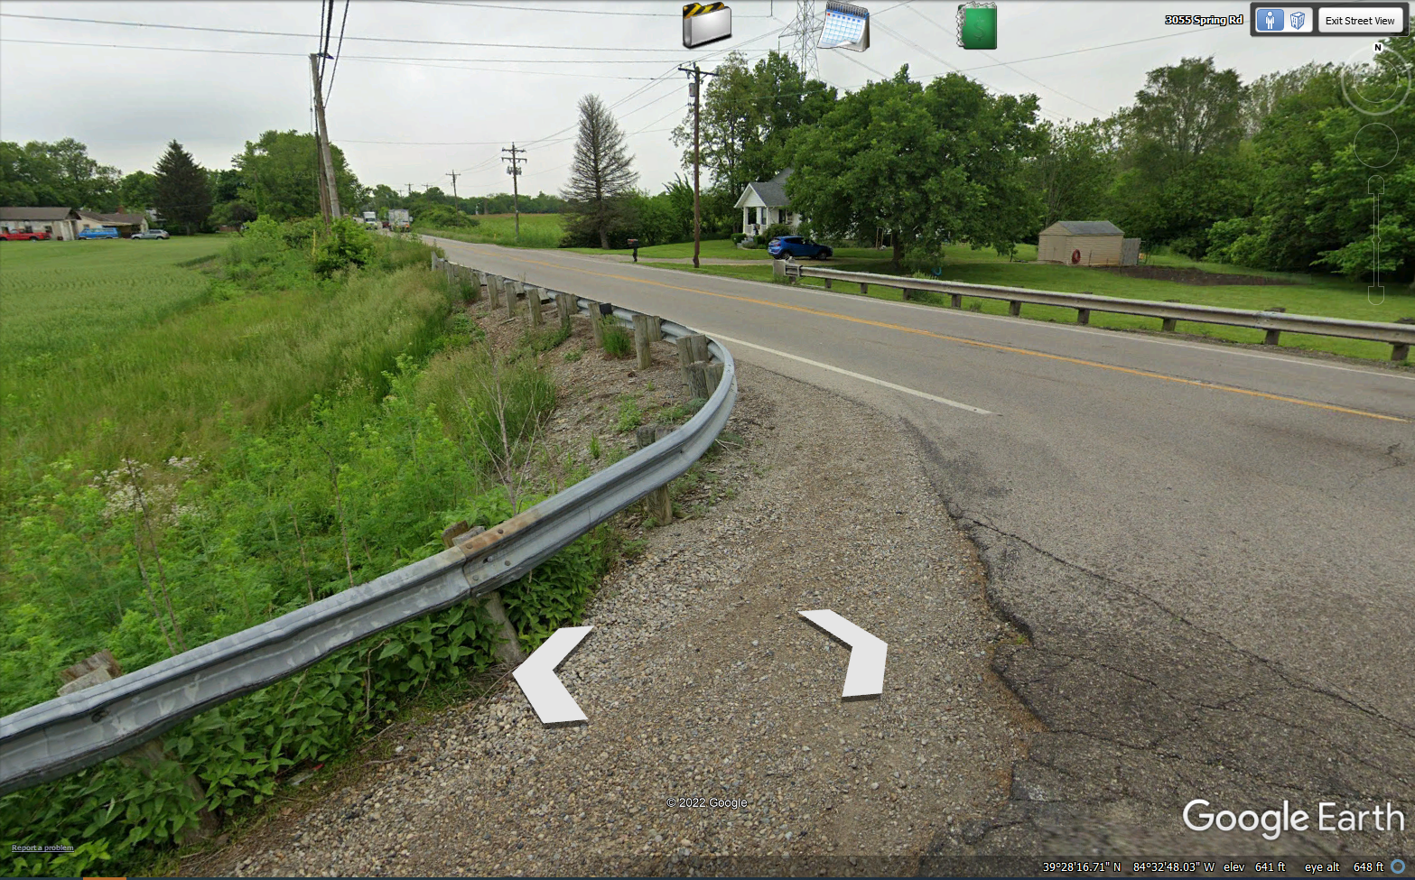

Spring Rd. Site Distance looking north on US 127.
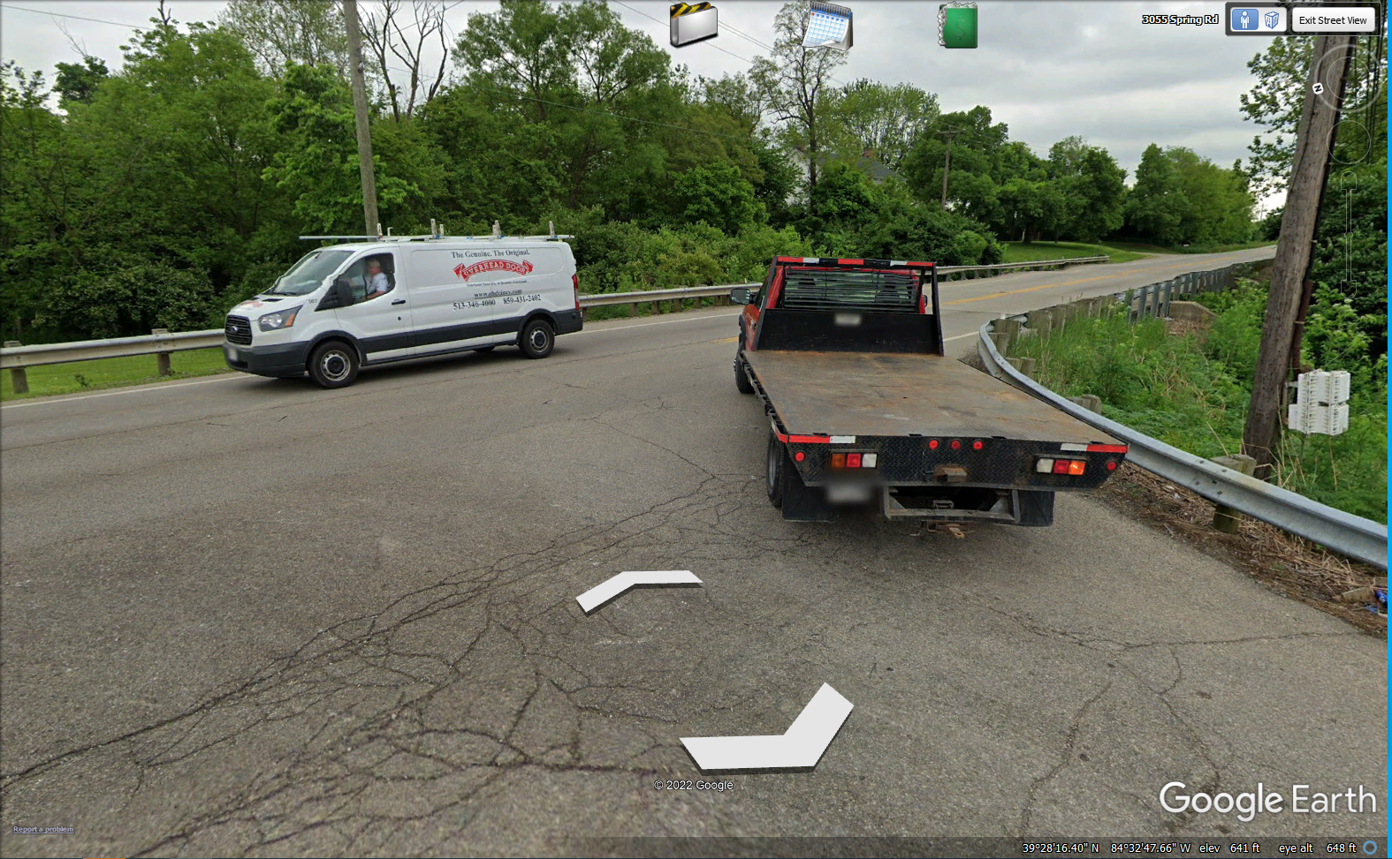
Spring Rd. Site Distance looking south on US 127.
Verdict => Intersection Site Distance is adequate.

