**CLE-SR133-20.29**

**STAGE 3 DRAINAGE**

PID 114264

Village of Williamsburg, Clermont County, Ohio

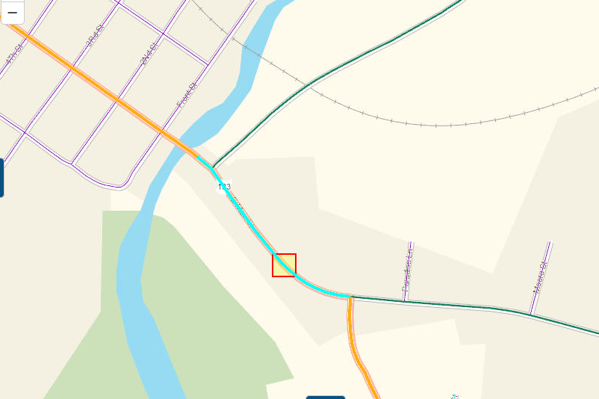

|  |  |
| --- | --- |
| Prepared by: |  |

*Prepared for: ODOT District 8  
April 2023*

Table of Contents

1. Project Overview 3

1.1 Project Overview 3

2. Drainage Computations 5

2.1 Drainage Area Maps 6

2.2 Inlet Spacing Calculations 11

2.3 Storm Sewer Calculations 13

2.4 Ditch Calculations 17

3. Post-Construction Storm Water BMP Calculations 20

3.1 PC-BMP Drainage Area Maps 21

3.2 PC-BMP Calculations 26

4. Temporary Erosion and Sediment Control Calculations 29

4.1 Notice of Intent Acreage Calculation 30

4.2 Temporary Sediment Erosion Control Spreadsheet 32

5. Appendix 35

5.1 FEMA FIRMETTE 36

# Project Overview

## Project Overview

Improvements will include construction of 1,830 feet of shared use path along the south side of East Main Street (SR133/CR351) from the East Fork Little Miami River to the intersection of East Main St. and SR 133, including new curb and gutter, drainage improvement, driveway aprons, signage and pavement markings.

Current year (2021) ADT is 7,200. Design Speed is of 35MPH

AECOM designed the proposed storm sewer and drainage elements per the latest edition of the ODOT Location & Design Manual Volume II – Drainage Design.

In general, the drainage patterns flow from East to West on south side of the road and from south to north on the northside of the road thoughout the site. The storm water on the south ends up outletting to East Fork Little Miami River and the on the north to Five Mile Creek respectively. To the north there are 2-104” CMP existing culverts under Dela Palma Road carrying Five Mile Creek to East Fork Little Miami River.

The existing roadway is currently considered low speed (Posted speed limits 35 miles per hour).

The inlet spacing was based on the 5-year design storm frequency due to the facility being a rural high-volume highway (Over 6,000 ADT). The allowable spread per Table 1103-1 of the ODOT L&D Manual - Volume II is 6 feet for a 2-lane high volume highway under 45 miles per hour. This is 6 feet distance is measured into the travel lane. The proposed design has a combination curb and gutter, so the allowable pavement spread in this scenario is 8 feet (6 foot plus 2-foot gutter plate width), in general. A slotted drain has been proposed along the new curbed shared used path at the gas station to carry the storm, which will be collected in a catchbasin downstream, which then outlets into the ditch.

The proposed storm sewer system was sized for a 10-year design storm frequency with a 25-year hydraulic grade line check. The proposed storm sewer has been analyzed utilizing CDSS software.

Drainage area maps, inlet spacing calculations, storm sewer capacity calculations and ditch calculations are included herein.

Post Construction Best Management Practice (BMP) design was based on the latest edition of the ODOT Location & Design Manual Volume II – Drainage Design, specifically Section 1112. The project does have a Project Earth Disturbed Area (EDA) greater than 1 acre and would not be classified as a Routine Maintenance Project; therefore, BMPs are required. The project only needs to address Water Quality (WQ) treatment as there is no new permanent right of way.

We have chosen Vegetated Filter Strips as the BMP to address the WQ treatment requirements. The Vegetated Filter Strip was designed per Section 1113.2.1. Separate Post Construction BMP drainage area maps and calculations are also included herein. Location in the middle of the project site from Sta. 848+50 to Sta. 852+90 has been utilized for Vegetated Filter Strip. Since the project only includes the addition of a shared used path and no roadway improvements, a 10-foot wide Vegetated Filter Strip has been utilized to meet post-construction treatment requirements. The proposed Vegetated Filter Strip is inside the Village owned property.

The Notice of Intent Earth Disturbing Activities (NOI EDA) area was calculated using Figure 1109-1 of the latest edition of the ODOT Location & Design Manual Volume II – Drainage Design.

A portion of the project approximately (Sta. 841.67 to Sta. 845+00) is located within the FEMA designated Special Flood Hazard Area (Zonae AE) for the East Fork of the Little Miami River. The 100-year base flood elevation (BFE) is 803.1 The existing roadway would be inundated during a 100-year flood event. The project limits are located outside of the regulatory floodway. This project will have no impact upon the BFE, and no hydraulic analysis is required. No fill will be placed below the Ordinary Highwater Elevation of the East Fort of the Little Miami River.

A Letter of Notification of SFHA LD-53 Exemption will be provided to the Local Floodplain Coordinator at the Village of Williamsburg and copy to the project file.

In Stage 3, proposed catch basins D1, D2, and D3 have been removed since during the Village reconstruction of the driveway two catch basins have been placed around the same location. Existing condition inlet spacing calculations and storm sewer calculations have been provided with this report.

# Drainage Computations

## Drainage Area Maps

## Inlet Spacing Calculations

## Storm Sewer Calculations

## Ditch Calculations

# Post-Construction Storm Water BMP Calculations

## PC-BMP Drainage Area Maps

## PC-BMP Calculations

# Temporary Erosion and Sediment Control Calculations

## Notice of Intent Acreage Calculation

## Temporary Sediment Erosion Control Spreadsheet

# Appendix

## FEMA FIRMETTE