ITS FIBER NODE BUILDING

GENERAL REQUIREMENTS
The building shall be designed with the following minimum requirements:
- Two separate points of conduit entry
  - Each point of entry shall contain six, 4-inch conduits run into the upper portion of the wall of the building through a wall mounted junction box
    - Conduits shall be sealed with temporary means once work has been completed
    - This allows the fiber splice enclosures to be wall mounted over the work desk to allow for easy removal for a future fiber splicing work
  - One for local route and one for US-33 route
  - 48 inch pull boxes for each point of entry
- Two separate rooms inside the building
  - One for Telecommunications providers (smaller in size, minimum 8 cabinets)
  - One for Government Agency connections (larger in size, minimum 16 cabinets)
- Separate Building Access Doors
  - Exterior dual-swing Telecommunication provider room
  - Exterior dual-swing Government Agency room
  - Interior access door separating rooms
- Power entry
  - Separate 24 inch pull boxes for power
- Backup Generator
  - Natural Gas – If available
  - Propane – only if natural gas is not available
    - ODOT will have final approval if natural gas is available, but not in close proximity and may choose to provide extension to connect to natural gas at a longer distance away
  - Sized to allow the complete system (all cabinets at 20 amps) to run during power outages for a duration of 72 hours without refueling (duration only applies to propane system)
  - Network Management capability
- Uninterruptible Power Supply
  - UPS designed to operate building for 1 hour
  - Network Management capability
- Power alarms notifications
  - Capability of emailed alerts
  - Capability of being monitored by network management software (Accelops)
  - Capability of auto-generating a service-now ticket
  - Types of alarms
    - UPS Status / Failures
    - Generator On/Off
    - UPS On / Off
    - Generator Status (Fuel levels if applicable)
- Lighting Plan
  - Utilizing LED fixtures
  - Placed over work desk
  - Motion Sensor Lighting on each exterior side of the building
  - LED ceiling lighting placed that would illuminate the components inside of the building as well as the components inside each server rack when the doors are opened (lighting directly over the server racks is not allowed)
  - Motion Sensor Light on center of each side of building
- Security CCTV Cameras on all door accesses of building (interior and exterior)
  - Vandal resistant PTZ security cameras compatible with ODOT’s Milestone camera control software shall be installed on the exterior and interior of the building to monitor each door of the facility.
- Each Cabinet shall have one separate electrical outlet (LS-20R Twist-Lock Type) directly above.
- HVAC Units for server room environment, climate control for entire building
- 30 year maintenance plan developed for building and all components
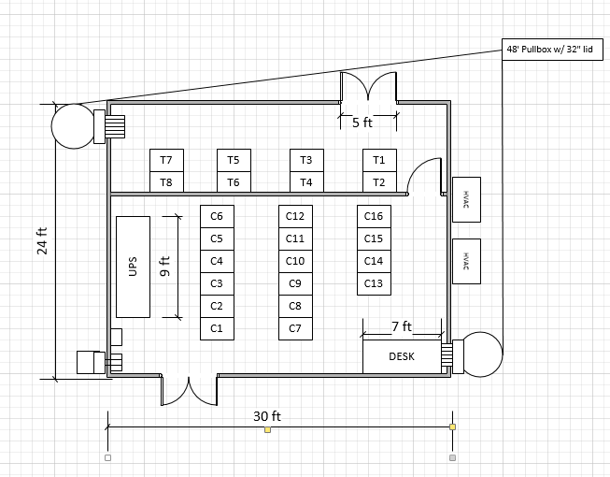
- Conceptual floor plan below

MATERIAL
The CONTRACTOR shall furnish and install the following components in a telecommunications building that meets the following minimum specifications:

- Server Racks (Qty. 24)
  - Equipment rack cabinets shall be furnished and installed for the purpose of housing network equipment, patch panels, server equipment, and other various equipment at the direction of the engineer.
  - EIA Standard 19” wide rack for equipment mounting
  - Keyed differently
    - 4 sets of keys for each server rack
    - 10 sets of master keys to open all racks
  - Adjustable rails, independent of frame
  - Cable management
    - Vertical and Horizontal
  - Adjustable casters and leveling feet
  - Dimensions
    - Inner rack: 77”H(44RU) x 19”W x 30” D
    - Outer cabinet: 85”H x 24”W x 36”D
  - Doors
    - Vented split front and rear doors
    - Lockable swinging doors
  - Solid top panel with 4” holes with grommets and cover plates for cable management
  - Textured powder coat finish – dark gray
  - Factory assembled
- Building Exterior Finish
  - Brick Inlay Finish Type
- Proper compacted base material, foundation, and building hold downs shall be installed as recommended by the industry and the building manufacturer.
- Sloping Roof

ELECTRONIC ACCESS CONTROL
The ITS Fiber Node Building shall have an electronic access control system installed on all exterior doors. This system shall monitor and provide access control via electronic reading devices (keypad, proximity cards, and RF). The system shall tie into ODOT’s existing Security Access Software System. The exterior doors shall also be accessible via an emergency key to be used during extended power outages and possible system failures. The access control system shall have the following minimum capabilities:

- Shall be capable of being connected to an Ethernet network for offsite monitoring and control.
- Shall be configured with outdoor-rated, vandal resistant electronic readers.
- Shall be powered from building power and connected to the UPS system
- Shall provide an output for alarms for all entry to the building. These alarms shall be capable of sending an email when the door is opened and when the door is kept open for a user defined time period.
- All door locks shall be commercial grade 1 locks.
- All access system hardware and software required for a fully functional system shall be provided for an out of the box solution. This includes, but is not limited to the wall mounting brackets, card readers, wire, cable, etc.

Each equipment cabinet shall be equipped with different keys from each other. Four keys shall be provided per cabinet. These keys shall be stored and access control shall be provided separately for each key. The ley management system shall have the following minimum specifications:
- Shall have locking receptor strips that lock the keys (minimum of 20) for each cabinet into a panel and restrict access to authorized personnel down to the individual key
- Shall restrict access to key panel by way of polycarbonate door.
- The key panel shall be accessible by way of RFID Proximity Readers, and shall utilize the same proximity cards as used for the ITS Fiber Node Building Access Control System (as issued by ODOT for the S2 security system)
- Shall be black or gray in color.
- Shall be capable of programming for up to 1000 users
- Shall be hardwired into the building power and shall be equipped with battery backup system
- LED’s over each key shall be provided to indicate which keys are restricted and assist the user with returning the key to the correct location. Time limits shall be capable of being set for key being out of the panel (return-by) and if the key is not returned within in that allotted time interval and alert shall be capable of being sent via SMS text and email notification.
- Shall provide notification via email and SMS text
- Shall produce detailed audit reports and usage information to those users defined in system
- Shall be capable of managing key systems across many remote ITS sites
- All keys shall be tagged and color coded per agency/department
- All access system hardware and software required for a fully functional system shall be provided for an out of the box solution. This includes, but is not limited to the proximity card programmers, pc hardware, software, wall mounting brackets, card readers, wire, cable, etc.

FIBER OPTIC REQUIREMENTS
- High Density Fiber Optic Termination Panels in C13 with all cables entering the building being terminated in C13, unless otherwise specified during plan review period.
- 2- 12 Strand MTP Jumper Cables from C13 to every server rack in the Building (connected to termination panel per ODOT Spec 804/904)

- Splice Enclosures shall be wall mounted on hangers above 7’ x 3’ desk and shall be capable of being easily removed and laid on the desk (for future splicing work to be performed)
- Cables shall be routed through the building via basket racks hung from the ceiling.

BUILDING SITE REQUIREMENTS
- Building perimeter shall have a minimum 6’ high chain link fence with two strands of barb wire on the top. Fence shall be adequately sized to allow service personnel to walk completely around the building within the fenced in area. If the building utilizes propane as a backup power source the fencing shall be designed such that a propane filling vehicle can access the propane tank. The fence shall have a minimum of one gate with minimum opening of 20’-0”. The gate may consist of two swinging gates or a single sliding gate. The gate shall include hardware to securely lock the gate.
- The building site shall include a minimum parking area of 24’ wide x 20’ long to easily accommodate two service vehicles. The parking area surface shall have a minimum of a 4” lift of #57 limestone aggregate. The parking area subsurface shall be treated to be sufficient to support service vehicles including a propane tanker truck.
- The existing loop ramp service access drive shall be improved from the loop ramp pavement to the building parking area. This shall include installation of an appropriate sized culvert to convey stormwater along the loop ramp ditchline. The driveway shall have a minimum width of 12’. The driveway surface shall have a minimum of a 4” lift of #57 limestone aggregate. The driveway subsurface shall be treated to be sufficient to support service vehicles including a propane tanker truck.
- The building elevation shall be set to provide positive drainage on all four sides away from the building to an appropriate outlet.
- All disturbed area not occupied by new building, parking area, or driveway shall be restored to pre-existing condition or better.

