- Existing Plans:
 | Arch No | Name | Year | PID | Description
1 | 08c1473 | HAM-25-0.46 / HAM-50-20.43 | 1960 | n/a | Original Construction (Sheet 316
2 | 08c1979 | FWW Contract 6A | 1999 | n/a | Added a span (Sheet 276)

Project Map

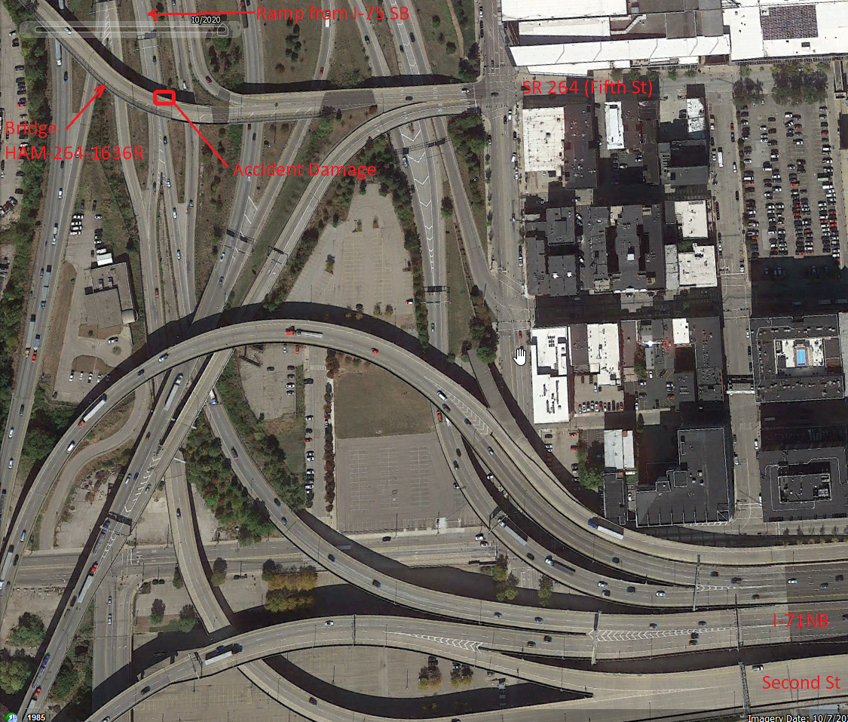

Project Schedule
Note: This the schedule in Ellis at the time of scoping (7/21/21). Refer to Ellis for the official scheudle.

