Coring Report – June 2019
PID 109232 – MED SR 0003 15.05
Phillip Gabel and Spencer Smole

________________________________17.04 NB______________________________________________
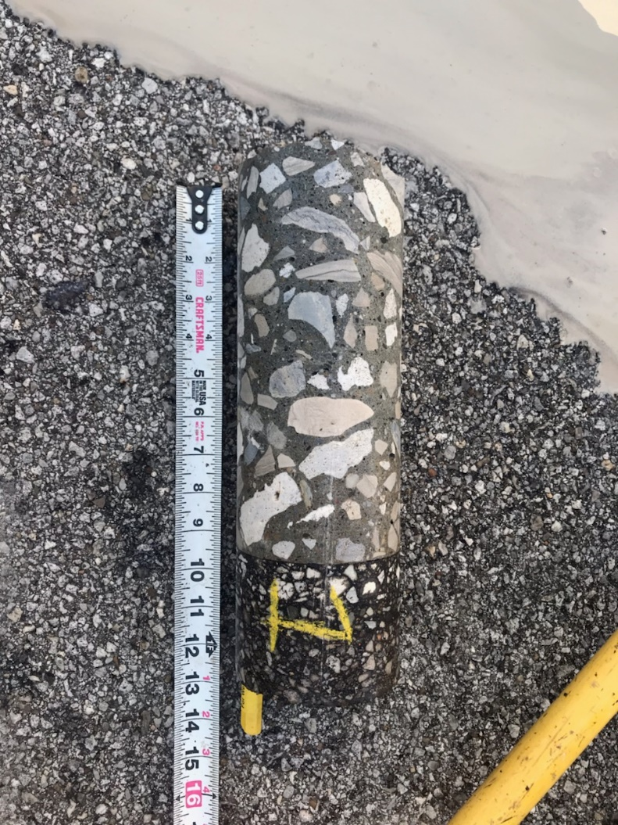
SLM 17.04 – LWP (5’ from LL under I-71) – 3” of asphalt – 9” of concrete
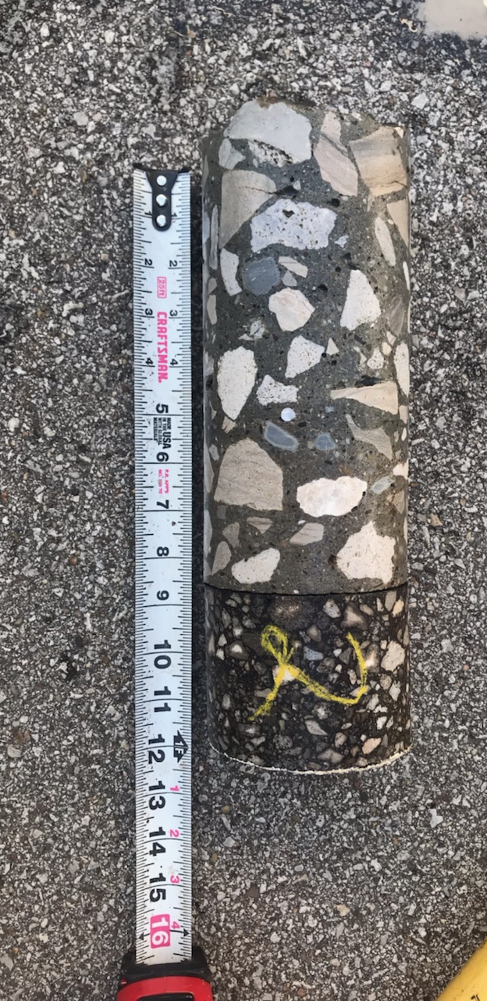
SLM 17.04 – WEL – 3” of asphalt – 8.5” of concrete

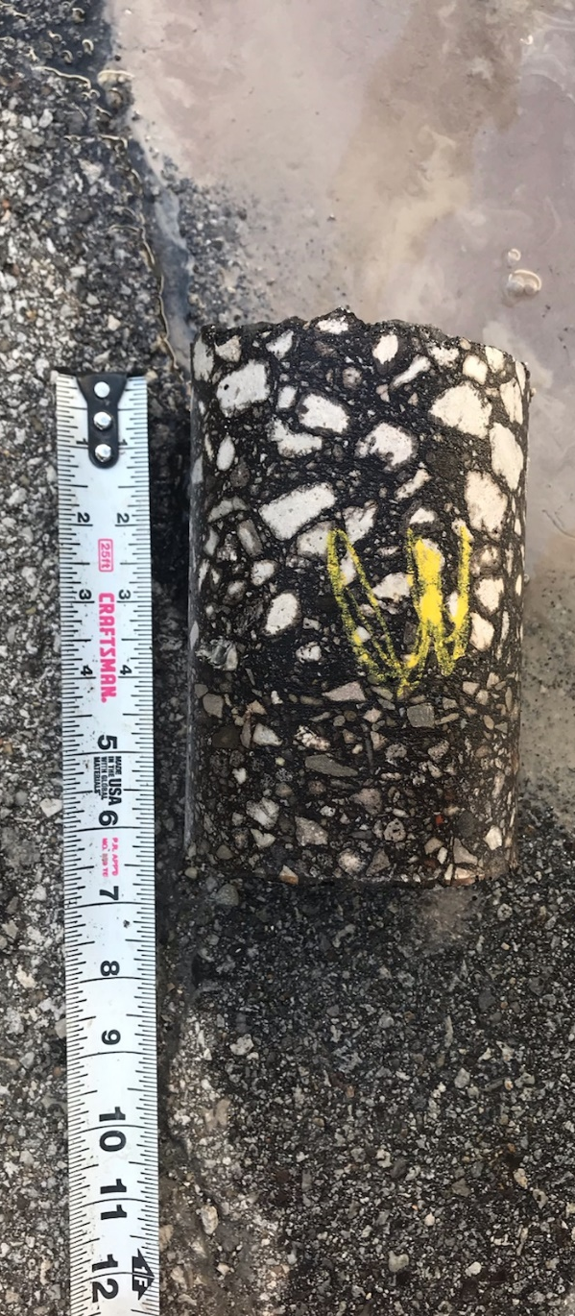
SLM 17.04 – shoulder (2’ from WEL) – 6” of asphalt
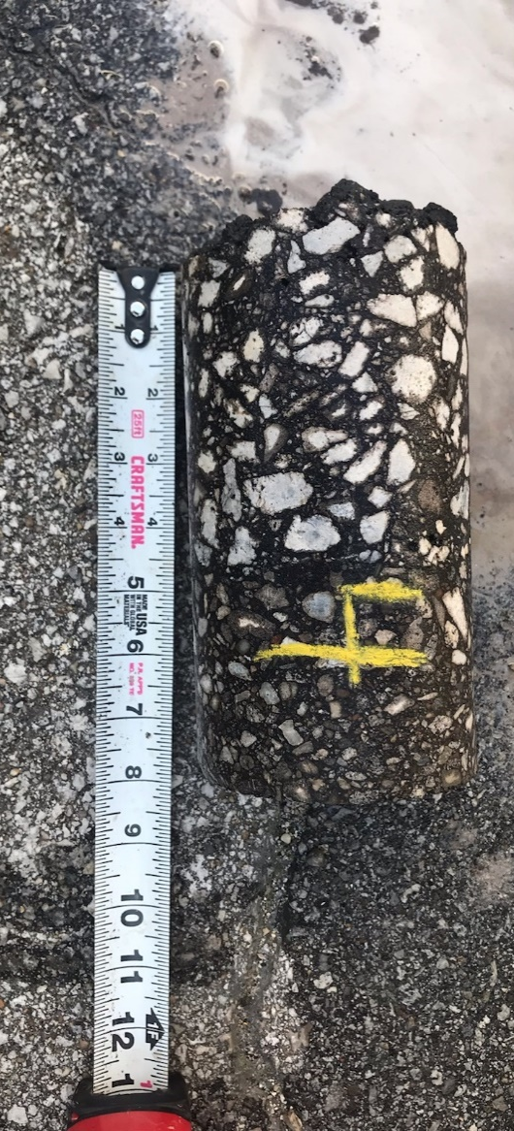
SLM 17.04 – shoulder (1’ from WEL) – 7.5” of asphalt

___________________________________17.24 SB___________________________________________
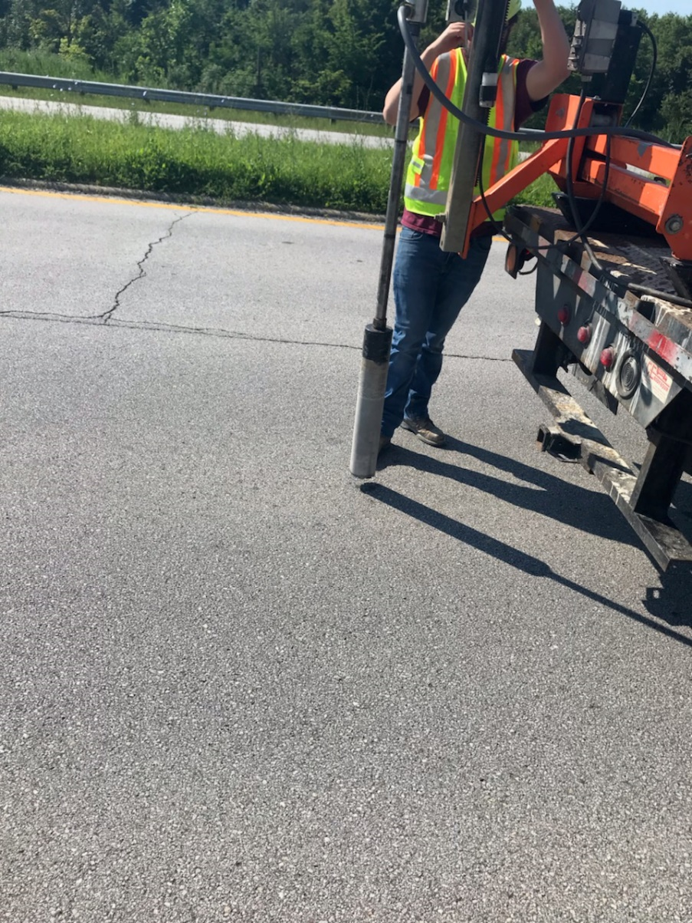 SLM 17.24 coring location
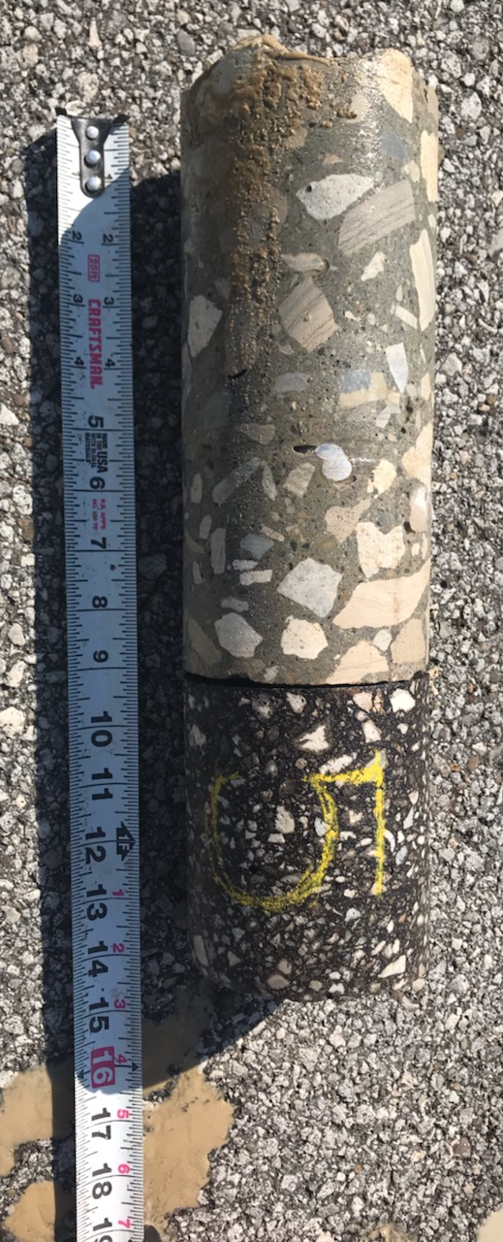
SLM 17.24 – WEL (driving lane) – 4.5” of asphalt – 9” of concrete

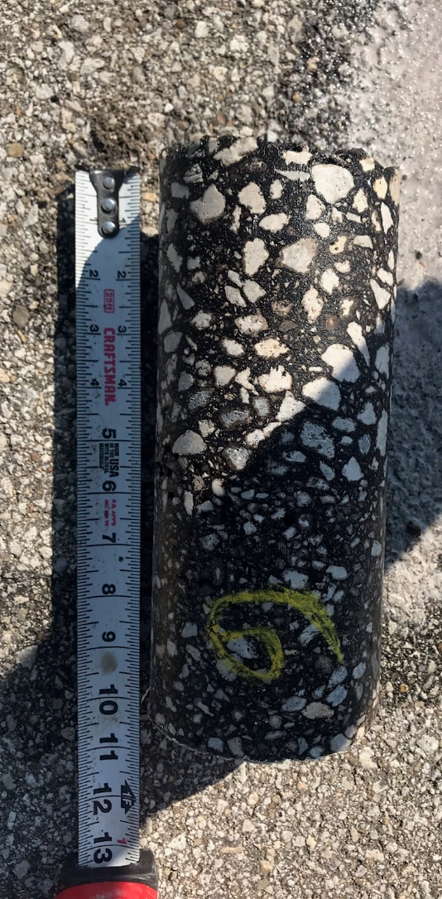
SLM 17.24 – WEL (12’3” from LL) – 9.5” of asphalt

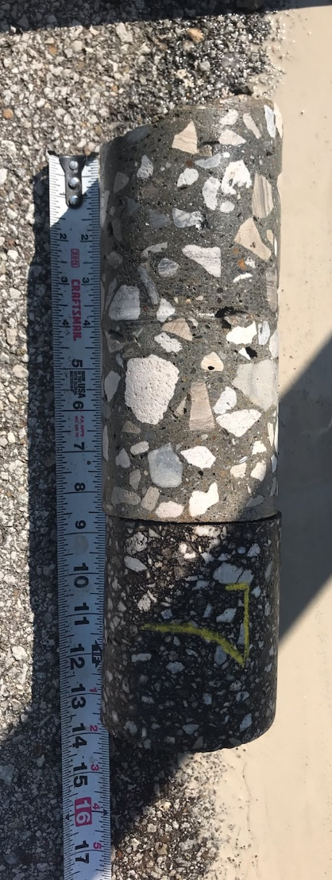
SLM 17.24 – 6” from WEL, 11’4” from LL – 4.5” of asphalt – 8.5” of concrete

_________________________________________16.83 SB_____________________________________
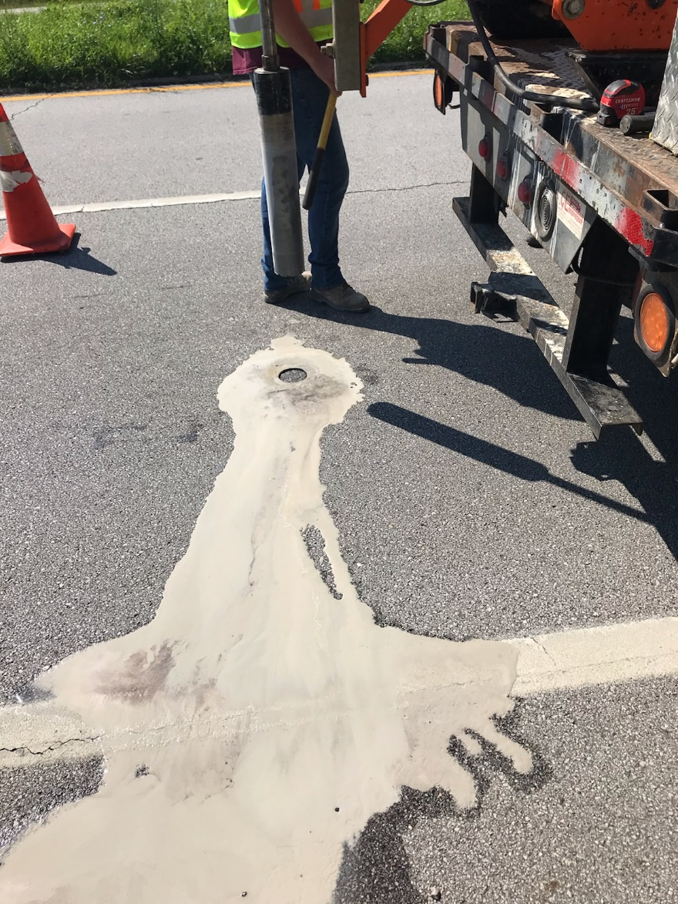 SLM 16.83 coring location

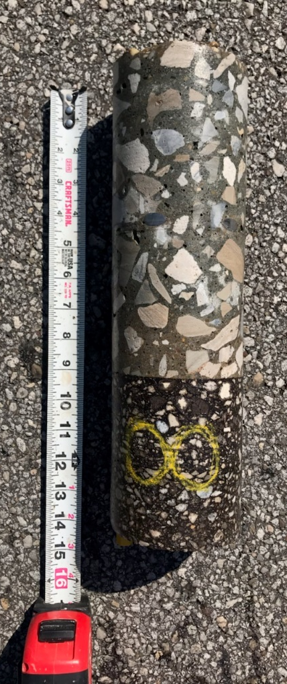
SLM 16.83 – MWP – 4.5” of asphalt – 8.5” of concrete

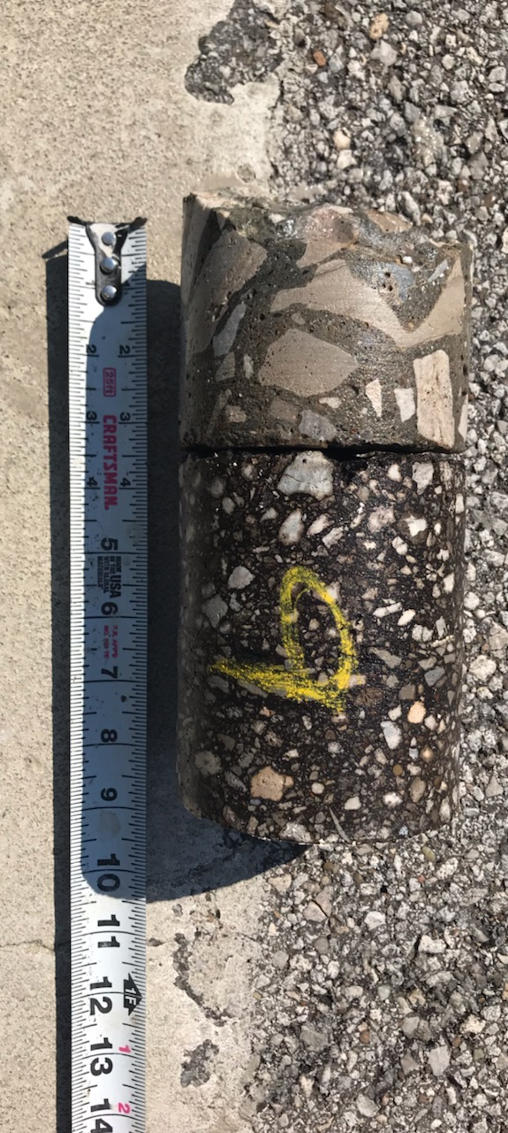
SLM 16.83 – WEL (11’8” from LL) – 4.5” of asphalt – 3.5” concrete (mostly rubble)

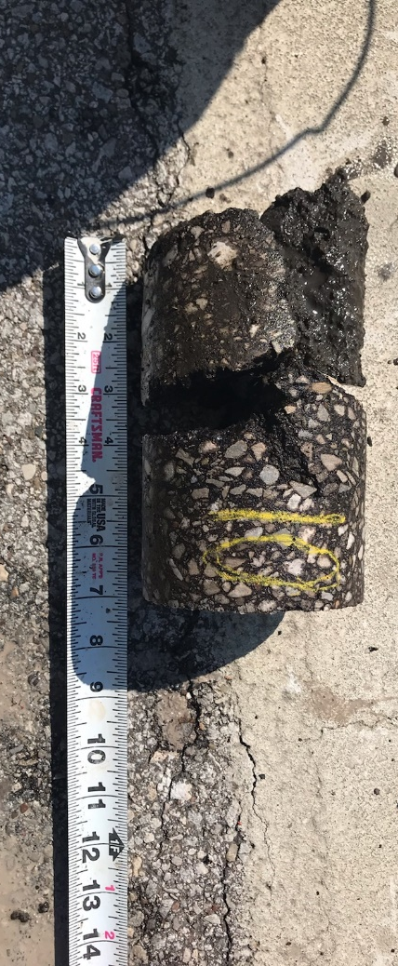
SLM 16.83 – WEL/shoulder (12’2” from LL) – 6” of asphalt

_________________________________________16.31 SB_____________________________________
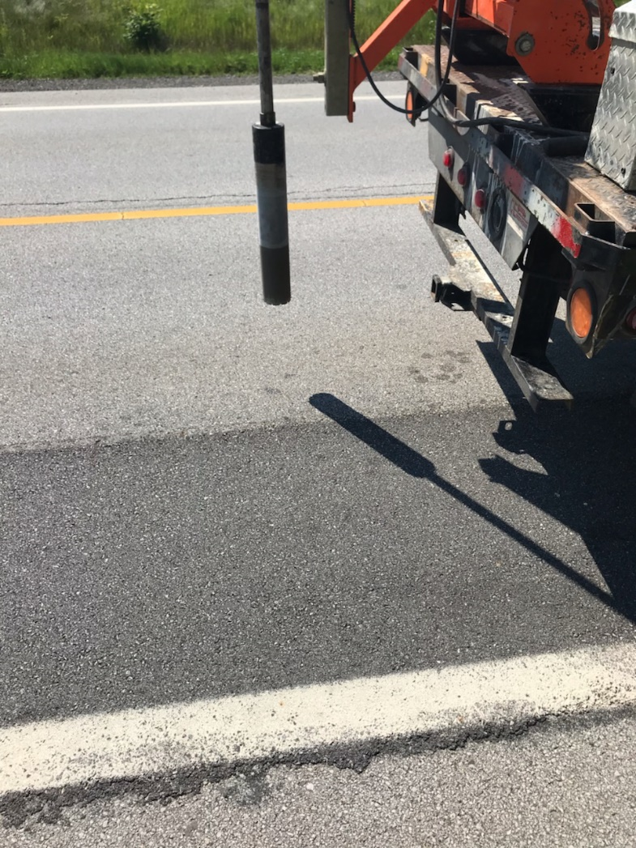 SLM 16.31 coring location

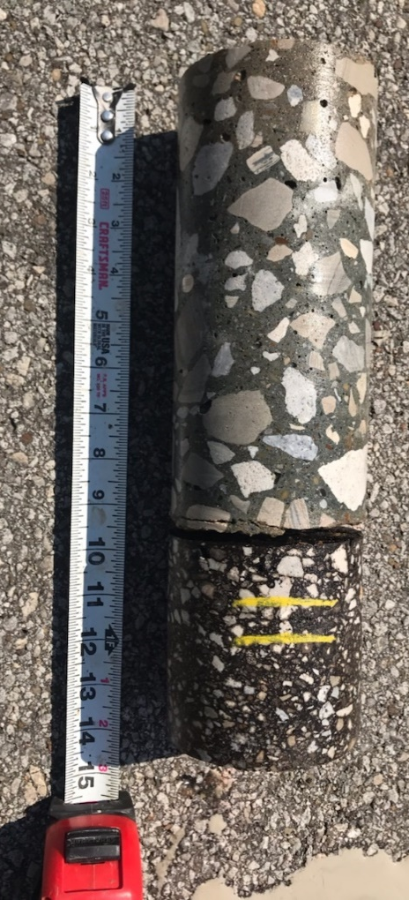
SLM 16.31 – MWP – 4” of asphalt – 8.5” of concrete

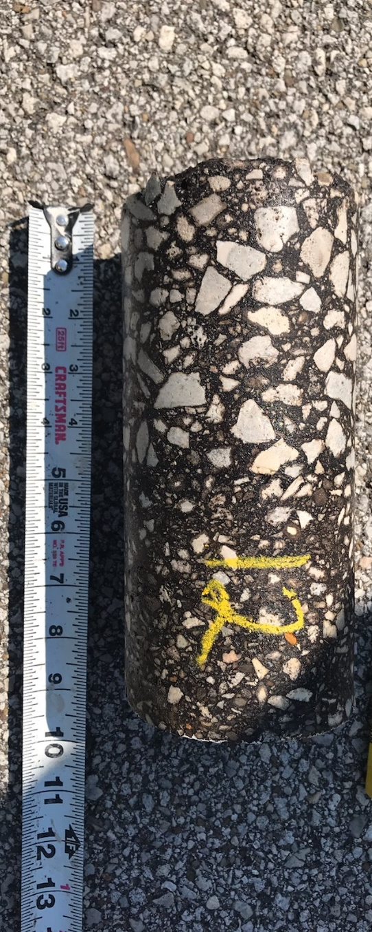
SLM 16.31 – 12’2” from centerline – 9” of asphalt
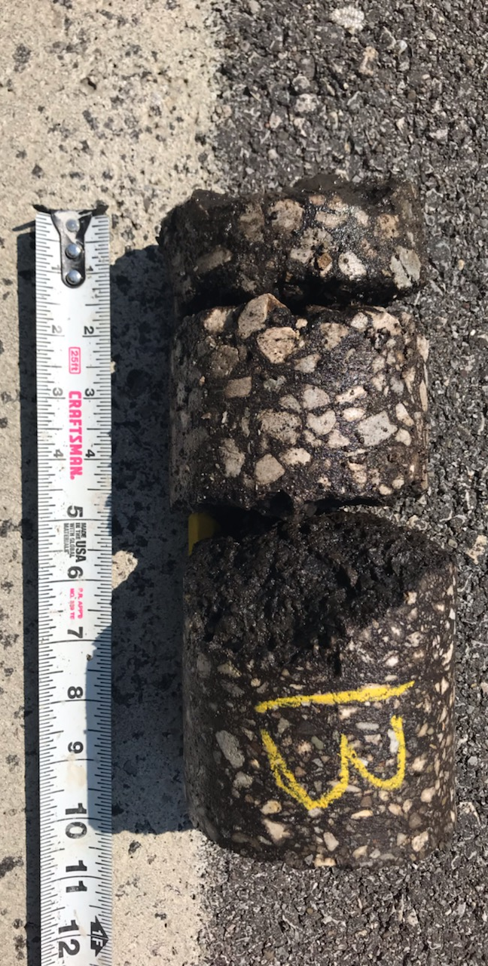
SLM 16.31 – RWP (11’6” from centerline) – 9” of asphalt

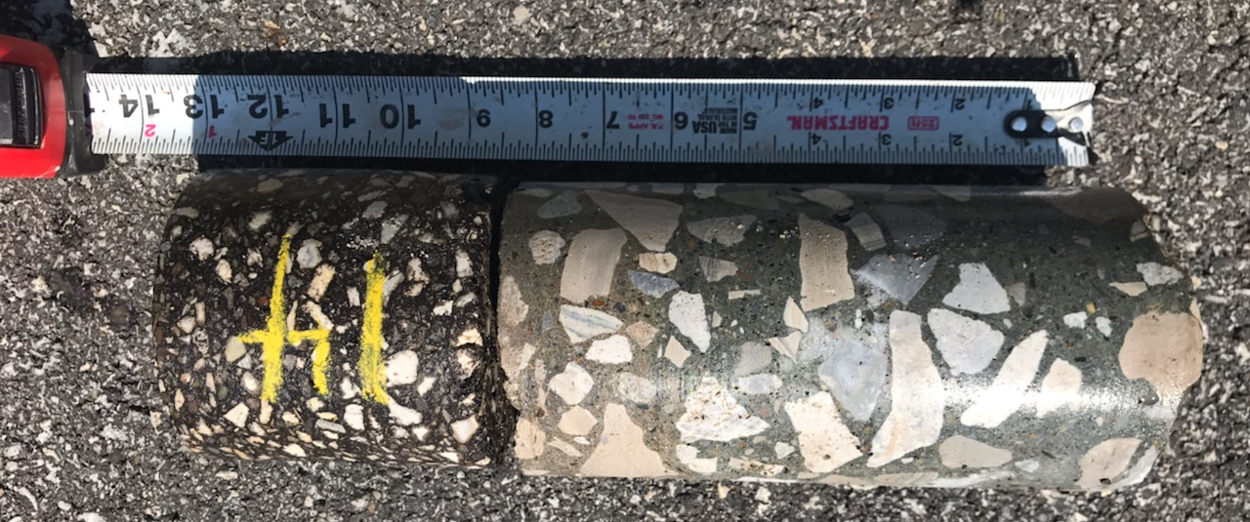
SLM 16.31 – 11’ from centerline (RWP) – 4” of asphalt – 9” of concrete

______________________________________15.78 SB________________________________________
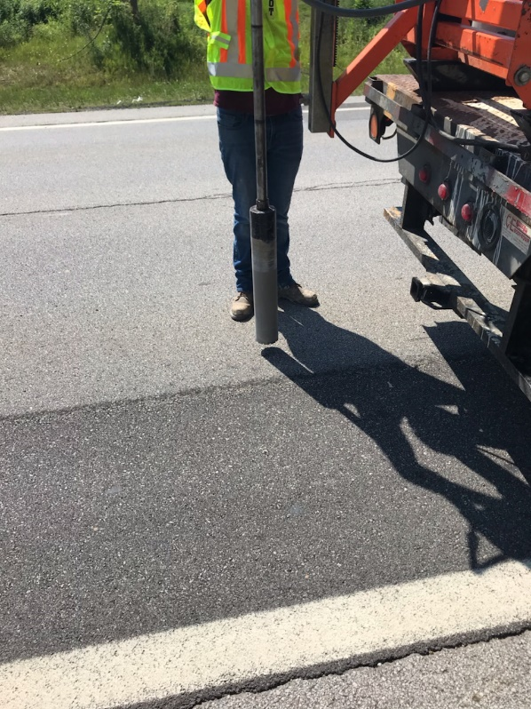 SLM 15.78 coring locating

SLM 15.78 – MWP – 4” of asphalt – 9” of concrete
SLM 15.78 – 11’6” from center line (RWP) – 4” of asphalt – 9” of concrete

SLM 15.78 – 12’ from centerline (WEL) – 9” of asphalt
______________________________________15.25 SB________________________________________
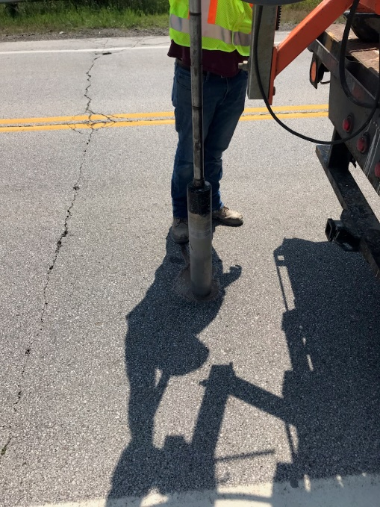 SLM 15.25 coring location

SLM 15.25 – MWP – 4.5” of asphalt – 9” of concrete

SLM 15.25 – 11’4” from center line (WEL) – 4” of asphalt – 9” on concrete

SLM 15.25 – WEL – 4” of asphalt – 8.5” of concrete (concrete ended at 12’2” from centerline)

