MIA-C.R. 25A-3.54
PID 103159

City of Tipp City
260 S. Garber Drive
Tipp City, Ohio 45371

May 1, 2019

Stage 2 Drainage Report
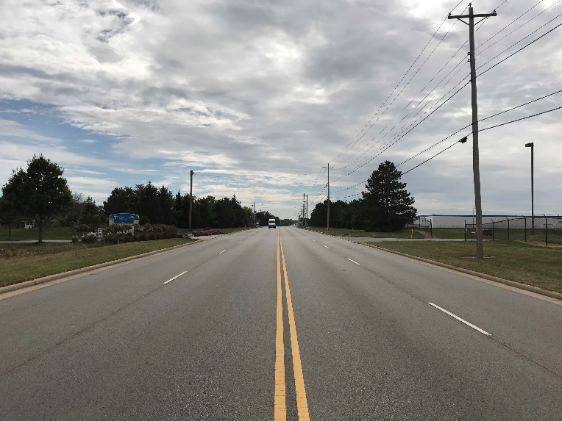

10816 Millington Court, Suite 104
Cincinnati, Ohio 45242
513.734.8542
www.cmtran.com

