Engineer’s Report
Bridge No. RIC-30-1642
Carrying Reed Road over US Route 30, Richland County, OH
Bridge Hit on Span 3 - Beam 1
PID 122937 & 122940

General Information
- Bridge No.: RIC-30-1642 SFN: 7001517
- Bridge Location: Reed Road over US Route 30, Mifflin TWP, Richland County, OH; for Location Map, see Attachment A
- Date & Time of Crash: Wednesday, November 13, 2024 5:13 PM

Crash and Damage Information
- Police Report: The Ohio State Highway Patrol is pending submission at the time of this report. The District will obtain a copy and make it availible on request when it is completed. The responsible party of the hit to the bridge appears to be Superior Logistics, LLC, PO Box 668 Hallandale Beach, FL 33008. The driver was Andrey Mikhay, of Hallandale, FL.

- Damage Details: See Attachment A for identification of bridge members.

The collision occurred on Wednesday, November 13, 2024 5:13 PM when a westbound unpermitted oversized load carried on a flatbed semitruck struck the inside surface of Span 3, Beam 1, on the structure named above. It is likely that the load struck the inside of the far fascia beam due to rising roadway profile and minor contact with the previous beams causing the load, a large tank-like container, to rise and rotate up to meet the location of impact. Beam 1 sustained deformative damage, primarily rotational, causing significant separation of the top flange from the haunch. Six of 7 steel angle crossframe assemblies connecting Beam 1 to Beam 2 in Span 3 had all three members fractured at or near welds, and the five over westbound traffic were subsequently removed. At least three of these fractures tore portions of the attached web away. Significant spalling of the haunch was sustained along both sides of Beam 1 and 2 throughout Span 3, as well as approximately 25’ along Beam 1 in Span 4.

Beam 1

Beam 1 is deformed over a length of approximately 80’ to within a few feet of the fixed bearing at Pier 2 and a few feet of the rocker bearing at Pier 3, with points of inflection roughly at the bottom flange moment plates. The exact dimensions and extent of the deformation are scheduled to be measured ODOT District 3 Survey no later than 15 DEC 2024. The impact to the beam was to the inner side bottom flange and web, up to about half the height of the beam, and was spread to almost the full width between crossframes 4 and 5. Local gouging and flange rotation at the point of impact is present but minimal; we believe that the impact load was primarily distributed across the surface of the web, minimizing point damage. The bottom portion of Beam 1 exhibits a sweep likely in excess of 6” at the point of impact, and spanning almost all of the beamline is Span 3, appearing to end roughly at the moment plates. This sweep is primarily rotational, as the top flange, while rotated out of contact with the haunch, exhibits little to no transverse deformation. The inside of the top flange has rotated up to 2.5” from its prior contact with the deck at the point of impact, and is separated throughout the deformation; the deck must be assumed to be bearing only minimally on Beam 1 in Span 3.

Section loss to the lower portion of the web was sustained at Crossframes 4, 5, and 7, due to material being torn out with the diagonal crossframe member. At Crossframe 7, the material welded to the crossframe member was torn out through the full thickness of the web.

While there is evidence of major spalling on both sides of the beam from prior incidents, freshly exposed concrete and the locations of fallen spall indicate spalling on both sides of the haunch throughout Span 3 and up to 24’ in Span 4. A large loose spall on the facia side was removed by ODOT personnel.

Neither of the adjacent bearings, fixed at Pier 2 and rocking at Pier 3, exhibit any indication of movement or damage.

Beam 2

Beam 2 exhibits no visible deformation. Superficial scraping is evident on the bottom flange. Section loss was sustained in the lower portion of the web at Crossframe 4, due to material welded to the horizontal crossframe member being torn out. Fresh spalling is evident on both sides of the beam in Span 3.

Span 3 Bay 1 Crossframes

Crossframe 1: Appears to be undamaged
Crossframe 2: All three welded connections to Beam 1 fractured. Left in place as not over traffic.
Crossframe 3: All three welded connections to Beam 1 fractured. Assembly removed by ODOT Maintenance forces.
Crossframe 4: Both diagonal welded connections to Beam 1 fractured. Horizontal welded connection to Beam 2 fractured. Assembly removed by ODOT Maintenance forces.
Crossframe 5: All three welded connections to Beam 1 fractured. Assembly removed by ODOT Maintenance forces.
Crossframe 6: All three welded connections to Beam 1 fractured. Assembly removed by ODOT Maintenance forces.
Crossframe 7: All three welded connections to Beam 1 fractured. Assembly removed by ODOT Maintenance forces.

Roadway

At three locations in the Westbound driving lane, the pavement is gouged through the surface course, each approximately 6’ long. Richland County forces filled these locations with cold patch asphalt material.

(See photos – Attachment D)

- District Follow-Up: ODOT’s Richland County forces were on site shortly after the crash. District Bridge Engineer Kent Kapustar also was on site during the post-crash cleanup and accident reporting, where he directed County teams to close the Southbound shoulder of the bridge above the struck beam pending detailed inspection. Richland County forces drove the District platform truck to the site the following morning, and allowed the Assistant District Bridge Engineer Joseph Clark and Bridge Inspector 2 Rich Harding to inspect the damage at arm’s length. The imminent concern was the partially attached angles from the crossframes in Span 3, Bay 1. Richland County forces removed those detached angles that threatened traffic on US 30. The bridge shoulder above Beam 1 remains closed at this time.

- Disposition: Based on the immediate post-collision inspection, and the subsequent removal of the loose crossframes, the Bridge Engineer permitted the roadway below the bridge to open without restriction. Reed Road roadway on the bridge also remained open with the shoulder above Beam 1 closed pending repairs.
Site Conditions Prior to Incident
(1) Condition of structure prior to bridge hit:
a) Type: Continuous steel beam with reinforced concrete deck and substructure.
- Span: 4 spans for a total length of 289.50 feet.
- Clear Width: Bridge Roadway Width – 42.50 feet. O/O Deck – 46’
- Overhead Clearance: 14’-3” Posted; 14’-6” Actual
- Type & Condition of Wearing Surface: Monolithic Concrete,1977; Condition Rating – 7 Good Condition.
- Height of Roadway Above Water: N/A.
- Year Built: 1977.
- Overall Condition: Satisfactory Condition – General Appraisal = 7. Structural elements and deck haunches show evidence of prior bridge strikes. Superstructure is in “7 - Good” condition; Protective Coating System is 1%-5% degraded and is rated “7 - Good”.
- Warning Signs Present: No.
- Previous History: Bridge has been struck four times previously by over-height loads. Repairs for these strikes were carried out under PIDs: 79352 (2010), 97639 (2014), 110382 (2019), and 114029 (2023). Beam 1 in Span 3 was repaired via grinding in 2010, and heat straightened in 2014, 2019, and 2021. See Attachment C for details of these repairs.
(2) Conditions of Approaches Prior to Crash: Satisfactory. The U.S. Route 30 pavement near and under the bridge was recently resurfaced and is in good condition.
(3) Previous Inspection Reports: See Attachment E for 2023 & 2021 Inspection Reports, the last two Bridge Inspection Reports prior to the crash damage. In 2021 and 2023, the bridge was rated in “7 – Good” condition and the deck in “7 – Good” condition.
(4) Average Daily Traffic:
USR 30: 2024 AADT = 19,500 (from SHIFT)
Reed Road: 2024 AADT = 2050 (from TIMS)
(5) Future Maintenance and Repair Projects: The bridge is not currently programmed for any maintenance or repair projects.
Repair Project Planning
- Two projects are proposed to repair the bridge, PIDs 122937 & 122940. The former PID will encompass immediate action to stabilize the damaged beam; the later will include comprehensive repair efforts.
  - PID: 122937 – Proposed Immediate Work:
    - Immediate Intervention: Following consultation with Office of Structural Engineering (OSE), the District proposes to seek a contractor to install temporary struts to substitute for the removed crossframes to brace the compression flange of Beam 1 across Span 3. These will remain in place until a permanent repair contract is executed.
  - PID: 122940 – Proposed Comprehensive Repair work:
    - Beam 1: Heat straighten overall sweep and rotation of beam and the localized collision damage at the bottom flange. Minor grinding on the bottom flange at the point of impact. Repair locations of section loss due to tearing by removing a segment of web including the damaged weld and replacing with a field welded steel coupon with drilled holes at the corners. Field painting the beam where the protective coating was damaged. Epoxy injection throughout areas of top flange separation and spalling.
    - Bay 2: Epoxy injection throughout areas of top flange separation and spalling.
    - Bay 1: Remove remaining damaged crossframe assembly. Install six new crossframe assemblies between Beams 1 and 2. Shop prime and paint the angles.

- Estimated Construction Cost: The proposed projects have planning-level construction cost estimates of $50,000 for immediate action, and $355,000 for comprehensive repairs. The extent of required repairs extends over the entirety of US 30 Westbound. See Attachment F for estimate breakdown by bid item.

- MOT: Individual sequential lane closures will be utilized for the emergency project for installation of temporary struts and various other items of work.
A full detour of US 30 WB may be required for heat straightening, impacting nearby interchanges; further research may indicate that individual sequential lane are sufficient. Individual sequential lane closures will likely be utilized for installation of crossframes, painting, and various other items of work. It should be possible to maintain one or both lanes of Reed Road during repair operations.
- District Field Work to Date: The District Bridge Engineer was on site after the collision on November 13, 2024. The District Assistant Bridge Engineer and Bridge Inspector were able to assess the damage at arm’s length using a platform truck the following morning. The items in need of repair were cataloged and damaged crossframes over traffic removed.

The District Survey Department will collect a 3-D point cloud scan of the site to more exactly determine the limits of deformation on the beams.

The District will design and prepare the construction plans.

- Anticipated Schedule: The District would like to have this bridge repaired as soon as practical, and intends to apply for a Type 2 Emergency project for immediate stabilization of the beam, engaging a contractor immediately to install struts to stiffen the compression flange. Following this, with expedited plan preparation commencing shortly and an expedited 8-week letting schedule, a more comprehensive project would be sold mid-February. A 12-week letting would lead to a mid-March sale. Work would not likely begin until a March-April timeframe due to weather, as the heat-straightening and painting work is temperature sensitive. Because the damage is not under the driving lanes, it likely does not justify the use of expensive heated enclosures to ensure the work is completed before Spring 2025.

The District would like to sell the project through an expedited 8-week letting with an early Spring 2025 construction start. The preferred sale date is February 27, 2025 with an award of March 10, 2025. This would require a plan file of December 23, 2024.

Attachment A
Location Map & Bridge Diagram

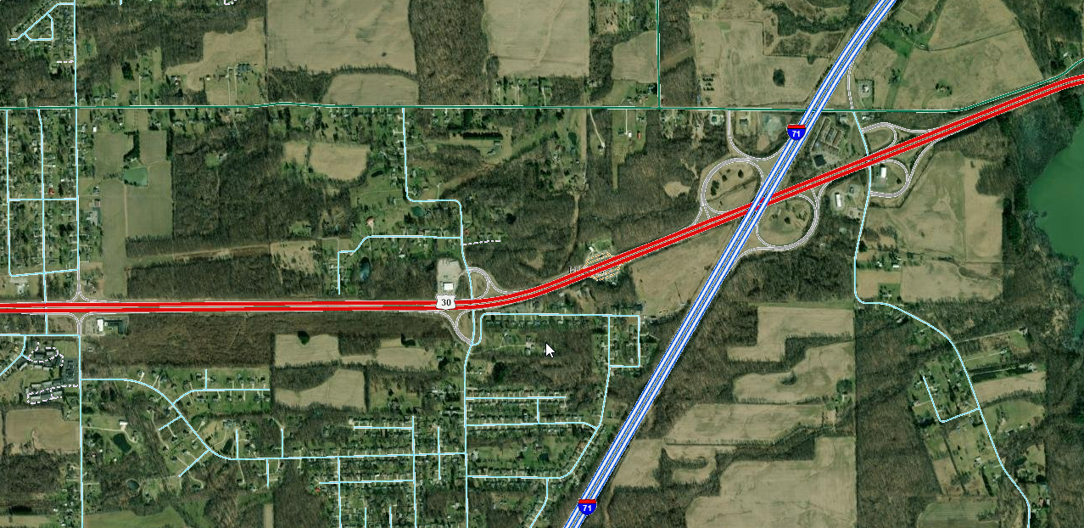
RIC-30-1642
SFN 7001517

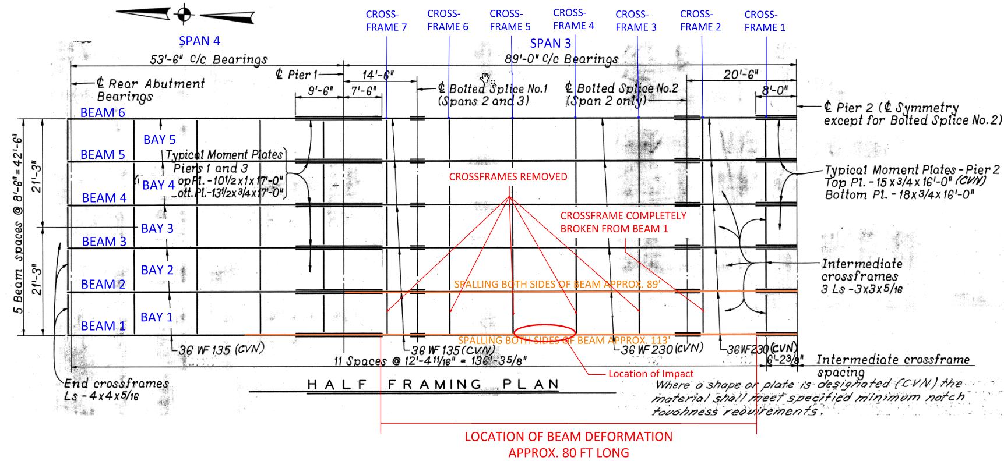

Attachment B
Ohio State Highway Patrol Department
Incident Report

(PENDING COMPLETION – Request from District)

Attachment C
Selected Details from Previous
Bridge Hit Repairs

Attachment D
Damage Photographs

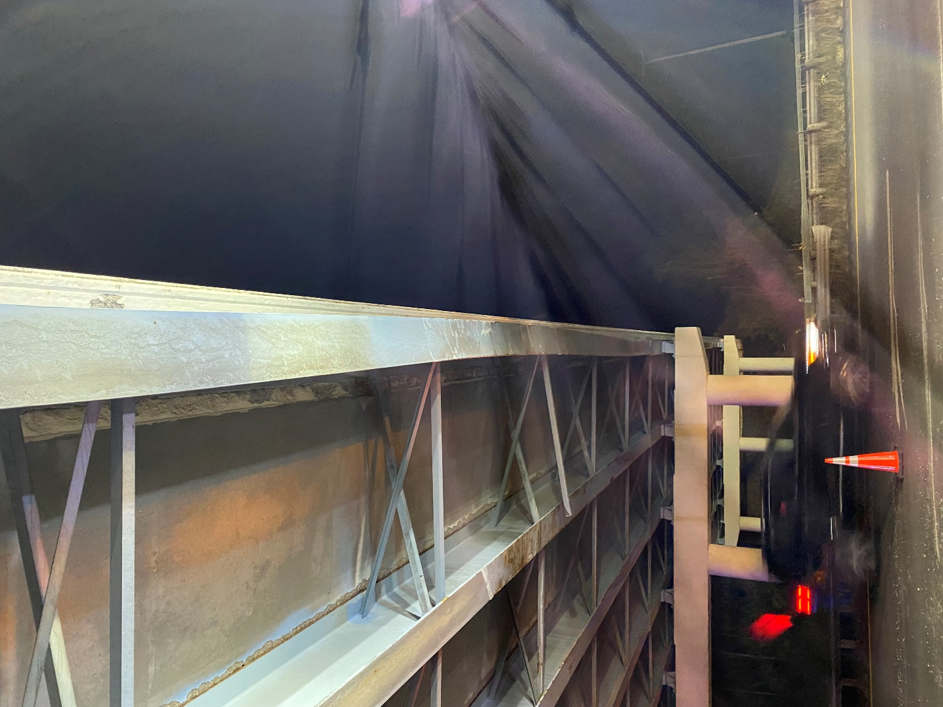
Photo # 1 - Span 3 Beams 1 and 2, looking south, immediately following impact
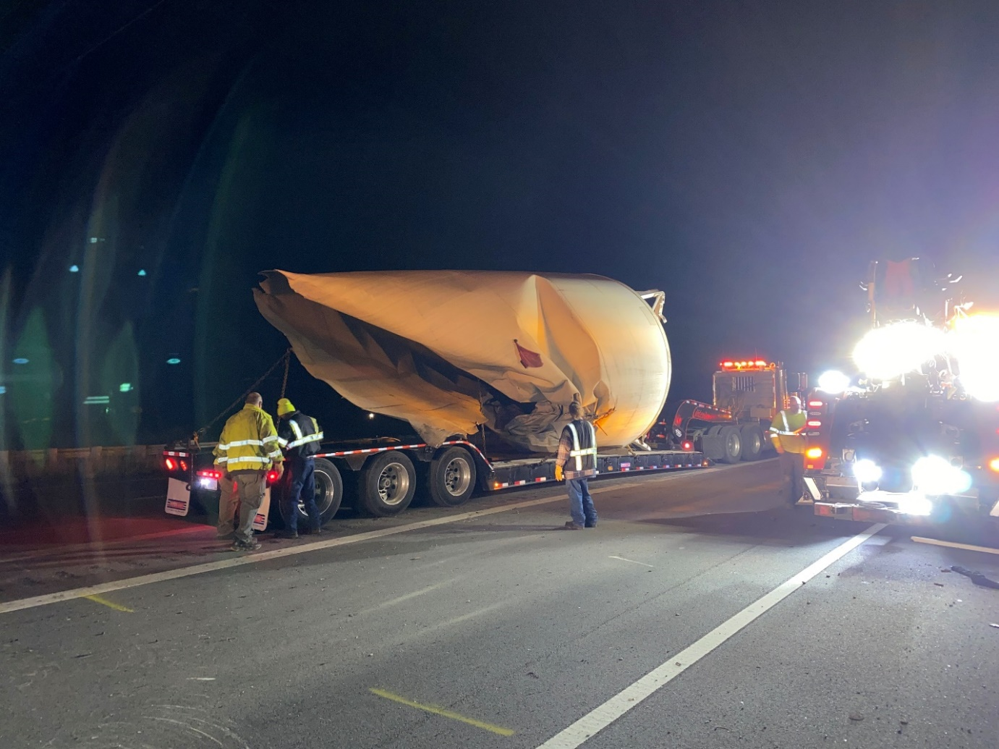
Photo # 2 - Oversized load that impacted the bridge, loaded for removal
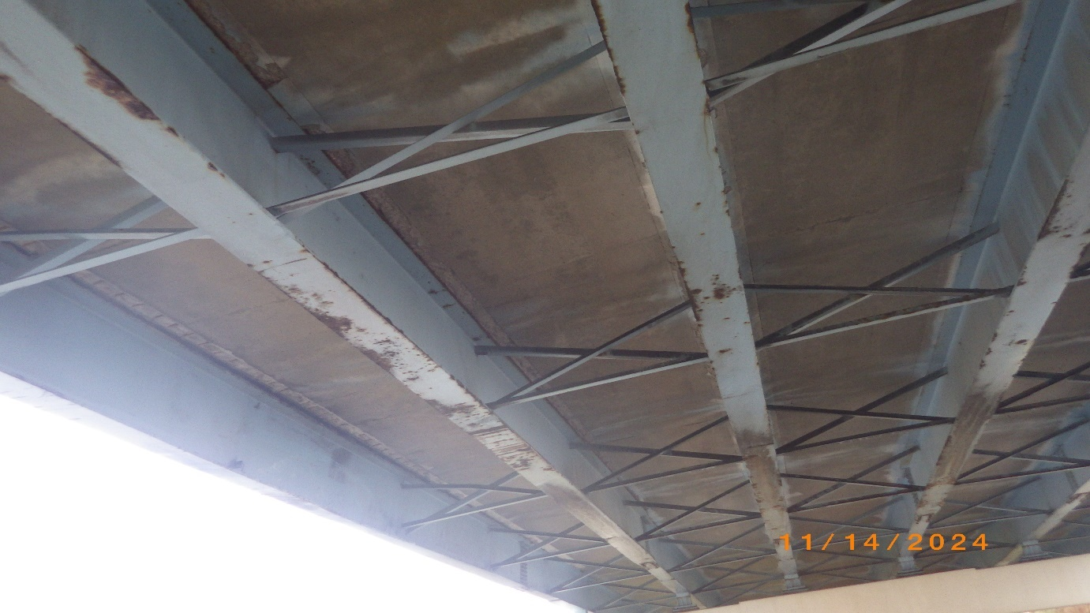
Note the semi-circular scraping, indicating contact with the curved edge of the impacting load and delineating the area of impact
Photo # 3 - View of point of impact, looking Northwest from median
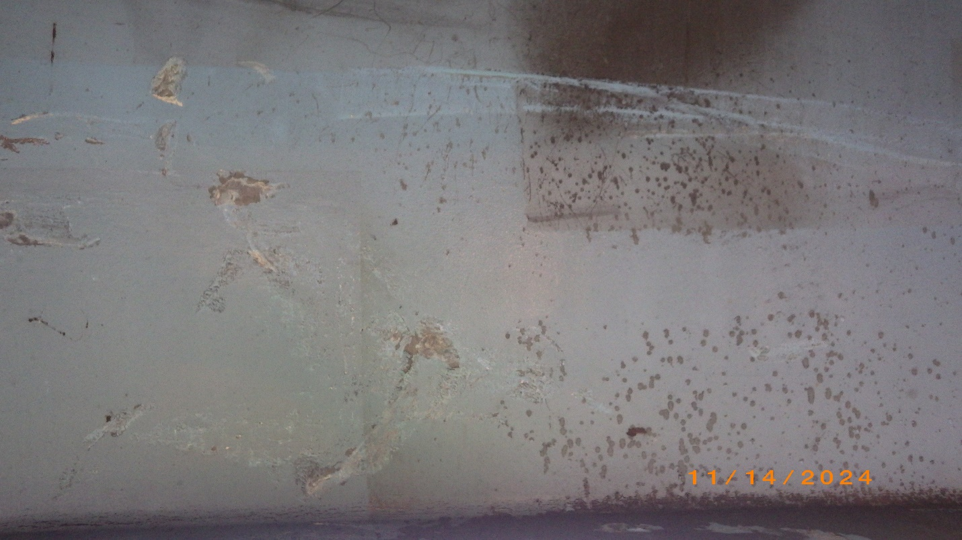
Note the semi-circular scraping, indicating contact with the curved edge of the impacting load
Photo # 4 - Beam 1, inside surface of web at point of impact, showing superficial damage
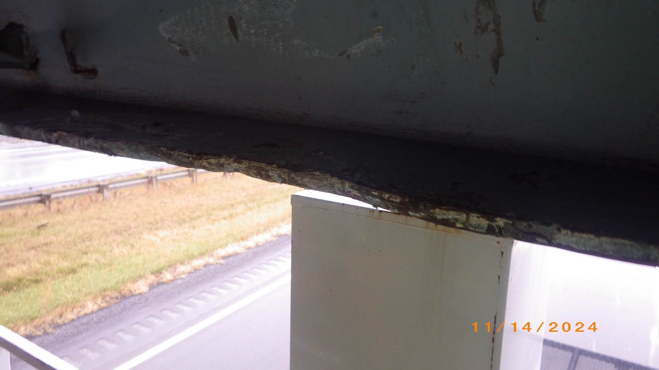
Photo # 5 - Beam 1, bottom flange condition at point of impact
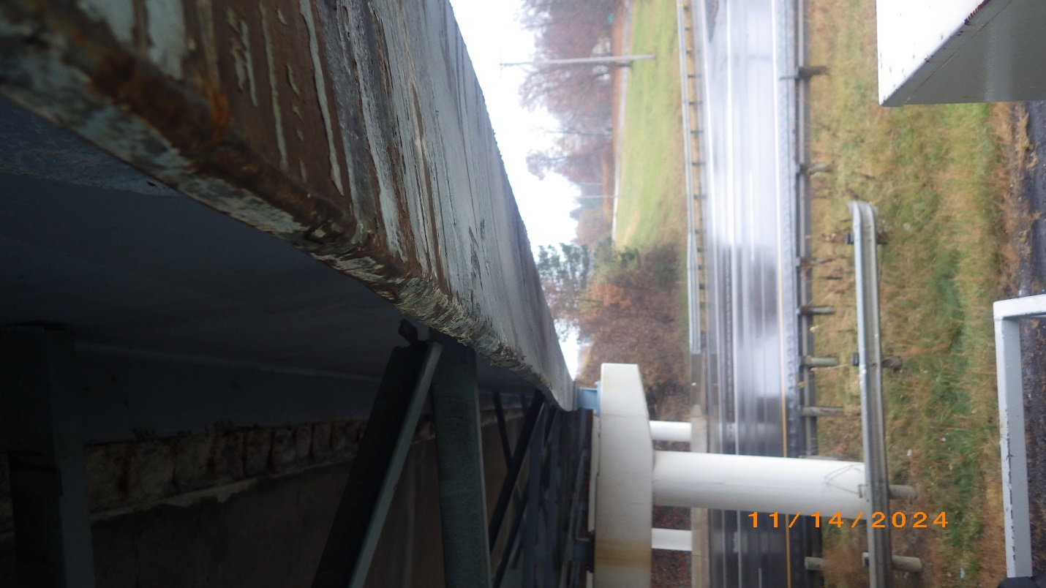
Photo # 6 - Beam 1, bottom flange, looking South from point of impact
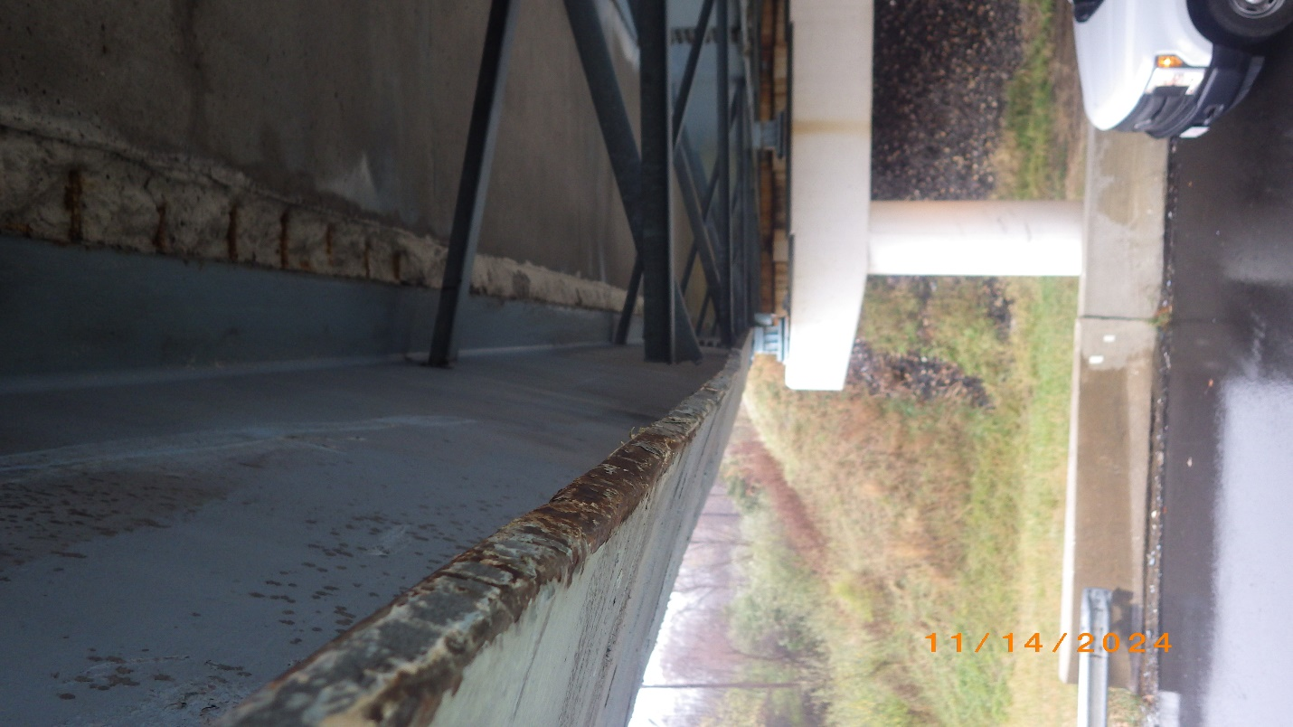
Photo # 7 - Beam 1, bottom flange, looking North from point of impact
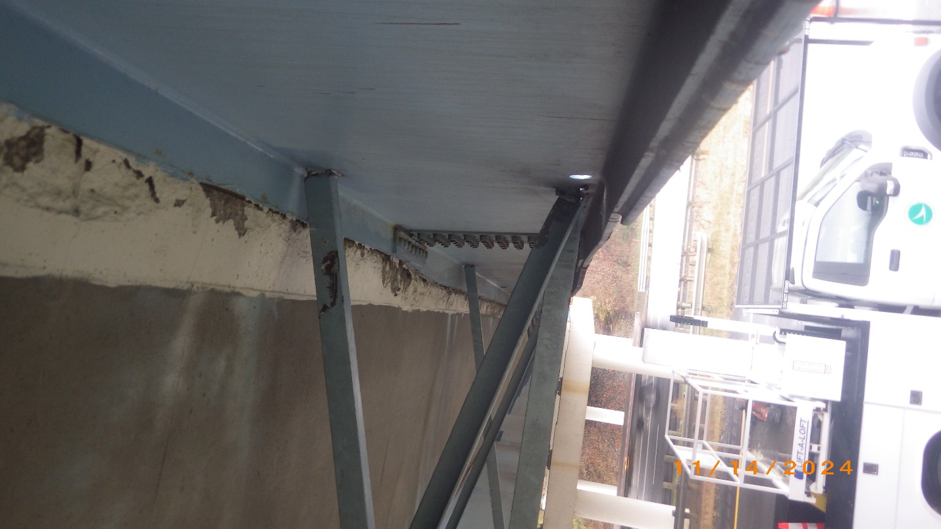
Photo # 8 - Beam 1, looking South from Pier 3
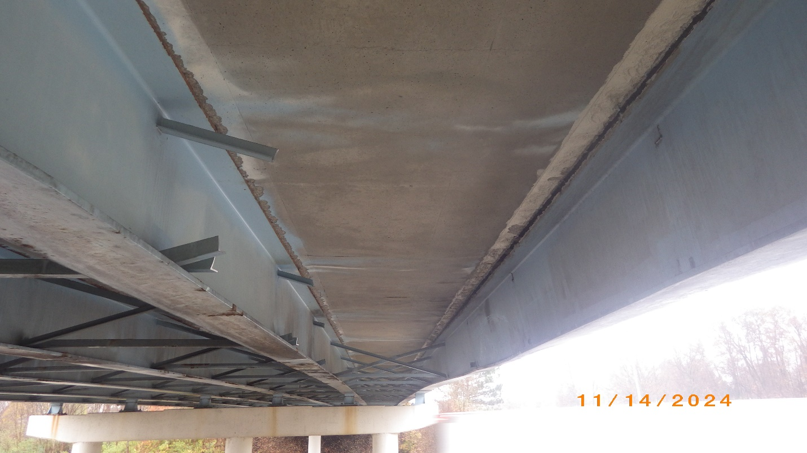
Photo # 9 - Bay 1, looking South from Crossframe 7 following removal of Crossframes 4-7

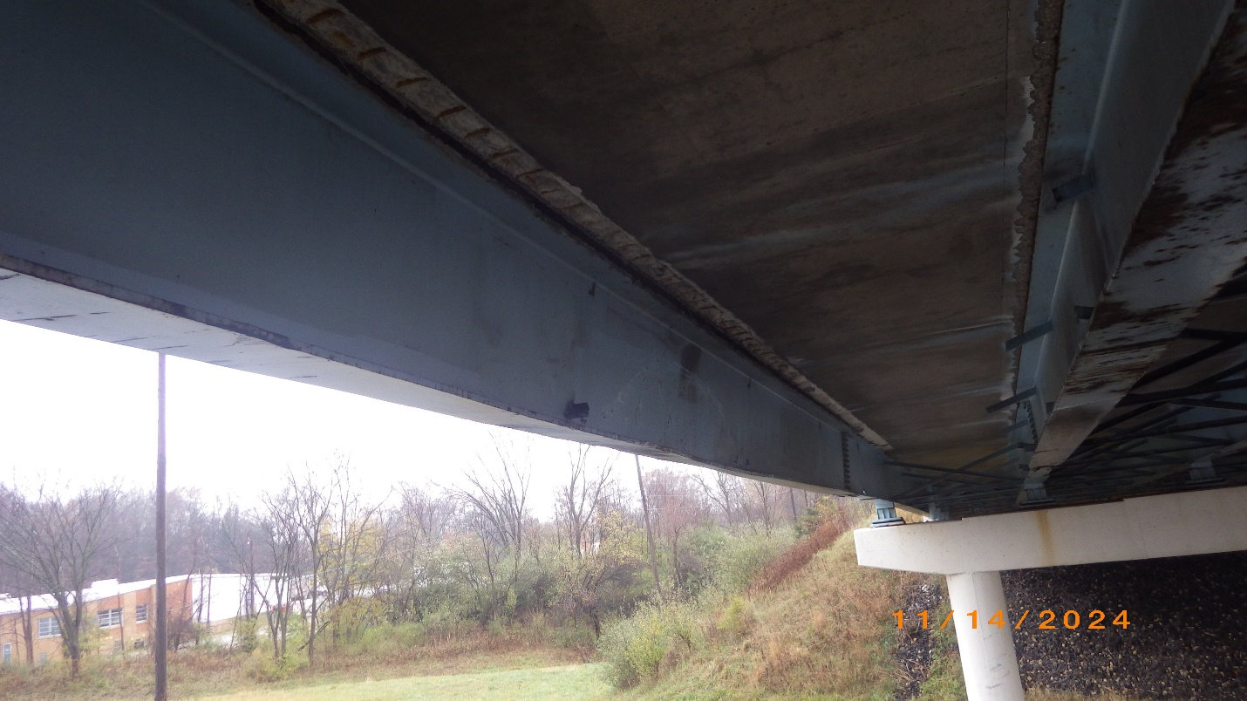
Photo # 10 – Bay 1, looking North from Crossframe 3, following removal of Crossframes 3-7
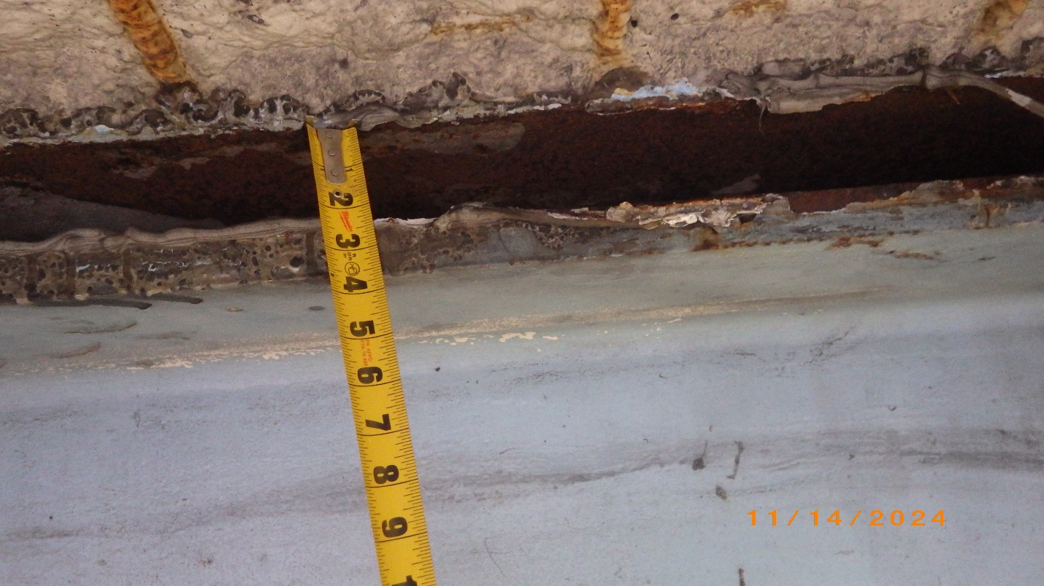
Photo # 11 – Beam 1, inside of top flange, separation from haunch at point of impact
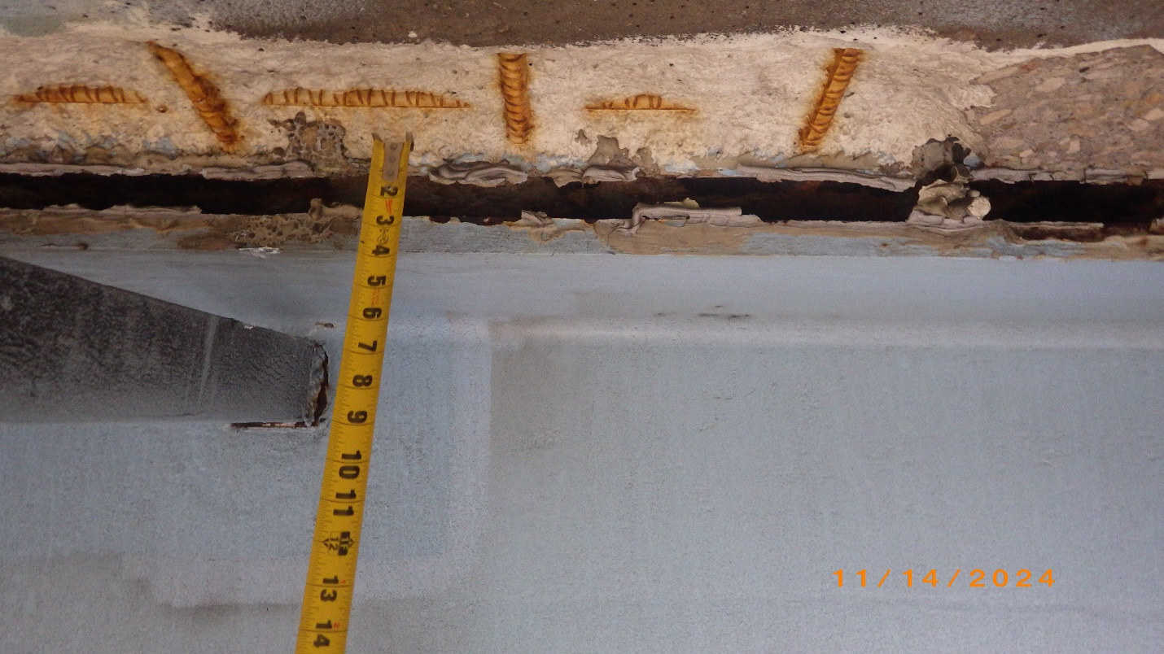
Photo # 12 – Beam 1, inside of top flange, separation from haunch at Crossframe 3
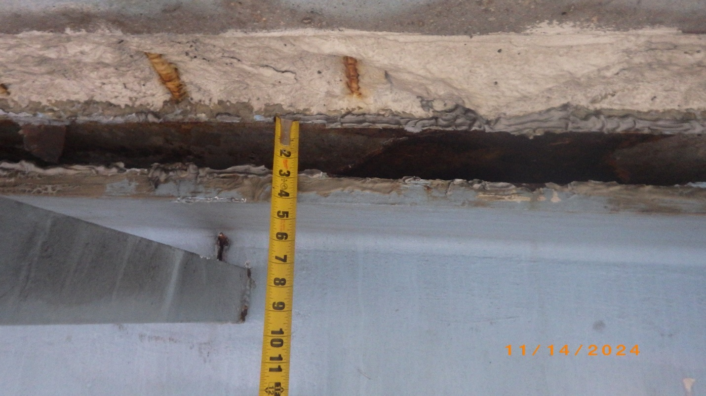
Photo # 13 – Beam 1, inside of top flange, separation from haunch at Crossframe 5
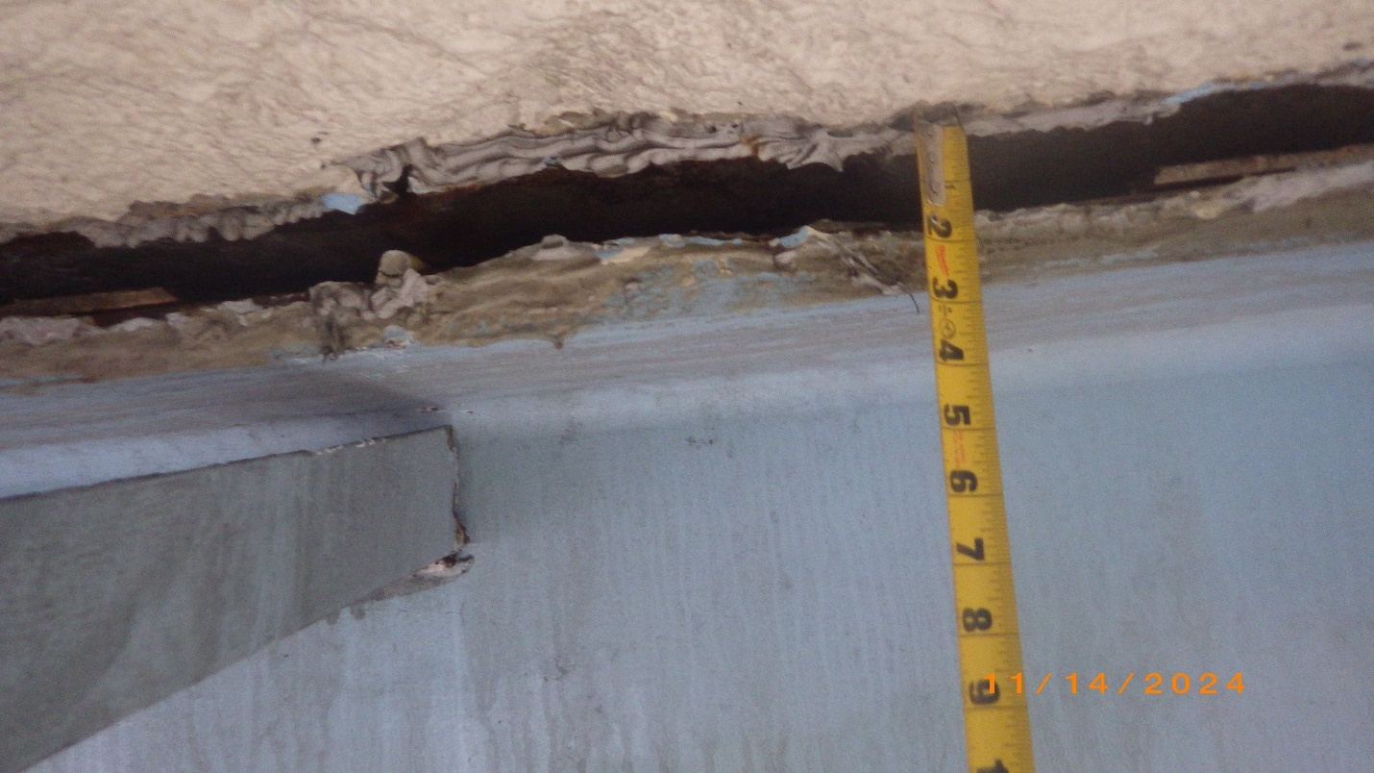
Photo # 14 – Beam 1, inside of top flange, separation from haunch at Crossframe 6
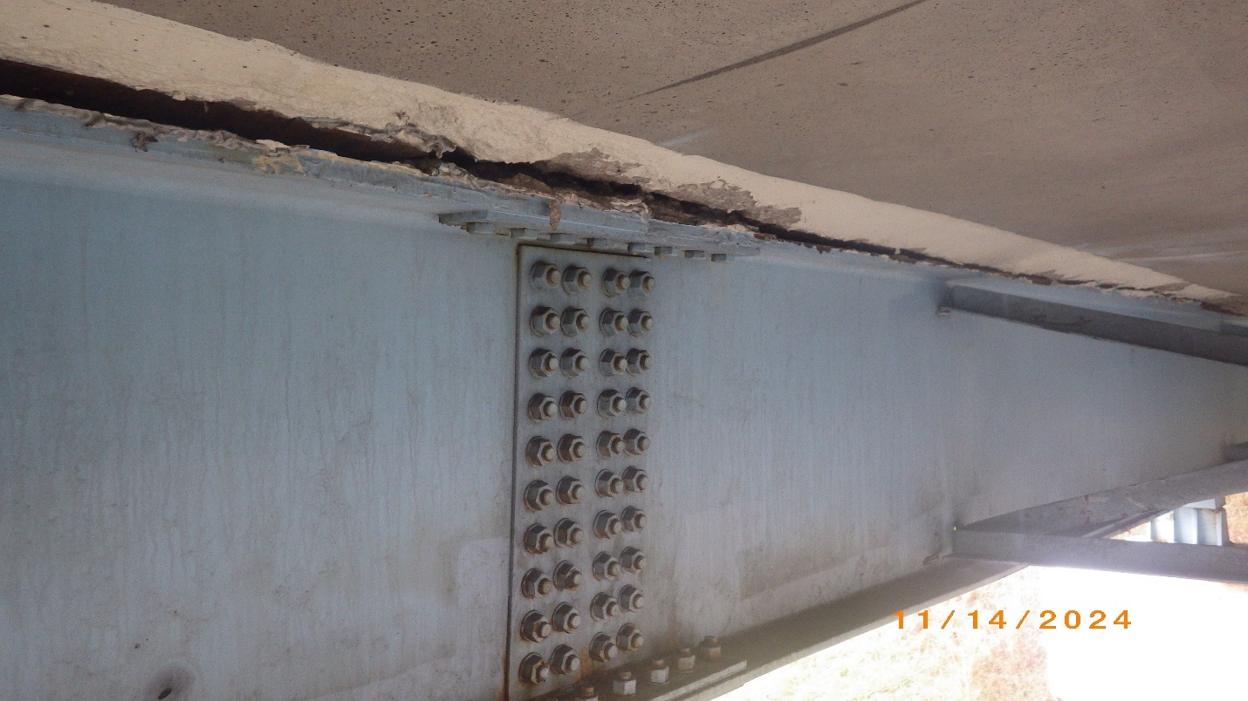
Photo # 15 – Beam 1 Span 3 Splice Plate. Note fresh spalling

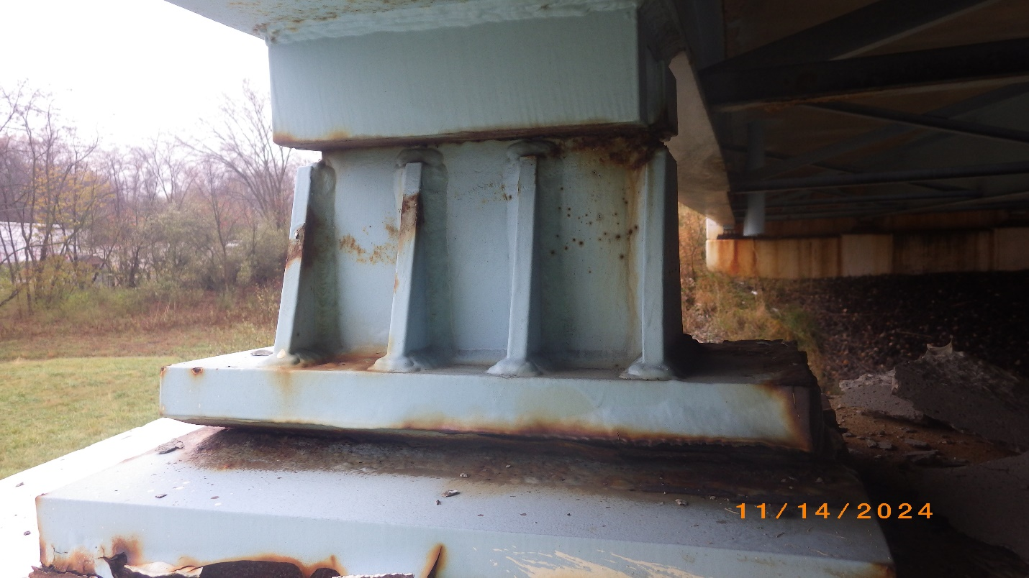
Photo # 16 – Bearing 1, Pier 3
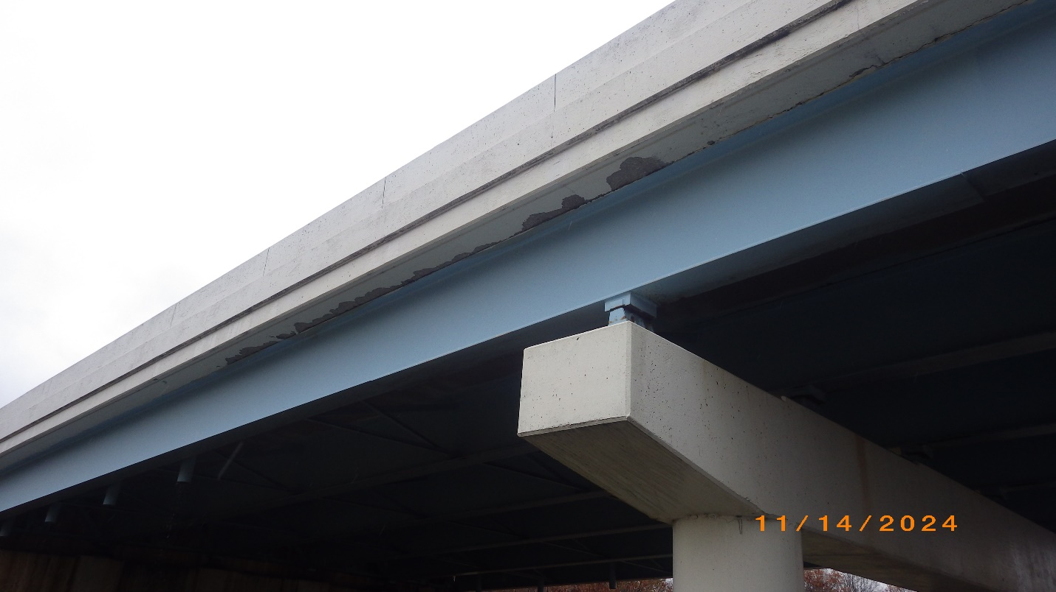
Photo # 17 – Span 3, Beam 1, outside, looking South. Note spalling
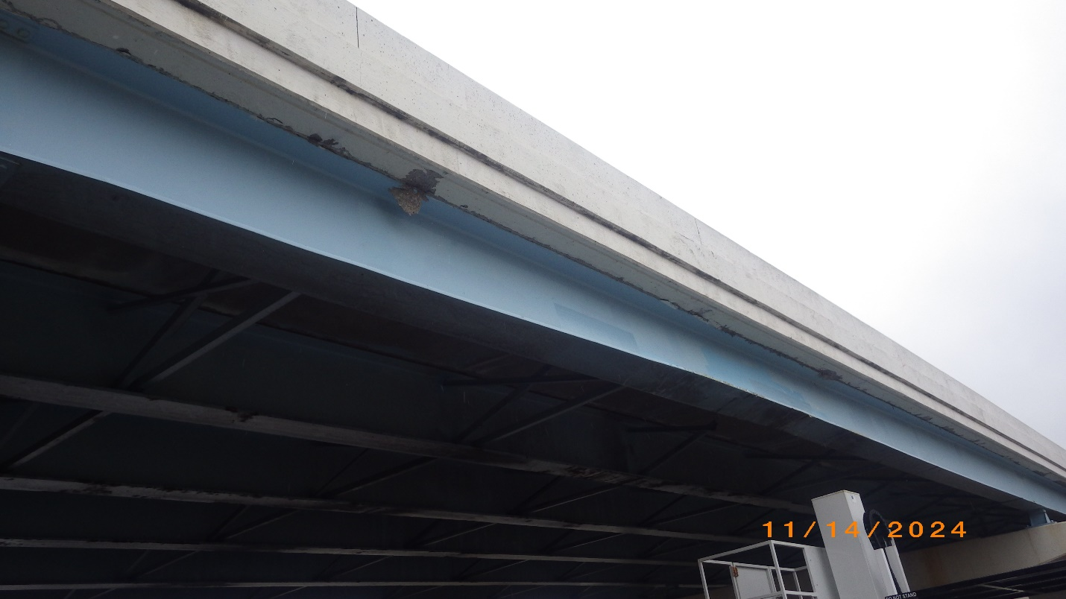
Photo # 18 – Span 3, Beam 1, outside, looking North. Note spalling. The hanging spall was removed by ODOT forces
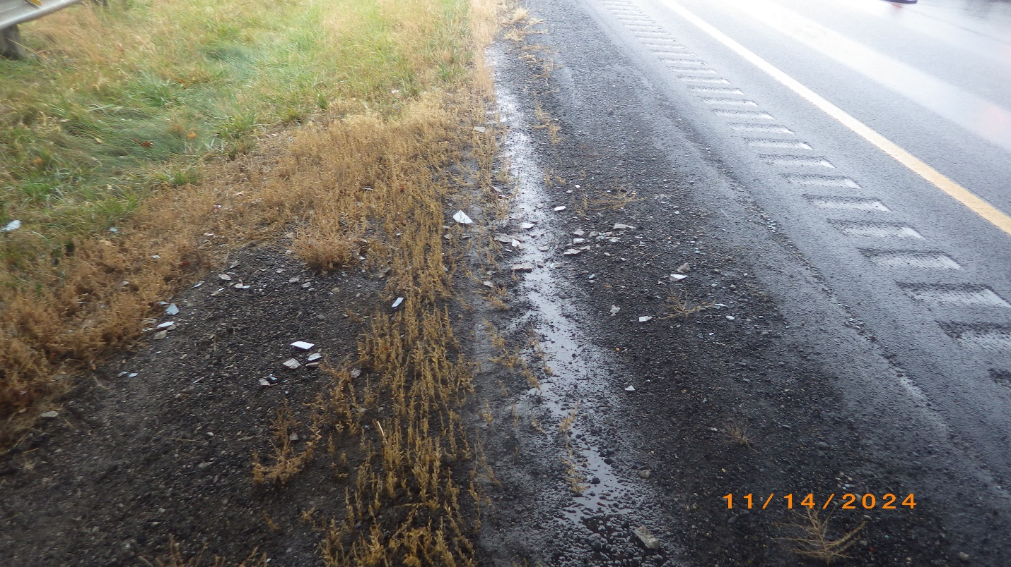
Photo # 19 – Fresh spalling on shoulder, South side of Westbound roadway
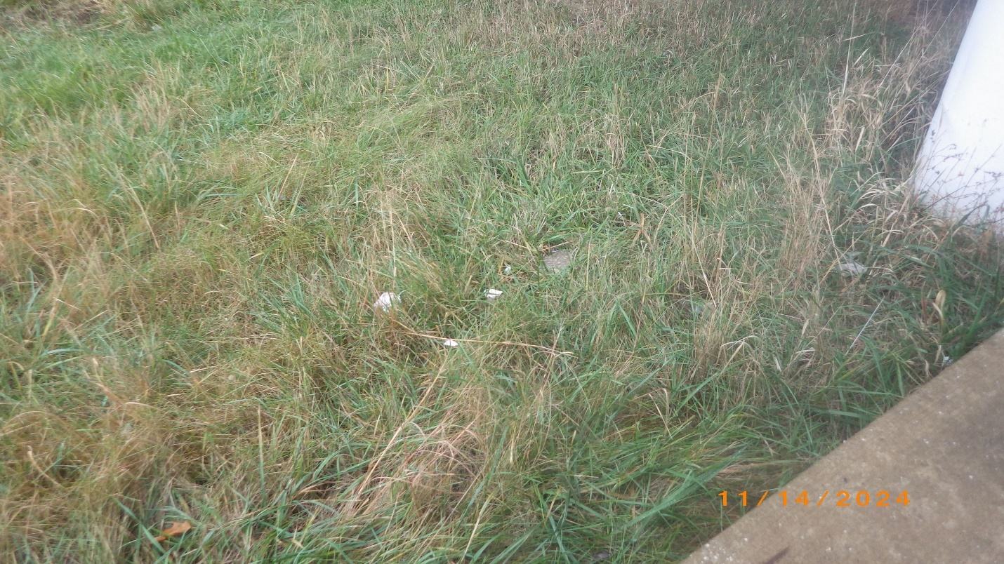
Photo # 20 – Fresh spalling on shoulder, North side of Westbound roadway

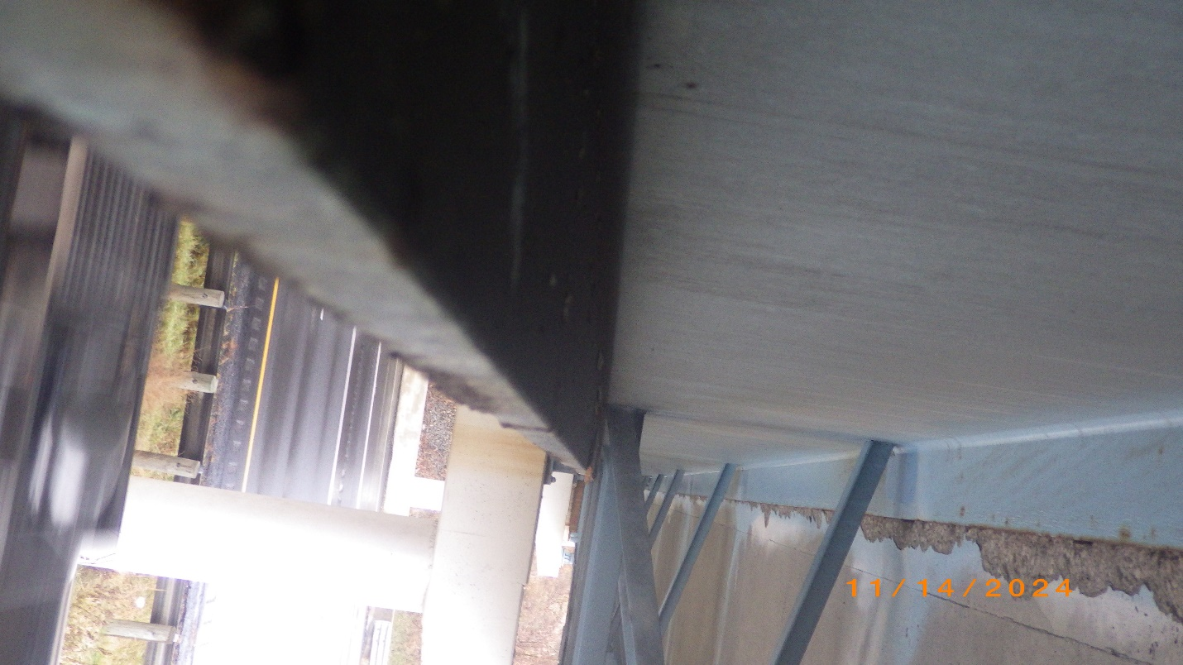
Photo # 21 – Beam 2, looking South from point of impact. Note spalling
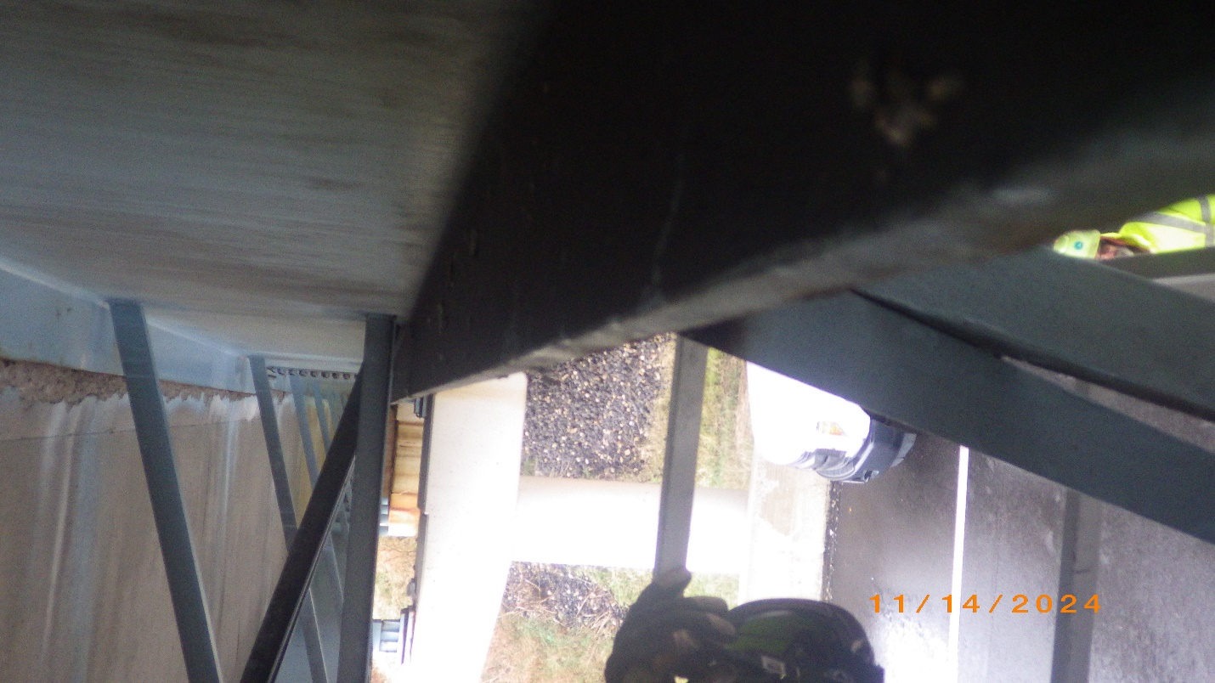
Photo # 22: Beam 2, looking North from point of impact. Note spalling
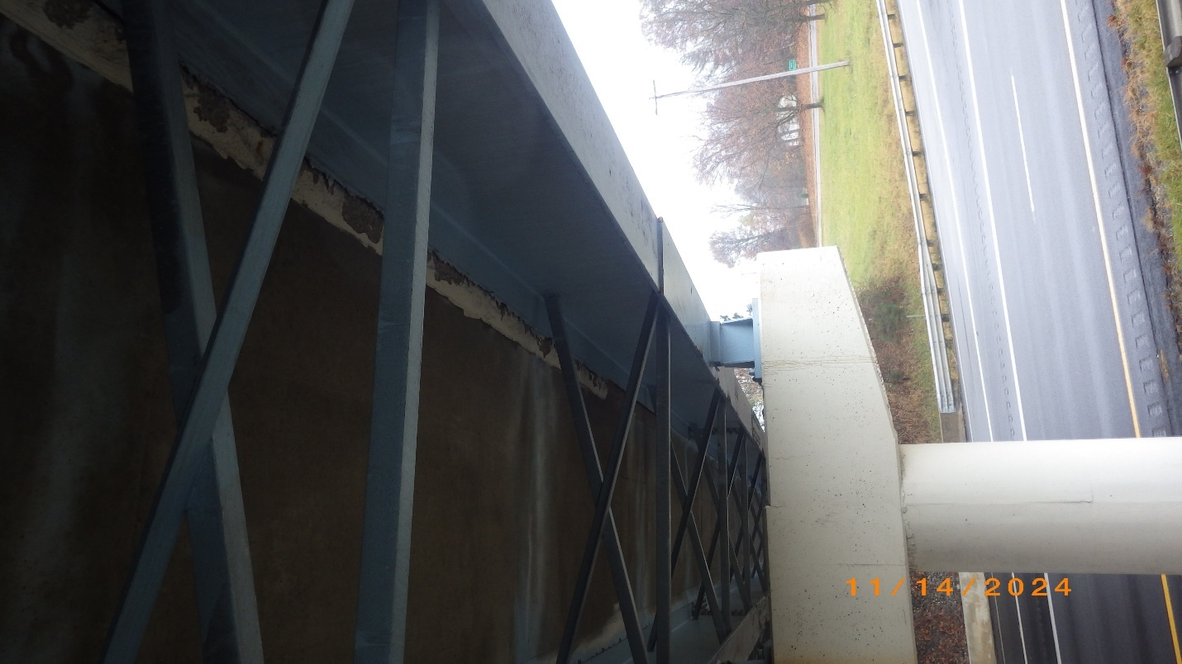
Photo # 23 – Crossframe 1 & 2, looking south
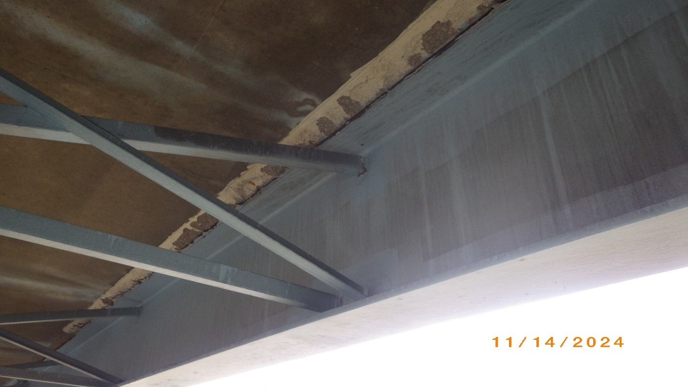
Photo # 24 – Crossframe 2 at Beam 1
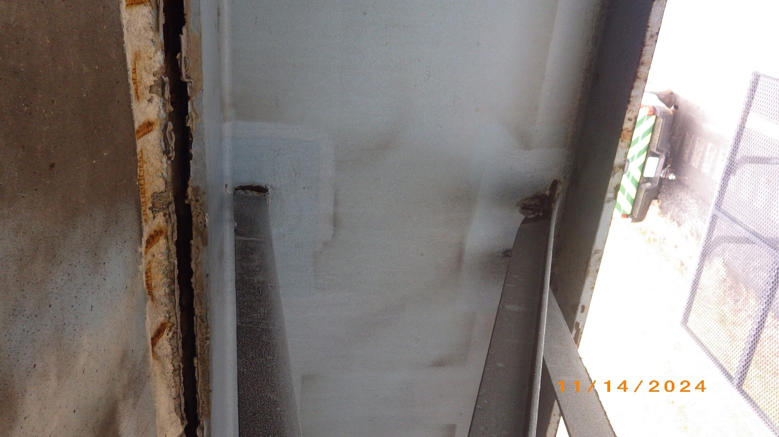
Photo # 25 – Crossframe 3 at Beam 1
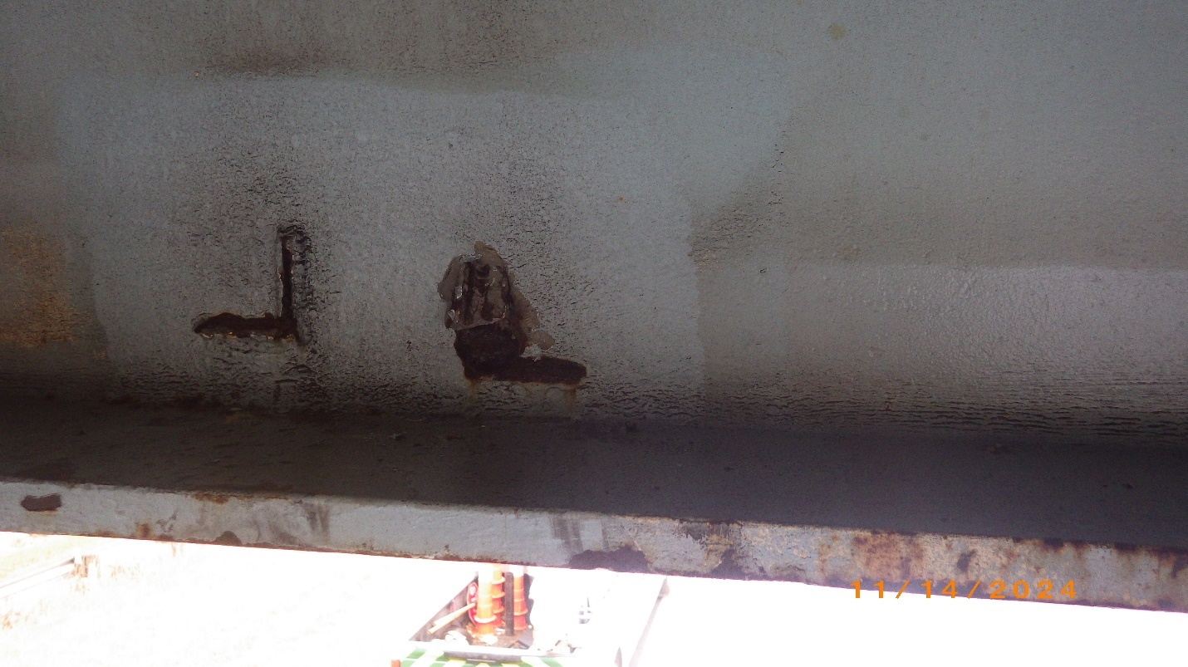
Photo # 26 – Crossframe 3 at Beam 1, lower welds
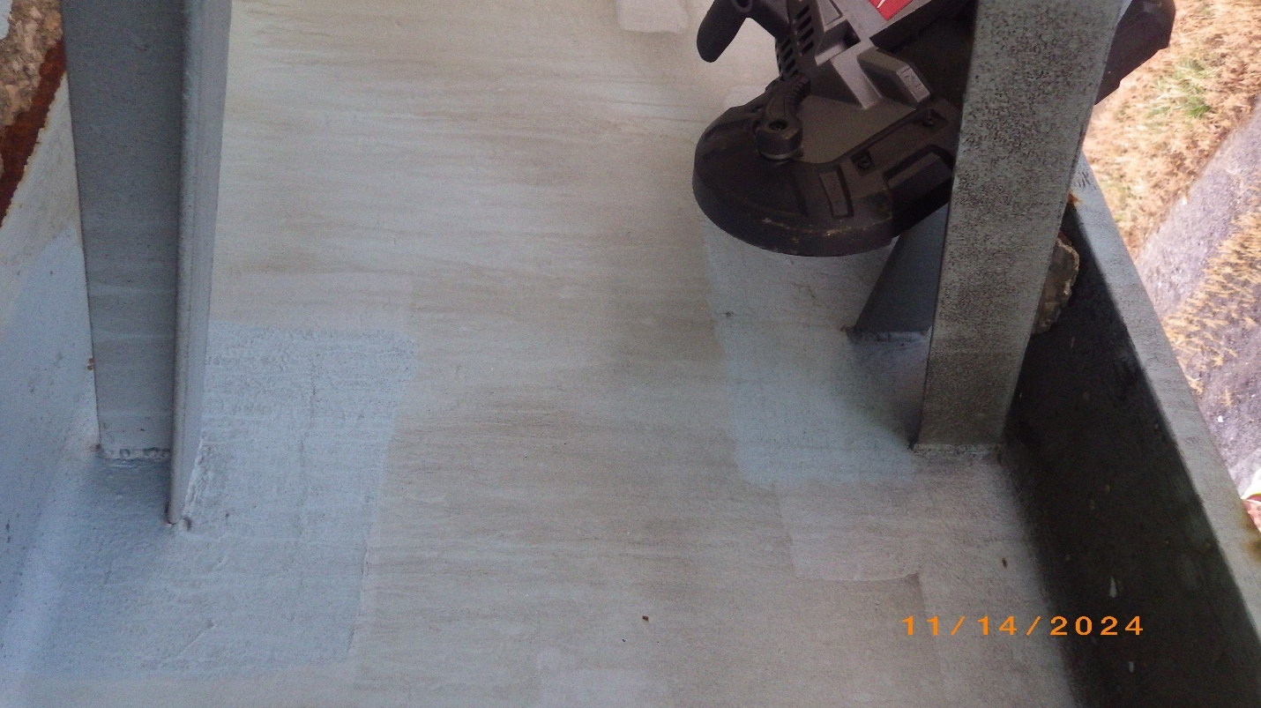
Photo # 27 – Crossframe 3 at Beam 2

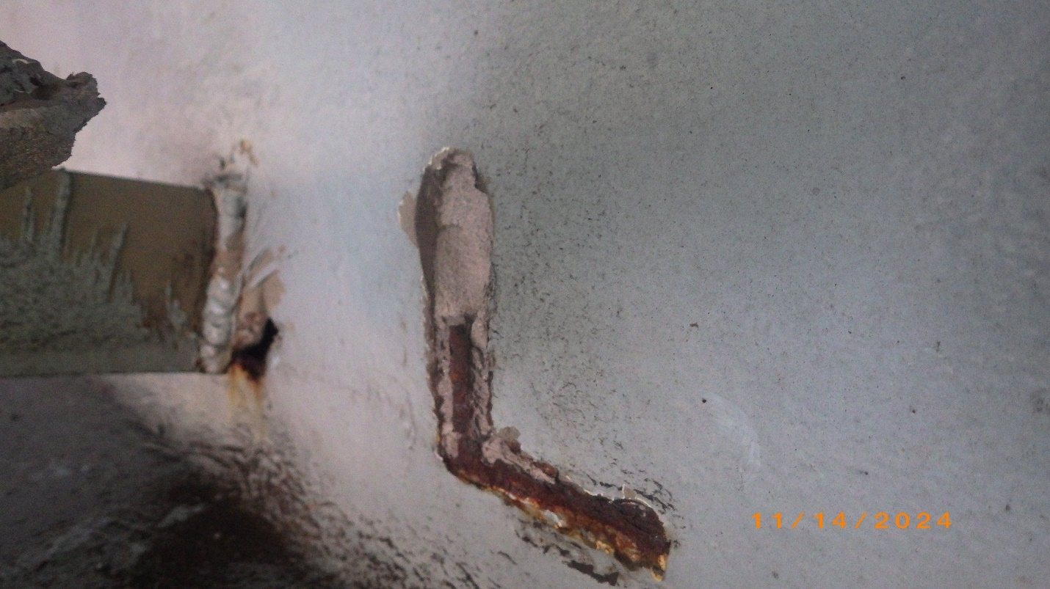
Photo # 28 – Crossframe 4 at Beam 1, lower diagonal weld. Note ~ 1/4” deep tearout of web material
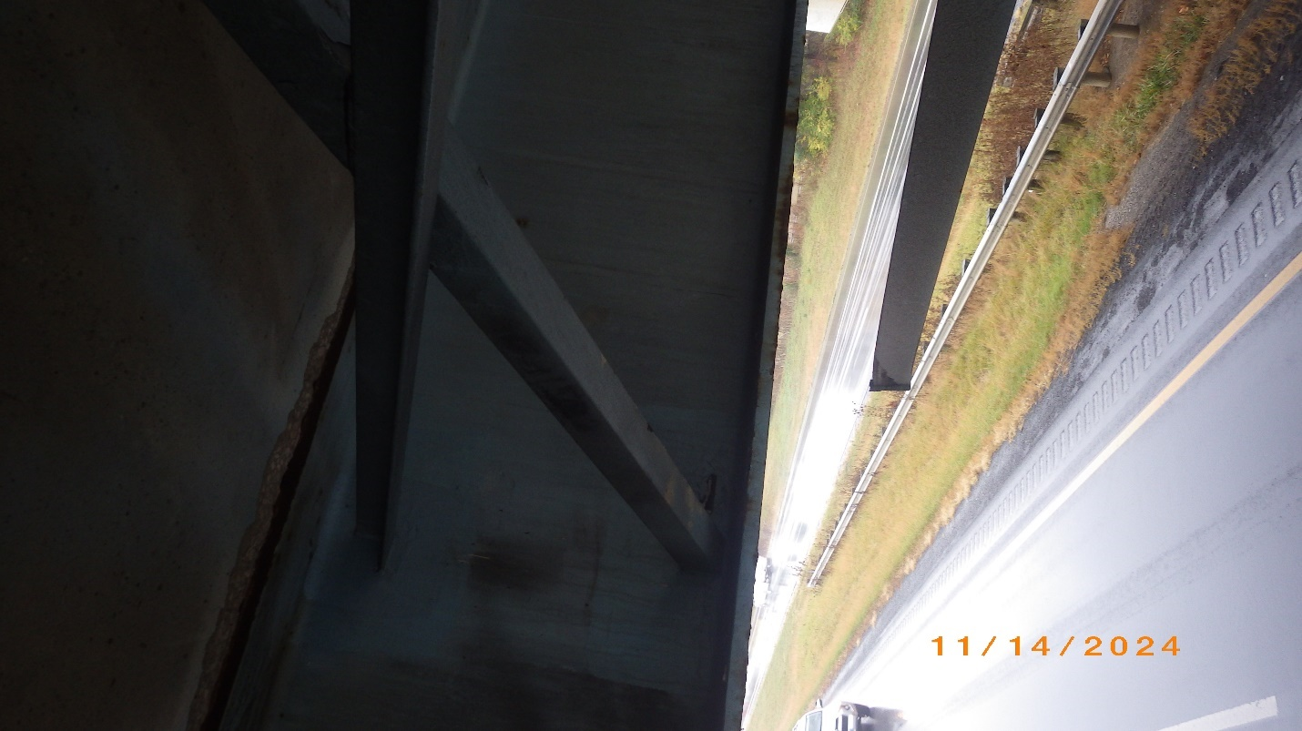
Photo # 29 – Crossframe 4 at Beam 2
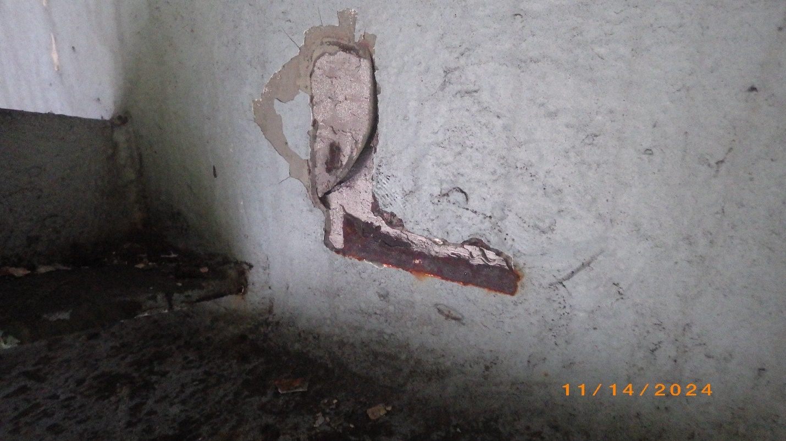Photo # 30 – Crossframe 4 at Beam 2, lower horizontal weld. Note tearout of web material
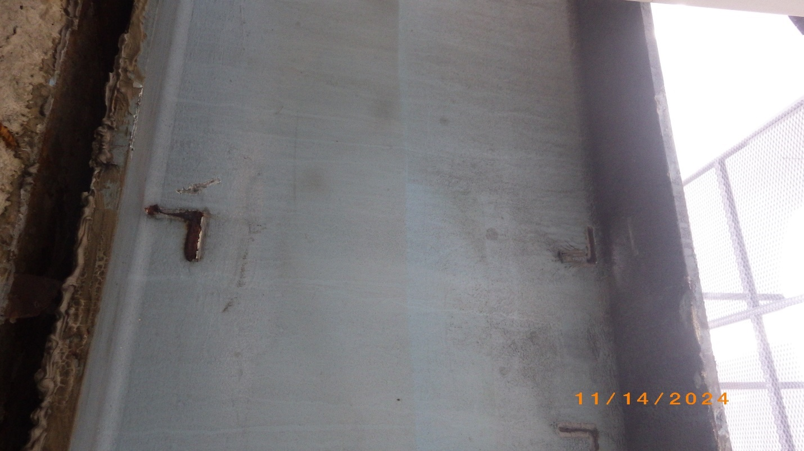
Photo # 31 – Crossframe 5 welds at Beam 1
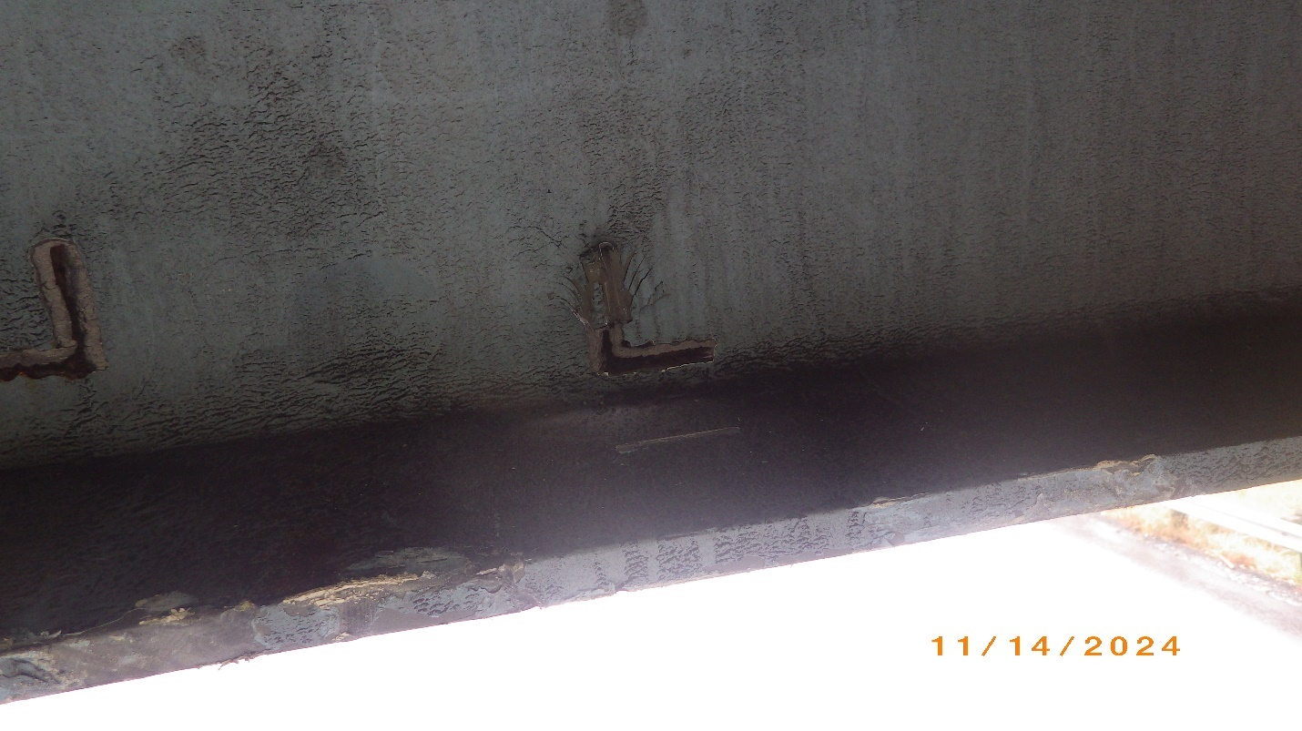
Photo # 32 – Crossframe 5 at Beam 1, lower welds. Note tearout of web material at horizontal member weld
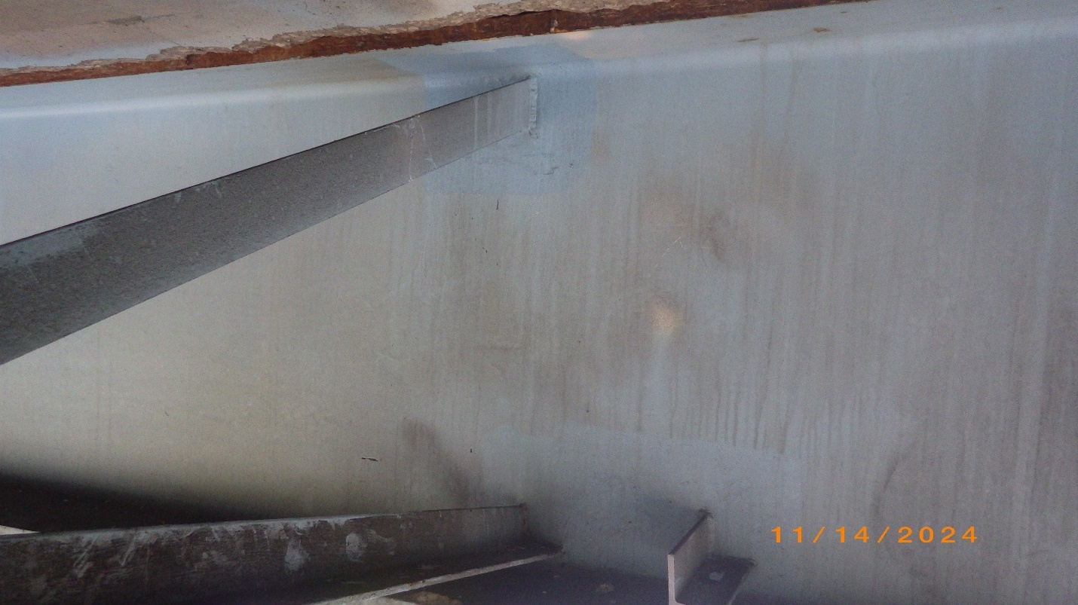
Photo # 33 – Crossframe 5 at Beam 2
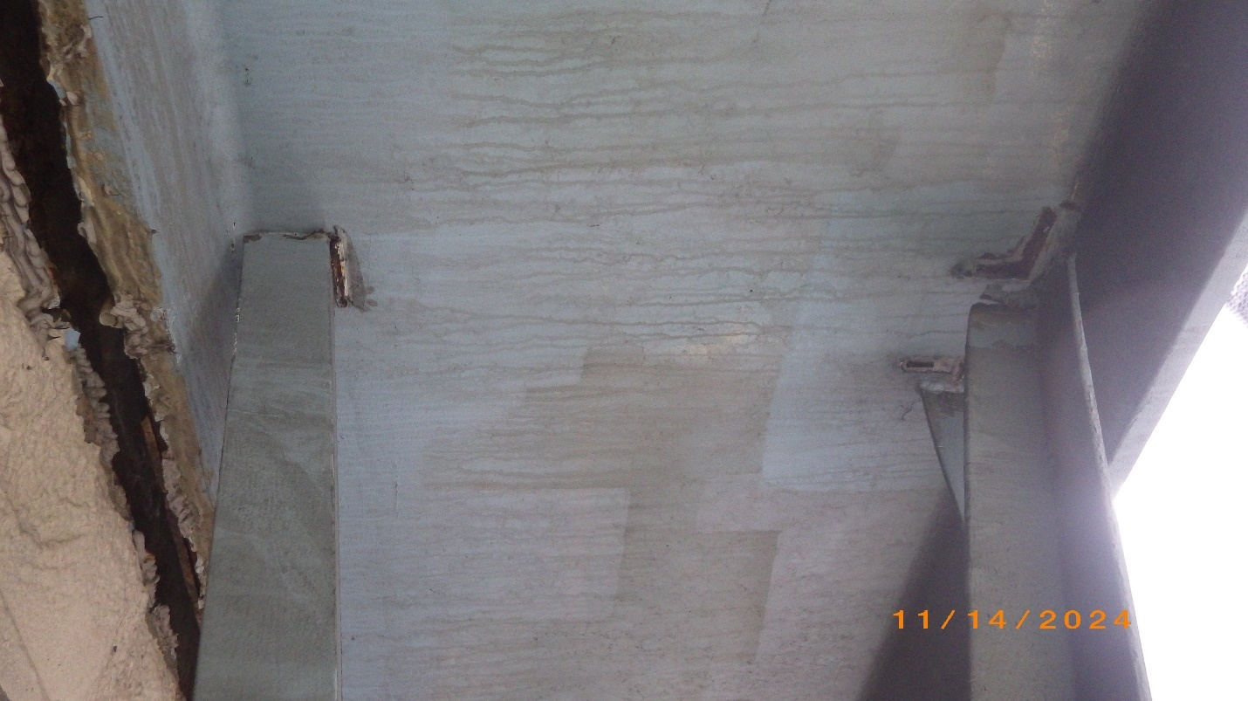
Photo # 34 – Crossframe 6 at Beam 1
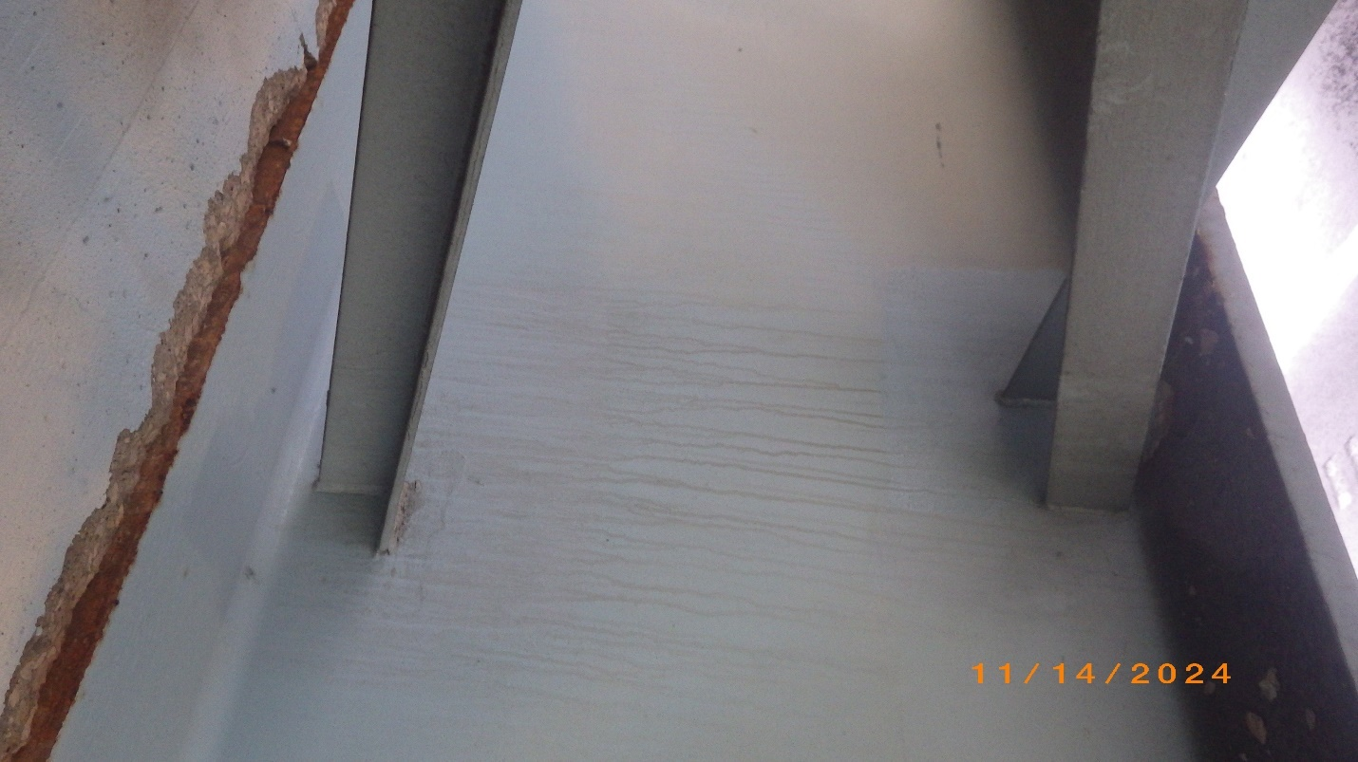
Photo # 35 – Crossframe 6 at Beam 2
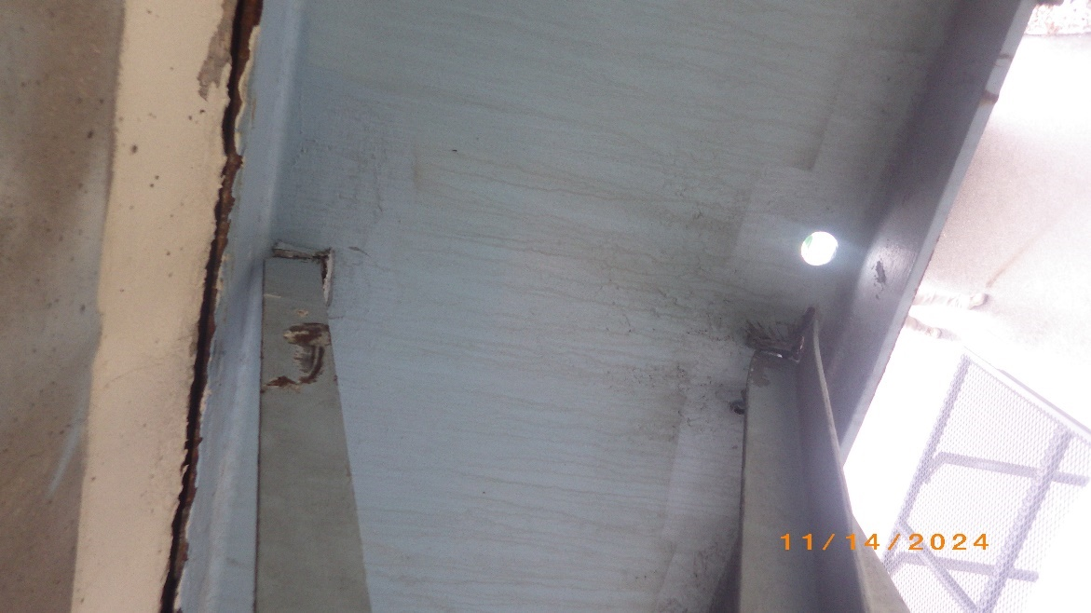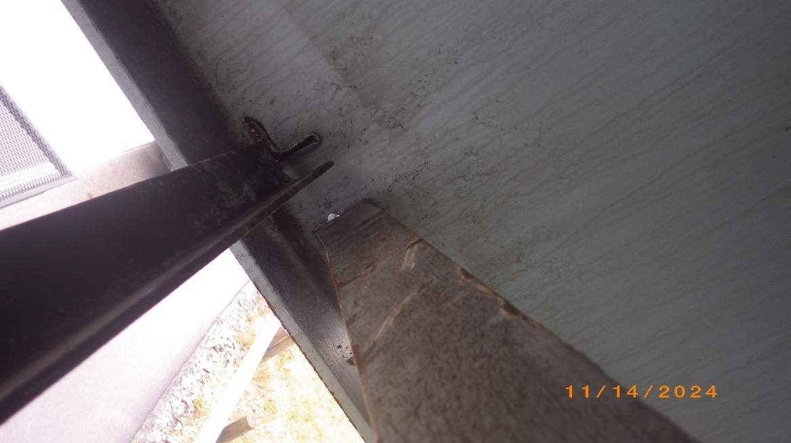
Photo # 36 & 37 – Crossframe 7 at Beam 1
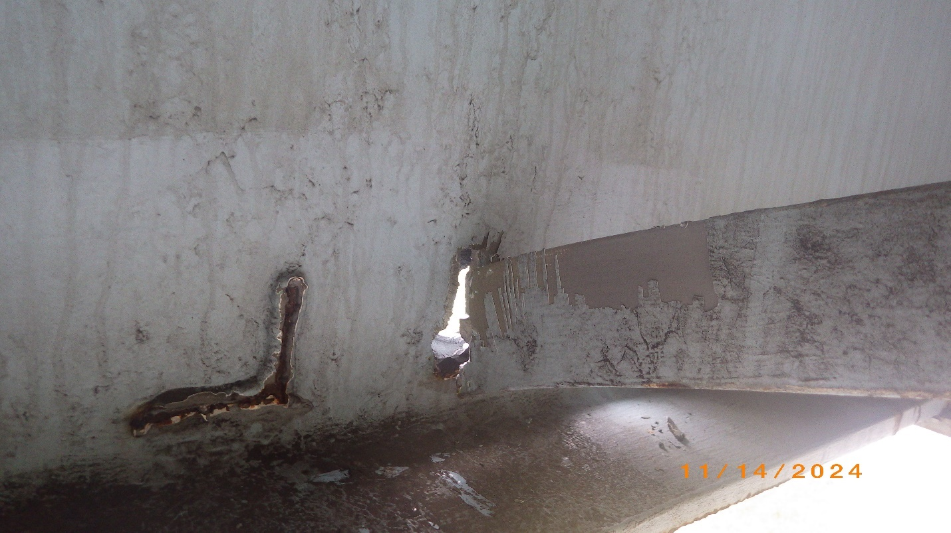
Photo # 38 – Crossframe 7 at Beam 1. Note full tearout of the web at the diagonal weld
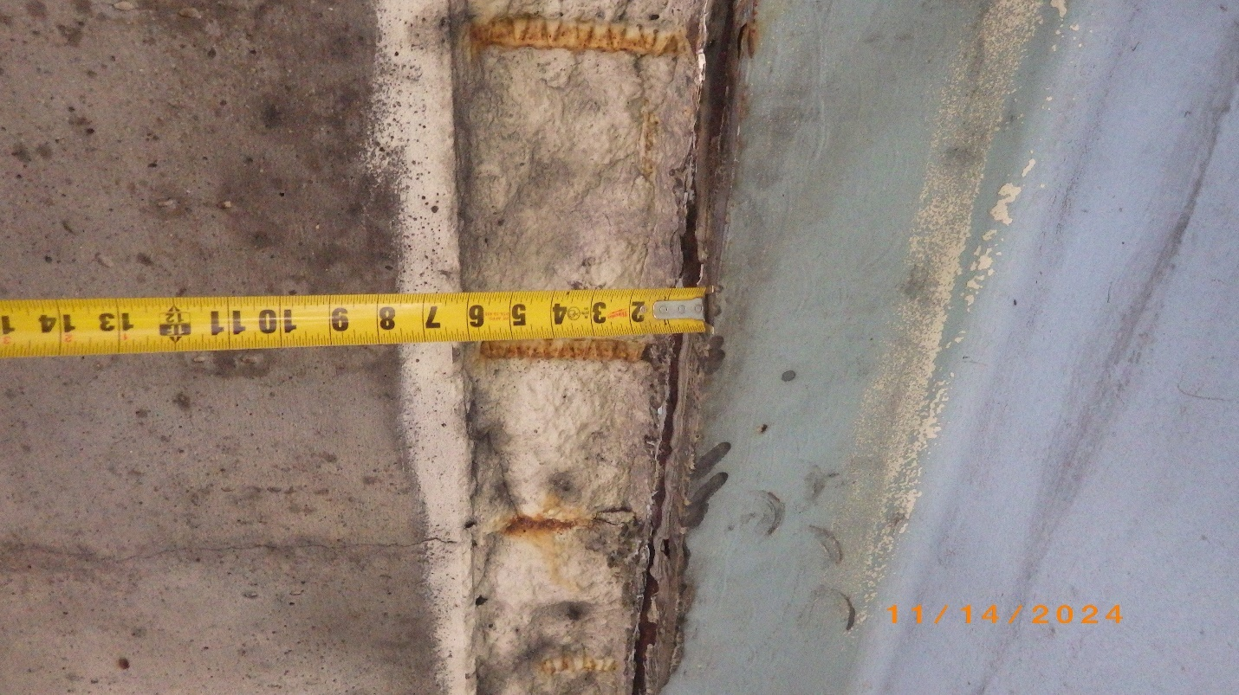
Photo # 39 – Existing spall from prior incidents, inside of Beam 1 top flange, shown near point of impact
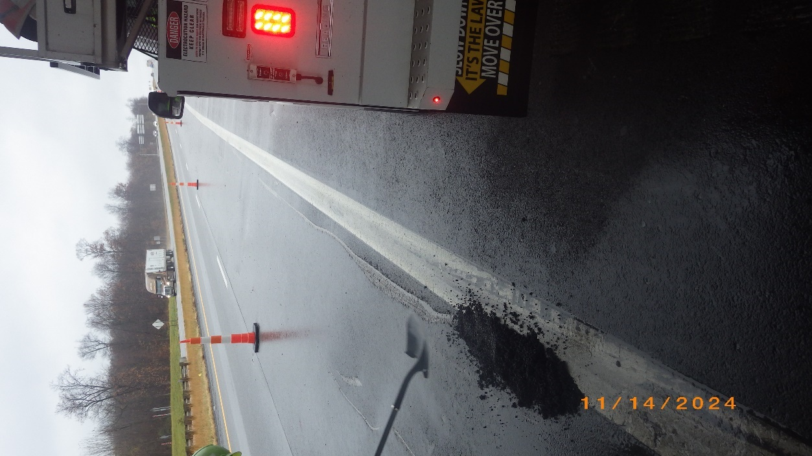
Photo # 40 – Pavement gouge in Westbound driving lane
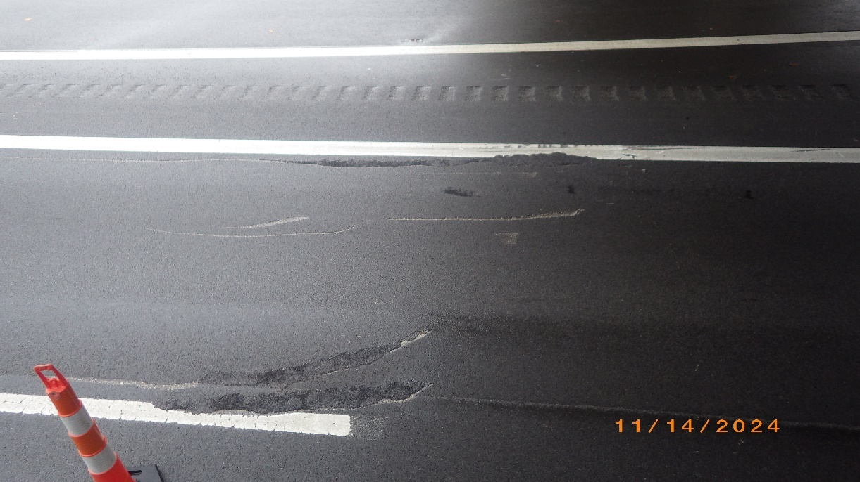
Photo # 41 – Pavement gouges in Westbound driving lane, filled with cold patch asphalt

Attachment E
Bridge Inspection Reports
2023
2021

Attachment F
Construction Cost Estimate

IMMEDIATE ACTION ESTIMATE
PID: 122937 | PLANNING-LEVEL ESTIMATE | RIC-30-16.42 BRIDGE HIT, CRASH DATE 13NOV2024
ITEMS, QUANTITIES AND UNIT COSTS BASED ON FIELD DATA AND HISTORICAL BID DATA |  |  |  |  | PREPARED BY JNC, 16NOV2024
PROPOSED BID ITEM | DESCRIPTION | UNIT | BASE EST. UNIT COST | INFLATION FACTOR | EST. UNIT COST | EST. QTY | EST. COST
103E05000 | PREMIUM FOR CONTRACT PERFORMANCE BOND AND FOR PAYMENT BOND | LS | $3,604.93 | 1 | $3,604.93 | 1 | $3,604.93
202E11401 | PORTIONS OF STRUCTURE REMOVED, AS PER PLAN | LB | $2.50 | 1 | $2.50 | 473 | $1,182.30
513E90000 | STRUCTURAL STEEL, MISC.: INSTALLATION OF TEMPORARY CROSSFRAME STRUTS | LB | $26.00 | 1 | $26.00 | 515 | $13,377.00
614E11000 | MAINTAINING TRAFFIC | LS | $15,000.00 | 1 | $15,000.00 | 1 | $15,000.00
614E11110 | LAW ENFORCEMENT OFFICER WITH PATROL CAR FOR ASSISTANCE | HOUR | $76.00 | 1 | $76.00 | 40 | $3,040.00
614E18600 | PORTABLE CHANGEABLE MESSAGE SIGN | SNMT | $1,200.00 | 1 | $1,200.00 | 1 | $1,200.00
624E10000 | MOBILIZATION | LS | $2,000.00 | 1 | $2,000.00 | 1 | $2,000.00
832E30000 | EROSION CONTROL | EACH | $1.00 | 1 | $1.00 | 250 | $250.00
 | MISC. & CONTINGENCIES | LS | $10,000.00 | 1 | $10,000.00 | 1 | $10,000.00
TOTAL PROJECT EST. COST = |  |  |  |  |  |  | $ 49,654.23

COMPREHENSIVE REPAIR ESTIMATE
PID: 122940 | PLANNING-LEVEL ESTIMATE | RIC-30-16.42 BRIDGE HIT, CRASH DATE 13NOV2024
ITEMS, QUANTITIES AND UNIT COSTS BASED ON FIELD DATA AND HISTORICAL BID DATA |  |  |  |  |  |  | PREPARED BY JNC, 16NOV2024
PROPOSED BID ITEM | DESCRIPTION | UNIT | BASE EST. UNIT COST | INFLATION FACTOR | EST. UNIT COST | EST. QTY |  | EST. COST
103E05000 | PREMIUM FOR CONTRACT PERFORMANCE BOND AND FOR PAYMENT BOND | LS | $32,234.70 | 1 | $32,234.70 | 1 |  | $32,234.70
202E11401 | PORTIONS OF STRUCTURE REMOVED, AS PER PLAN | LB | $5.00 | 1.29 | $6.45 | 624 |  | $4,026.74
512E10601 | CONCRETE REPAIR BY EPOXY INJECTION, AS PER PLAN | FT | $200.00 | 1.29 | $258.00 | 89 |  | $22,962.00
513E10201 | STRUCTURAL STEEL MEMBERS, LEVEL UF, AS PER PLAN | LB | $18.00 | 1.29 | $23.22 | 971 |  | $22,544.67
513E95020 | STRUCTURAL STEEL, MISC.: REPAIR OF DAMAGED MAIN MATERIAL BY WELDING | LS | $7,500.00 | 1.29 | $9,675.00 | 1 |  | $9,675.00
514E20001 | FIELD PAINTING OF DAMAGED STRUCTURAL STEEL, AS PER PLAN | SF | $77.00 | 1.29 | $99.33 | 799 |  | $79,381.21
614E11000 | MAINTAINING TRAFFIC | LS | $40,000.00 | 1.29 | $51,600.00 | 1 |  | $51,600.00
614E11110 | LAW ENFORCEMENT OFFICER WITH PATROL CAR FOR ASSISTANCE | HOUR | $76.00 | 1.29 | $98.04 | 60 |  | $5,882.40
614E12420 | DETOUR SIGNING | LS | $10,000.00 | 1.29 | $12,900.00 | 1 |  | $12,900.00
614E18600 | PORTABLE CHANGEABLE MESSAGE SIGN | SNMT | $1,200.00 | 1.29 | $1,548.00 | 2 |  | $3,096.00
619E16000 | FIELD OFFICE, TYPE A | MNTH | $1,500.00 | 1.29 | $1,935.00 | 1 |  | $1,935.00
623E10000 | CONSTRUCTION LAYOUT STAKES AND SURVEYING | LS | $5,000.00 | 1.29 | $6,450.00 | 1 |  | $6,450.00
624E10000 | MOBILIZATION | LS | $8,000.00 | 1.29 | $10,320.00 | 1 |  | $10,320.00
832E30000 | EROSION CONTROL | EACH | $1.00 | 1 | $1.00 | 500 |  | $500.00
849E10001 | DAMAGE ASSESSMENT, AS PER PLAN | LS | $5,000.00 | 1.29 | $6,450.00 | 1 |  | $6,450.00
849E10500 | SURFACE PREPARATION | LS | $12,000.00 | 1.29 | $15,480.00 | 1 |  | $15,480.00
849E10600 | REPAIRING DAMAGED MEMBERS BY GRINDING | HOUR | $450.00 | 1.29 | $580.50 | 8 |  | $4,644.00
849E10700 | STRAIGHTENING DAMAGED MEMBERS | LS | $50,000.00 | 1.29 | $64,500.00 | 1 |  | $64,500.00
TOTAL PROJECT EST. COST = |  |  |  |  |  |  |  | $ 354,581.72

