100603 OUPS Identified Utilities
SR 800, SLM 26.95 (N. end of Dover Dam) to SLM 30.48 (Mineral City S. Corp Limit)
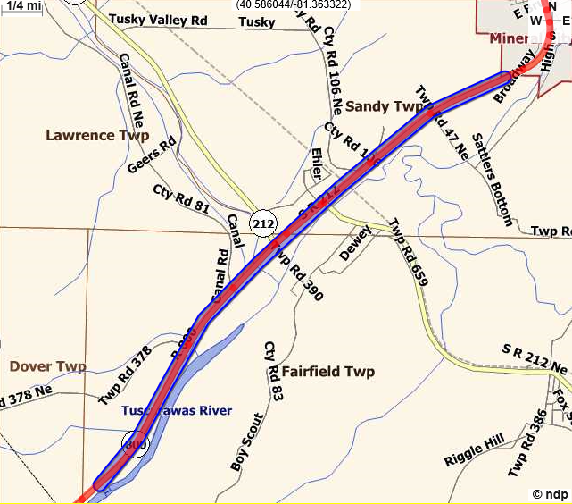
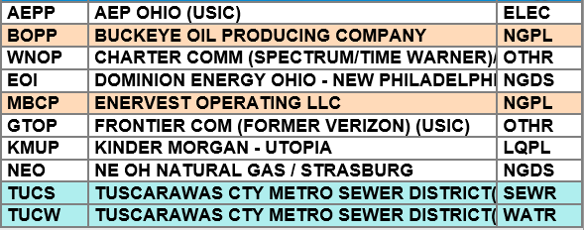

SR 800, SLM 31.71 (Mineral City N. Corp Limit) to 34.91 (Stark County)
