TUS-800-22.74, PID 100603
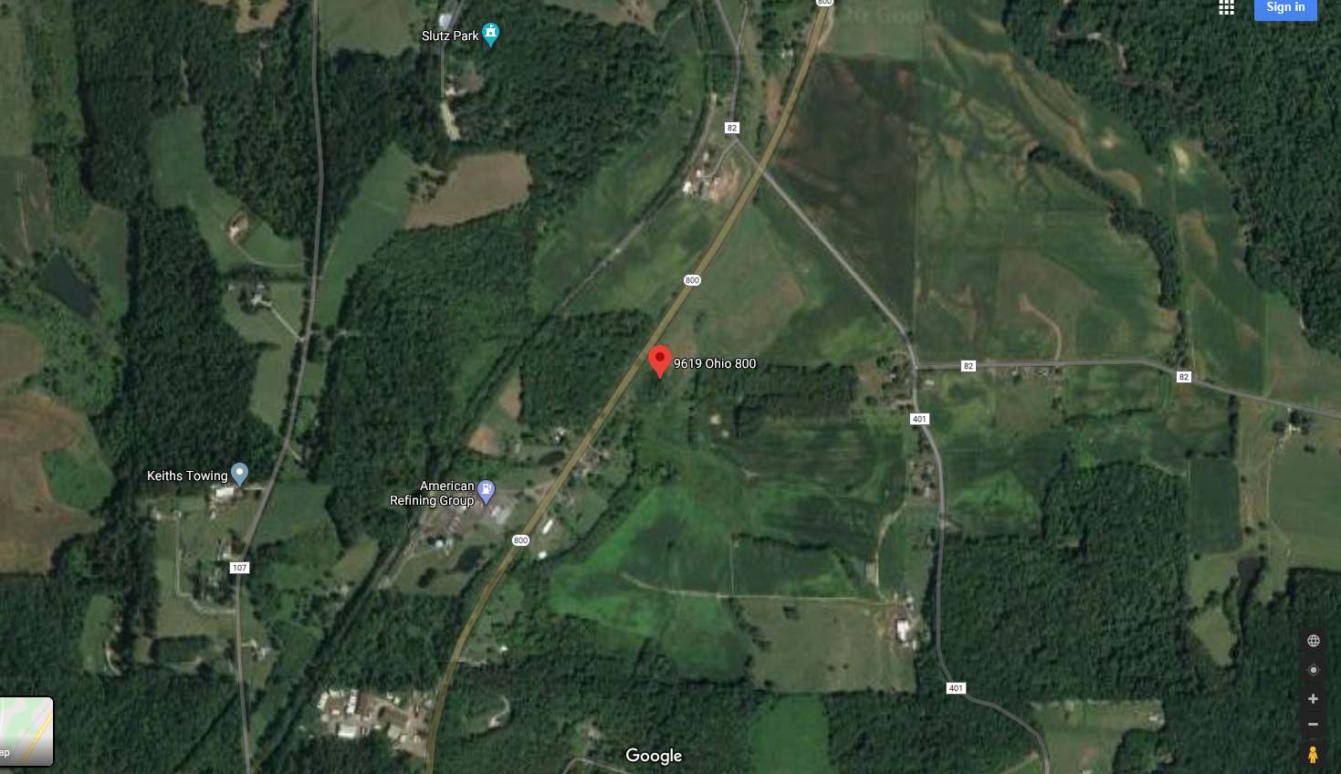
Energy Transfer (Rover pipeline) crossing

