**Designated Local Detour Maps (Phase 1)**

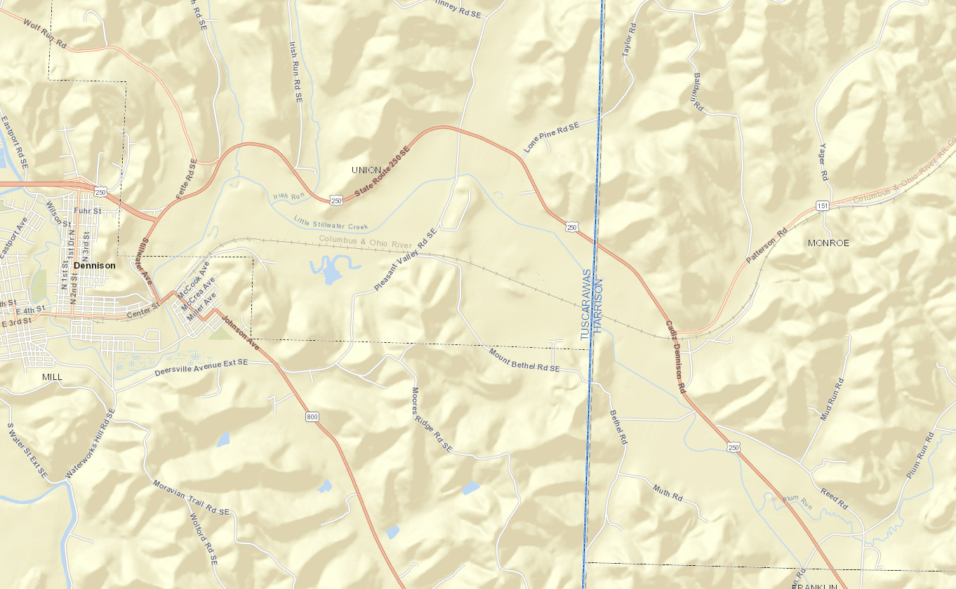

**Pleasant Valley Rd.**

**Designated Local Detour Maps (Phase 2)**



**Pleasant Valley Rd.**

**Mt. Bethel Rd.**

**Edie Rd.**

**Dennison**

**Harrison County**

Tuscarawas County

Carroll County

**Azalea Rd.**

**CR 22**

**Pleasant Valley Rd.**

**CR 37**

**Beitler Rd.**

**TR 194**

**SR 212**

**Leesville**

**SR 151**

Harrison County

Tuscarawas County

**Dennison**

**SR 151**

**US 250**

**Plum Run Rd.**

**Feed Spring Hill Rd.**

**SR 800**