**Existing Conditions**

* **Chevrons in both travel directions**
* **30 mph advisory speed**
* **Lighting is present**
* **Overhead flasher**

**Safety Application Summary; DEF – SR 15 & SR 18**

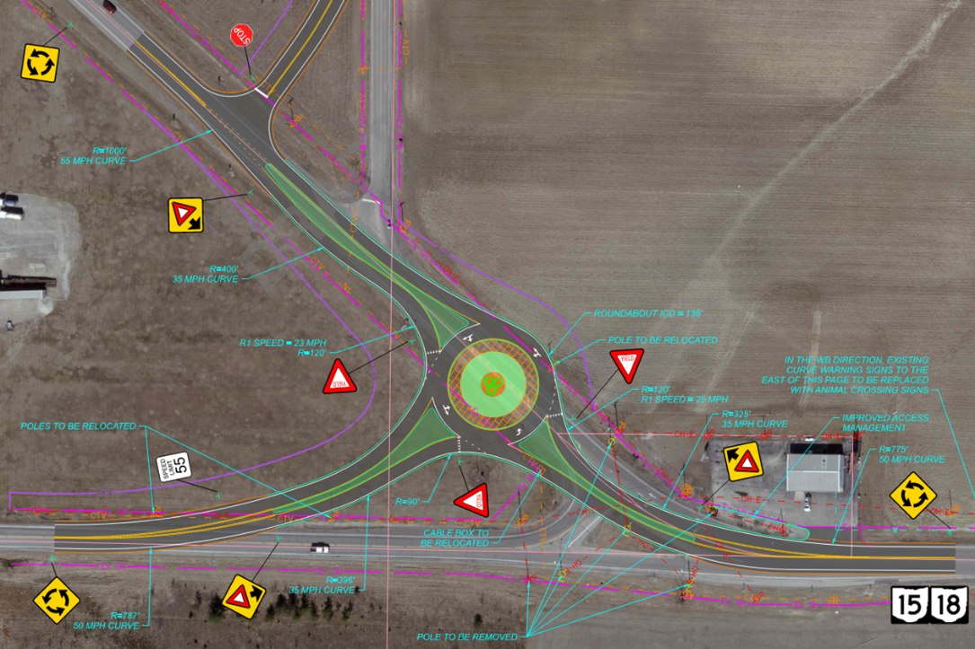

**Feasibility Study recommended a 3-Leg Roundabout**

**Project Estimate: $2,530,962**

* **Single lane roundabout**
* **Design - $750,000 (FY 2025)**
* **Right of Way - $163,725 (FY 2026)**
* **Construction - $1,617,237 (FY 2028)**

**\*Awarded $1M in TSMO funds for Construction in FY 2028**

**Crash History (2018-2022)**

**21 Total Crashes**

* **10 fixed object, 5 rear end**
* **4 serious injury**
* **38% injury rate, 4.2 crashes/year**