**Underwater Dive Inspection Procedure Checklist**

Acceptable written procedures communicate to the next dive team what is necessary to ensure a safe and successful inspection. Each bridge requiring underwater dive techniques must have a unique written inspection procedure. The prior inspection report does not suffice for the required procedures. It is valuable to review the last inspection notes, but they do not serve the same purpose as a stand-alone inspection procedure.

This document shall be completed for all underwater dive inspections. This document shall be reviewed prior to performing the field work and it shall be updated when necessary.

1. **Bridge Identification**
2. Agency with Inspection Responsibility: ODOT DISTRICT 2

Dive Frequency: 60 months

SFN: 6200184 Bridge Number (County-Route-SLM-SD): OTT-2-1312

Superstructure Type Main Span Type: CONTINUOUS CONCRETE SLAB

Approach Span: REINFORCED CONCRETE

Substructure Type Abutment Type: REINFORCED CONCRETE Pier Type: REINFORCED CONCRETE BENTS

Total Pier Count: 2

Total Pier Count in water: 2

Foundations: UNKNOWN

Feature Intersected RUSHA CREEK

1. **Photographs**

Endview

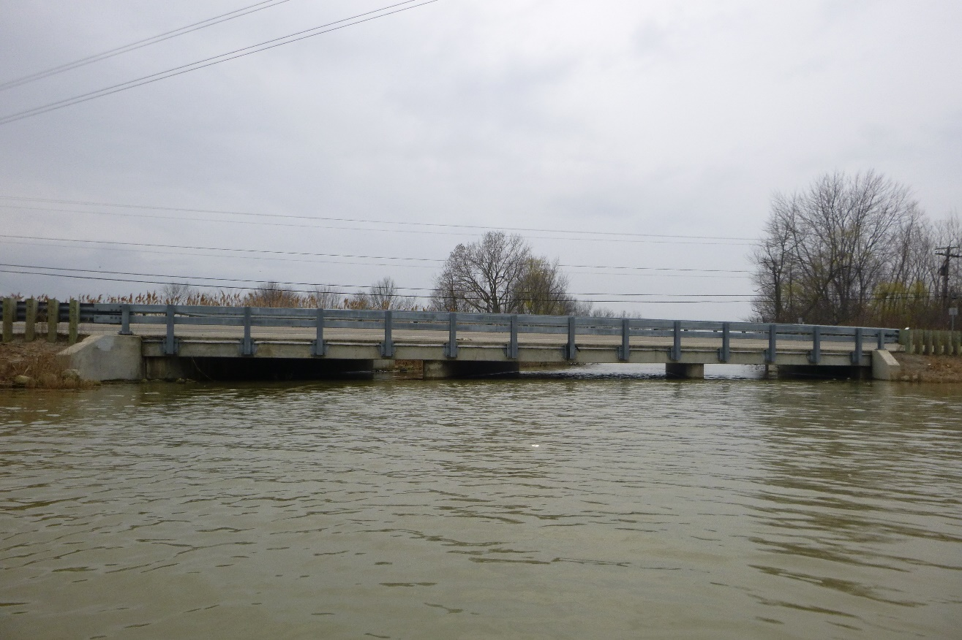

Elevation

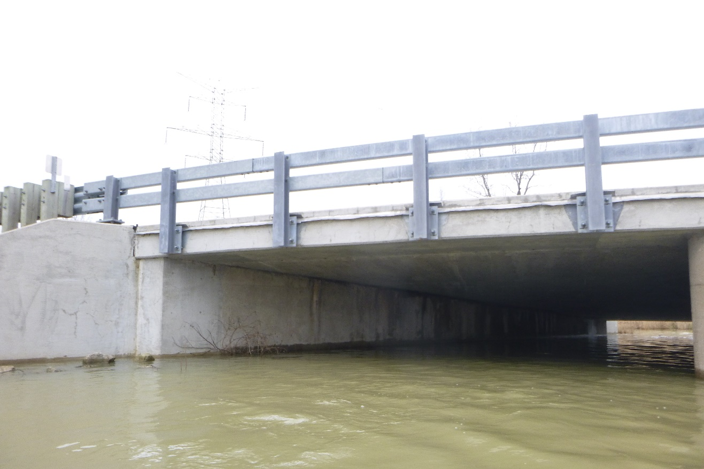

Underside

1. **Office and Field Assessment**

Prior to the inspection, obtain and review copies of the previous underwater inspection reports, routine inspection reports, scour and hydraulic information, and design plans in preparation of the inspection. Divers should pay particular attention given to any observed areas of deterioration, the channel conditions and factors that may accelerate material deterioration. Changes shall be noted in the inspection procedure. Site conditions should be reviewed prior to diving.

1. Channel Conditions

____Waterway features

____Rapid stream flows,

____Significant debris accumulation

____Constricted waterway openings

____Soft or unstable streambeds

____Meandering channels

____Other which may promote scour and undermining of substructure elements

____Navigable Waterway

____Flow Controls

1. Anticipated Water conditions which may affect the inspection

____Cold Water (Apprx. Temp____)

____Black water

____Rapid stream flows

____Near military facility

____Tribal fishing

____Water quality

____History of Log jams

1. Identify factors that may accelerate the deterioration of the bridge elements:

____Highly corrosive water

____Unprotected steel members

____Other

Risk Factor Narrative:

1. **Contacts Prior to Work**

District 2 Bridge Engineer: David Geckle, P.E.

Email: [david.geckle@dot.ohio.gov](mailto:david.geckle@dot.ohio.gov) – Phone: 419-373-4377

Point of contact for immediate action such as closing the bridge due to findings

Contact Bridge Owner ____14________ (number) days before the proposed underwater inspection.

Special contracting and scheduling procedures prior to inspection, include recommended lead time

|  |  |  |  |
| --- | --- | --- | --- |
| Entity | Contact Name and Title | Contact Phone | Lead Time |
| Coast Guard |  |  |  |
| Property Owner |  |  |  |
| Access Equipment |  |  |  |
| Lake or River draw-down |  |  |  |
| Canal dry time |  |  |  |
| Tree removal |  |  |  |
| Other: |  |  |  |
| Other: |  |  |  |

1. **Dive Team Shall Include the Following:**

Dive Team Narrative:

The dive team consisted of one Team Leader (NBIS, P.E., ADCI) and two Team Members (NBIS, UW, ADCI).

*Example: The Bridge shall be investigated using a three-member dive team: one supervisor to monitor rack box and take notes, one diver, and one tender/standby diver. There shall be one NBIS Team Leader onsite at all times.*

1. **Site Information**

Navigable waterway: Y / **N**

If Yes, waterway river point ______

Anticipated water visibility depth _0___ ft

Anticipated Dive depth __8.6__ ft

Anticipated current _0____ ft

Scour Critical (item 113): __5_____

POA in place: Y/**N**

Scour Monitoring devices present: Y/**N**

Verify the Scope of Services when work is contracted for the procedure for underwater elements that are not in water during an inspection.

Site Information Narrative:

The underwater inspection consists of a visual and tactile examination of the accessible surfaces of the substructure items in water. Additional items should reference the scope of services in the contract. For reference the following items are in water:

|  |  |  |
| --- | --- | --- |
| **Item** | **Number of Units** | **Level of Inspection (1, 2 or 3) with Commentary** |
| Piers and Number of Columns | 2 | 100% LEVEL I  100% LEVEL II |
| Abutment | 2 | 100% LEVEL I  100% LEVEL II |
| Culvert | N/A |  |
| Scour Countermeasures | N/A |  |
| Fenders or Dolphins | N/A |  |

Photographs should be taken, if water clarity permits, for typical conditions, conditions that have changed since last inspection and significant or noteworthy deficiencies. The type of channel bottom material, the presence or extent of scour, the presence or extent of riprap, the presence or extent of drift and debris, and the location of any foundation exposure or undermining shall be quantified. Include depth, length, height and location of deficiencies.

1. **Equipment and Field Logistics**
2. The inspection should be conducted using:

____Chest waders

____Hip waders

__X_Diving equipment

____SCUBA (Note that ADCI Consensus Standards require communication systems be employed for both SCUBA and Surface-Supplied (whether air or mixed-gas) dive modes)

____SCUBA with communication

__X_Surface Supplied with communication

1. The channel bottom should be sounded utilizing

_X__Digital fathometer

_X__Telescoping survey rod

____ acoustic imaging

1. During the inspection, the divers should work from

____Shore

_X__Boat

____Either

The note taker should work alongside the dive team.

1. Access to the waterway should be obtained from the shore (north bank, southwest quadrant, driveway 30 yards north etc.)

NORTHWEST CORNER OF STRUCTURE

_______________________________________

1. The maximum depth of the channel is typically measured_____ feet from

EAST CENTERLINE QUARTER POINT BETWEEN PIERS 1 AND 2

Reference Datum: 1.9FT. BELOWTHE TOP OF THE PIER AT THE DOWNSTREAM NOSE OF PIER 2

Soundings should be dictated by the scope of work. When not detailed in the scope they should be repeated from the previous soundings. If neither exist then they need to be taken in a grid pattern between substructure units 100’ upstream and 100’ downstream.

1. **Inspection Procedure History**

Created: COLLINS ENGINEERS Date: 09/25/2020

Updated By: Date:

Updated By: Date:

Updated By: Date:

Updated By: Date:

Updated By: Date:

1. **Other Narrative Not Included In Previous Sections**