BRIDGE STA-30-1505
FRACTURE CRITICAL Inspection report

US30 over Cleveland Avenue

Structure File Number: 7600860
FRACTURE CRITICAL INSPECTION REPORT

August 22, 2008
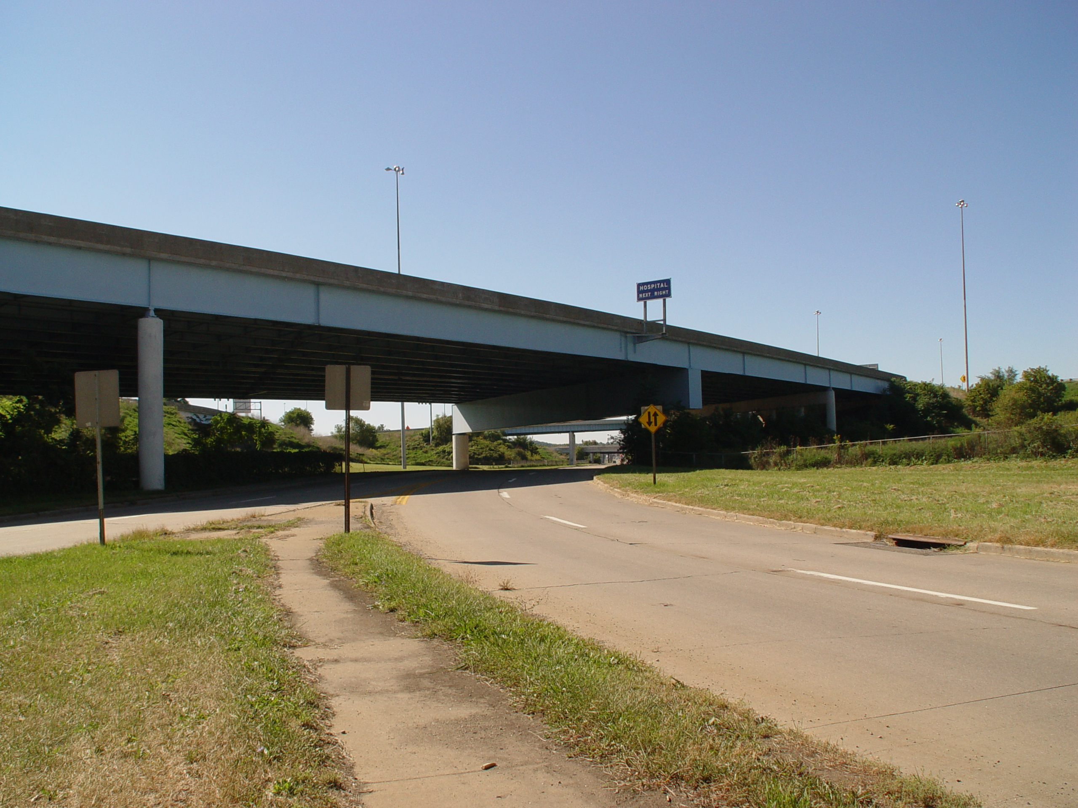
PREPARED FOR
Ohio Department of Transportation, District 4
2088 South Arlington Street
Akron, Ohio 44306
Phone: (330) 786-3100
Fax: (330) 786-2210
Contact:
David E. Sicker, P.E.
PREPARED BY
HNTB Corporation
1100 Superior Avenue
Suite 1300
Cleveland, Ohio 44114
Phone: (216) 522-1140
Fax: (216) 522-0554

