77555 PCL 037

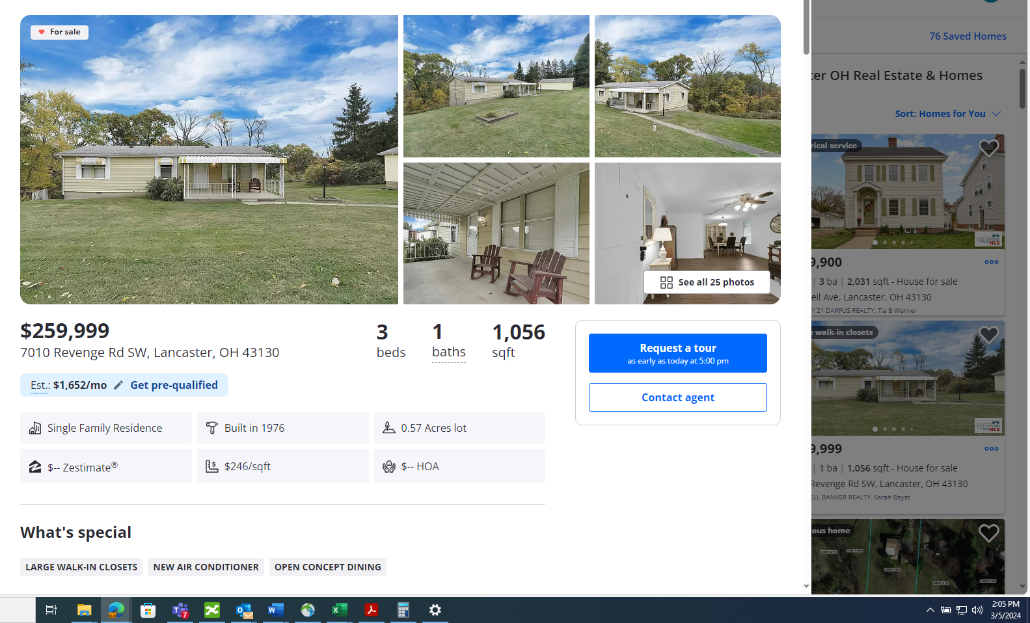

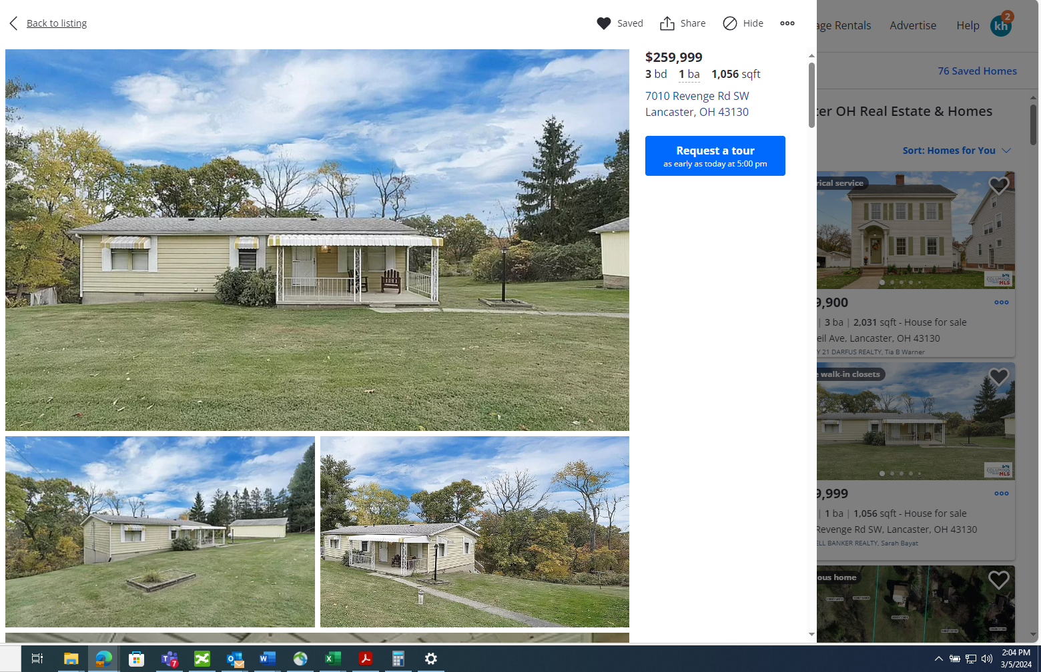

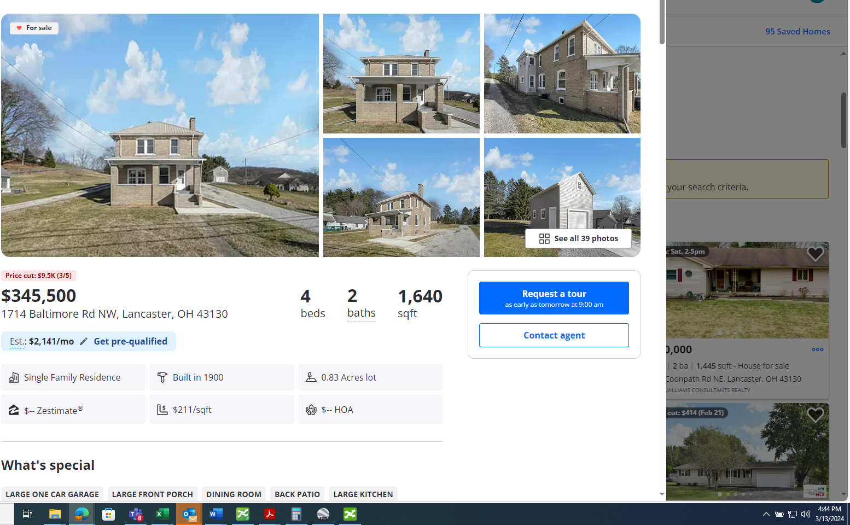

• 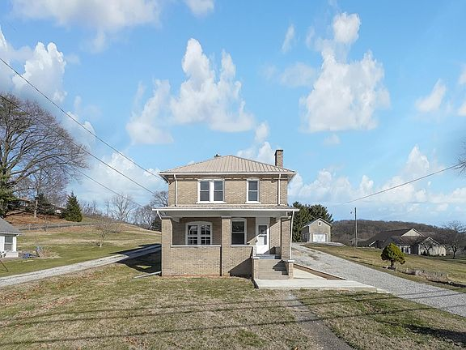
• 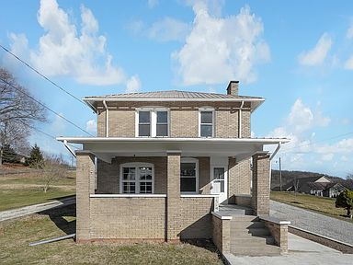
• 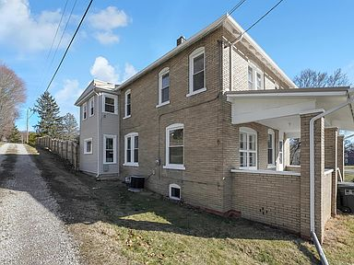
• 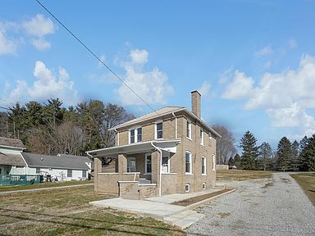
• 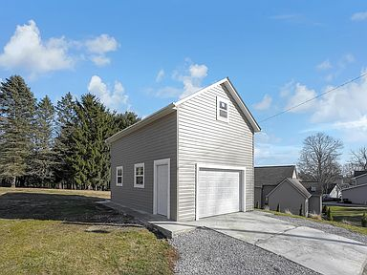
Price cut: $9.5K (3/5)
$345,500

1714 Baltimore Rd NW, Lancaster, OH 43130
4beds
2baths
1,640sqft
Est.: $2,141/moEdit your inputGet pre-qualified
Single Family Residence
Built in 1900
0.83 Acres lot
$-- Zestimate®
$211/sqft
$-- HOA

What's special
LARGE ONE CAR GARAGELARGE FRONT PORCHDINING ROOMBACK PATIOLARGE KITCHEN
Refreshed and Remodeled! This four bedroom, one and a half bath is a great mix of space and convenience! The property offers a large front porch, ready for your porch swing, a back patio to hang out and. 83 acres to enjoy. At the edge of the property you will notice a large one car garage ready for all your toys. Once inside the large living room leads to a dining room, and large kitchen and a half bath. The updates include and new roof, windows, Siding on garage, flooring, drywall, paint, fixtures, Kitchen, baths, tile and soo much more!!
Show more
20 days
on Zillow
|
1,329
views
|
60
saves
|
Likely to sell faster than 81 % nearby
Zillow last checked: 3 hours ago
Listing updated: March 04, 2024 at 11:31pm
Listed by:
Audrey Barr 740-974-2973,
CRT, Realtors
Source: Columbus and Central Ohio Regional MLS ,MLS#: 224005107

Get pre-qualified for a loan
At Zillow Home Loans, we can pre-qualify you in as little as 3 minutes with no impact to your credit score.
An equal housing lender. NMLS #10287.
Start now

Tour with a buyer’s agent
We’ll find a local expert to take you on a private tour of 1714 Baltimore Rd NW.

Next available tour time:Tomorrow at 9am
See all available times

Facts & features

Interior

Bedrooms & bathrooms
- Bedrooms: 4
- Bathrooms: 2
- Full bathrooms: 1
- 1/2 bathrooms: 1

Bedroom
- Level: 0

Family room
- Level: 1

Kitchen
- Level: First

Living room
- Level: First

Basement
- Basement: Full

Flooring
- Flooring: Carpet, Vinyl

Heating
- Heating features: Forced Air, Natural Gas

Cooling
- Cooling features: Central Air

Appliances
- Appliances included: Dishwasher, Gas Range, Refrigerator
- Laundry features: Lower Level

Interior features
- Window features: Insulated Windows

Other interior features
- Total structure area: 1,640
- Total interior livable area: 1,640 sqft
- Total number of fireplaces: 1
- Fireplace features: Decorative, One

Property

Parking
- Total spaces: 1
- Parking features: 1 Car Garage, Detached
- Garage spaces: 1
- Covered spaces: 1

Property
- Levels: Two
- Stories: 2
- Patio & porch details: Patio

Lot
- Lot size: 0.83 Acres

Other property information
- Parcel number: 0532013600

Construction

Type & style
- Home type: SingleFamily
- Architectural style: 2
- Property subType: Single Family Residence

Material information
- Construction materials: Brick

Condition
- New construction: No
- Year built: 1900

Utilities & green energy

Utility
- Sewer information: Public Sewer

Community & neighborhood

Location
- Region: Lancaster

HOA & financial

Other financial information
- Buyer's Agency fee: 3.00%

Other

Other facts
- Listing terms: Conventional,FHA
Show more

Services availability

Make this home a reality
Top of Form
Get pre-qualifiedBe ready to make an offer.
Connect with an agentGet info on this home, tour, and more.
Calculate monthly paymentSee if you can afford this home.
Bottom of Form

Price history
Date | Event | Price
3/5/2024 | Price change | $345,500-2.7%$211/sqft
Source: Columbus and Central Ohio Regional MLS #224005107 Report a problem
2/23/2024 | Listed for sale | $355,000+163%$216/sqft
Source: Columbus and Central Ohio Regional MLS #224005107 Report a problem
5/15/2023 | Sold | $135,000-34.1%$82/sqft
Source: Columbus and Central Ohio Regional MLS #223011292 Report a problem
5/7/2023 | Contingent | $205,000$125/sqft
Source: Columbus and Central Ohio Regional MLS #223011292 Report a problem
4/24/2023 | Listed for sale | $205,000+148.5%$125/sqft
Source: Columbus and Central Ohio Regional MLS #223011292 Report a problem
Show more

Public tax history
Year | Property taxes | Tax assessment
2022 | $2,591 -24.3% | $42,280 -25.2%
2021 | $3,423 +3.1% | $56,530
2020 | $3,320 +65.4% | $56,530
Show more

- 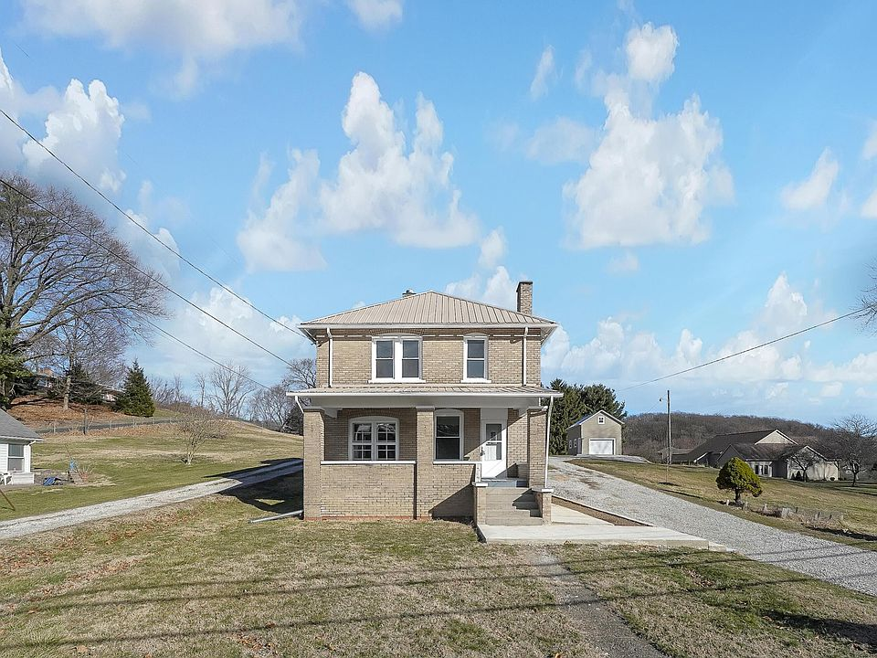
- 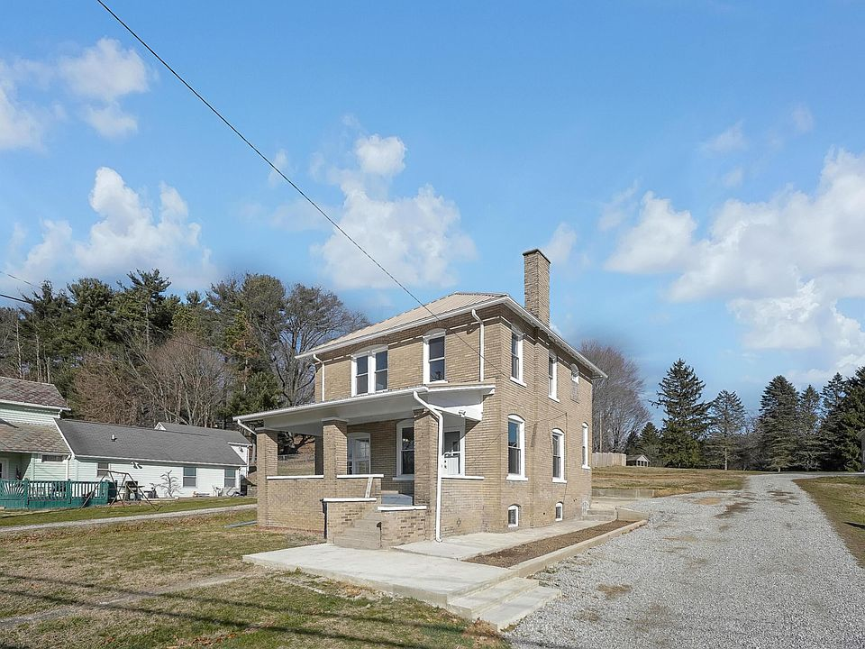
- 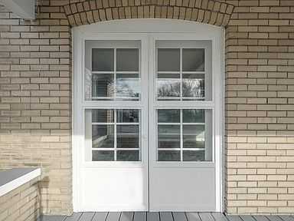
- 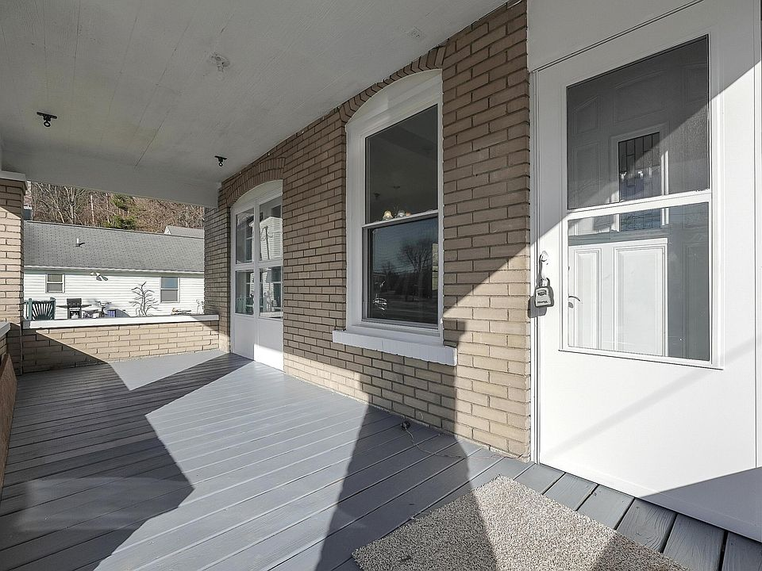
- 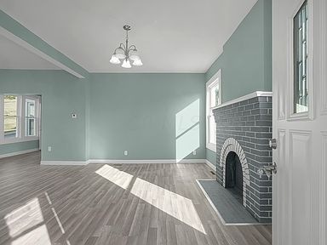
- 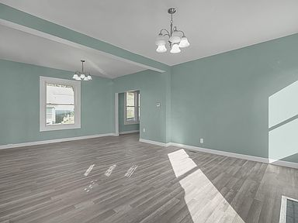
- 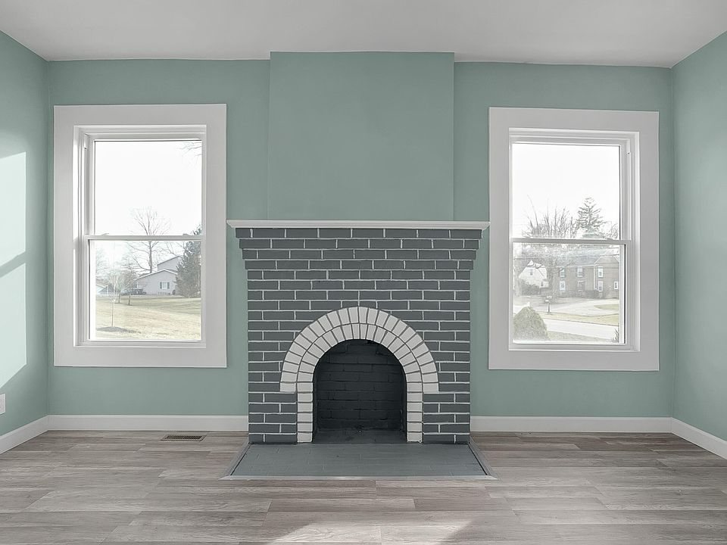
- 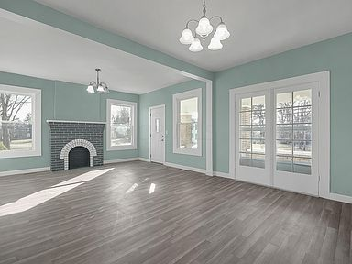
- 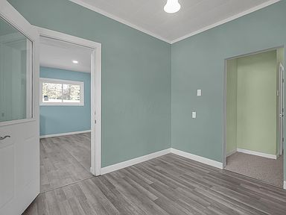
- 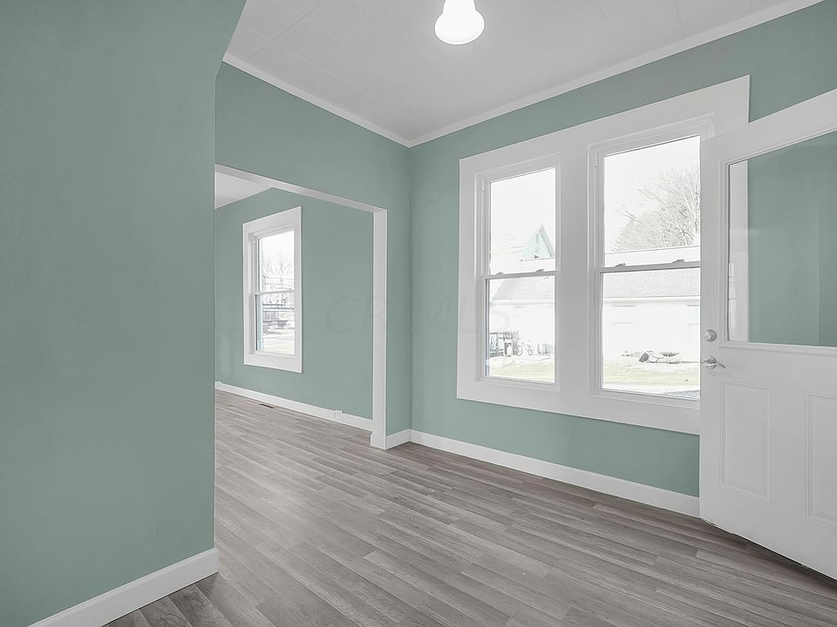
- 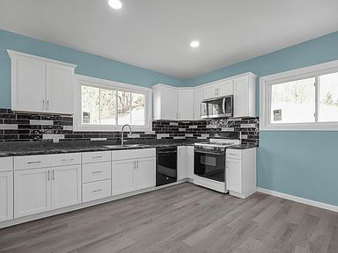
- 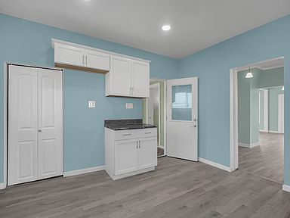
- 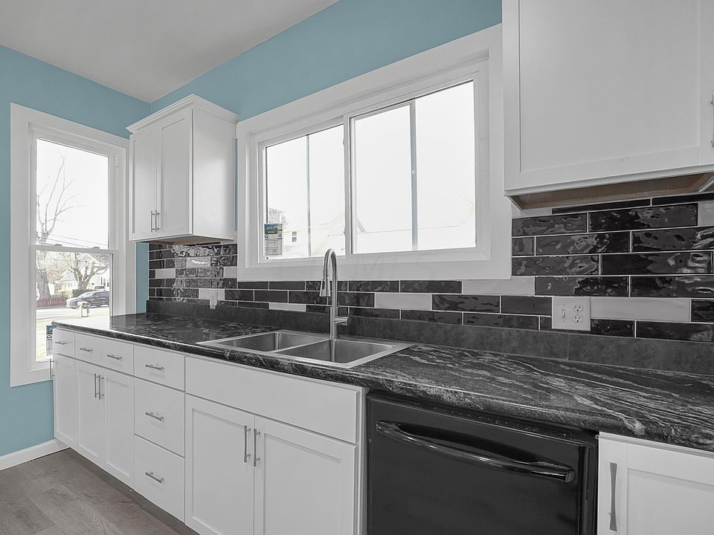
- 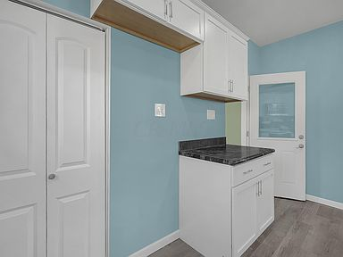
- 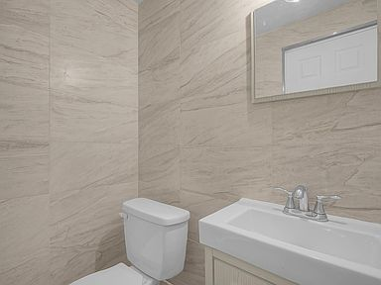
- 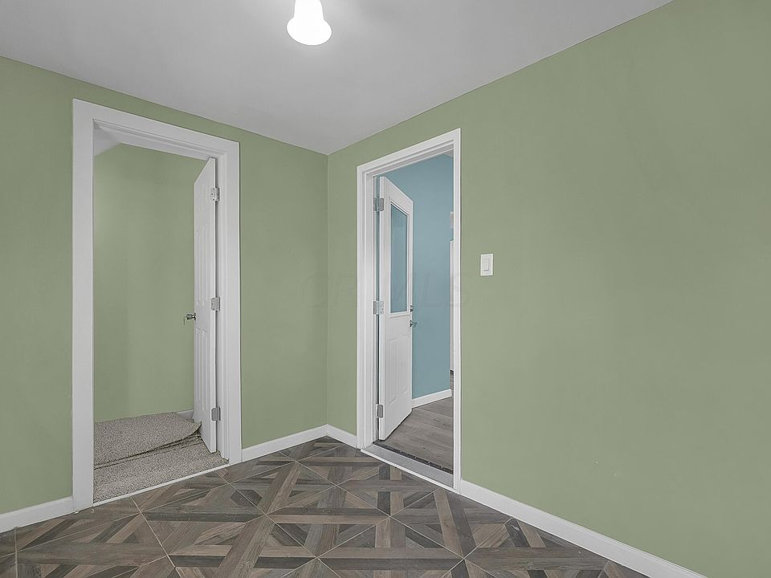
- 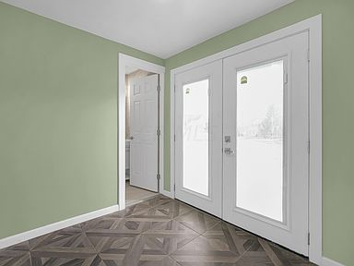
- 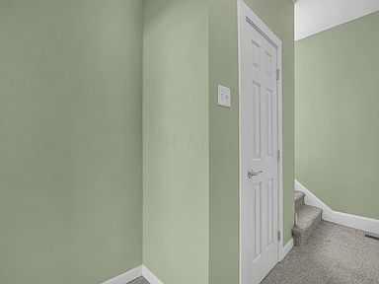
- 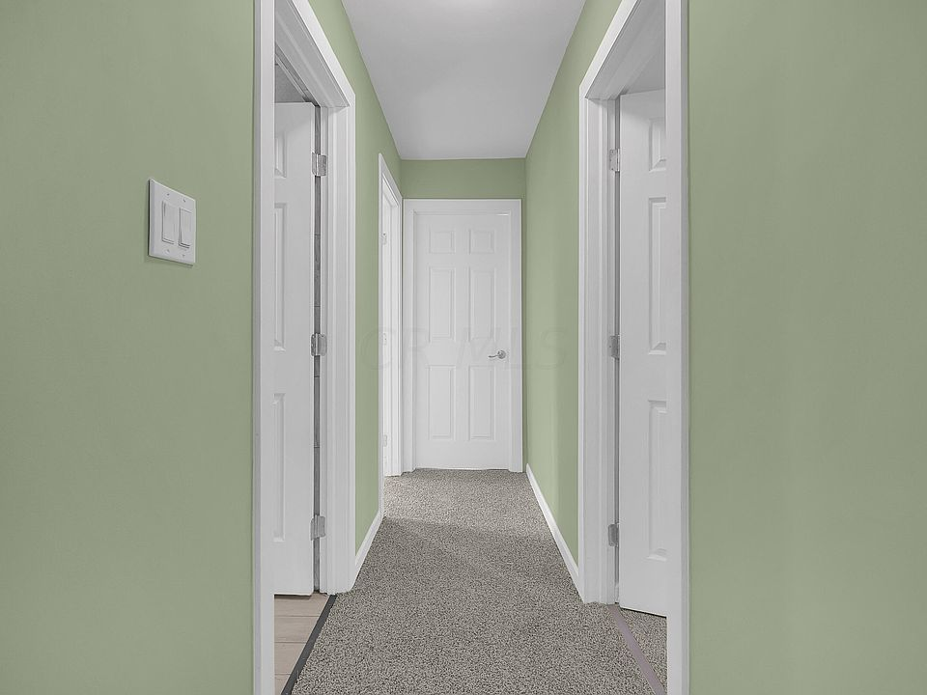
- 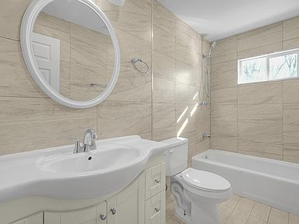
- 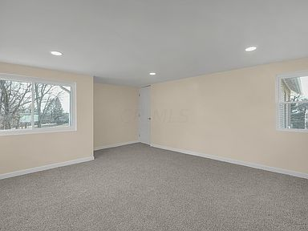
- 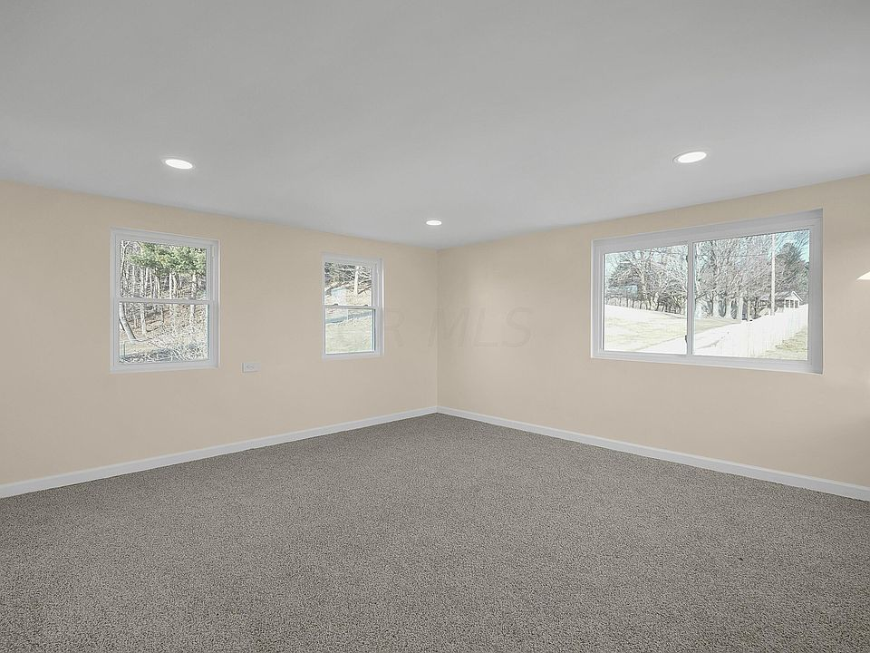
- 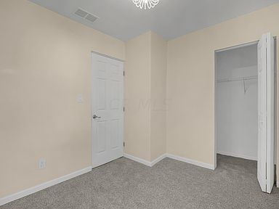
- 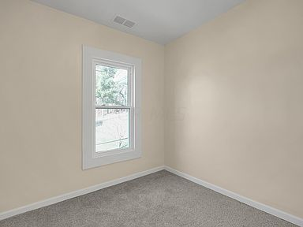
- 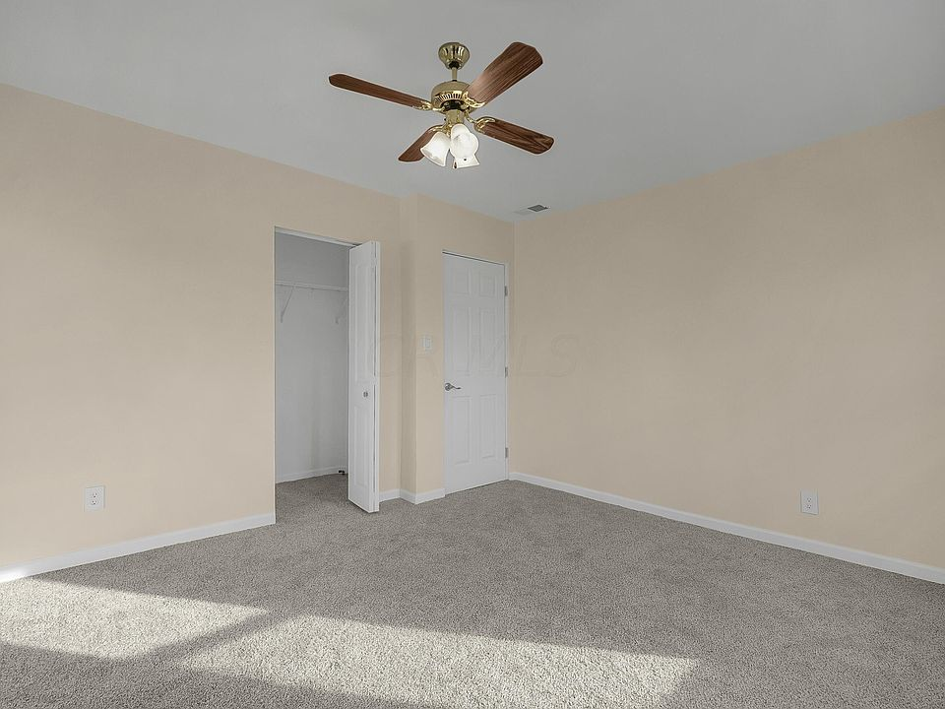
- 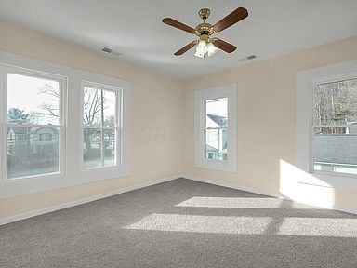
- 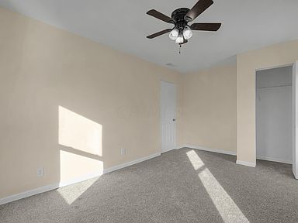
- 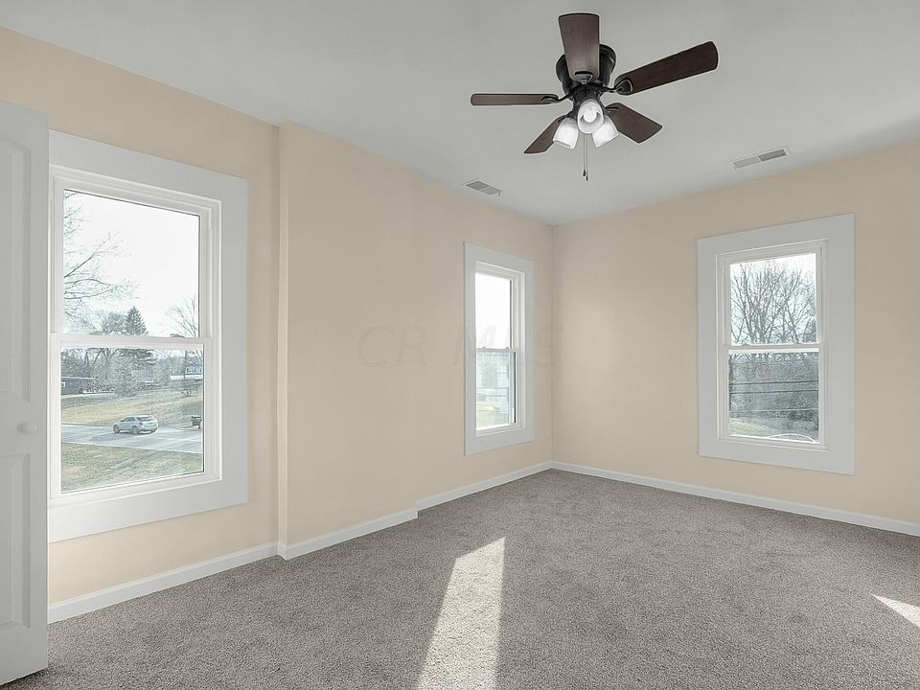
- 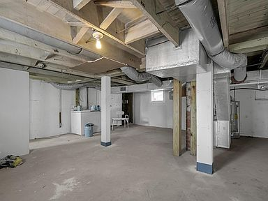
- 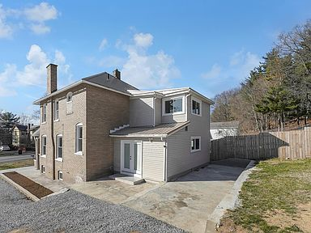
- 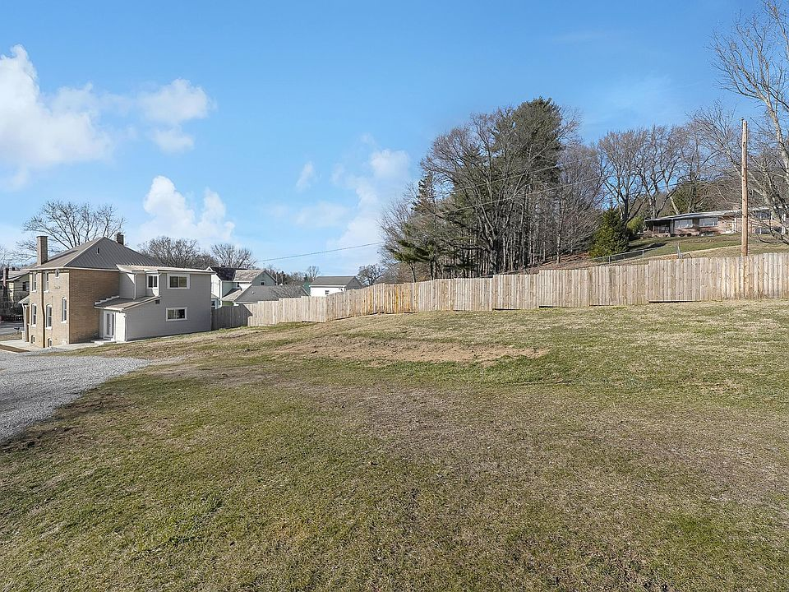
- 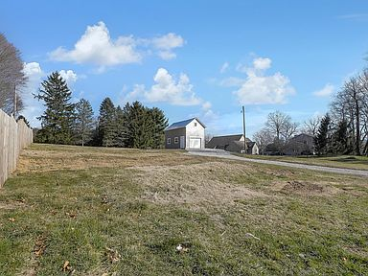
- 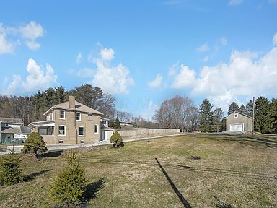
- 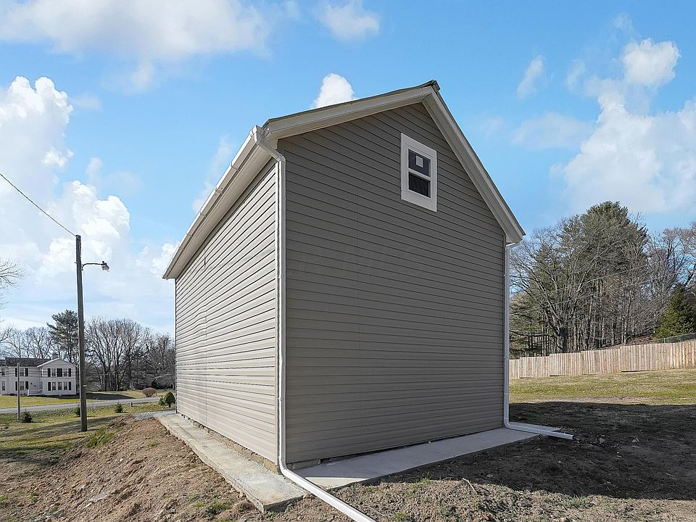
- 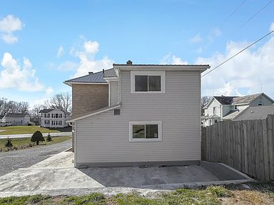
- 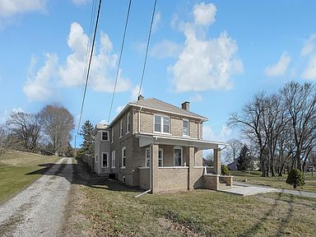

Save
Share
Hide
OverviewFacts & featuresMarket valuePayment calculatorNeighborhood
For sale
See all 50 photos
• 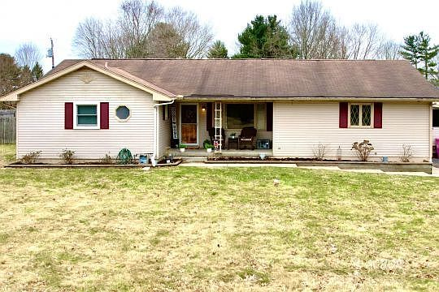
• 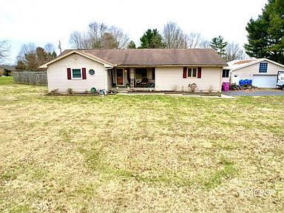
• 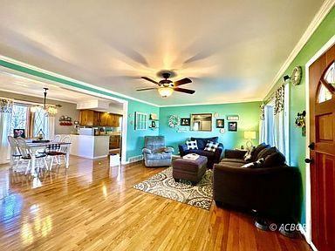
• 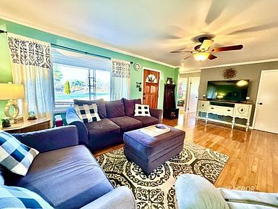
• 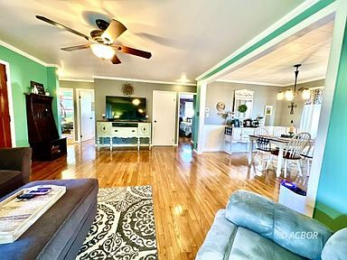
Price cut: $10K (3/11)
$350,000

1591 Coonpath Rd NE, Lancaster, OH 43130
3beds
2baths
1,445sqft
Est.: $2,169/moEdit your inputGet pre-qualified
Single Family Residence, Single Family, Resale Home, HOA-No, SF-Site Built
Built in 1972
0.91 Acres lot
$342,400 Zestimate®
$242/sqft
$-- HOA

What's special
REC ROOMBONUS ROOMBRAND NEW FURNACEORIGINAL HARDWOOD FLOORING THROUGHOUTPLAY AREABUILT-IN TV CENTERLARGE FIRE PIT
WOW!! IMPROVED PRICE! It doesn't get any better than this beautifully updated ranch-style home! Sitting on almost one acre, this 1445 sq. ft home offers 3 bedrooms/2 full baths, original hardwood flooring throughout. All electric SS appliances. Adding another 490+ sq ft to the space, the finished basement is fully remodeled w/ a family/tv room, built-in tv center, & fresh carpet. The rec room, play area, and a bonus room gives something for everyone to enjoy in the basement. A fully fenced backyard boasts a screened in porch, large fire pit, pool, chicken coops, garden, & playground. Spacious 32'x40' pole barn deep enough to house 4-6 cars & workshop in the back. Brand new furnace & a/c unit. Well water. Septic. All electric; gas tap is available. 10 mins from DT Lancaster. Make your offer!
Show more
11 days
on Zillow
|
1,897
views
|
72
saves
|
Likely to sell faster than 98 % nearby
Zillow last checked: 3 hours ago
Listing updated: March 11, 2024 at 01:52pm
Also listed on Columbus and Central Ohio Regional MLS
Listed by:
Robert Mack (864)497-7291,
Keller Williams Consultants Realty
Source: Athens County BOR,MLS#: 2431736

Get pre-qualified for a loan
At Zillow Home Loans, we can pre-qualify you in as little as 3 minutes with no impact to your credit score.
An equal housing lender. NMLS #10287.
Start now

Tour with a buyer’s agent
We’ll find a local expert to take you on a private tour of 1591 Coonpath Rd NE.

Next available tour time:Tomorrow at 9am
See all available times

Open houses
- Sat, Mar 16
2:00 PM - 5:00 PM
Add to calendar
- Sun, Mar 17
1:00 PM - 3:00 PM
Add to calendar

Facts & features

Interior

Bedrooms & bathrooms
- Bedrooms: 3
- Bathrooms: 2
- Full bathrooms: 2

Basement
- Basement: Full,Fully Finished

Flooring
- Flooring: Carpet, Tile, Wood

Heating
- Heating features: Forced Air-Electric, Heat Pump-Electric, Wall Heater, Floor Furnace-Electric

Cooling
- Cooling features: Central Air HP

Appliances
- Appliances included: Dishwasher, Disposal, Microwave, Refrigerator, Electric Water Heater, Oven/Range- Electric, Dryer
- Laundry features: Washer Hookup

Interior features
- Window features: Windows- Bayed, Double Pane Windows, Windows- Picture
- Interior features: Ceiling Fan(s), Tile Counters, Sump Pump

Other interior features
- Total structure area: 1,445
- Total interior livable area: 1,445 sqft

Property

Parking
- Total spaces: 6
- Parking features: Attached, Detached, Garage Door Opener, Manual Open
- Garage spaces: 6
- Covered spaces: 6

Property
- Levels: 1 story + basement
- Exterior features: Rain Gutters, Garden
- Patio & porch details: Deck, Porch- Covered, Screened
- Fencing: Full

Lot
- Lot size: 0.91 Acres
- Lot size dimensions: 180 x 220

Other property information
- Additional structures included: Out Building, Work Shop, Pole Barn/Building
- Parcel number: 0270137300
- Zoning description: Residential: R-1, None/Unknown

Construction

Type & style
- Home type: SingleFamily
- Architectural style: Ranch
- Property subType: Single Family Residence, Single Family, Resale Home, HOA-No, SF-Site Built

Material information
- Construction materials: Vinyl Siding
- Foundation: Concrete Block
- Roof: Asphalt Shingle

Condition
- Year built: 1972

Utilities & green energy

Utility
- Electric information: 220 Volts, Power: AEP
- Sewer information: Septic: Leach, Private Sewer
- Water information: Water: Private Well
- Utilities for property: TV-Cable, Internet-Wireless, Garbage Collection, Internet-Cable, Natural Gas Available

Community & neighborhood

Location
- Region: Lancaster

HOA & financial

HOA
- Has HOA: No

Other financial information
- Buyer's Agency fee: 3%
Show more

Services availability

Make this home a reality
Top of Form
Get pre-qualifiedBe ready to make an offer.
Connect with an agentGet info on this home, tour, and more.
Calculate monthly paymentSee if you can afford this home.
Bottom of Form

Estimated market value
Zestimate®
$342,400
Estimated sales range
$325,000 - $360,000
Rent Zestimate®
$1,834/mo
Zestimate history
Table view
This home
$343.5K
Listed for
$375K
on 2/29/24
20162018202020222024$150K$200K$250K$300K$350K$400K
Show more

Price history
Date | Event | Price
3/11/2024 | Price change | $350,000-2.8%$242/sqft
Source: Athens County BOR #2431736 Report a problem
3/6/2024 | Price change | $360,000-4%$249/sqft
Source: Columbus and Central Ohio Regional MLS #224005856 Report a problem
3/1/2024 | Listed for sale | $375,000+116.4%$260/sqft
Source: Columbus and Central Ohio Regional MLS #224005856 Report a problem
8/26/2015 | Sold | $173,300-1%$120/sqft
Source: Public Record Report a problem
7/9/2015 | Pending sale | $175,000$121/sqft
Source: ERA Home Network Real Estate #215016804 Report a problem
Show more

Public tax history
Year | Property taxes | Tax assessment
2022 | $3,550 +9.8% | $87,180 +12.9%
2021 | $3,234 -0.5% | $77,230
2020 | $3,250 +9.6% | $77,230
Show more
Find assessor info on the county website

Monthly payment calculator
Estimated monthly payment$2,169

Principal & interest
$1,751

Mortgage insurance
$0

Property taxes
$295

Home insurance
$123

HOA fees
N/A

Utilities
Not included
All calculations are estimates and provided by Zillow, Inc. for informational purposes only. Actual amounts may vary.
Mortgage interest rates are dependent on a number of factors, including credit score, down payment, and repayment length. Interest rate data provided by Zillow Group Marketplace, Inc. as of 3/13/2024 from various mortgage lenders with which we have lead or other similar arrangements; the Estimated Payment is an average of those rates.
See how much you could borrow to make a competitive offer.
Get pre-qualified

Down payment assistance
19 programs may be available to provide you with up to $25,000 in down payment assistance, depending on your specific information.
Check eligibility
Source: Down Payment Resource®

Getting around
Walk Score®
1 / 100
Car-Dependent
Bike Score®
20 / 100
Somewhat Bikeable

Nearby schools

GreatSchools rating
- 4/10
Medill Elementary School
Grades: K-5Distance: 2.6 mi
- 5/10
Thomas Ewing Junior High School
Grades: 6-8Distance: 1.2 mi
- 5/10
Lancaster High School
Grades: 9-12Distance: 2.6 mi
Show more

Schools provided by the listing agent
- Middle: Lancaster CSD
Source: Athens County BOR. This data may not be complete. We recommend contacting the local school district to confirm school assignments for this home.
Skip carousel

Nearby homes
Previous itemsNext items
Skip to the end of the carousel

$269,500
3 bd|2 ba|1.2k sqft
2975 Susalou Ct NE, Lancaster, OH 43130
Off Market
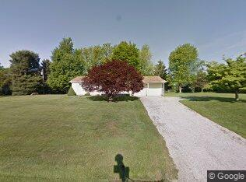

$313,100
3 bd|3 ba|1.8k sqft
2978 Maradon Ct NE, Lancaster, OH 43130
Off Market
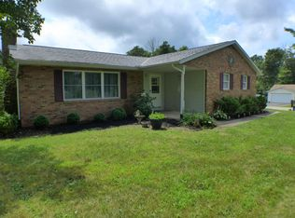

$262,900
3 bd|1 ba|1.2k sqft
2949 Susalou Ct NE, Lancaster, OH 43130
Off Market
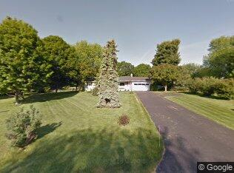

$270,700
3 bd|2 ba|1.2k sqft
2950 Maradon Ct NE, Lancaster, OH 43130
Off Market
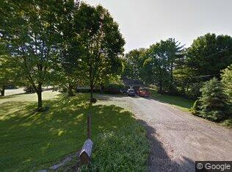

$257,500
2 bd|1 ba|1.1k sqft
1570 Coonpath Rd NE, Lancaster, OH 43130
Off Market
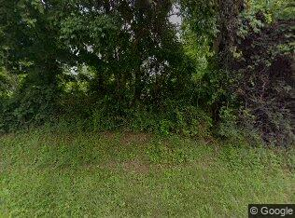

$280,700
4 bd|2 ba|947 sqft
1661 Coonpath Rd NE, Lancaster, OH 43130
Off Market
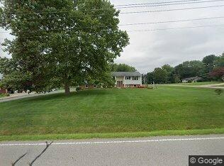

$218,900
3 bd|2 ba|1.2k sqft
2941 Susalou Ct NE, Lancaster, OH 43130
Sold
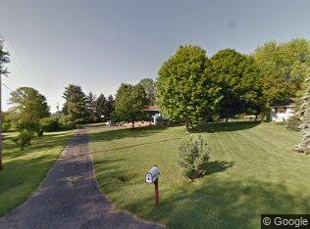

$312,300
3 bd|2 ba|1.2k sqft
2918 Maradon Ct NE, Lancaster, OH 43130
Off Market
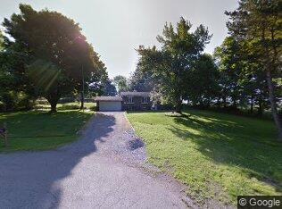

Skip to the beginning of the carousel
Skip carousel

Local experts in 43130
A local agent can set up tours, give advice and negotiate with sellers.
Browse local experts
A local lender can help you make sure your offer is ready when you are.
Daniel Sa
NMLS #173224
Brian Dawson
NMLS #142285

Local legal protections
Current legal protections at the county level in Fairfield County
Show more
IDX information is provided exclusively for personal, non-commercial use, and may not be used for any purpose other than to identify prospective properties consumers may be interested in purchasing. Information is deemed reliable but not guaranteed.
The listing broker’s offer of compensation is made only to participants of the MLS where the listing is filed.

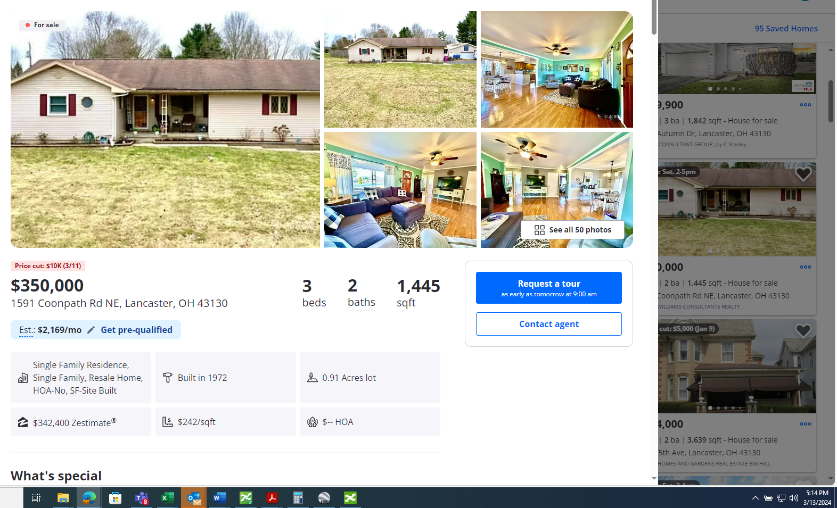as early as tomorrow at 9:00 am
- 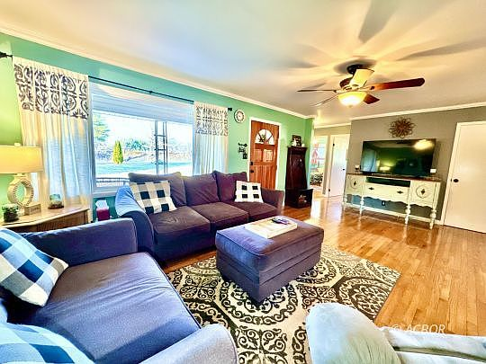
- 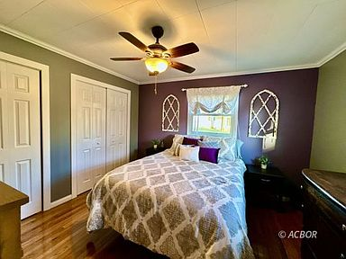
- 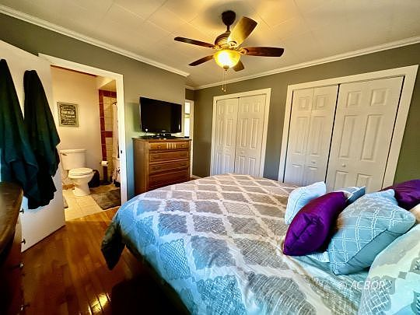
- 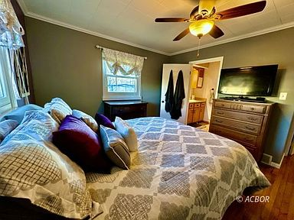
- 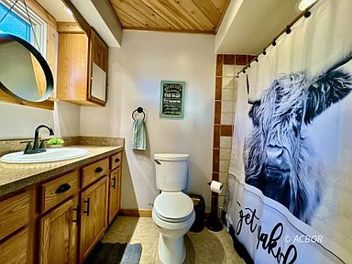
- 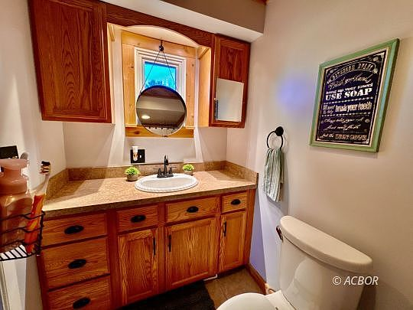
- 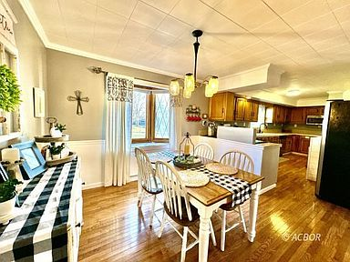
- 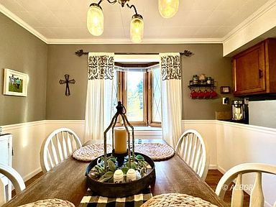
- 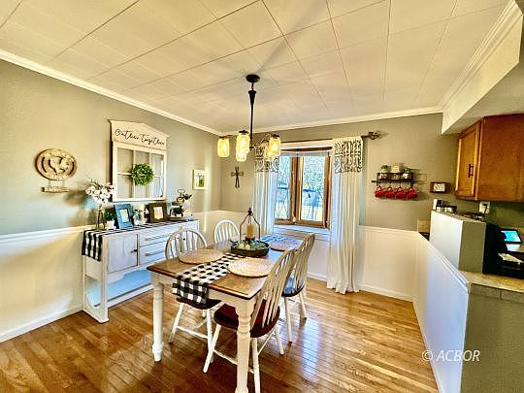
- 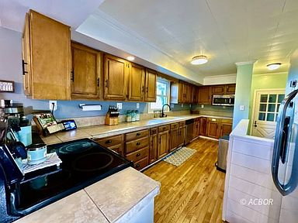
- 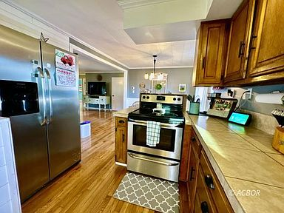
- 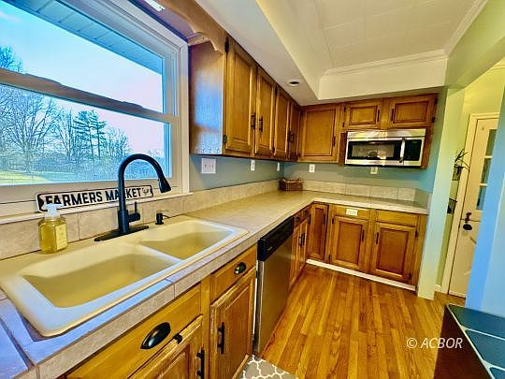
- 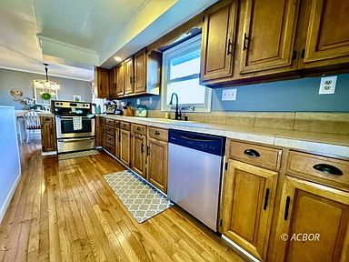
- 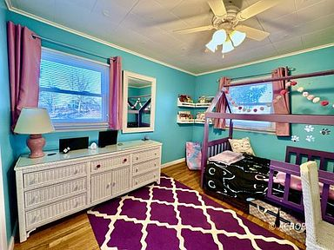
- 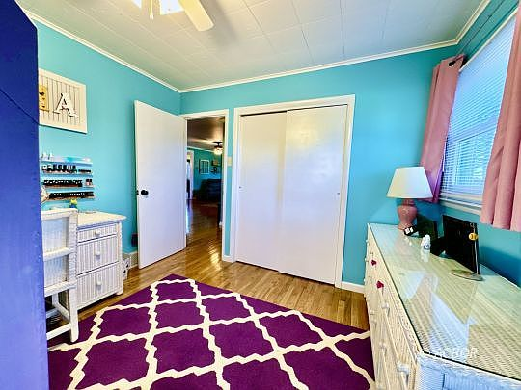
- 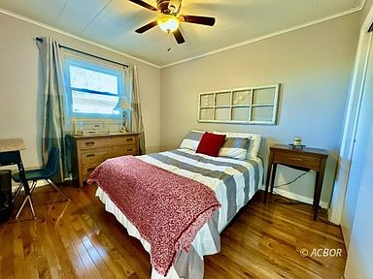
- 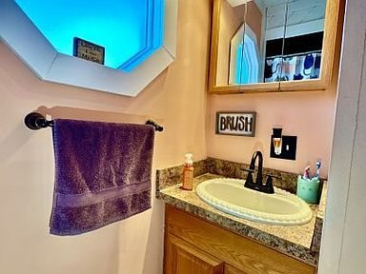
- 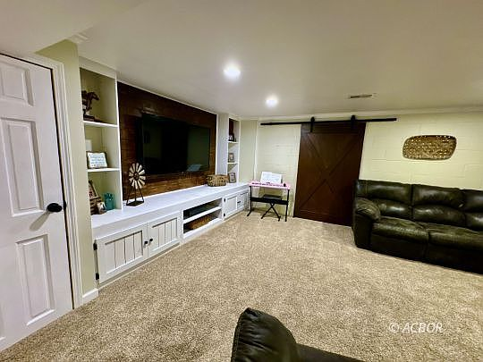
- 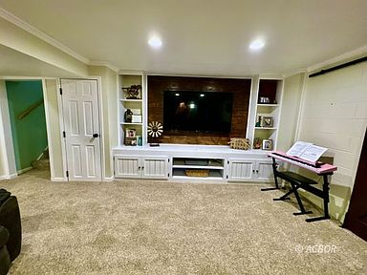
- 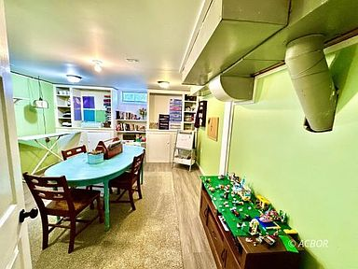
- 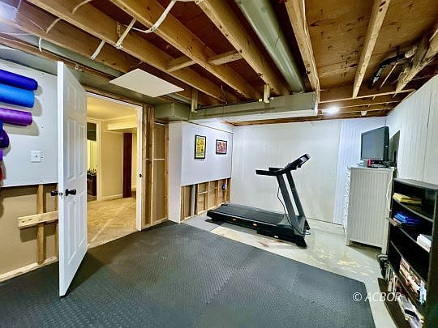
- 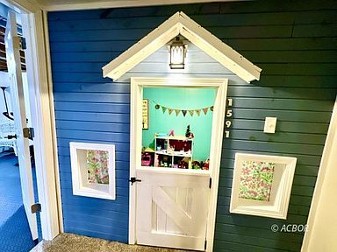
- 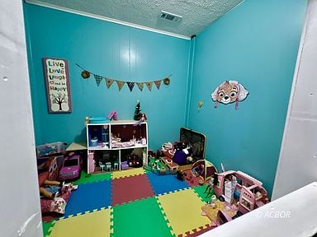
- 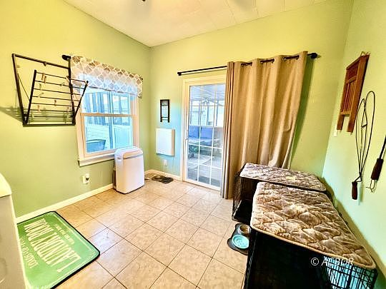
- 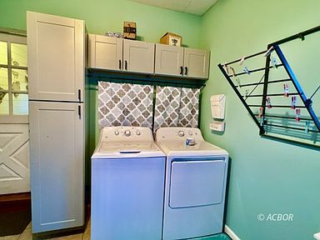
- 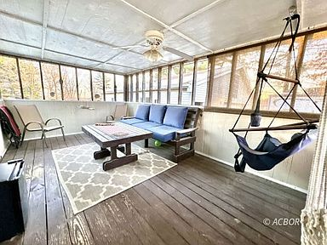
- 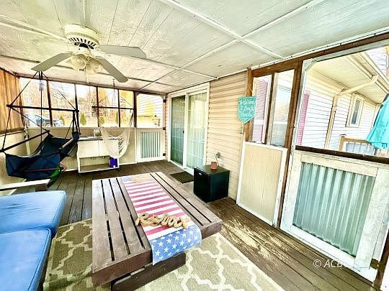
- 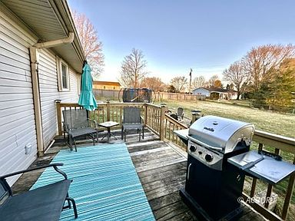
- 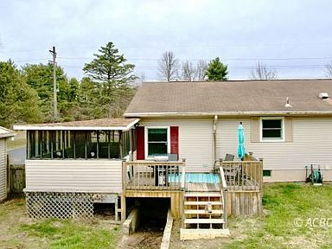
- 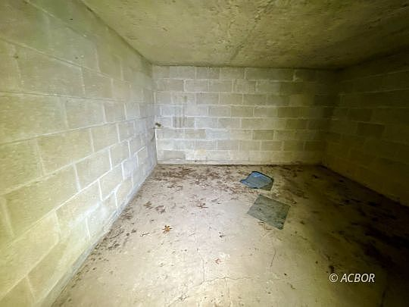
- 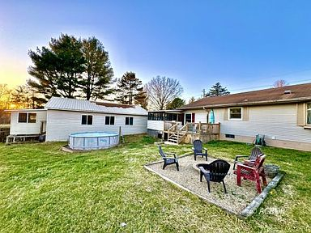
- 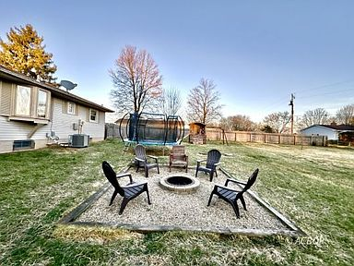
- 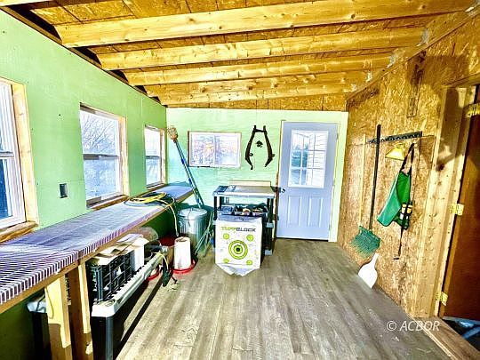
- 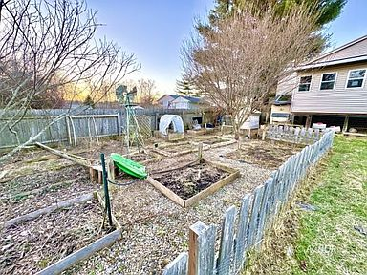
- 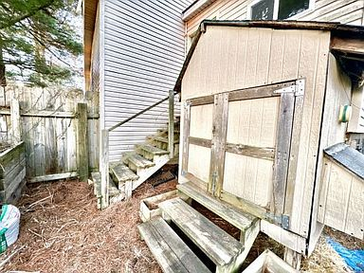
- 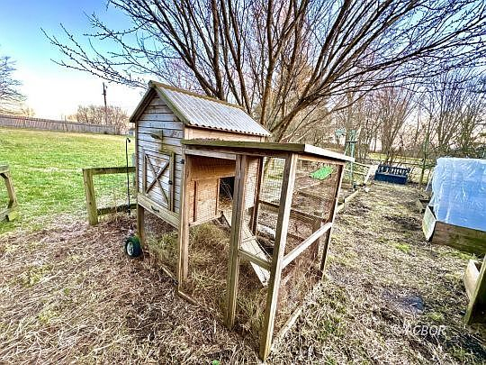
- 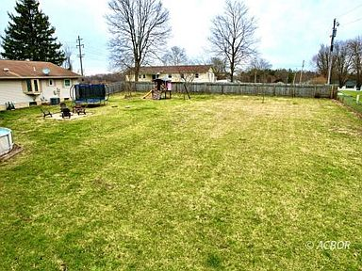
- 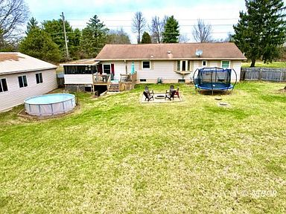
- 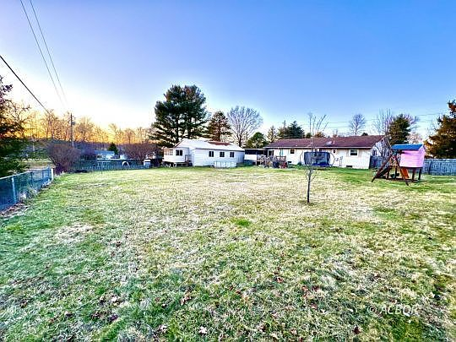
- 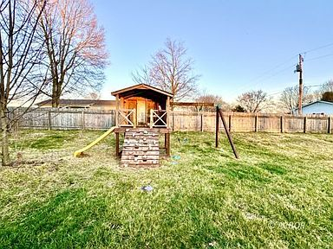
- 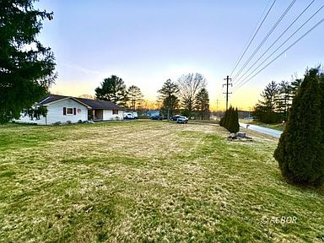
- 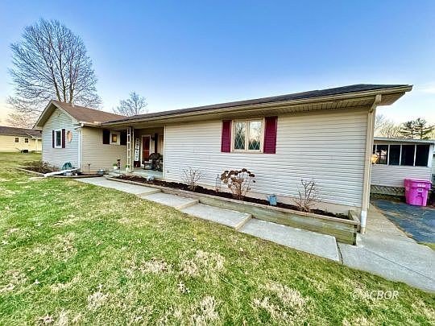
- 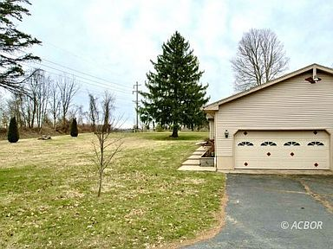
- 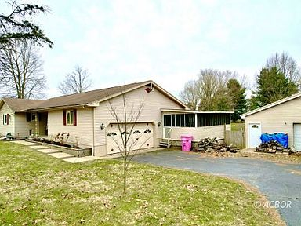
- 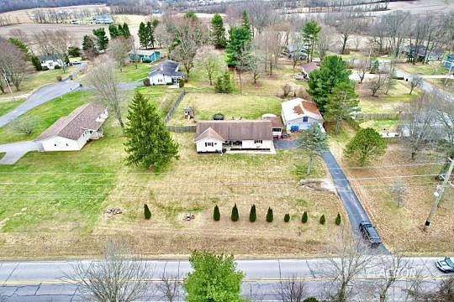
- 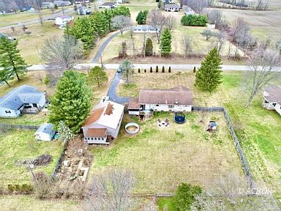

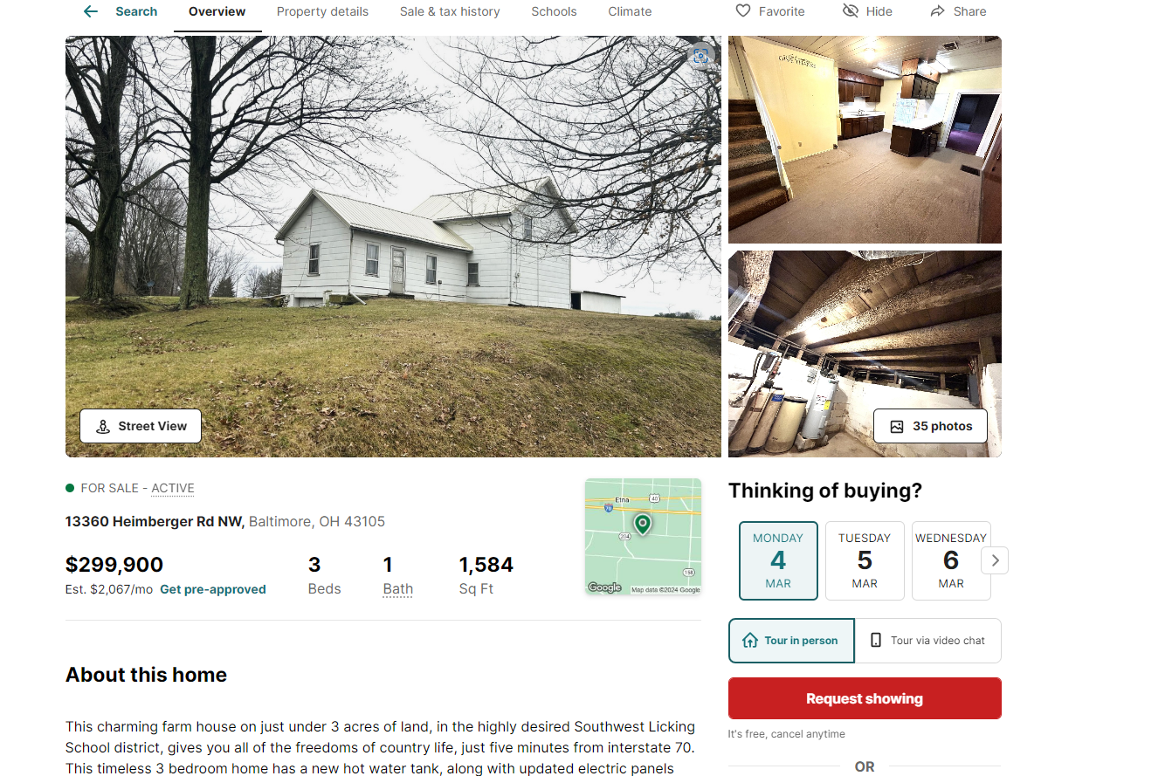

77555 PCL 037
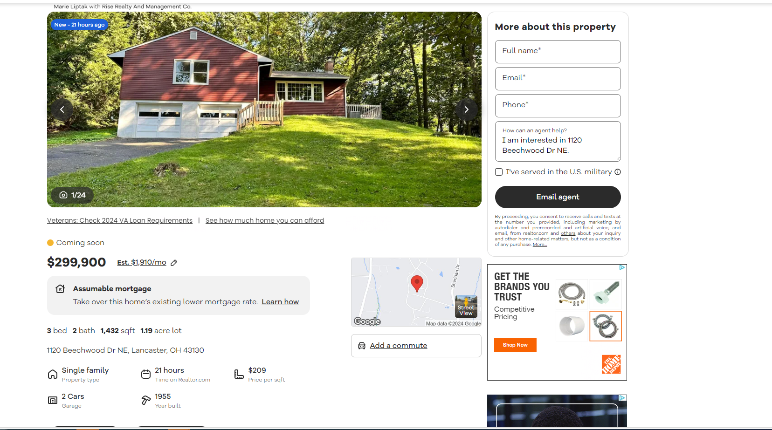

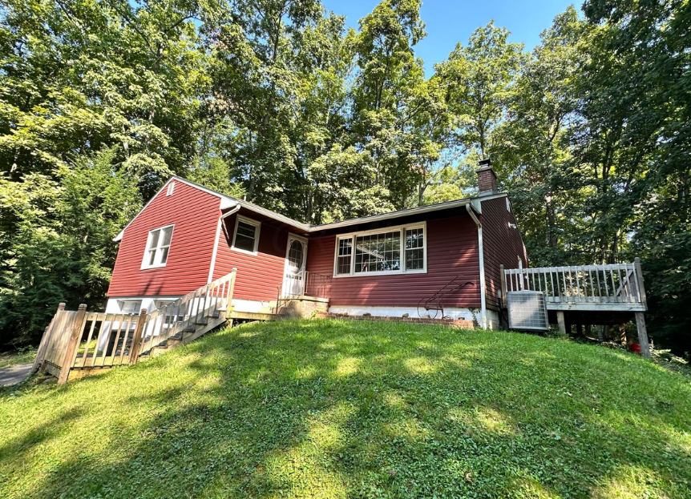

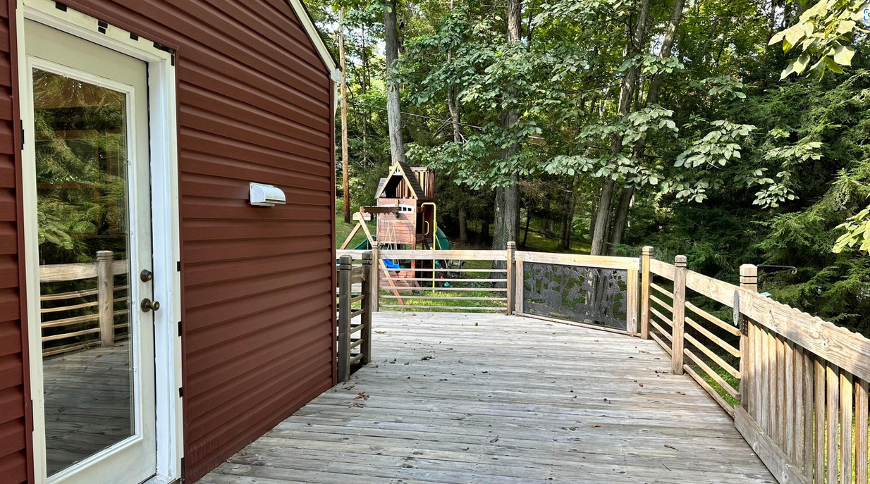

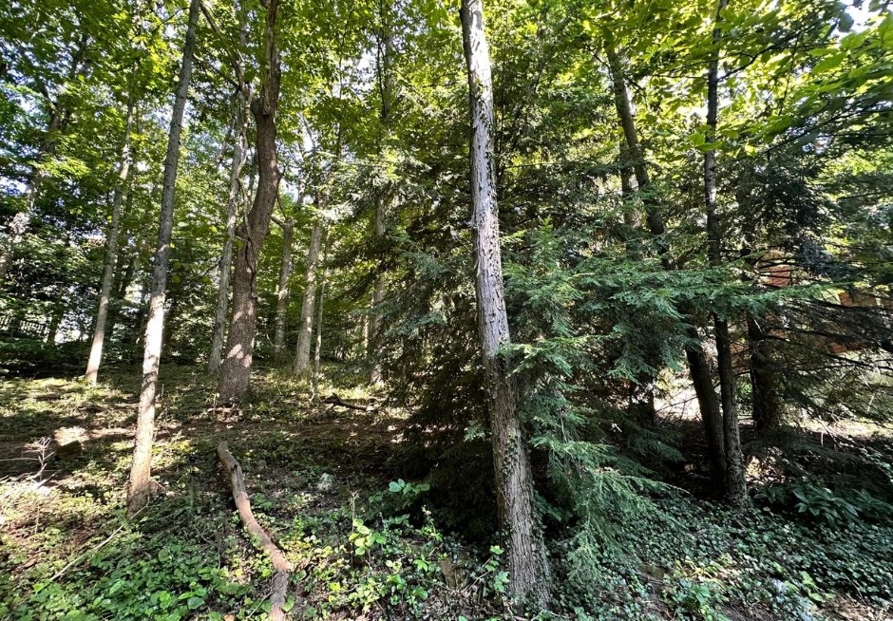

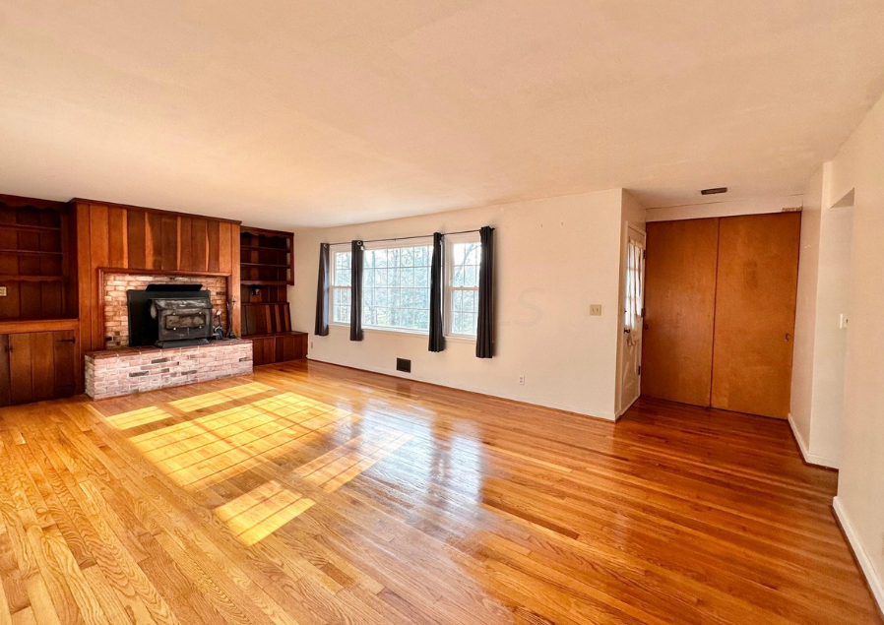

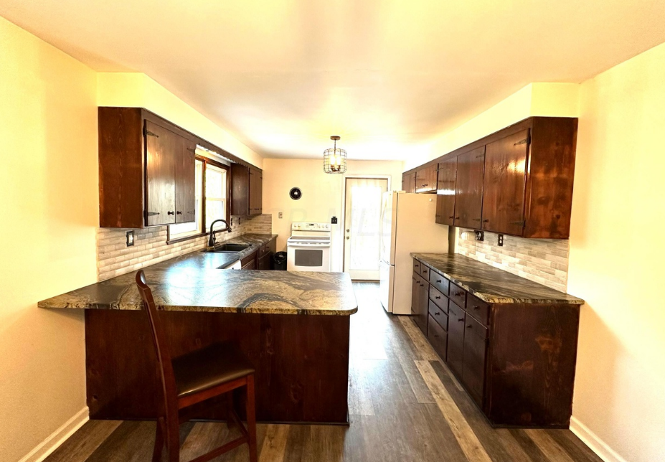

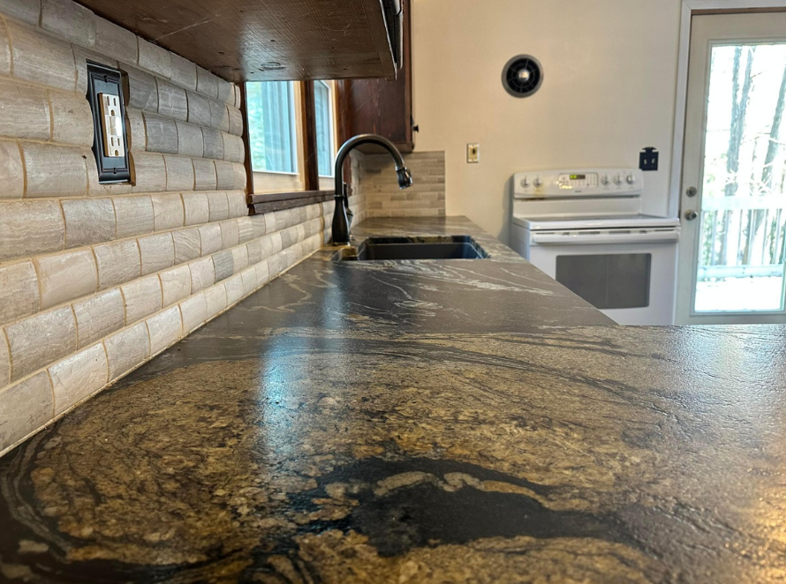

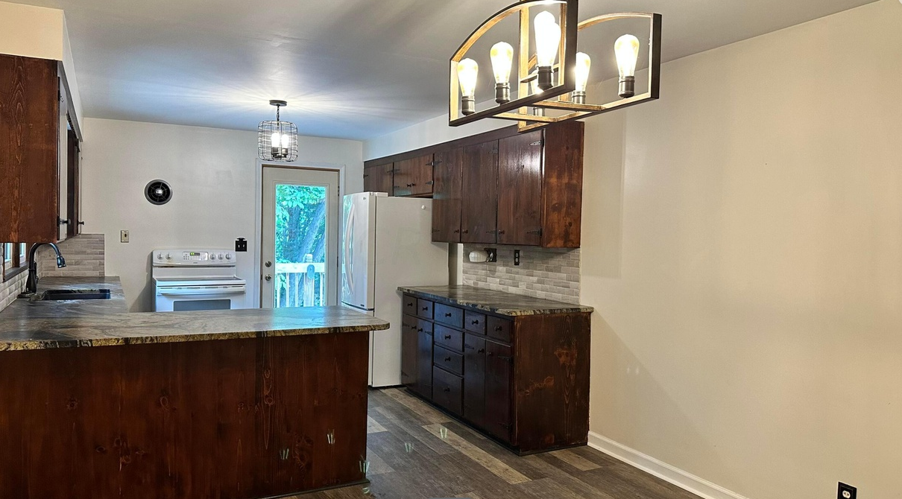

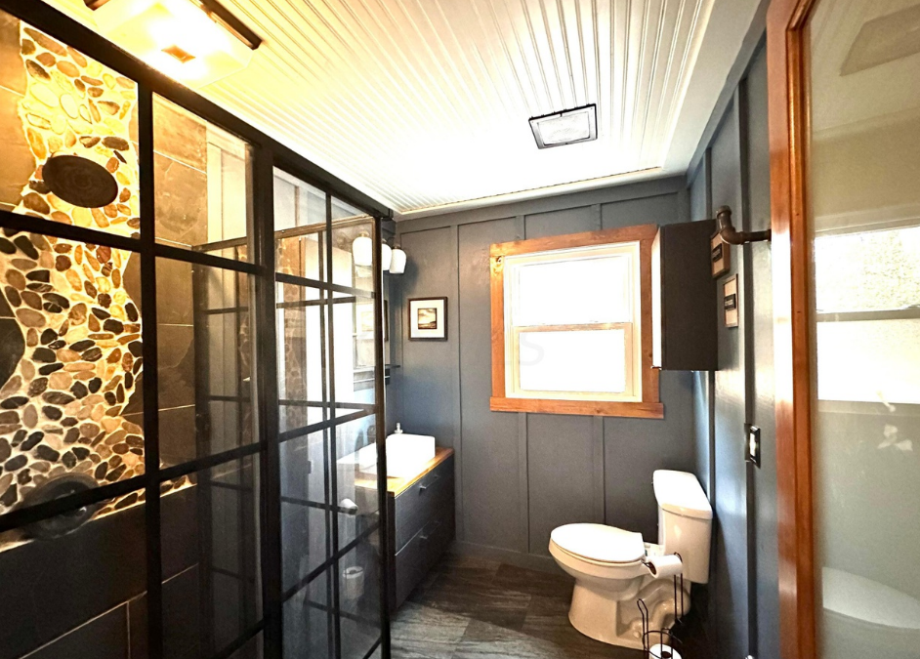

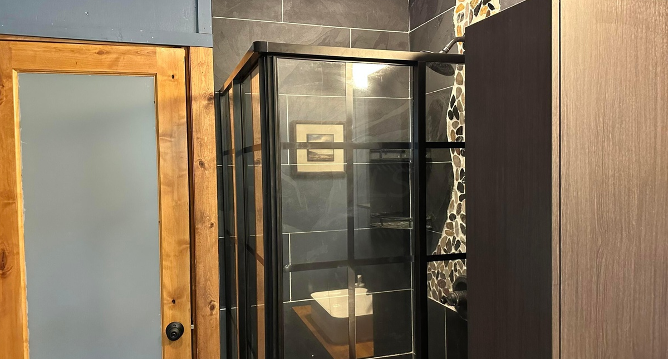

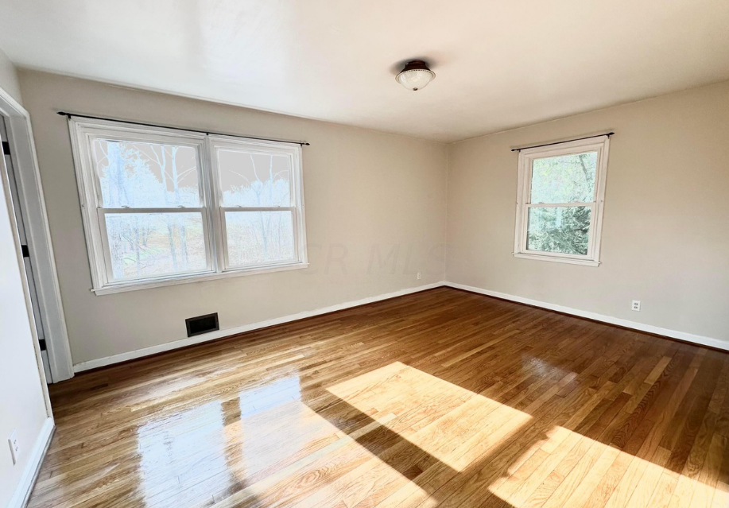

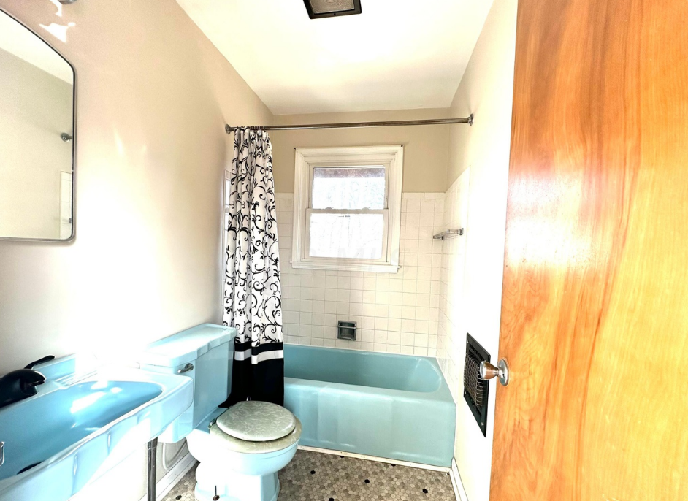

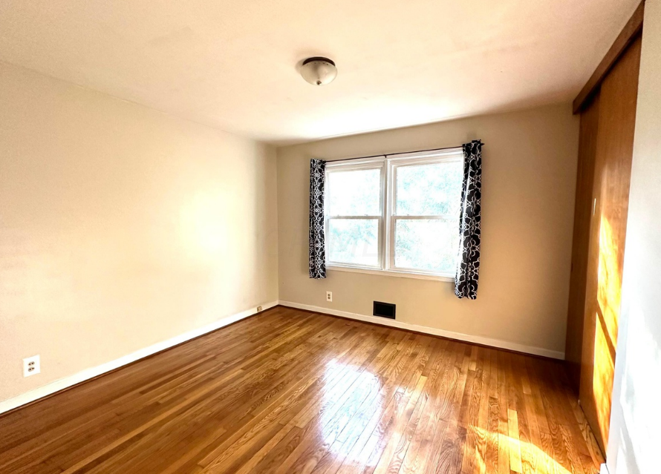

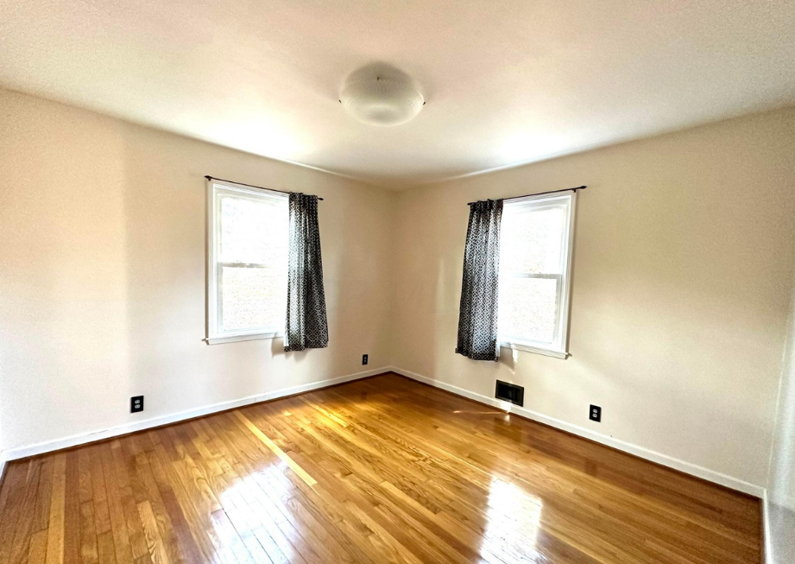

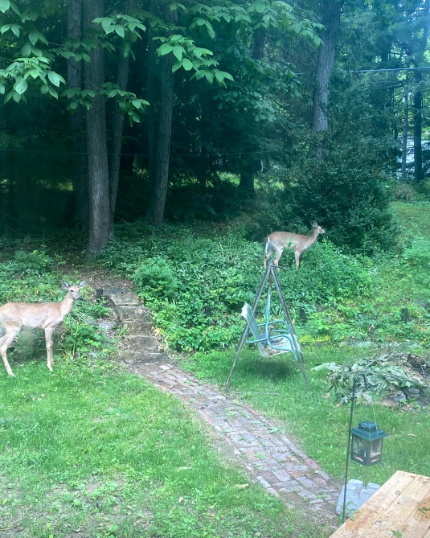

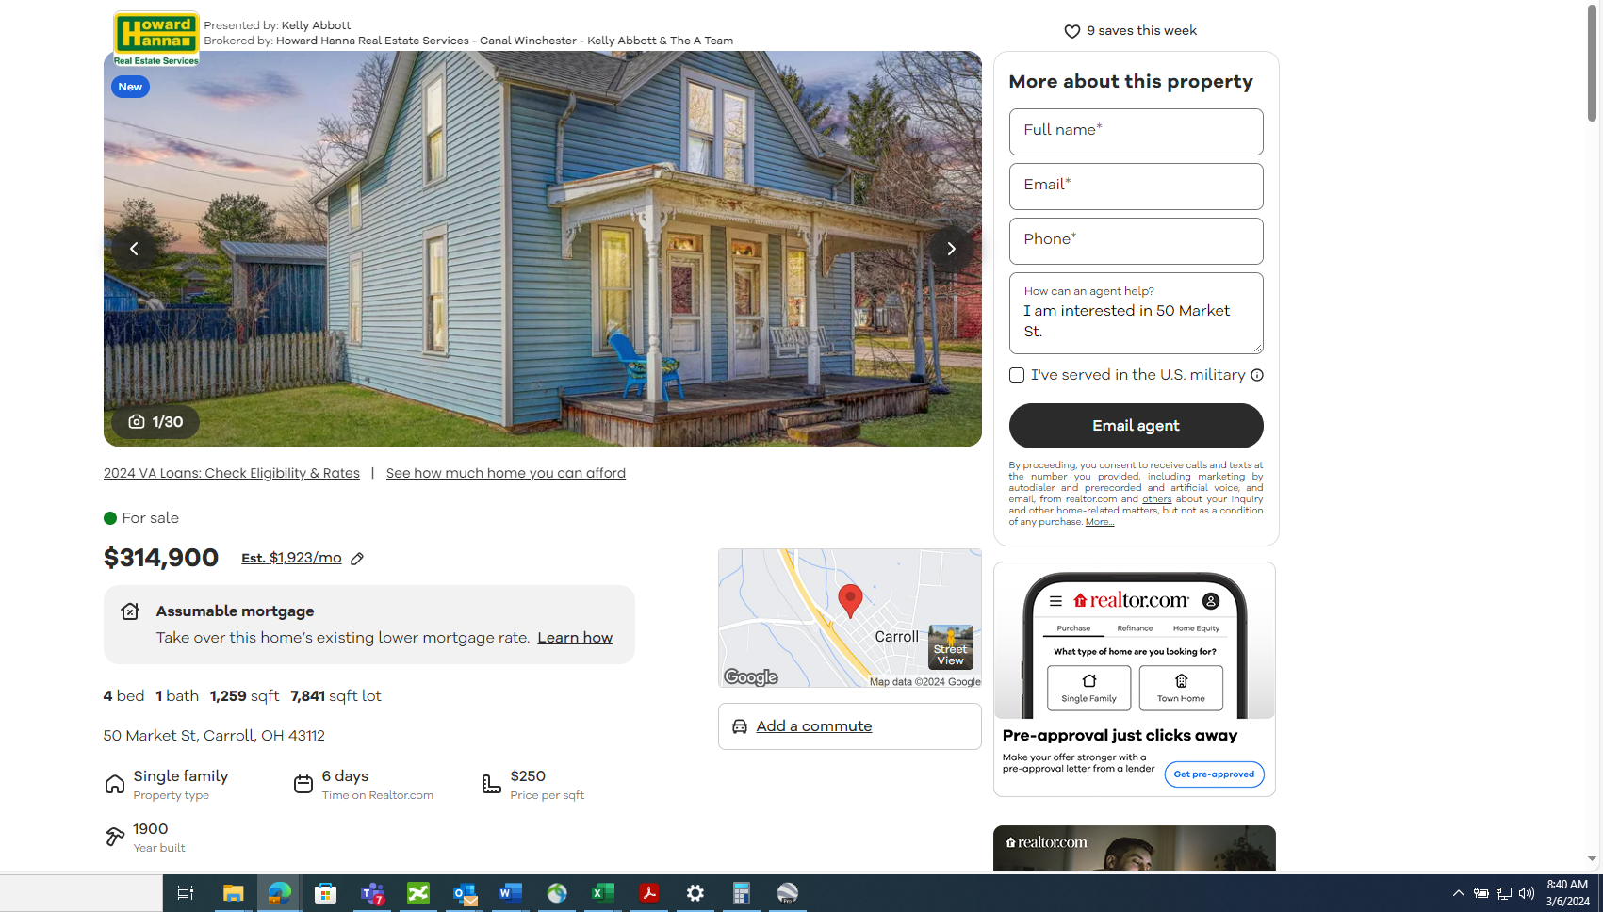

- School District:
BLOOM CARROLL LSD 2303 FAI CO.
Source:Kelly Abbott
Nearby schoolsElementaryMiddleHigh
Rating | School name | Grades | Type | Students | Reviews | Distance
NR | Bloom Carroll Primary School | K - 2 | Public | 512 | 1 reviews | 0.4 mi
7 | Bloom-Carroll High School | 9 - 12 | Public | 606 | 5 reviews | 0.6 mi
6 | Bloom-Carroll Middle School | 5 - 8 | Public | 721 | 2 reviews | 0.5 mi
Great Schools Ratings are based on student performance on state tests, progress over time, and college readiness, in addition to how effectively schools serve students from different racial, ethnic, and socioeconomic backgrounds. Ratings are on a scale of 1 (below average) to 10 (above average). Ratings and reviews help parents compare schools. We encourage parents to also visit schools, ask questions, learn about programs, and consider family needs as part of the school selection process.
Show more
Source: Location provided by Precisely | Ratings provided by GreatSchools

RealEstimate℠
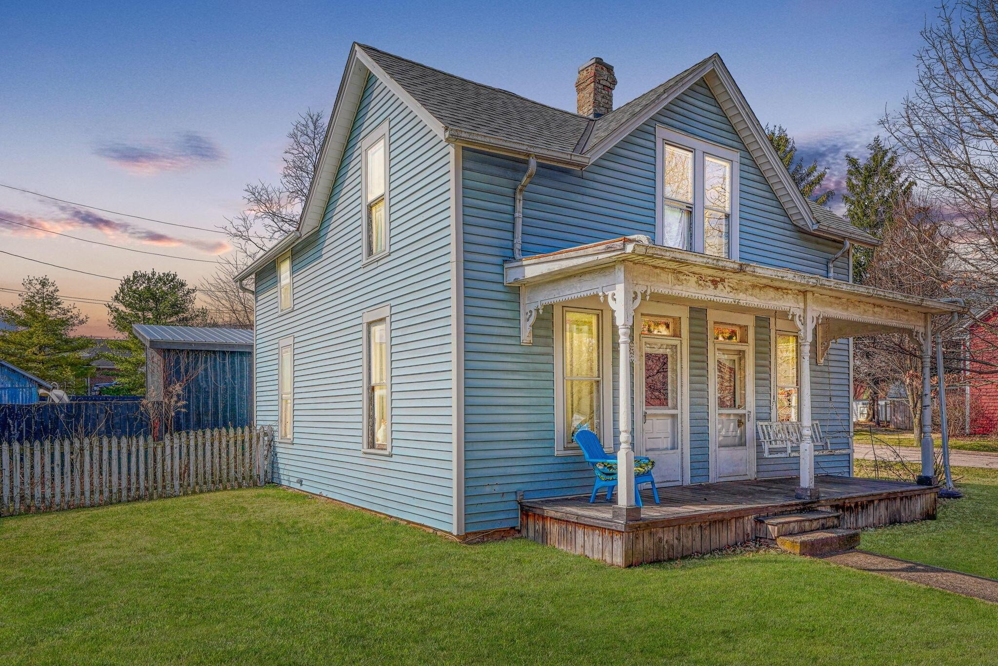
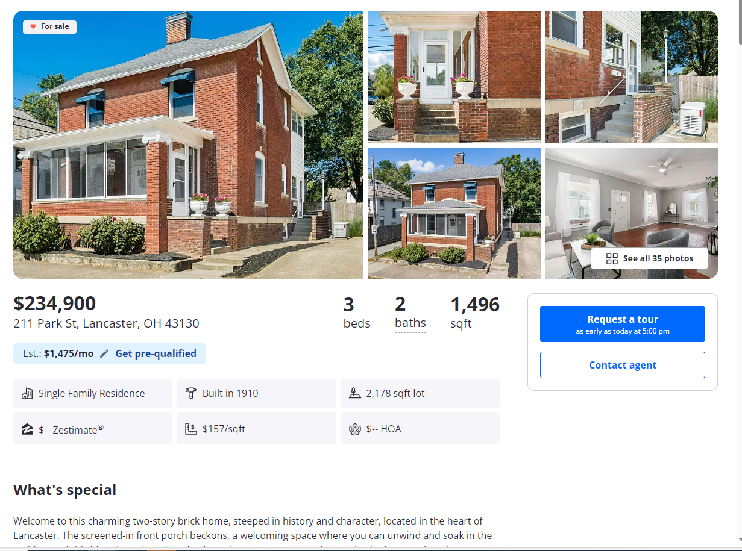
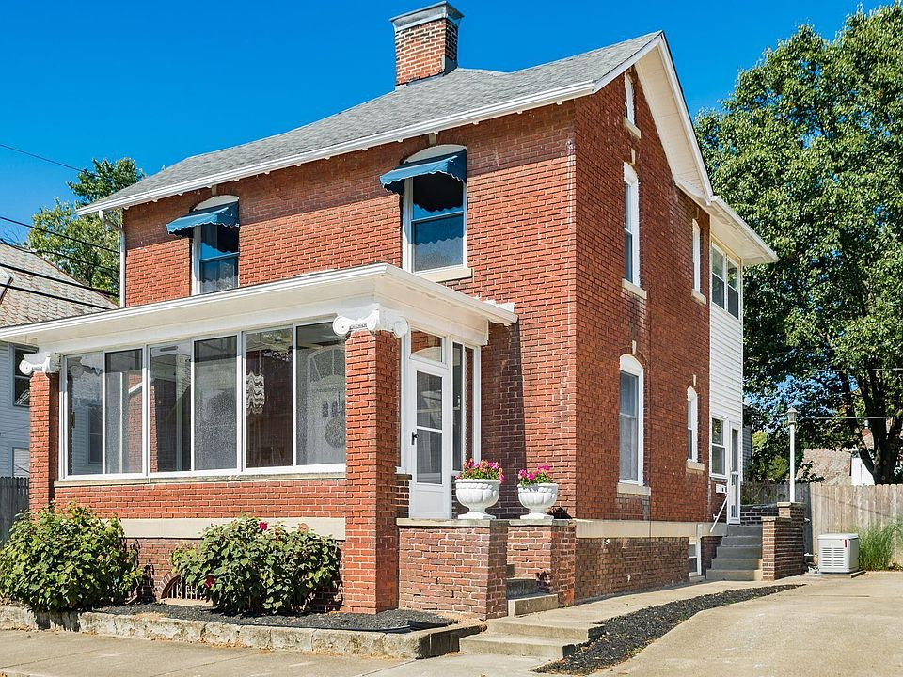
• 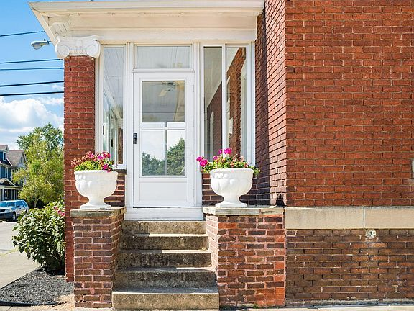
• 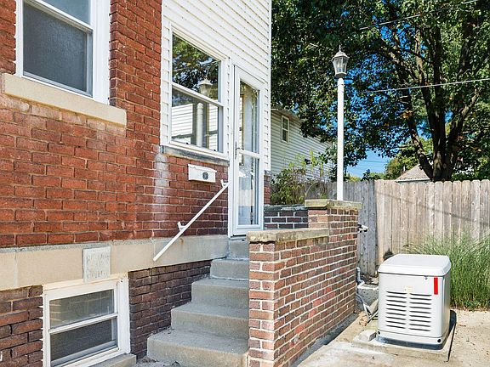
• 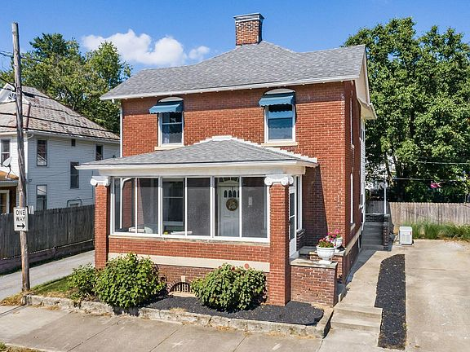
• 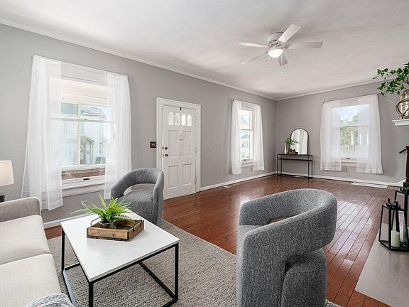
$234,900

211 Park St, Lancaster, OH 43130
3beds
2baths
1,496sqft
Est.: N/AEdit your inputGet pre-qualified
Single Family Residence
Built in 1910
2,178 sqft lot
$-- Zestimate®
$157/sqft
$-- HOA

What's special
Welcome to this charming two-story brick home, steeped in history and character, located in the heart of Lancaster. The screened-in front porch beckons, a welcoming space where you can unwind and soak in the ambiance of this historic enclave. Imagine lazy afternoons spent on the porch, sipping your favorite beverage. One of the standout features of this residence is its prime location. Close proximity to the Fairgrounds means you're at the center of community events and festivities. Rising Park, is a haven for outdoor enthusiasts. Meanwhile, the bustling downtown area of Lancaster offers its shops and restaurants all within easy reach. Don't miss the chance to make this unique property your own!
Show more
37 days
on Zillow
|
2,173
views
|
162
saves
|
Likely to sell faster than 83 % nearby
Zillow last checked: 3 hours ago
Listing updated: February 08, 2024 at 06:57am
Listed by:
Caitlyn Mulroy 614-961-9505,
Coldwell Banker Realty
Source: Columbus and Central Ohio Regional MLS ,MLS#: 224002514

Travel times

Get pre-qualified for a loan
At Zillow Home Loans, we can pre-qualify you in as little as 3 minutes with no impact to your credit score.
An equal housing lender. NMLS #10287.
Start now

Tour with a buyer’s agent
We’ll find a local expert to take you on a private tour of 211 Park St.

Next available tour time:Tomorrow at 9am
See all available times

Facts & features

Interior

Bedrooms & bathrooms
- Bedrooms: 3
- Bathrooms: 2
- Full bathrooms: 1
- 1/2 bathrooms: 1

Bedroom
- Level: 0

Dining room
- Level: 1

Living room
- Level: First

Basement
- Basement: Full

Flooring
- Flooring: Wood

Heating
- Heating features: Natural Gas

Cooling
- Cooling features: Central Air

Appliances
- Appliances included: Dishwasher, Electric Range, Microwave, Refrigerator
- Laundry features: Lower Level

Other interior features
- Total structure area: 1,496
- Total interior livable area: 1,496 sqft
- Total number of fireplaces: 1
- Fireplace features: Decorative

Property

Parking
- Parking features: 1 Off Street

Property
- Levels: Two
- Stories: 2
- Patio & porch details: Deck, Screened

Lot
- Lot size: 2,178 sqft

Other property information
- Parcel number: 0532081500

Construction

Type & style
- Home type: SingleFamily
- Architectural style: 2
- Property subType: Single Family Residence

Material information
- Construction materials: Brick

Condition
- New construction: No
- Year built: 1910

Utilities & green energy

Utility
- Sewer information: Public Sewer

Community & neighborhood

Location
- Region: Lancaster

HOA & financial

Other financial information
- Buyer's Agency fee: 3.00%

Other

Other facts
- Listing terms: Conventional,FHA
Show more

Services availability

Make this home a reality

Get pre-qualifiedBe ready to make an offer.
Connect with an agentGet info on this home, tour, and more.
Calculate monthly paymentSee if you can afford this home.

Price history
Date | Event | Price
2/1/2024 | Listed for sale | $234,900-4.1%$157/sqft
Source: Columbus and Central Ohio Regional MLS #224002514 Report a problem
11/23/2023 | Listing removed | --
Source: Columbus and Central Ohio Regional MLS #223025666 Report a problem
11/1/2023 | Price change | $245,000-2%$164/sqft
Source: Columbus and Central Ohio Regional MLS #223025666 Report a problem
10/5/2023 | Listed for sale | $250,000$167/sqft
Source: Columbus and Central Ohio Regional MLS #223025666 Report a problem
9/19/2023 | Listing removed | --
Source: Columbus and Central Ohio Regional MLS #223025666 Report a problem
Show more

Public tax history
Year | Property taxes | Tax assessment
2022 | $1,475 +32% | $49,140 +31.3%
2021 | $1,118 -0.5% | $37,420
2020 | $1,124 +10.4% | $37,420
Show more
Find assessor info on the county website

Monthly payment calculator
Estimated monthly payment$1,218

Principal & interest
$911

Mortgage insurance
$0

Property taxes
$225

Home insurance
$82

HOA fees
N/A

Utilities
Not included
All calculations are estimates and provided by Zillow, Inc. for informational purposes only. Actual amounts may vary.
Mortgage interest rates are dependent on a number of factors, including credit score, down payment, and repayment length. Interest rate data provided by Zillow Group Marketplace, Inc. as of 3/6/2024 from various mortgage lenders with which we have lead or other similar arrangements; the Estimated Payment is an average of those rates.
See how much you could borrow to make a competitive offer.
Get pre-qualified

Down payment assistance
19 programs may be available to provide you with up to $15,000 in down payment assistance, depending on your specific information.
Check eligibility
Source: Down Payment Resource®

Getting around
Walk Score®
73 / 100
Very Walkable
Bike Score®
54 / 100
Bikeable

Nearby schools

GreatSchools rating
- 5/10
East Elementary School
Grades: K-5Distance: 0.4 mi
- 6/10
General Sherman Junior High School
Grades: 6-8Distance: 2.8 mi
- 5/10
Lancaster High School
Grades: 9-12Distance: 1.1 mi
Show more

Schools provided by the listing agent
- District: LANCASTER CSD 2305 FAI CO.
Source: Columbus and Central Ohio Regional MLS . This data may not be complete. We recommend contacting the local school district to confirm school assignments for this home.
Skip carousel

Nearby homes

- 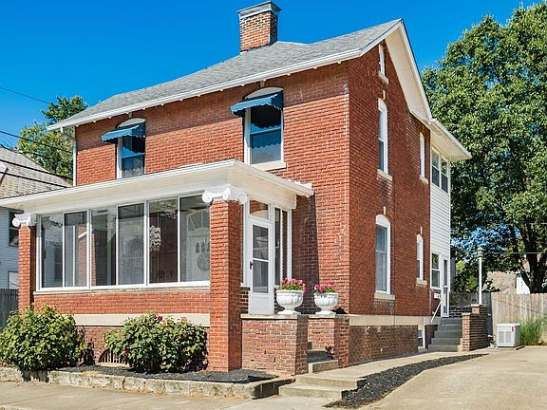
- 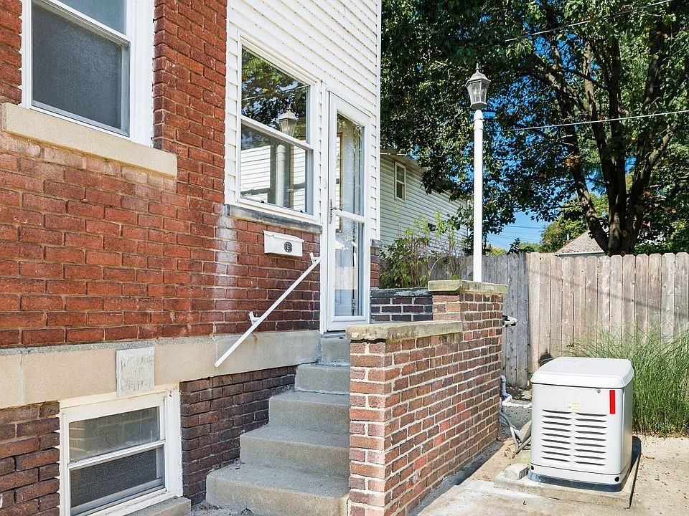
- 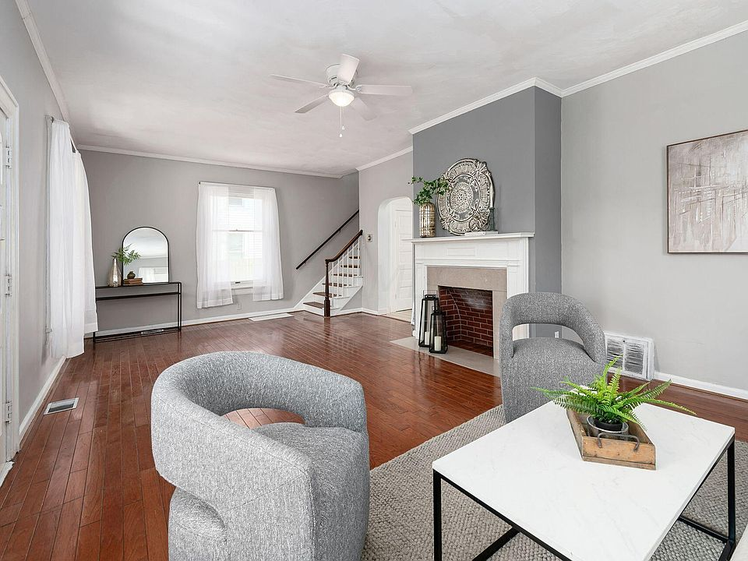
- 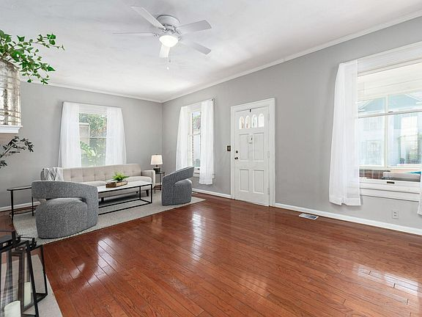
- 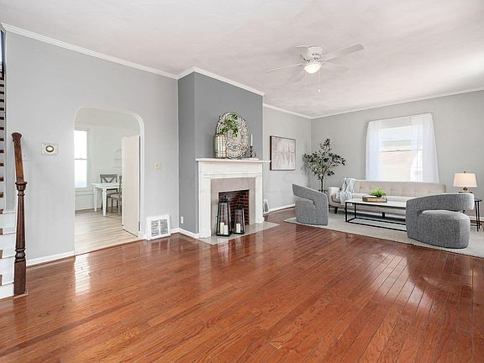
- 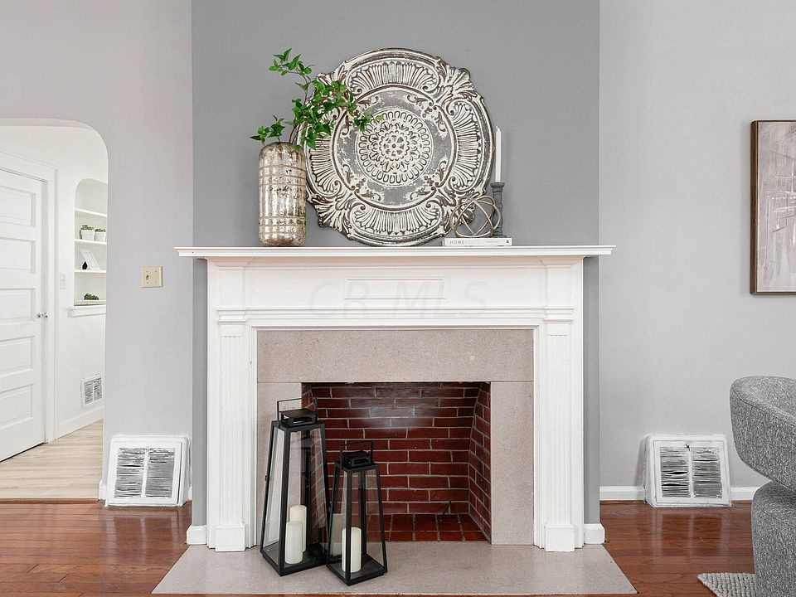
- 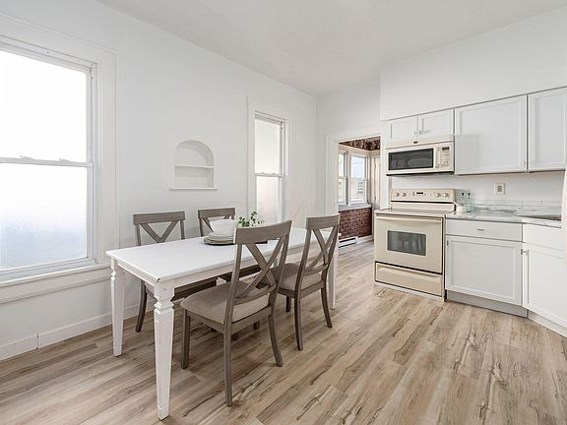
- 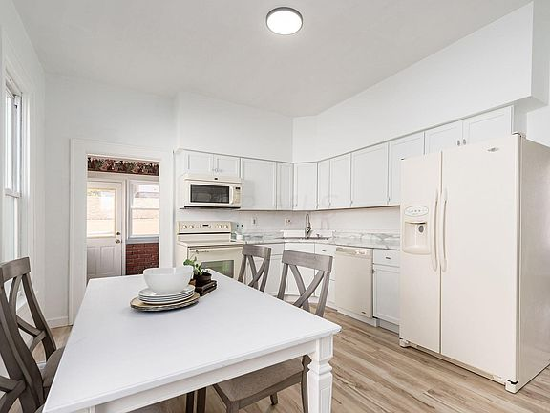
- 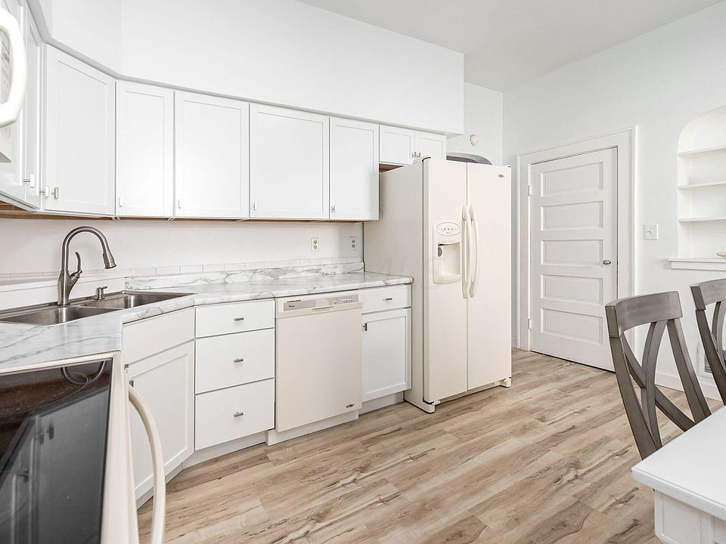
- 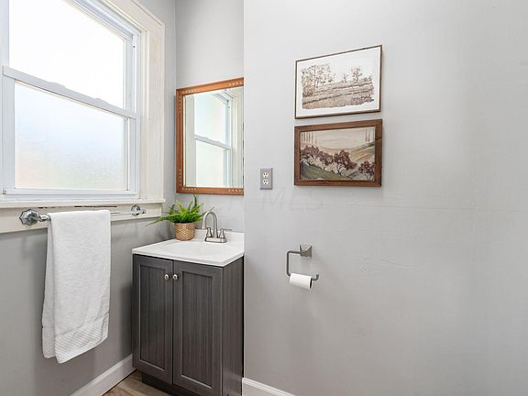
- 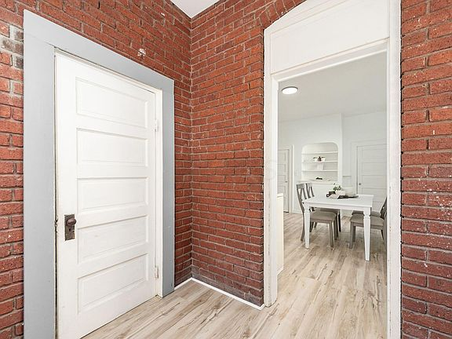
- 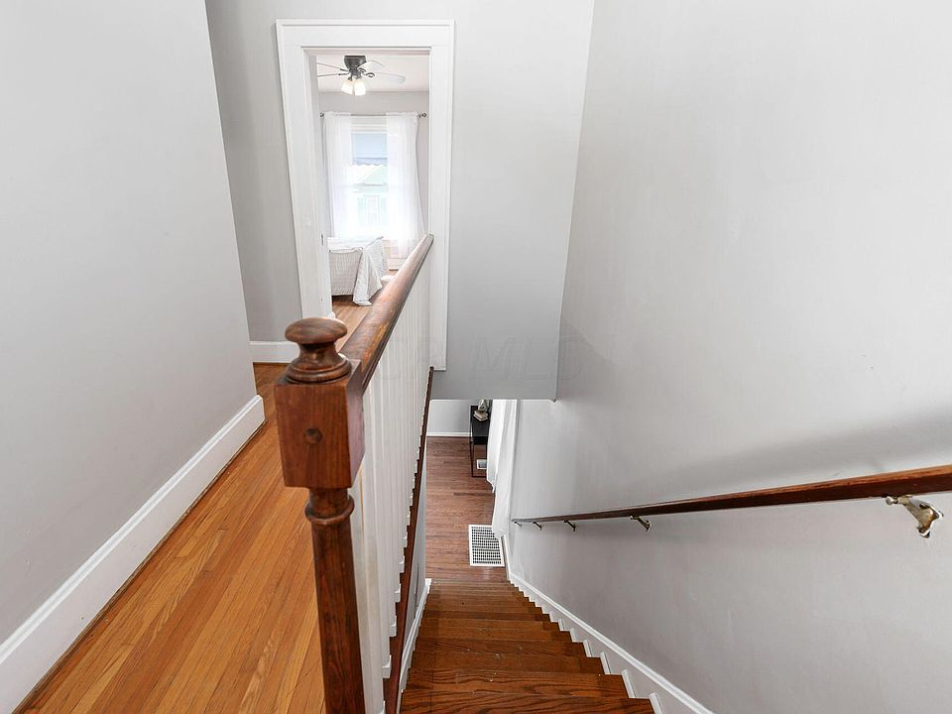
- 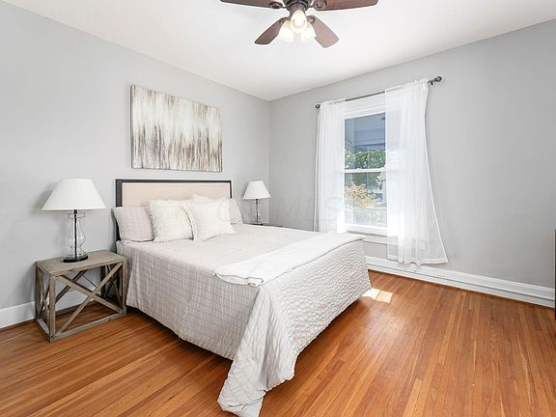
- 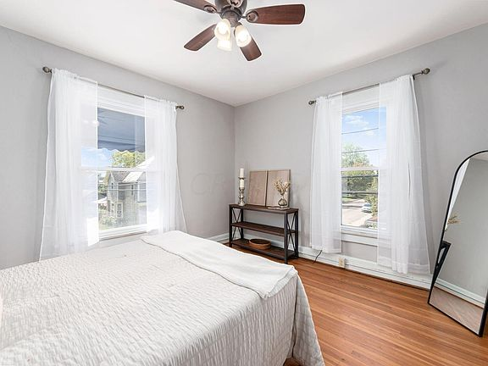
- 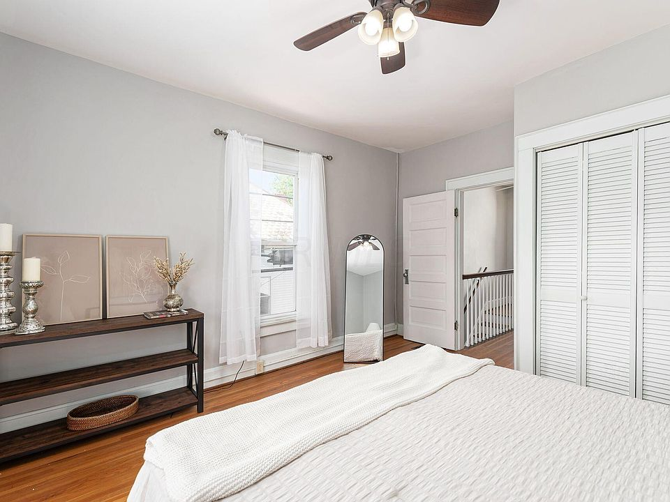
- 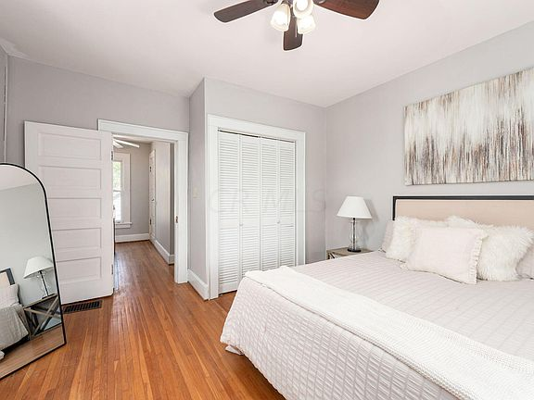
- 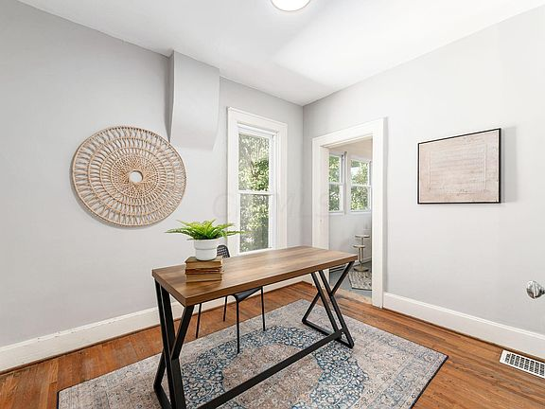
- 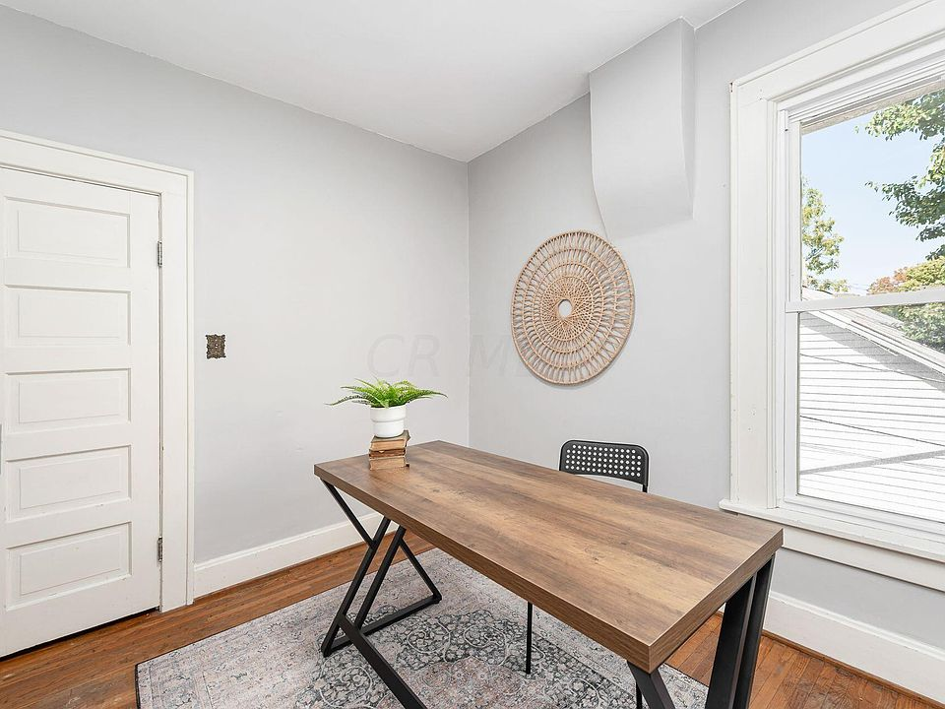
- 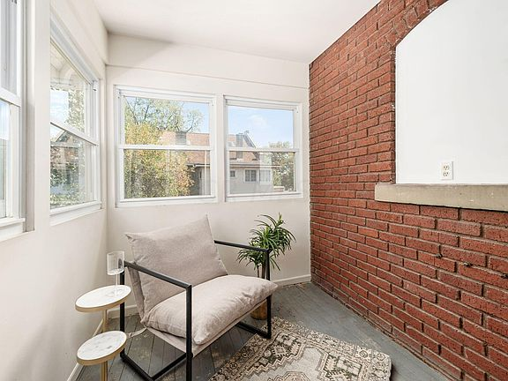
- 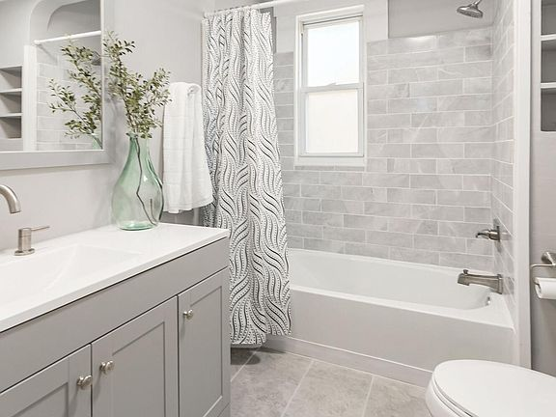
- 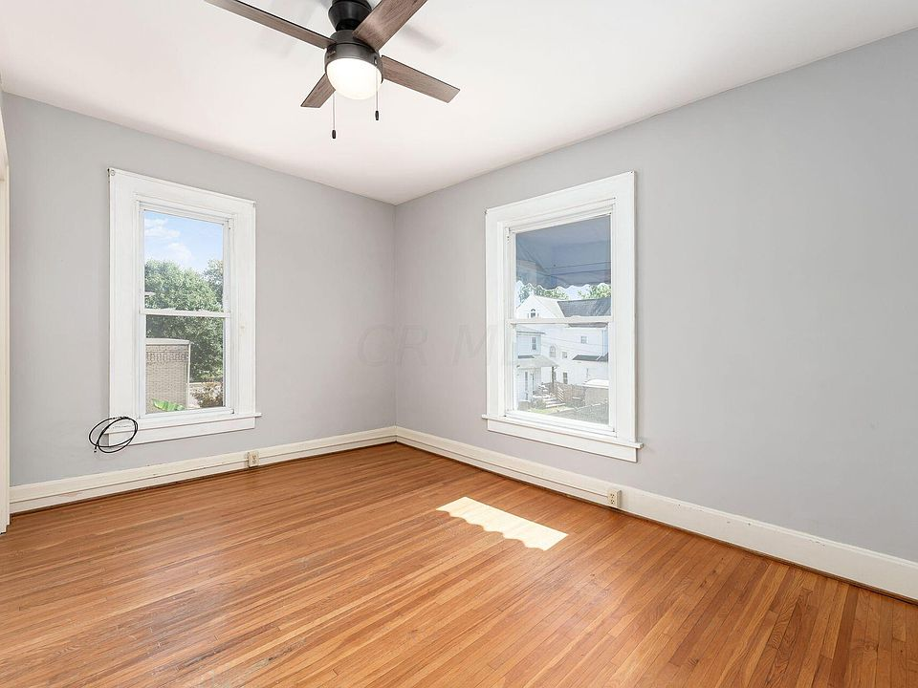
- 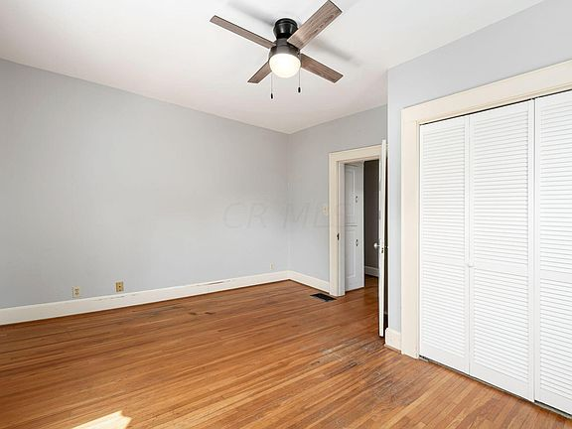
- 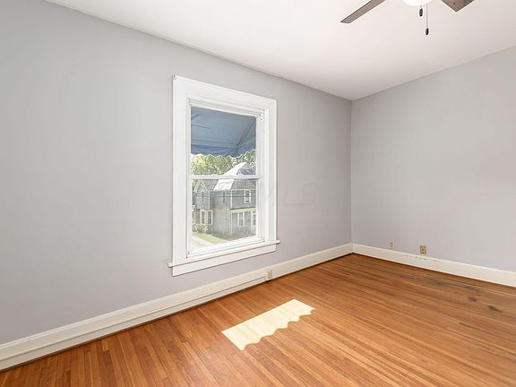
- 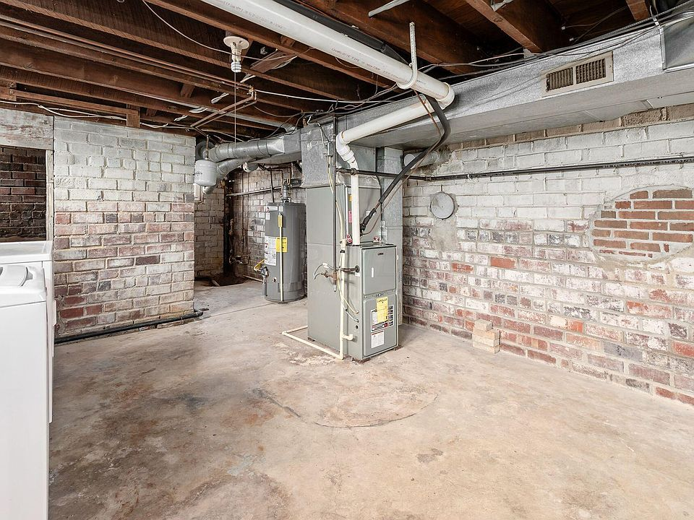
- 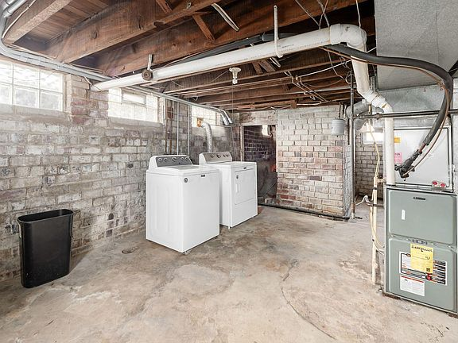
- 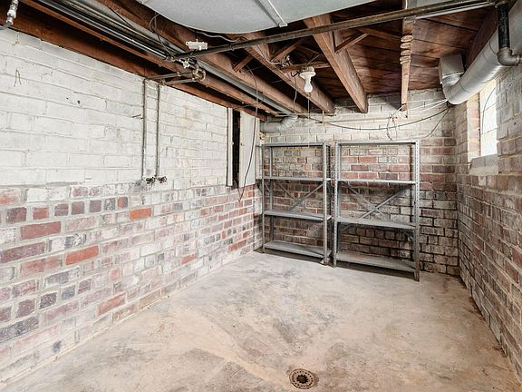
- 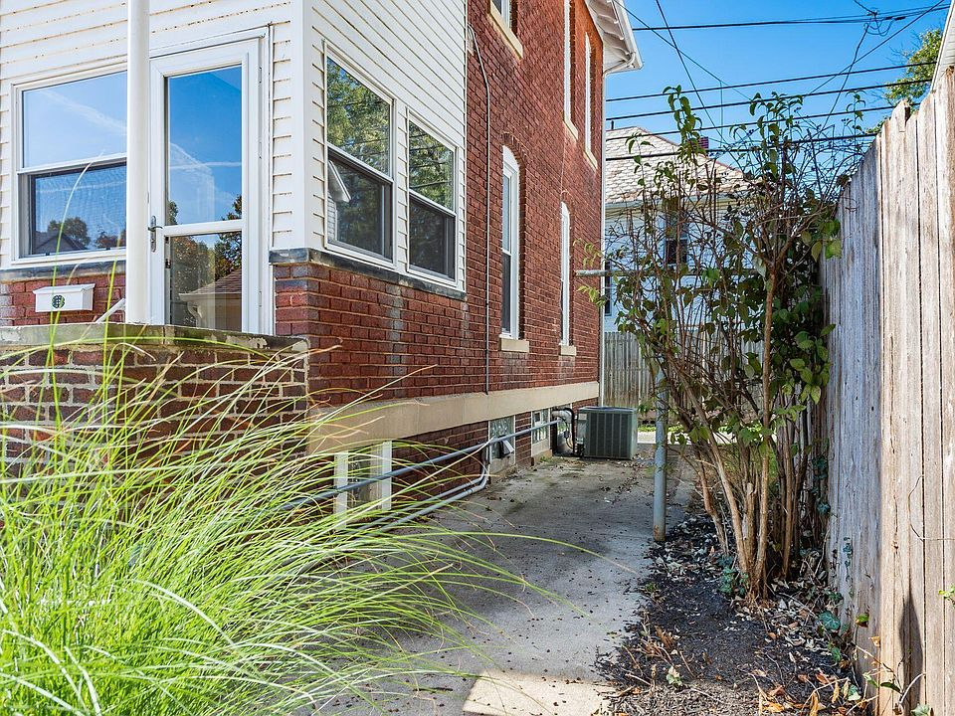
- 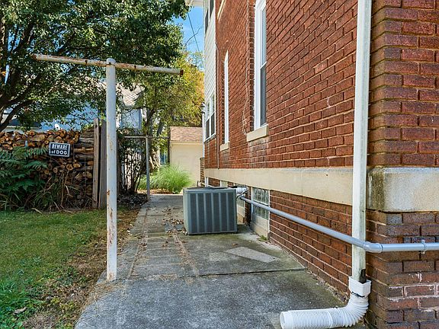
- 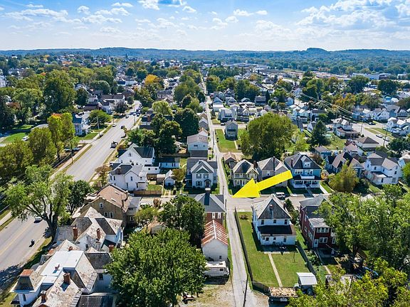
- 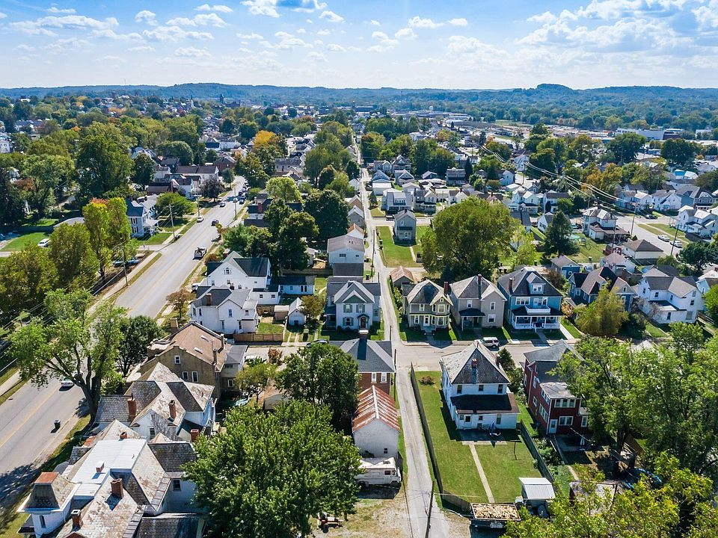
- 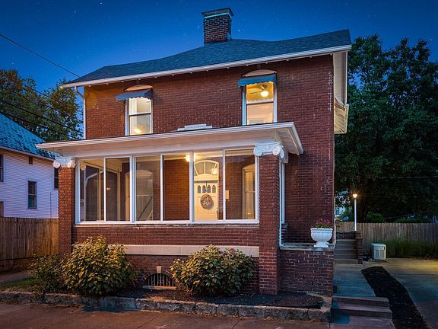
- 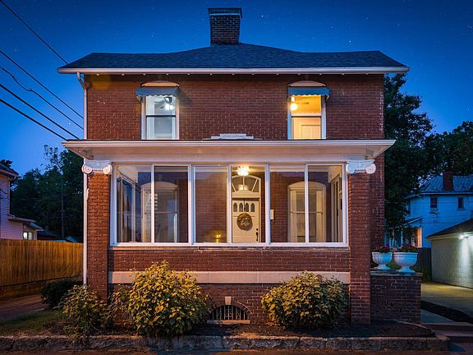

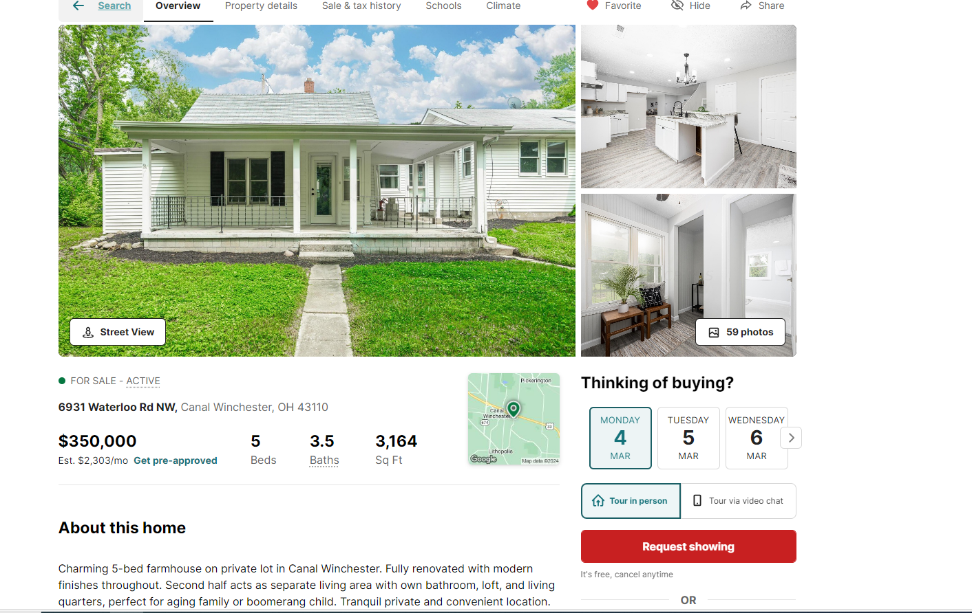

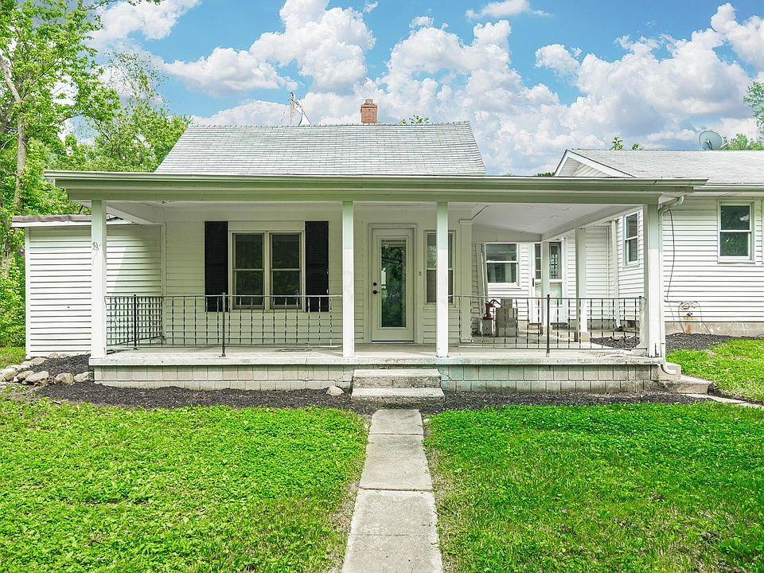
• 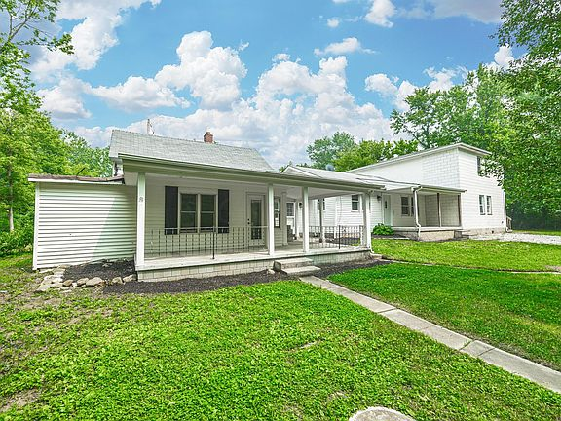
• 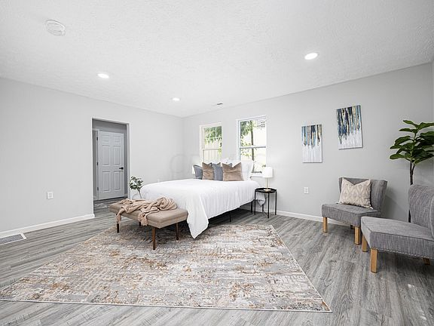
• 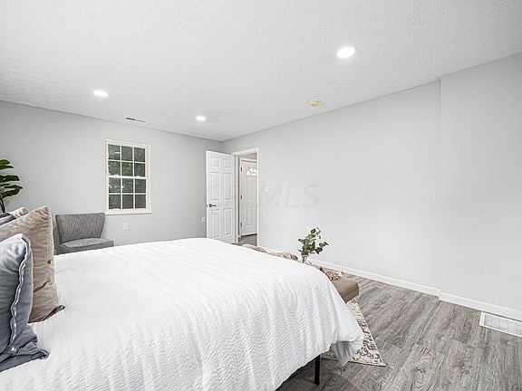
• 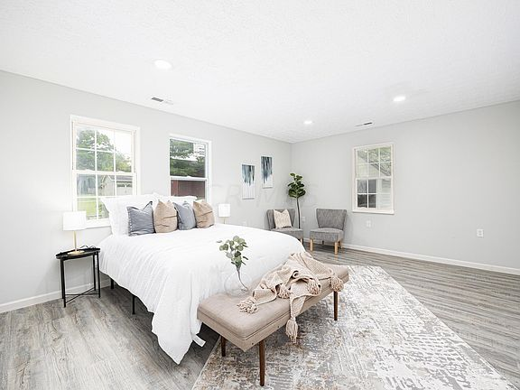
Price cut: $25K (2/15)
$350,000

6931 Waterloo Rd, Canal Winchester, OH 43110
5beds
4baths
3,164sqft
Est.: $2,228/moEdit your inputGet pre-qualified
Single Family Residence
Built in 1900
0.25 Acres lot
$-- Zestimate®
$111/sqft
$-- HOA

What's special
LIVING QUARTERSCANAL WINCHESTERPRIVATE LOTOWN BATHROOM
Charming 5-bed farmhouse on private lot in Canal Winchester. Fully renovated with modern finishes throughout. Second half acts as separate living area with own bathroom, loft, and living quarters, perfect for aging family or boomerang child. Tranquil private and convenient location. Don't miss this exceptional home!
250 days
on Zillow
|
4,616
views
|
354
saves
Zillow last checked: 3 hours ago
Listing updated: February 29, 2024 at 04:47am
Listed by:
Ginson D Speich 614-312-0883,
Keller Williams Greater Cols
Source: Columbus and Central Ohio Regional MLS ,MLS#: 223020254

Get pre-qualified for a loan
At Zillow Home Loans, we can pre-qualify you in as little as 3 minutes with no impact to your credit score.
An equal housing lender. NMLS #10287.
Start now

Tour with a buyer’s agent
We’ll find a local expert to take you on a private tour of 6931 Waterloo Rd.

Next available tour time:Tomorrow at 9am
See all available times

Facts & features

Interior

Bedrooms & bathrooms
- Bedrooms: 5
- Bathrooms: 4
- Full bathrooms: 3
- 1/2 bathrooms: 1

Bedroom
- Level: 2

Basement
- Basement: Full

Other interior features
- Total structure area: 3,164
- Total interior livable area: 3,164 sqft

Property

Parking
- Parking features: 2 Off Street

Property
- Levels: Multi/Split
- Stories: 1

Lot
- Lot size: 0.25 Acres

Other property information
- Parcel number: 0370215100

Construction

Type & style
- Home type: SingleFamily
- Architectural style: 1.5
- Property subType: Single Family Residence

Condition
- New construction: No
- Year built: 1900

Utilities & green energy

Utility
- Sewer information: Private Sewer
- Water information: Well

Community & neighborhood

Location
- Region: Canal Winchester

HOA & financial

Other financial information
- Buyer's Agency fee: 3.00%
Show more

Services availability

Make this home a reality

Get pre-qualifiedBe ready to make an offer.
Connect with an agentGet info on this home, tour, and more.
Calculate monthly paymentSee if you can afford this home.

Price history
Date | Event | Price
2/15/2024 | Price change | $350,000-6.7%$111/sqft
Source: Columbus and Central Ohio Regional MLS #223020254 Report a problem
1/21/2024 | Listed for sale | $375,000$119/sqft
Source: Columbus and Central Ohio Regional MLS #223020254 Report a problem
1/10/2024 | Contingent | $375,000$119/sqft
Source: Columbus and Central Ohio Regional MLS #223020254 Report a problem
12/8/2023 | Listed for sale | $375,000$119/sqft
Source: Columbus and Central Ohio Regional MLS #223020254 Report a problem
9/23/2023 | Contingent | $375,000$119/sqft
Source: Columbus and Central Ohio Regional MLS #223020254 Report a problem
Show more

Public tax history
Year | Property taxes | Tax assessment
2022 | $3,893 -64.1% | $48,610 +33.7%
2021 | $10,830 +410.2% | $36,370
2020 | $2,123 -62.2% | $36,370
Show more
Current legal protections at the county level in Fairfield County

- 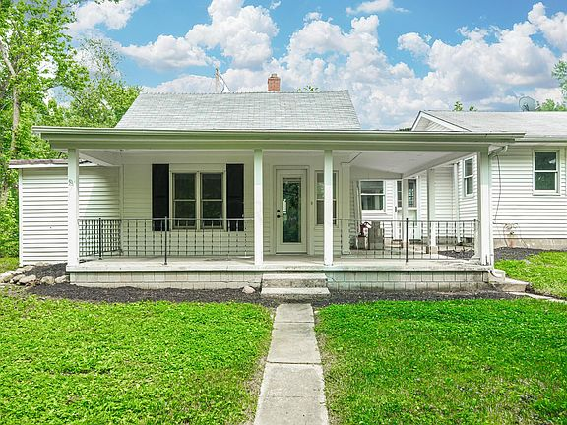
- 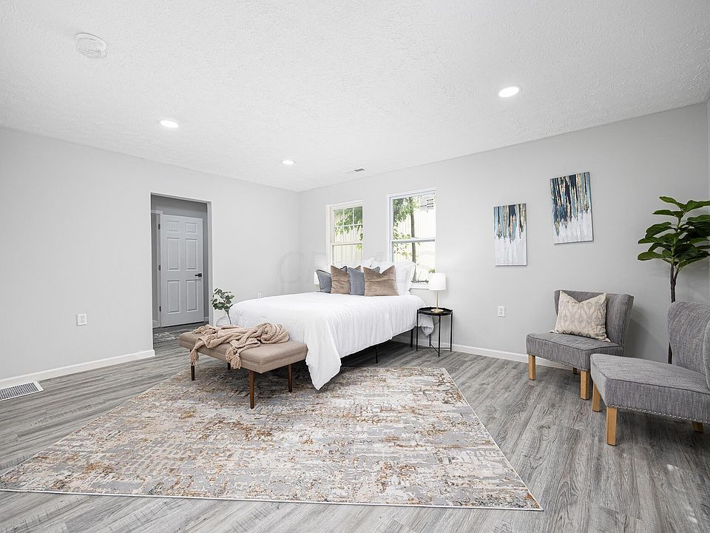
- 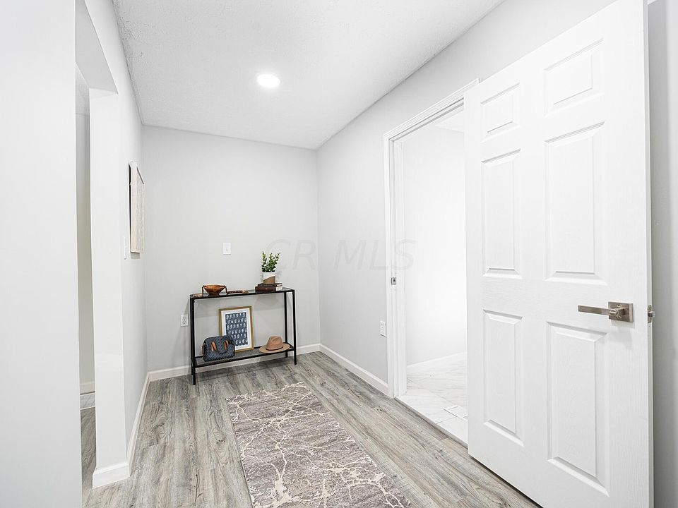
- 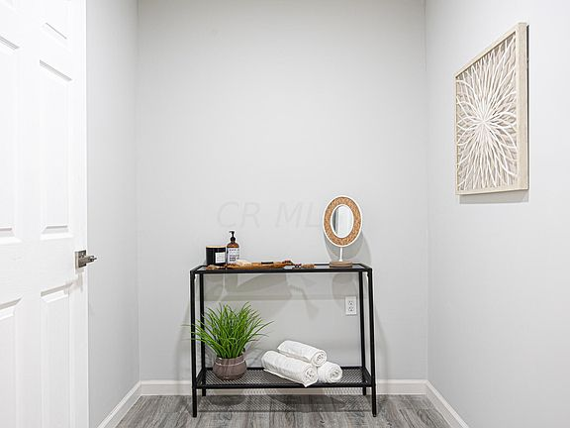
- 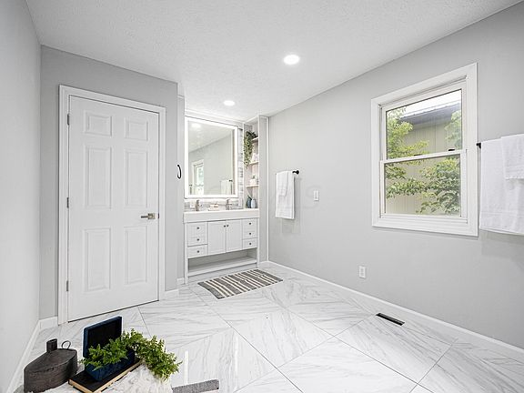
- 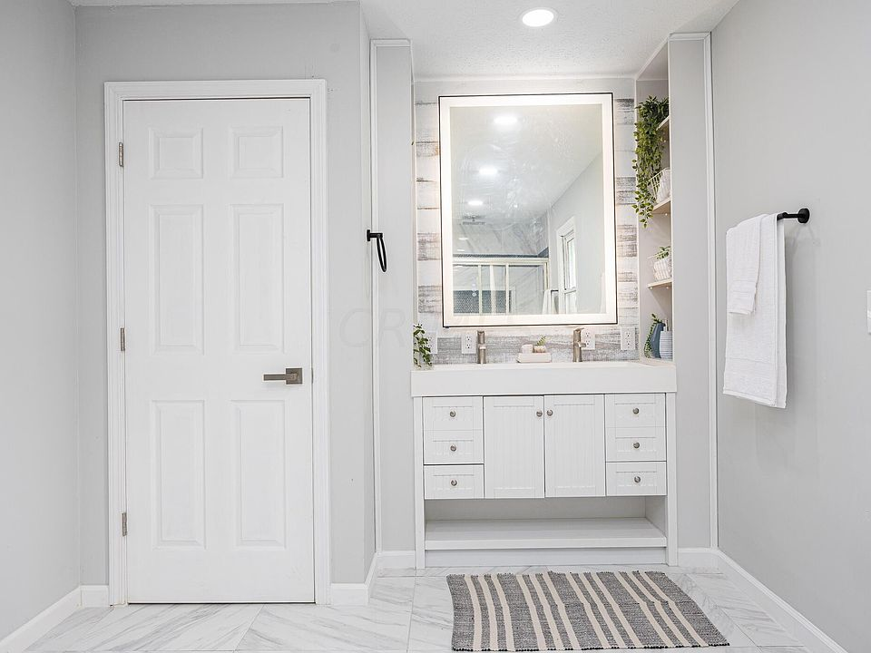
- 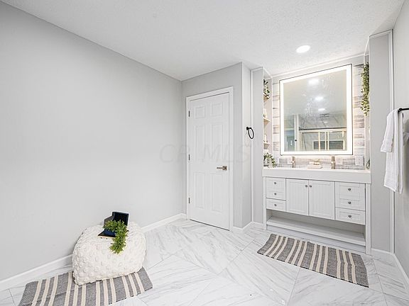
- 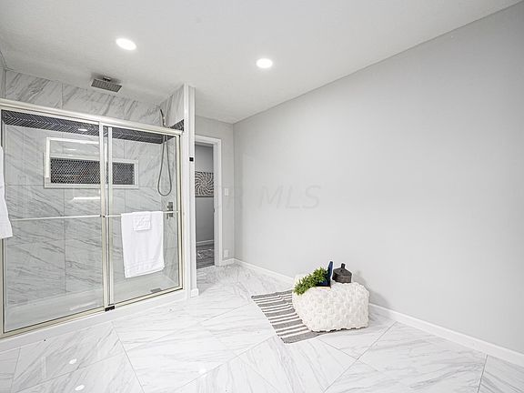
- 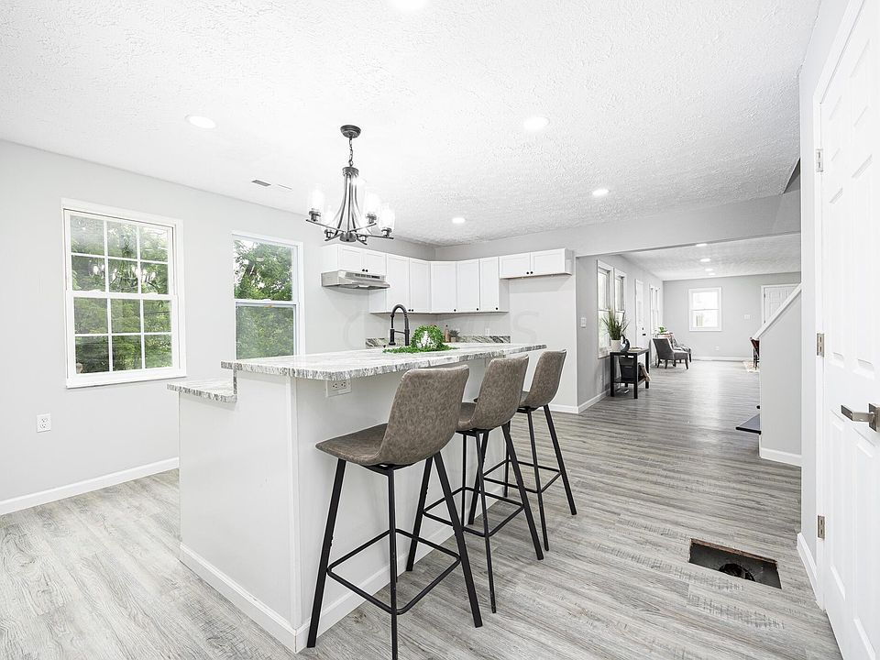
- 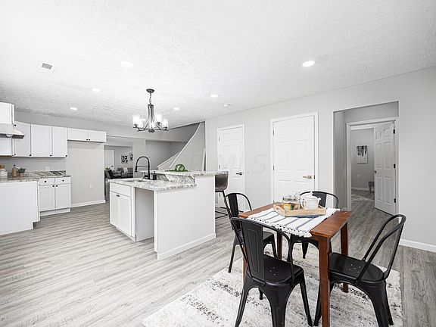
- 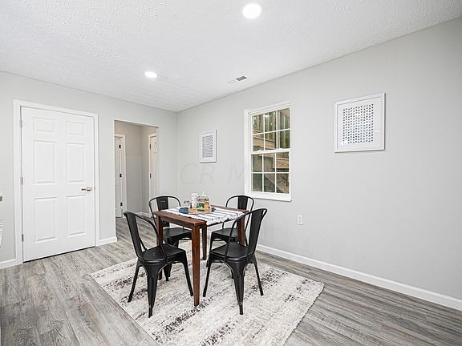
- 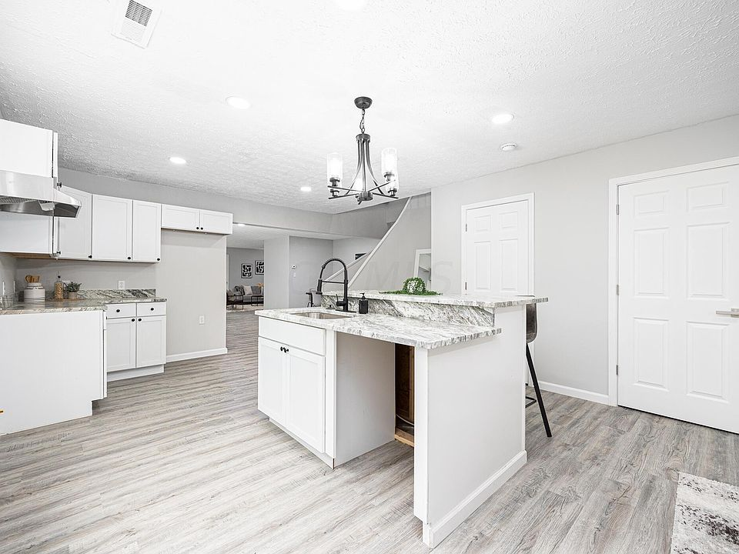
- 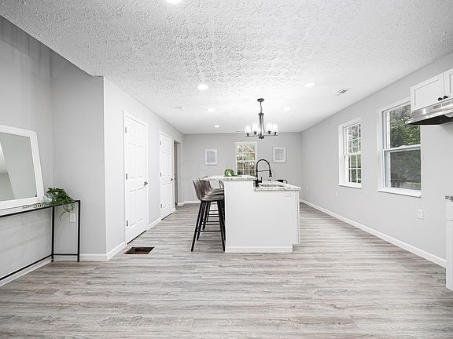
- 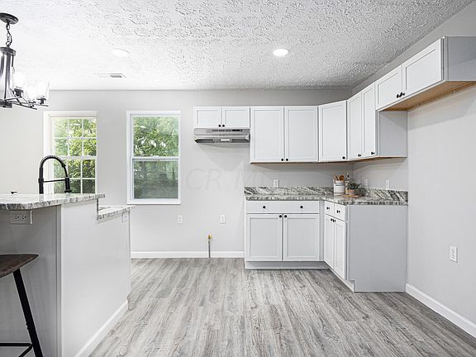
- 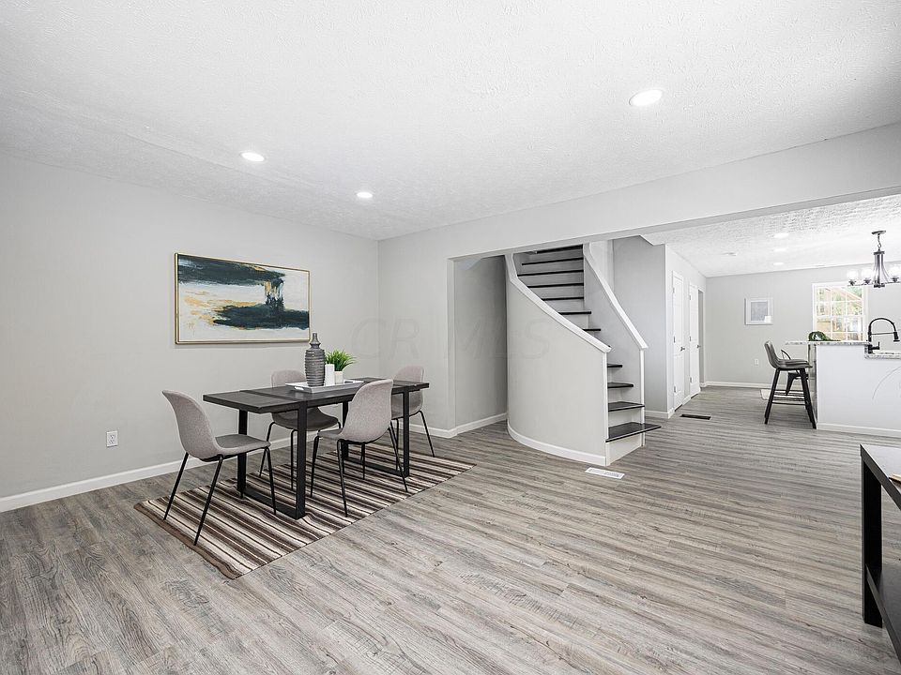
- 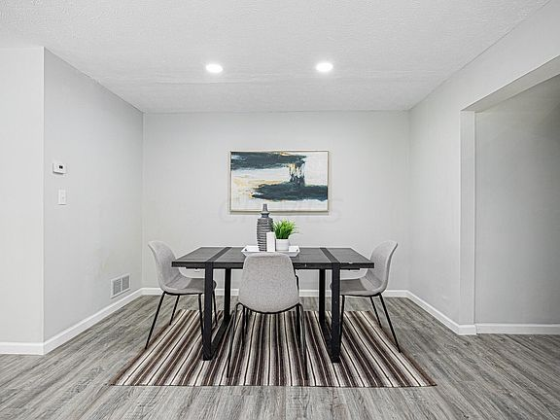
- 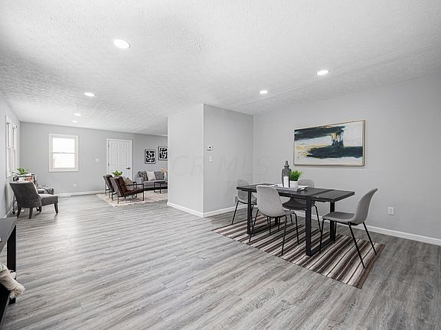
- 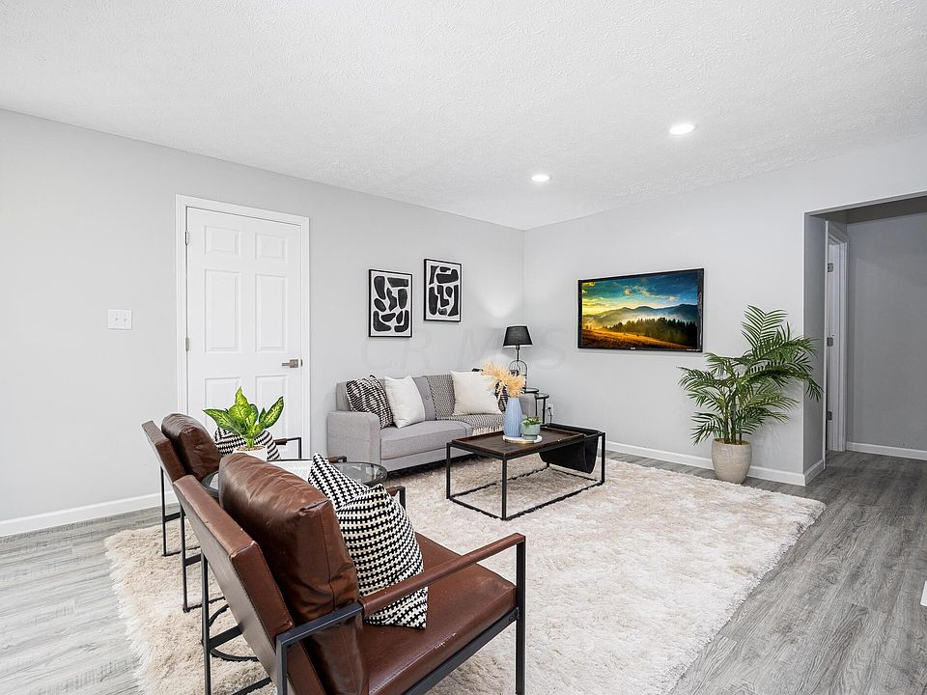
- 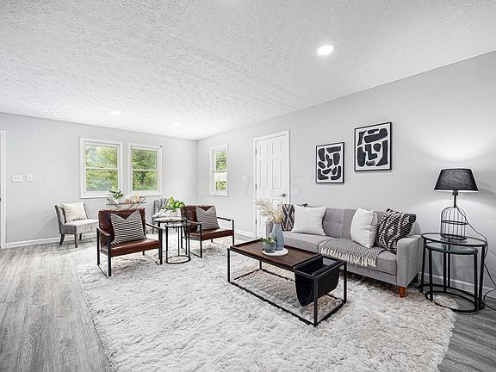
- 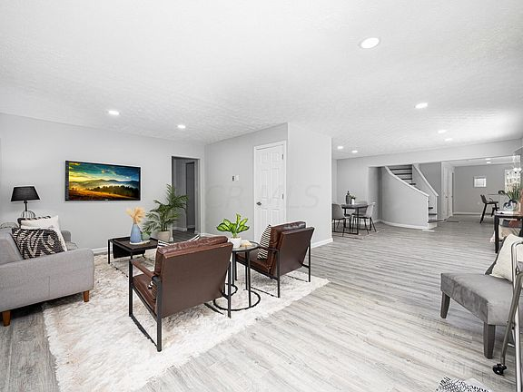
- 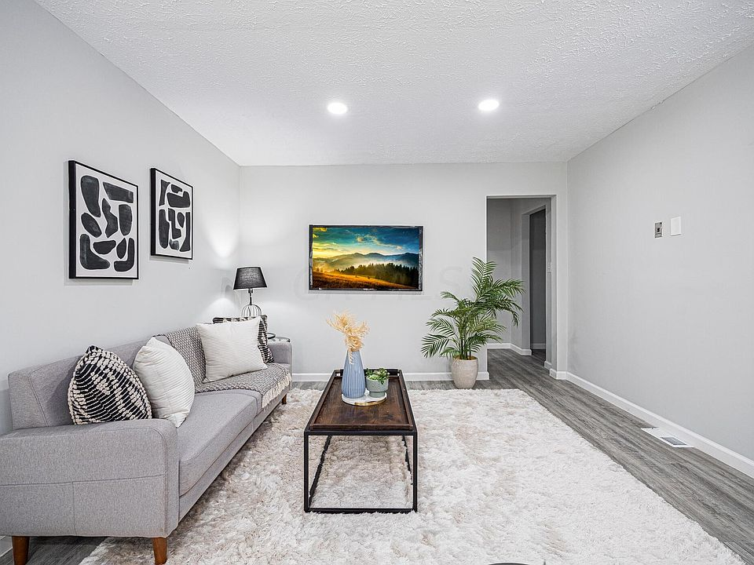
- 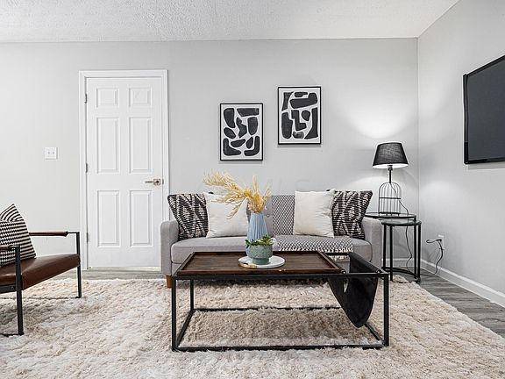
- 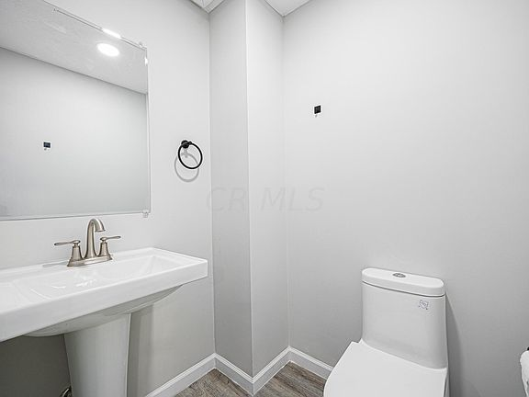
- 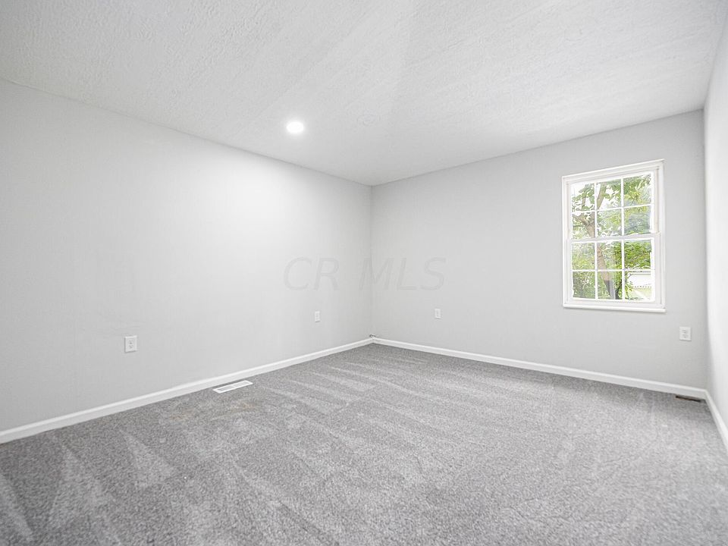
- 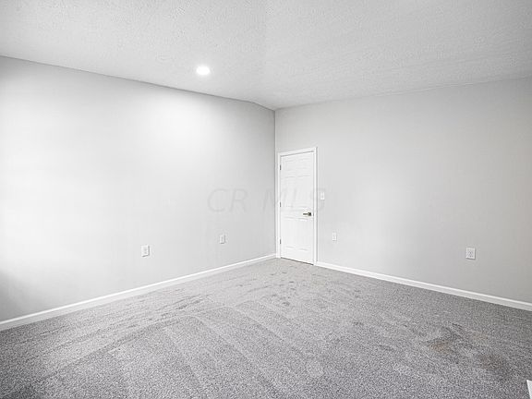
- 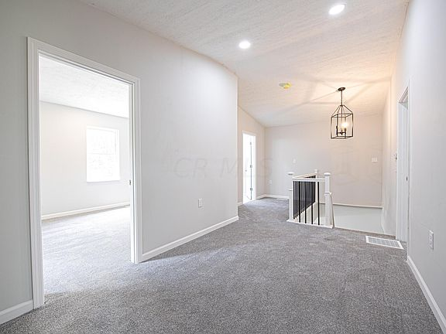
- 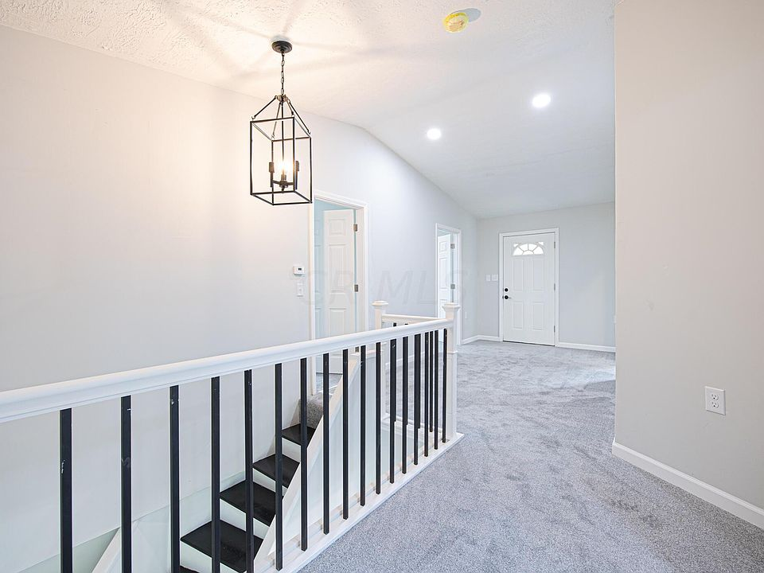
- 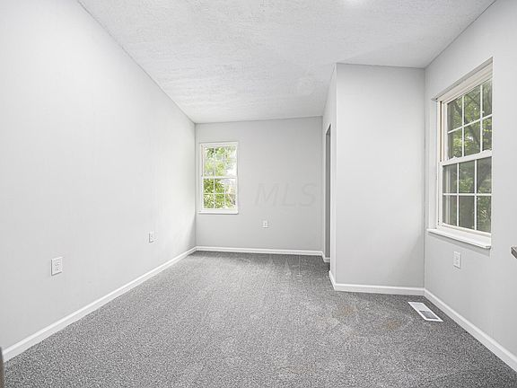
- 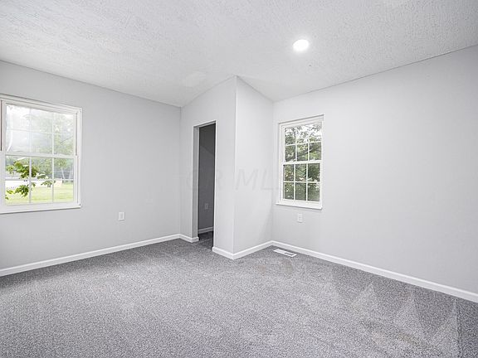
- 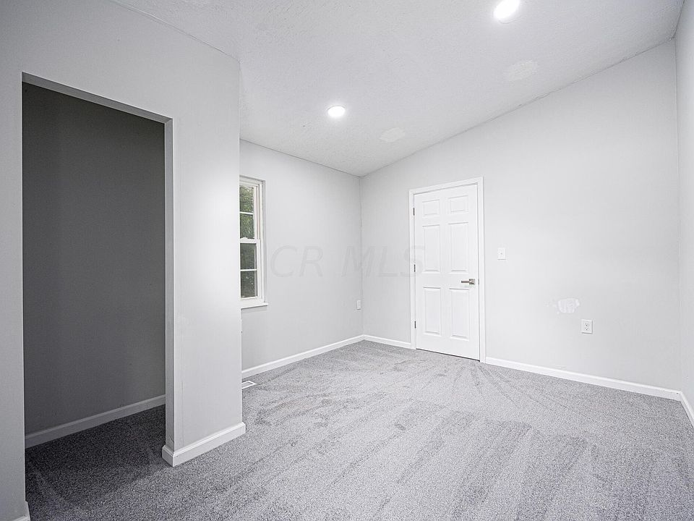
- 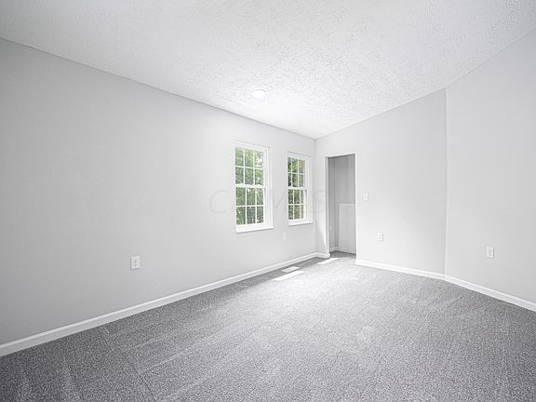
- 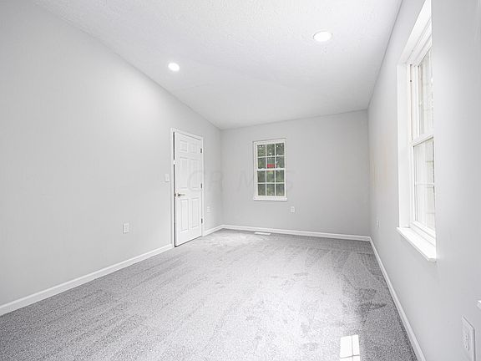
- 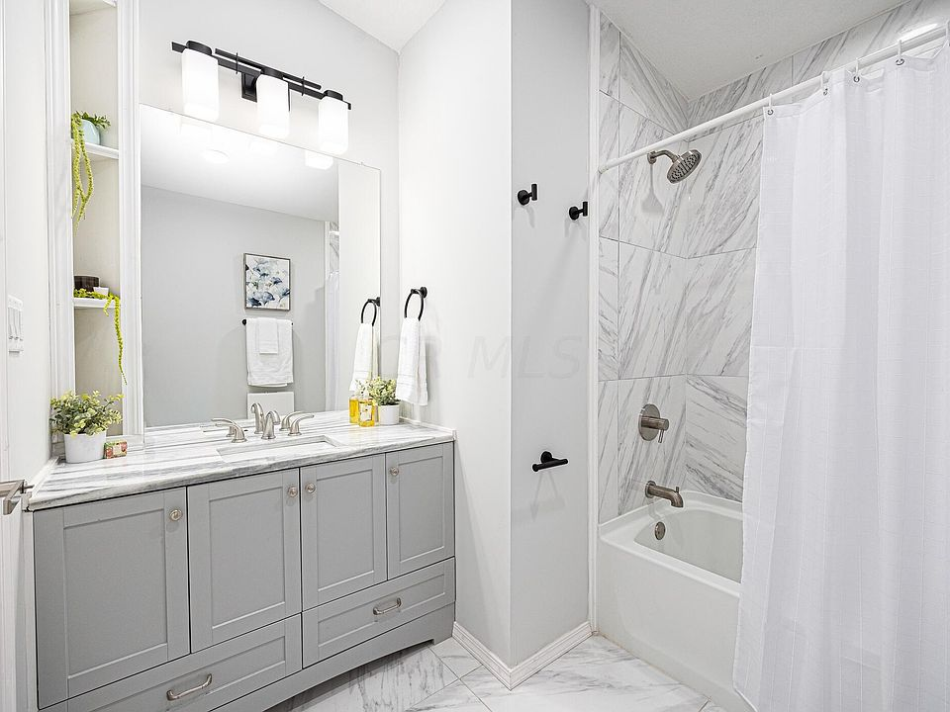
- 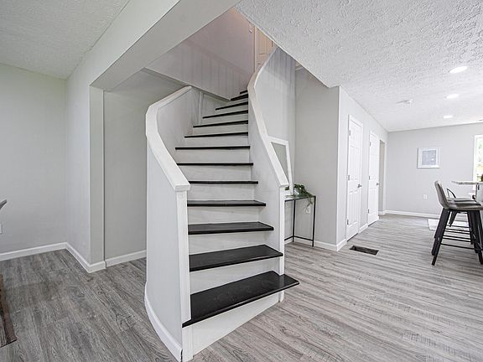
- 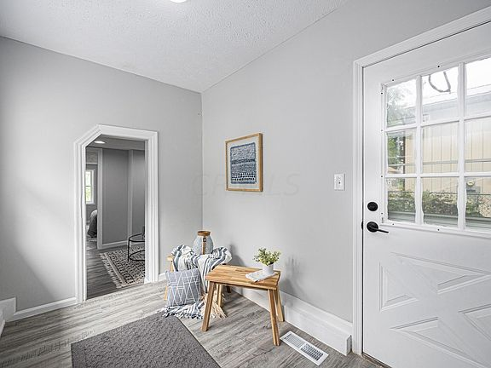
- 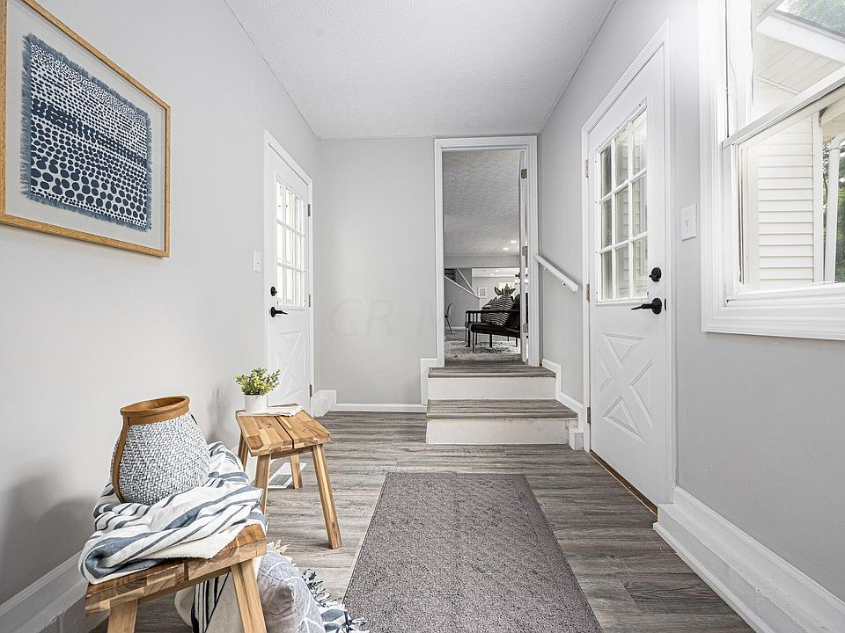
- 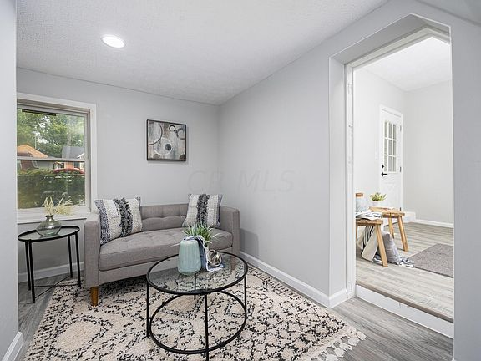
- 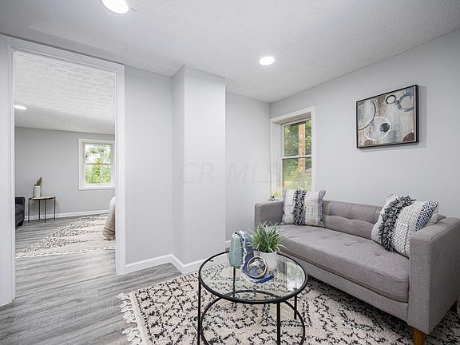
- 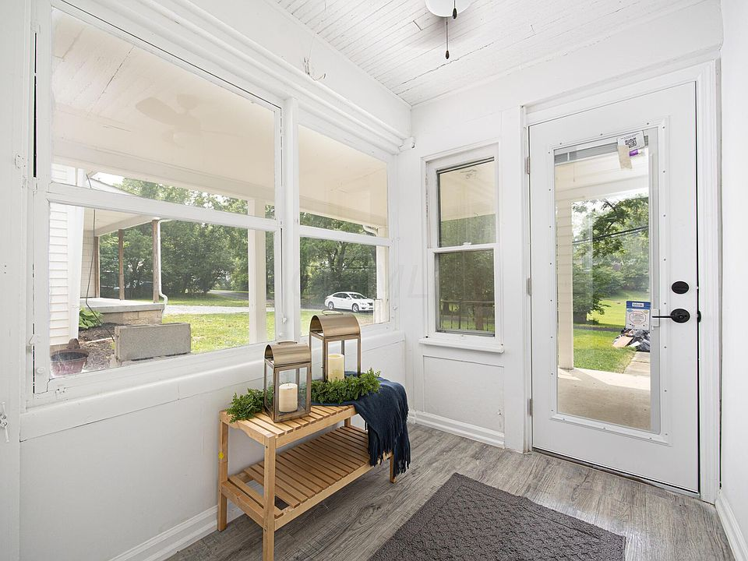
- 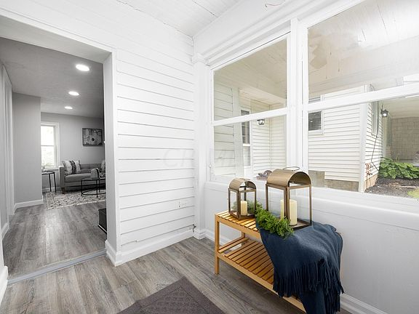
- 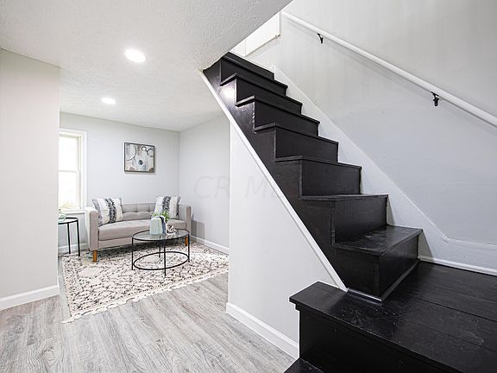
- 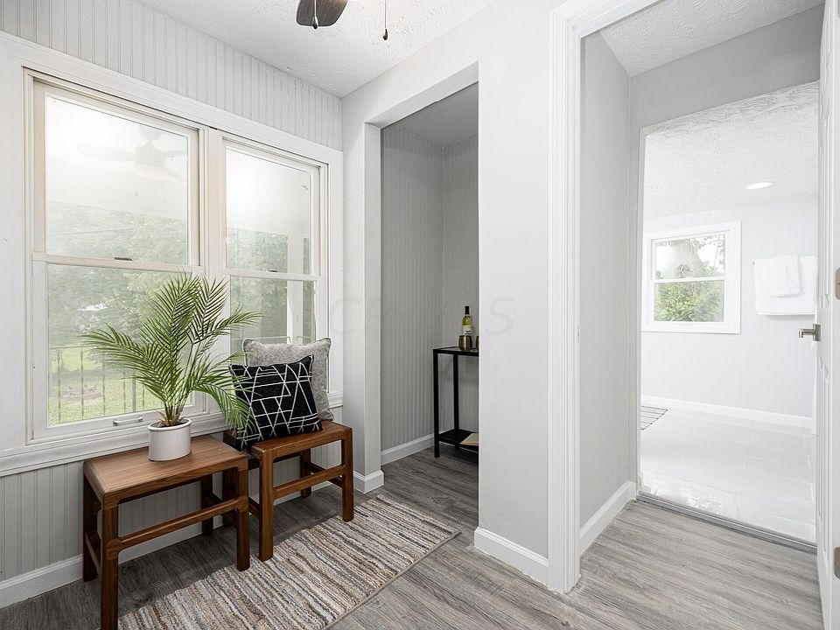
- 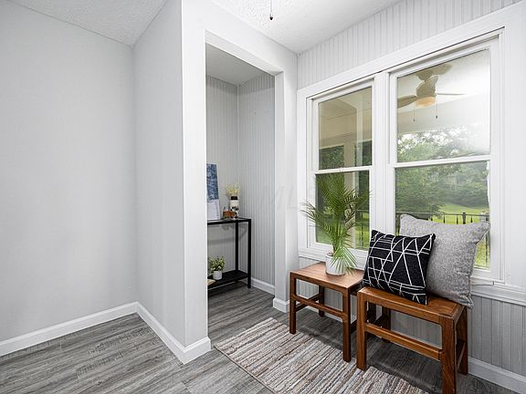
- 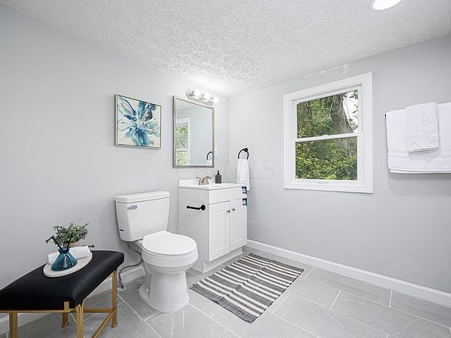
- 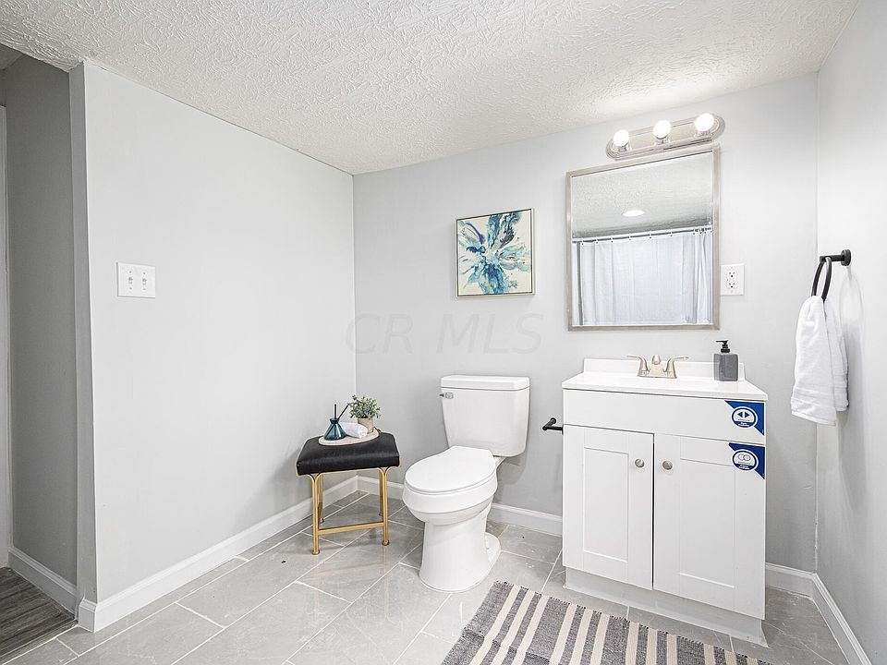
- 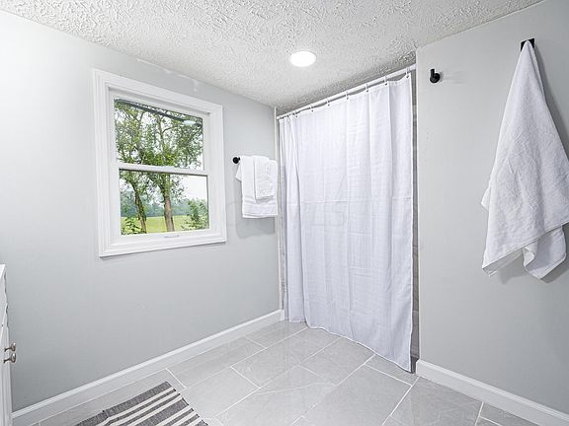
- 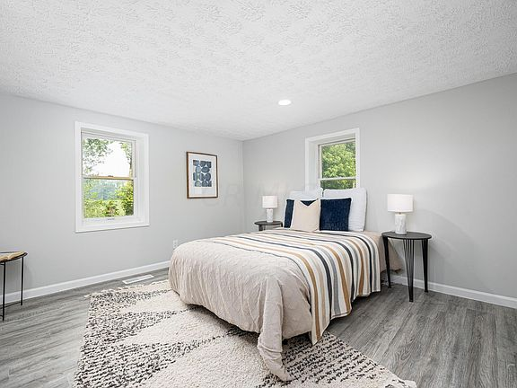
- 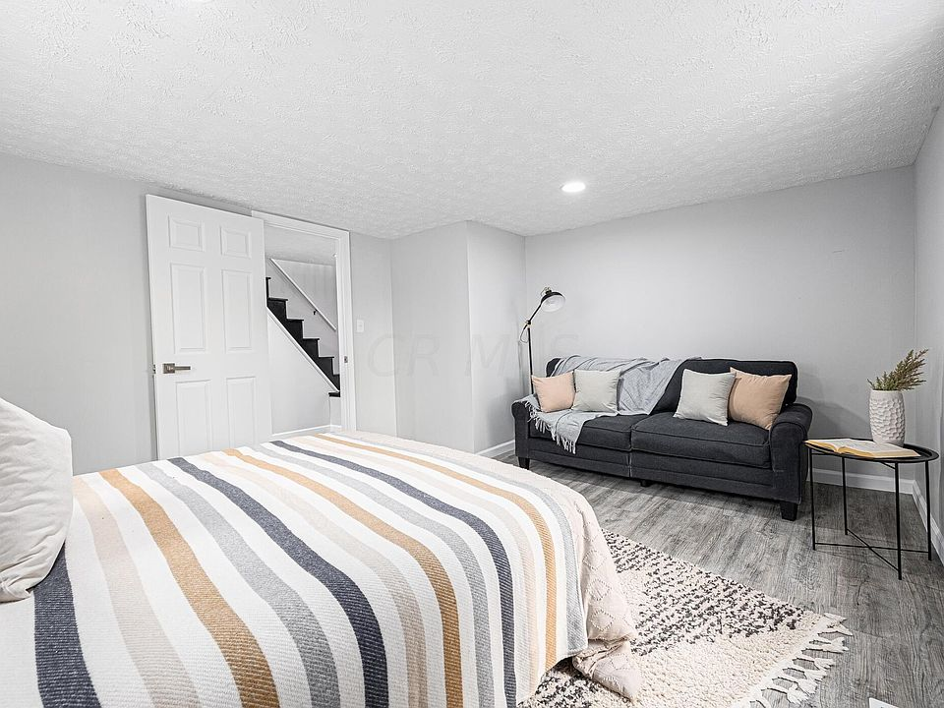
- 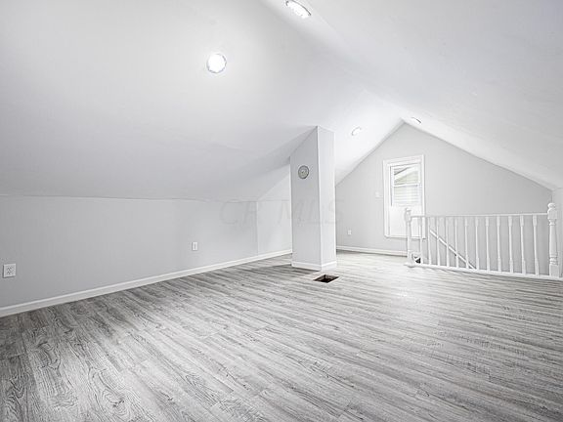
- 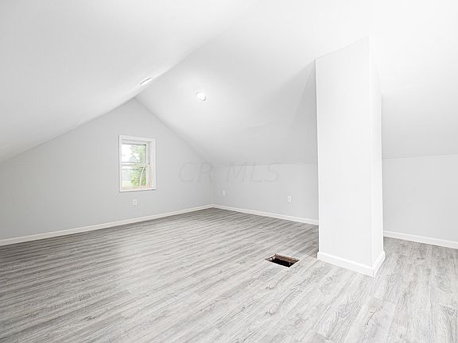
- 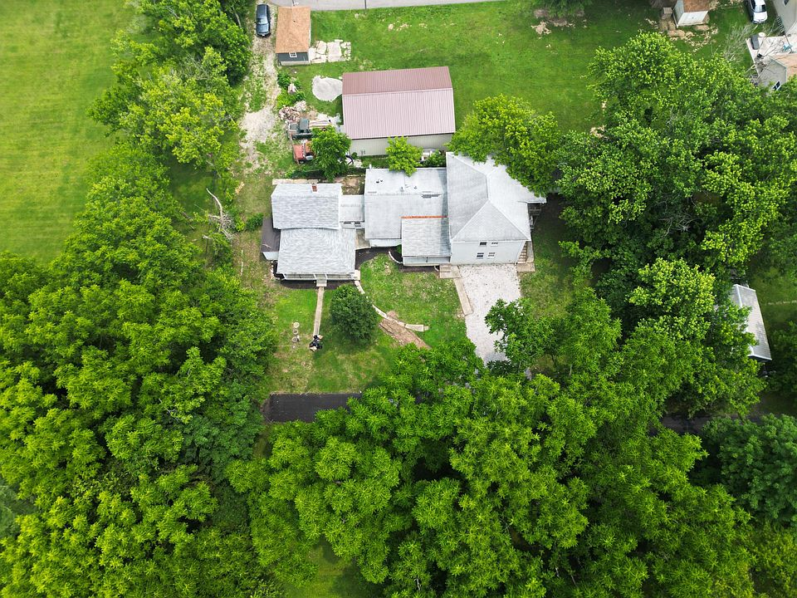
- 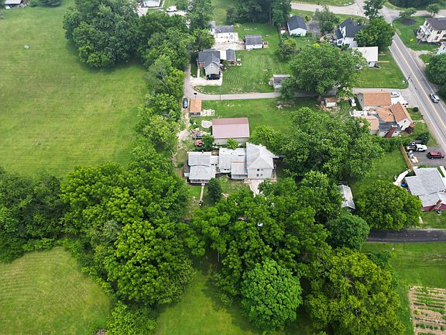
- 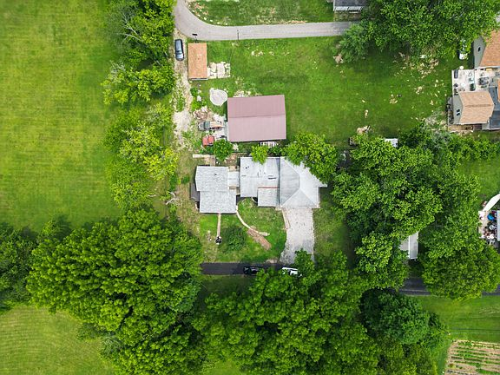
- 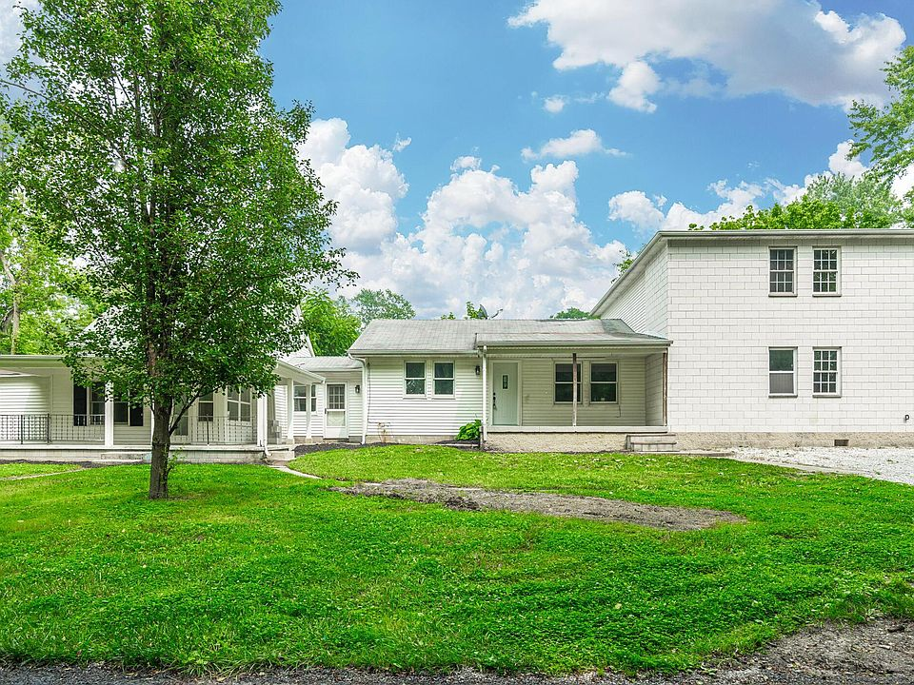
- 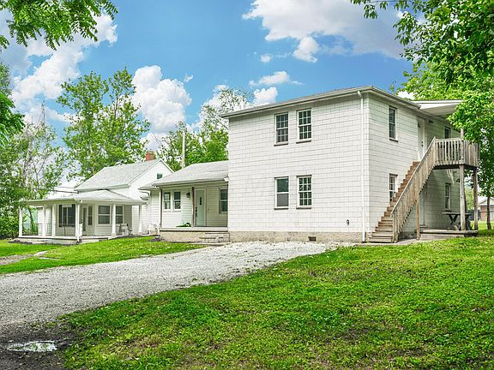
- 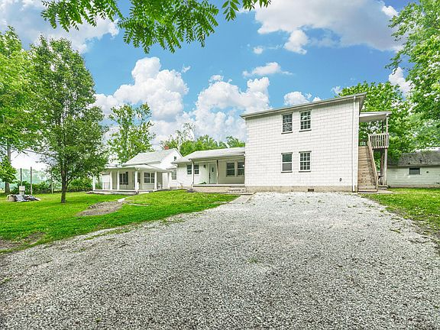

AUCTION PROPERTY
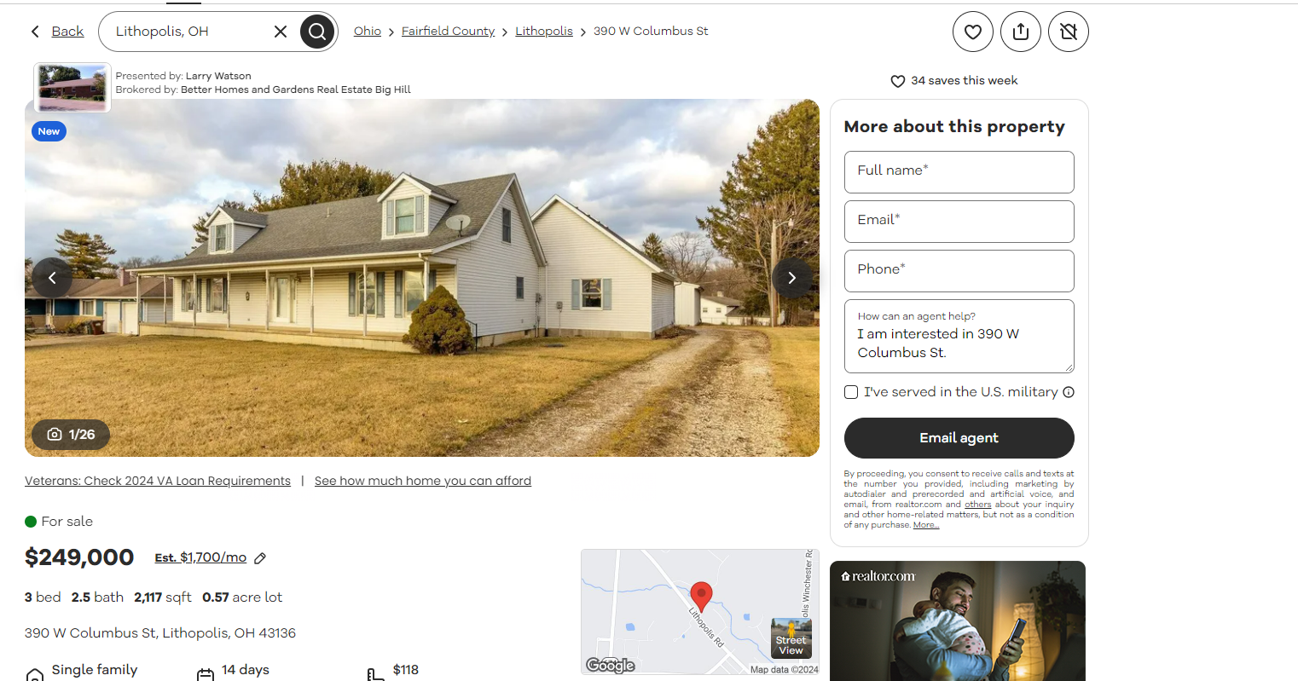

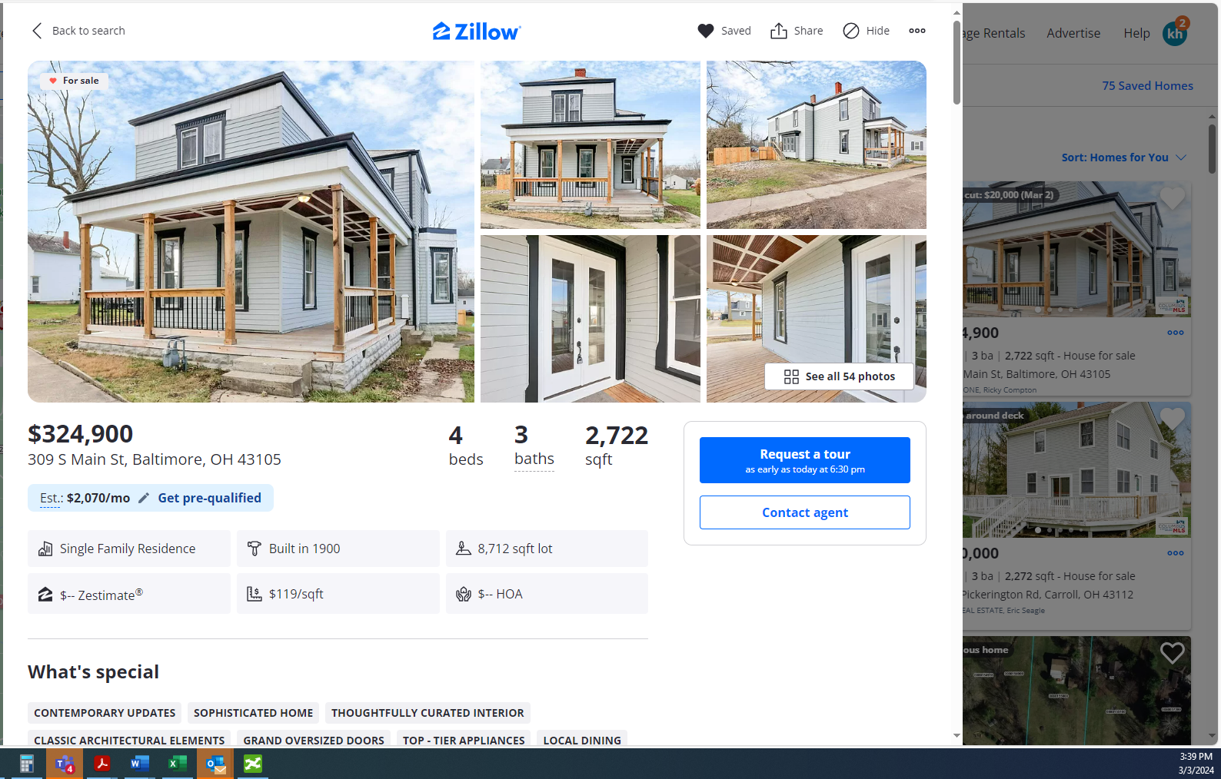

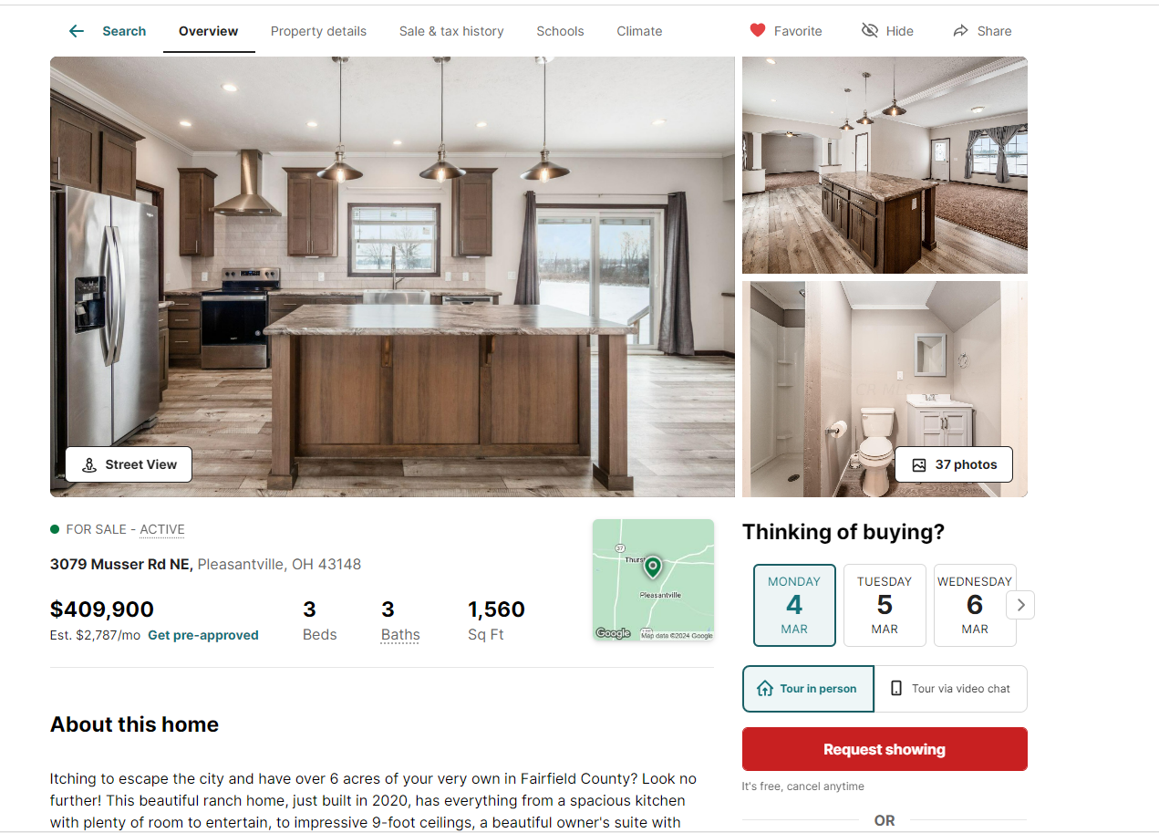

111621 YOUNG
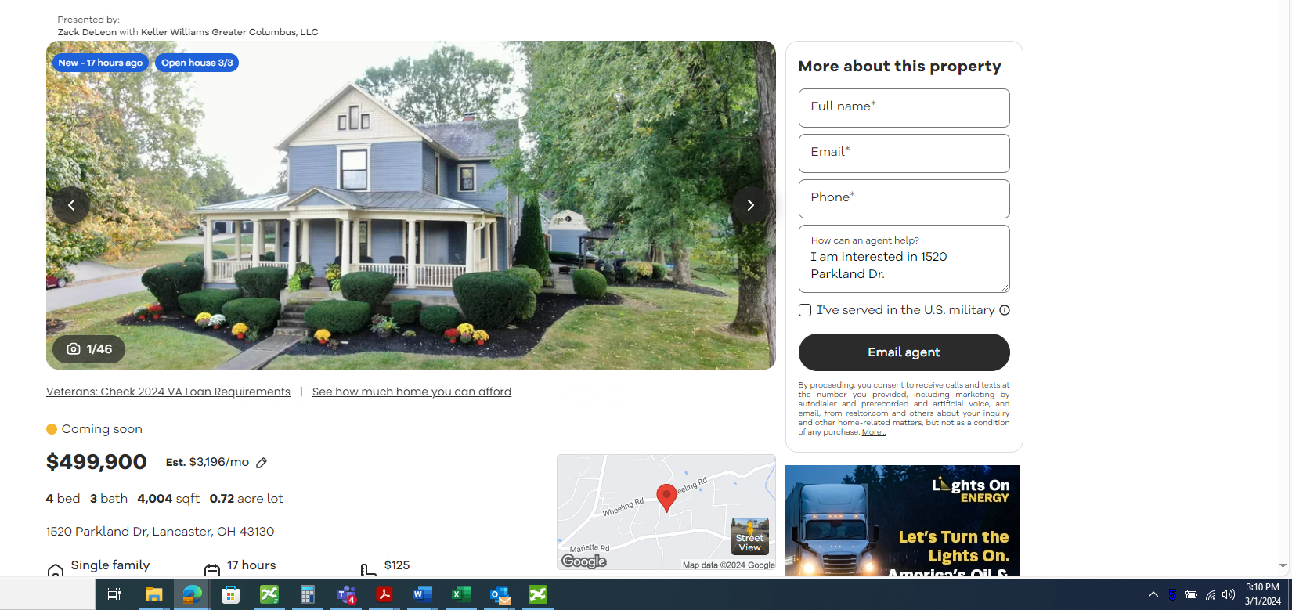

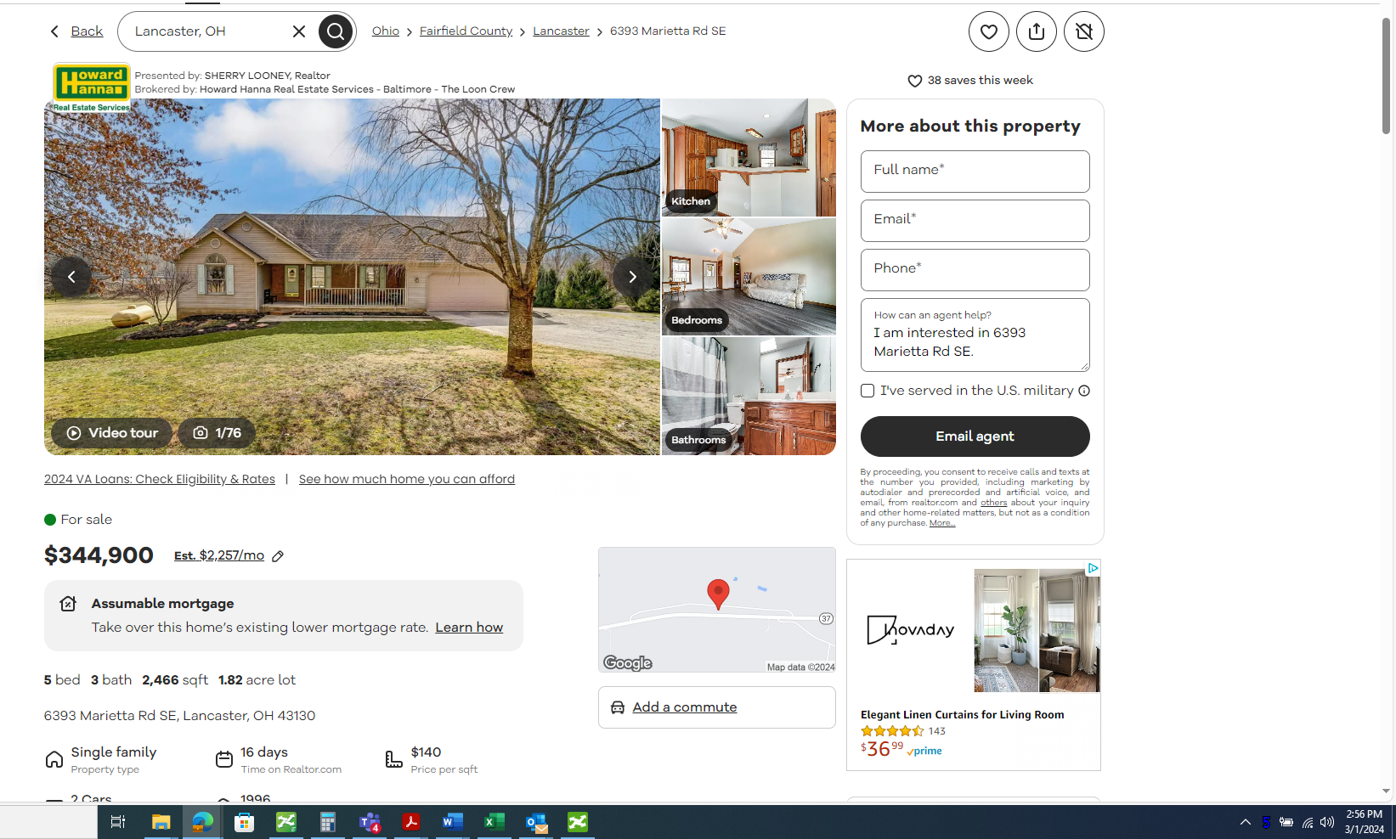

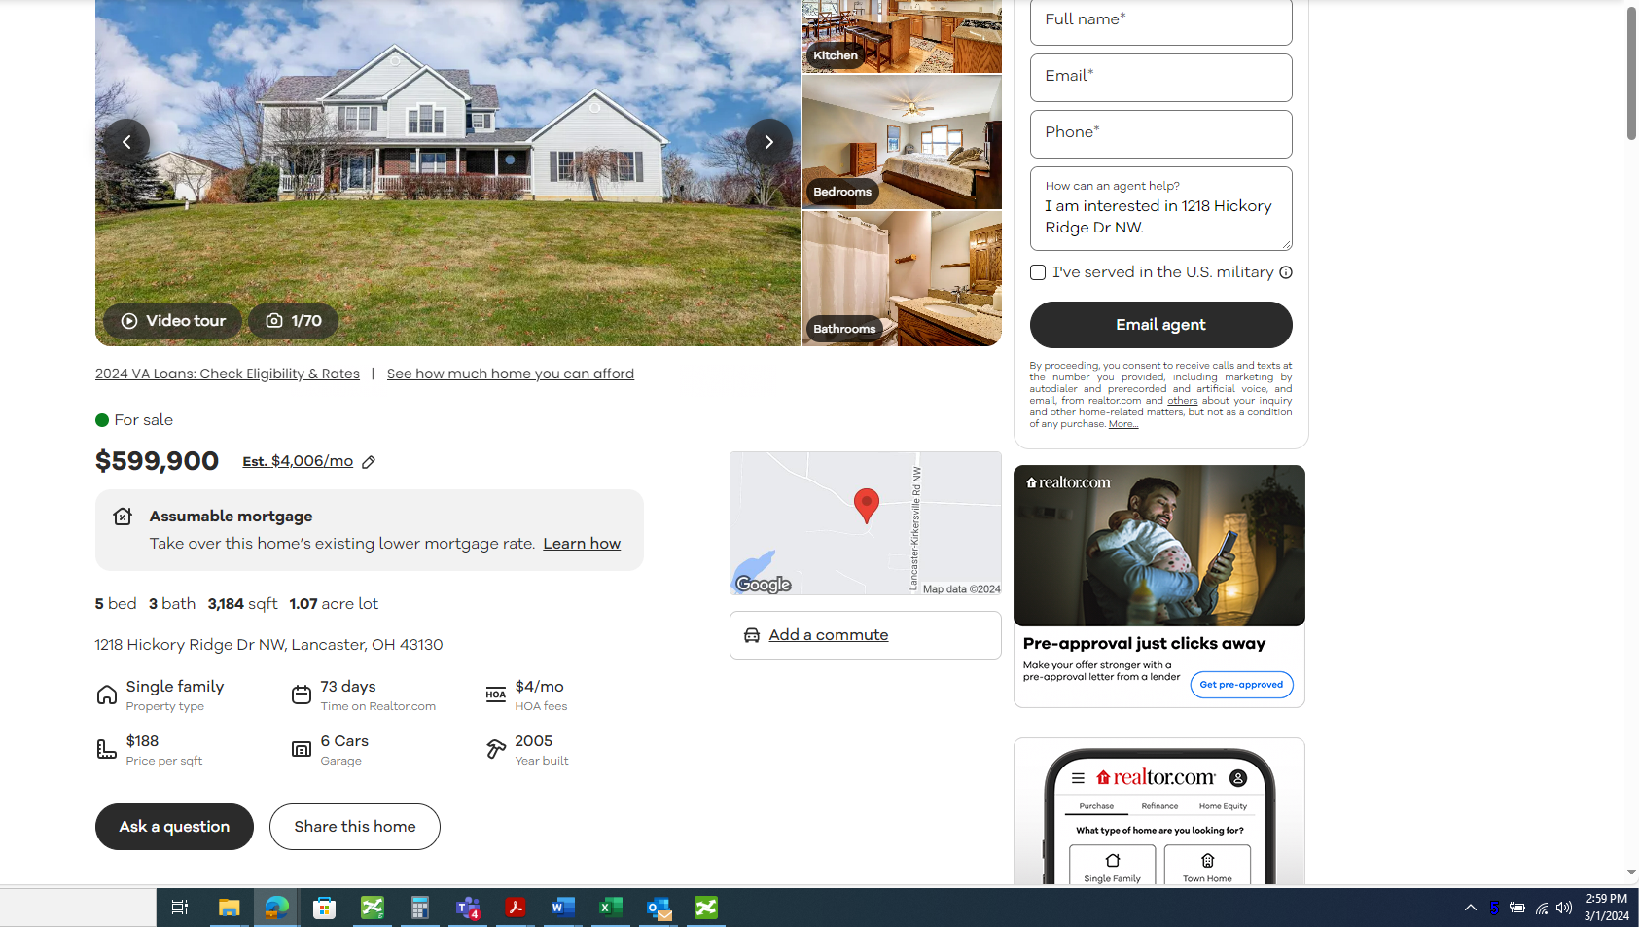

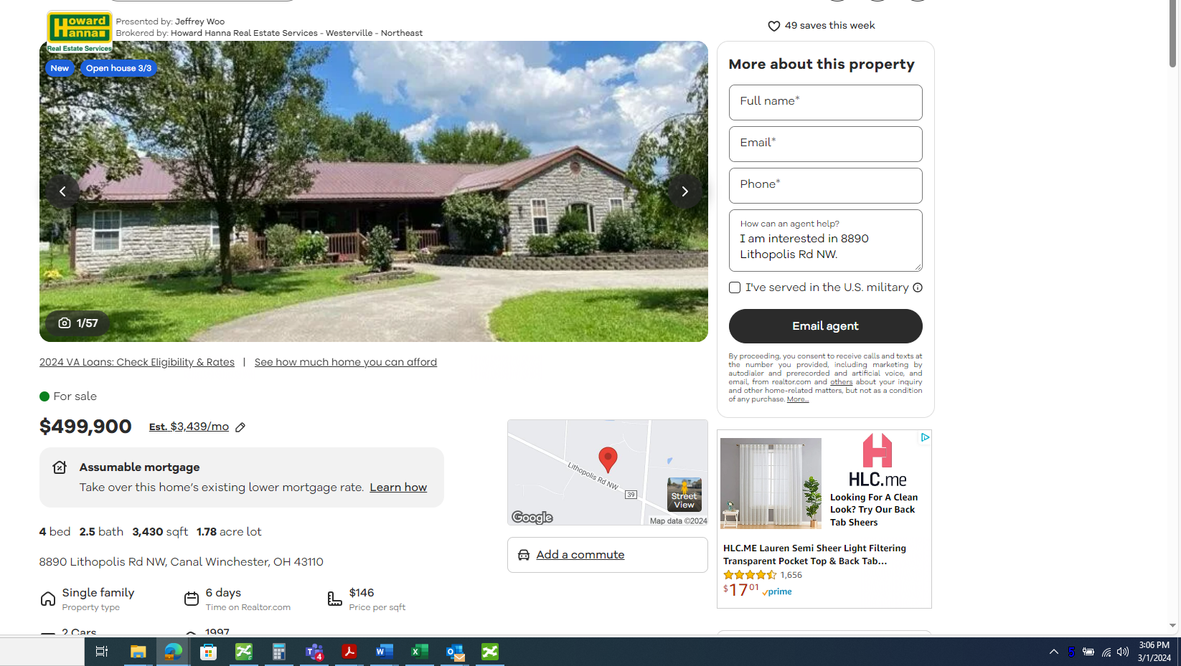

111621 HORN

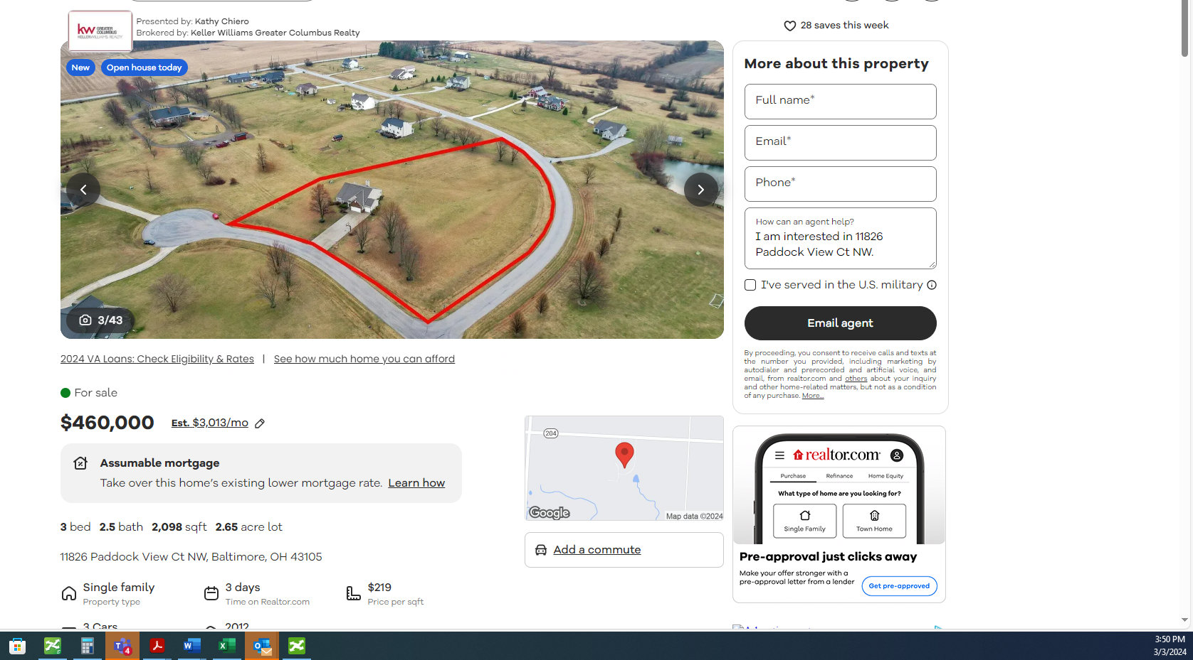

- Manage Rentals

- Advertise
- Help
- kh
2
Back to listing
Save
Share
Hide
OverviewFacts & featuresMarket valuePayment calculatorNeighborhood
Contingent
See all 43 photos
• 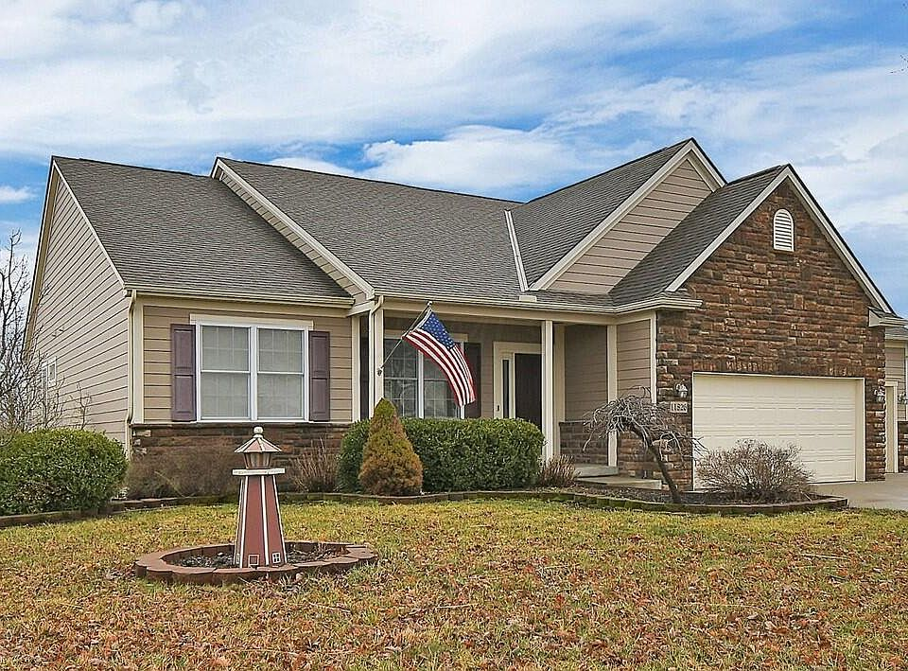
• 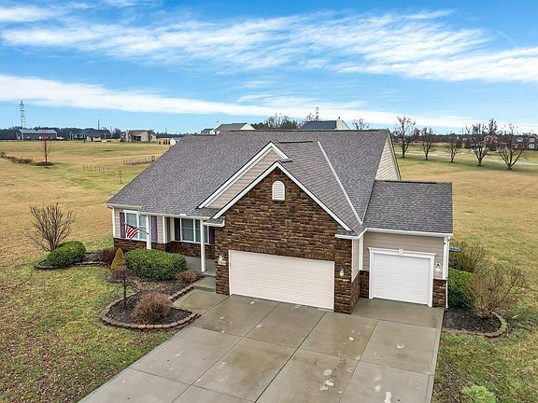
• 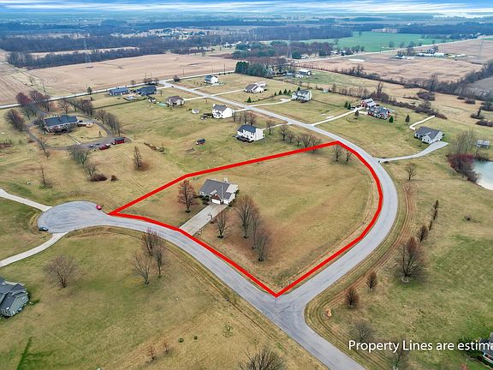
• 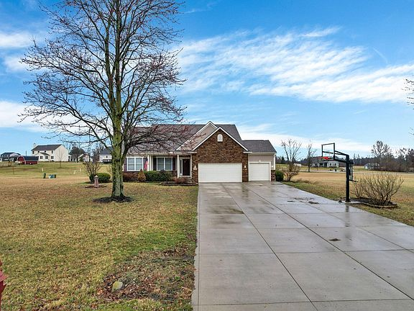
• 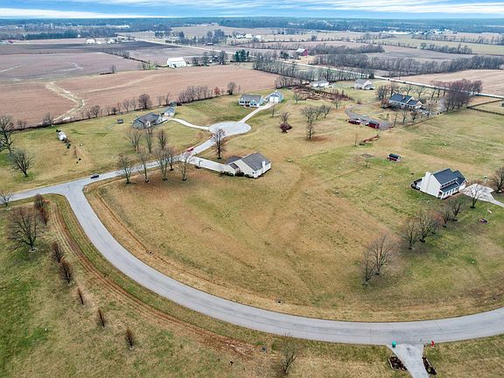
$460,000

11826 Paddock View Ct NW, Baltimore, OH 43105
3beds
3baths
2,098sqft
Est.: $2,930/moEdit your inputGet pre-qualified
Single Family Residence
Built in 2012
2.65 Acres lot
$-- Zestimate®
$219/sqft
$-- HOA

What's special
OPEN FLOOR PLANPOTENTIAL LIVING SPACEPOND VIEWUPGRADED SS STOVECUSTOM ORGANIZERSPENDANT LIGHTINGGRANITE TOP
Open Sunday, 3/3 2-4:00 p.m. Stunning, rarely available ranch on 2.65 acres w/pond view. Entire main flr is hrdwd flrs, 9' ceilings, open floor plan. FDR opens to GR w/vaulted clgs, gas FP, bay eat-in area and brand new kitchen ('24) features upgraded ''soft close'' cabinetry, huge eating bar w/granite top, pendant lighting. Upgraded SS stove & microwave ('23-'24) Two Guest BR's w/shared bath, Owner's suite has luxury bath w/dual sinks, large shower, walk-in closet w/custom organizers. Unfinished FULL, poured wall basement, w/egress window adds over 1000 SF of potential living space. 3-car garage and additional parking, concrete driveway. Saddlebrook community is accessed within 10 minutes of I-70, rural peace, close-to-the-city convenience.
Show more
6 days
on Zillow
|
1,001
views
|
106
saves
|
Likely to sell faster than 99 % nearby
Zillow last checked: 3 hours ago
Listing updated: March 04, 2024 at 03:13am
Listed by:
Kathy L Chiero 614-218-1010,
Keller Williams Greater Cols
Source: Columbus and Central Ohio Regional MLS ,MLS#: 224005783

Travel times

Get pre-qualified for a loan
At Zillow Home Loans, we can pre-qualify you in as little as 3 minutes with no impact to your credit score.
An equal housing lender. NMLS #10287.
Start now

Facts & features

Interior

Bedrooms & bathrooms
- Bedrooms: 3
- Bathrooms: 3
- Full bathrooms: 2
- 1/2 bathrooms: 1
- Main level bathrooms: 3
- Main level bedrooms: 3

Bedroom
- Level: 3

Dining room
- Level: 1

Family room
- Level: 0

Kitchen
- Level: First

Basement
- Basement: Full

Flooring
- Flooring: Wood

Heating
- Heating features: Natural Gas

Cooling
- Cooling features: Central Air

Appliances
- Appliances included: Dishwasher, Electric Range, Gas Water Heater, Microwave, Refrigerator
- Laundry features: 1st Flr Laundry

Interior features
- Window features: Insulated Windows

Other interior features
- Total structure area: 2,098
- Total interior livable area: 2,098 sqft
- Total number of fireplaces: 1
- Fireplace features: Gas Log, One

Property

Parking
- Total spaces: 3
- Parking features: 3 Car Garage, Attached, Garage Door Opener
- Garage spaces: 3
- Covered spaces: 3

Property
- Levels: One
- Stories: 1
- Exterior features: Waste Tr/Sys
- View description: Water
- Has waterview: Yes
- Waterview: Water

Lot
- Lot size: 2.65 Acres

Other property information
- Parcel number: 0230123500

Construction

Type & style
- Home type: SingleFamily
- Architectural style: 1
- Property subType: Single Family Residence

Material information
- Construction materials: Brick, Fiber Cement

Condition
- New construction: No
- Year built: 2012

Utilities & green energy

Utility
- Sewer information: Private Sewer
- Water information: Well

Community & neighborhood

Location
- Region: Baltimore
- Subdivision: Saddlebrook Farms

HOA & financial

Other financial information
- Buyer's Agency fee: 3.00%

Other

Other facts
- Listing terms: Conventional
Show more

Services availability

Make this home a reality

Get pre-qualifiedBe ready to make an offer.
Connect with an agentGet info on this home, tour, and more.
Calculate monthly paymentSee if you can afford this home.

Price history
Date | Event | Price
3/4/2024 | Contingent | $460,000$219/sqft
Source: Columbus and Central Ohio Regional MLS #224005783 Report a problem
2/29/2024 | Listed for sale | $460,000+22.7%$219/sqft
Source: Columbus and Central Ohio Regional MLS #224005783 Report a problem
3/3/2020 | Sold | $375,000-3.8%$179/sqft
Source: Public Record Report a problem
2/26/2020 | Listed for sale | $389,900$186/sqft
Source: HER, Realtors #219031362 Report a problem
1/15/2020 | Pending sale | $389,900$186/sqft
Source: HER Realtors #219031362 Report a problem
Show more

Public tax history
Year | Property taxes | Tax assessment
2022 | $5,215 -2.9% | $123,570 +5.4%
2021 | $5,369 -0.4% | $117,280
2020 | $5,390 0% | $117,280
Show more
Find assessor info on the county website

Monthly payment calculator
Estimated monthly payment$2,931

Principal & interest
$2,329

Mortgage insurance
$0

Property taxes
$441

Home insurance
$161

HOA fees
N/A

Utilities
Not included
All calculations are estimates and provided by Zillow, Inc. for informational purposes only. Actual amounts may vary.
Mortgage interest rates are dependent on a number of factors, including credit score, down payment, and repayment length. Interest rate data provided by Zillow Group Marketplace, Inc. as of 3/6/2024 from various mortgage lenders with which we have lead or other similar arrangements; the Estimated Payment is an average of those rates.
See how much you could borrow to make a competitive offer.
Get pre-qualified

Down payment assistance
19 programs may be available to provide you with up to $23,000 in down payment assistance, depending on your specific information.
Check eligibility
Source: Down Payment Resource®

Getting around

Nearby schools

GreatSchools rating
- 7/10
Millersport Elementary School
Grades: K-6Distance: 3 mi
- 5/10
Millersport Jr/Sr High School
Grades: 7-12Distance: 3 mi
Show more

Schools provided by the listing agent
- District: WALNUT TOWNSHIP LSD 2308 FAI CO.
Source: Columbus and Central Ohio Regional MLS . This data may not be complete. We recommend contacting the local school district to confirm school assignments for this home.
Skip carousel

Nearby homes
Previous itemsNext items
Skip to the end of the carousel

$485,000
4 bd|3 ba|3.4k sqft
11837 Saddlebrook Dr NW, Baltimore, OH 43105
Sold
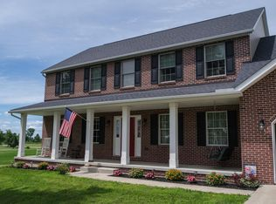

$535,900
4 bd|3 ba|2.4k sqft
Saddlebrook Dr NW, Baltimore, OH 43105
Off Market
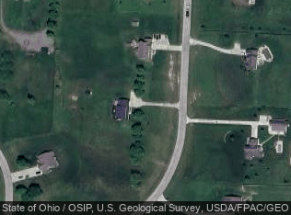

$1,210
-- bd|-- ba|-- sqft
Saddlebrook Dr NW, Baltimore, OH 43105
Off Market

$481,200
3 bd|2 ba|2.2k sqft
Saddlebrook Dr NW, Baltimore, OH 43105
Off Market

$32,065
-- bd|-- ba|-- sqft
Saddlebrook Dr NW, Baltimore, OH 43105
Off Market

$1,210
-- bd|-- ba|-- sqft
Saddlebrook Dr NW, Baltimore, OH 43105
Off Market

$311,200
2.133 Acres
11819 Paddock View Ct NW, Baltimore, OH 43105
Off Market
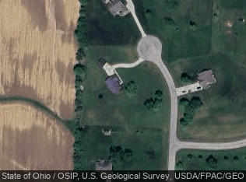

$58,880
2.3 Acres
11864 Paddock View Ct NW, Baltimore, OH 43105
Off Market
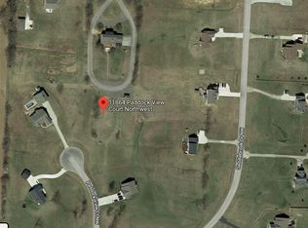

Skip to the beginning of the carousel
Skip carousel

Local experts in 43105
A local agent can set up tours, give advice and negotiate with sellers.
Browse local experts
A local lender can help you make sure your offer is ready when you are.
Lori Ashcraft
NMLS #968500
Brian Courtney
NMLS #912587

Local legal protections
Current legal protections at the county level in Fairfield County
Show more
IDX information is provided exclusively for personal, non-commercial use, and may not be used for any purpose other than to identify prospective properties consumers may be interested in purchasing. Information is deemed reliable but not guaranteed.
The listing broker’s offer of compensation is made only to participants of the MLS where the listing is filed.
- Contact agent
- Ohio
- Fairfield County
- Baltimore
- 43105
- 11826 Paddock View Ct NW

Nearby cities
- Amanda Real estate
- Baltimore Real estate
- Bremen Real estate
- Canal Winchester Real estate
- Carroll Real estate
- Lancaster Real estate
- Millersport Real estate
- Pickerington Real estate
- Stoutsville Real estate
- West Rushville Real estate
Show more
- About
- Zestimates
- Research
- Careers
- Careers - U.S. Privacy Notice
- Careers - Mexico Privacy Notice
- Help
- Advertise
- Fair Housing Guide
- Terms of use
- Privacy Portal
- Cookie Preference
- Blog
- AI
- Mobile Apps
- Trulia
- StreetEasy
- HotPads
- Out East
- ShowingTime+
Do Not Sell or Share My Personal Information→
Zillow Group is committed to ensuring digital accessibility for individuals with disabilities. We are continuously working to improve the accessibility of our web experience for everyone, and we welcome feedback and accommodation requests. If you wish to report an issue or seek an accommodation, please let us know.
Zillow, Inc. holds real estate brokerage licenses in multiple states. Zillow (Canada), Inc. holds real estate brokerage licenses in multiple provinces.
§ 442-H New York Standard Operating Procedures
§ New York Fair Housing Notice
TREC: Information about brokerage services, Consumer protection notice
California DRE #1522444Contact Zillow, Inc. Brokerage
For listings in Canada, the trademarks REALTOR®, REALTORS®, and the REALTOR® logo are controlled by The Canadian Real Estate Association (CREA) and identify real estate professionals who are members of CREA. The trademarks MLS®, Multiple Listing Service® and the associated logos are owned by CREA and identify the quality of services provided by real estate professionals who are members of CREA. Used under license.

- Follow us:Visit us on facebookVisit us on instagramVisit us on tiktok
- © 2006 to 2024 Zillow© 2006-2024 ZillowEqual Housing Opportunity

- 
 