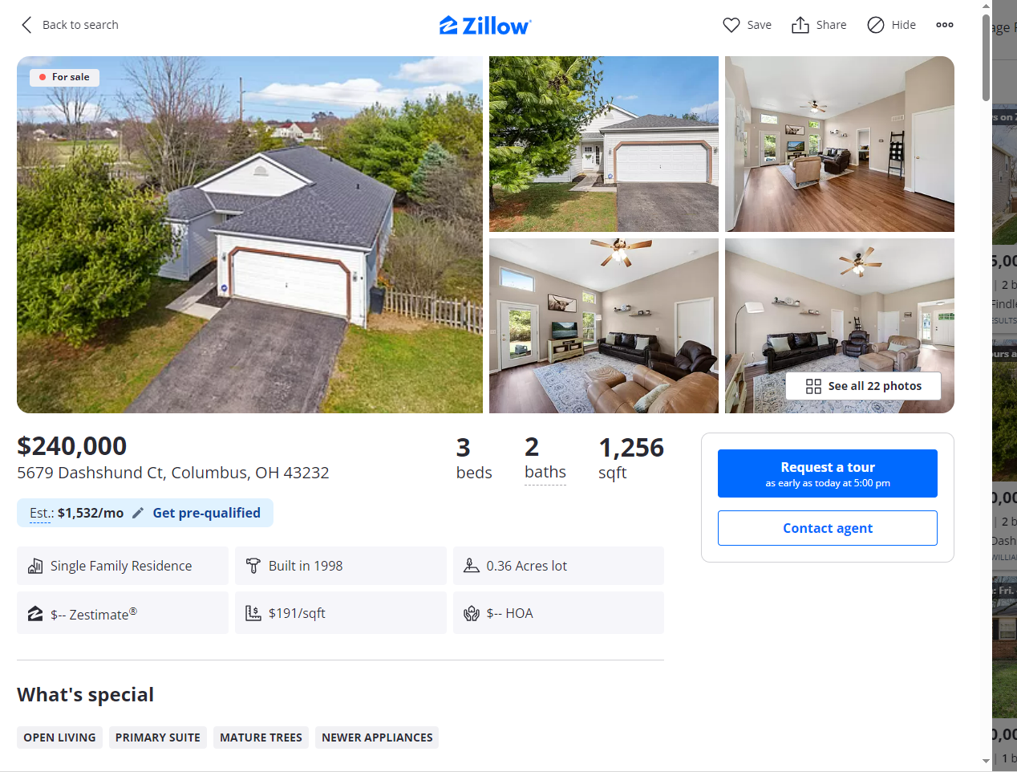
1 moreLancaster OH

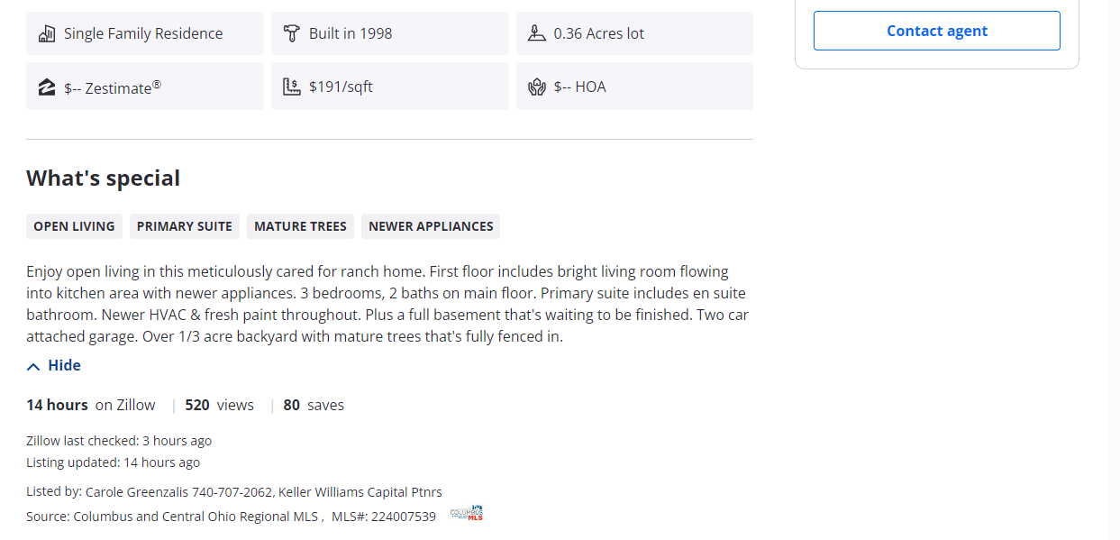

For Sale
Price
2+ bd, 1+ ba
Home Type (1)
More (4)
Save search

97 Saved Homes

Columbus OH, Lancaster OH Single Family Homes
228 results
Sort: Homes for You

1568 Hocking Valley Pl, Lancaster, OH 43130

HOWARD HANNAREALESTATESERVICES, Leanne Henry

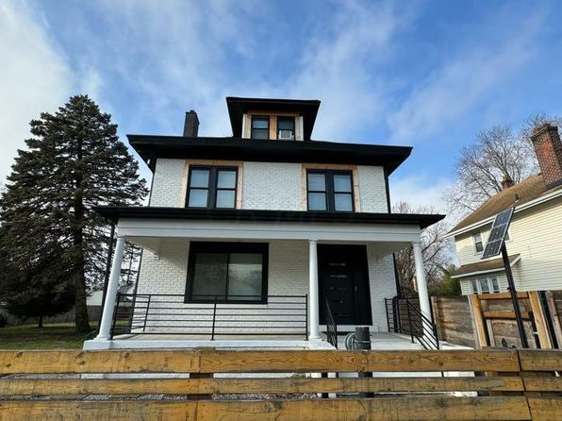

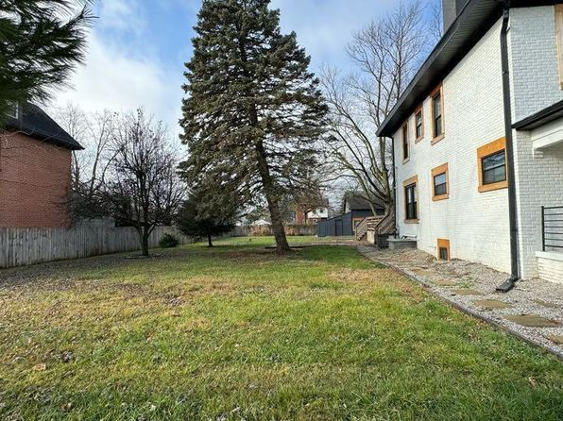

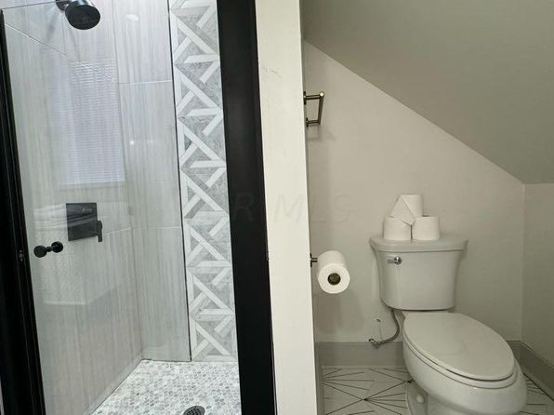

Use arrow keys to navigate
Image 1 of 57

6433 Brice Dale Dr, Canal Winchester, OH 43110

ART RUSSO, REALTORS, Brandon Griffin
$299,500
  - 3 bds
  - 3 ba
  - 1,560 sqft
- House for sale
Show more
Price cut: $15,500 (Mar 12)
Previous photoNext photo

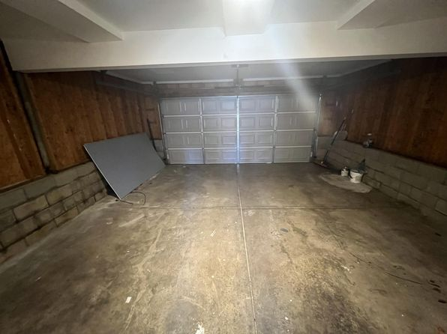

Use arrow keys to navigate

Use arrow keys to navigate
Image 1 of 35

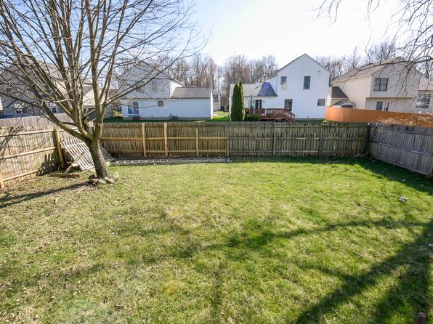

Use arrow keys to navigate
  - Image 1 of 38

  - 549 E Gates St, Columbus, OH 43206

  - RED 1 REALTY, Carly Kauppila
  - $369,999
  - 4 bds
  - 3 ba

Use

Previous photoNext photo

5679 Dashshund Ct, Columbus, OH 43232

KELLER WILLIAMS CAPITAL PTNRS, Carole Greenzalis
$240,000
  - 3 bds
  - 2 ba
  - 1,256 sqft
- House for sale
Show more
18 hours ago
Previous photoNext photo

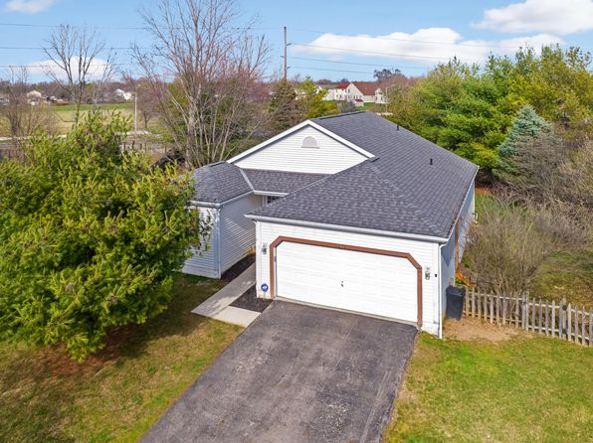

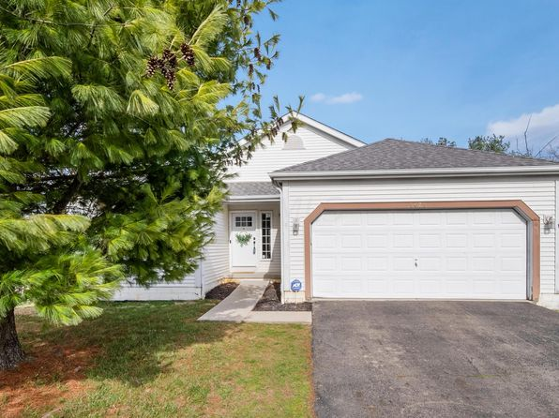

Open: Sat. 1-3pm

Use arrow keys to navigate
Image 1 of 36

5348 Woodglen Rd, Columbus, OH 43214

RE/MAX REVEALTY, Courtney Campagna
$290,000
  - 3 bds
  - 1 ba
  - 1,132 sqft
- House for sale
Show more
Open: Fri. 4-6pm

3494 Makady Ct, Canal Winchester, OH 43110

KELLER WILLIAMS GREATER COLS, Darrell L Hunter
$274,900
  - 3 bds
  - 2 ba
  - 1,336 sqft
- House for sale
Show more
Open: Sun. 2-4pm
Previous photoNext photo

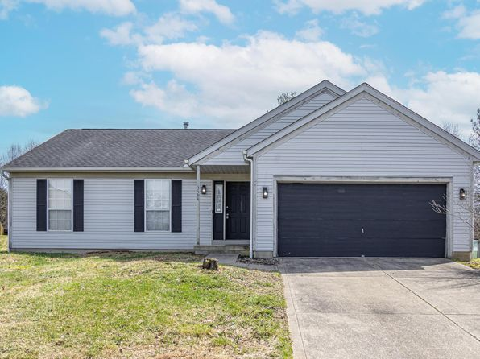

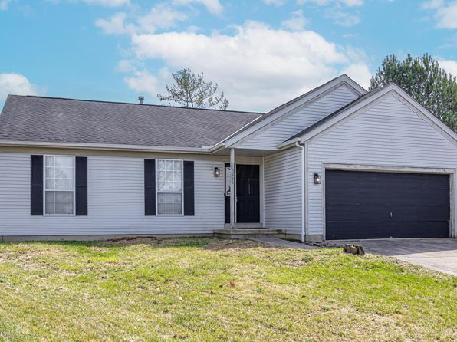

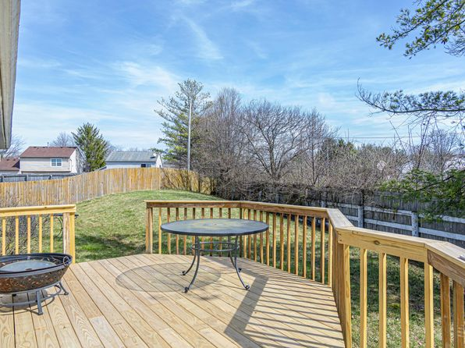

1465 Lockbourne Rd, Columbus, OH 43206

PRODIGY PROPERTIES, Jeffrey S Lane
$230,000
- 5 bds
- 5 ba
- 1,964 sqft
- House for sale
Show more
Multiple shopping
Previous photoNext photo

Use arrow keys to navigate
Image 1 of 57

Keyboard shortcuts
Map data ©2024 Google
Terms of Use
Report a map error
SchoolsRemove Boundary
Map
Zoom InZoom Out
Back to listing
Save
Share
Hide
OverviewFacts & featuresMarket valuePayment calculatorNeighborhood
For sale
See all 22 photos
• 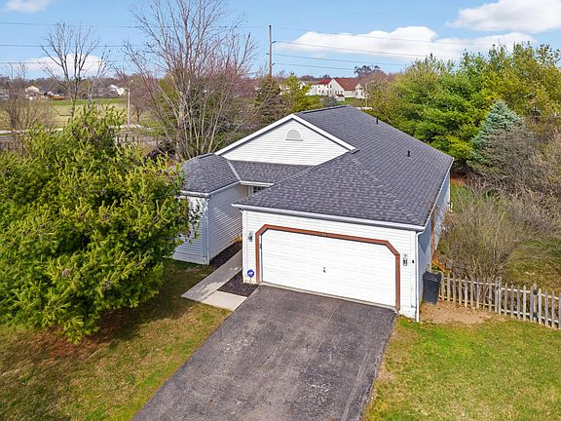
• 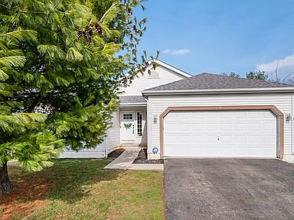
• 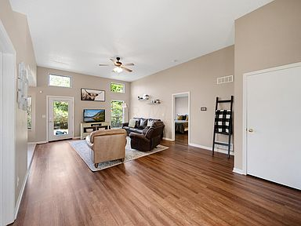
• 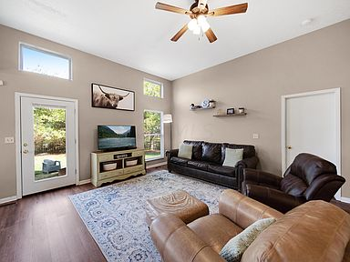
• 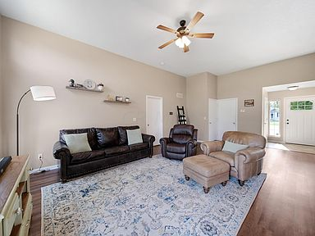
$240,000

5679 Dashshund Ct, Columbus, OH 43232
3beds
2baths
1,256sqft
Est.: $1,532/moEdit your inputGet pre-qualified
Single Family Residence
Built in 1998
0.36 Acres lot
$-- Zestimate®
$191/sqft
$-- HOA

What's special
OPEN LIVINGPRIMARY SUITEMATURE TREESNEWER APPLIANCES
Enjoy open living in this meticulously cared for ranch home. First floor includes bright living room flowing into kitchen area with newer appliances. 3 bedrooms, 2 baths on main floor. Primary suite includes en suite bathroom. Newer HVAC & fresh paint throughout. Plus a full basement that's waiting to be finished. Two car attached garage. Over 1/3 acre backyard with mature trees that's fully fenced in.
Show more
14 hours
on Zillow
|
520
views
|
80
saves
Zillow last checked: 3 hours ago
Listing updated: 14 hours ago
Listed by:
Carole Greenzalis 740-707-2062,
Keller Williams Capital Ptnrs
Source: Columbus and Central Ohio Regional MLS ,MLS#: 224007539

Get pre-qualified for a loan
At Zillow Home Loans, we can pre-qualify you in as little as 3 minutes with no impact to your credit score.
An equal housing lender. NMLS #10287.
Start now

Tour with a buyer’s agent
We’ll find a local expert to take you on a private tour of 5679 Dashshund Ct.

Next available tour time:Today at 5pm
See all available times

Facts & features

Interior

Bedrooms & bathrooms
- Bedrooms: 3
- Bathrooms: 2
- Full bathrooms: 2
- Main level bathrooms: 2
- Main level bedrooms: 3

Bedroom
- Level: 3

Kitchen
- Level: First

Basement
- Basement: Full

Flooring
- Flooring: Ceramic/Porcelain, Vinyl

Heating
- Heating features: Forced Air, Natural Gas

Cooling
- Cooling features: Central Air

Appliances
- Appliances included: Dishwasher, Electric Range, Gas Water Heater, Microwave, Refrigerator
- Laundry features: Lower Level

Interior features
- Window features: Insulated Windows

Other interior features
- Total structure area: 1,256
- Total interior livable area: 1,256 sqft

Property

Parking
- Total spaces: 2
- Parking features: 2 Car Garage, Attached
- Garage spaces: 2
- Covered spaces: 2

Property
- Levels: One
- Stories: 1
- Fencing: Fenced

Lot
- Lot size: 0.36 Acres
- Lot features: Cul-De-Sac

Other property information
- Parcel number: 010239730

Construction

Type & style
- Home type: SingleFamily
- Architectural style: 1
- Property subType: Single Family Residence

Material information
- Construction materials: Vinyl Siding

Condition
- New construction: No
- Year built: 1998

Utilities & green energy

Utility
- Sewer information: Public Sewer

Community & neighborhood

Community
- Community features: Bike/Walk Path

Location
- Region: Columbus

HOA & financial

Other financial information
- Buyer's Agency fee: 3%

Other

Other facts
- Listing terms: Conventional,FHA
Show more
$256,500
3 bd|2 ba|1.2k sqft
5688 Dashshund Ct, Columbus, OH 43232
Off Market
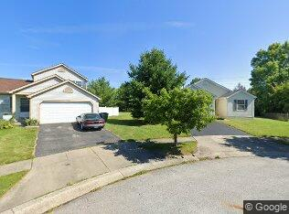

$248,100
3 bd|2 ba|1.2k sqft
5671 Dashshund Ct, Columbus, OH 43232
Off Market
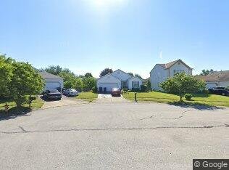

- 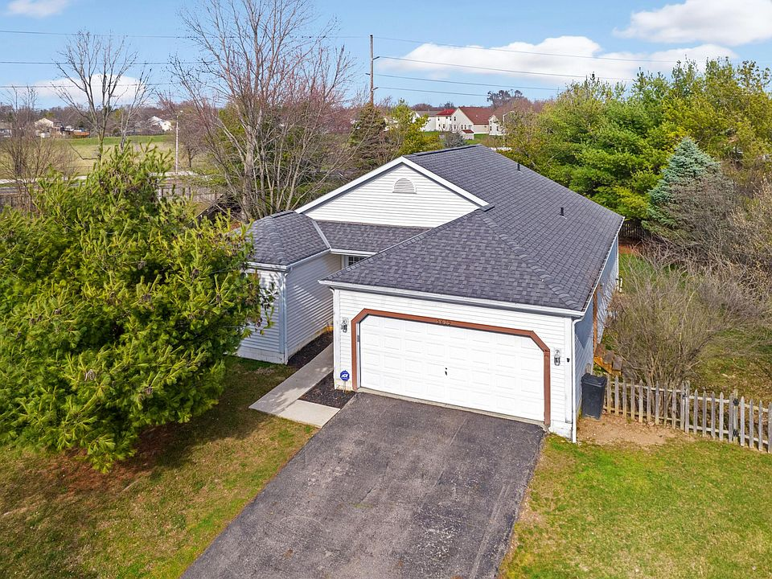
- 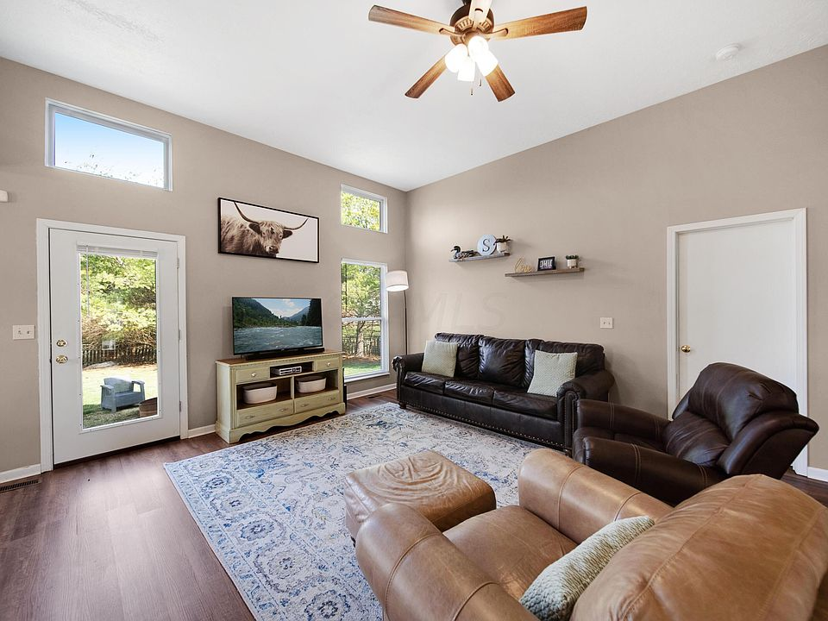
- 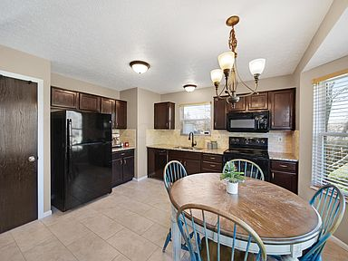
- 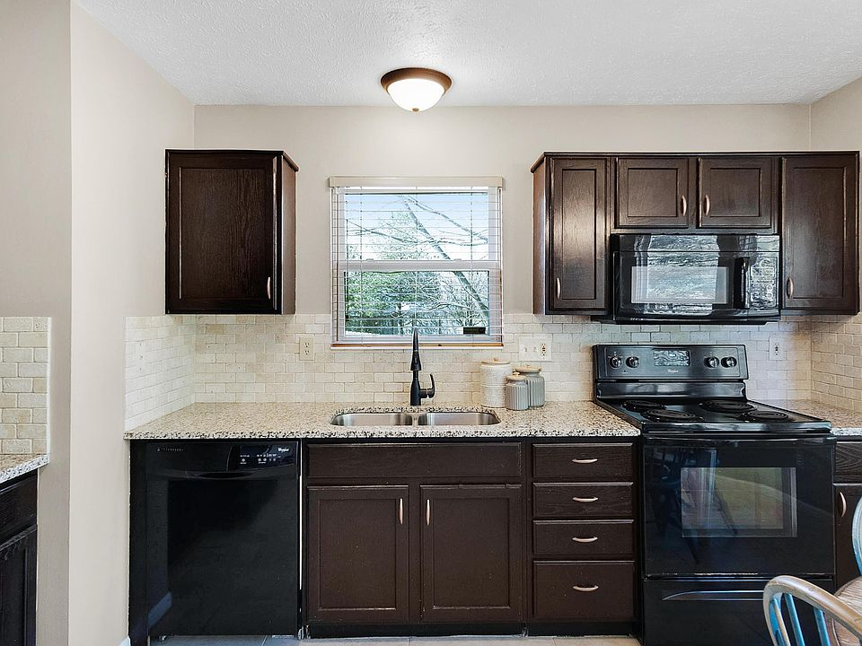
- 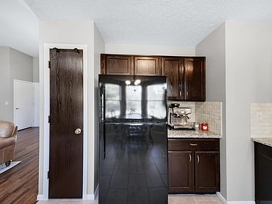
- 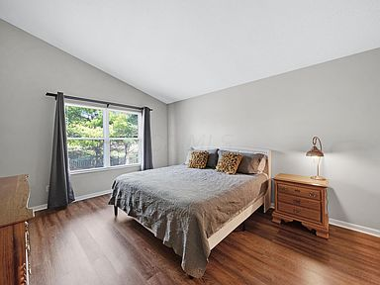
- 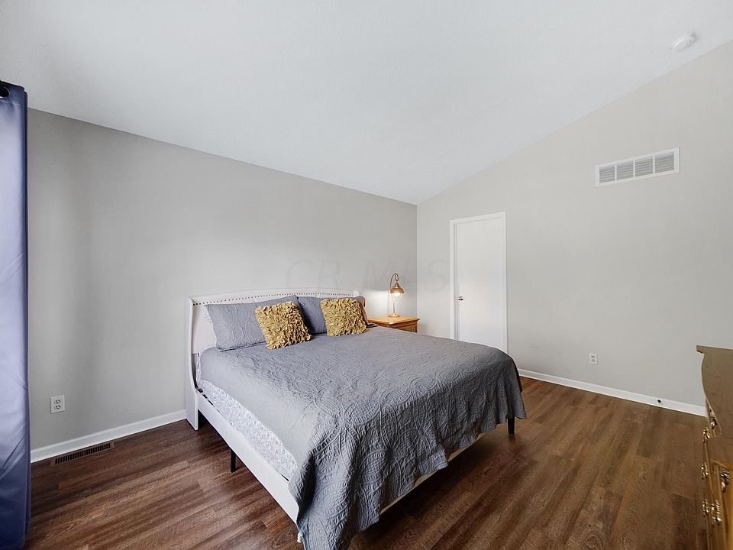
- 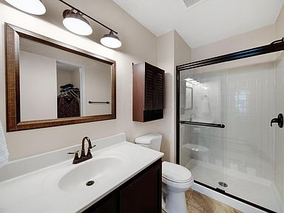
- 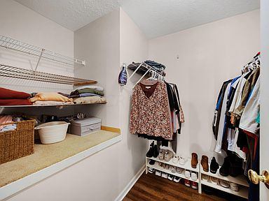
- 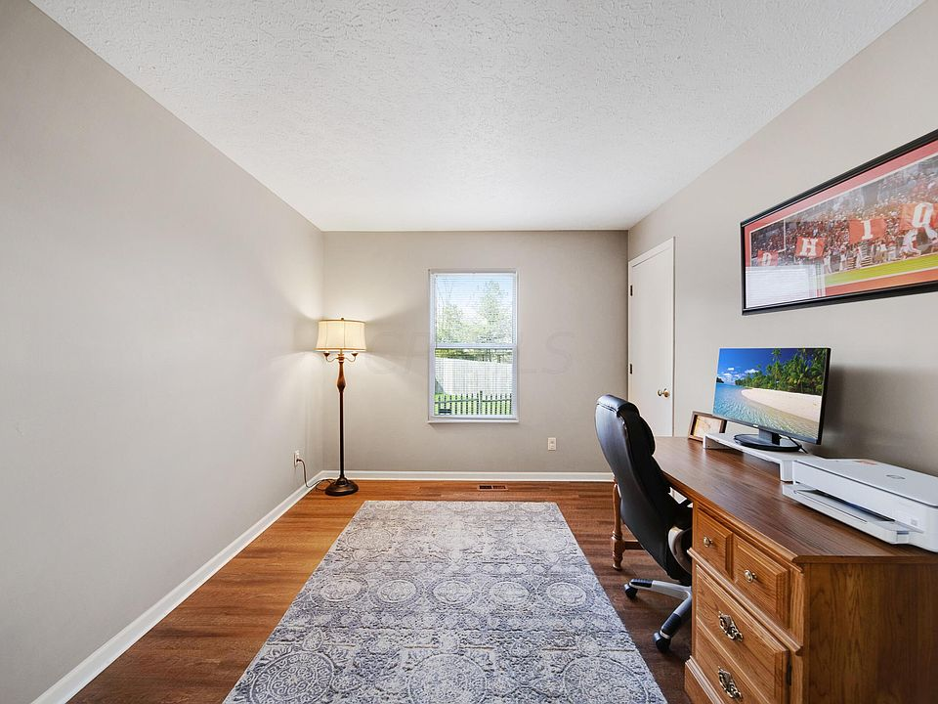
- 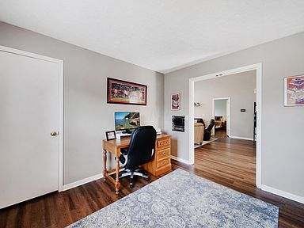
- 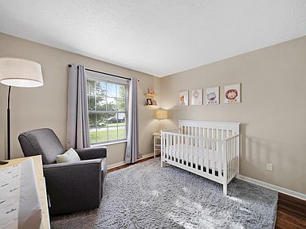
- 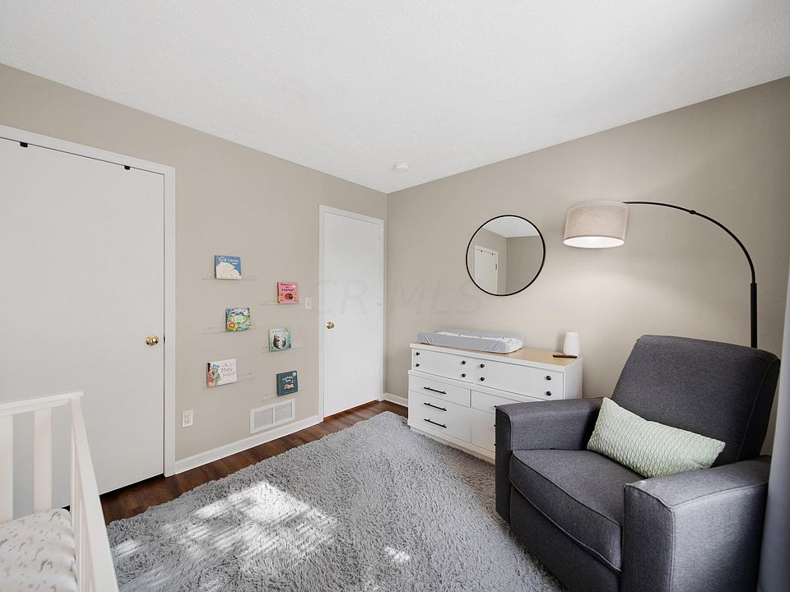
- 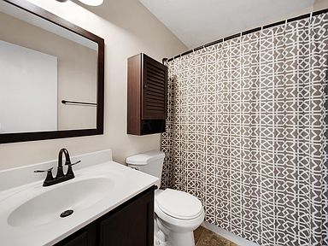
- 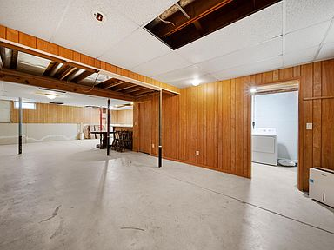
- 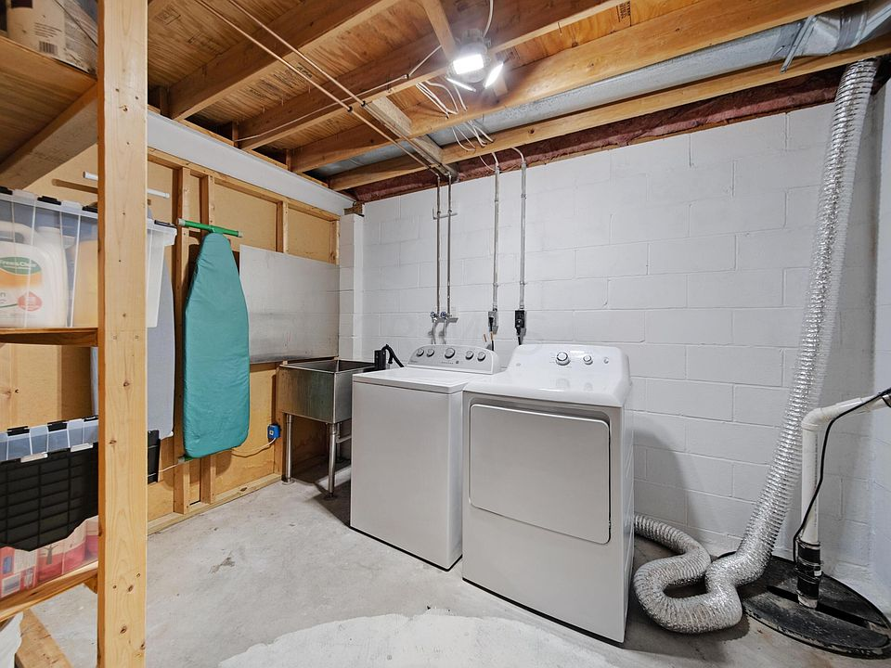
- 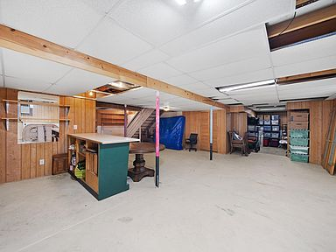
- 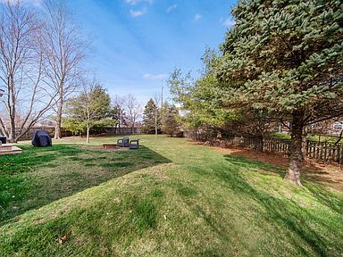
- 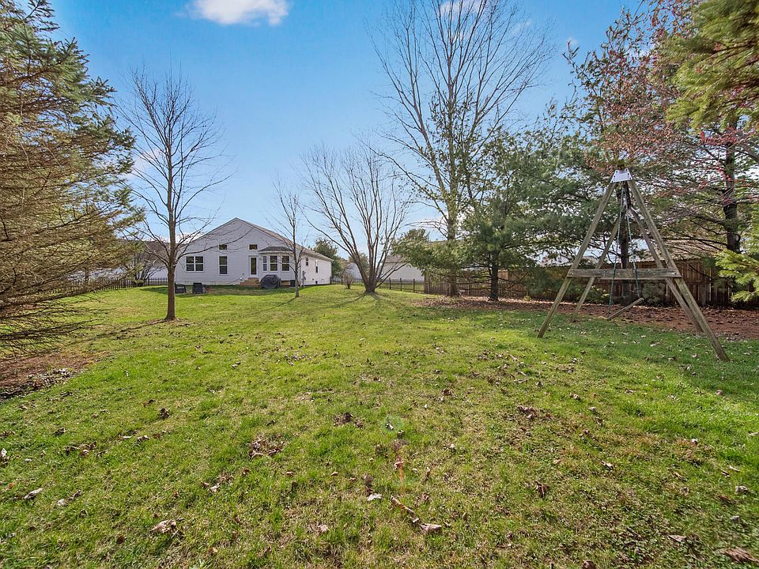

17.8 miles
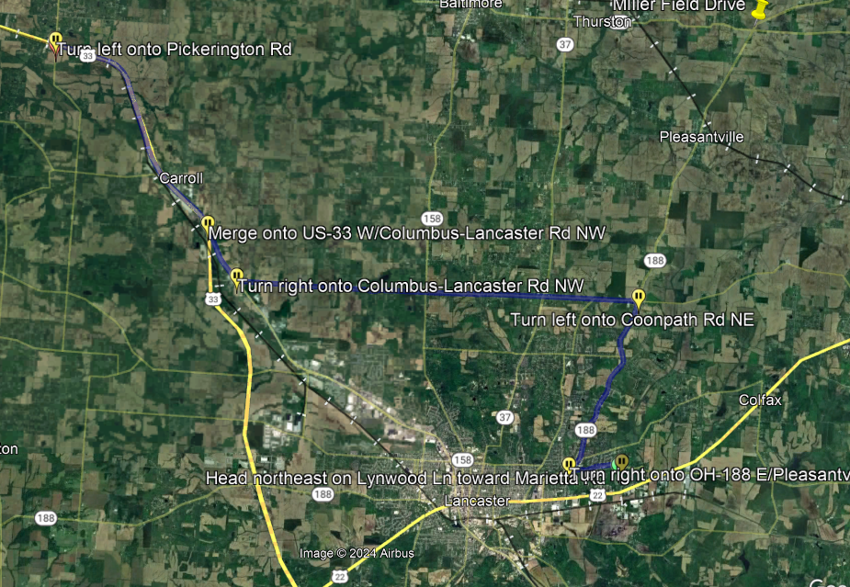
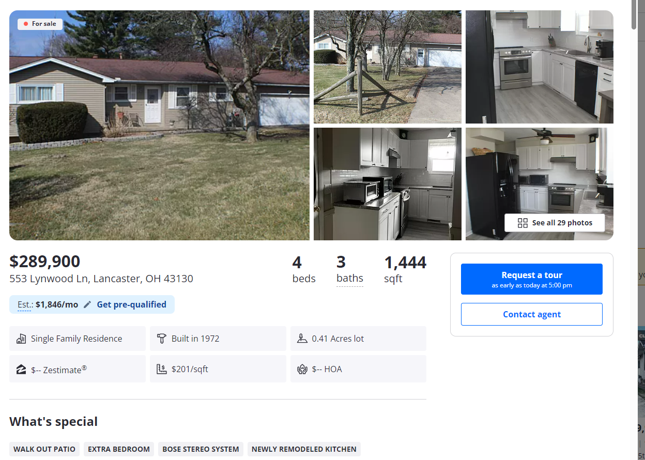

• 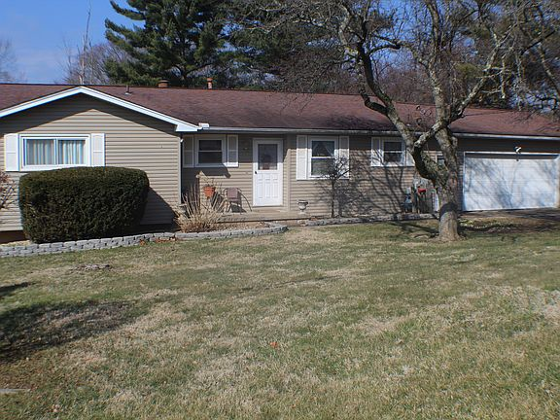
• 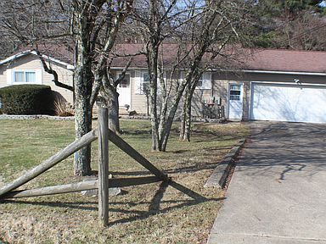
• 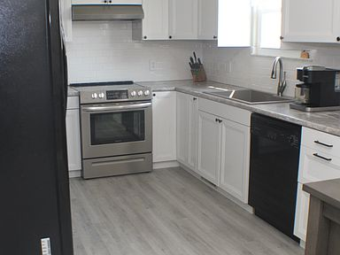
• 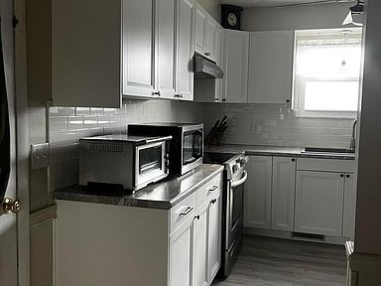
• 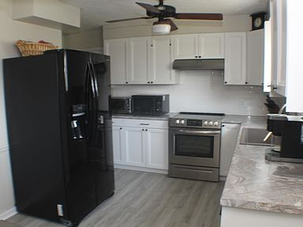
$289,900

553 Lynwood Ln, Lancaster, OH 43130
4beds
3baths
1,444sqft
Est.: $1,846/moEdit your inputGet pre-qualified
Single Family Residence
Built in 1972
0.41 Acres lot
$-- Zestimate®
$201/sqft
$-- HOA

What's special
WALK OUT PATIOEXTRA BEDROOMBOSE STEREO SYSTEMNEWLY REMODELED KITCHENBATHROOM FIXTURES
Ranch home with newly remodeled kitchen. Livingroom downstairs, extra bedroom and full bath with jacuzzi tub, fireplace and walk out patio. Established and quiet neighborhood. Updates in the past few years include carpeting,flooring, deck. hot water heater, bathroom fixtures, landscaping. Well maintained, lots of storage, Bose stereo system included. Window clings are removable.
Hide
18 days
on Zillow
|
1,617
views
|
65
saves
|
Likely to sell faster than 89 % nearby
Zillow last checked: 3 hours ago
Listing updated: March 13, 2024 at 02:14am
Listed by:
Kathy L Duffus 740-407-6460,
Coldwell Banker Realty
Source: Columbus and Central Ohio Regional MLS ,MLS#: 224005412
See all available times

Facts & features

Interior

Bedrooms & bathrooms
- Bedrooms: 4
- Bathrooms: 3
- Full bathrooms: 3
- Main level bathrooms: 3
- Main level bedrooms: 4

Bedroom
- Level: 3

Dining room
- Level: 1

Kitchen
- Level: First

Living room
- Level: First

Basement
- Basement: Walk-Out Access

Flooring
- Flooring: Carpet, Laminate, Vinyl

Heating
- Heating features: Forced Air, Natural Gas

Cooling
- Cooling features: Central Air

Appliances
- Appliances included: Dishwasher, Electric Range, Gas Water Heater, Refrigerator
- Laundry features: Lower Level

Interior features
- Window features: Insulated Windows

Other interior features
- Total structure area: 1,444
- Total interior livable area: 1,444 sqft
- Total number of fireplaces: 1
- Fireplace features: Wood Burning, One

Property

Parking
- Total spaces: 2
- Parking features: 1 Off Street, 2 Car Garage
- Garage spaces: 2
- Covered spaces: 2

Property
- Levels: One
- Stories: 1
- Patio & porch details: Deck

Lot
- Lot size: 0.41 Acres
- Lot features: Sloped

Other property information
- Parcel number: 0534142400

Construction

Type & style
- Home type: SingleFamily
- Architectural style: 1
- Property subType: Single Family Residence

Material information
- Construction materials: Vinyl Siding

Condition
- New construction: No
- Year built: 1972

Utilities & green energy

Utility
- Sewer information: Public Sewer

Community & neighborhood

Location
- Region: Lancaster
- Subdivision: Rae High Acres

HOA & financial

Other financial information
- Buyer's Agency fee: 3%

Other

Other facts
- Listing terms: Conventional,FHA

- 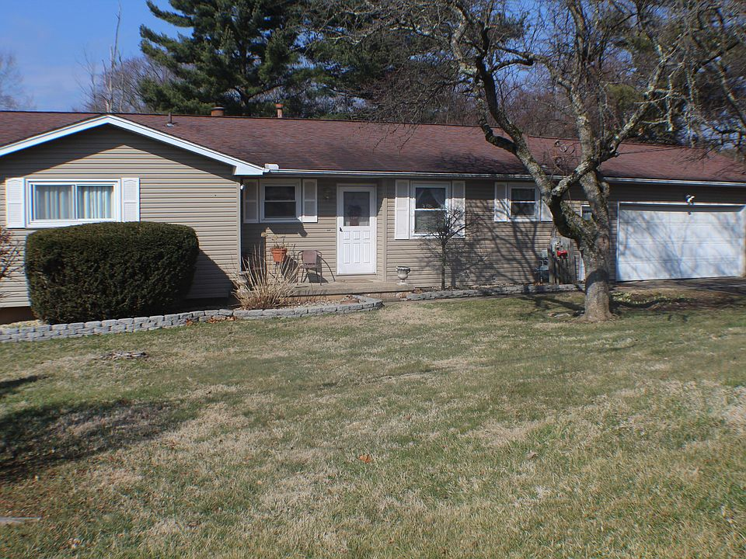
- 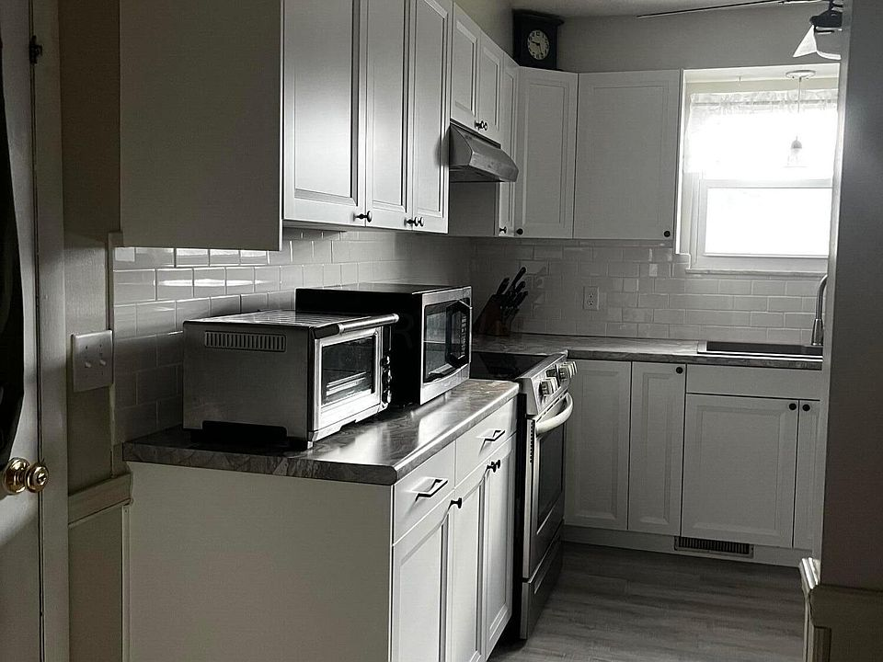
- 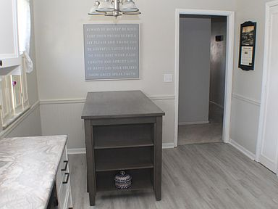
- 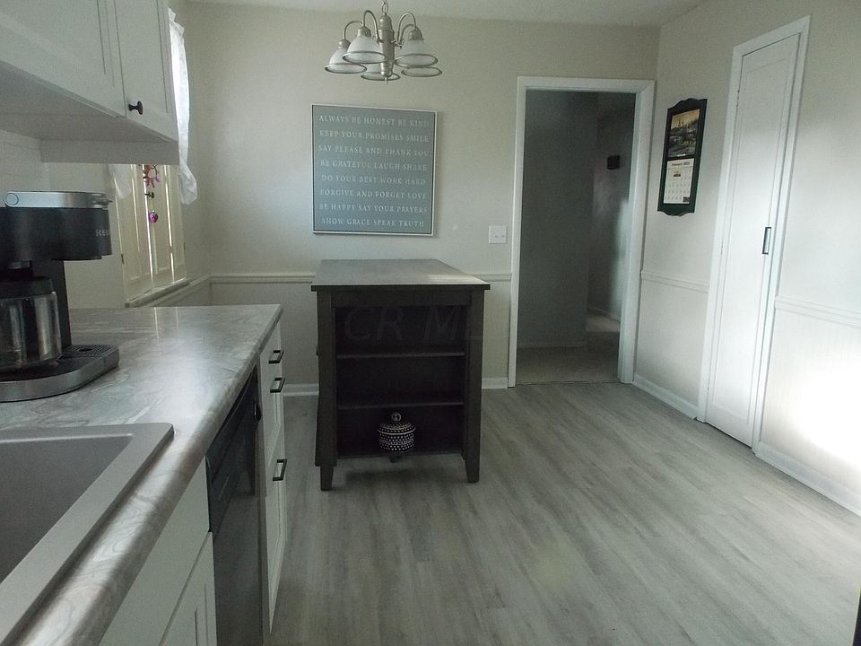
- 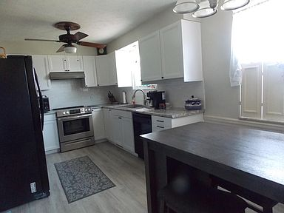
- 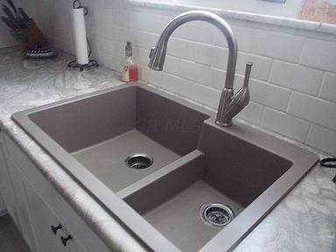
- 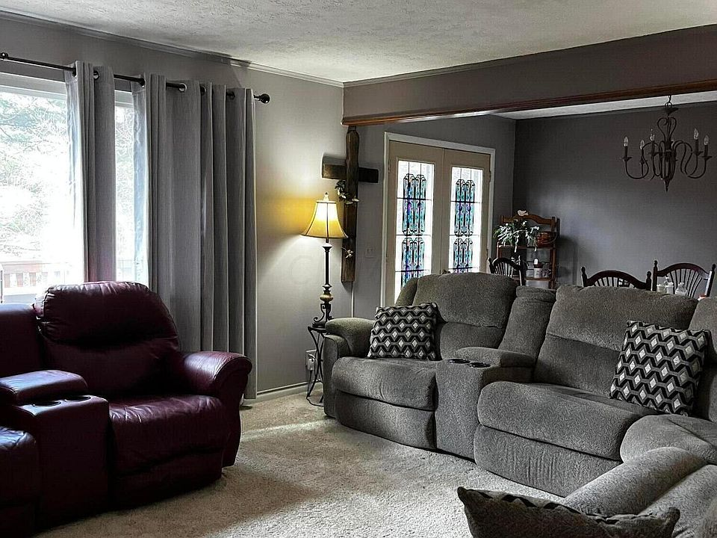
- 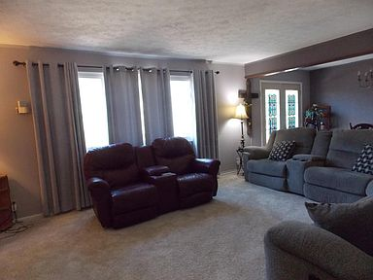
- 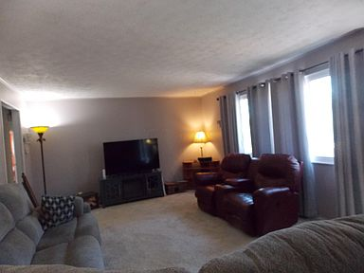
- 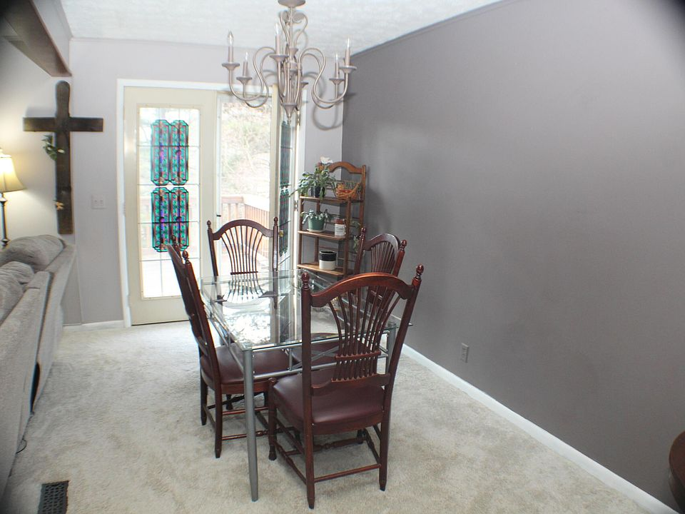
- 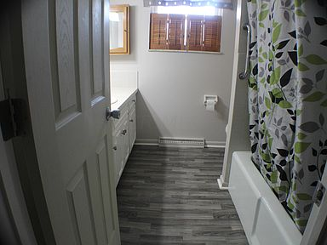
- 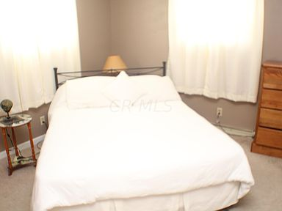
- 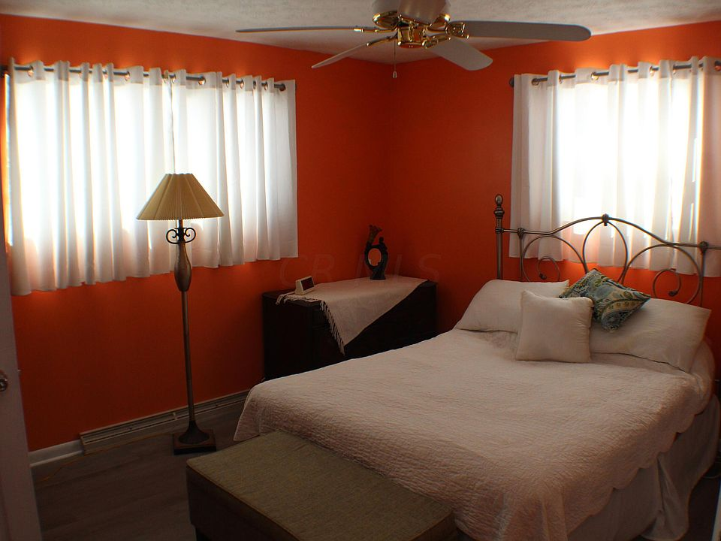
- 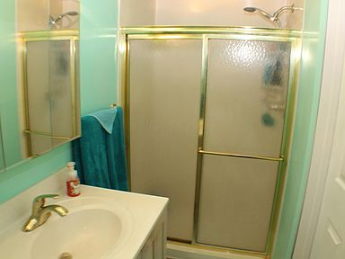
- 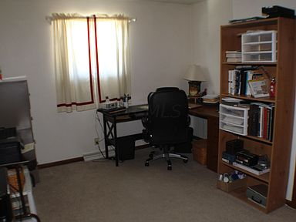
- 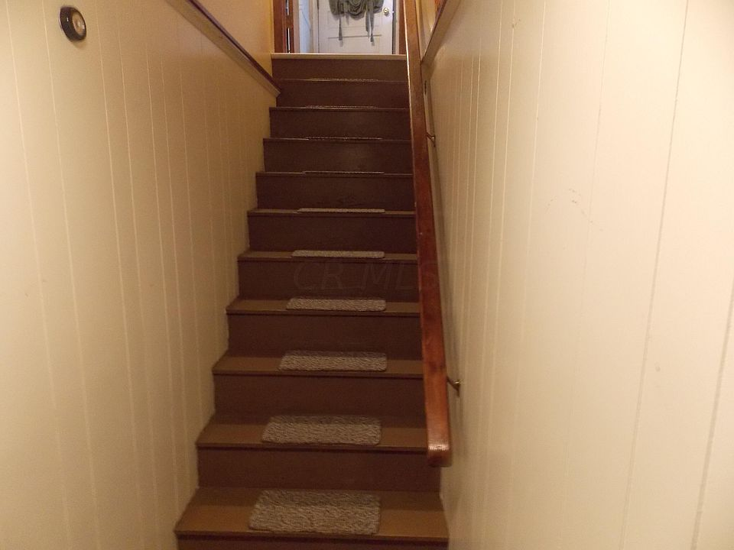
- 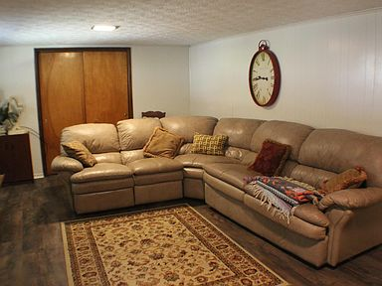
- 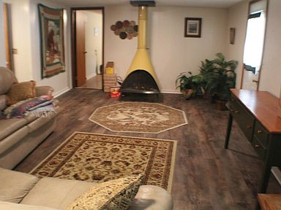
- 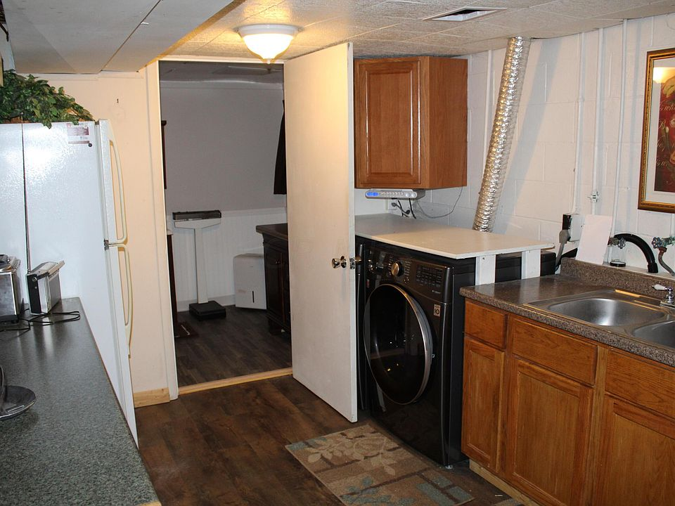
- 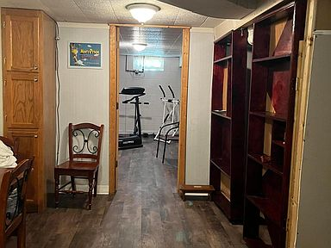
- 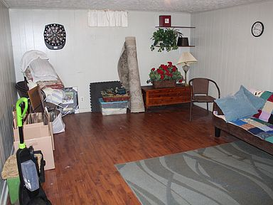
- 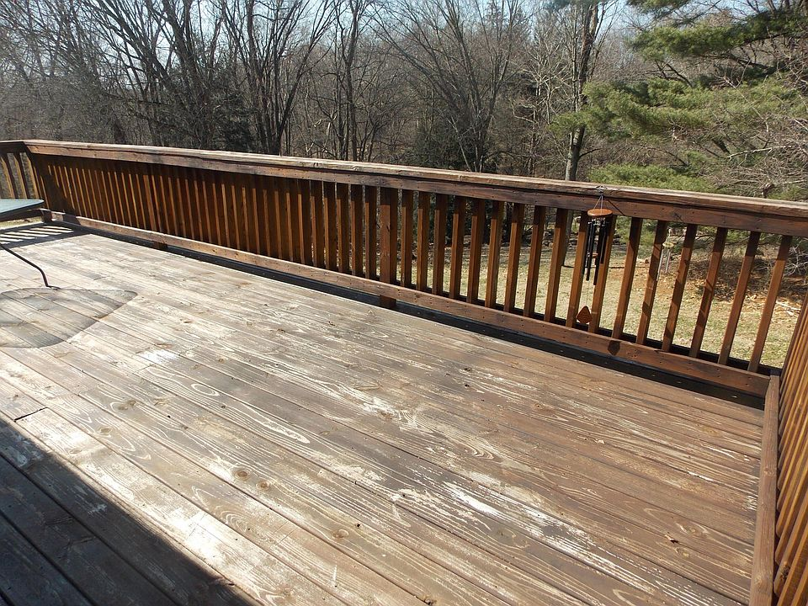
- 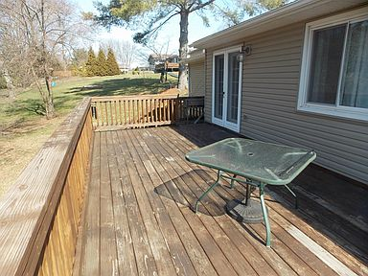
- 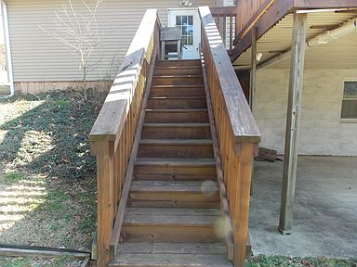
- 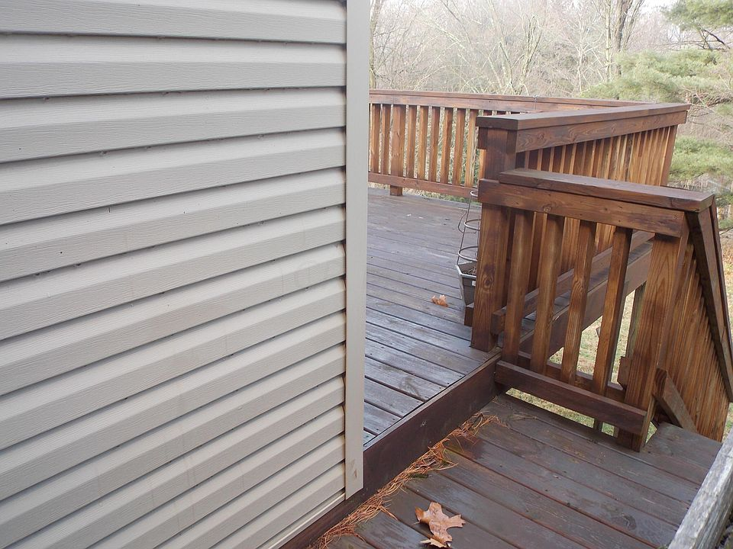
- 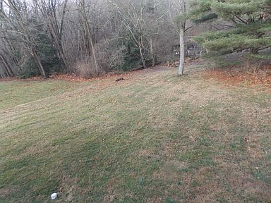

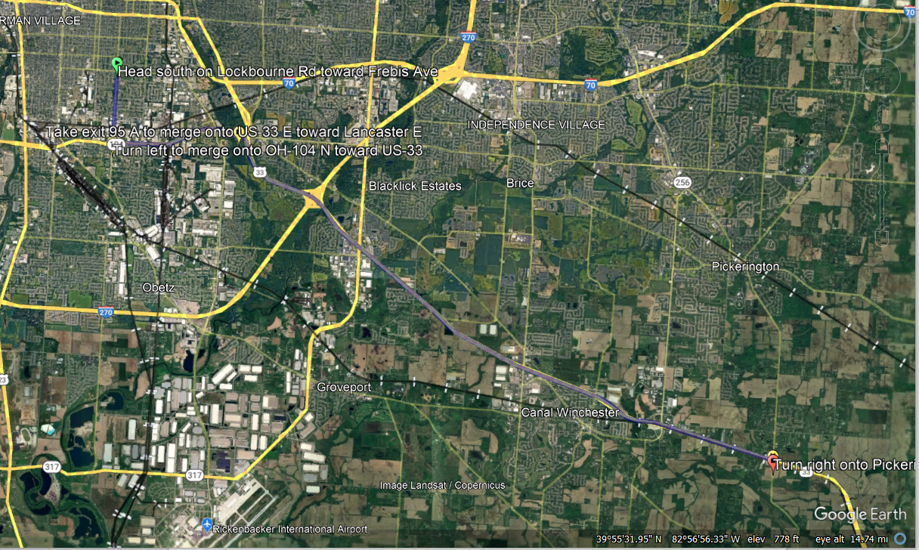
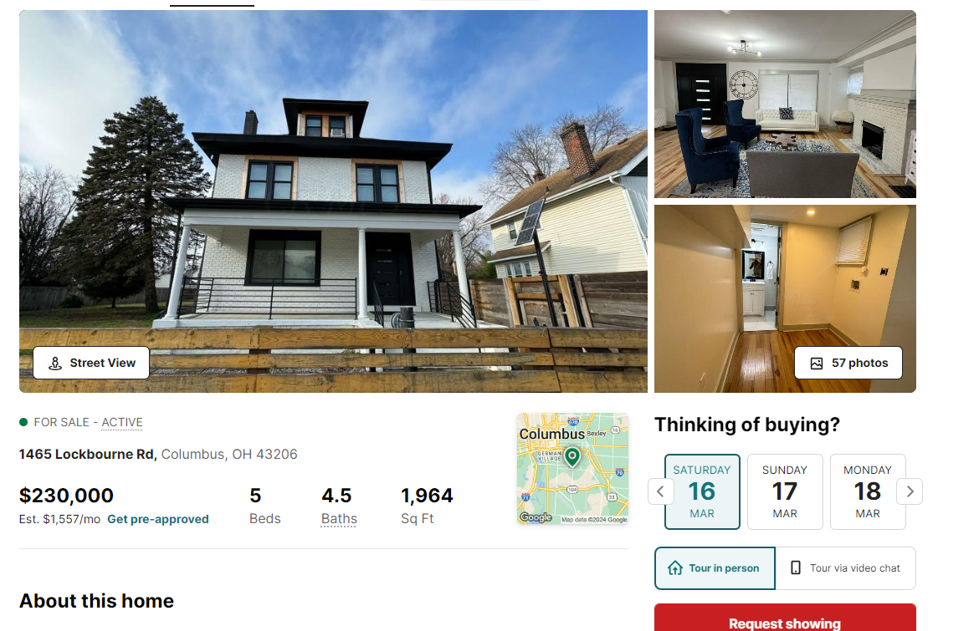
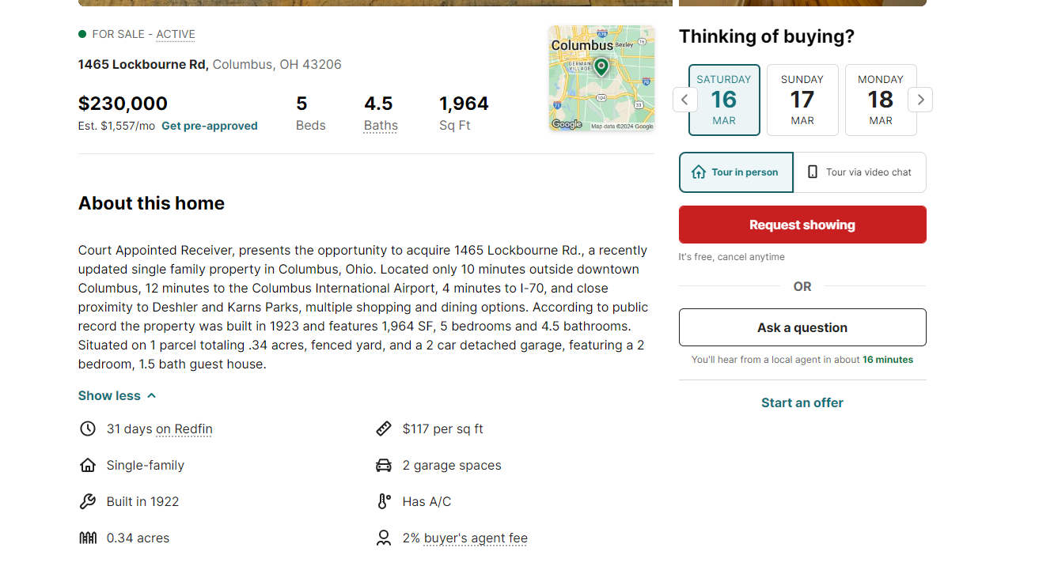

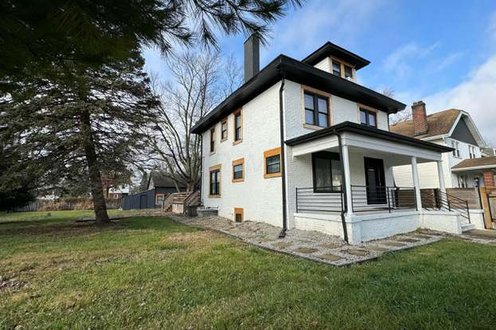

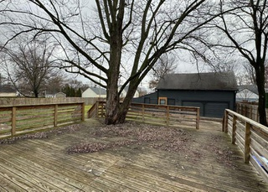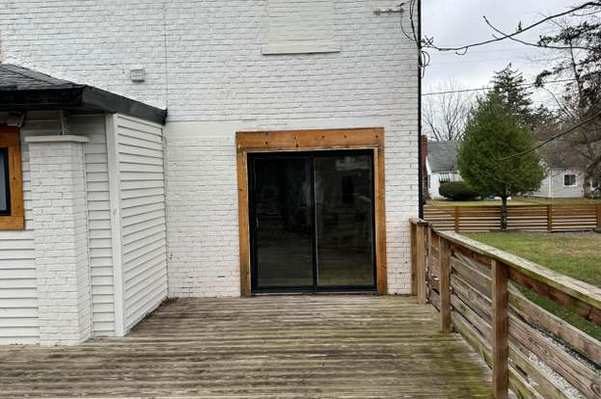

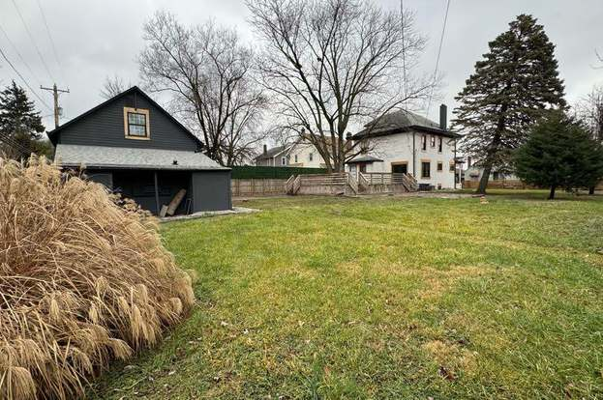

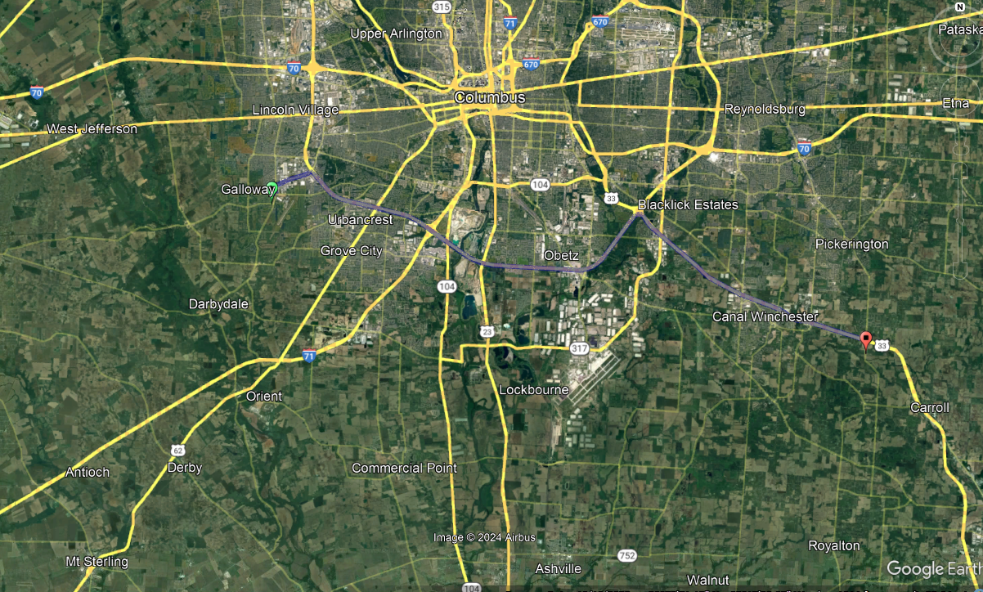
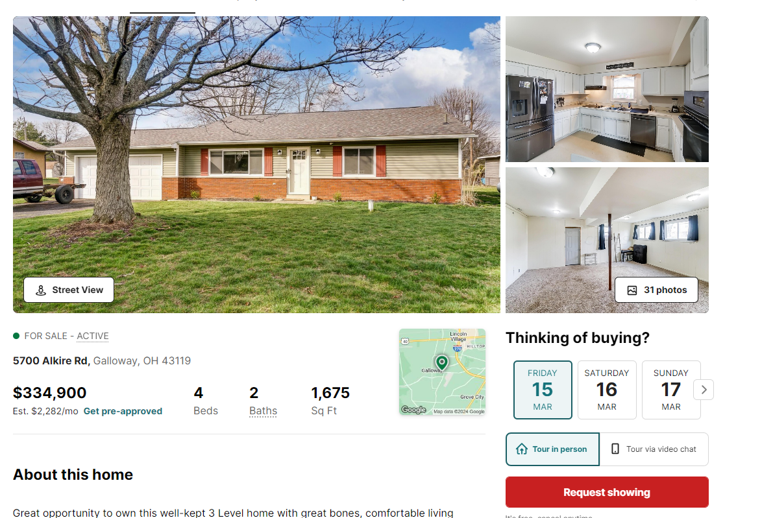
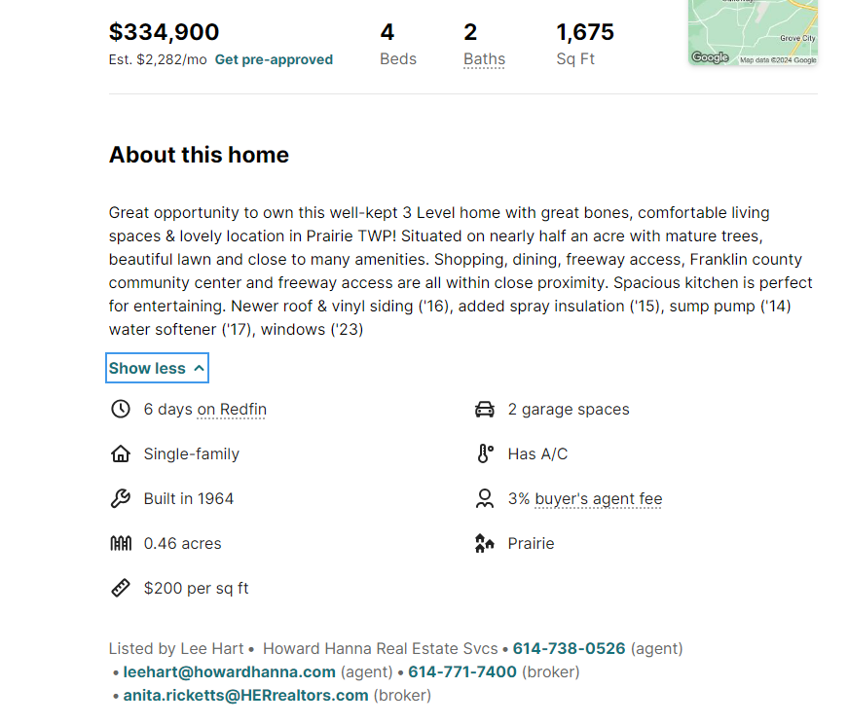

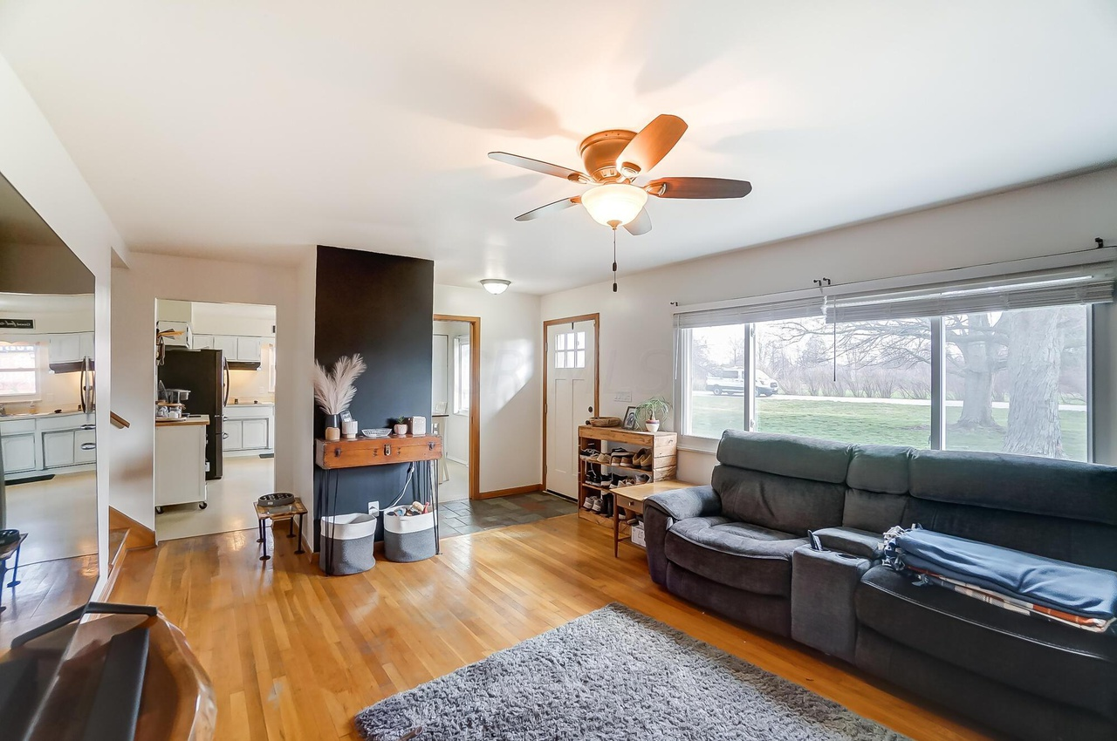
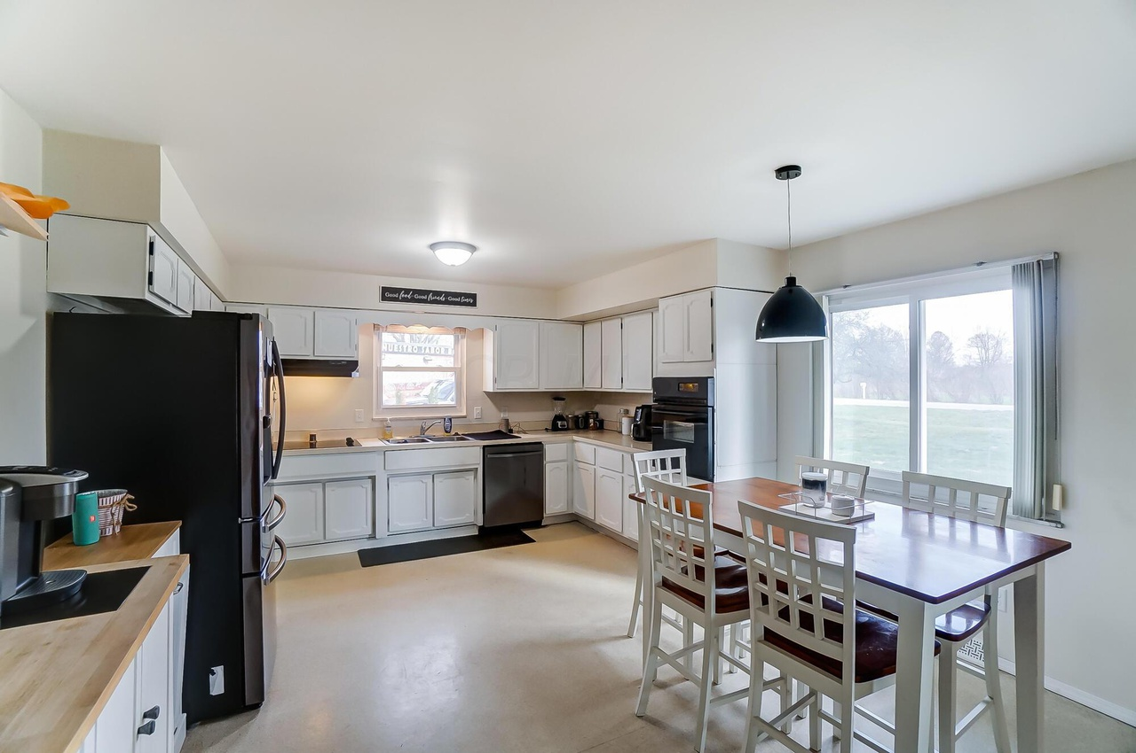
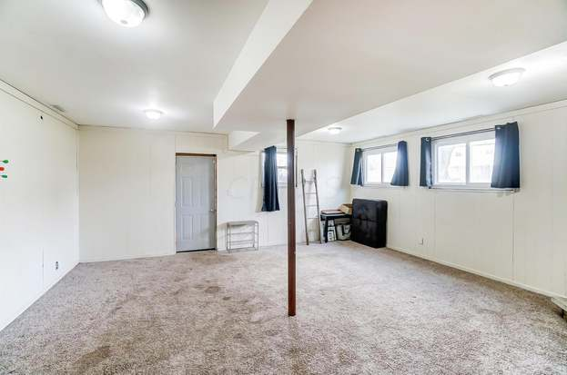
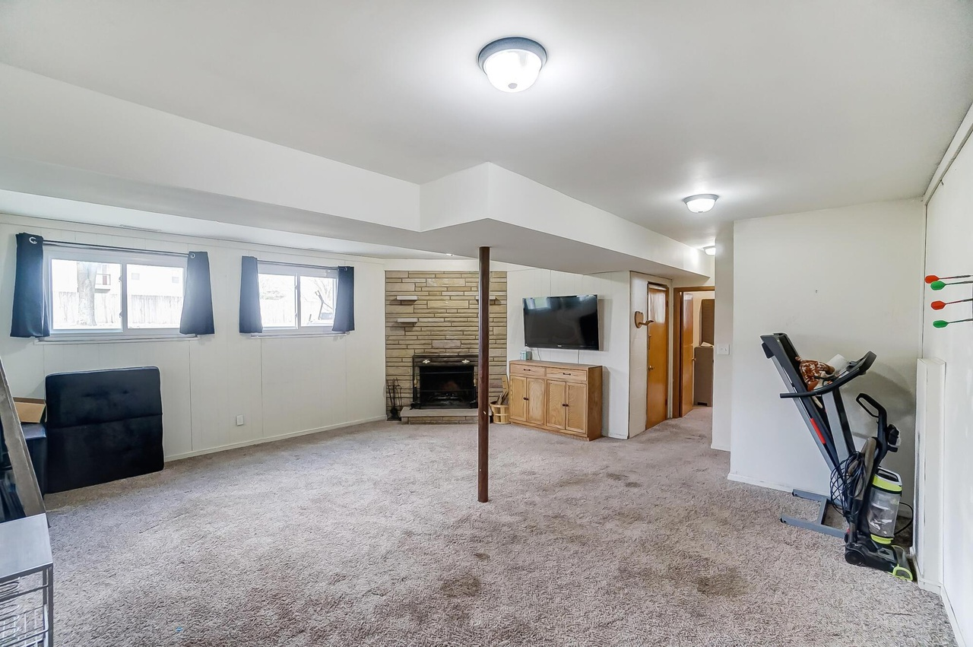
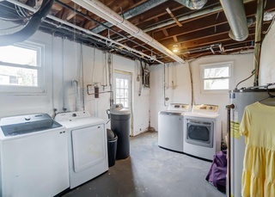
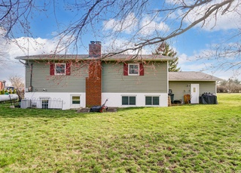

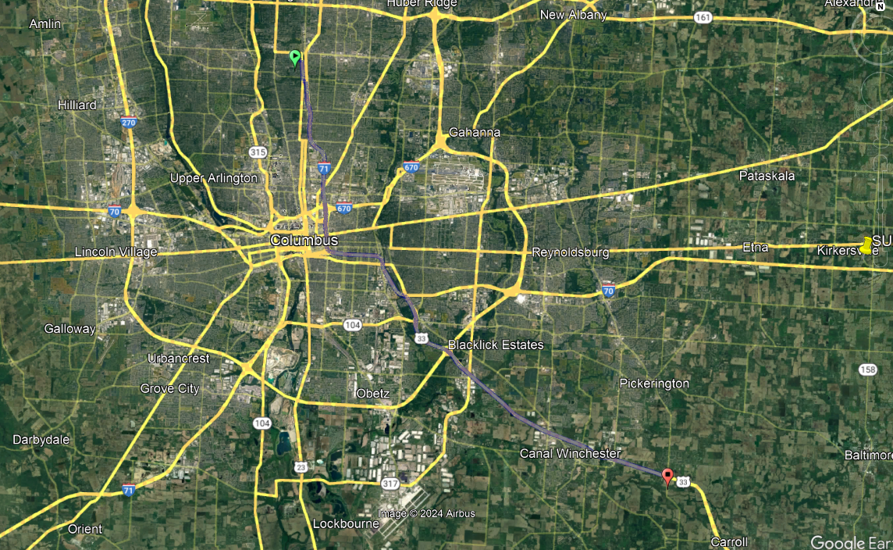

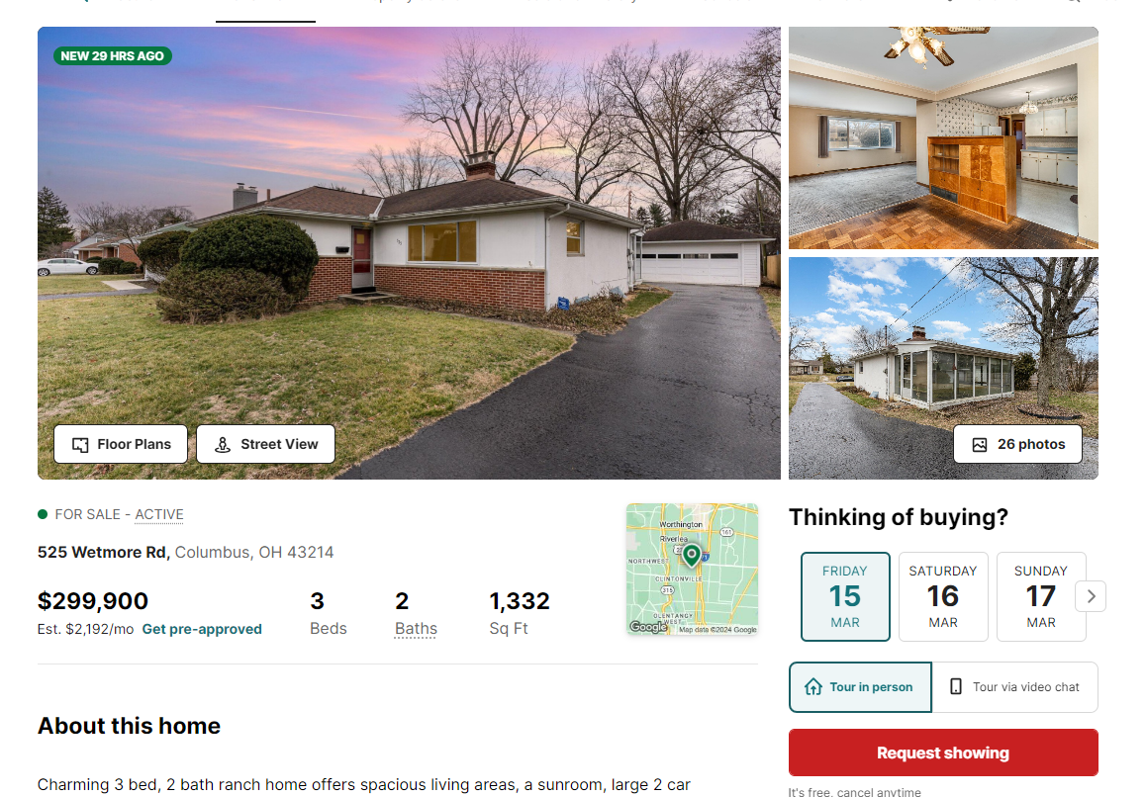

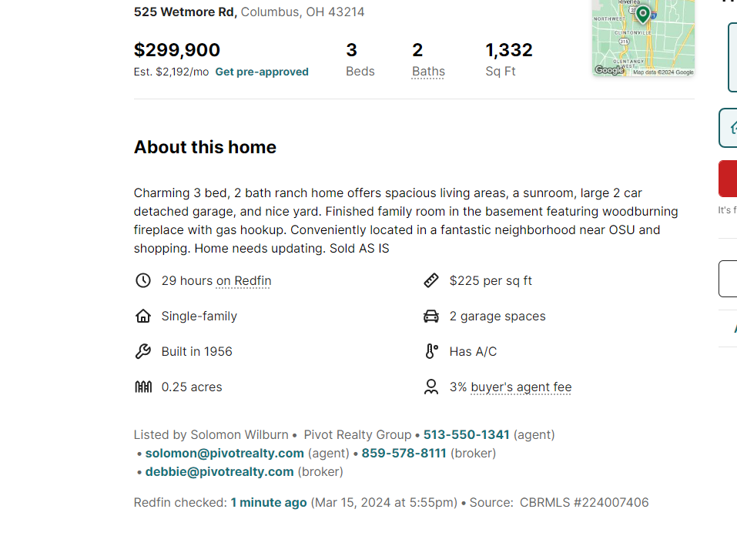

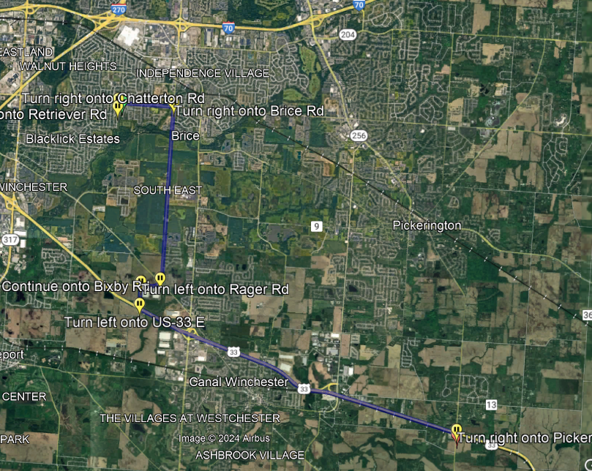
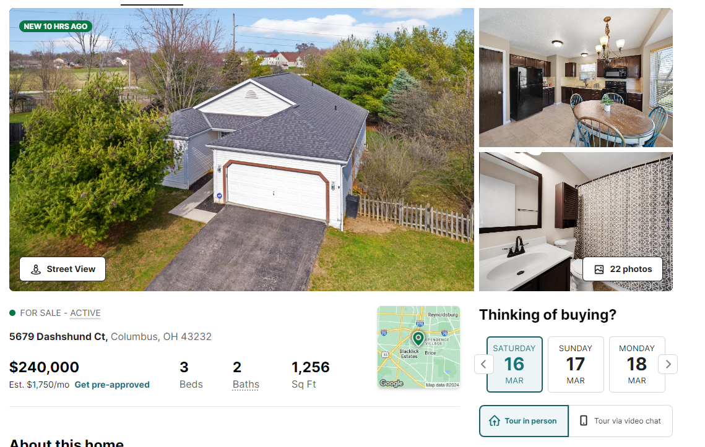

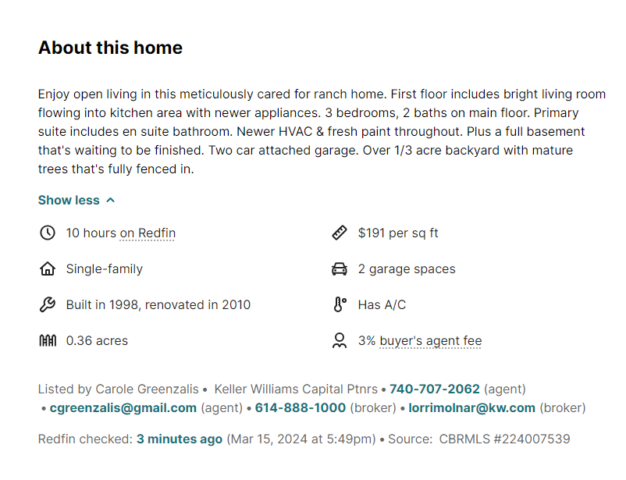

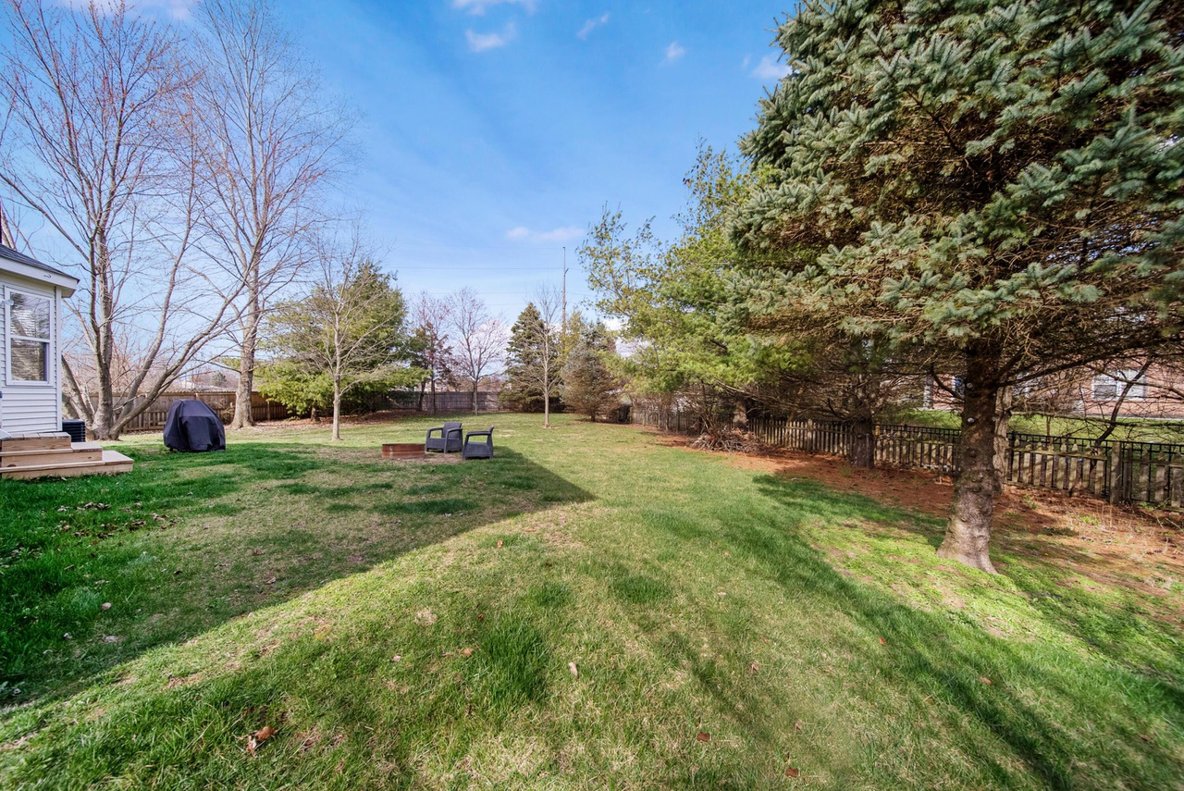

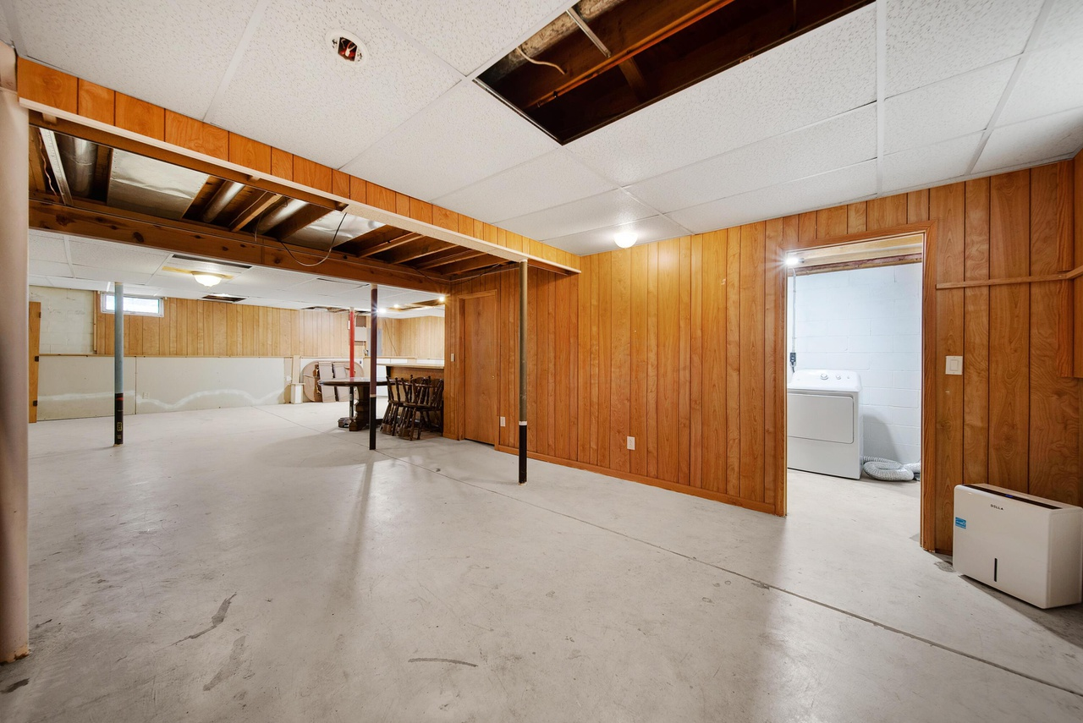
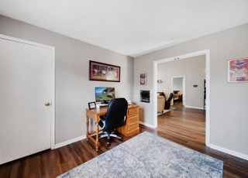

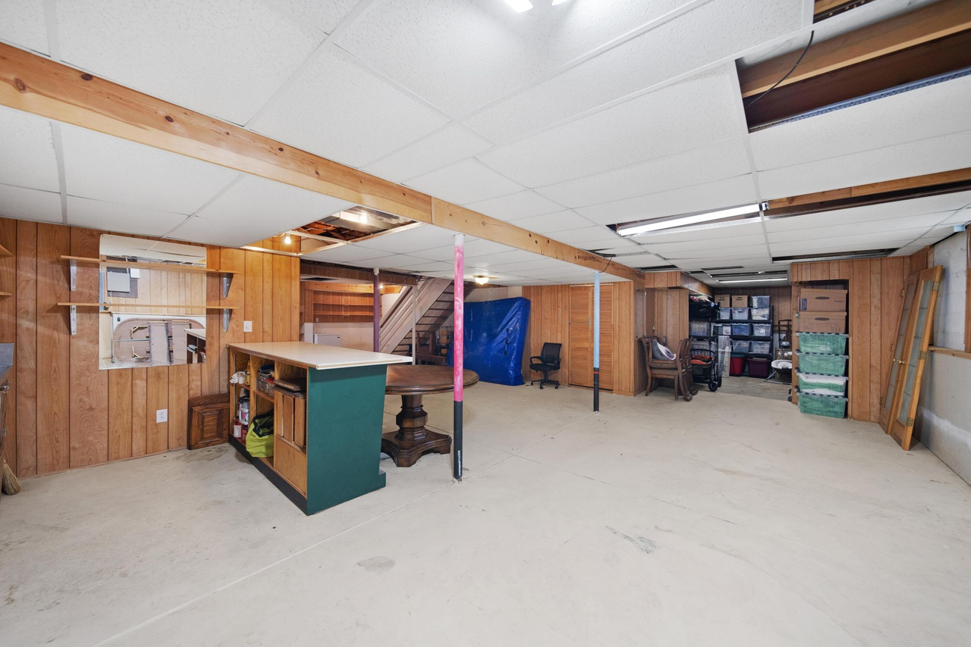

22.7 miles away

