MR. PARKER COMPS
1120 W Market Street in Baltimore OH 43105 $230,000
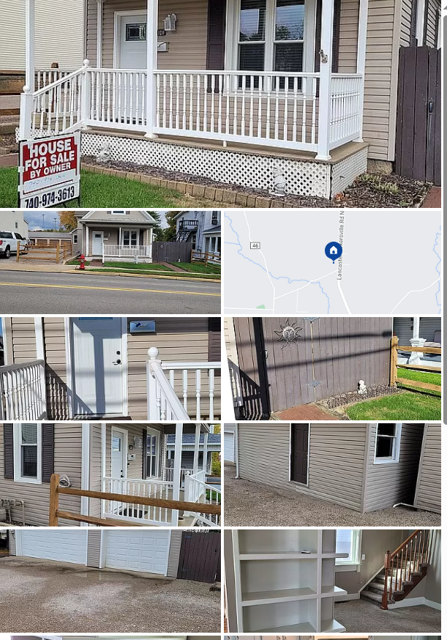

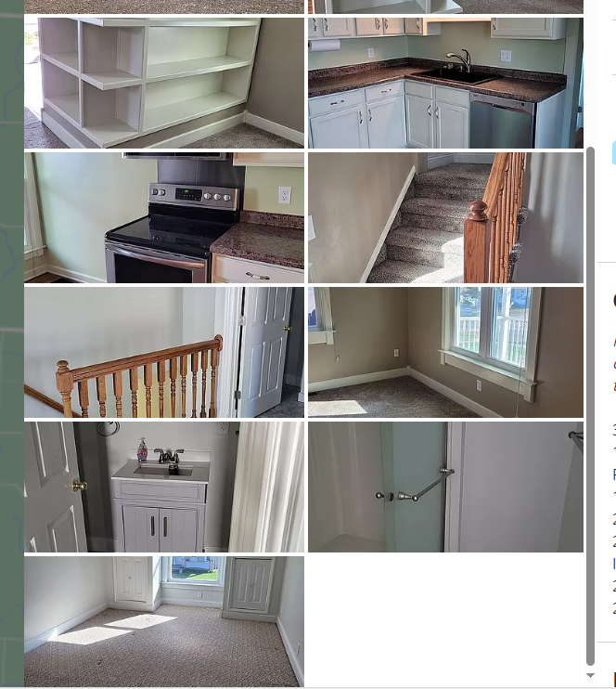
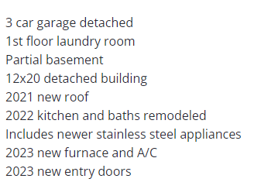

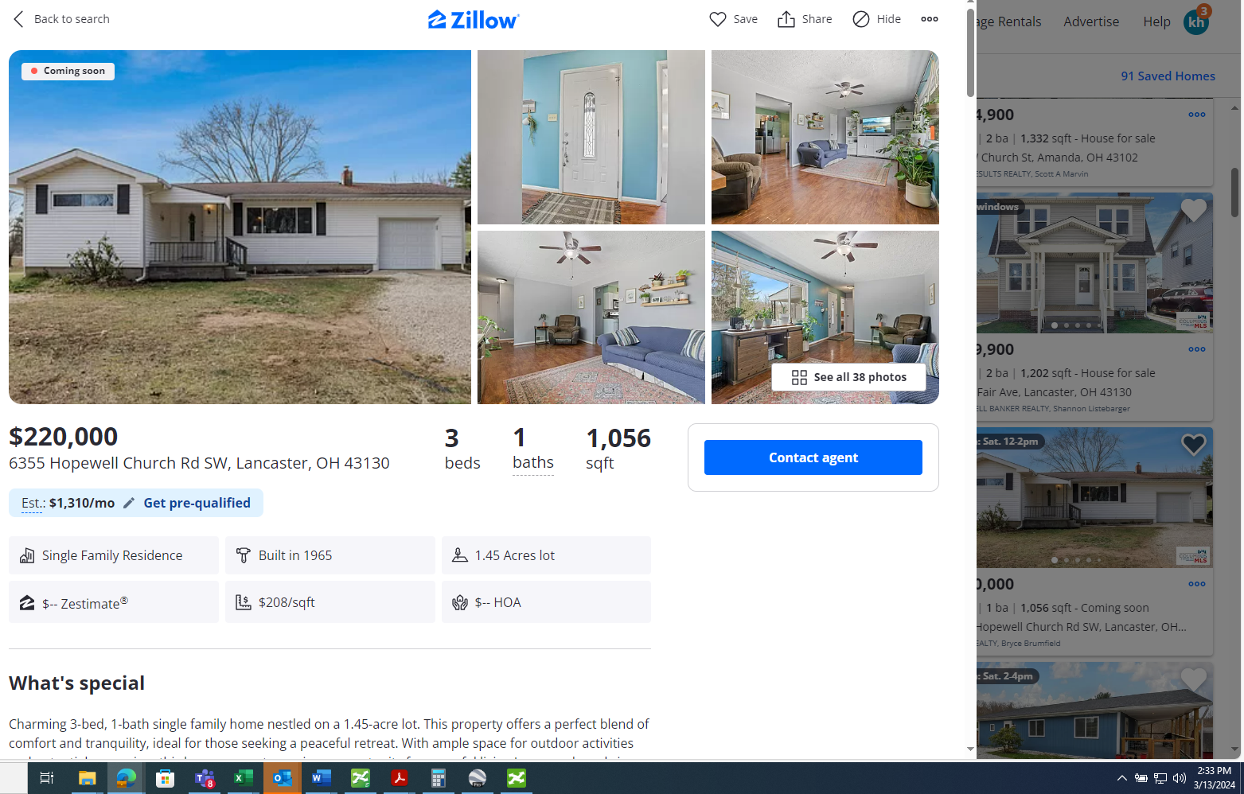
Save
Share
Hide
OverviewFacts & featuresMarket valuePayment calculatorNeighborhood
Coming soon
See all 38 photos
• 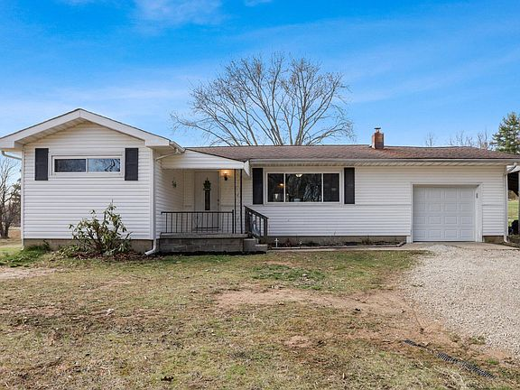
• 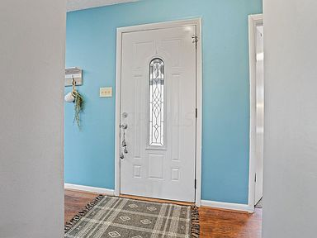
• 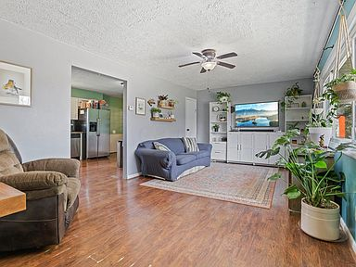
• 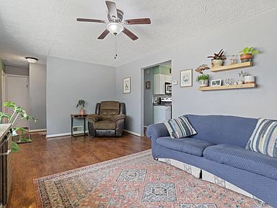
• 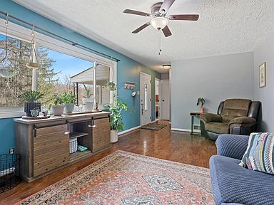
$220,000

6355 Hopewell Church Rd SW, Lancaster, OH 43130
3beds
1baths
1,056sqft
Est.: $1,310/moEdit your inputGet pre-qualified
Single Family Residence
Built in 1965
1.45 Acres lot
$-- Zestimate®
$208/sqft
$-- HOA

What's special
Charming 3-bed, 1-bath single family home nestled on a 1.45-acre lot. This property offers a perfect blend of comfort and tranquility, ideal for those seeking a peaceful retreat. With ample space for outdoor activities and potential expansion, this home presents a unique opportunity for peaceful living.Large cupboards in living room do not convey.
6 days
on Zillow
|
1,371
views
|
121
saves
Zillow last checked: 3 hours ago
Listing updated: March 10, 2024 at 07:45am
Listed by:
Bryce Brumfield 740-407-4853,
Red 1 Realty
Source: Columbus and Central Ohio Regional MLS ,MLS#: 224006616
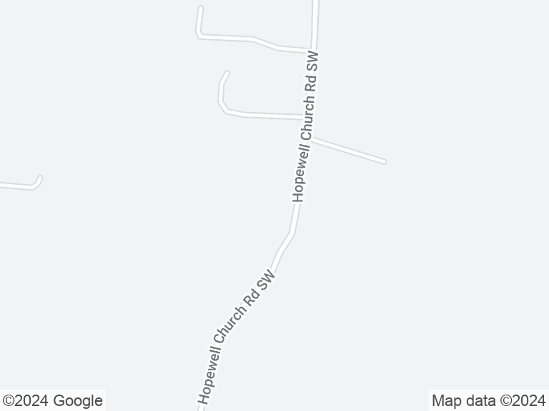

Travel times
enter a commute destination (Google autocomplete)

Get pre-qualified for a loan
At Zillow Home Loans, we can pre-qualify you in as little as 3 minutes with no impact to your credit score.
An equal housing lender. NMLS #10287.
Start now

Open house
- Sat, Mar 16
12:00 PM - 2:00 PM
Add to calendar

Facts & features

Interior

Bedrooms & bathrooms
- Bedrooms: 3
- Bathrooms: 1
- Full bathrooms: 1
- Main level bathrooms: 1
- Main level bedrooms: 3

Bedroom
- Level: 3

Kitchen
- Level: First

Living room
- Level: First

Basement
- Basement: Full

Flooring
- Flooring: Carpet, Ceramic/Porcelain, Laminate

Heating
- Heating features: Oil

Cooling
- Cooling features: Central Air

Appliances
- Appliances included: Dishwasher, Electric Range, Electric Water Heater, Microwave, Refrigerator
- Laundry features: Electric Dryer Hookup, Lower Level

Interior features
- Window features: Insulated Part

Other interior features
- Total structure area: 1,056
- Total interior livable area: 1,056 sqft

Property

Parking
- Total spaces: 2
- Parking features: 1 Car Garage, 1 Carport, Attached, Garage Door Opener
- Garage spaces: 1
- Covered spaces: 2
- Carport spaces: 1

Property
- Levels: One
- Stories: 1
- Patio & porch details: Patio

Lot
- Lot size: 1.45 Acres
- Lot features: Sloped

Other property information
- Additional structures included: Additional Building
- Parcel number: 0250002700

Construction

Type & style
- Home type: SingleFamily
- Architectural style: 1
- Property subType: Single Family Residence

Material information
- Construction materials: Vinyl Siding

Condition
- New construction: No
- Year built: 1965

Utilities & green energy

Utility
- Sewer information: Private Sewer
- Water information: Well

Community & neighborhood

Location
- Region: Lancaster

HOA & financial

Other financial information
- Buyer's Agency fee: 3.00%

Other

Other facts
- Listing terms: Conventional,FHA
Show more

Make this home a reality

Get pre-qualifiedBe ready to make an offer.
Connect with an agentGet info on this home, tour, and more.
Calculate monthly paymentSee if you can afford this home.

Price history
Date | Event | Price
4/28/2018 | Sold | $147,500+5.4%$140/sqft
Source: Public Record Report a problem
3/21/2018 | Pending sale | $139,888$132/sqft
Source: Gorsuch Realty Company #218008007 Report a problem
3/19/2018 | Listed for sale | $139,888+29.5%$132/sqft
Source: Gorsuch Realty Company #218008007 Report a problem
5/13/2014 | Sold | $108,000+140%$102/sqft
Source: Public Record Report a problem
8/15/2013 | Sold | $45,000-22.3%$43/sqft
Source: Public Record Report a problem
Show more

Public tax history
Year | Property taxes | Tax assessment
2022 | $1,501 +28.6% | $45,810 +31.8%
2021 | $1,167 -3.4% | $34,760
2020 | $1,208 -0.8% | $34,760
Show more
Find assessor info on the county website

Monthly payment calculator
Estimated monthly payment$1,310

Principal & interest
$1,048

Mortgage insurance
$0

Property taxes
$185

Home insurance
$77

HOA fees
N/A

Utilities
Not included
All calculations are estimates and provided by Zillow, Inc. for informational purposes only. Actual amounts may vary.
Mortgage interest rates are dependent on a number of factors, including credit score, down payment, and repayment length. Interest rate data provided by Zillow Group Marketplace, Inc. as of 3/13/2024 from various mortgage lenders with which we have lead or other similar arrangements; the Estimated Payment is an average of those rates.
See how much you could borrow to make a competitive offer.
Get pre-qualified

Getting around

Nearby schools

GreatSchools rating
- 6/10
Amanda-Clearcreek Elementary School
Grades: 3-5Distance: 4 mi
- 6/10
Amanda-Clearcreek Middle School
Grades: 6-8Distance: 4 mi
- 3/10
Amanda-Clearcreek High School
Grades: 9-12Distance: 4 mi
Show more

Schools provided by the listing agent
- District: AMANDA CLEARCREEK LSD 2301 FAI CO.
Source: Columbus and Central Ohio Regional MLS . This data may not be complete. We recommend contacting the local school district to confirm school assignments for this home.
Skip carousel

- 
 