District | Program | Sponsoring Agency
5 | TAP | Village of Fredericktown
Date | Reviewer | Project Name
02-13-25 | BB/JS | Fredericktown Streetscape Phase 2

FY Funds Are Requested: | FY28
Amount Requested: | $2,243,598.00
Project Description and Development: | 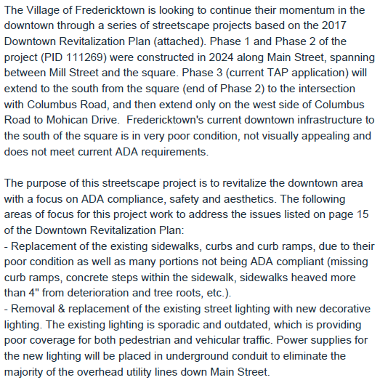
Strengths and Weaknesses of the Project:
Is the Project Estimate Realistic? | Yes
If not wholly funded, can this project be successful with partial funding? | Likely if funded as phased (D5 recommendation below)
Is the Project Schedule Realistic? | Sure
Is the Project Scope Appropriate? | Yes
Potential Obstacles? | RW/Utilities - some design elements on Phase 3B
Experience with Sponsor? | Good
LPA Financial Status  with ODOT | Good
Does the District Recommend Funding? | Yes – Partial might be a good option.

Additional Comments:
Recommend partial funding - fund 3A with TAP, have Village apply to SRTS for 3B (more preconstruction costs likely in this area)

