115989 MUS 376 PCL 010 Tenant PP Photos
Air compressor | Tire Ramps (set of 2) | Suburban wTags
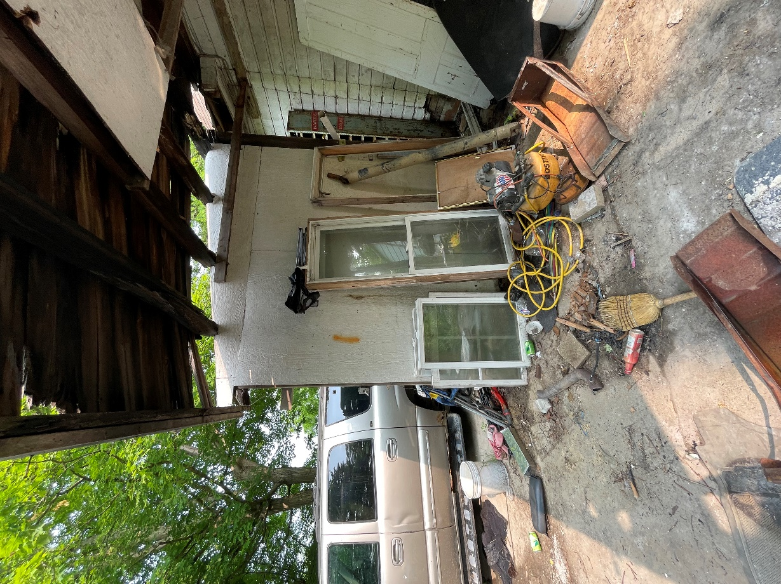 | 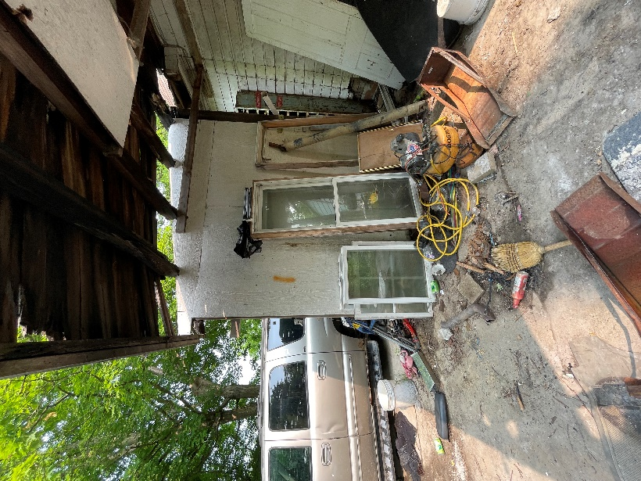 | 