

# MEMO TO FILE

|  |  |
| --- | --- |
| **Date:** | **January 30, 2024** |
| **TO:** | **Patty Moorman – Relocation Reviewer** |
| **FROM:** | **Kimber L. Heim, Realty**  **Specialist Manager** |
| **RE:** | **Approval Requested for Market Rent, Supplement Payment and Use of Last Resort Housing** |
| The subject property is located at 8895 Gaysport Hill Road, Blue Rock, OH 43720. The subject is a one-story converted schoolhouse located in a rural residential area of Muskingum County, Ohio. The subject sits on 1.061 acres of land on a hill above Blue Rock/Gaysport, Ohio. Most of this property is heavily wooded with a steep ravine topography surrounding the house. This home sits on a hill and is accessed by a long, narrow drive. There is limited mowable, usable lawn. The project has a take area of 1.061 acres due to the instability of the hill the property sits on in Blue Rock. There is no garage for this home, though there is a carport in poor condition and barn that sits down in the ravine. This barn is not utilized by the tenant/occupants, but by a third party.  The subject property has a room count of 4/2/1, which includes a Living Room, combination kitchen/dining room, one full bathroom, and 2 bedrooms. There also is a utility room, which is not included in the total room count, but which was considered in searching for comparables and another room utilized for storage. There is a room blocked off, which could be a bedroom, but it has a collapsed ceiling. It should be noted that the appraiser states there are four bedrooms— per my inspection, one is considered storage only with minimal items on the ﬂoor, and one is uninhabitable as noted above. The appraisal also states that there is baseboard heat, but upon inspection, the owner veriﬁed there is currently only heat by a wood pellet stove. There is no central air.  The property has 1918 sq ft of living space per auditor. There is a partial basement and part cellar, both areas considered unsafe to access and enter, per the occupants and a personal inspection of the stairway leading down. Due to the lack of utility of several rooms, and the inability to enter them to measure, the estimated habitable living space of this home is 919 per measurements of accessible rooms. The property has a deck and carport. The building was originally built in 1885 and used as a schoolhouse until decommissioned in 1950’s and sold in late 1950 to be used as a residence. The heating by pellet stove, unknown condition of the well servicing the property and the septic system does not seem to be up to code. The property is in poor maintenance and is not decent, safe, and sanitary due to the condition of the two rooms and basement. | |

An exhaustive search has been on-going since June 2023. I have utilized internet sites ZILLOW, REDFIN, FACEBOOK Marketplace, Zanesville Rentals, and driven the area looking for Owner Rental signs. I have had discussions with the three local rental/property agencies in Muskingum County. My search was for the entirety of Muskingum County from Blue Rock to South Zanesville to Zanesville. I have visited six properties and determined that Comparable 1 is a suitable relocation location for Thomas and Hope. This determination has three comparable properties utilized for this determination.

The home located at 830 Race Street, Zanesville, OH 43701 which is DS&S, currently available meets or exceeds all points of comparability which are noted on the RE 611 (T). This property is deemed to be equal to or better than the subject property due to condition of the subject, and has been chosen as the Prime Comparable for determination of the Rent Supplement Payment. See attachment of Site Description and Comparable Analysis for more information on all three comparables. Utility information was gathered from the Zanesville Metropolitan Housing Authority, 01/01/2023 published.

The subject tenants were not charged rent due to a family member owning the property. A market rent determination was made based on the information gathered from Shields Properties, Missy Brest, Chad James and Tami Passwaters, all independent owners of rental properties in Zanesville Municipal Area. Rented units range from $475 to $895 and a determination was made that $475 was most comparable and equal while remaining DS&S. See Memo and grid for more information on the market rent. **Approval is requested for the Market Rent.**

30% income was not considered as the tenant occupants would not provide employment information or income information despite the process of calculating an RSP based on low income being fully explained.

The Prime Comparable is located at 830 Race Street, Zanesville OH and has a rent of $850 plus utilities as determined using the ZMHA grid = $208.00 for a total base rent of $1,058.00. The subject has a market rent of $475, plus utilities of $144 for a total base rent of $619.00. To calculate the Rent Supplement Payment the difference between $1,058.00 and $619.00 is multiplied by 42 months = **$18,438.00** as a Rent Supplement Payment to be provided Thomas Rodgers and Hope Miller. **Approval is requested for the Calculated Rent Supplement Payment.**

The exhaustive, lengthy search of all rental properties available from Gaysport/Blue Rock through Maple Avenue in Northern Zanesville has calculated out to an amount above the $7,200 limit. If nothing is available within the limit of $7,200, the displacing agency will provide rental supplement payment under the provisions of Last Resort Housing. Per section 6607.01 of the ODOT Real Estate Manual, Determination to Provide Housing of Last Resort. Whenever a project or program cannot proceed on a timely basis because of comparable replacement rental properties are limited or quickly on and off the market within the monetary limits of $7,200, the displacing agency shall provide additional or alternate assistance under the provisions of Laas Resort Housing. The condition of the subject property and the added hurdle of market rent calculation being required as no rent was being paid to Property owner and the current market for rental properties in the area has caused our search to exceed the RSP monetary limit of

$7,200.00. **Therefore, I am requesting approval for use of Last Resort Housing.**

# I request approval of this RSP (Rent Supplement Payment) and the use of Last Resort Housing (LRH) due to disparity between displacement site market rent and replacement site rent.

**Kimber L. Heim**

**Realty Specialist Manager Relocation Agent**

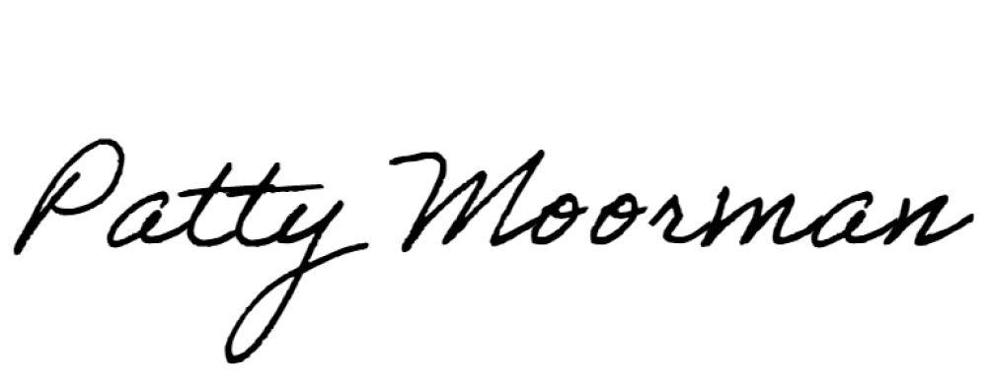**Approval given for Market Rent, Rent Supplement Payment and Last Resort Housing.**

1/30/2024

# Patty Moorman Relocation Reviewer

**Central Office Relocation Unit Manager**

**Thank you in advance for your time and consideration of this request.**

**________________________________ ___________________**

**John R. Wooldridge, Date**

**D5 Real Estate Administrator**