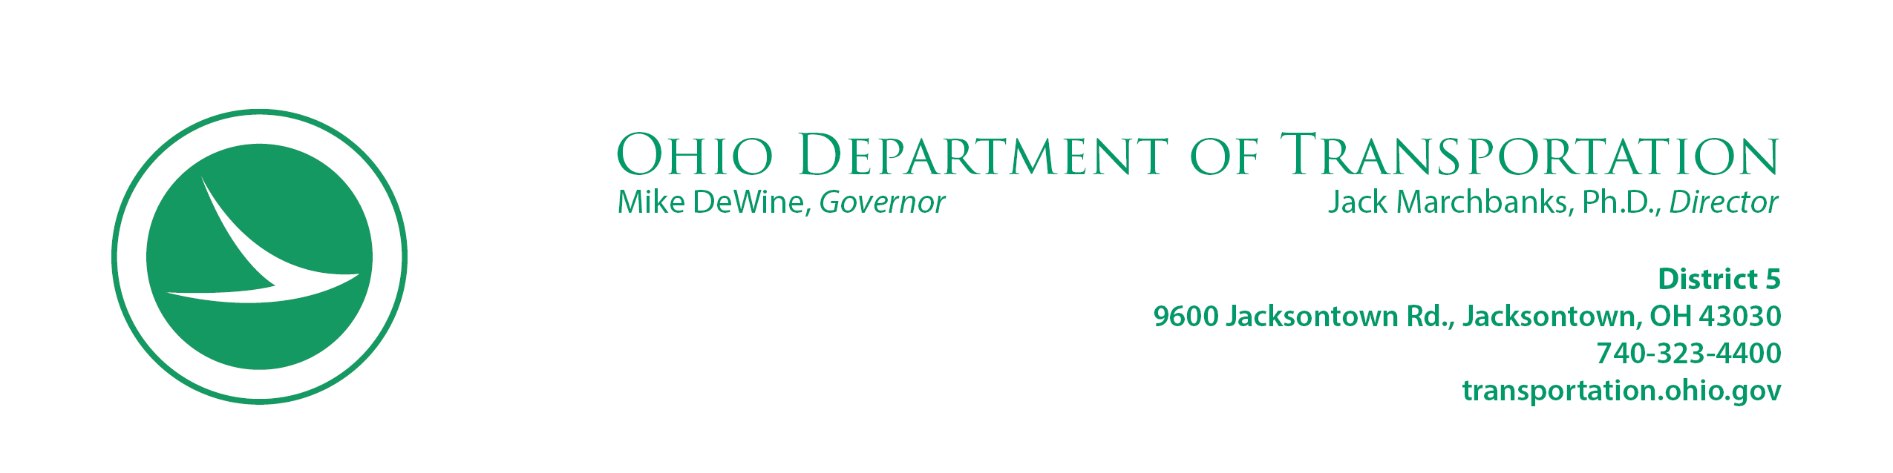
INTRODUCTION LETTER

June 5, 2023

Charlie N. Rodgers
883 Goddard Avenue
Zanesville, Ohio 43701

Project: MUS-376-5.09
Parcel: 010-WD

Dear Charlie N. Rodgers:

This letter is to advise you of the impending improvement on MUS-376-5.09 . The purpose of this improvement is to provide a transportation facility which will better serve the needs of the public. For this project the transportation facility is conducting a remediation of a rock cut slope that will improve the stability of the slope.

This proposed project may possibly involve some of your real property. In the near future, a representative of our office will be contacting you to explain the exact nature of the area required and the amount of compensation involved.

In advance of our personnel contacting you, we are enclosing a brochure entitled “When ODOT Needs Your Property.” This booklet outlines our right of way acquisition procedures, and provides answers to some of the most frequently asked questions.

We sincerely appreciate your time in this important matter and we look forward to contacting you in the near future to arrange an appointment to meet with you. If you have any questions, please do not hesitate to contact our office.

Respectfully,

John R. Wooldridge,
District 5 Real Estate Administrator

Enclosure

