115989 Rental Comparables







Forget sit-ups — this 4-move ab workout targets your deepest core muscles
When it comes to targeting your deepest core muscles, not all ab exercises are created equal. Forget crunches and sit-ups, if you’re really looking to work your deep core, you’ll need to switch up your ab routine. The transverse abdominis is the deepest muscle in your midsection and works to stabilize the trunk and protect your spine.
If you’re looking to target the deepest muscles in your core, we’ve found a simple workout by Lottie Alice Lamb, a hybrid athlete and trainer. Working your deep core muscles can improve your stability, help you move with better posture, and protect the body from injury. Ready to find out more? Add these four exercises to your next ab workout to work those all-important muscles.
As a reminder, if you’re new to exercise, or you’re returning to exercise following an injury or pregnancy, it’s a good idea to check in with a personal trainer before adding a new exercise to your routine.

What is the workout?
Complete the circuit of four exercises three times, with a 45-second rest between each circuit.

Jack Knife Tuck: 30 seconds
To do this exercise, start by lying on your back, with your head and neck lifted off the floor, and your body weight resting on your elbows. Keep your forearms alongside your body, and your lower back imprinted onto your exercise mat. Engage your core, and extend your elbows, crunching your torso off the mat, and the same time, tuck both knees in towards your chest. As you lower your trunk back down towards your mat, open and close your legs. Keep your core engaged throughout.
Flutters: 30 seconds
Starting from the same position, raise both legs a few inches off the ground, and cross one over the other, flutter kicking them up to the ceiling, then back down. If this is too much on your lower back, or you feel your lower back peeling off the mat during this move, drop your head and neck down to the ground, and place your hands underneath your glutes. Here’s more on how to do flutter kicks with perfect form.

Leg raises: 30 seconds
From the same starting position, with your body weight on your elbows and your lower back pressed into the mat, engage your core and lift both legs up to the ceiling, then back down, stopping a few inches from the floor. Again, if this is too difficult, lower your body down to the exercise mat.

Table top: 30 seconds
For this exercise, start lying on your back, with your legs in a tabletop position, with a 90-degree bend in your knees. Crunch your head and neck up a few inches off the floor and hold. From here, tap one heel to the mat, then the other, then lower your head and neck back to the ground. That’s one rep.

What are the benefits?
For a lot of this workout, you’ll be holding a modified v-sit position, with your torso and legs lifted. V-sit isn’t just a fancy sit-up, it’s a stabilization exercise that really forces your core to work hard to hold your body stable as you move. As well as working on your core, you’re also working on your balance as you hold, and move in and out of the v-sit position. The v-sit also targets your hip flexor muscles. So this is a great workout to try if you’re a runner, or you spend a great deal of time sitting down behind a desk.

Ty Pennington Has One Useful Furniture Placement Tip To Add Interest To Your Living Room
Story by Alexandra Rodriguez • Yesterday 1:30 PM
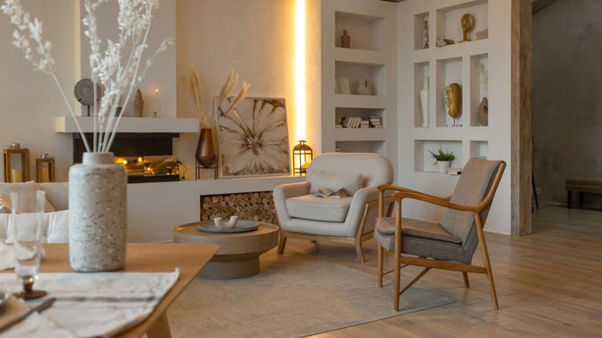
chairs slanted in living room© Pinkystock/Shutterstock
Furniture placement can elevate or ruin your living room's ambiance. You want to create an inviting, cozy, and comfortable space for your family and guests. Figuring out the best way to set up your furniture can feel limiting when you have walls enclosing the space or an open layout. However, you don't need an in-depth strategic way for your furniture placement -- they simply need to be slanted.
HGTV's "Battle on the Beach" interior designer Ty Pennington suggests slanting your furniture to add interest to your living room. You don't need expensive furniture to make your space look luxurious; slightly slanting them will draw attention to them.
When configuring furniture around your living room, consider how you want it to look when people first enter it. Pennington told House Beautiful, "Individual pieces set at a slant evoke a much more interesting and engaging perspective." Angling your furniture can transform your space by making it appear larger, creating a better flow, and softening harsh lines. Here's how to incorporate Pennington's tip in your home.

Take Advantage Of Curved Furniture
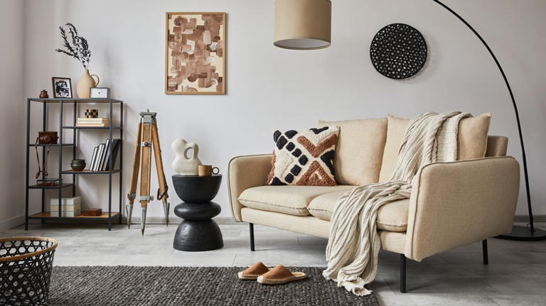
slanted couch in living room© Followtheflow/Shutterstock
Living rooms can be designed in many ways. You can have a traditional living room with three walls enclosing the space, an open sans-wall layout, or an awkward layout with slanted walls. As Ty Pennington suggests, slanting your furniture is the best way to make your living room interesting.
For example, if you have a traditional living room that's rectangular and slightly cramped, you don't have to line up your furniture along the wall. Instead, you might angle the couch diagonally along two walls and put a chair on either side to create a curved effect. Moreover, having a rug that mimics the couch anchors them to the living room, making the TV the focal point if they're facing it.
However, if you have an awkward or open layout, curved furniture can help take the room's look to the next level. Its round edges will give the space a softened look and a welcoming feel. They won't look awkward in front or beside slanted walls because multiple straight edges won't overlap. You can still slant curved furniture, especially in an open layout.
They take up more room, so you'll be able to use fewer items and prevent overcrowding in the living room. In addition, it's an excellent way to add interest and texture, and you can incorporate them with other curved or rounded items like coffee tables or end tables.

Add Mirrors To Your Living Room
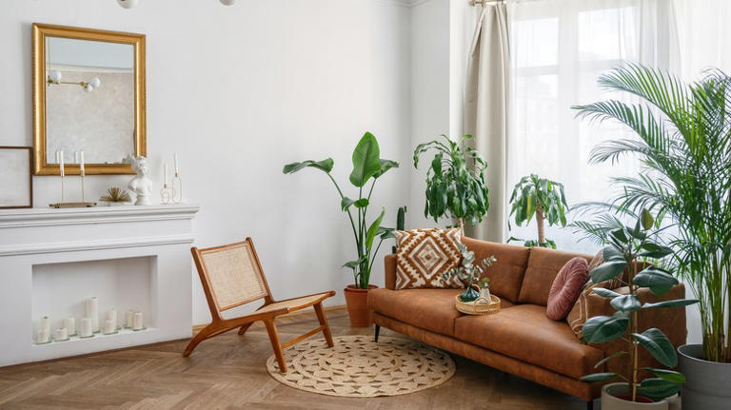
mirror across couch© brizmaker/Shutterstock
If you struggle with making your living feel open and airy, Ty Pennington advises hanging a few mirrors on the walls to make the walls retreat. Mirrors are ideal for every room -- when you hang them, they reflect everything across from it. So if you have any-sized window in your living room, place a mirror in front of it to reflect the outdoors and light coming inside. It'll make the living brighter and more expansive and help make the walls disappear from the room.
In addition, hanging mirrors can help guide where you place your furniture. For example, use mirrors as art and display one that will fill up more than half of your largest wall. Then, situate your couch below it, and everything else will fall into place. Or, put your sofa diagonally across to walls and place a mirror right across it. If you have two adjacent windows, the light that filters will reflect the mirror and illuminate the rest of the room. Slanting furniture and hanging mirrors are the dynamic duos that will turn a mundane living room into an enticing and comfortable space.

This 3-Ingredient French Side Never Fails to Impress
Yesterday 1:00 PM

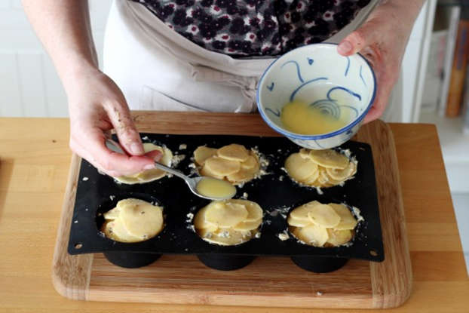

- Bird dog
- 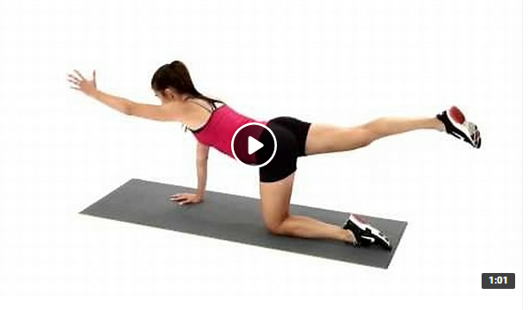
- Bird dog crunches
- 
- Four-point arm and leg extension with lateral rotation
- Bear walks
- Three legged downward facing dog knee to elbow
- 





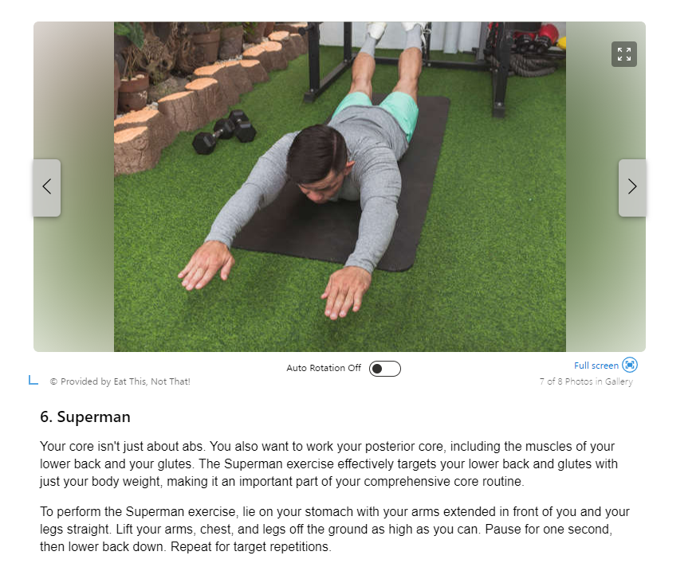
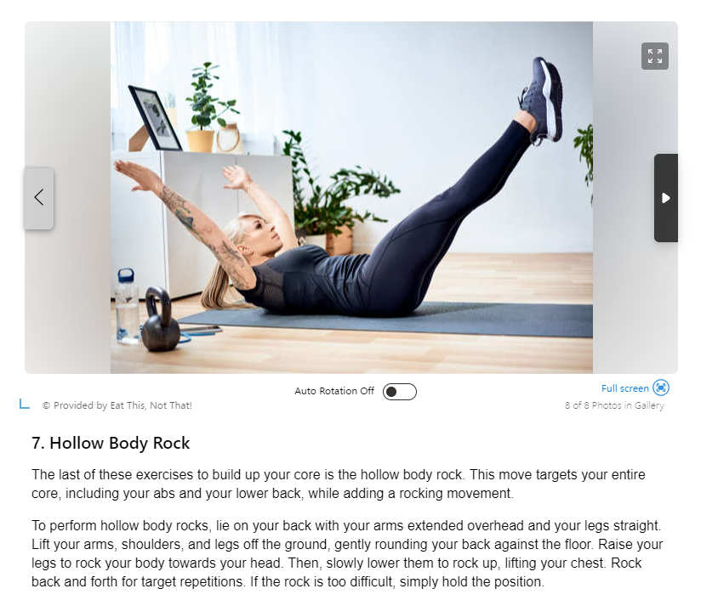



The Dinner My Family Asks for Every Week—And the Secret Ingredient That Makes It Even Better
Story by Allrecipes Staff, Robin Shreeves • Yesterday 3:00 PM
This small tweak takes it from yum to best ever.

Lauri Patterson/Getty Images© Provided by Allrecipes
I love my slow cooker. I used it sporadically before I had children, but once my sons outgrew the infant-food stage, it became a trusted tool in my getting-dinner-on-the-table arsenal. Using the slow cooker meant dinner would cook while I helped them with homework. On other days it meant dinner would be hot and ready to eat when the family got home from sports practices or games.
I particularly like using the slow cooker for beef dishes. Beef stew, beef barley soup, and beef roasts always turn out well when cooked low and slow. There’s one beef recipe that my sons ask me to make all the time and is easily in our family’s top five favorite dinners of all time: Easy Slow Cooker French Dip.
About 15 years ago, the second time I made it, I made one small tweak that took the sandwich from yum to the best French dip sandwich ever.

The Secret Ingredient I Always Add to the Easy Slow Cooker French Dip Recipe
Related video: The #1 Mistake You re Making When Hosting a Dinner Party, According to Ina Garten & Nigella Lawson (Dailymotion)
This recipe isn’t making false promises when it uses the word “easy” in the title. This is a dump-and-go slow-cooker masterpiece with just four ingredients (five with my addition), plus the rolls and butter for serving.
Add a 4-pound rump roast (trimmed of excess fat) to the slow cooker and pour a can of condensed French onion soup (I use Campbell’s), a can of beef broth, and a bottle of beer over the roast. Cook on Low for about seven hours. The most time-consuming part of this recipe is slicing the roast when it’s done. A good sharp knife makes the task easier.
The first time I made the French dip recipe, it was good, but I wanted the jus to have a deeper flavor. The next time I made it, I added a 1/4 cup of low-sodium soy sauce along with the soup, beef broth, and beer. That did the trick, and I’ve been adding soy sauce ever since. It ups the savory umami factor in the juices that go straight from the slow cooker into a bowl for dipping.

Other Tips for the Best French Dip Sandwich Ever
Here are a few other things I’ve learned over the years while making this recipe:
- Dark beer is a better choice than light beer or India Pale Ale (IPA). The recipe calls for a 12-ounce bottle of beer. I always use stout because it adds additional richness to the jus. I usually use Guinness.
- The rolls matter. Use crusty rolls. The recipe calls for French rolls. I like to use Portuguese rolls when I can find them. Kaiser rolls work in a pinch. But soft burger rolls won’t hold up to the jus.
- Add your favorite cheese. The recipe calls for buttered bread, but we like to add cheese. I prefer Swiss cheese. My son likes American (but I think American gives the sandwich a cheesesteak vibe that I don’t always want).
- Leftovers freeze really well. Freeze the beef in the jus for up to three months. Defrost in the fridge. Heat on the stovetop.
One final thing: my boys aren’t the only family members who love it when I make this French dip recipe. Buddy, my border collie, enjoys a small drizzle of jus on his dry food. Once, and only once, each time I make this recipe, I let him have just a little after I run it through a fine-mesh strainer to remove any onion pieces. It's hard to beat this delicious meal when it makes the whole family happy—even Buddy.

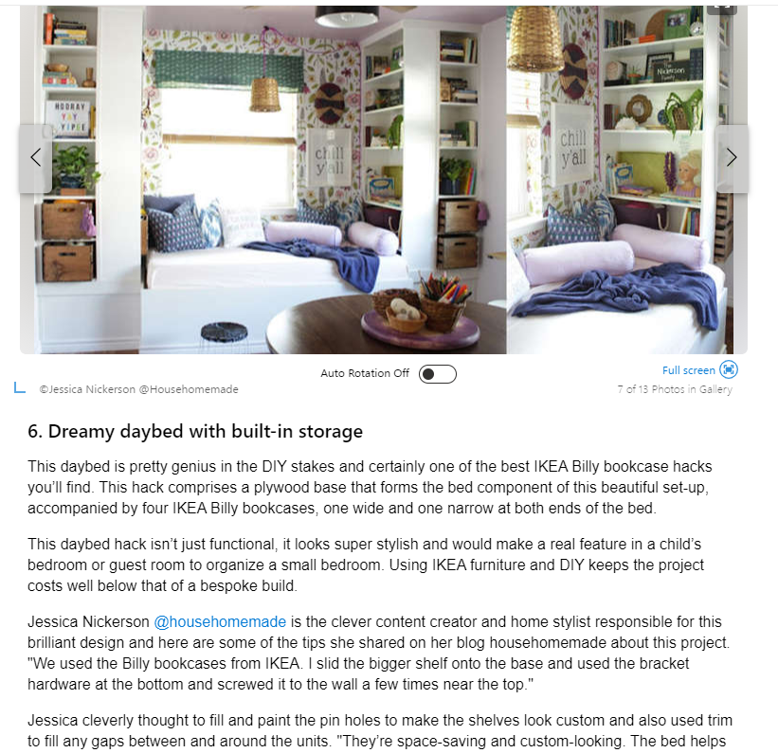



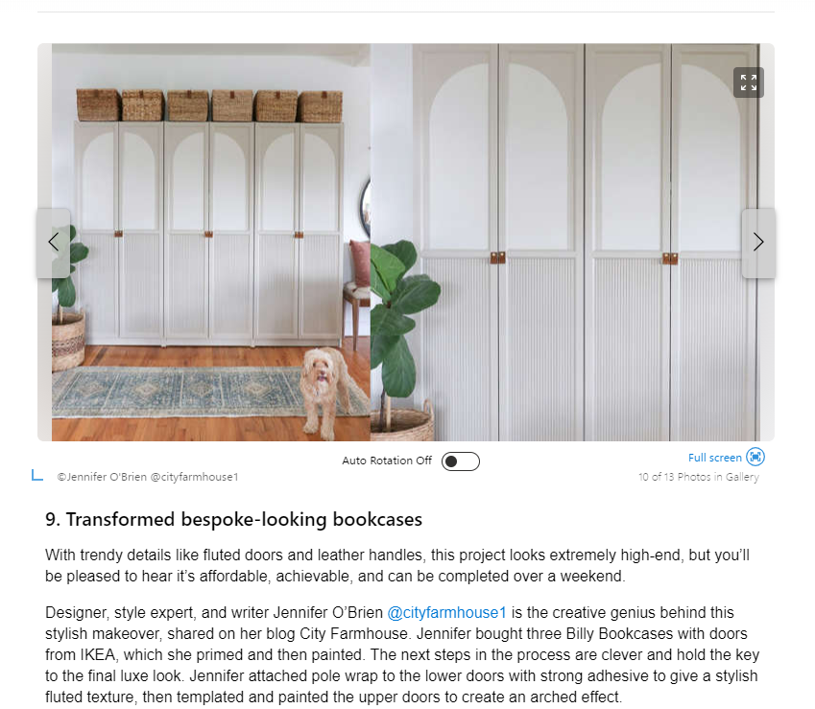



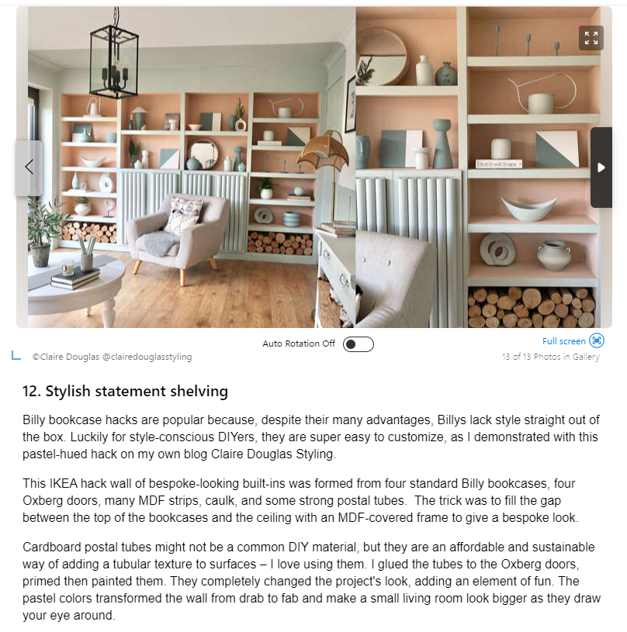

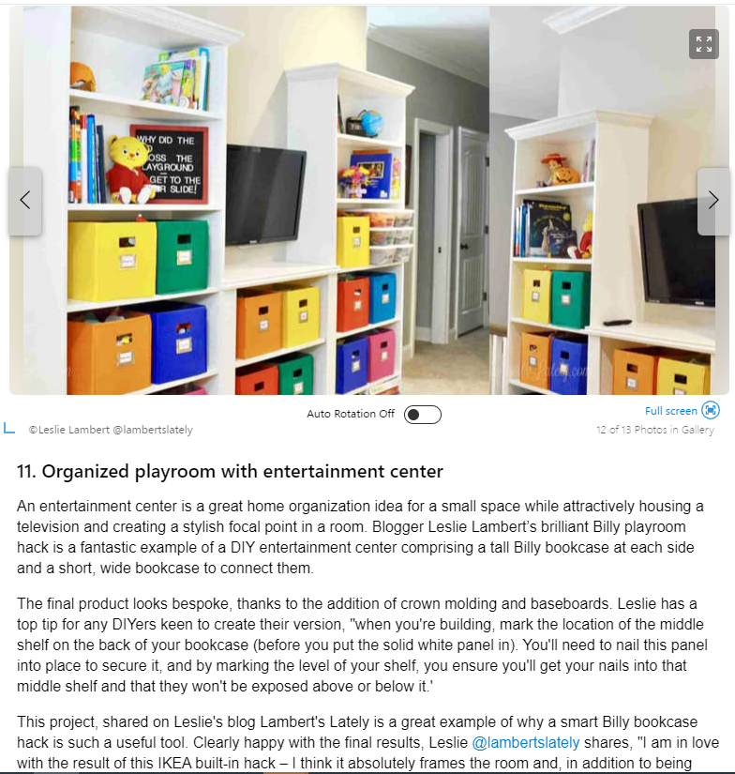

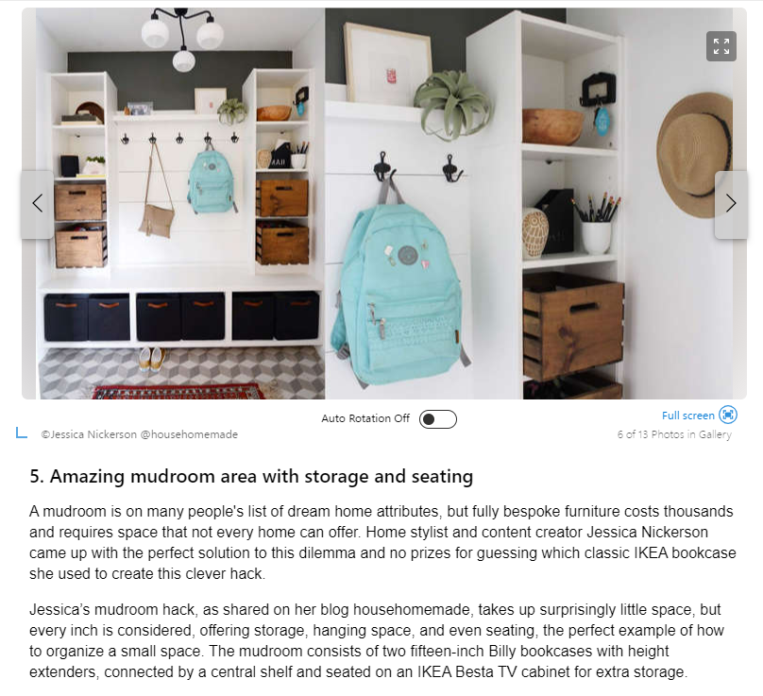

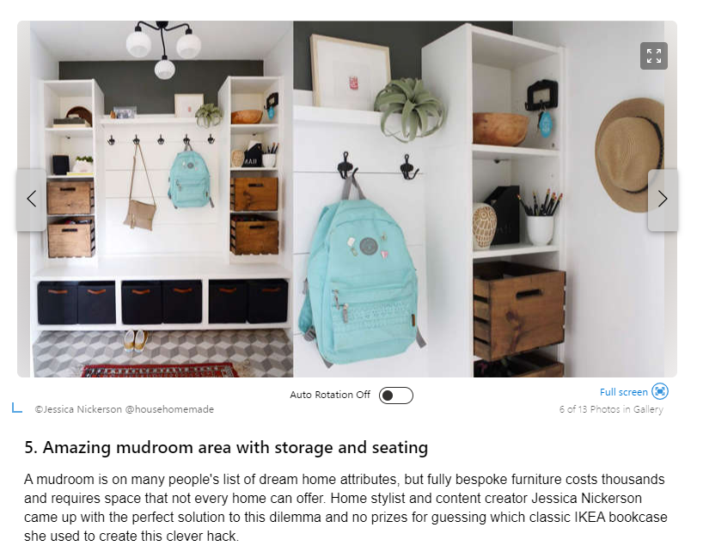

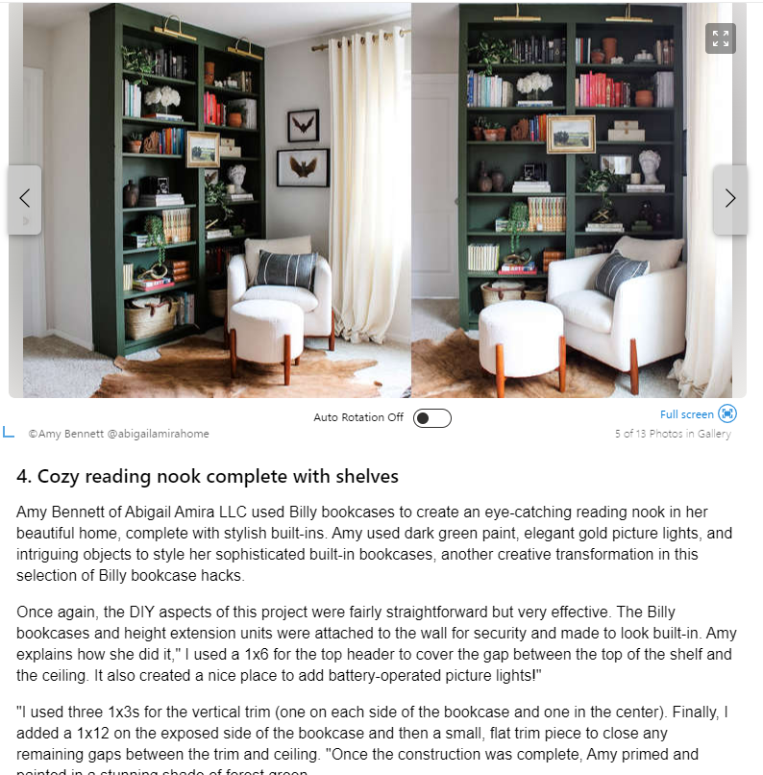

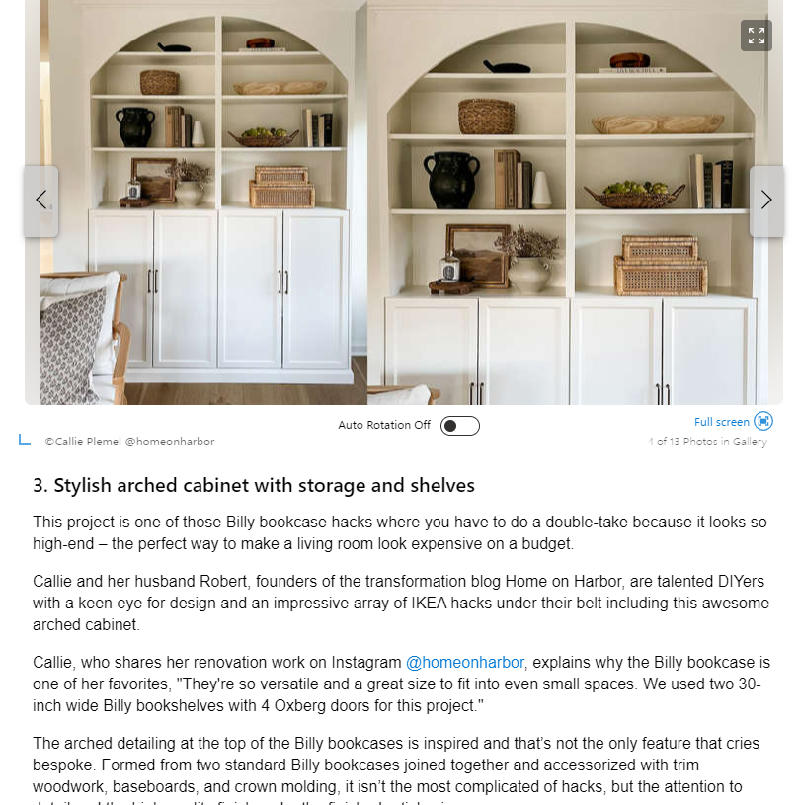
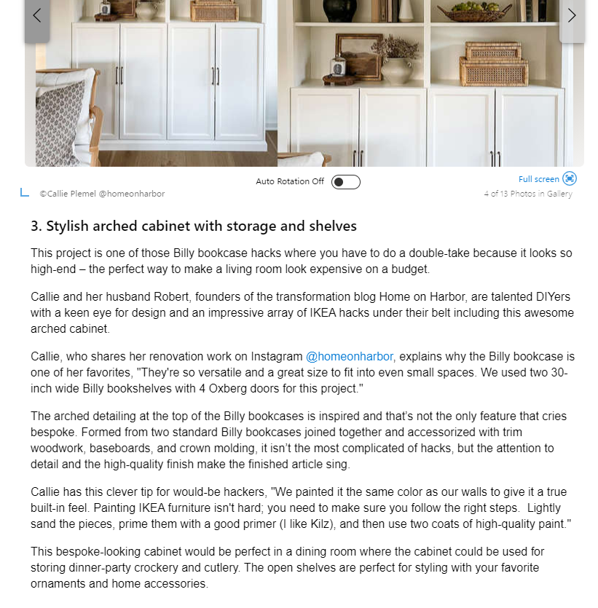

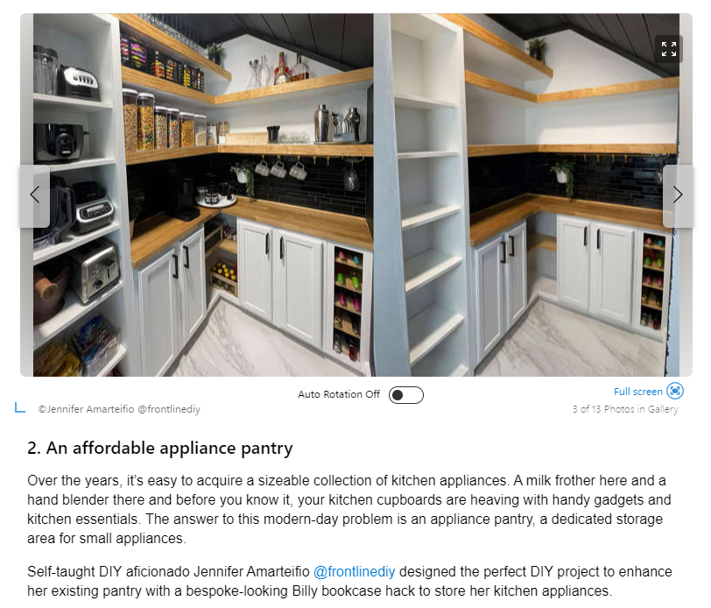
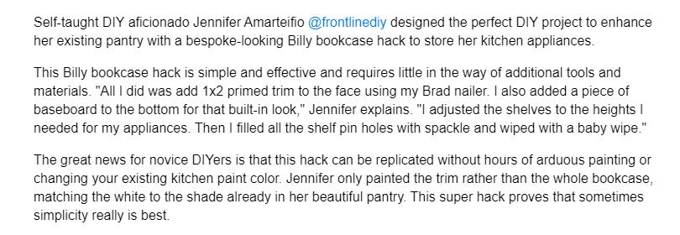

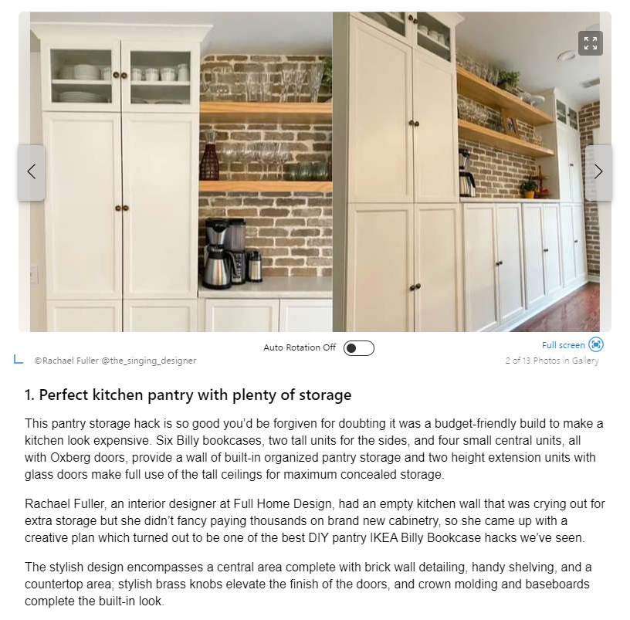

Style at Home: Understanding the differences between cluttercore and clustercore
Story by Katie Laughridge, Tribune News Service • 2h ago
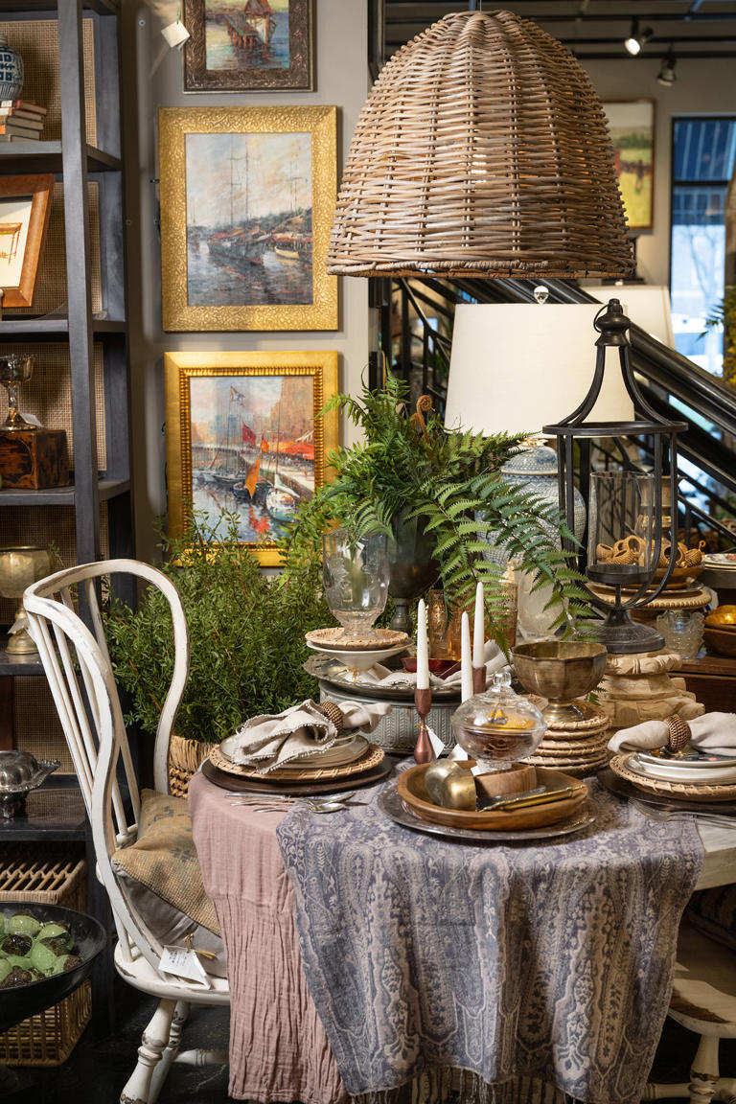
Creating a cluttercore look in your home involves embracing imperfection and creating a space filled with cherished objects and personal mementos.© Handout/Handout/TNS
When it comes to home design, two seemingly similar concepts have gained attention in the online world in recent years: cluttercore and clustercore.
While they share similarities, a few key differences set them apart. Cluttercore and clustercore represent two contrasting philosophies when it comes to organizing and displaying personal belongings.
Ultimately, both cluttercore and clustercore offer unique ways to infuse personality and creativity into home design, allowing you to express your individuality through your living spaces.
What is cluttercore?
Cluttercore finds beauty in the chaos, embracing the idea that a space can be filled with items that bring joy and nostalgia. It encourages a sense of comfort and familiarity, where every nook and cranny tells a story. Cluttercore enthusiasts often prioritize sentimentality over minimalism, allowing their homes to become a reflection of their personal journeys and experiences.
Functionally, it embraces a more haphazard approach, where an abundance of objects and knickknacks are intentionally scattered throughout a space, creating a cozy and lived-in atmosphere. It celebrates the beauty of imperfection and embraces the sentimental value of personal belongings.
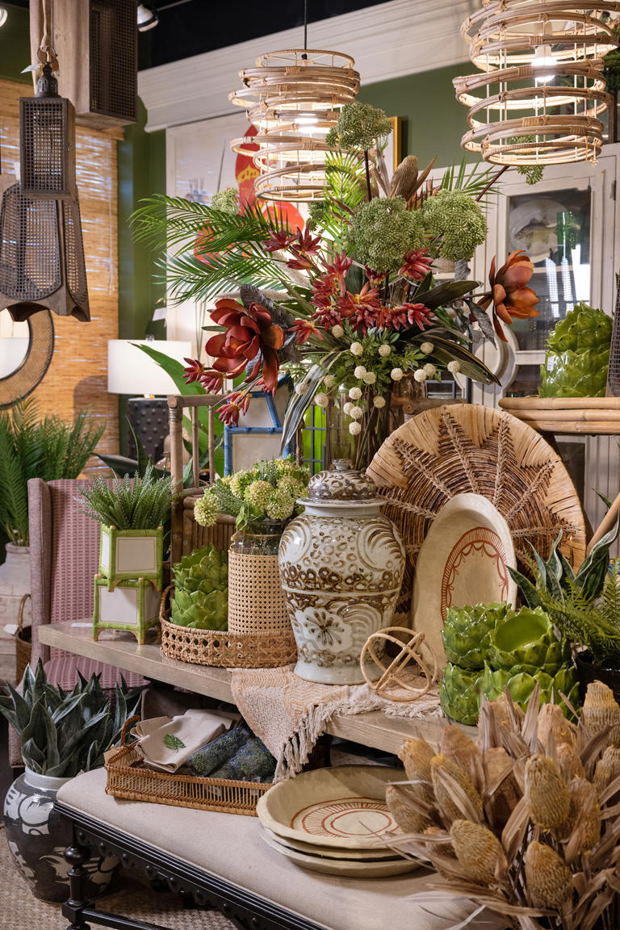
Cluttercore finds beauty in the chaos, embracing the idea that a space can be filled with items that bring joy and nostalgia.© Handout/Handout/TNS
What is clustercore?
Related video: Clustercore Is Trending—and It's the Perfect Decorating Style for Collectors (Daily Paws)
Loaded: 100.00%
Play
Current Time 0:21
/
Duration 0:47
QualitySettings
Captions
Fullscreen
Daily Paws
Clustercore Is Trending—and It's the Perfect Decorating Style for Collectors
Unmute
0
View on Watch
More videos

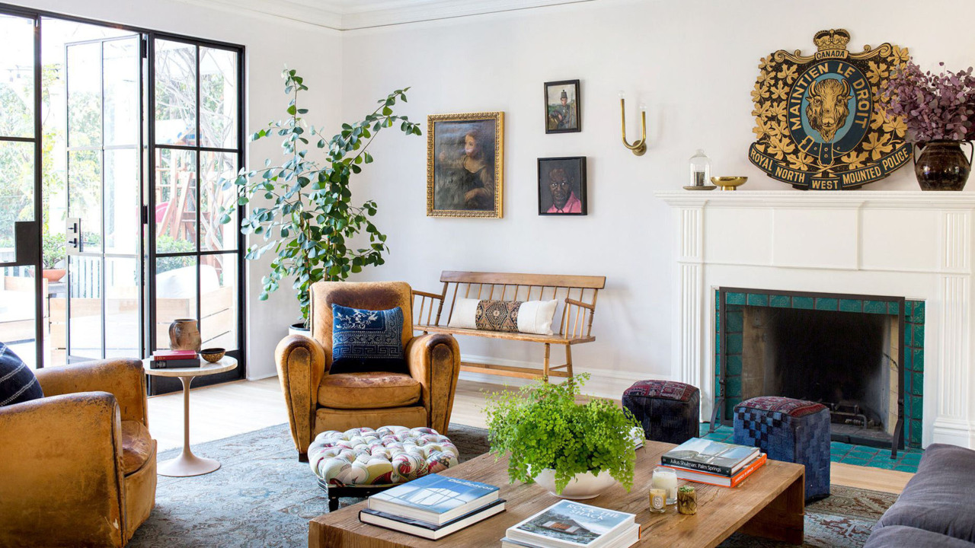
Martha Stewart LivingClustercore Is Trending—and It's the Perfect Decorating Style for Collectors
0:47


NewsweekLucy the Rescue Dog Who Loves To Fight The Sprinkler Wins Pet of the Week
0:18


FOX NewsLouisiana dad slammed for social media post celebrating faith, calling out pride month
5:10

On the other hand, clustercore takes a more curated and intentional approach. It involves grouping objects and decor in deliberate clusters, creating captivating focal points that draw the eye and tell a story. Clustercore strikes a balance between showcasing personal items and maintaining a sense of order. It encourages thoughtful curation and careful placement to achieve a harmonious and visually striking space.
Clustercore enthusiasts pay attention to the relationship between objects, considering color schemes, textures and shapes to create a cohesive and aesthetically pleasing arrangement. Each cluster becomes a focal point within the space, capturing attention and inviting exploration. It encourages a mindful approach to showcasing personal belongings while maintaining balance.
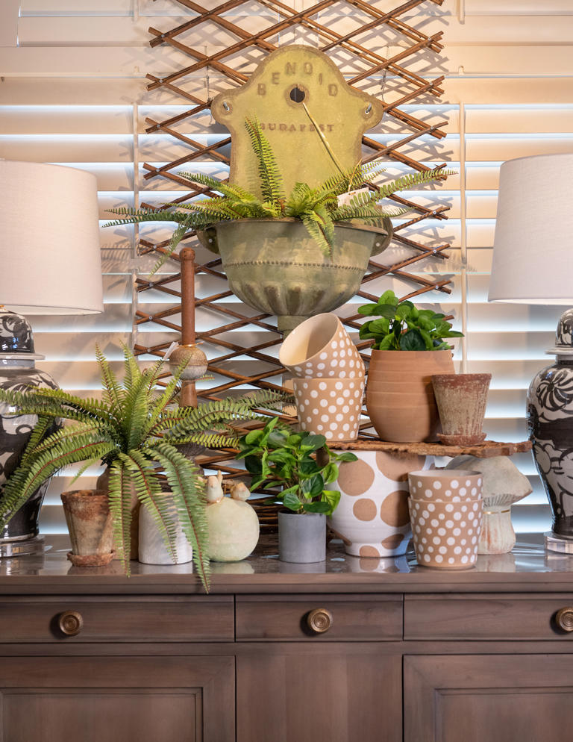
Clustercore strikes a balance between showcasing personal items and maintaining a sense of order.© Handout/Handout/TNS
Re-creating the looks at home
Creating a cluttercore look in your home involves embracing imperfection and creating a space filled with cherished objects and personal mementos. Start by curating a collection of items that hold sentimental value or evoke happy memories. They could be vintage trinkets, family heirlooms or quirky finds from flea markets.
Embrace the concept of organized chaos by strategically placing the objects throughout your space. Avoid strict organization and instead allow your belongings to be casually scattered and displayed on shelves, tabletops and even walls. Embrace an eclectic mix of textures, colors and patterns to add visual interest and depth. The key is to create a space that feels cozy and filled with stories.
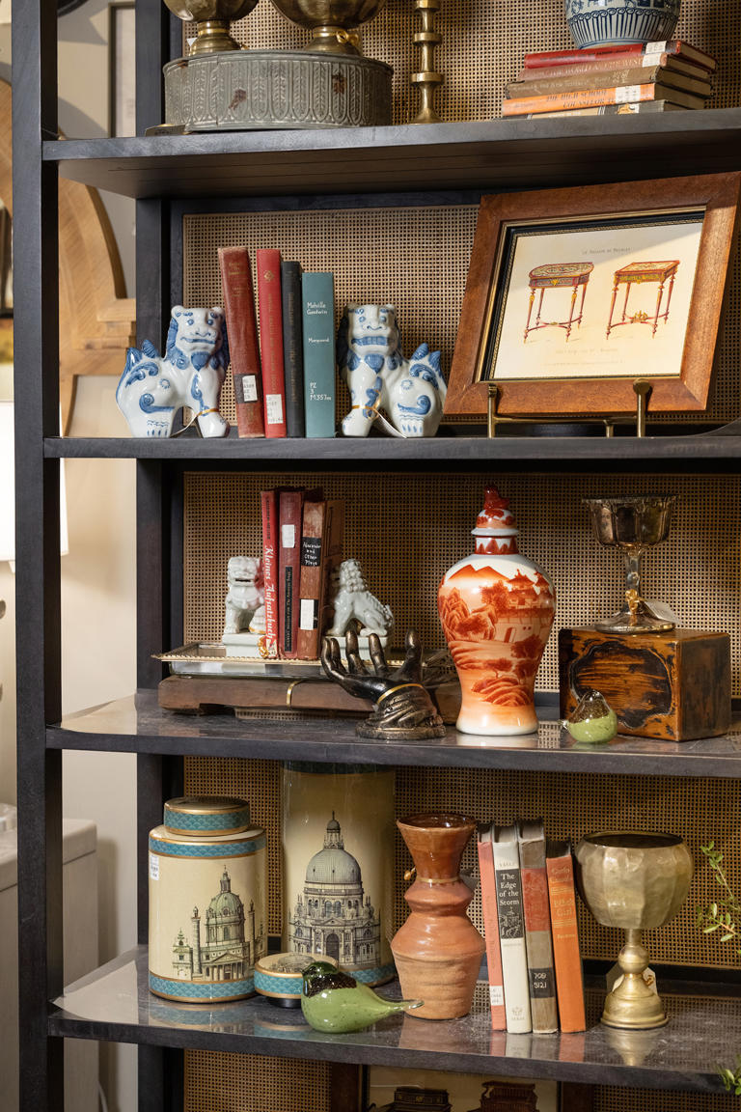
To achieve a clustercore look, it's important to strike a balance between intentional curation and visual appeal.© Handout/Handout/TNS
To achieve a clustercore look, it’s important to strike a balance between intentional curation and visual appeal. Start by selecting a few key items that hold sentimental value or reflect your personal interests. They could include cherished photographs, vintage treasures or artwork. Next, consider the composition of your clusters. Arrange items in groups of varying sizes, heights and textures to create visual interest. Experiment with different arrangements until you find a configuration that feels harmonious and visually captivating. Don’t be afraid to mix and match different styles and eras to add depth and character to your clusters.
Remember to consider the surrounding space and ensure that the clusters complement the overall aesthetic of the room. By curating thoughtfully arranged clusters, you can create striking focal points that tell a story and infuse your home with the enchanting allure of clustercore.
I am continually inspired by how these design philosophies can transform a space. Cluttercore celebrates the joy that comes from surrounding ourselves with cherished belongings, while clustercore invites us to curate intentional arrangements that captivate the eye. Both styles offer opportunities for self-expression and creativity in home design.
Whether you prefer the cozy chaos of cluttercore or the curated compositions of clustercore, the styles remind us that our homes are not just spaces, but reflections of our personalities and journeys. So let’s embrace the allure of clutter and the art of clustering as we design spaces that truly feel like home.



Get volume fast with your blow-dryer
Here's the simplest trick in the pro hairstyle book to get supermodel hair, according to Rahal: Blow-dry in the opposite direction of where you want your hair to lie. "Separate your hair into sections, and direct the dryer away from your hair's final resting place," says Rahal. "You'll provide a lot of lift at the roots." Va-va-voom!
Now that you know these expert-recommended hair tips, find out the makeup-artist secrets that will help you look gorgeous every day.
Sources:

Control frizz with a round brush
Doing a blowout at home can give you great hair that defies gravity ... or it can cause a lot of frizz that makes your strands look stressed and damaged. Well, the secret to frizz control is apparently a round brush, according to Dorram. "Wrap sections of your hair in the brush (I love the Ibiza brand), and hit it with the blow-dryer. The round brush distributes the heat evenly so certain areas don't get overexposed and start to fry," she says. "But then here's the real secret: Continue to hold the hair in the brush for a count of six seconds after you remove the heat. This creates tension as hair cools, which helps to smooth your strands." Voila!

Never deviate from the three-month rule
When you see yourself every day in the mirror, it's easy to lose sight of the state of your hair. Over time, the strands are getting longer, losing their shape, becoming more tangly and starting to get dry at the ends ... all so slowly that you don't notice, until one day, when it's drastic enough, you suddenly do. According to Niani, that danger zone when your mane goes rogue is around the three-month mark. "Be consistent with your trims," she says. And that's every three months—no exceptions. Get regular shape-ups and you'll never go down that awkward road.
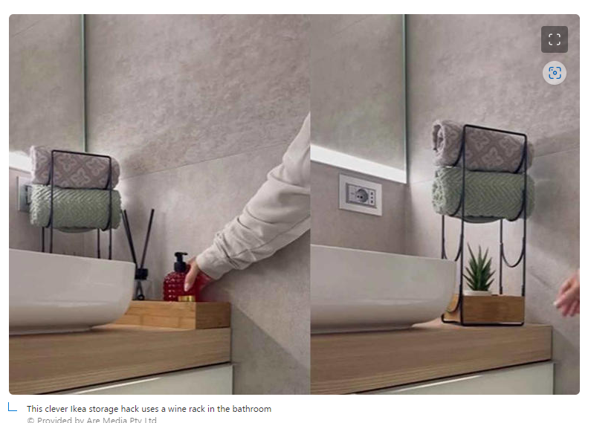

Simple Organizing Tips From Martha Stewart To Help Your Kitchen Run More Smoothly
Story by Carol Benton • Yesterday 12:54 PM
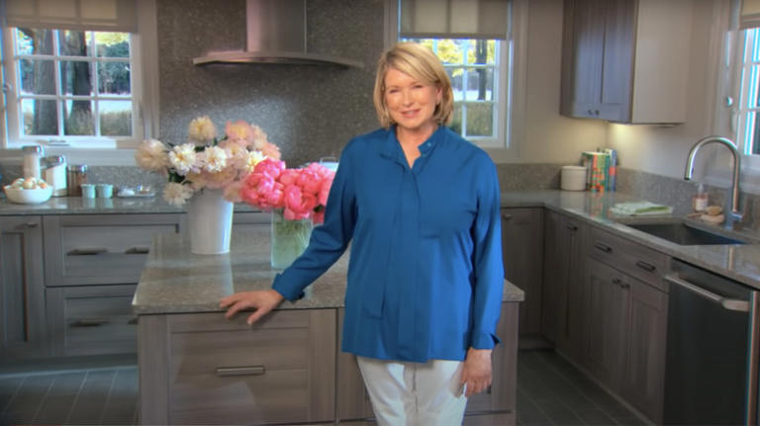
Martha Stewart in her kitchen© Larry Busacca/Getty Images
We may receive a commission on purchases made from links.
The key to Martha Stewart's kitchen design success lies in her approach to organization. Fortunately for the rest of us, she shares her tips for creating a kitchen workspace that is both functional and beautiful. One of Stewart's prime organizational rules is to utilize every bit of storage space possible. To do this, she relies on open shelving as well as cabinets, and these storage options extend all the way to the ceiling. Within her kitchen cabinets and drawers, Stewart employs multiple divider systems to organize the spaces for both storage and easy access.
Stewart takes a logical approach to kitchen organization by assembling objects, tools, and utensils according to their function and storing or displaying them in groups. For example, she stores all of her pet supplies together in one cabinet. This includes food, medicine, grooming tools, and pet toys. Stewart carries this organizational principle throughout her kitchen designs. Consequently, baking supplies are stored together in a drawer, pots and pans occupy a different space, and small utensils are separated into groups and stored vertically in containers next to the stovetop. Follow these organizing tips from Martha Stewart to create an efficient kitchen space that runs smoothly.

Keep Like Items Together
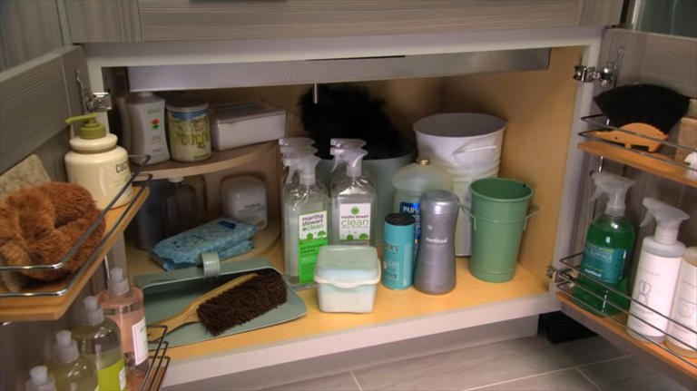
cleaning supplies© Provided by House Digest
The concept of storing similar items together in a defined location is a basic principle of organization in any room of the house. For most of us, the kitchen is the hub of functionality for our homes. When we embark on any task or project, it's crucial to have the necessary tools, ingredients, and products at our fingertips. Whether we're cleaning, cooking, or prepping food, the project runs more smoothly when we can easily find everything that's needed to complete the job. On the contrary, it's a frustrating waste of time when we have to hunt through cabinets and drawers to find the items we need.

The best walking shoes suitable for elderly people to wear all day.
Ad
Libiyi
That's why Martha Stewart adheres to the rule of storing like items together. For example, she stores her pots and pans (including their lids) together in a large drawer located under the stovetop. That way, she always knows where to look for a cooking vessel, and the items are close to the stove where she will use them.
Based on this principle, Stewart keeps her coffee cups on a shelf above the coffee maker and her mixing bowls in a drawer underneath the counter where she preps food. When cleaning day comes around, she looks no further than the one lower cabinet where she stashes all of her cleaning products, brushes, buckets, and sponges. Once you organize your own kitchen along the lines of Stewart's maxim to group similar items in your storage spaces, you'll find that you accomplish chores more easily.

Store Everyday Items At Eye Level
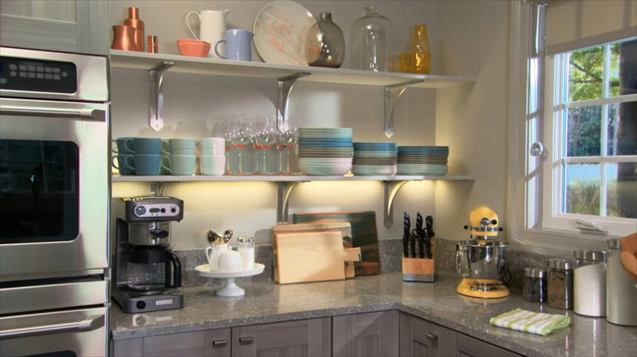
organized kitchen shelves© Provided by House Digest
When objects are stored at eye level, we can see them and access them without any effort. Think of the available storage spaces in your kitchen. You probably have upper cabinets or shelves as well as lower cabinets and drawers. Perhaps you even have a pantry with shelving and doors. Every storage area is a piece of valuable real estate that you'll want to maximize to make your kitchen run smoothly, and keeping some items at eye level is one way to do so.
Now, think about the kitchen items that you use on a daily basis (perhaps several times a day). Those items should occupy the prime spots where you can see them and reach them most easily. In Martha Stewart's kitchen, everyday items are neatly grouped and displayed at eye level on countertops and open shelving. The coffee maker, mugs, dinner plates, wine glasses, knives, and cutting boards all occupy the open, eye-level spaces in her kitchen. By contrast, seldom-used pieces of glassware and pottery occupy the top shelf where they serve a decorative purpose and can be reached with the help of a step stool.
Some people debate the usefulness of open shelving due to the fact that items collect dust over time as they sit on the shelves. Although this situation may create the need to pre-wash dishes before using them, it's not an issue with the things you use every day. Typically, those hard-working items get washed on a frequent basis.

Store Cooking Utensils In Vertical Containers
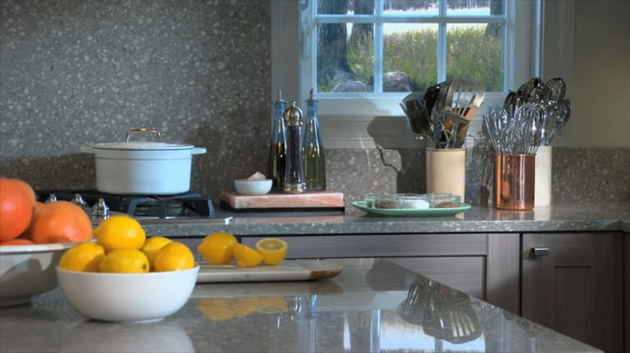
kitchen work area© Provided by House Digest
When you're prepping and cooking your favorite dishes, it's necessary to grab the proper utensils quickly and easily. If the sauce is simmering or the pancakes need to be turned, you don't have time to rummage through a drawer for a spoon or a spatula. To ensure that her cooking tasks run smoothly, Stewart stores utensils vertically in containers that she keeps on the countertop adjacent to the stovetop.
For maximum efficiency, Stewart deposits the utensils in the vertical containers with the handles down and the working parts of the tools visible above the tops of the containers. To enhance the organization, Stewart uses three utensil containers: one for spoons, one for spatulas, and one for wire whisks.
Sturdy, wide-mouth crocks and cylindrical containers make excellent repositories for cooking utensils in your kitchen work area. For example, this marble utensil crock from Sur La Table is available on Martha. Alternatively, you can use a heavy ceramic pitcher or a wide-mouth vase to store cooking utensils in an upright position. Be sure that the container you choose is heavy enough to hold the utensils without tipping over.

Create Storage Space Up High
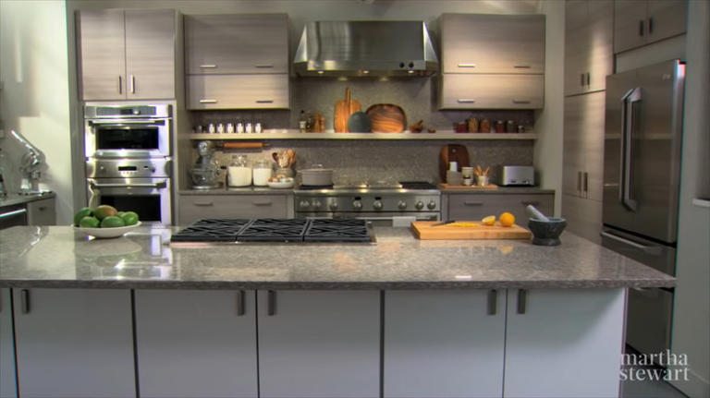
modern kitchen© Provided by House Digest
To achieve maximum organization, Stewart advocates using every available storage space in your kitchen. One way to do this is to think vertically. Although you'll want to keep everyday items in easy-to-reach spaces, you can stash seldom-used dishes and equipment in high places. Install cabinets or shelving all the way to the ceiling, and you'll find new places to organize and store kitchen items.
For example, the space above the refrigerator goes unused in many kitchens. But Stewart transforms this dead space into storage space with cabinets mounted up high. This is an optimal solution for storing serving dishes and items that you only bring out for holiday celebrations or infrequent dinner parties.
When you use high spaces in your kitchen for storage, it frees up the lower areas for things that you need to access more frequently. However, you should be aware of the fall risk involved in using a step stool to retrieve items from high cabinets and shelves. You'll want to ensure that there is someone in your home who can accomplish this task safely.

Install A Shallow Shelf Above The Stovetop
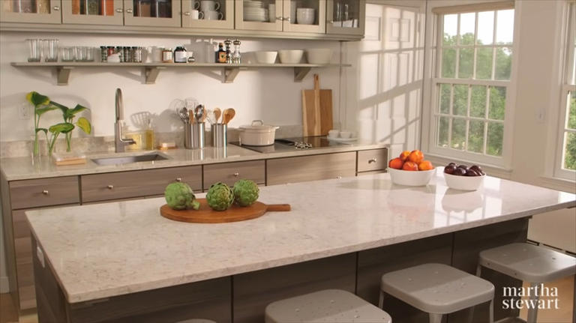
shelf above stovetop© Provided by House Digest
Stewart is a master of food preparation, cooking, and hosting dinners for family and friends. It's no wonder that she organizes her kitchen for maximum efficiency. A shallow shelf running along the wall above the stove and food prep area is an example of the simple and ingenious features that make Stewart's kitchen run smoothly.
The shallow shelf is installed 22 inches above the sink, countertop, and stove top. It protrudes only a few inches from the wall, leaving plenty of room for manipulating pots, pans, and kitchen equipment. The shelf is painted in a color that matches the cabinets, and simple corbels lend a decorative touch.
On the shelf, Stewart keeps cruets of cooking oils, salt and pepper grinders, frequently used spices, small mixing bowls, and water glasses. The things on the shelf are within easy reach when she's cooking and preparing food. By displaying the small, commonly used items on the shelf, Stewart frees up space in the cabinets and drawers to store less-used condiments and dishware as well as large pieces of cookware.

No Built-In Pantry? Use Open Shelves
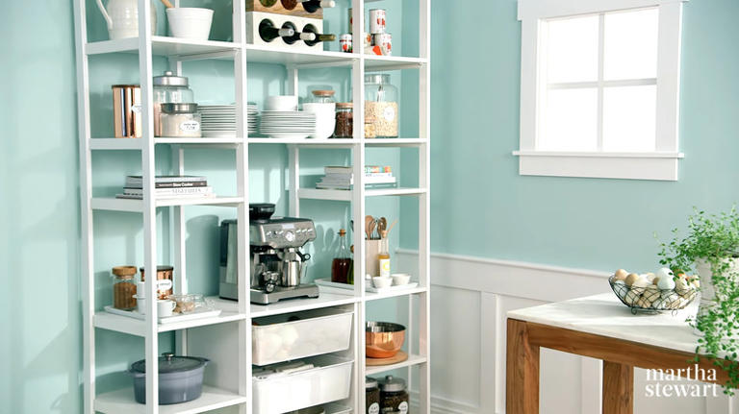
open shelves in kitchen© Provided by House Digest
If you don't have a walk-in pantry in your home, kitchen organization can be a challenge. Fortunately, Martha Stewart offers an attractive and functional solution with her pantry storage system. She partnered with California Closets to design this open, modular shelving unit that can be configured to suit your individual needs. Use this unit or a similar one to turn any blank wall into a pantry.
First, select the number of shelving sections you need to fit your wall width and to create enough storage space. In Stewart's pantry system, you can choose your shelves in either 14-inch or 20-inch depths and adjust them to desired heights. Then, you can add wire mesh drawers that slide on tracks installed in the shelving units.
Stewart advocates open shelving to keep food and kitchen supplies visible. On her modular pantry shelves, dishes occupy eye-level shelves, and a coffee maker sits in an easy-to-reach, central position. Stewart fills the shelves with dry goods like oatmeal and sugar stored in large, clear, glass jars. The wire mesh drawers hold vegetables, cloth napkins, and bowls. She keeps pet food in clear glass containers on the lower shelves and positions seldom-used items on the top shelves.

Use Drawer Dividers To Organize Multiple Like Items
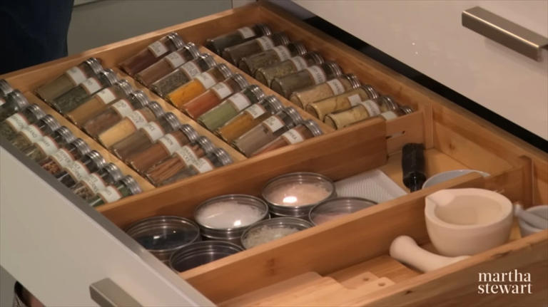
spices in drawer© Provided by House Digest
Even after you've mastered Stewart's organizational principle of storing similar objects together, you might need additional help to put the contents of your drawers in order. Rather than having a jumble of loose items tossed into a drawer, you can increase your kitchen's efficiency by dividing each drawer into sections for specific contents.
Stewart uses slanted shelves inside a drawer to store multiple jars of spices. She recommends this type of storage because spices stay fresh over long periods of time when they are stored away from sunlight. The angle of the shelves facilitates easy reading of the spice labels when the drawer is opened.
The spice drawer is not the only place where Stewart uses drawer organizers. One drawer is divided in half to keep cloth placemats on one side and cloth napkins on the other side. A knife drawer features dividers to separate the different types of knives as well as cork receptacles that keep the knives from sliding around and banging into each other inside the drawer. Additionally, Stewart's drawer for cooking utensils is neatly organized with dividers installed on the diagonal axis. This arrangement creates long and short sections to accommodate utensils of various sizes.

Install A Peg Board To Organize Dishes In Drawers
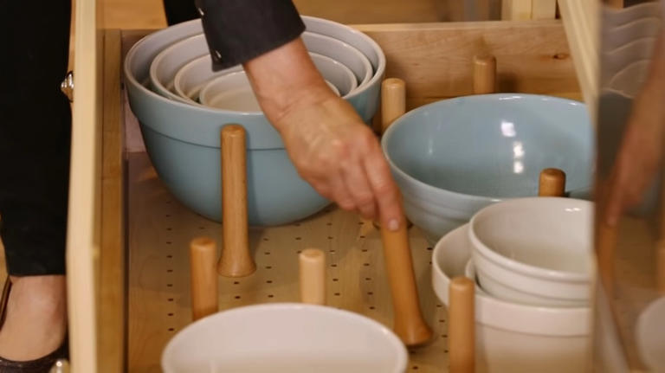
pegboard system drawer organization© Provided by House Digest
In the kitchens that Martha Stewart designs for The Home Depot, she includes innovative ideas for organizing multiple pieces of cookware and dishware. One surprising detail is a pegboard installed horizontally in the bottom of a large, deep drawer. Several removable pegs fit into the pegboard, creating vertical impediments to keep things from sliding around inside the drawer. The system is completely customizable for endless variations of drawer contents.
Wide and deep drawers make excellent storage areas for serving dishes, mixing bowls, and cookware. You can access the equipment more easily from a pullout drawer than from a cabinet. The problem with this type of storage is that when you open and close the drawer, the contents can shift. Glass, porcelain, and ceramic items may crack or chip due to sliding into each other within the drawer.
To alleviate this problem, Stewart's system with the pegboard and pegs keeps the items separated. The pegs can be removed completely, and you may use only as many pegs as you need. When you re-organize your kitchen, you can change the arrangement of pegs within a drawer to accommodate a different set of cookware or dishware pieces.

Double Up On Flatware Storage Trays
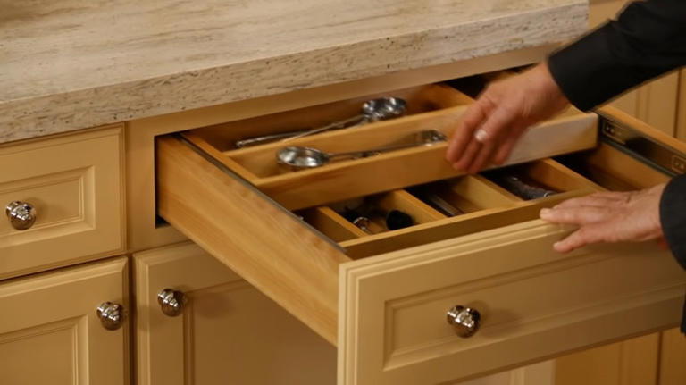
flatware drawer in kitchen© Provided by House Digest
Flatware (AKA silverware) consists of the knives, forks, and spoons that we use on a daily basis for eating meals. Many kitchens have a flatware drawer with a divided tray that organizes the utensils. But, did you ever think that the drawer is deep enough to house two layers of flatware for dining as well as small utensils for food preparation?
Martha Stewart uses a layered system where two divided flatware-storage trays are stacked within one drawer. In effect, she doubles her available storage space while organizing and separating the flatware. Martha's system operates by sliding on a track installed in the inner sides of the drawer. The upper-level flatware tray slides back to reveal the contents of the lower-level tray.
Even if you don't have a system as sophisticated as Stewart's sliding flatware trays, you can organize your flatware drawer for maximum functionality. For example, VaeFae offers multiple bamboo drawer organizers for knives, flatware, and kitchen utensils.

Use Dividers To Store Trays Vertically
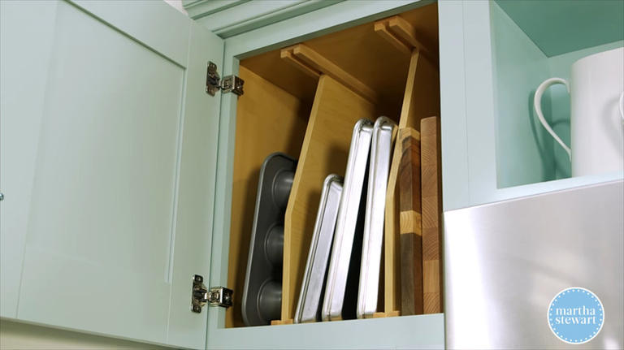
kitchen cabinet storage© Provided by House Digest
Some pieces of kitchen equipment feature awkward shapes and sizes that are difficult to organize and store. These include cookie sheets, shallow baking pans, muffin pans, cutting boards, and serving trays. It's a frustrating task to retrieve these items when they're stored flat in drawers and cabinets. Frequently, they slide around and become a jumbled mess.
The answer to organizing these large, flat pieces of kitchen equipment is to store them vertically, like books on a bookshelf. Then, it's necessary to create barriers that keep them from falling over and crashing into each other.
In Stewart's kitchen, one deep, upper cabinet is set aside for organizing items that are large and relatively flat. It contains vertical dividers that section off the interior cabinet space. Stewart slides the pieces of cookware in between the dividers, and they're conveniently visible as well as neatly organized. To make things even easier, this cabinet is located above the ovens, so the large pans are within easy reach when Stewart is baking or cooking.







This 6-move workout burns calories fast and only takes 10 minutes
Story by Bryony Firth-Bernard • 7h ago

null© Getty
Running is great if you’re looking to lose weight as it burns a lot of calories, but here at T3 we know there’s two camps: the keen runners and the ones who are not so keen. This workout is for the latter. It will get your heart rate pumping, fire up your metabolism and it’s going to take you the best part of 10 minutes, if that. Just grab your best workout trainers and you’re good to go.
This workout is actually a high intensity interval training (HIIT) workout, an ideal style of training if you’re always struggling to fit a workout in, as they’re short and speedy. But as well as being able to burn lots of calories during a HIIT workout, Healthline also points out that it can actually increase your metabolic rate, so you continue to burn more calories even after the workout is complete. Again, making it ideal if you want to lose weight, but don’t have hours to spend in the gym or going for a run.
We won’t lie, this workout is a little intense, but the good news is it’s only 10 minutes, so the quicker you get it done, the faster it will be over. There’s only six exercises and you’ll do each one for 30 seconds, with a 10 to 15 second rest in between. The only piece of equipment you need is a skipping rope — don't worry if you don't have one though, either check out our best HIIT equipment guide, or check out the alternative exercise you can do at the end of this article. You want to try and do three rounds of the workout in total, resting for 60 seconds in between each round. Remember, it’s quicker than going for a run. Are you ready? Here’s what you’ll be doing:

- Skipping
- High knees
- Criss-cross jumps
- Standing X crunch
- Mountain climbers
- Half burpee
If you don’t own a skipping rope, you can simply do little jumps on the spot, but it is a great piece of home gym equipment as skipping is a brilliant full-body workout. If you loved this HIIT workout and fancy doing some more, you should definitely give this six-move full-body HIIT workout a try, which requires no equipment whatsoever.

13 Before and After Backyard Makeovers You Can Do in a Weekend
Story by Jenny Stanley • Yesterday 9:46 AM

before deck makeover cheap backyard makeover ideas, patio makeovers© Family Handyman

Before: Sound Structure, Worn Decking
This home's existing decking and railing was in in poor condition, but the pressure-treated structure holding it up was still sound. There's no need to tear down the entire deck when adding new decking and railings does the job. The results of this simple makeover will surprise you.

after deck makeover

After: Refreshed Decking Looks Brand New
If your existing deck is old, shabby and a maintenance nightmare, you don’t have to tear it all down and start over. Chances are that the structural parts are still in good shape. If so, you can simply remodel it with new decking, rails and stairs, and save tons of money over the cost of a complete rebuild.
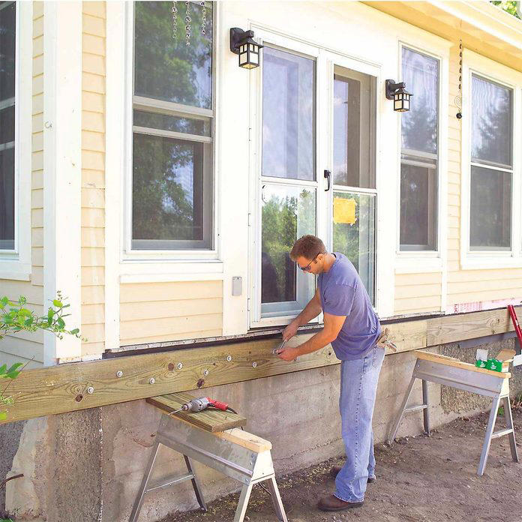
no-rot deck before

Before: No Space for Relaxing Outdoors
When a deck is inviting, you know it, and here's one that will definitely draw you outdoors. It's spacious and attractive. It features large planter boxes to put green plants and flowers close at hand. And it has a versatile railing system that lets you combine solid panels for privacy and open sections for great views and cooling breezes.
We framed the deck with pressure-treated wood, which will last for decades. Then we covered the framing with plastic/wood composite decking and an engineered wood trim, aluminum balusters and fiber cement siding. With these materials your deck will look great for a decade with little more than an occasional cleaning.

no-rot deck after

After: Amazing, Maintenance-Free Deck
Build this spacious, semi-private deck, which features planters, a handsome railing, low-voltage outdoor lighting and a wide range of low-maintenance, durable materials.
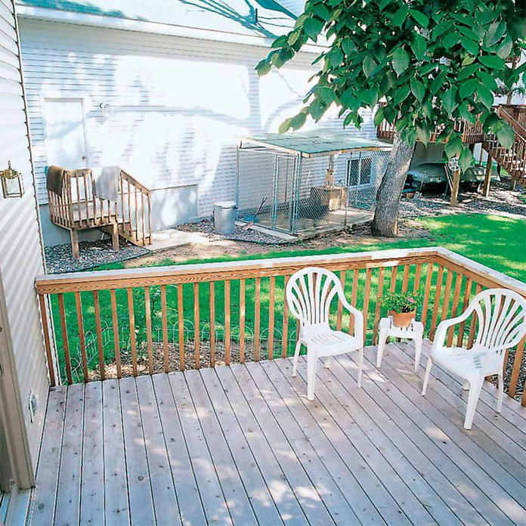
before privacy fence

Before: Unattractive View
The deck location on this home includes an unsightly view of the neighbor's backyard and dog pen. When you can't relocate a deck, try this simple project instead...
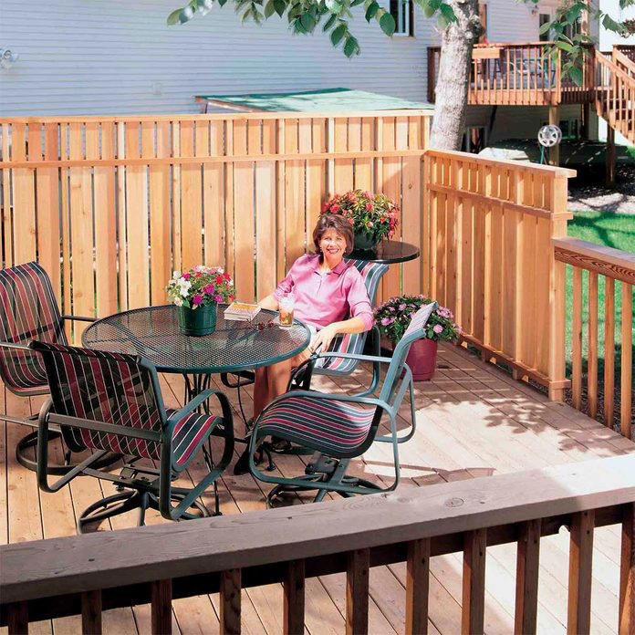
finished privacy fence

After: Perfect Private Hideaway
If you enjoy spending time on your deck but the neighborhood pest seems to pop over every time you step outside, this deck privacy fence is for you. It's designed to gracefully replace sections of your existing railing and make your deck more private. It also blocks unsightly views, reduces outdoor noise and gives you shelter from the wind, making your deck a more comfortable spot on those breezy days that usually drive you inside.

before overall deck

Before: No Place to Kick Back
If there are no areas to gather with friends or just sit and relax, your backyard space is being wasted. Turn it into something special.

full deck after

After: Space to Relax and Entertain
This dream deck isn't huge — about 16 ft. wide x 18 ft. deep plus bays and stairs — but it's big on features. The upper deck is just the right size for entertaining small groups — spacious but intimate. Cantilevered nooks on both sides provide space for seating and barbecue storage. The pergola shades the upper deck and the home's interior from the sun, and it offers a space for hanging or climbing plants. The lower deck is a great place to hang out in the sun, while the cascading stairs flow into the yard and provide lots of space for planters and pots.
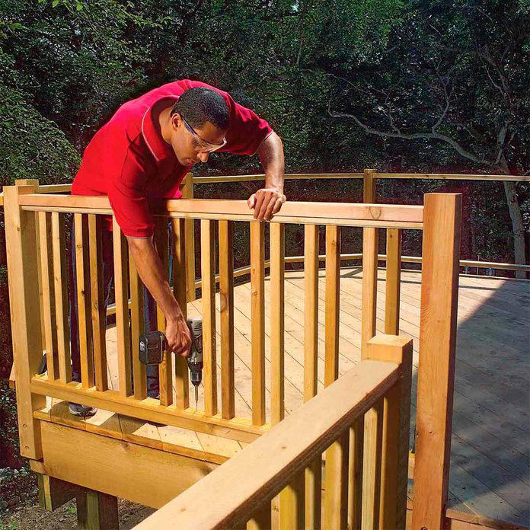
new railing before

Before: Blah Deck Railing
We'll show you how to dress up a dull deck with sturdy, handsome railing that provides a wide-open view.

new deck railing

After: Safe, See-Through Deck Railing
Any deck can benefit from a cedar deck railing with glass. In addition to adding flair to your outdoor space, it also creates a feeling of spaciousness on even the smallest decks.

gravel path before

Before: No Place to Pass
Add an element of interest as well as a practical way to walk through your backyard with a gravel path. It's easier to do (and less expensive) than you may think.
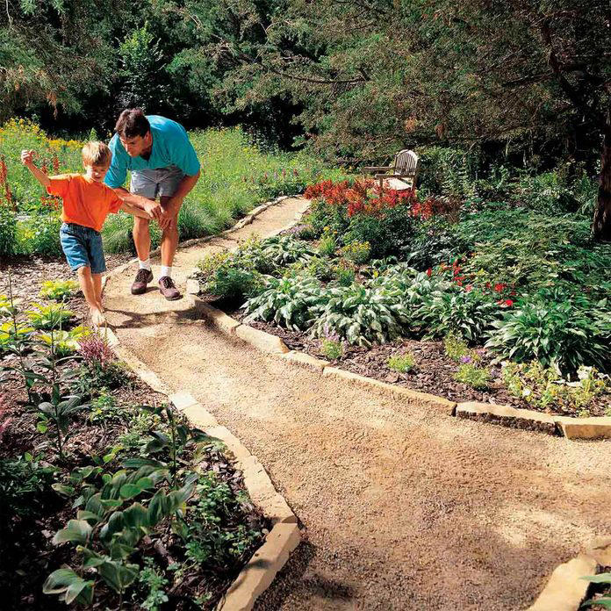
gravel path after

After: Affordable Backyard Pathway
Establishing a gravel path provides the simplest and most cost-effective way to create a pleasant garden walkway. It feels soft underfoot, but it's solid enough to handle a loaded wheelbarrow. And although it looks informal, it can complement a formal garden, especially if you add a stone border.
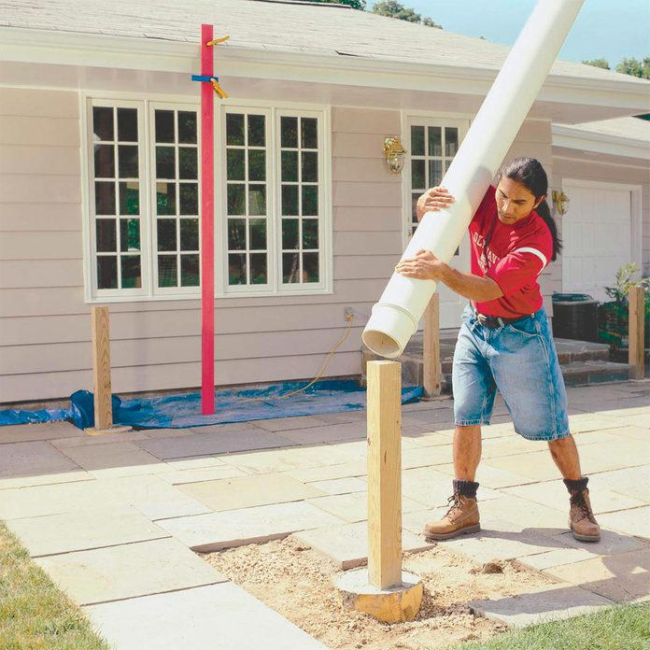
white pergola

Before: Hot Paver Patio
Is your paver patio too hot to sit on for more than two minutes? Create a touch of backyard shade by adding a pergola.
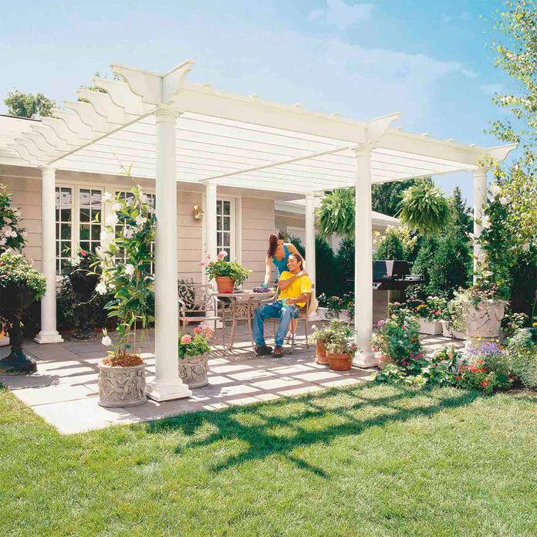
white pergola after

After: Pretty Pergola for a Hint of Shade
Build a vine-covered pergola in your backyard to shade a stone patio or wood deck using wood beams and lattice set on precast, classical-style columns. The dappled sunlight created by the overhead latticework creates a cool, relaxing environment perfect for backyard entertaining.

screen porch before

Before: Buggy, Blank Backyard
Are you chased out of your own backyard by mid-summer bugs? Keep scrolling for the ultimate solution to take back your outdoor space! Here are a few tips to help you renovate your yard on a budget.

screen porch after

After: Bug-Free Outdoor Room
You can add a spacious, airy outdoor screened-in porch to your home. We'll show you everything you need to complete the project yourself, including how to frame the porch, attach it to your house and all of the finishing details. Sure, it'll take a lot of time and work. But once it's done, you can beat the bugs and spend more time outdoors during the summer.
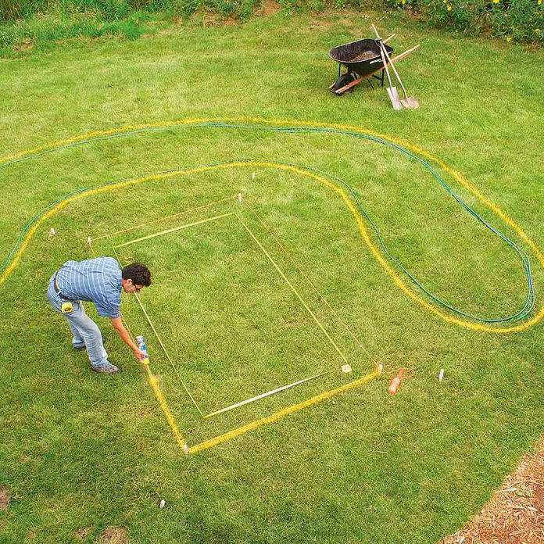
pond deck before

Before: Wishing for a Water Feature
Have space in your backyard for a unique garden water feature?

deck pond after show-stopping home projects© Family Handyman

After: Zen Space, And Less to Mow!
Let us show you how to add this easy-to-build garden pond and deck to your yard. This serene retreat can be built by a novice and doesn't require a lot of expensive tools, yet it offers a unique design.
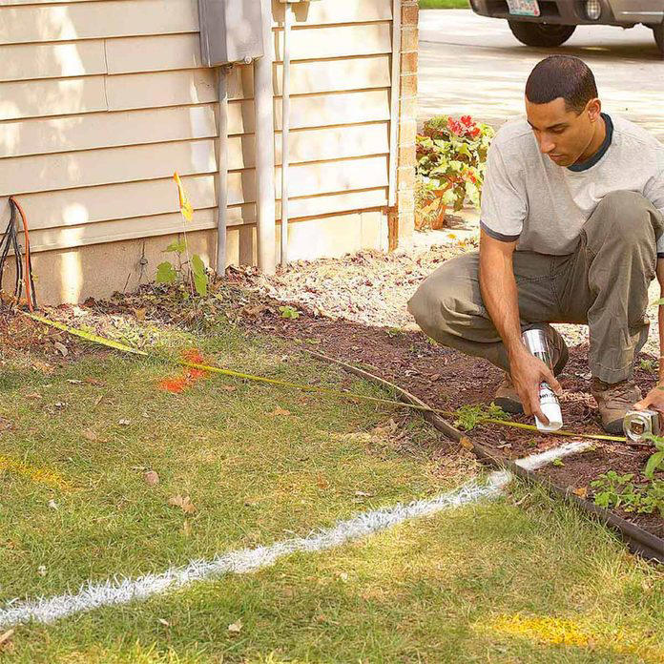
before brick and stone pathway

Before: Trampled Grass Walkway
Do you want to spruce up an ordinary, all-purpose sidewalk or patch of grass that's constantly walked on? If so, this project is a great eye-catching solution.
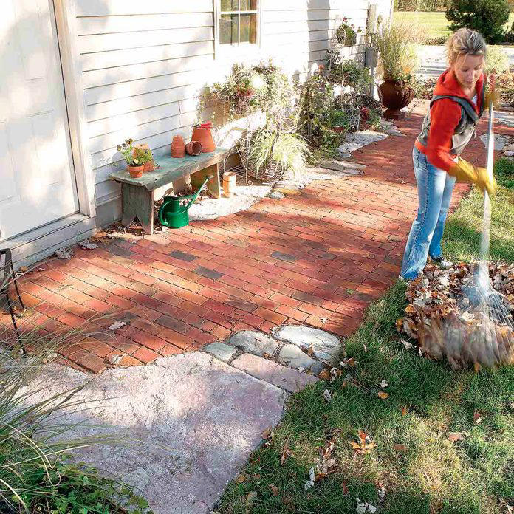
after brick and stone pathway

After: Heirloom Garden Pathway
This brick and stone pathway dresses up a space along the side of the house from the driveway to a service door. It also provides a firm, smooth surface for rolling a garden cart or wheelbarrow and keeps your feet out of the mud on a rainy day. Its seven-foot width allows room for a bench to kick off your boots, with plenty of space left over for potted plants.
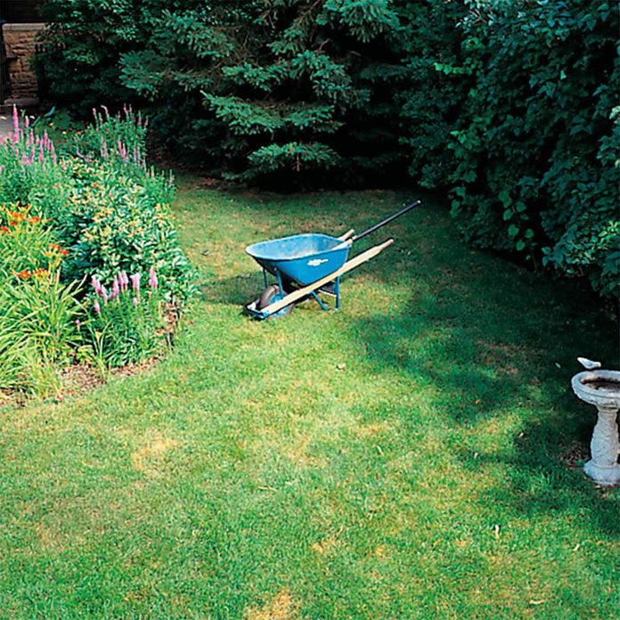
patio before

Before: Place for a Patio
Want to put in a patio for outdoor dining? There's more to think about besides just space. You must consider critical factors such as ground slope, drainage, shade and obstacles like tree roots and underground utility lines.
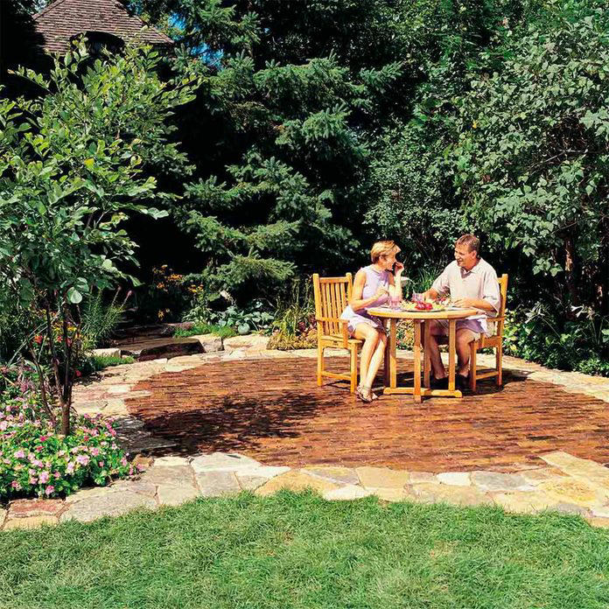
stone patio finished

After: Natural Stone Patio
Add a welcoming feature to your backyard with this attractive, long-lasting stone and brick patio. This design easily adapts to fit your yard. Choose from a wide variety of stone types and brick styles. The result will be permanent and maintenance-free.

before backyard stairs

Before: Sloped Site for Stairs
Installing stone steps in your yard can be complex, but it is a doable DIY project. You'll first need to figure out how many step risers you’ll need. Gentle slopes like ours require short risers and long treads, while steep slopes require taller risers (a maximum of eight inches) and short treads. If your hill has steep and gentle slopes, break it up into sections and calculate the step layout for each area.
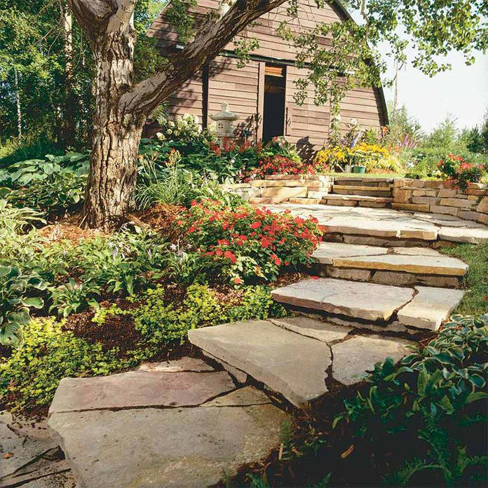
backyard stairs finished

After: Natural, Stepping Stone Stairs
These garden path steps are built on a gradual slope, but by changing the riser and tread sizes you can build them on slopes as steep as about 40-degrees. Rustic steps like these are well suited for informal garden paths like ours, but we wouldn’t recommend them for entry or other steps that get heavy daily use.
Besides basic gardening tools, leather gloves and carpenter’s level, you’ll need a few special tools for breaking and moving stone. Buy a 4-lb. maul to chip and break stone. If you have to cut a few stones, buy a dry-cut diamond blade. To move the stone, rent or buy a two-wheeled dolly with large wheels.
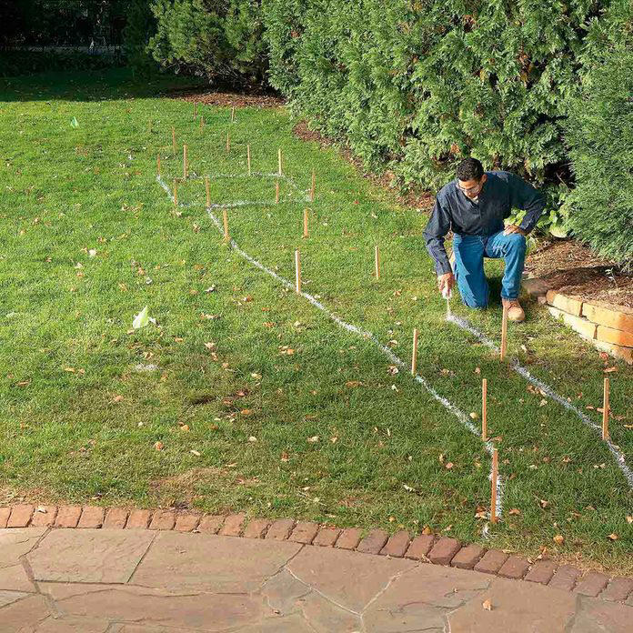
focal point before

Before: Lacking Backyard
You don't need heavy equipment and a week of work to lay an attractive and durable path. We designed this brick walkway for simplicity and ease of construction. It's made from old street pavers and granite cobbles set on a sand bed. But you can substitute just about any pavers or types of stones that are readily available and fit your landscape.
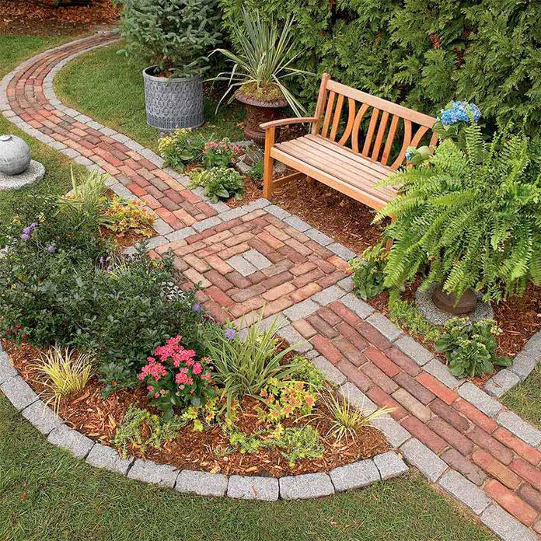
backyard focal point

After: Fantastic Focal Point
Make a simple garden path from recycled pavers or cobblestones set on a sand bed. Learn the details of path building, from breaking cobblestones to easy, fast leveling using plastic landscape edging.

5 Stylish Ways to Wear Pearls for Any Occasion
Pearls are chic, classy, and usually paired with elegant outfits or bridal gowns. But did you know that you can actually wear pearls anytime? That’s right, you don’t need to wait for your next formal event to take out that beautiful string of pearls. Whether a necklace, bracelet, or a set of earrings, pearl jewelry can enhance even the most casual outfit.
In this article, we’re exploring trendy and chic ways you can wear pearls for any occasion.
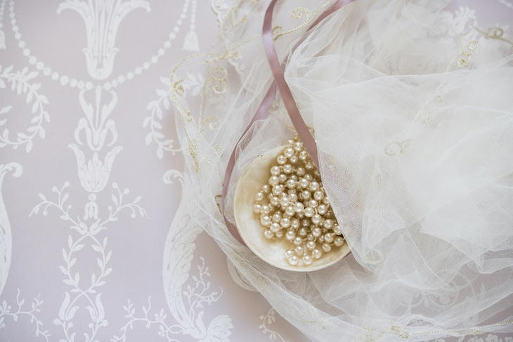

5 Ways to Wear Pearls for Any Occasion

Luxurious and Refined
Let’s start with the most obvious way to wear pearls — when you’re going for a formal or glam look. Go all-out, and wear a full set of pearls—earrings, bracelet, and necklace—with a cocktail dress for an elegant look when going to a high-end restaurant, or with a full-length gown for a night at the opera.
You can opt for pearl pins in your hair for a wedding, wear gloves with pearl buttons, or pair a pearl choker with red lipstick and a little black dress for a timeless Audrey Hepburn-inspired look.

At Work
Wondering if wearing pearl jewelry at the office could be too much? We say no, because going to work should be fun. A single to three-strand pearl necklace is appropriate for most workplaces, as long as you keep it short (under 18 inches) for a more practical, everyday look.
You can also wear a close-fitting pearl bracelet for a little glam, pair some freshwater pearls with a sweater and jeans to elevate your casual clothes, or opt for teardrop-shaped earrings to frame your face.
However, when wearing pearls at work, you should be careful not to make your outfit look too busy. Avoid wearing two pieces of pearl jewelry together, and stay away from imposing or chunky pieces. Instead, choose simple, understated items to ensure the attention falls on your work, not your jewelry. Finally, be sure to take into consideration the type of job you are performing. There are certain fields of work where wearing too much jewelry of any kind is not appropriate, like medical offices and hospitals.

Lift a Casual Look
Pearls work well with casual attire too because the formality of pearl jewelry provides a beautiful contrast. Wearing one pearl jewelry item, such as a pearl necklace, can elevate an everyday outfit into ‘smart casual’ — a refined, yet relaxed look that is ladylike and comfortable at the same time.
When you’re dressed more casually, it’s best that you only wear one pearl jewelry item at a time, especially if you’re wearing more elaborate jewelry pieces. Spherical pearls are available in simple necklace strands, pendants, and stud earrings, and one piece should be enough to lend a gentle touch of polish to your look. Try combining them with blocked-color outfits to allow the pearls’ natural sheen to pick up the colors of your clothes, or keep the clothes neutral, and allow the pearls to serve as a quiet statement piece. In any case, keep other jewelry to a minimum so that the pearls can take center stage.

To the Beach
Yes, you can wear pearls for any occasion–even the beach! Pearls are a great choice for cabana parties and beach club luncheons. You can also pair your favorite rope necklace with beach jeans and your favorite top for some beach fun after sunset.
However, be sure not to break or lose your pearls and never go swimming with them. These precious gems might be created inside pools of water but water from any source—your shower, pools, and lakes—tends to weaken the silken threads used to string strands of pearls. Saltwater, damp salt air, and chlorine can also be harmful to cultured pearls, whereas sand is extremely abrasive, so be sure to remove your pearls before taking a dip.


Ways to Wear Pearls for Any Occasion© Provided by MomsWhoSave

Have Some Fun
White pearls are classic, but why not have some fun? Pearls come in many colors: peacock, golden, and pink are especially valued, but let’s not forget the dramatic black pearls and the rainbow iridescence of mother-of-pearl. So if, for instance, white pearls feel a little too traditional for you, consider pairing a set of black pearls with black boots and a leather jacket for an edgier look.
Pearls are also found in a multitude of shapes. Besides the traditional round shape, they come in button, oval, baroque, tear-drop, and other shapes. Layering multiple strands of different-sized pearls can add a dash of the dramatic to any look, whereas pairing brown, blue, or black pearls with copper or steel metal jewelry creates an unusual industrial combo.

Final Thoughts
Now that you know how to style pearls for any occasion, don’t be afraid to experiment. Find more ways to make pearls part of your everyday attire.



The Viral Hack For Cleaning Tarnished Sterling Silver Will Have Your Jewelry Looking Brand New
Story by Jennifer Betts • Yesterday 7:30 PM


woman wearing sterling silver necklace© Uladzimir Cyargeenka/Getty Images
Nothing is more irritating than pulling out the necklace you want to add to complete your ensemble and finding it tarnished. Since you don't have time for jewelry cleaning, you throw it in a drawer of your jewelry box and head out. However, eventually that drawer of tarnished silver jewelry is going to fill up and demand your attention.
Thankfully, cleaning your silver jewelry doesn't have to be an arduous task. In fact, like most tasks, TikTok has a few hacks to save you time and money. Rather than pulling out the polish, exposing yourself to chemicals, and wasting your Saturday bringing Aunt Ruby's sterling silver necklace back to its full glory, it's as simple as running to your pantry for materials abundant in your kitchen.
You can make silver jewelry cleaning a lot easier with only three simple ingredients and a few easy steps for cleaning all your silver, from your sterling silver serving platter to your favorite rings. You'll also learn how to tackle heavily tarnished silver with a few additional ingredients and a bit of elbow grease.

Clean Tarnished Silver With These Simple Steps
When it comes to hacks, TikTok is where it's at. The app's users literally have a hack for absolutely everything under the sun, including using a little bit of aluminum foil, baking soda, and boiling water to get your sterling silver necklaces and rings sparkling again.
Related video: Should You Put Silverware Pointed Up or Down in the Dishwasher? (Dailymotion)
To try out this satisfying hack, grab about a cup of baking soda, a roll of aluminum foil, and something to soak the jewelry in, like a glass baking sheet or bowl. It's important to make sure that your silver can be fully submerged in the solution. With your materials at the ready, roll out enough aluminum foil to completely cover the pan or bowl, secure it down to the receptacle, and add your jewelry. Make sure you have enough boiling water to fully cover the jewelry or tableware; then, it's time to add the baking soda. How much baking soda you use is going to depend on what you're de-tarnishing and how badly it's tarnished, but one cup per gallon of water is a good starting point.

As soon as all the ingredients are in place, sit back and watch all that tarnish just come right off. Wait about 20-30 minutes and pull out the silver, rinse, and dry it off. If you need a little more cleaning power for heavily tarnished pieces, you can also add a little white vinegar and salt to the mix, according to our next TikTok hack.

Variations Of This TikTok Hack To Try
For necklaces, charms, and silverware with light tarnish, the baking soda and aluminum foil hack can work wonders. However, for larger pieces or those with heavy tarnish, it's going to take a little more cleaning power to get them glittering than what baking soda and aluminum foil can offer. Try adding white vinegar and salt to the mix to get a bit of extra oomph.
For this TikTok tarnish-blasting hack, you'll need a cup of boiling water, a tablespoon of salt, a tablespoon of baking soda, and half a cup of white vinegar. You'll follow the instructions from before about lining your bowl or pan with foil and placing your jewelry. Pour the water, baking soda, and salt over the jewelry, and add the white vinegar to the mixture. The fizz is totally reminiscent of elementary school science fairs. Let it sit for ten or more minutes and rinse. If the silver is still heavily tarnished, allow it to sit a little longer for an hour or more, then polish it.
In addition to removing the tarnish, make sure to keep your jewelry safe from the elements like sun and water. It's also good to keep it in a lined case. If tarnish happens, make your life easier and your jewelry brighter by trying a fun TikTok hack to add a little bit of sparkle to your life. It's simple, easy, and even fun! Plus, it made the list of Marth Stewart's best tips and tricks.
Read this next: Things In Your House You Should Be Cleaning But Aren't

TikToker shares cheap hack for cleaning soap scum from your bathtub: ‘It’s so easy and works every time’
Story by Sara Klimek • Yesterday 10:00 AM


Hack to get rid of soap scum© Provided by The Cool Down
Soap scum is a nuisance that impacts homeowners everywhere. In a recent video, TikToker Eco OG (@eco_og) presented a two-ingredient hack to clean soap scum.

The scoop
The video suggests sprinkling baking soda in the tub before spritzing around with a coating of hydrogen peroxide. Then, Eco OG allows the mixture to sit for 15 to 20 seconds before wiping it off with a paper towel.
“It’s so easy and works every time,” the creator says.

How it’s helping
This simple hack is an inexpensive way to get a cleaner tub or shower — while also reducing the use of toxic chemicals in the household. Studies have indicated that the average American family spends $40 to $50 monthly on household cleaning supplies. Homeowners can decrease this expenditure by already using ingredients they have in their households, like baking soda and hydrogen peroxide.
Eco OG explained in the video’s comments section that hydrogen peroxide is an organic compound that biodegrades completely into oxygen and water. Therefore, it is a preferable alternative to more toxic cleaning products like bleach, which can cause skin and respiratory irritation to plants and animals.

The best walking shoes suitable for elderly people to wear all day.
Ad
Libiyi
The Occupational Safety and Health Administration (OSHA) lists bleach as a Category 1 chemical with the highest human health risk of the five categories. This means it’s looped in with other chemicals that cause irreversible skin damage and blindness as well as substances known to cause cancer, sterility, and genetic alteration … all just to clean out your shower.
Therefore, improper handling of bleach can cause numerous health threats and exacerbate conditions like asthma, while hydrogen peroxide is a much safer (and just as effective) alternative.
In addition, chlorine, one of the components of bleach, can react with minerals and form toxic compounds like dioxin and persistent organic pollutants. These compounds remain in soil and water for long periods, harming aquatic and wildlife.

What everyone’s saying
TikTok users praised Eco OG’s hack.
One user wrote, “​​Man I did try this and my shower turned so white. Love it thank you so much.”
Other users suggested alternative cleaning mixtures to try.
One wrote, “Another option that works really well for me is mixing baking soda, cleaning white vinegar, dawn dish soap, and a tad bit of alcohol and lemon juice!”








t
See new Tweets

Conversation



Mark R. Levin

@marklevinshow

While beating their chests about the horrors of Trump holding classified information, the fact is that the corrupt Biden DOJ, sleazy Jack Smith’s office, and the usual corrupt media lapdogs have publicly identified, characterized, and even released whatever classified information is known to the public. In this, they’ve committed scores of felonies, interfered in a presidential election, and have pushed the nation to the brink of some kind of civil war, while smearing and denouncing Trump and his supporters. Trump hasn’t leaked anything to the public. They have. After 50 years in Washington, Biden owns the federal bureaucracy. The thoroughly corrupt Biden family and Biden regime use the power of federal law enforcement against their political opponents (“MAGA extremists,” pro-lifers, parents — all “white supremicists,” whatever that means), while the same investigators and prosecutors pull all punches, lie, censor, coverup, dismiss, play down, all the publicly known evidence (thank you FBI and IRS whistleblowers, Kevin McCarthy, Jim Jordan, and James Comer) of millions and millions of dollars in foreign government payoffs, bribes, influence-peddling, money laundering, and other sleazy Biden financial schemes, especially involving selling out to our biggest threat, communist China. We’ve a Manchurian president. The whistleblowers have testified about obstruction, political interference, multiple underlying crimes, etc. They’ve been ignored by the corrupt media, personally attacked by the power-hungry Democrat Party, and punished by the Biden regime. AG Garland, corrupt to the core like most mob lawyers, has been caught perjuring himself before Congress and obstructing justice by claiming to not have interfered in the Hunter investigation when IRS whistleblowers say the prosecutor told them he did. And they’ve numerous witnesses and contemporaneous notes to back them up. Garland has approved every sleazy investigative and prosecutorial tactic against Trump and “MAGA” Republicans, while trying to create a public image of the earnest judge. He’s a dangerous man with Stalinist characteristics. Garland has stonewalled appointing a special counsel to investigate his boss, Joe Biden, because he wants to smother with a political pillow Biden’s multiple criminal activities, that even involve our national security. He’s the man in charge of the Biden coverup and the Trump imprisonment effort. Garland appointed and unleashed the disgraced Jack Smith, known for Gestopo-like tactics, to pursue Biden’s political targets (especially “MAGA” Republicans) and his biggest threat and nemesis, Trump. Smith was publicly admonished in an 8-0 Supreme Court decision for his abuse of power in a phony public corruption case brought against a former Republican governor. Garland saw that as a compelling credential. Garland, Biden, his operatives, the hopelessly corrupt media, and the Democrat Party are destroying our country right before our eyes. This latest prosecutorial leak of an audio clip to CNN, is further intended to poison a jury pool and deny the former president due process, as he was denied attorney-client privilege and the usual administrative processes afforded former presidents when leaving office. To be clear, we know nothing about the context of the audio. Nothing. We are fed exactly two minutes via CNN, a favorite state-run media outlet. We know no more or no less than they tell us. And the multiple felonies committed by the regime in leaking the tape will be ignored. Felonies committed in pursuit of Trump are no longer felonies. The “justice system “ is dead. The Democrat Party owns the federal government.

