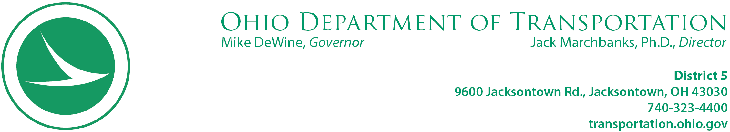

January 19, 2024

Thomas Rodgers, Jr.
Hope Miller
8895 Gaysport Hill Road
Blue Rock, OH 43720

RE: CRS: MUS-376-5.09
PCL: 010-1
PID: 115989

Dear :

Please contact me at your earliest convenience at 740-323-5422, my direct office number, or 740-814-0708, my cell phone number, to discuss the benefits available to you both. Charlie Rodgers met with our representative on 01/13/2024. I have been trying to reach you since 01/16/2024 to set a meeting with both of you via text and calls to your cell phone numbers.

It is imperative I speak with you with respect to your relocation benefits and move schedule.

Respectfully,

Kimber L. Heim
740-323-5422
kimber.heim@dot.ohio.gov
9600 Jacksontown Road
Jacksontown, OH 43030

