**Comparable Search 11/13/23**

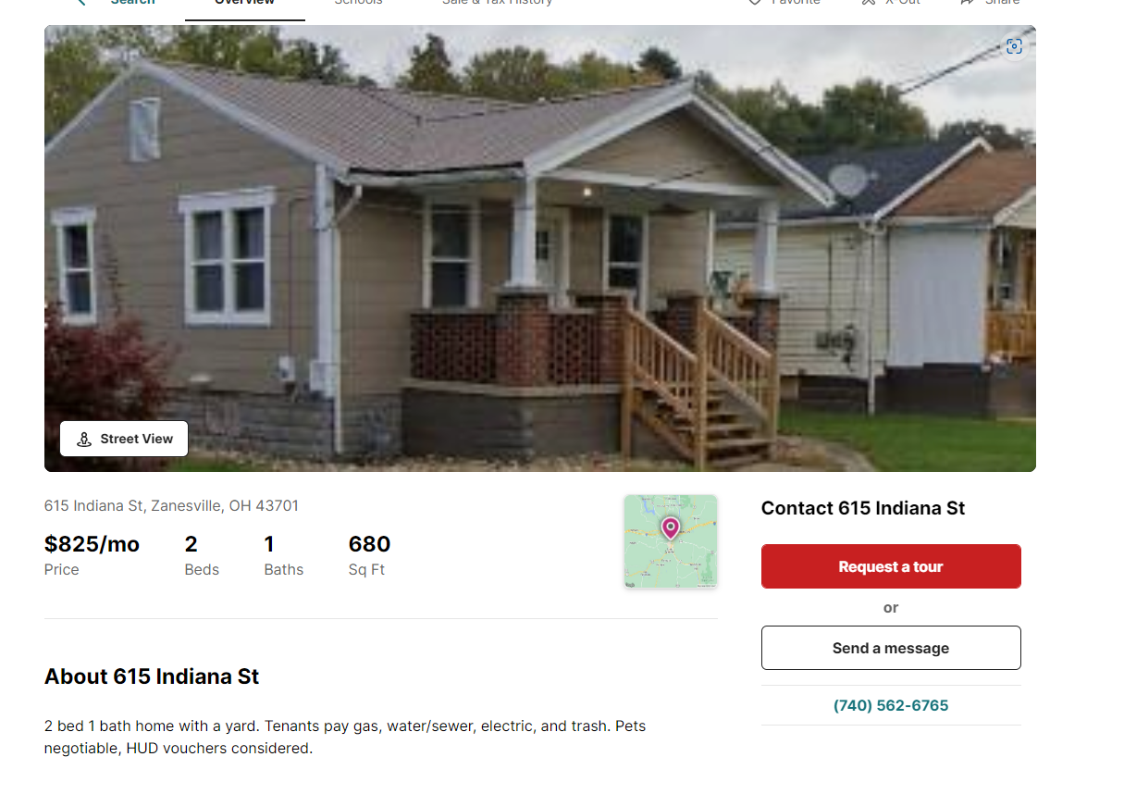

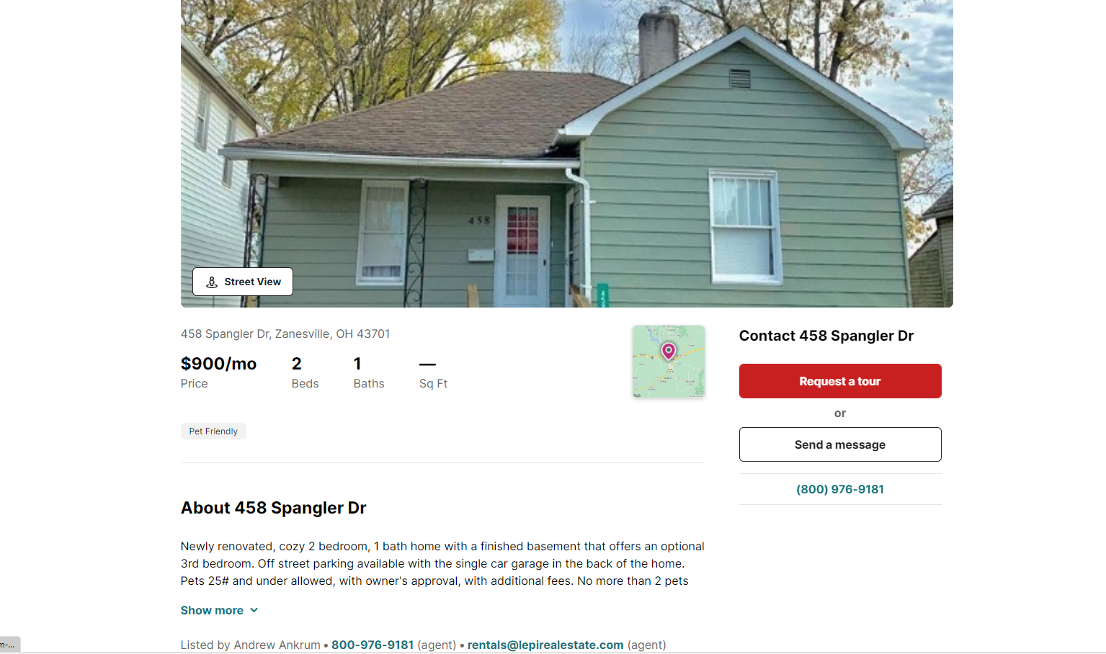

614-879-1935 rental manager

