RE-606 PP(B) Rev. 08/2017

Click here to enter a date.

Owners Name

Address

Cty, State, Zip

RE: CRS:

PCL:      -

PID:

Dear Owners Name:

I have reviewed all of the information relative to the move of your personal property.

As we discussed, you have indicated you wish to utilize a Choose an item. and Choose an item.. The maximum amount you will be reimbursed for the actual, reasonable and necessary costs of your personal property move is $0.00. This amount is based on: Choose an item..

You are now authorized to proceed with your move.

As applicable, I will monitor your move. It is your responsibility to notify me when the move is complete. You have indicated your move will be completed by Click here to enter a date.**.** Once completed, I will perform a post move inspection to ensure all items have been moved. All personal property must be moved according to the inventory and move specifications (as applicable), and if they are not, the agreed upon amount of the move may be reduced. If all items are not moved, and if the displacement site is not “broom-clean,” the agreed amount of the move may be reduced.

Please notify me upon the completion of your move. At that time I will complete a post-move inspection and process your move cost claim form. Final payment for your move costs cannot be released until I have successfully completed a post-move inspection.

If you have any questions about anything contained herein, please do not hesitate to contact me directly at the numbers or email address provided below.

Respectfully,

**(Insert Agent’s name, phone numbers and email address)**

**Pictures of Thomas Rodgers, Sr. Personal Property**

**as of April, 18, 2024**

**pictures taken by Kimber L. Heim**

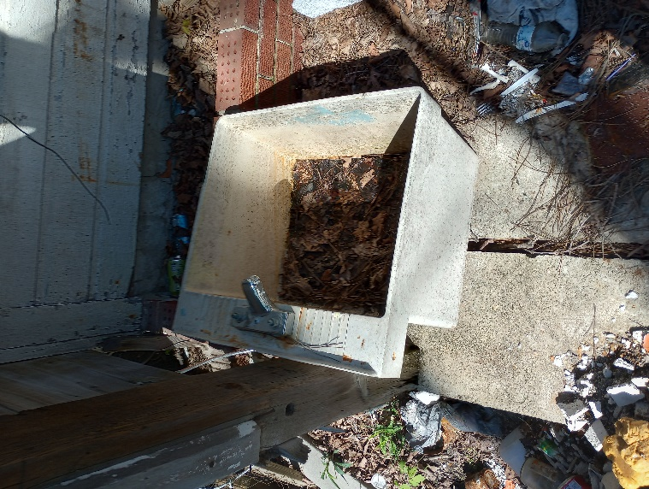

Personal Property of Thomas Rodgers, Sr.

Property in outbuilding storage shed

Pictures taken 6/15/23 by Nathan Garnett

