115989 MUS 376 PCL 010 O Structure Photos
Outside Attached Deck |  | Electrical Box
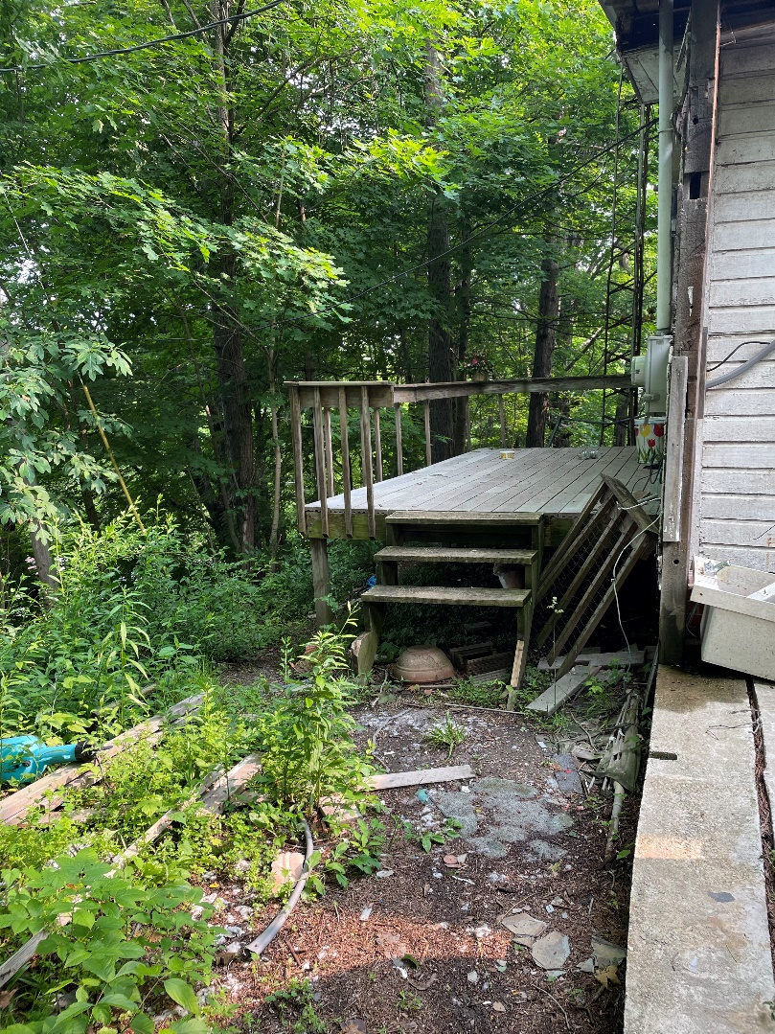 |  | 