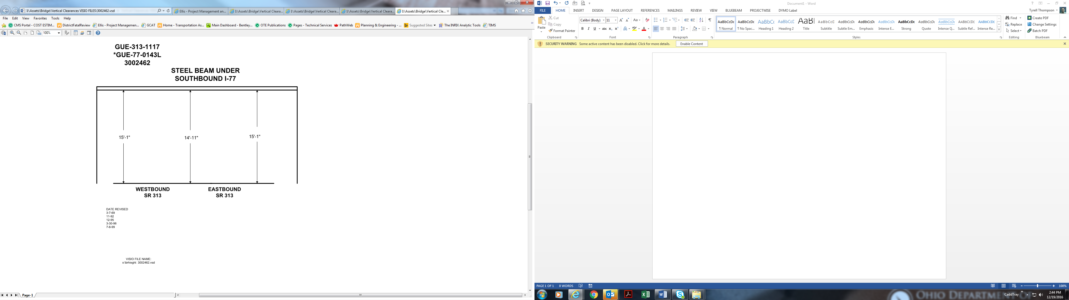

Date Revised: 3-7-69

11-92

12-95

3-30-98

7-8-99

15’-1” 14’-11” 15’-1”