CRITICAL FINDINGS REPORT
PURPOSE: The National Bridge Inspection Standards (23 CFR 650 subpart C) states critical findings are to be documented and addressed in a timely manner. This documentation is to be completed upon the finding of a critical bridge deficiency.
Date: 10-11-2011 Page: 1 of 1
Owner: Ohio Department of Transportation
Structure File Number: 3002462
Bridge Number: GUE-77-0143L
Inspection Agency: Ohio Department of Transportation, District 5
Description of Critical Findings: Collision damage to beam 1 of span 2 resulting in the beam being bent.
Immediate action taken to ensure safety of the traveling public: Conducted an in-depth inspection of the damaged beam.
Current plan of action for the bridge: The beam will be repaired on a future heat straightening contract.
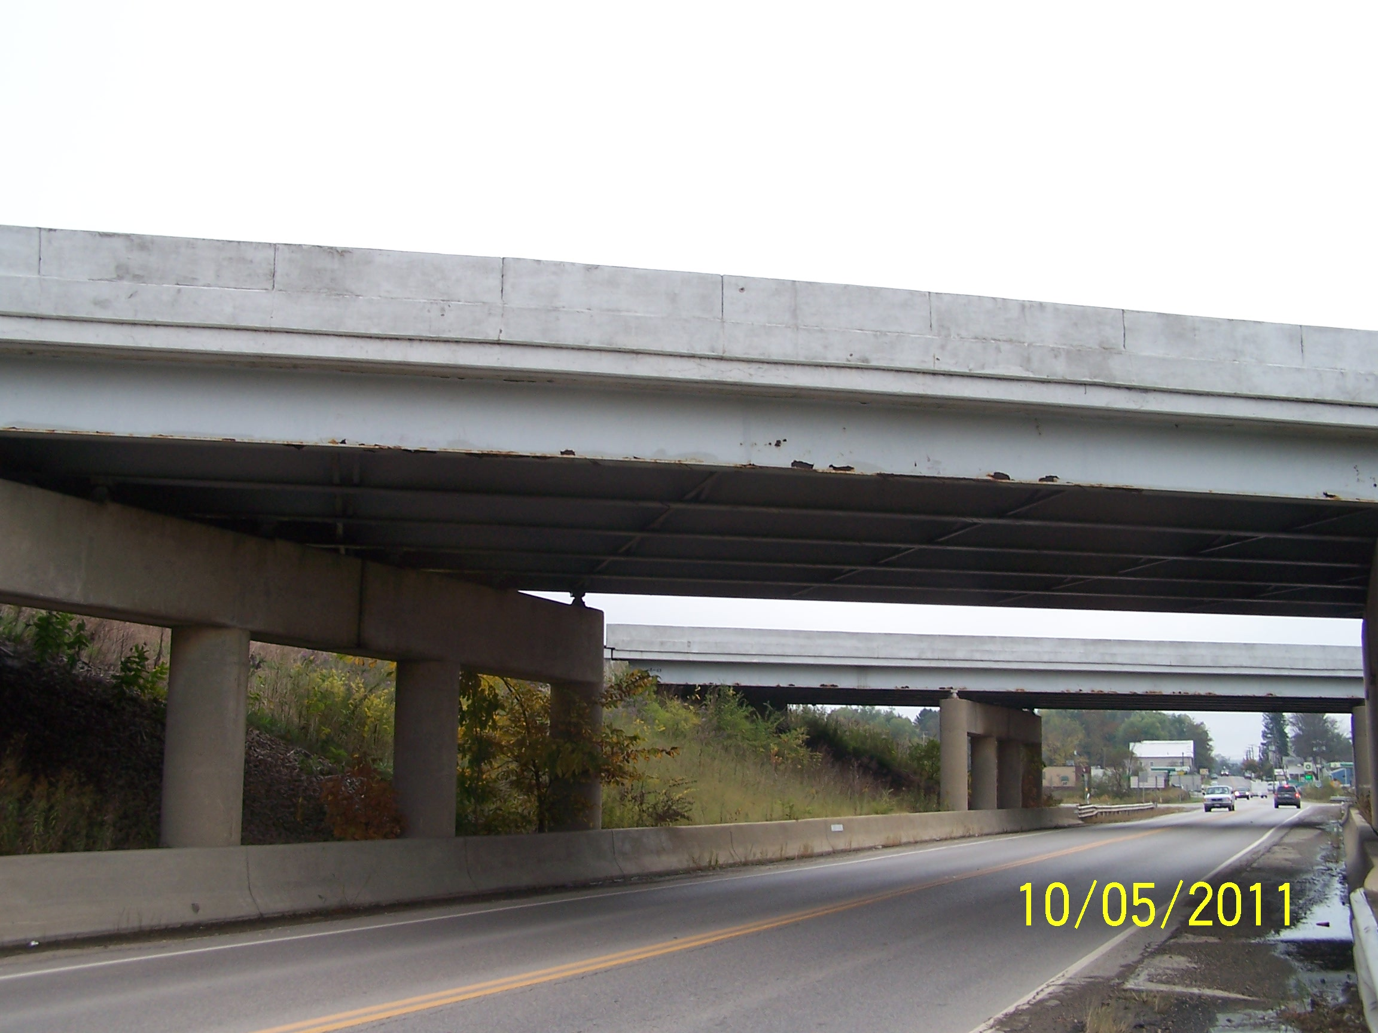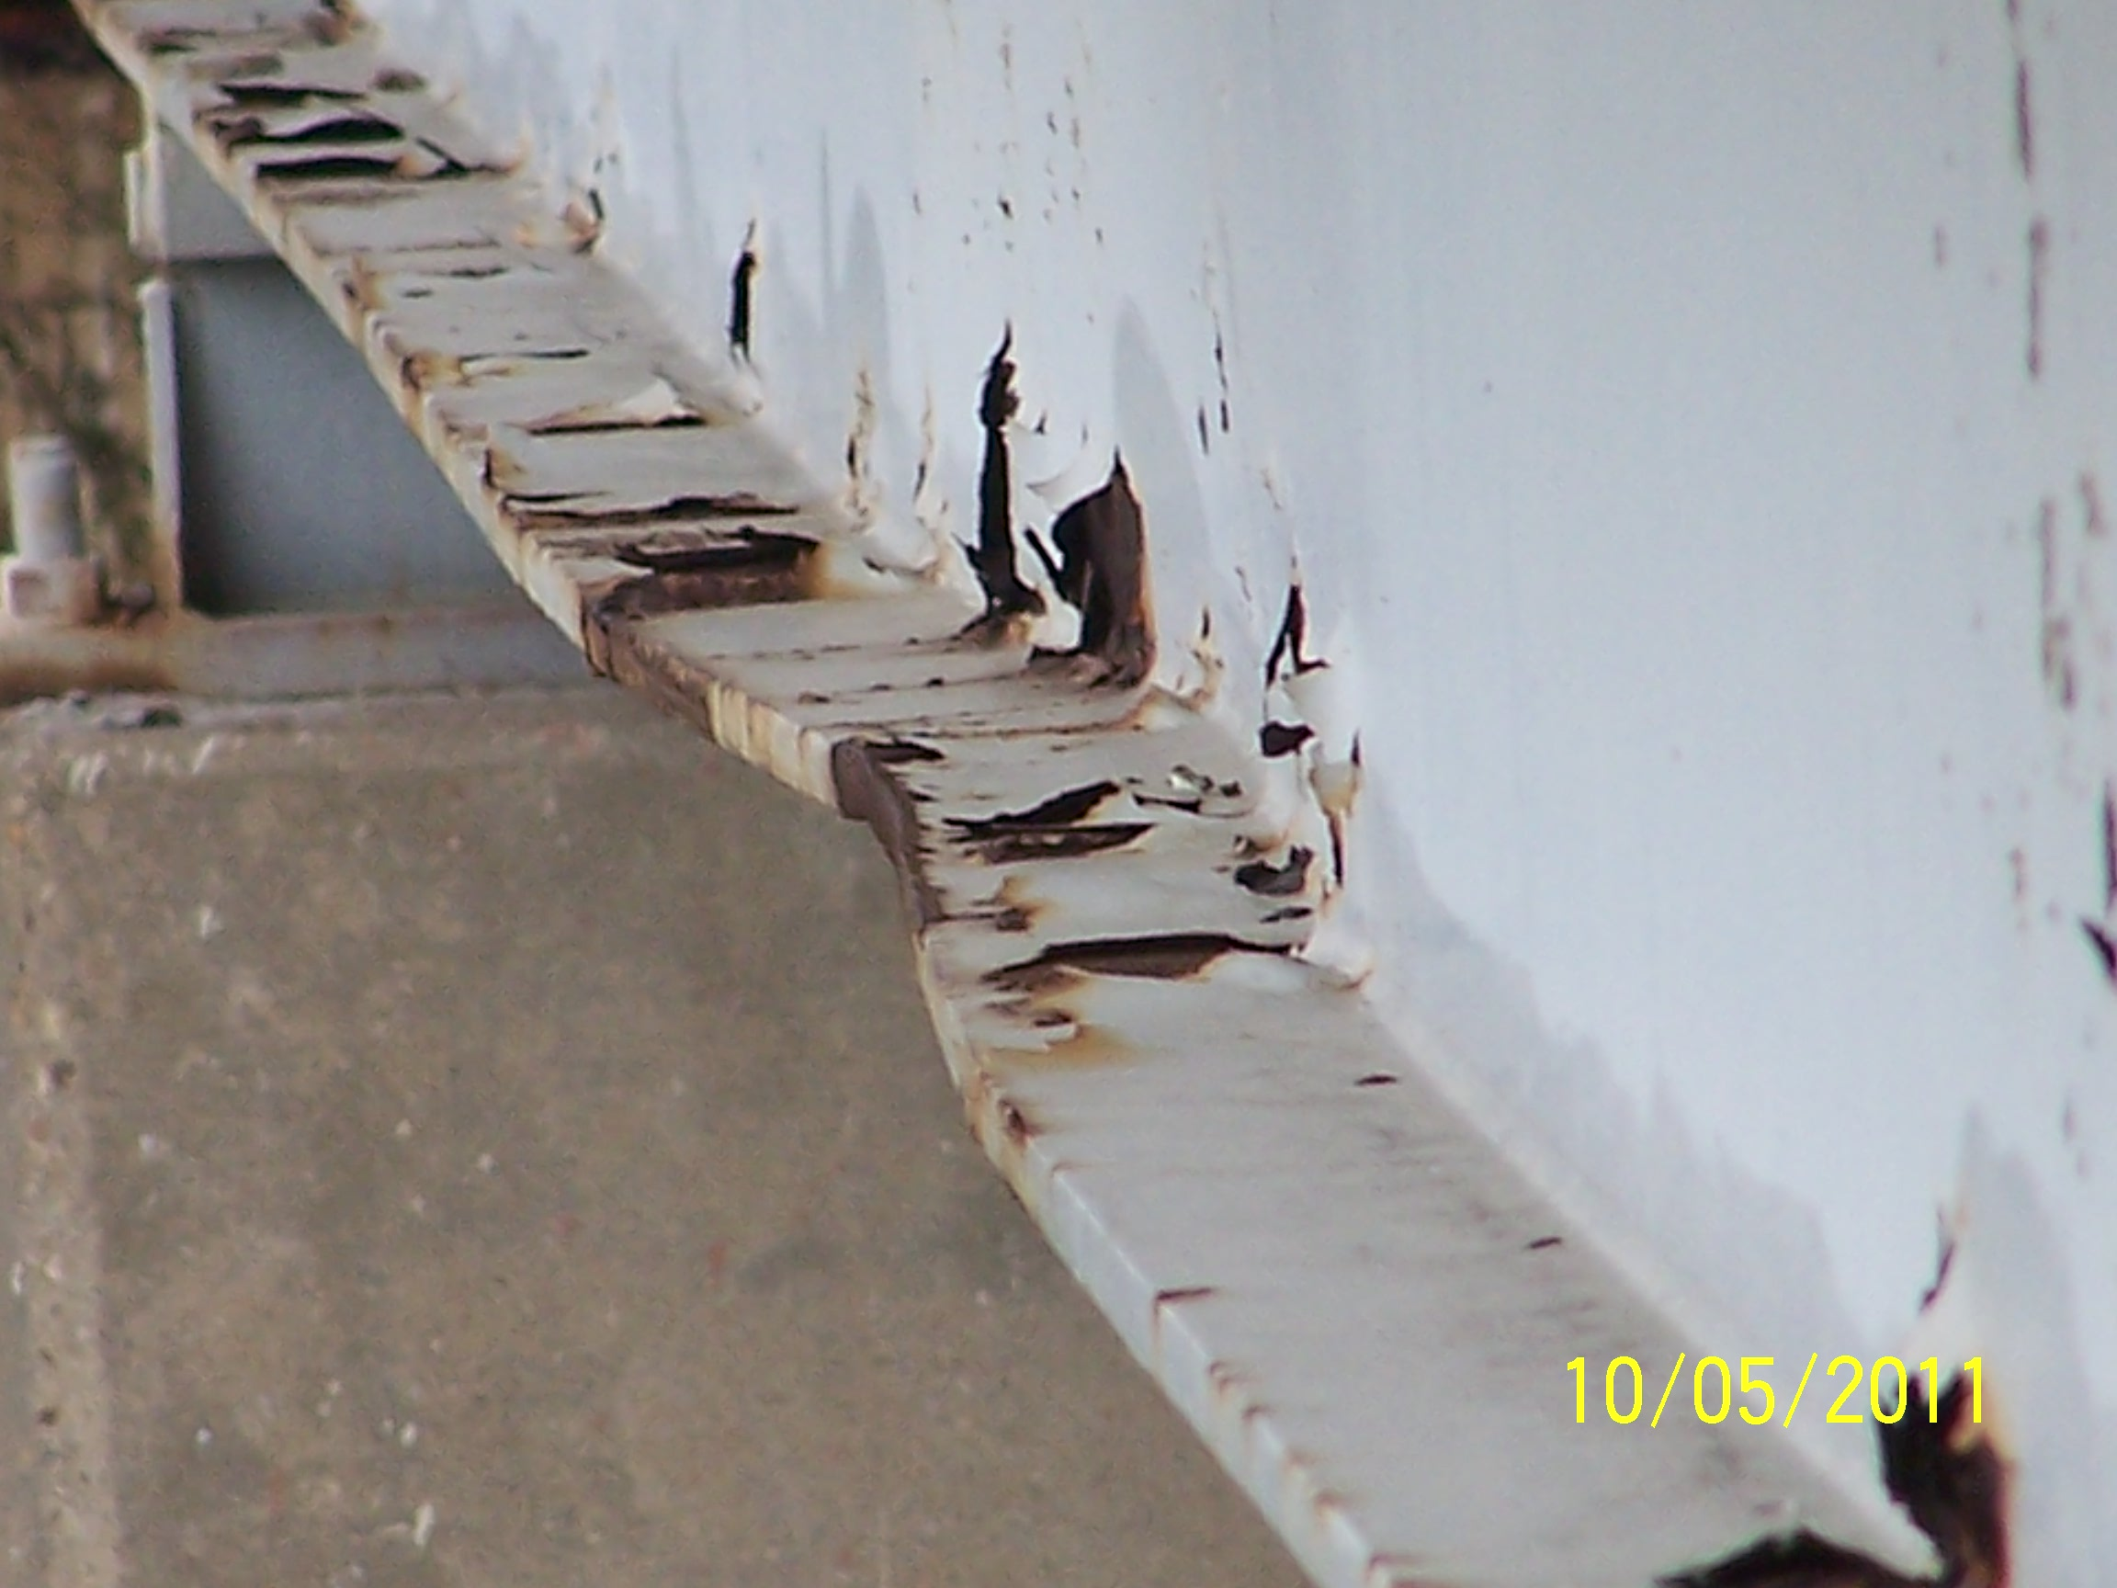
Left edge span 2 Beam 1 span 2
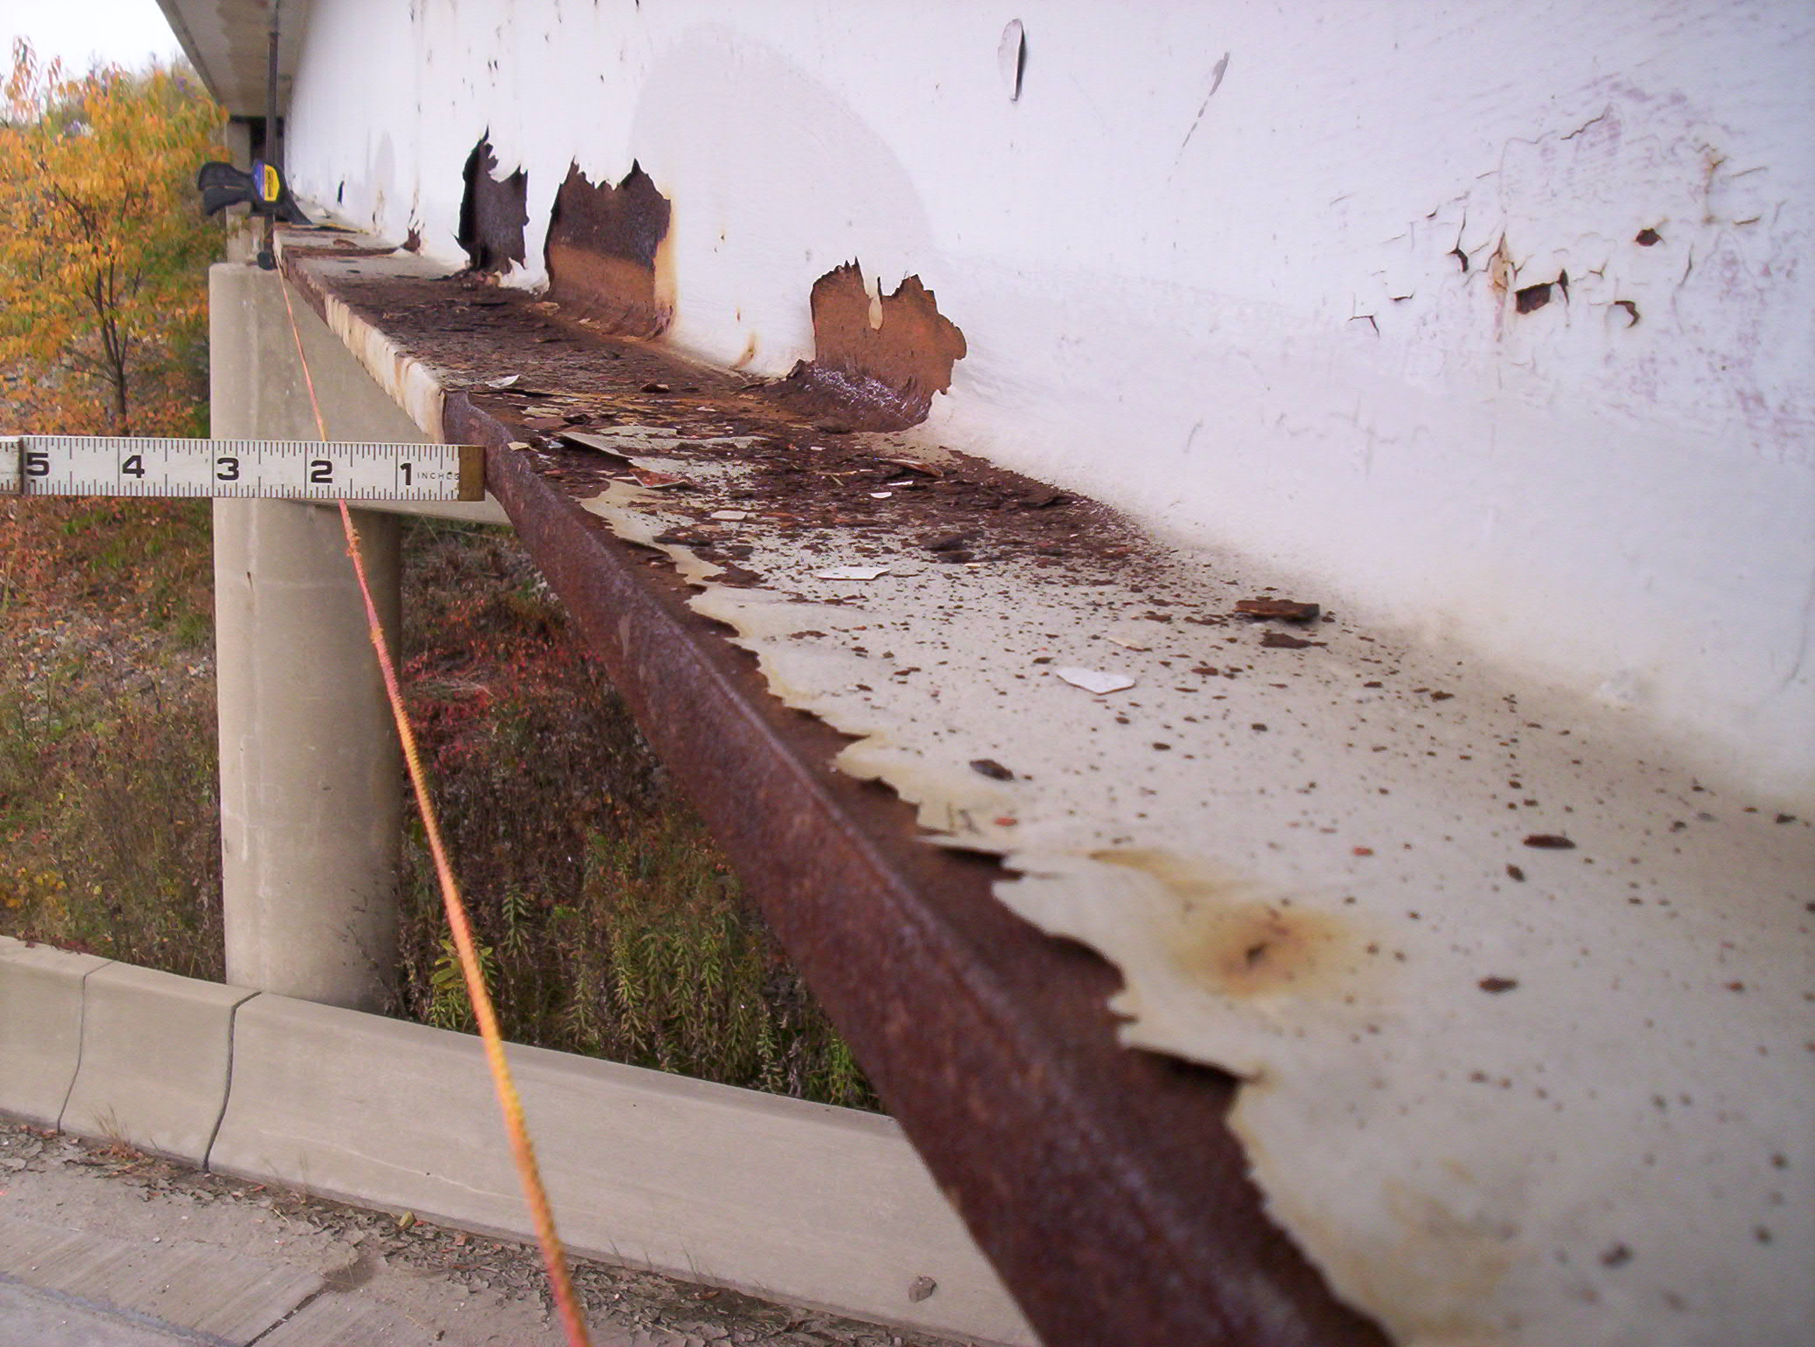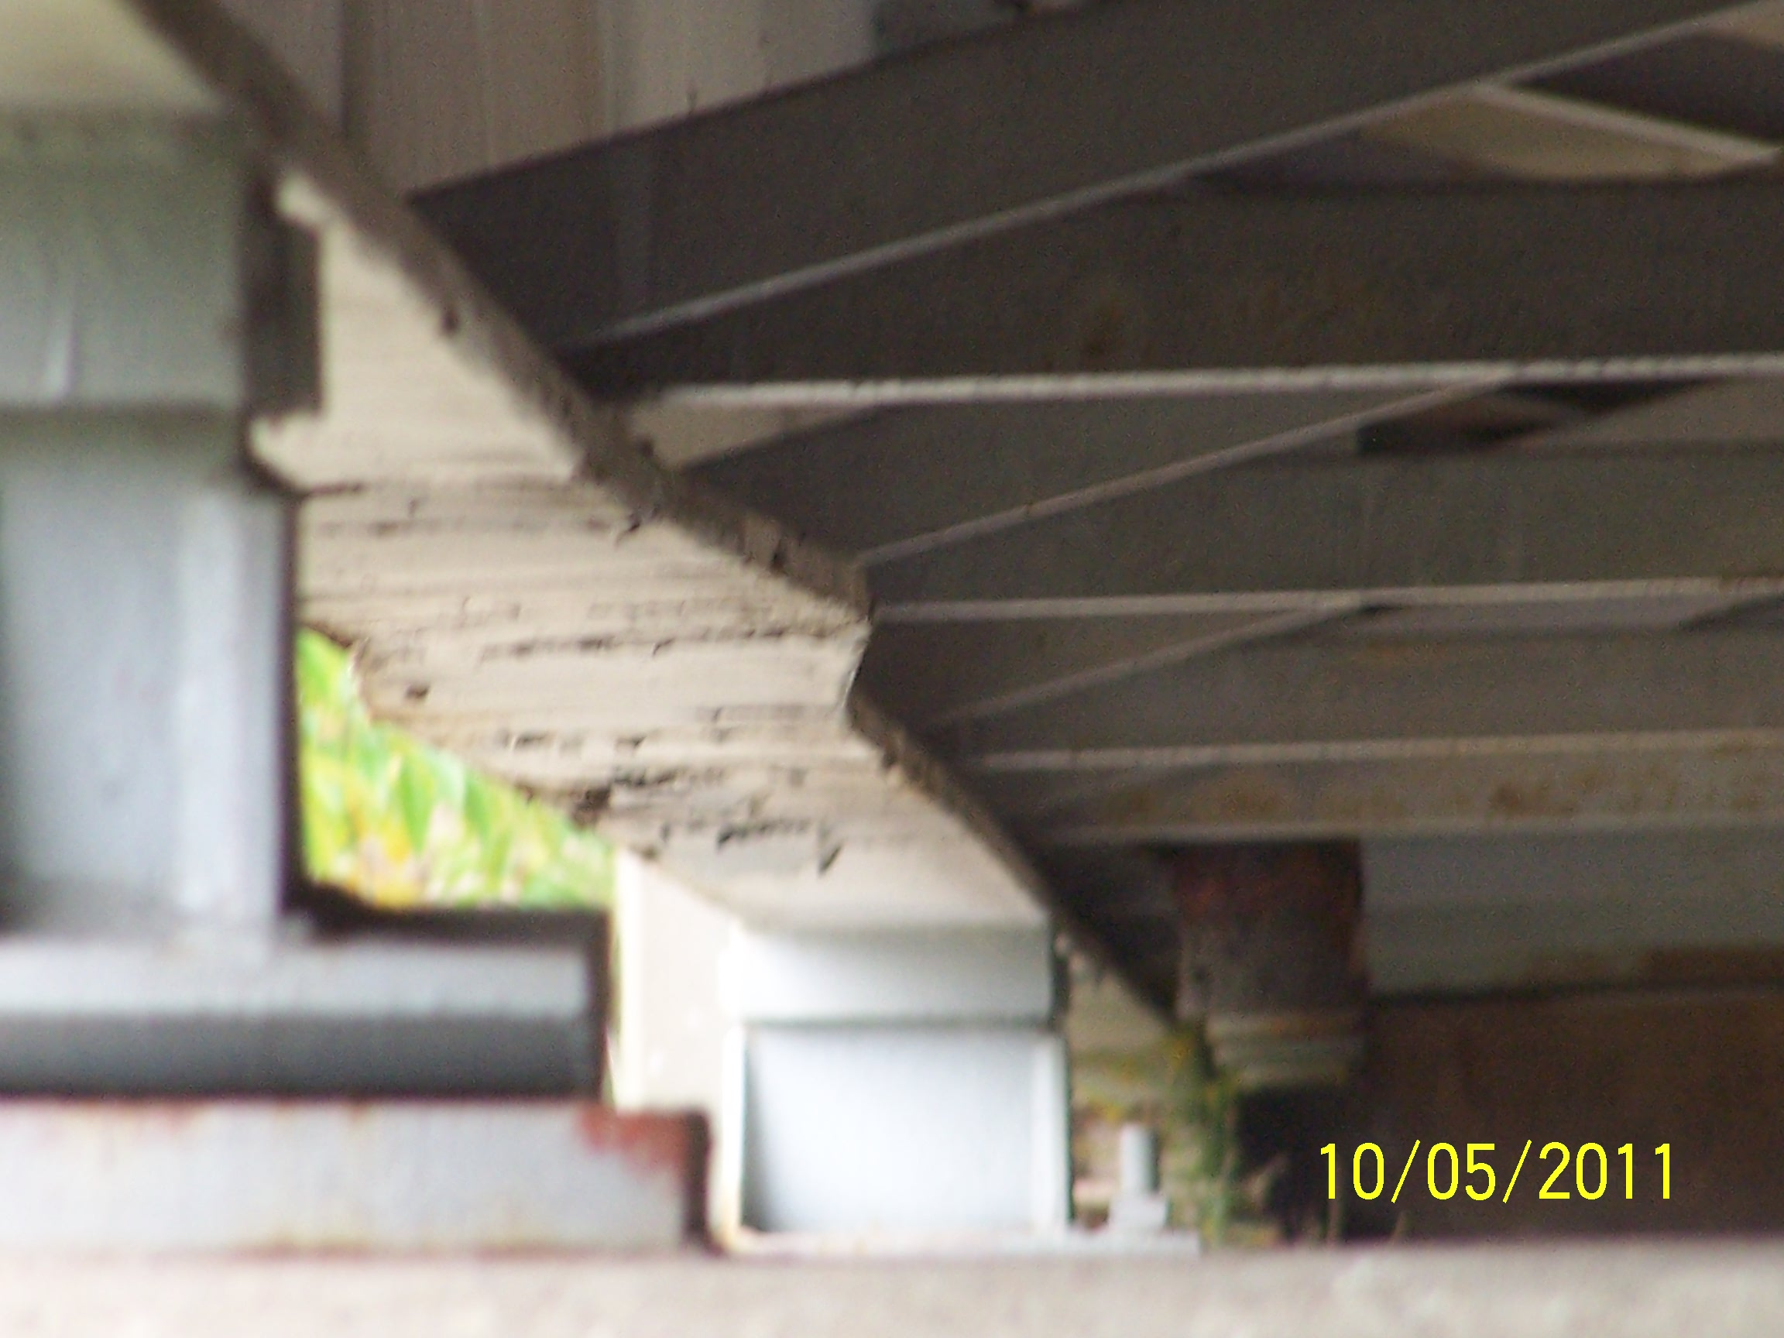
Beam 1 span 2 Beam 1 span 2

