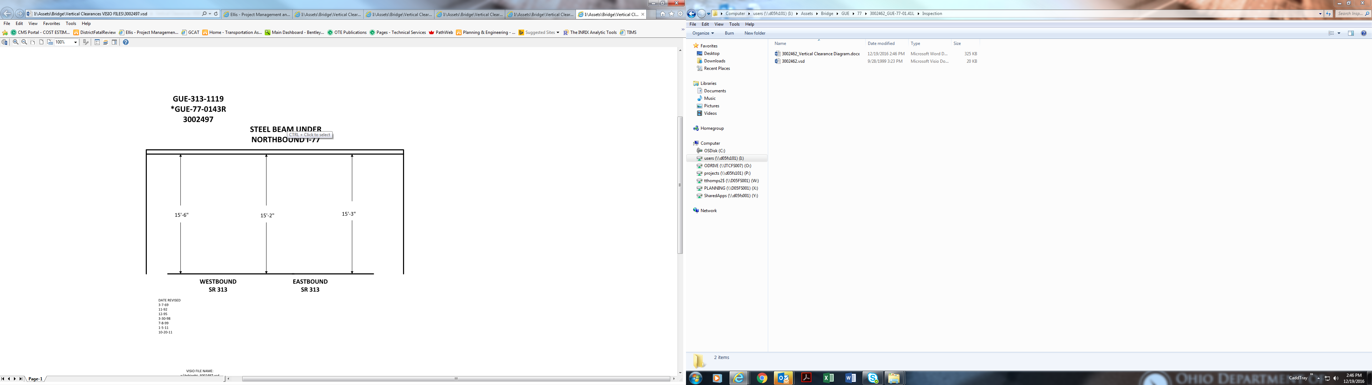

Date Revised: 3-7-69 10-20-11

11-92

12-95

3-30-98

7-8-99

1-5-11

15’-6” 15’-2” 15’-3”