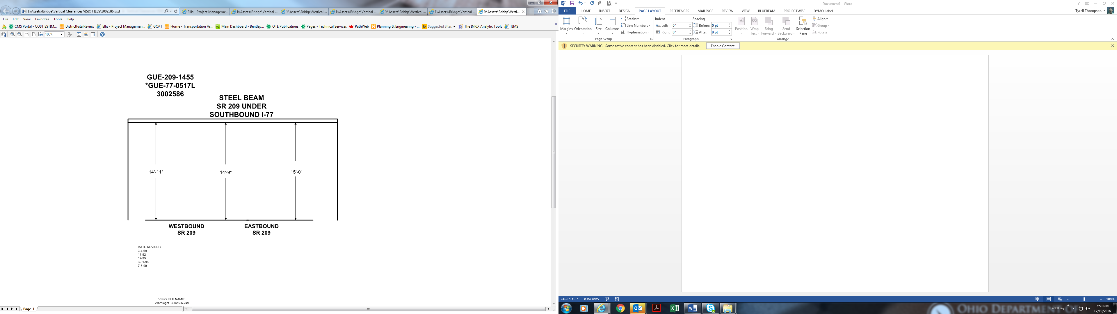

Date Revised: 3-7-69

11-92

12-95

3-31-98

7-8-99

14’-11” 14’-9” 15’-0”